A3VERIFILE: AI - POWERED VERIFICATION, ARCHIVING & CERTIFICATION STREAMLINING DOCUMENT PROCESSING

A Capstone and Research Project Presented to the
Department of Information Technology
University of Science and Technology of Southern Philippines
Oroquieta City



In Partial Fulfillment of the Requirements for
Capstone Project and Research Study leading to the Degree in Bachelor of
Science in Information Technology

Meshezabel V Igiya Liezelnit Jean G. Musade Jamaika Kim P. Bacsan Rio A. Facturan

DECEMBER 2025

APPROVAL SHEET

ABSTRACT

The A3VeriFile system was developed to address the challenges faced by the Registry of Deeds (ROD) and its clients in processing document requests such as Certified True Copies (CTCs), certifications, and verifications. The traditional process was time-consuming, prone to delays, and often required multiple visits to the office. A3VeriFile offers a faster and more convenient solution through features like OCR-powered data extraction, real-time tracking, and secure digital archiving.

The system simplifies the workflow by allowing clients to submit requests online and monitor their progress, while ROD staff can efficiently review, classify, and store documents. Developed using the Agile methodology, A3VeriFile was continuously refined based on feedback from users and administrators. Testing showed that the system improved processing time, accuracy, and communication between clients and ROD personnel.

In conclusion, A3VeriFile modernizes the document management process at the Registry of Deeds. It enhances accessibility, efficiency, and transparency creating a more organized and dependable platform for handling official records.

DEDICATION

This project represents the team's dedication, collaboration, and perseverance throughout the development process. Every challenge encountered became an opportunity for learning and growth not only as students, but as individuals who believe that technology can create meaningful change in public service.

The proponents sincerely dedicate this work to their families and loved ones, whose constant support, encouragement, and understanding served as their source of strength. Their confidence in the team’s abilities motivated them to continue the journey with determination and hope.

The team extends their heartfelt gratitude to their mentors and professors for their guidance, patience, and knowledge shared throughout the development. Their insights and continuous encouragement greatly contributed to the success of this project and inspired the team to pursue excellence.

Lastly, this system is dedicated to the Registry of Deeds staff and clients, who served as the inspiration behind A3VeriFile. May this project contribute to faster, more transparent, and reliable document processing reflecting the team's commitment to innovation and improving public service.

ACKNOWLEDGEMENT

The researchers give their utmost thanks and praise to Almighty God for His unending guidance, wisdom, and blessings that strengthened them throughout their journey. His grace served as their light in times of challenge, granting them perseverance and courage to complete this study successfully.

The researchers extend their heartfelt gratitude to their adviser, Ms. Lutherly Q. Bongcawel, for her patience, valuable insights, and continuous support. Her expertise and encouragement greatly contributed to the success of A3VeriFile and to the researchers’ growth as aspiring IT professionals.

Furthermore, the researchers express their gratitude to the professors of USTP Oroquieta City for their guidance and knowledge, which shaped the researchers’ academic and professional journey, as well as to the client testers for their cooperation and constructive feedback.

Finally, this work is dedicated to every member of the A3VeriFile development team, whose unity, effort, and passion transformed this idea into a meaningful innovation that promotes efficiency, transparency, and service to the community.

TABLE OF CONTENTS

TITLE PAGE..........................................................................................................i APPROVAL SHEET.............................................................................................ii ABSTRACT…......................................................................................................iii DEDICATION......................................................................................................iv ACKNOWLEDGEMENT....................................................................................v TABLE OF CONTENTS .....................................................................................vi CHAPTER I ...........................................................................................................1
1.1 Background of the Study................................................................................1

1.2 Statement of the Problem................................................................................3

1.3 Statement of the Objectives............................................................................4

1.3.1 General Objectives............................................................................4

1.3.2 Specific Objectives............................................................................4

1.4 Significance of the Study................................................................................5

1.5 Scope and Limitation of the Study..................................................................6

1.6 Definition of Terms ........................................................................................7

CHAPTER II .........................................................................................................8

2.1 Review of Literatures.........................................................................................8

2.1.1 Automated Document Using OCR Technology .................................8

2.1.2 Mobile-Based Transaction and Tracking System................................9

2.1.3 Digital Solutions for Land Records and Property Management.........10

2.1.4 Fingerprint Biometrics for Secure Identity Verification. ..................11

2.2 Review of Related Applications....................................................................... 12

2.2.1 Papeles.PH........................................................................................13

2.2.2 PSASerbilis.......................................................................................14

2.2.3 LRA eSerbisyo..................................................................................15

2.2.4 NotaryNow ...................................................................................... 16

2.3 Synthesis and Gap Analysis..............................................................................17

2.4 Summary .........................................................................................................18

CHAPTER III.......................................................................................................21

3.1 Description of the Current System (Information Gathering…..........................26

3.2 System Architecture and Development............................................................27

3.2.1 Overview of the Proposed System.....................................................28

3.2.2 System Objectives.............................................................................28

3.3 System Tools and Requirements.......................................................................29

3.3.1 Programming Language ...................................................................29

3.3.2 Hardware Requirements................................................................... 30

3.3.3 Software Requirements..................................................................... 31

3.3.4 System Flow/Functions.....................................................................32

3.3.5 Scope and Limitation of the System ..................................................42

3.3.6 Calendar of Activities .......................................................................36

3.4 Conceptual Design and Implementation.......................................................... 3

3.4.1 System Design ..................................................................................37

3.4.2 Database Design ...............................................................................39

3.4.3 Use Case Design ...............................................................................41

3.4.5 Context Diagram...............................................................................51

CHAPTER IV …………………………………................................................. 54

4.1 Discussions...................................................................................................... 54

4.2 Results............................................................................................................. 55

4.4.1 System Evaluation Results............................................................................ 58

4.4.2 ROD Staff Evaluation…............................................................................... 67

4.4.2 Public User Evaluation…............................................................................. 68

CHAPTER V …………………………………................................................... 70

5.1 Conclusion....................................................................................................... 71

5.2 Recommendation............................................................................................. 72

REFERENCES.....................................................................................................74

APPENDICES......................................................................................................81

Appendix A…........................................................................................... 76

Appendix B…............................................................................................ 77

Appendix C…............................................................................................ 78

Appendix D…........................................................................................... 79

Appendix E…............................................................................................ 80

Appendix F…............................................................................................ 81

Appendix G…........................................................................................... 82

Appendix H…........................................................................................... 83

CURRICULUM VITAE......................................................................................96

LIST OF FIGURES

Figure 1 PAPeLES.PH ..........................................................................................13

Figure 2 PSA Serbilis ............................................................................................14

Figure 3 LRA eSerbisyo… .................................................................................... 15

Figure 4 Notary Now .............................................................................................16

Figure 5 Agile SDLC Model ................................................................................. 22

Figure 6 Calculation using Cochran’s Form…………………….......................... 26

Figure 7 Flowchart Diagram (user)………. .......................................................... 32

Figure 8 Flowchart Diagram (staff) ....................................................................... 35

Figure 9 Flowchart Diagram for OCR (staff) ........................................................ 38

Figure 10 Flowchart Diagram (admin)………...................................................... 40

Figure 11 Gantt Chart for A3VeriFile ................................................................... 43

Figure 12 System Architecture ..............................................................................44

Figure 13 Use Case Diagram.................................................................................46

Figure 14 Entity-Relationship Diagram for A3VeriFile ....................................... 48

Figure 15 Context Diagram for A3VeriFile ......................................................... 51

Figure 16 Mean Formula…………………………………………………………55

Figure 17 OCR Data Extraction and Archiving Interface…………………...……58

Figure 18 Request Tracking Interface………………….……………….…...……59

Figure 19 Notification Dashboard………………………..………………………61

Figure 20 ROD Administrator Dashboard……….………...……..………………63

Figure 21 Fingerprint Authentication Interface…………..………………………64

Figure 22 Digital Archived Management Interface………..………………..……66

LIST OF TABLES

Table 1 Related Applications .................................................................................11

Table 2 Synthesis and Gap Analysis …..................................................................16

Table 3 Hardware Requirements ........................................................................... 28

Table 4 Software Requirements ............................................................................ 29

Table 5 Scale Range and Verbal Interpretation for Weighted Mean………….…..54

Table 6 Usability Evaluation of the A3VeriFile System………………………….55

Table 7 Evaluation Criteria……………………………………………………….56

Table 8 ROD Staff Evaluation Results………………..………………………….58

Table 9 Public User Evaluation Results……………………………………….….59

CHAPTER I INTRODUCTION
This chapter presents the background, statement of the problem, objectives, significance, scope and limitations, and definition of terms for the A3VeriFile system. It highlights the need to replace manual document processing at the Registry of Deeds with an automated, AI-powered solution to improve accuracy, efficiency, and transparency.

1.1 Background of the Study

The Registry of Deeds handles essential property documents, yet many offices still depend on manual verification, certification, and archiving. These outdated processes result in delays, errors, disorganized records, and lack of real- time updates causing frustration for property owners, lawyers, and staff. Interviews revealed common issues such as long processing times, difficulty locating records, and no transparent way to track request status, leading to inefficiency and reduced trust in public services.

A3VeriFile addresses these gaps by introducing an automated CCV workflow supported by OCR, AI-driven data extraction, and a secure digital archiving system. The platform provides real-time tracking, faster processing, and organized digital records for easy retrieval. By reducing manual tasks, minimizing

errors, and improving transparency, A3VeriFile enhances operational efficiency and user satisfaction, setting a new standard for fast, accurate, and secure document processing in the Registry of Deeds.

1.2 Statement of the Problems

Many government agencies, including the Registry of Deeds, still rely on manual verification, certification, and archiving of documents. This traditional process causes slow transactions, frequent errors, missing records, and long waiting times for those requesting Certified True Copies (CTCs) and other legal documents. These delays affect property owners, legal professionals, and small businesses, especially during property transactions where accuracy and speed are crucial. Manual CCV processing and poor record organization remain the core issues, resulting in inefficiency, frustration, and additional workload for government employees.
A3VeriFile addresses these challenges by providing a fully digital and automated solution for document verification, certification, and archiving. By integrating OCR, AI-assisted checking, and real-time tracking, the system reduces human error, speeds up processing, and ensures secure and well-organized digital records. This streamlined workflow improves accuracy, efficiency, and user

satisfaction, helping the Registry of Deeds deliver faster, more reliable, and transparent public service.

1.3 Statement of the Objectives

1.3.1 General Objectives

This study aims to develop A3VeriFile, a digital system that will make the processing of document requests at the Registry of Deeds faster, safer, and more organized. It focuses on solving problems such as delays, manual errors, and lack of updates.
1.3.2 Specific Objectives

• To create a mobile app where users can easily send requests, track the status of their requests, and receive updates.
• To build a web platform for ROD staff that helps them review requests and update request progress quickly.
• To integrate an OCR-powered feature that extracts and classifies data from submitted legal documents for faster verification and archiving.
• To provide an admin dashboard for managing staff accounts, handling system settings, checking reports, and fixing technical problems.
• To ensure transparency and better service by giving users access to payment notice, real-time updates, and securely archived files.

1.4 Significance of the Study

This study is significant as it aims to enhance the efficiency, accuracy, and transparency of document verification and certification processes at the Registry of Deeds (ROD) through the development of A3VeriFile, an automated document verification and certification system. It benefits the Registry of Deeds personnel by streamlining document search, verification, and certification processes, thereby reducing the manual workload and human errors. Clients, including property owners, real estate professionals, and legal practitioners, will benefit from faster document processing times, real-time updates, and a more transparent and reliable system. Educationally, the study contributes to the growing body of knowledge on e governance and digital transformation in public service delivery, particularly in records management and document authentication using artificial intelligence and automation. Additionally, this research supports government digitalization efforts by demonstrating how technology can improve service delivery, enhance records security, and prevent fraudulent document manipulation.

1.5 Scope and Limitations of the Study

The scope of this study is to enhance and automate the document verification and certification processes at the Registry of Deeds (ROD) through the development of A3VeriFile, an AI-powered document verification system. The system utilizes automated document matching technology, digital archives, and real time tracking features to streamline the handling of Certified True Copies (CTCs) and other property-related documents. A3VeriFile aims to improve document processing efficiency, reduce manual errors, and provide real-time status updates to clients, ensuring transparency and faster service delivery. The study covers the design, development, implementation, and evaluation of the system’s effectiveness in improving document processing times, accuracy, and customer satisfaction. However, the study has several limitations. The system is specifically designed for property-related documents handled by the Registry of Deeds, and does not extend to other government agencies or document types. The system’s performance depends on the quality and completeness of existing digital records in the ROD’s database, meaning missing, outdated, or low - quality scanned documents may still require manual verification.

1.6 Definition of Terms

Certified True Copy (CTC) – In this system, this is the type of document requested by users through A3VeriFile. It is the officially verified digital or printed copy issued by the Registry of Deeds confirming that it matches the original record stored in their archive.

Digital Archive – Within A3VeriFile, this is the secured digital storage where processed documents such as CTCs, certifications, and request records are organized and stored for quick retrieval and future use.

Document Tracking System – A feature of A3VeriFile that allows users to see the real-time status of their requests (e.g., submitted, reviewing, processing, ready for release) through the mobile app, reducing follow-up inquiries and walk-ins.

Optical Character Recognition (OCR) – In this system, OCR refers to the automated process used by A3VeriFile to extract text and key information from scanned or uploaded documents. Using Google Gemini this allows A3VeriFile to classify, verify, and archive documents automatically without manual encoding, improving accuracy and processing efficiency.

CHAPTER II

REVIEW OF RELATED LITERATURE

This chapter explores existing research on digital platforms for government services, focusing on automated verification and document management. It highlights the challenges faced in traditional processes within registries of deeds and the need for efficient, secure, and accessible digital solutions. By delving into key concepts, theories, and past studies, this chapter establishes the foundation for A3VeriFile, emphasizing the need for a system that streamlines document processing and enhances service delivery in government agencies.

2.1 Review of Literatures

2.1.1 Automated Data Extraction Using OCR Technology

Mendoza and Reyes (2023) discussed the use of Optical Character Recognition (OCR) in improving document processing within government offices. Their study highlighted that OCR can extract text from scanned or uploaded documents, allowing physical records to be converted into searchable digital formats. The extracted text can then be used for categorizing and organizing documents in archiving systems. Their findings emphasized that OCR eliminates manual encoding, improves processing efficiency, and speeds up document classification in digital government platforms.

Similarly, recent studies show that OCR, when paired with Generative AI tools, further enhances data extraction accuracy and reduces human error. Abinaya et al. (2024) demonstrated that integrating OCR with Generative AI models such as Google Gemini can produce more accurate text extraction, automatic summarization, and structured data output, especially when handling complex legal documents. This supports the decision to incorporate Google Gemini OCR in the A3VeriFile system for extracting key document details, improving workflow efficiency, and ensuring reliable digital archiving.

2.1.2 Mobile-Based Transaction and Tracking Systems

A reliable digital archiving system plays a vital role in improving accessibility, efficiency, and user confidence in document management. Acebron et al. (2024) emphasized that digital archiving systems in government offices significantly enhance sustainability and storage capability, allowing faster document retrieval and reducing reliance on physical records. Similarly, Soulthoni and Itasari (2025) found that electronic-based archiving promotes operational efficiency and supports government digitalization by simplifying document organization and retrieval. Watanabe, Delmo, and Alfikri (2023) highlighted that mobile-

based archive management systems enable users to store and access important files anytime and anywhere, contributing to a more user-friendly and convenient workflow. In addition, Azzam, Al-Khalifa, and Alotaibi (2023) demonstrated that integrating AI technologies such as Optical Character Recognition (OCR) improves the accuracy of document classification and indexing. Likewise, Dela Cruz Abubo et al. (2024) showed that AI-assisted OCR data extraction increases the consistency and reliability of digital archives in public institutions. Altogether, these studies emphasize that enhancing efficiency, accuracy, and accessibility through digital and mobile-based archiving systems can lead to better service delivery and higher user satisfaction principles that align with the goals of A3VeriFile.

2.1.3 Digital Solutions for Land Records and Property Management

Rodriguez (2023) explored the digital transformation initiatives of the Land Registration Authority (LRA) in modernizing land and property records. The study emphasized that the adoption of digital systems helped improve the organization and accessibility of land information, resulting in faster and more reliable services for clients. Similarly, Santos and Velasco (2022) discussed how web-based tracking and verification systems simplify the management of property records by allowing users to request and

monitor documents online. These innovations reduce manual paperwork, promote accurate record-keeping, and streamline overall workflows in land management offices. Furthermore, Patel and Singh (2021) noted that the integration of automation in document processing improves accuracy and consistency, ensuring that land transactions are processed efficiently. Collectively, these studies highlight how digital solutions can transform traditional record management into a more efficient, transparent, and user- centered process objectives that align with the development goals of A3VeriFile.

2.1.4 Fingerprint Biometrics for Secure Identity Verification

Karale et al. (2022) highlighted the importance of biometric authentication in improving accuracy and reliability in digital identification systems. Their study explained that fingerprint scanning provides a convenient and consistent way of verifying user identity, as each fingerprint is unique and remains stable over time. By using fingerprint recognition, systems can easily identify users without the need for manual login credentials, reducing verification time and simplifying user interaction. Similarly, Kumar and Shukla (2023) noted that fingerprint biometrics enhance user experience by offering a faster and more dependable method of accessing digital services. The findings of these studies show that

fingerprint-based authentication supports more efficient and user-friendly transactions, making it a practical feature for government and public service applications. This supports the integration of fingerprint recognition in systems like A3VeriFile, where accurate and effortless identity verification can streamline document processing and improve overall user satisfaction.

2.2 Review of Related Applications

Table 1 Related Applications

Application/ System | AI Powered  Verification  & Certification | Archiving and  Indexing | Ticketing  System | Real Time  Tracking
PaPeLES.PH | ✗ | ✗ | ✗ | ✓
PSASerbilis | ✗ | ✓ | ✗ | ✓
LRA eSerbisyo | ✗ | ✗ | ✗ | ✓
Notary Now | ✗ | ✗ | ✗ | ✗
A3VeriFile | ✓ | ✓ | ✓ | ✓

Table 1 shows that existing platforms lack full integration of automated verification, document management, and workflow optimization. A3VeriFile addresses this gap with enhanced efficiency, security, and transparency.

2.2 Review of Related Application

2.2.1 PAPeLES.PH

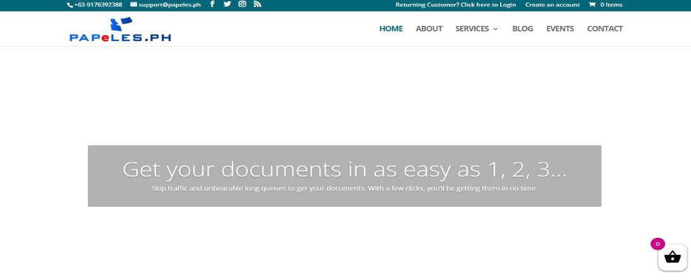

Figure 1. PAPeLES.PH Website

Figure 1 shows PAPeLES.PH a web-based platform designed to simplify the process of managing and requesting official documents in the Philippines. It provides a centralized online portal where users such as individuals, businesses, and government agencies can submit requests for documents, track their status, and receive notifications about updates in real time.

2.2.2 PSA Serbilis

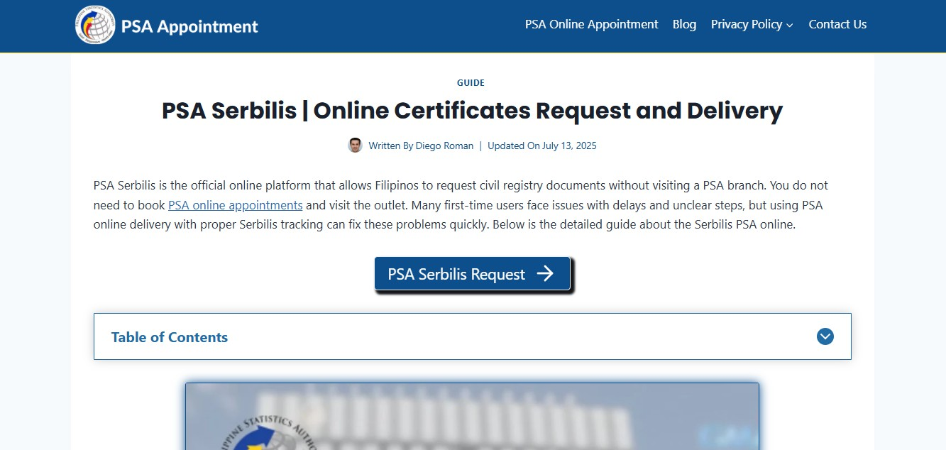

Figure 2. PSA Serbilis Website

Figure 2 shows the PSA Serbilis is the Philippine Statistics Authority's (PSA) official online platform for requesting copies of civil registry documents, including birth, marriage, and death certificates, as well as Certificates of No Marriage Record (CENOMAR). The platform offers a convenient, door-to-door delivery service for both domestic and international clients.

2.2.3 LRA eSerbisyo

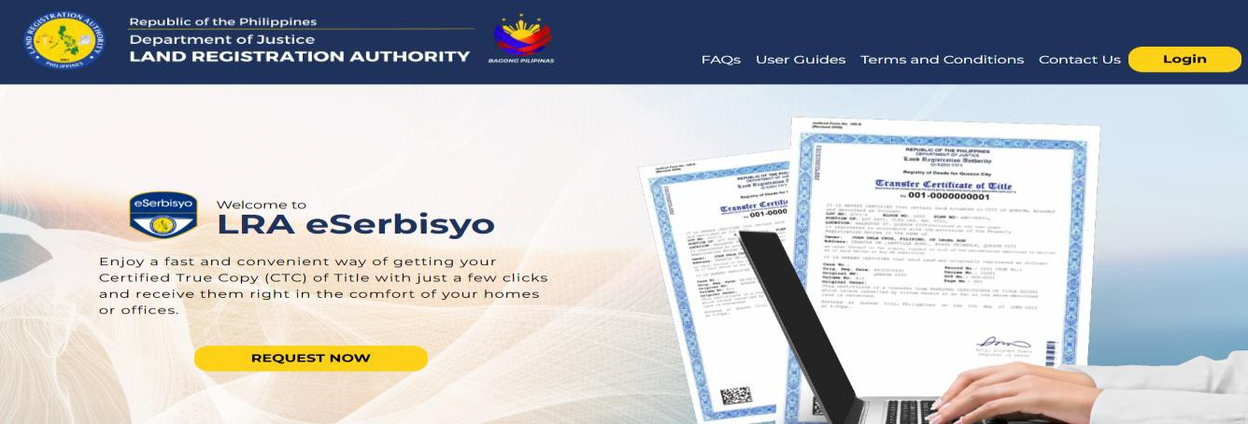

Figure 3. LRA eSerbisyo Website

Figure 3 shows the LRA eSerbisyo Portal is an online platform developed by the Land Registration Authority (LRA) of the Philippines, designed to facilitate the remote request and delivery of Certified True Copies (CTCs) of land titles. This service enables individuals to obtain essential land documents without the need to visit LRA Offices in person.

2.2.4 NotaryNow

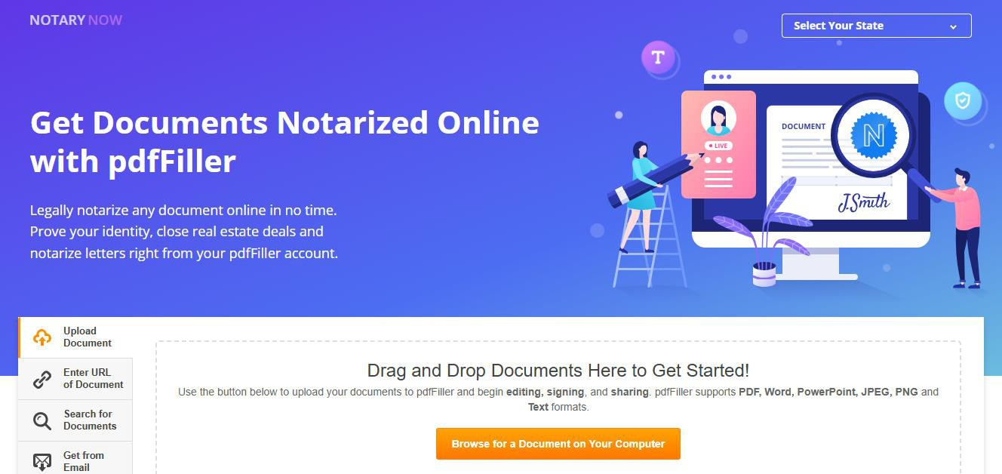

Figure 4. NotaryNow Website

Figure 4 shows the NotaryNow is an online platform that facilitates remote notarization of documents, allowing users to connect with certified notaries via secure video calls. This service enables individuals and businesses to have their documents legally notarized without the need for in-person meetings, offering convenience and efficiency.

2.3 Synthesis and Gap Analysis

Research shows that digital platforms have improved efficiency and transparency in processing public documents. However, there is still a gap in delivering an all-in-one system that combines automated verification, certification, and real-time tracking particularly in agencies like the Registry of Deeds where manual processes often cause delays. Most existing systems only focus on specific features such as online request forms or digital payments, but lack full integration. Additionally, many still depend on human verification, which is prone to errors and slow turnaround times. Real-time tracking tools and client support features like ticketing systems are also underutilized.
The proposed A3VeriFile system addresses this gap by offering a centralized and intelligent platform designed to streamline document processing and record management. It integrates OCR-powered text extraction and document verification, automated archiving and indexing, and a ticketing and tracking system that allows users to monitor request progress in real time. With its user-friendly interface and organized workflow, A3VeriFile promotes efficiency, accessibility, and reliability in document management enhancing both staff productivity and public satisfaction in government transactions.

Table 2. Synthesis and Gap Analysis

Study | Methodology | Findings | Limitation
Mendoza and | Integration of | OCR enhances the | Dependent on
Reyes | OCR in | efficiency of | the Quality of
 |  | document
(2023) | Government | verification, | the scanned
 | Service | reduces human | documents and
 | Platforms | error, and | OCR to
 |  | improves
 |  | accuracy in | accuracy,
 |  | identifying | complex
 |  | inconsistencies in | document
 |  | records. | formats
Alvarez (2024) | Mobile based | Mobile | Challenges in
Alvarez (2024) | Government | accessibility | adoption in areas
Alvarez (2024) | Service App | reduces queuing | with limited
Alvarez (2024) |  | and improves | infrastructure user
Alvarez (2024) |  | transparency, with | internet
Alvarez (2024) |  | real-time tracking
Alvarez (2024) |  | and updates
Rodriguez (2023) | Digital solutions | Digitalization | Requires
Rodriguez (2023) | for Land Records | reduce, | significant upfront
Rodriguez (2023) | and Property | paperwork | investment and
Rodriguez (2023) | Management | enhance | infrastructure
Rodriguez (2023) |  | processing speed | digital
Rodriguez (2023) |  | and increases
Rodriguez (2023) |  | transparency

A3VeriFile | Automated | Streamline | Requires initial
(Proposed | verification | document | investment in
System) | Document | processing | system
 | management | reduces errors | development
 | Platform | enhances security | implementation
 |  | and provides real time tracking | and user training

Table 2 shows the comparison of methodologies, findings, and limitations across different studies. It highlights the need for a system like A3VeriFile that offers automated document verification, real-time tracking, and enhanced security. The table underscores the challenges of current systems, such as limited integration, human errors, and lengthy processing times, which A3VeriFile aims to address by providing a more efficient, accurate, and accessible document verification solution.

CHAPTER III METHODOLOGY

This chapter presents the research methodology and system development process for A3VeriFile, a digital document processing and archiving system designed for the Registry of Deeds (ROD). The study employed a quantitative research approach to collect measurable data regarding system performance and user experience. The system was developed using the Agile methodology, allowing for iterative testing, evaluation, and continuous improvement throughout the development cycle. The chapter also provides an overview of the current manual workflow in ROD offices, highlighting the challenges encountered in processing document requests.
It further discusses the core features of A3VeriFile, its system architecture, and the technologies utilized in its implementation. Data collection was conducted through interviews and survey questionnaires involving property owners, legal professionals, and ROD personnel. The objective was to identify the key issues experienced under the manual document request system particularly in obtaining Certified True Copies (CTCs), certifications, and verifications. Insights gathered from these respondents guided the design and development of A3VeriFile, ensuring that the system directly addresses existing challenges and enhances user experience in public document processing.

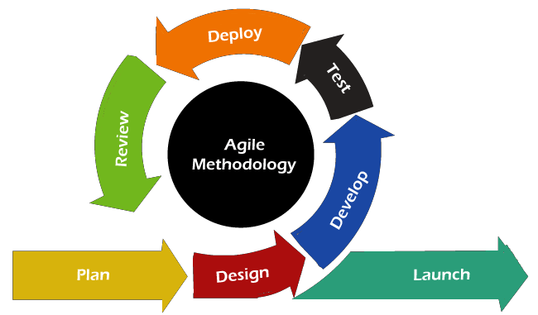

Figure 5. Agile SDLC Model

Figure 5 presents the Agile Software Development Life Cycle (SDLC) used in developing A3VeriFile. This approach supports both qualitative and quantitative research methods. Qualitative data were gathered through user interviews and observations to understand workflow issues, while quantitative data were collected through surveys and system testing to measure usability, functionality, and efficiency. Agile’s sprint-based process allowed continuous improvement of the system based on user feedback and performance results, ensuring A3VeriFile meets both technical and user needs.

Plan

The Researchers start by interviewing Registry of Deeds staff and customers to understand how the current process works, and it was found that it is slow, filled with errors, and requires users to visit the office multiple times. From these interviews, the researchers identified features that could help, such as online document request submission, AI-powered document scanning and verification, ticket tracking, and a secure archiving system.

Design

In this phase, the researchers will design the system comprising two main

Platforms :

• A mobile application for public users to request, track, and receive documents.
• A web-based platform for Registry of Deeds (ROD) personnel to process, verify, and archive requests.
• To enhance functionality, the researchers will incorporate AI-powered features, such as Optical Character Recognition (OCR to extract data from submitted documents for easier classification and digital archiving. Additional components including email and pop-up notifications to provide users with real-time updates will also be included in the design.

Develop

In this phase, the researchers will develop the key modules of A3VeriFile based on the approved designs. This will include setting up the OCR-based data extraction and document classification, the real-time request tracking, the ticketing system, and the generation of a Payment Notice after request approval. Development will be conducted in multiple sprints, allowing regular testing and refinement after each cycle. Mobile responsiveness, security features, and database structuring for document storage and tracking will also be prioritized during development.

Test

Following the completion of development, the system will undergo testing with actual users and ROD personnel. The focus was on evaluating user experience, system speed, and accuracy. The OCR functionality will be tested specifically tested to ensure accurate reading of scanned documents and matching with stored records. Notification features were also tested to confirm that users received timely updates.

Deploy

After successful testing and refinement, A3VeriFile will be prepared for

deployment across mobile and web platforms. The Mobile App will allow public users to submit and monitor document requests, while the Web Portal will be used internally by ROD personnel to process and manage these requests. During the initial deployment phase, the researchers will monitor the system stability, user satisfaction, and server performance to address any potential issues quickly. Continuous updates and improvements will be planned based on user feedback to ensure long-term success and reliability of A3VeriFile.

Review

In the review phase, user feedback and system performance were assessed to identify issues and potential improvements. This ensured that A3VeriFile remained aligned with user needs and operational goals.

Launch

In the launch phase represents the final stage of the A3VeriFile system development, where the complete version is officially deployed for use by its intended users. During this phase, deployment is closely monitored, and technical support is provided to ensure a smooth transition from testing to actual operation. This study includes two groups of respondents: 10 ROD staff and twenty 49 public users. The ROD staff were chosen through purposive sampling because of their direct involvement in document verification and records management, which are

central functions of the A3VeriFile system. Meanwhile, the number of public user respondents was determined using Cochran’s formula to ensure statistical reliability and representativeness of the data collected.
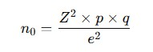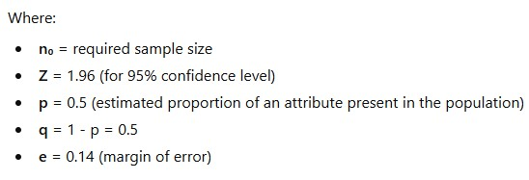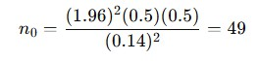To ensure that the sample size is statistically reliable, Cochran’s Formula is applied:

Figure 6. Calculation using Cochran’s Formula

Figure 6 illustrates the computation of the total number of respondents using Cochran’s Formula. Based on the calculation, a total of 49 respondents were determined to represent the target population of public users. This sample size ensures that the data collected are statistically valid and reliable, providing an accurate basis for analyzing user experiences and perceptions of the A3VeriFile system.

3.1 Description of the Current System (Information Gathering)

The current document processing system at the Registry of Deeds is largely manual and paper-based. Based on interviews with legal professionals, property owners, and staff from the Registry of Deeds, it was observed that individuals must physically visit the office to request certified true copies (CTCs), verifications, or certifications of property documents. Staff manually receive requests, retrieve physical records, and fill out verification forms, which are then reviewed and processed by different personnel. Data is usually stored in filing cabinets or semi digital formats like Excel spreadsheets. There have been instances reported where records were misplaced or difficult to locate due to the lack of a centralized archiving and tracking system. This leads to delays of three to seven additional days in processing, as documented in previous studies, and a 10–15% error rate (Bautista and Reyes, 2020) due to manual encoding and document matching. This outdated process not only wastes time but also increases the risk of data loss and public dissatisfaction. These issues emphasize the need for a smarter, automated, and digitally accessible solution like A3VeriFile, which can reduce bottlenecks and improve efficiency in handling official document requests.

3.2 System Architecture and Development

3.2.1 Overview of the Proposed System

A3VeriFile is a digital document management system developed to improve and simplify the operations of the Registry of Deeds. It automates the process of document verification, certification, and archiving, replacing the traditional manual system that often leads to delays and misplaced records. The system provides both mobile and web platforms where clients can easily submit requests, monitor their status in real time, and receive updates once their documents are ready. On the other hand, staff can efficiently manage verification, payment, and release of documents through a centralized dashboard.
A3VeriFile also applies Optical Character Recognition (OCR) technology to extract key information from uploaded documents before storing them in a secure digital archive. With features like data encryption, user authentication, and access control, the system ensures strong data protection while promoting faster, more accurate, and transparent document processing.

3.2.2 System Objectives

The following are the objectives of the A3VeriFile system:

• To develop an OCR-powered system that extracts data from submitted legal documents for faster classification and digital archiving.
• To provide a real-time tracking feature that allows users to monitor the progress of their document requests.
• To notify users through automated email and in-app notifications regarding request updates and payment notices.
• To build a web platform for ROD administrators and staff to review requests, classify and archive documents, and update request statuses efficiently.
• To implement fingerprint biometric authentication for secure user access.
• To ensure accurate, organized, and easily retrievable digital records for improved workflow and transparency.

3.3 System Tools and Requirements

3.3.1 Programming Languages

The A3VeriFile system uses a combination of programming languages and supporting development tools to enable its intelligent document processing and tracking features. The backend is developed using JavaScript, which handles OCR integration, automated data extraction, and validation of property-related information. The frontend, used by both public users and Registry of Deeds personnel, is built with Flutter, using the Dart programming language to create a smooth and responsive mobile interface. For data storage and authentication, the system uses Firebase, which manages real-time records, ticketing logs, and user credentials while ensuring secure and scalable cloud-based operations.

3.3.2 Hardware Requirements

Component | Description
Mobile Devices (Public | Smartphones or tablets capable of
Users) | running Flutter-based applications.
 | Likely requires standard mobile device
 | specifications (processing power,
 | memory, screen)
Desktop Computers (ROD | Standard desktop or laptop computers
Staff) | capable of running modern web
 | browsers for accessing the web
 | application.
Server Infrastructure | Servers to host the Java Script backend  and AI functionalities (OCR, machine learning, data processing). Specifics depend on anticipated load and data volume

3.3.3 Software Requirements

Software | Description
System Application | Windows Server – Used to host the  server side application, providing a secure and stable environment for the system
Database | Firebase
Front-End Development | Flutter framework Dart (with  programming language)
Backend Development | Java Script, Libraries for AI/ML, O  data processing/validation.
Mobile App Development | Visual Studio Code-Used for develop  the A3VeriFile mobile app and web platform supporting online requests real-time tracking, AI verification, and

3.3.4 System Flow/Functions

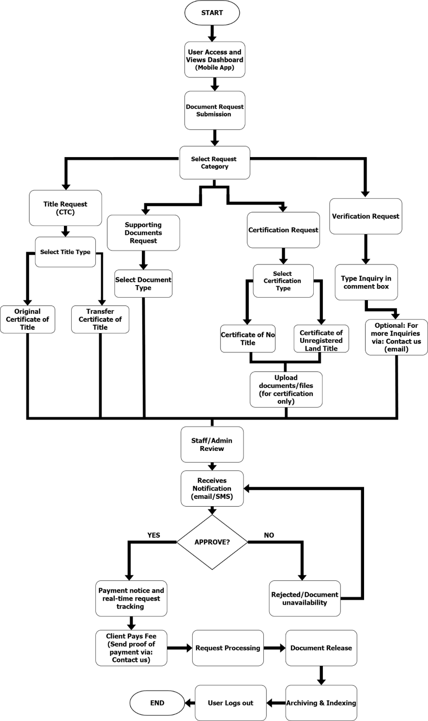

Figure 7. Flowchart Diagram of A3VeriFile (PUBLIC USER)

Figure 7 shows the Public User process in A3VeriFile, beginning when the user opens the mobile app and selects a request from the main dashboard. The system offers four options: Title Request (CTC), Supporting Documents Request, Certification Request, and Verification Request. Depending on the request type, the user may need to select document categories (e.g., OCT/TCT, Certificate of No Title) and upload required files such as Tax Declaration or Lot/Land Status.

After submitting the request, the system forwards it to the ROD Staff or Admin for review. The user then receives SMS or email updates regarding the status. Once approved, the system issues a payment notice, and real-time tracking becomes available. The user pays the necessary fees and uploads proof of payment through the app, after which the request moves to the processing stage.

When the document is ready for release, the user receives a final notification and proceeds to the ROD office to claim it. All completed request files are automatically archived and indexed in the system for secure storage and fast retrieval in future transactions.

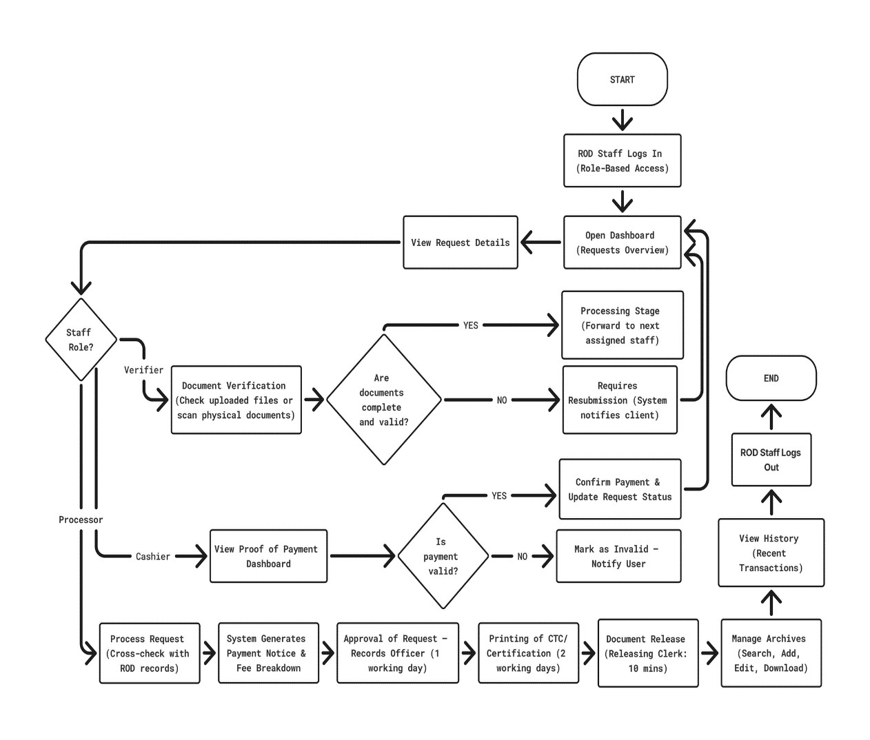

Figure 8. Flowchart Diagram of A3VeriFile (STAFF)

Figure 8 illustrates how the A3VeriFile system supports Registry of Deeds (ROD) staff in processing document requests. After logging in, staff members are directed to the dashboard where they can view all pending and ongoing requests. Each request displays the client’s information and uploaded documents, helping staff understand the details before proceeding. The system assigns tasks based on staff roles such as Verifier, Cashier, or Processor, ensuring that each step is handled by the right personnel.

The Verifier checks the completeness and validity of documents using the OCR feature. If requirements are incomplete or unclear, the system notifies the client for resubmission. Once verified, a payment notice is generated. The Cashier then validates the submitted proof of payment. If payment is incorrect, the request is returned to the client; if valid, the system forwards it to the Processor.

Finally, the Records Officer approves the request, and the document is prepared for printing. Once completed, the Releasing Clerk issues the document to the client. This organized and role-based workflow helps reduce processing errors, minimize delays, and improve overall service efficiency in the Registry of Deeds.

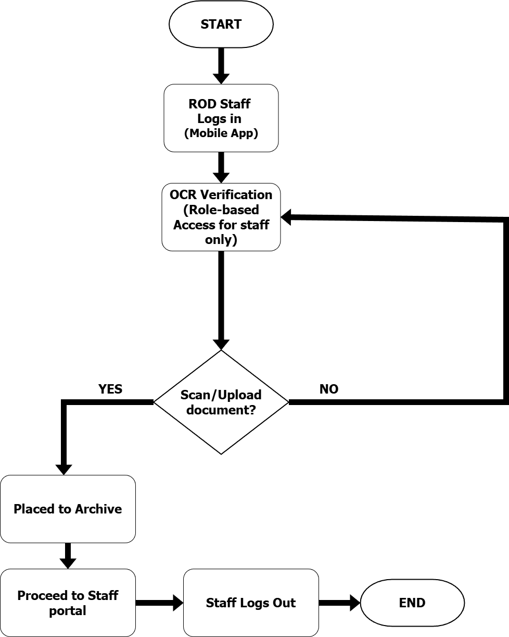

Figure 9. Flowchart Diagram of A3VeriFile in OCR (STAFF)

Figure 9 shows the flow of how ROD staff use the A3VeriFile mobile app for OCR verification and digital archiving. The process begins when authorized staff log in securely and access the OCR Verification feature. Only users with proper roles can scan or upload documents through this module.

Once a document is scanned or uploaded, the OCR engine automatically extracts key information such as title number, owner’s name, lot number, and property location. Uploaded files are classified and stored based on document type, while scanned documents are sent directly to the Digital Archive for secure storage and fast retrieval. Staff can easily store, preview, and download document details through the archive interface.

This workflow removes the need for manual searching and physical file handling, as all records become instantly accessible to both staff and administrators through the system. Overall, the process improves efficiency by automating verification, organizing digital records, and supporting faster coordination within the Registry of Deeds. retrieval, leading to a more accurate, paperless, and streamlined document management system.

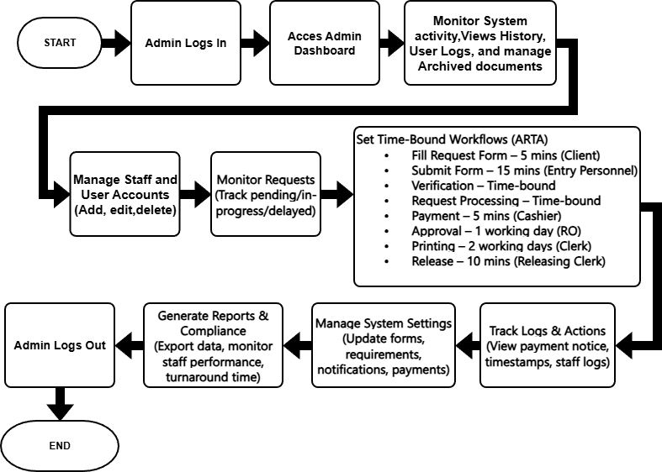

Figure 10. Flowchart Diagram of A3VeriFile (ADMIN)

Figure 10 shows the Admin Portal of A3VeriFile, which serves as the main control panel for authorized administrators at the Registry of Deeds. After logging in securely, the admin is directed to a dashboard displaying real-time updates such as pending, processing, completed, or delayed requests, along with staff and user activity logs. From the dashboard, the admin can manage accounts by adding staff, assigning roles, or deactivating users, as well as monitor the digital archive to ensure records are properly stored and accessible.

A key responsibility of the admin is setting standard processing times for each request stage based on ARTA guidelines (e.g., form

submission, verification, payment, approval, printing, and release). These time frames help the system detect delays, maintain transparency, and ensure smooth workflow across all processing steps. The admin can also adjust system settings, including requirements, forms, notification messages, and payment information, to keep the system accurate and updated.

Finally, the Admin Portal allows administrators to generate and export reports for performance evaluation, compliance monitoring, and documentation. With these tools, the portal ensures organized operations, efficient monitoring, and secure handling of document processes within the Registry of Deeds.

3.3.5 Scope and Limitations of the System

This project developed A3VeriFile, a digital system that allows users to request documents such as Certified True Copies (CTCs) through a mobile app while ROD staff manage and archive records through a web platform. However, the system has limitations. It currently does not connect to other government databases, so cross-agency verification is not supported. A stable internet connection is required for submitting requests, receiving updates, and logging in, which may be challenging in areas with weak connectivity. The accuracy of OCR data extraction also depends on the quality of the uploaded document; blurry or unclear images may lead to errors. Lastly, the system is designed specifically for the Registry of Deeds
- Oroquieta City, and may need adjustments for use in other locations.

3.3.6 Calendar of Activities
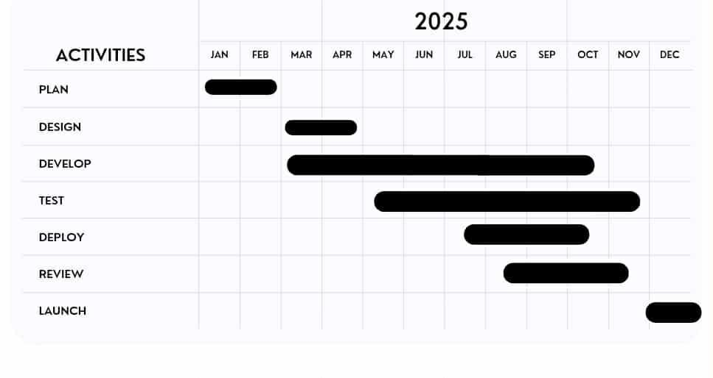

Figure 11. Gantt Chart for A3VeriFile

Figure 11 presents the 12-month project schedule, showing the planned duration of each development phase. It provides a clear overview of how the project activities are organized to ensure timely completion and effective workflow.

3.4 Conceptual Design and Implementation

3.4.1 System Design

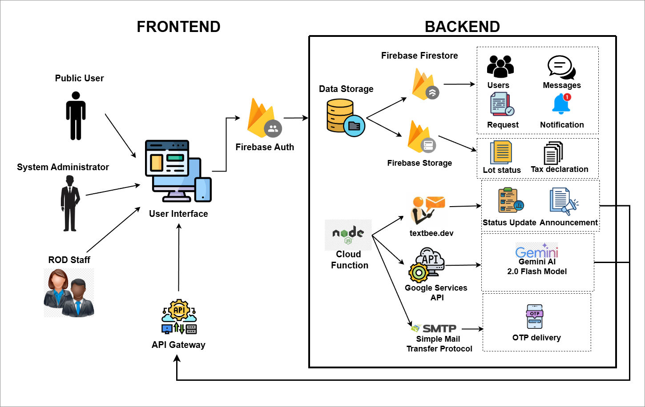

Figure 12. System Architecture

Figure 12 presents the system flow of A3VeriFile, showing how the frontend and backend work together to process document requests, perform verification, handle communication, and manage digital archiving. Public Users, ROD Staff, and Administrators access the system through their respective interfaces, which communicate securely with the backend via the

API Gateway and Firebase SDK. User authentication is managed by

Firebase Auth to ensure role-based access.

Public Users submit requests and upload required documents, which are stored in Firebase Storage, while request metadata is saved in Firestore. ROD Staff and Admins manage these submissions through their dashboards and may also upload scanned physical documents. Once documents are uploaded, Cloud Functions process the files and call the Gemini AI Flash Model for OCR, extracting key details that are automatically stored in Firestore for efficient classification and archiving.
Communication services are automated through Cloud Functions, sending SMS (textbee.dev), email (SMTP), and push notifications (Firebase Cloud Messaging) for status updates, payment notices, approvals, and OTPs. Users can track request progress in real time, while staff update statuses and complete verifications. When all processing steps are finished, the system archives the final documents and notifies the user that their request is ready for release.

3.4.2 Database Design

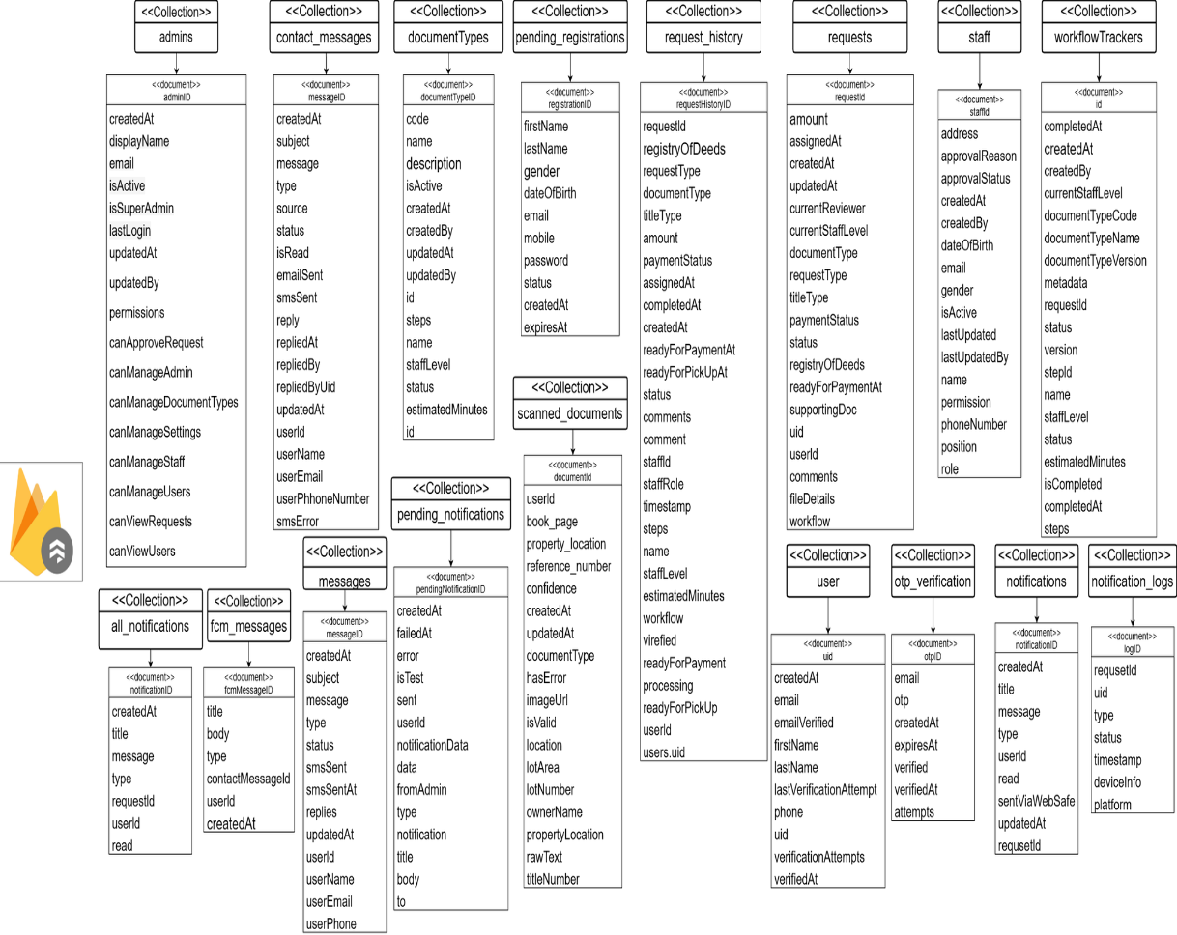

Figure 13. NoSQL Data Collection Model

Figure 13 presents the Firebase database design for the A3VeriFile System, showing how collections and documents are structured to support all system operations. Core collections such as Users, Staff, and Admins store account details, roles, and authentication data. The Requests and request_history collections manage all submitted document requests, including document type, status, payment information, and step-by-step processing updates performed by different staff roles.

The document_types collection defines available request categories, while scanned_documents stores OCR-processed files containing extracted information such as title numbers, lot numbers, property details, and owner names. Verified and classified records are then transferred to the Archive, which serves as the system’s long-term digital storage.
Notification-related collections-notification, notification_logs, and pending_notifications-ndle real-time alerts sent to users and staff through email and SMS. The Messages collection stores user-staff conversations, and otp_verifications secures authentication through one-time passwords. Additional collections like pending_registrations and Staff support onboarding and personnel management. Overall, the interconnected database structure ensures synchronized data flow across the web and mobile platforms, enabling efficient request processing and reliable digital archiving for the Registry of Deeds.

3.4.3 Use Case Design

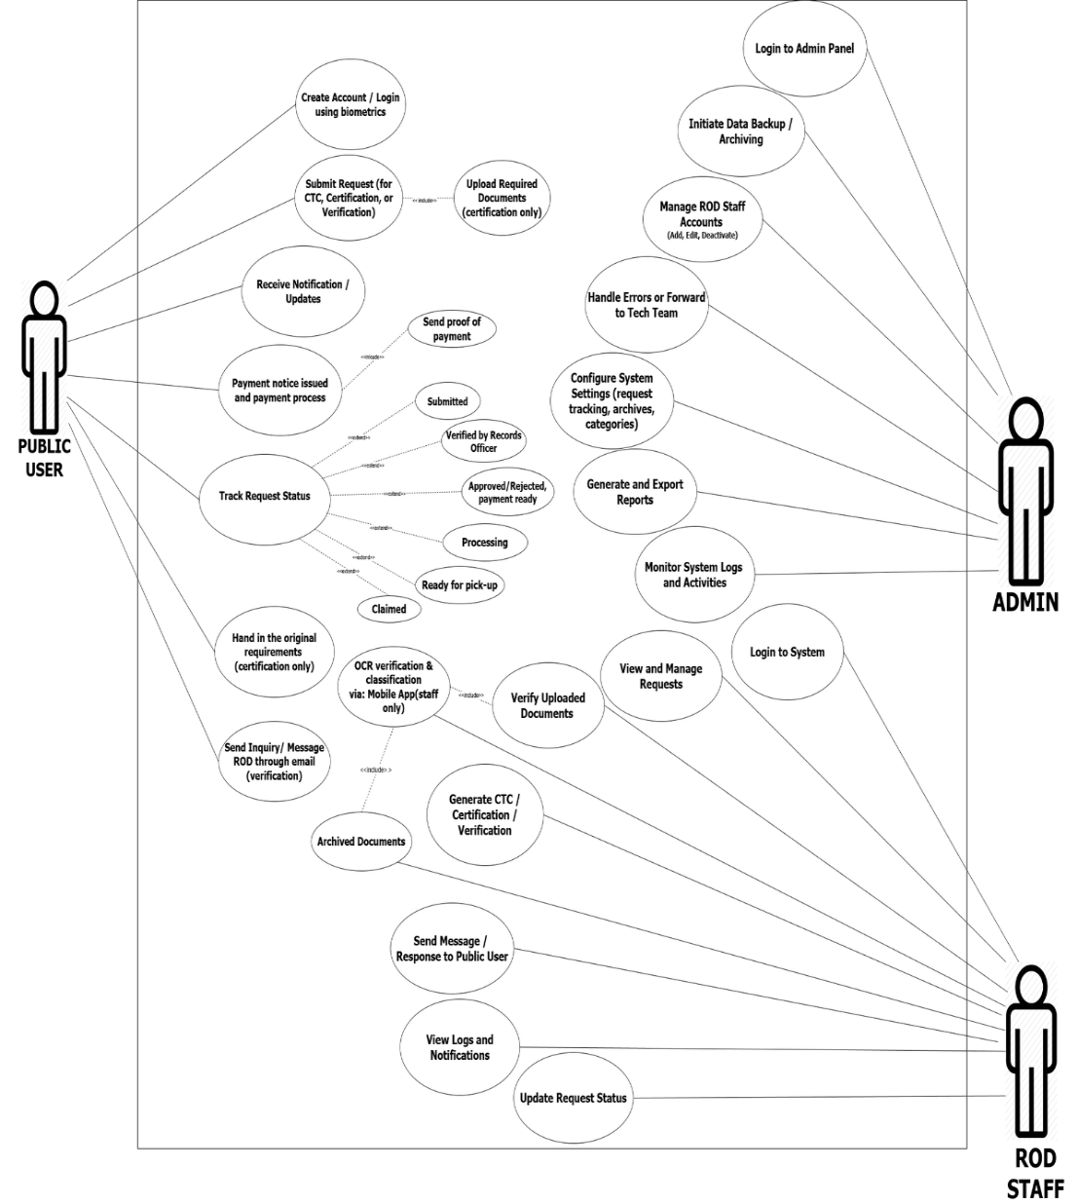

Figure 14 Use Case Diagram for A3VeriFile

Figure 14 presents the Use Case Diagram of the A3VeriFile System, showing the interaction of three main user roles: Public User, ROD Staff, and Admin. Public Users can create an account or log in using biometric authentication, submit requests for CTC, Certification, or Verification,

upload requirements, pay fees, and track their request status in real time. They also receive notifications and may contact the ROD through email or in-app messaging.
ROD Staff access the system through the web portal to review and validate user submissions. Their tasks include checking completeness, verifying authenticity, scanning physical documents using OCR for classification, and generating the requested documents. Once processing is complete, staff update the request status and notify users. They can also respond to inquiries and forward technical system concerns when needed.
The Admin manages the overall system, including staff accounts, system configurations, logs, reports, data backups, and archives. Admin ensures proper workflow, security, and record organization across all transactions. Overall, the Use Case Diagram illustrates how A3VeriFile enables coordinated operations, ensuring faster, accurate, and transparent document processing within the Registry of Deeds.

3.4.5 Context Diagram

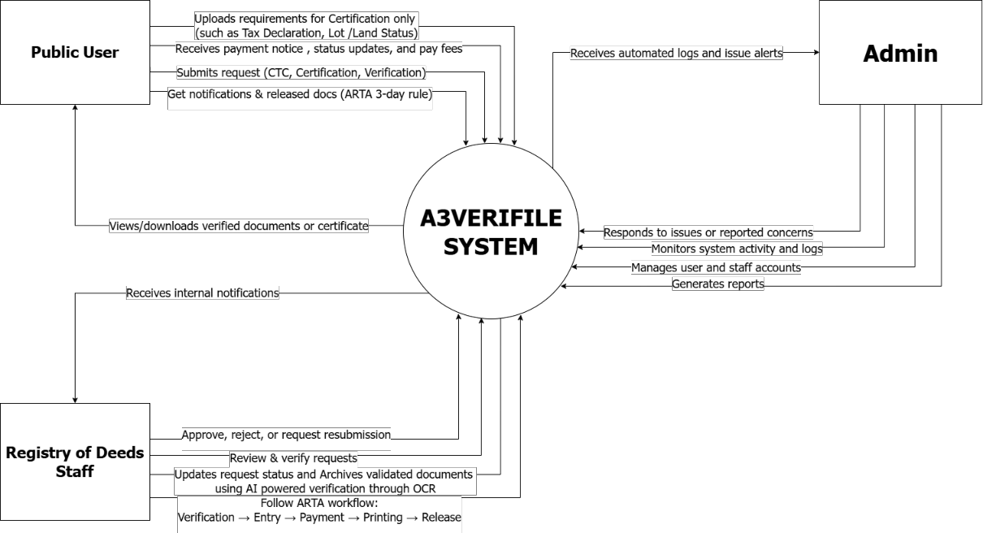

Figure 15. Context Diagram for A3VeriFile

Figure 15 shows how A3VeriFile connects Public Users, ROD Staff, and the Admin in one centralized platform. Public Users use the mobile app to submit requests for CTC, Certifications, and Verifications. They upload supporting documents when needed and receive real-time updates, payment notices, and release notifications once the document is ready.

ROD Staff access the web portal to review, verify, and process these requests. They check document completeness, approve or reject submissions, confirm payments, and prepare documents for release following ARTA timelines. Verified documents are digitally archived using OCR to ensure fast retrieval and secure storage. Admins oversee the entire system, manage accounts, monitor activities, update system settings, and generate reports.
This chapter summarized the methodology used to develop A3VeriFile, following a quantitative research approach and the Agile model. It outlined the challenges of the manual ROD workflow and how A3VeriFile addresses them through OCR-based processing, real-time tracking, automated notifications, fingerprint login, and secure digital archiving. Overall, the system aims to improve efficiency, transparency, and service reliability at the Registry of Deeds..

CHAPTER IV RESULTS AND DISCUSSIONS
This chapter presents the outcomes of the development and implementation of the A3VeriFile system, highlighting the challenges encountered during its creation and the strategies used to overcome them. Furthermore, it discusses how the system effectively addresses the identified problems in document processing and fulfills the objectives stated in the study.

4.1 Discussions

The A3VeriFile system was developed to address common challenges in the operations of the Registry of Deeds (ROD), particularly in document processing, tracking, and record management. By integrating features such as OCR-based data extraction, real-time tracking, automated notifications, fingerprint authentication, and secure digital archiving, the system provides a centralized platform for both clients and ROD personnel.

During the development and testing phase, the system demonstrated efficiency in delivering its core functionalities. Clients were able to submit requests and monitor their document status in real time, reducing the need for multiple office visits. ROD administrators, on the other hand, were able to review, classify, and

archive documents with ease, significantly minimizing manual workload and processing delays.

User testing showed that the interface was clear and user-friendly, allowing users of different technical backgrounds to navigate the system without difficulty. The automated notification and tracking features improved transparency and communication between clients and staff, ensuring that users were consistently updated on their requests.

The A3VeriFile system was evaluated by a total of 59 respondents, consisting of ten (10) Registry of Deeds (ROD) staff and forty-nine (49) public users. A five-point Likert scale was used to measure their level of agreement on the evaluation criteria of functionality, usability, and efficiency. The scale ranged from
5 – Strongly Agree, 4 – Agree, 3 – Neutral, 2 – Disagree, and 1 – Strongly Disagree. To compute the overall results, the mean formula was applied:
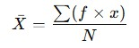

Figure 16. Mean Formula

Where:

f = frequency of responses

x = numerical value assigned to each rating

N = total number of respondents

This formula calculates the weighted mean for each evaluation criterion. The frequency of responses for each Likert option (f) was multiplied by its corresponding numerical value (x). The products were summed, then divided by the total number of respondents (N) to obtain the average rating.

The weighted mean was used to interpret how respondents rated the system in terms of functionality, usability, and efficiency. The results showed that both ROD staff and public users gave a weighted mean of 5, interpreted as Strongly Agree across all criteria.

Overall, the implementation of A3VeriFile demonstrated that digital solutions can significantly streamline document handling and improve efficiency within government offices. The system enhances productivity by reducing manual tasks and organizing workflows, while also promoting transparency, accountability, and more reliable public service delivery within the Registry of Deeds.

Discussion No. 1. To develop an OCR-powered system that extracts data from submitted legal documents for faster classification and digital archiving.
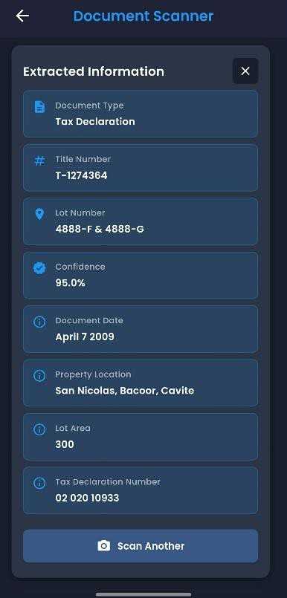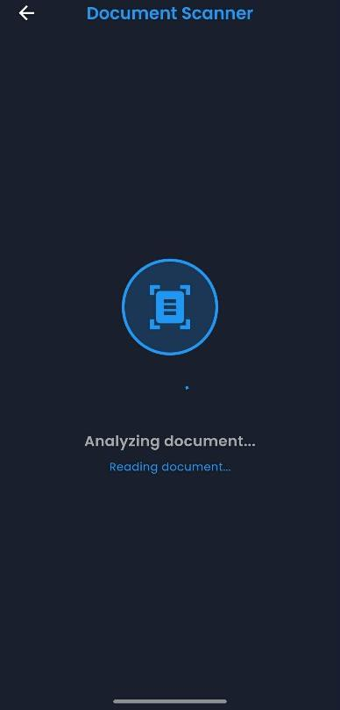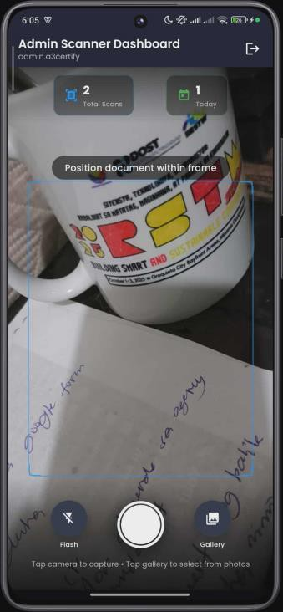

Figure 17. OCR Data Extraction and Archiving Interface

Figure 17 shows the A3VeriFile system’s OCR-powered data extraction feature, which automatically scans and converts uploaded legal documents into text for secure classification and archiving. The system operates with a 90 - 95% confidence level in text recognition, ensuring high accuracy in data extraction while maintaining the confidentiality of sensitive information. This allows the Registry of Deeds (ROD) personnel to efficiently organize, verify, and retrieve digital copies without manual encoding. The interface also displays extracted key details such as

document title, lot number, and transaction date, streamlining record management and reducing the risk of human error in document processing.

Discussion No. 2. To provide a real-time tracking feature that allows users to monitor the progress of their document requests.

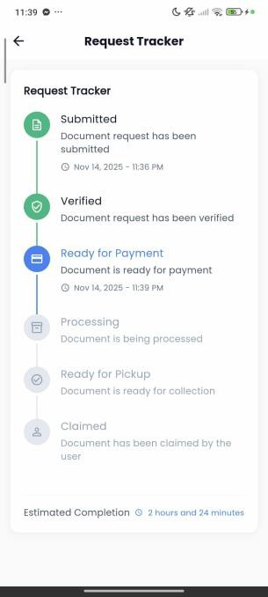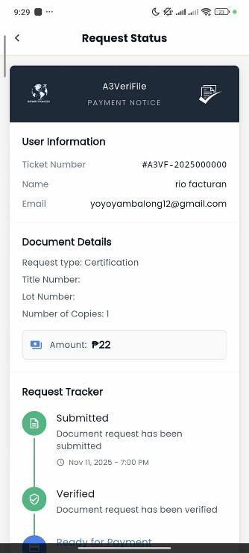

Figure 18. Request Tracking Interface

Figure 18 presents the A3VeriFile tracking interface, which allows users to view the current status of their requests from submission to approval. Each request displays stages such as “Submitted,” “Verified” to “Claimed”. This real-time tracking system improves transparency and eliminates the need for clients to visit the office for update inquiries. It ensures that users are informed of every step of

their transaction through both the mobile and web platforms. The evaluation showed that users strongly agreed that the real-time tracking feature helped them stay informed about their document status. The statement “Request tracking helps me stay informed about my documents” received a weighted mean of 4.92, which falls under the interpretation Strongly Agree. Users also rated related items such as the ease of finding request status and displayed information very high (4.92 and
4.79), indicating that the tracking updates were clear, accessible, and easy to understand.

These results indicate that the system successfully met the objective of providing an effective real-time tracking feature. Users found the tracking function reliable, easy to use, and helpful in monitoring their requests without the need for follow-up visits. The consistently high ratings demonstrate that real-time tracking significantly improves user convenience, transparency, and overall satisfaction with the document processing workflow in A3VeriFile.

Discussion No. 3. To notify users through automated email for OTP and in- app notifications regarding request updates and payment notices.

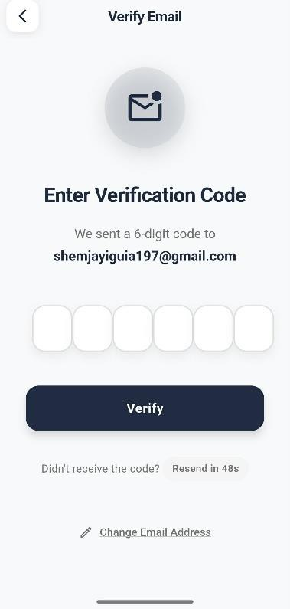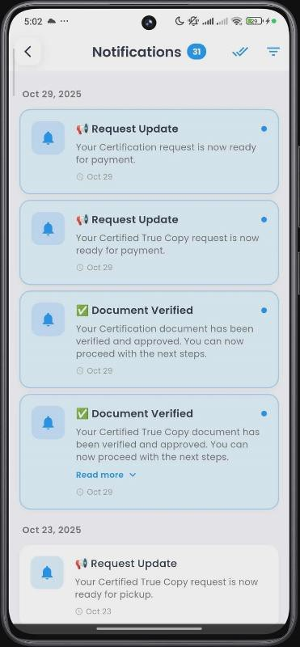

Figure 19. Notification Dashboard

Figure 19 shows the Notification Dashboard of the A3VeriFile system. Users receive automated notifications for every update in their document request, such as payment notices, approvals, or completion alerts. ROD staff can also send reminders and messages directly through the system. This feature ensures smooth communication and timely responses, improving customer satisfaction and reducing information delays. User evaluations showed strong agreement that the

system effectively provides clear and timely updates. The statement “Information and updates are displayed clearly” received a weighted mean of 4.79 (Strongly Agree), and “It is easy to find the information I need (request status, payment notice)” received a weighted mean of 4.92 (Strongly Agree). These high ratings reflect users’ positive experience with receiving and understanding system notifications. Feedback from respondents also indicated that OTP emails were received promptly and in-app notifications helped them stay informed throughout the processing of their requests.

The results indicate that the system successfully achieved its objective of notifying users through automated email OTP and in-app notifications. Users found the notifications clear, timely, and helpful in guiding them through each stage of their request. The strong agreement scores demonstrate that the notification features improved user awareness, minimized confusion, and enhanced overall communication between the system and its users.

Discussion No. 4. To build a web platform for ROD administrators and staff to review requests, classify and archive documents, and update request statuses efficiently.

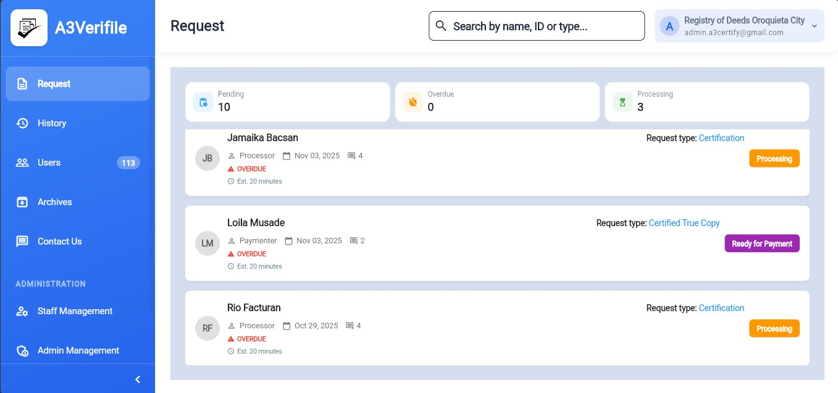

Figure 20. ROD Administrator Dashboard

Figure 20 illustrates the A3VeriFile Admin Dashboard, designed for Registry of Deeds personnel to efficiently manage and process document requests. Through this interface, staff can view all incoming requests, verify document details, update statuses, and archive completed files. The system allows for faster coordination and reduces paperwork by centralizing all processes within one digital platform, improving workflow and productivity. Feedback from ROD staff showed very strong agreement regarding the platform’s usability and efficiency. ROD staff strongly agreed that the system is easy to use (4.90), simple to navigate (4.92), and

equipped with useful features (4.90). They also rated the interface as organized and user-friendly (4.86-4.93), indicating that reviewing requests and updating statuses could be done smoothly. The results show that the platform effectively allows ROD staff to manage and process documents efficiently. High usability and functionality ratings confirm that the system meets its objective of streamlining document review, classification, and status updating.

Discussion No. 5. To implement fingerprint biometric authentication for secure user access.

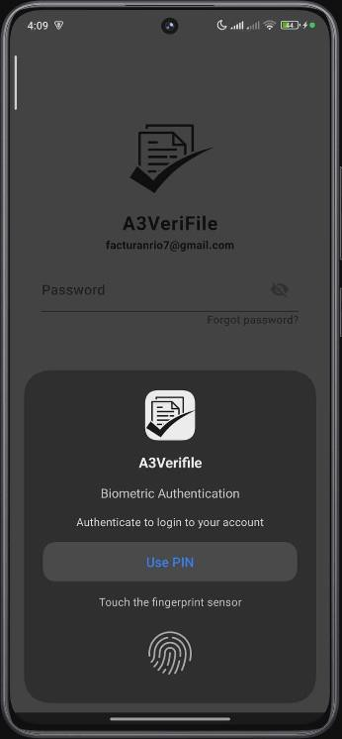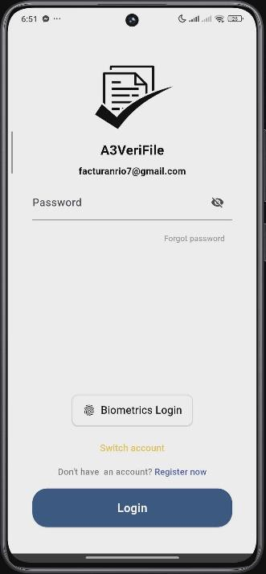

Figure 21. Fingerprint Authentication Interface

Figure 21 shows the fingerprint authentication feature of A3VeriFile. This function ensures that only verified users can access the system, protecting sensitive information and preventing unauthorized access. The biometric feature enhances data security by requiring users to authenticate their identity through fingerprint scanning during login or document submission. Users strongly agreed that the fingerprint authentication feature improves system reliability, with a weighted mean of 4.88, interpreted as Strongly Agree. Respondents found the feature easy to use and effective for quick identity confirmation. The results show that the fingerprint authentication feature successfully met its objective. Users recognized its value in providing fast and dependable access, contributing to a smoother and more convenient system login experience.

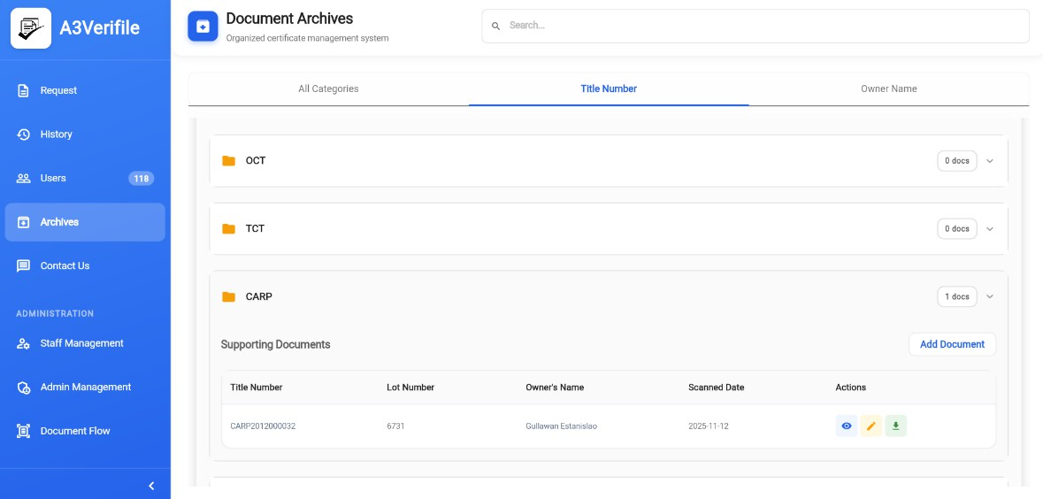Discussion No. 6. To ensure accurate, organized, and easily retrievable digital records for improved workflow and transparency.

Figure 22. Digital Archive Management Interface

Figure 22 illustrates the Digital Archive Management feature of the A3VeriFile system. All verified documents are securely stored in the Archived Documents within the system. ROD staff can retrieve files using search filters such as owner’s name, title number or lot number, ensuring quick and organized access to records. ROD administrators can search, filter, and view archived records efficiently. This feature supports a paperless environment, promotes data security, and ensures long-term accessibility of official documents. Users strongly agreed that the system’s features are relevant and useful (4.90) and that information and updates are clearly displayed (4.79). They also found it easy to locate needed

information such as request status and notices (4.92). These high ratings indicate that records were presented clearly and were easy to access. The results show that the system effectively achieved its objective of maintaining accurate, organized, and easily retrievable digital records. Users found the system reliable for accessing information quickly, which supports smoother workflows and improves transparency in document processing.

4.4 User Evaluation Results

This section presents the evaluation results of the A3VeriFile system as assessed by Registry of Deeds (ROD) staff and public users.

4.4.1 System Evaluation Results

Criteria | Weighted Mean | Interpretation
Functionality | 5 | Strongly Agree
Usability | 5 | Strongly Agree
Efficiency | 5 | Strongly Agree

Table 8. ROD Staff Evaluation Results

Interpretation : The ROD staff strongly agreed that the A3VeriFile system is functional, user-friendly, and efficient in processing document transactions. According to the staff, the system simplifies their workflow by allowing them to quickly review requests, track document progress, and archive records digitally in one platform. They also noted that features such as OCR data extraction, request tracking, and biometric authentication help reduce manual errors and speed up document verification, making the overall process more organized and efficient.

4.4.2 Public User Evaluation

Criteria | Weighted Mean | Interpretation
Functionality | 5 | Strongly Agree
Usability | 5 | Strongly Agree
Efficiency | 5 | Strongly Agree

Table 9. Public User Evaluation Results

Interpretation : The public users strongly agreed that the A3VeriFile system is functional, easy to use, and efficient in processing document requests. Users reported that they could easily navigate the platform, submit

requests, and receive updates without confusion. Features such as real-time tracking and notification updates made the process faster and more convenient compared to the traditional manual transaction. The consistent weighted mean of 5.00 across all criteria shows that users are highly satisfied with the system's performance, responsiveness, and overall user experience.

CHAPTER V

CONCLUSIONS AND RECOMMENDATIONS

This chapter presents the conclusions and recommendations derived from the development and evaluation of A3VeriFile: An AI-Powered Document Verification and Archiving System for the Registry of Deeds (ROD). The system was designed to streamline document processing by automating verification, enabling OCR-powered text extraction, digitizing record archiving, and providing real-time tracking of requests.

The results discussed in the previous chapter served as the basis for assessing the system’s overall effectiveness in terms of functionality, usability, and efficiency based on the ISO 9126 Software Quality Model. This chapter begins with a summary of the significant findings obtained from user evaluations, followed by the conclusions that demonstrate how the objectives of the study were achieved. Lastly, it presents recommendations for further enhancement, wider adoption, and continued research and development related to A3VeriFile and similar digital government service systems.

5.1 Conclusion

As technology continues to evolve, digital systems have become vital in improving public services and streamlining government processes. The researchers developed A3VeriFile, a web and mobile-based document management system designed to assist the Registry of Deeds (ROD) in enhancing the efficiency of document verification, certification, and archiving. The system was created to minimize manual errors, reduce processing delays, and improve transparency in handling official documents.

After system testing and evaluation with ROD - Oroquieta City, the researchers found that A3VeriFile met its main objectives. Test users, including both staff and clients, provided positive feedback, noting that the system is easy to use, organized, and effective in tracking requests. The document tracking and classification modules worked accurately, while the OCR feature efficiently extracted key data from submitted legal documents. The fingerprint authentication feature also performed reliably, ensuring secure access and data integrity.

Furthermore, the system’s archiving function successfully stored verified documents in a structured and retrievable format, promoting efficiency and reducing the reliance on manual recordkeeping. Real-time notifications and status

updates improved communication between clients and ROD personnel, resulting in a more transparent and responsive service.

In conclusion, A3VeriFile effectively addressed the limitations of the traditional manual document process by offering a faster, more accurate, and secure system. The researchers confirm that it aligns with its intended objectives and has the potential to enhance the quality of public service delivery within the Registry of Deeds.

5.2 Recommendations

Based on the system evaluation conducted with the Registry of Deeds (ROD) - Oroquieta City, the researchers recommend the following enhancements for future development of the A3VeriFile system:

• Improve OCR Accuracy : Train the OCR model using a larger set of document samples to increase text recognition accuracy and minimize manual corrections. The researchers also recommend exploring other OCR technologies such as Tesseract OCR to compare its performance with Google Gemini and determine which provides higher accuracy and efficiency in extracting text from legal and property-related documents.

• Integrate Face Authentication : Add facial recognition as an additional layer of security to strengthen identity verification and prevent unauthorized access.
• Enable Online Payment System : Incorporate a secure online payment feature to allow users to process payments digitally and receive real-time payment notices.

BIBLIOGRAPHY

Kumar, A., & Shukla, R. (2023). Fingerprint biometrics as a reliable approach for digital identity verification in public service systems. International Journal of Computer Science and Information Technology Research, 11(2), 45–53.

Karale, R., Patil, S., & Bhosale, P. (2022). Implementation of biometric fingerprint authentication in digital verification systems. Journal of Information Security and Applications, 70, 103418.

Rodriguez, M. A. (2023). Digital transformation initiatives of the Land Registration Authority (LRA) in modernizing land and property records. Philippine Journal of Information and Communication Technology, 9(1), 45–58.

Santos, M. P., & Velasco, L. R. (2022). Web-based tracking and verification system for public document requests. Asia Pacific Journal of Multidisciplinary Research, 10(3), 112–120.

Patel, V., & Singh, D. (2021). The role of automation in improving digital document management in government sectors. International Journal of Advanced Research in Computer Science, 12(6), 224–231.

Abinaya, P., Kumar, A., & Priya, R. (2024). Integration of optical character recognition with generative AI for enhanced document automation.

International Journal of Advanced Computer Science and Applications,

15(2), 76–84.

Acebron, M. L., Castillo, R. P., & Dizon, E. P. (2024). Effectiveness of digital archiving systems in selected offices of the Provincial Government of Laguna. Quest Journal of Research in Business and Management, 12(5),
101–123.

Azzam, F., Al-Khalifa, H., & Alotaibi, A. (2023). The use of blockchain technology and OCR in e-government document management. Applied Sciences,
13(14), 8463.

Dela Cruz Abubo, K., Abarquez Ramos, E. D., & Valencia, F. A. (2024).

Blockchain-based barangay document management system with OCR data extraction. International Conference on Information Technology and Computer Science (IC-ITECHS), 5(1), 76–85.

Watanabe, D., Delmo, S., & Alfikri, F. (2023). Analysis of mobile-based archive management information system design. Journal of Information Systems and Technology Research, 5(3), 1–8.

Gupta, A., & Kaur, S. (2022). Automation in document verification using OCR and natural language processing. International Journal of Computer Applications, 184(35), 1–7

Karale, R., Patil, S., & Bhosale, P. (2022). Implementation of biometric fingerprint authentication in digital verification systems. Journal of Information Security and Applications, 70, 103418.

Li, Y., & Chen, M. (2020). Intelligent document classification using OCR and machine learning techniques. Procedia Computer Science, 174, 715–723.

Patel, V., & Singh, D. (2021). The role of automation in improving digital document management in government sectors. International Journal of Advanced Research in Computer Science, 12(6), 224–231.

Santos, M. P., & Velasco, L. R. (2022). Web-based tracking and verification system for public document requests. Asia Pacific Journal of Multidisciplinary Research, 10(3), 100–110.

Javier, A. M., & Bautista, D. P. (2022). Automated public document request management system using cloud and OCR integration. Proceedings of the Philippine Computing Congress, 2022(1), 110–118.

Kumar, N., & Saini, A. (2020). Machine learning-enabled OCR systems for digital archiving and verification. International Journal of Computer Engineering Research, 15(3), 201–210.

Bautista, M. E., & Cruz, A. D. (2022). Implementation of automated payment notification systems in e-government transactions. Philippine Journal of Information Systems, 6(3), 92–104.

Chen, L., & Zhang, Y. (2021). Biometric fingerprint authentication for secure access in e-document management systems. IEEE Access, 9, 155340–
155350.

Dizon, K. M., & Ramos, J. L. (2024). Development of an automated record archiving and retrieval system for local government offices. Journal of Computing and Information Technology, 10(1), 21–31.

Hasan, M., & Rahman, F. (2020). A comparative study of biometric systems: Fingerprint, face, and iris recognition in authentication. International Journal of Computer Applications, 176(9), 8–15.

Li, T., & Wang, Z. (2023). Cloud-based secure document archiving using encryption and role-based access control. Journal of Cloud Computing Research, 14(1), 59–70.

Zhang, H., & Liu, X. (2022). Smart notifications and payment reminders in digital government platforms. E-Government Journal, 18(4), 214–226.

Tan, R. E., & Mendoza, P. L. (2023). Evaluating the usability of online document verification platforms in local government services. Philippine Information Technology Review, 15(4), 72–84.

Cruz, H. R., & Dela Peña, A. B. (2023). Integration of OCR technology for data extraction and archiving in government digital platforms. Philippine Journal of Digital Transformation, 5(2), 60–72

Ortega, S. F., & Lopez, D. J. (2021). Implementation of secure biometric fingerprint authentication in mobile applications. Procedia Computer Science, 190,
912–920.

Ramirez, K. L., & Tolentino, N. D. (2023). Developing a smart notification system with email and in-app alerts for public document requests. Journal of Computing Research and Development, 14(3), 110–123.

Villareal, T. C., & Chavez, R. M. (2024). Design of a hybrid document archiving system using OCR and metadata tagging for land registration. International Conference on Digital Systems and Innovations, 6(2), 64–78.

Angeles, R. D., & Soriano, M. C. (2023). Integration of SMS-based one-time password (OTP) verification in secure mobile applications. International Journal of Information Security and Technology, 8(2), 74–86.

Escobar, T. L., & Navarro, J. B. (2024). Automated SMS reminder systems for improved user engagement in government services. International Conference on Information Systems and Governance, 11(2), 55–67.

Beck, K., Beedle, M., van Bennekum, A., Cockburn, A., Cunningham, W., Fowler, M., & Thomas, D. (2001). Manifesto for agile software development. Agile Alliance

Singh, A., & Kaur, M. (2023). Implementation of optical character recognition (OCR) in document verification systems. International Journal of Computer Applications, 185(12), 45–52.

Purohit, N., & Jain, R. (2022). Biometric fingerprint authentication in secure digital systems: A review. Journal of Information Security and Applications, 67,
103284.

Yusof, M. M., & Zakaria, Z. (2021). Electronic document archiving systems for government transparency: A framework for digital recordkeeping. Records Management Journal, 31(4), 455–472.

lotaibi, M. (2021). Enhancing e-government service delivery using SMS-based notification systems. Government Information Quarterly, 38(2), 101567.

Abinaya, G., Rao, G. D., Gopal, P. S. R., Kaushik, M., & Vignesh, B. S. V. (2024).

Automated document processing: Combining OCR and generative AI for efficient text extraction and summarization., 1-5.

Smith, J., and A. Doe. (2023 ). “Enhancing OCR with Deep Learning for Document

Processing.” Journal of Document Analysis 12, no. 3. 45–60.

APPENDICES

APPENDIX A DATA GATHERING


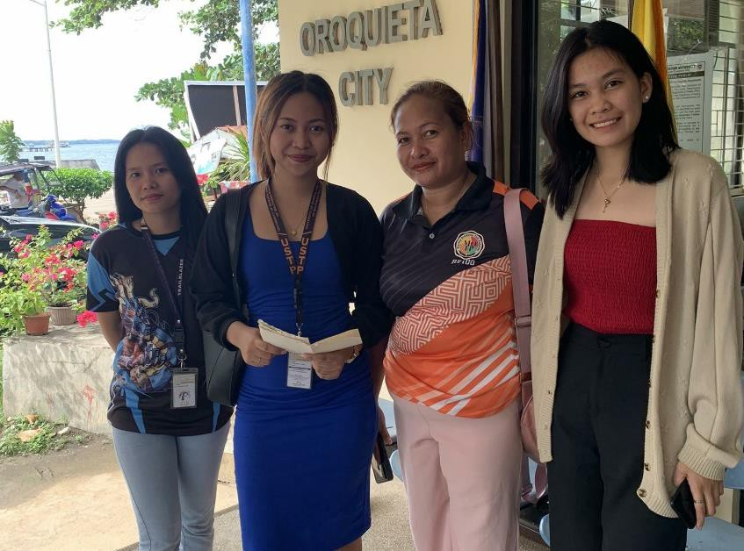

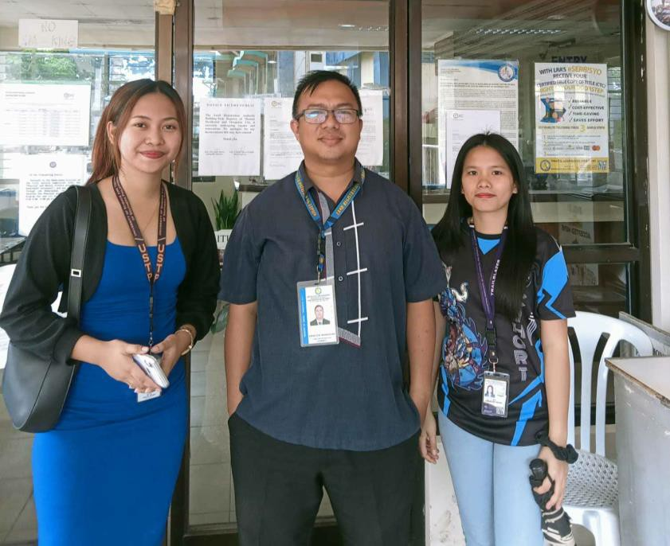APPENDIX B INTERVIEW WITH ROD STAFF

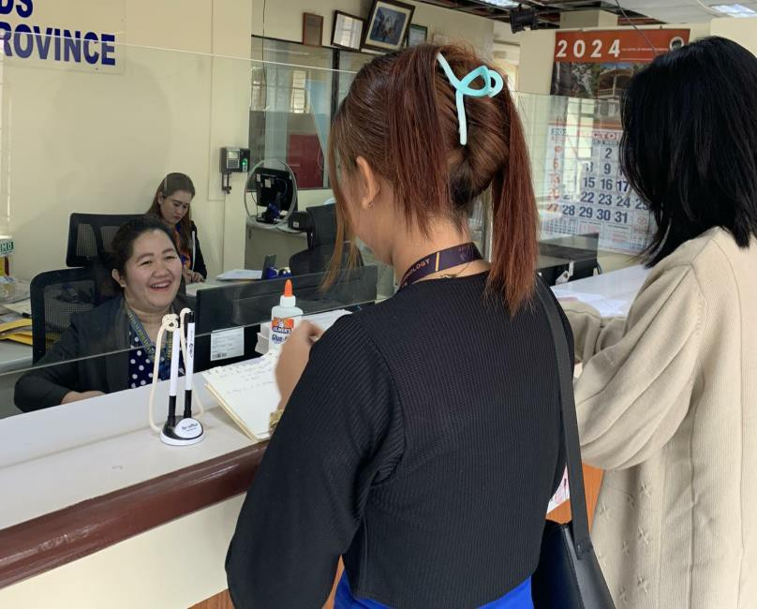

APPENDIX C TECH EXPO 2024

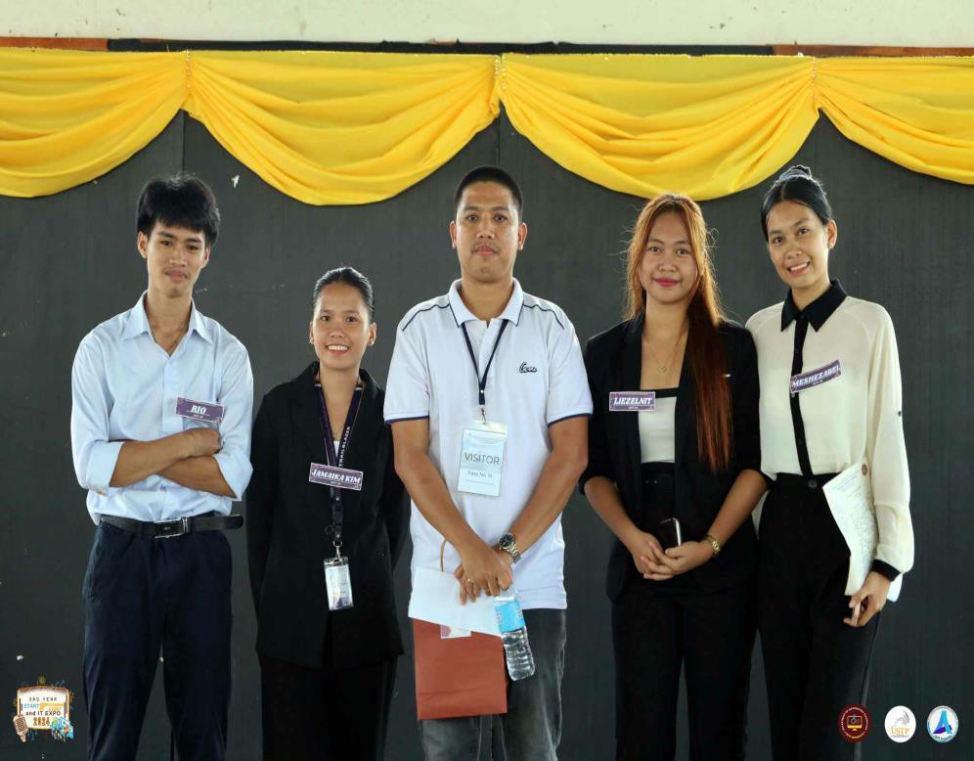

APPENDIX D TECH EXHIBIT 2025

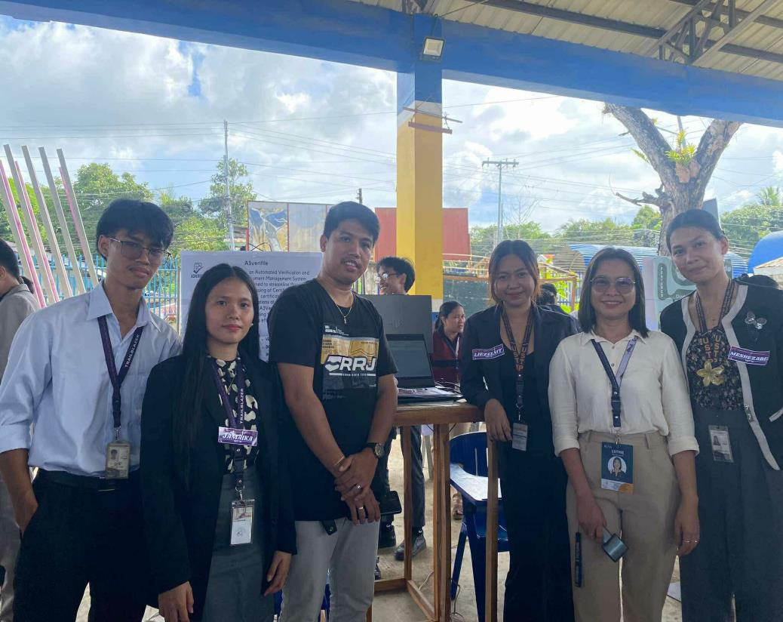

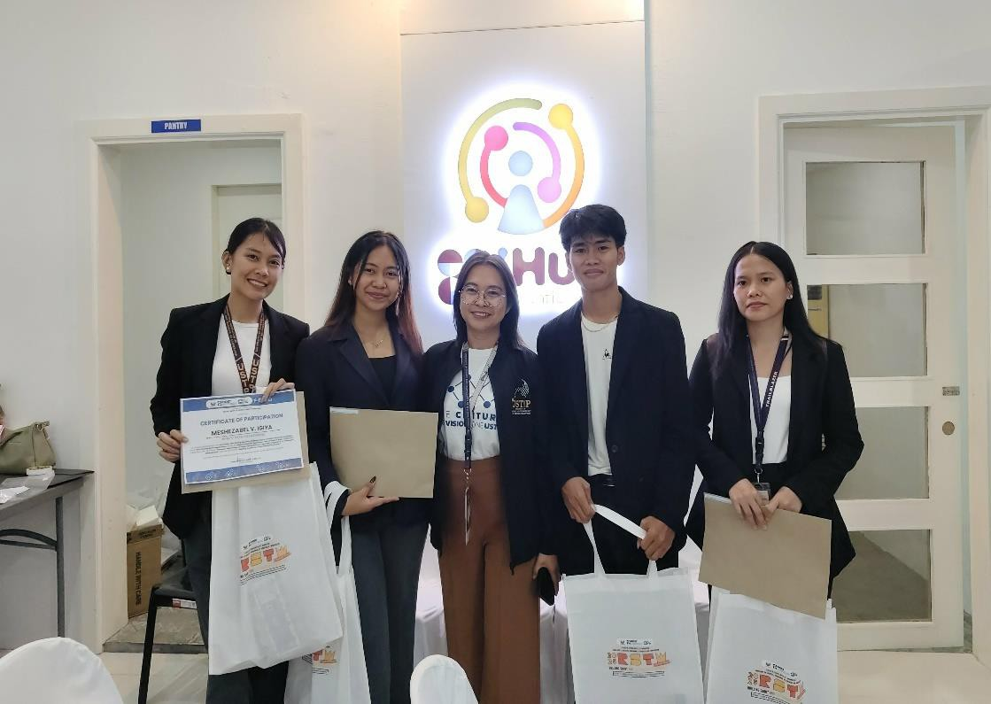APPENDIX E ACCOMPLISHMENTS

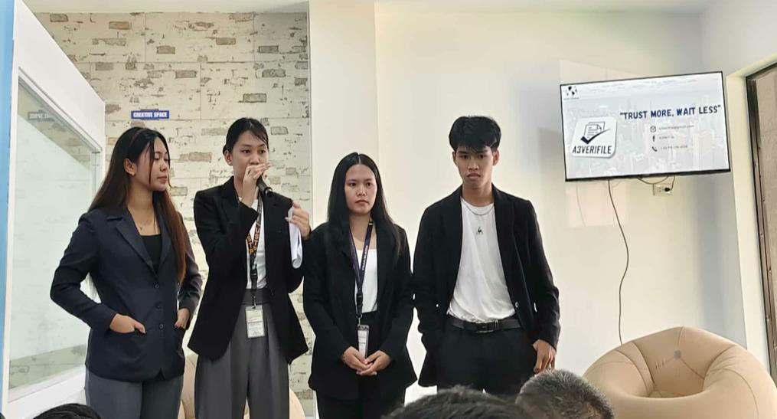

APPENDIX F CLIENT TESTING

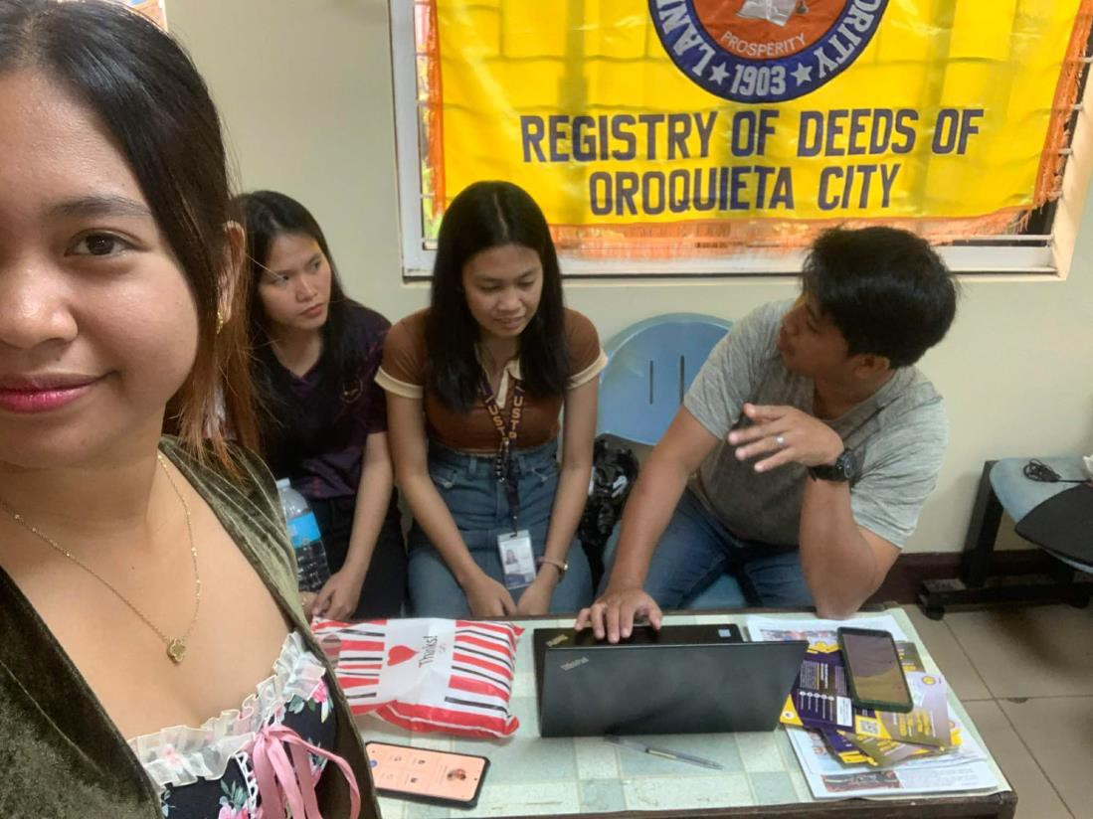

APPENDIX G

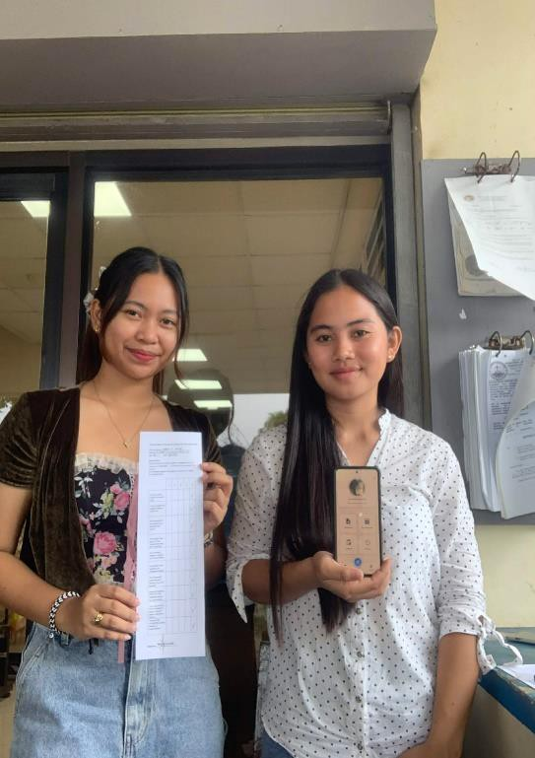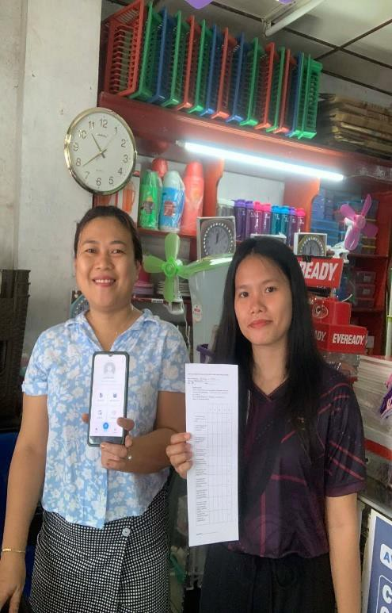SYSTEM EVALUATION TESTING

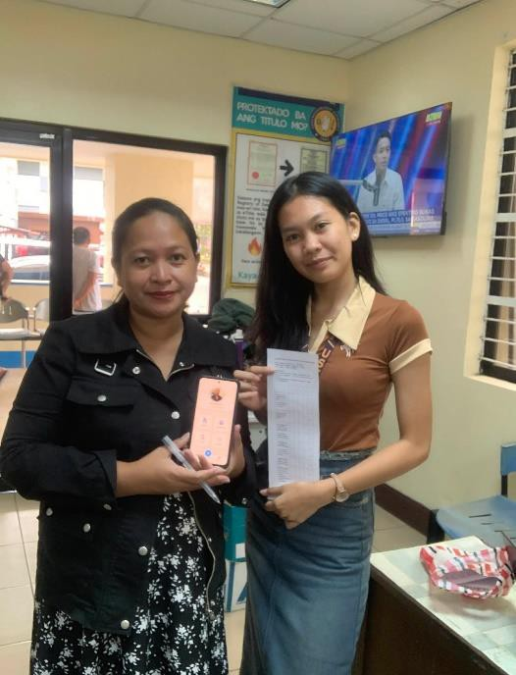

APPENDIX H

SYSTEM USABILITY SCALE (SUS) RATINGS

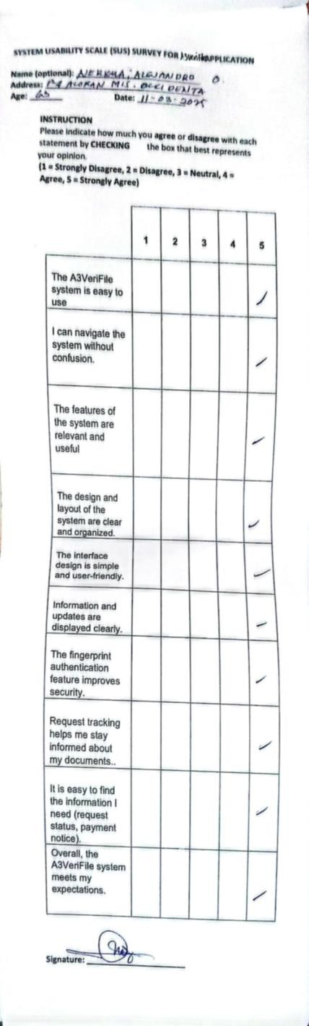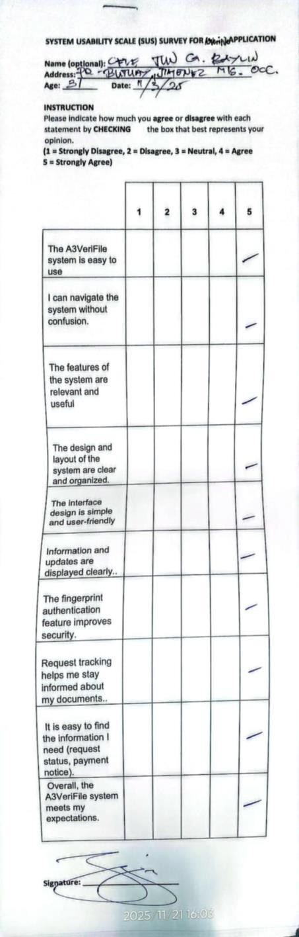

APPENDIX I ARTA

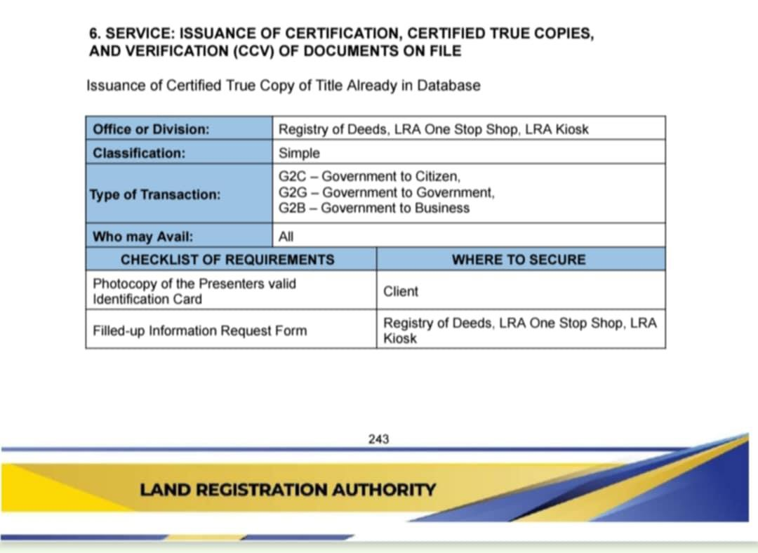

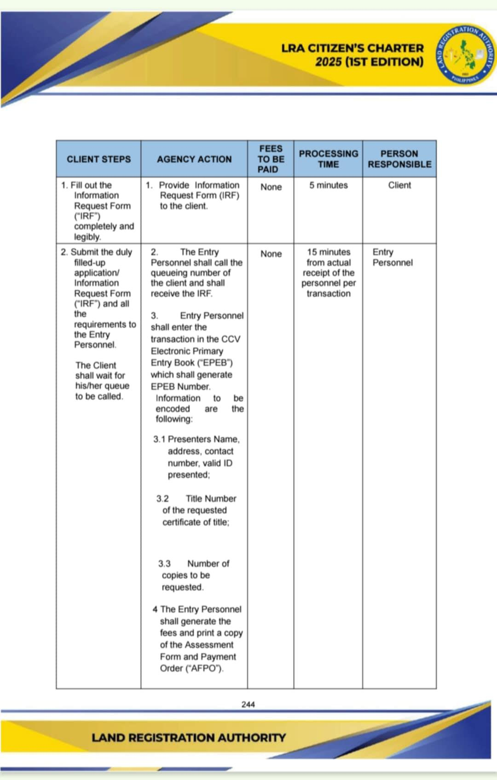

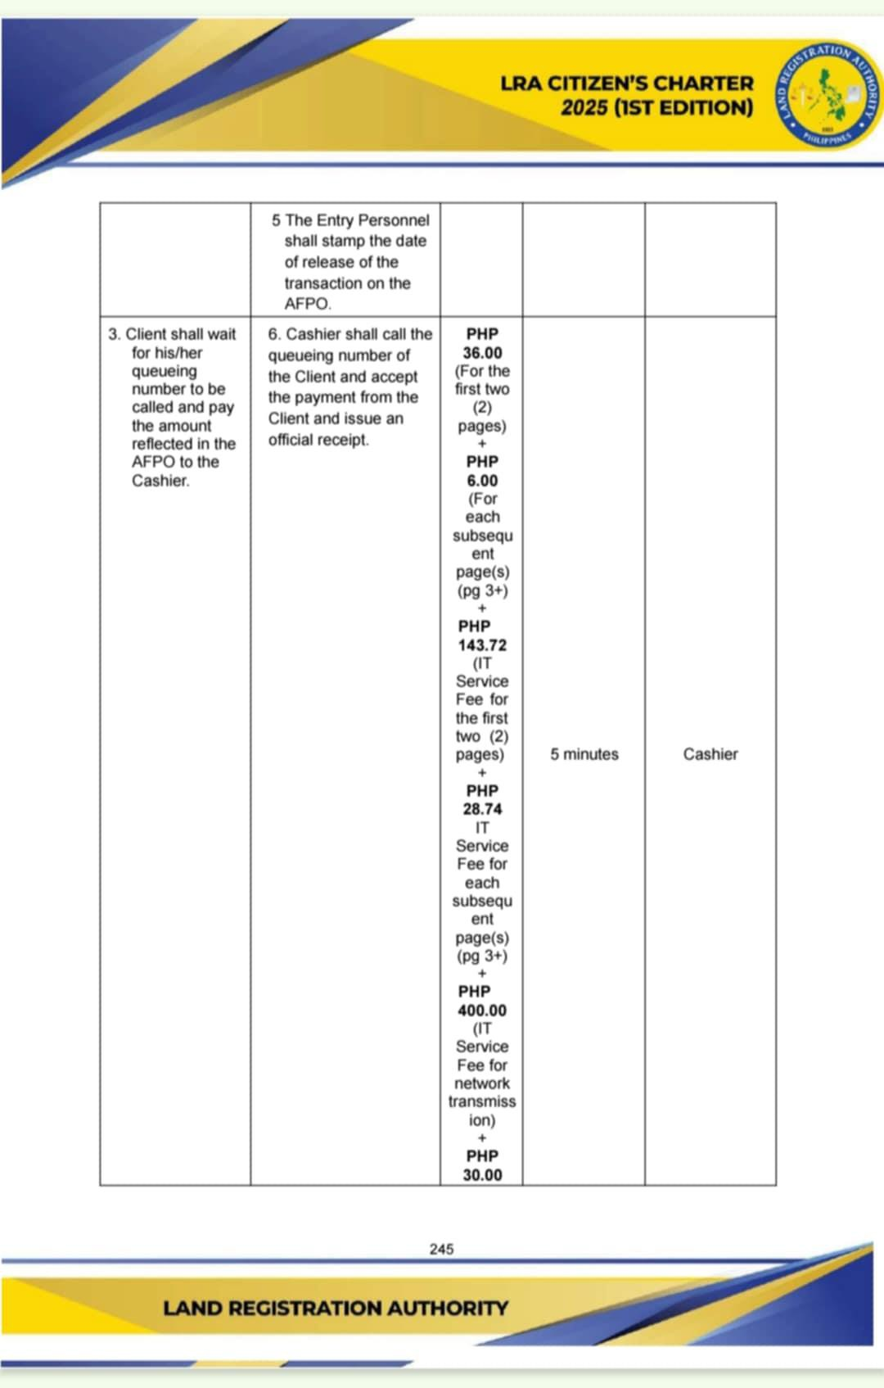

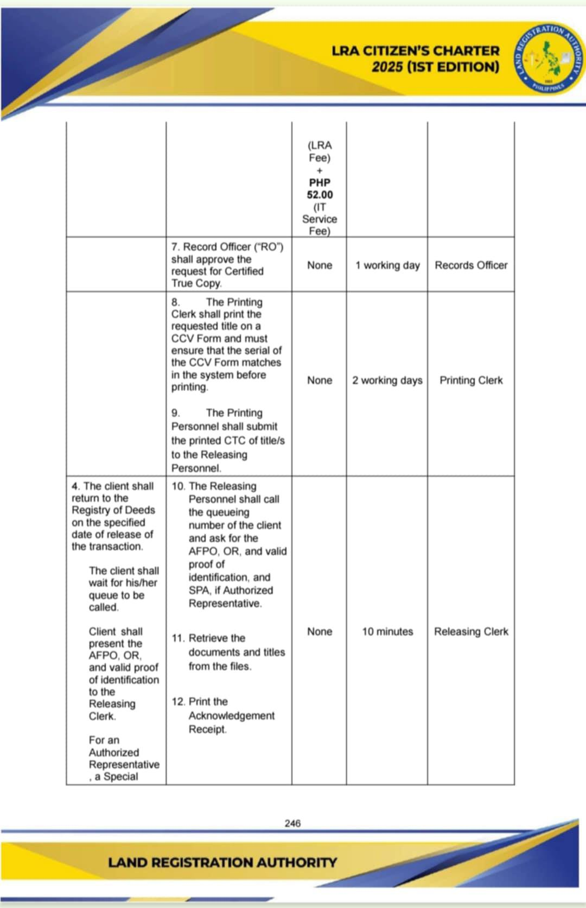

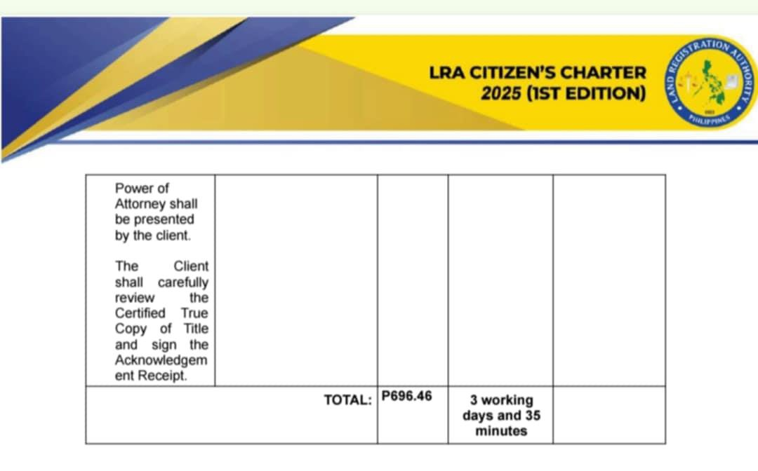

CURRICULUM VITAE

MESHEZABEL V. IGIYA Purok-5, Monterico,
Aloran, Misamis Occidental
09122966234 mesheguia18@gmail.com

A motivated and passionate individual with a strong eagerness to learn new technologies and skills. Dedicated to using innovation to solve real-world problems while continuously improving through experience and collaboration. Committed to personal growth and contributing effectively in team-oriented environments.

PERSONAL DATA

Place of Birth: Monterico, Aloran, Misamis Occidental

Birthdate: August 18, 2004

Age : 21

Civil Status: Single Citizenship : Filipino Religion : Assembly of God
Mother’s Name: Josephine V. Igiya

Father’s Name: Samuel G. Igiya

TECHNICAL SKILLS

• Knowledgeable in basic photo and video enhancement

• Experienced in using Microsoft Office tools such as Word, Excel, and

PowerPoint

PERSONAL SKILLS

• Flexible and quick to adjust to new situations

• Keen attention to accuracy and details

• Maintains a professional attitude in all tasks

INTERESTS & HOBBIES

• Watching K-drama, J-drama and C-drama

• Playing online games during free time

EDUCATIONAL BACKGROUND

2022 - 2026

2016 - 2022

2010 - 2016
University of Science and Technology of Southern
Philippines

Bachelor of Science in Information Technology

Aloran Trade High School Labo, Aloran Mis. Occ. TVL - Hairdressing
Monterico Elementary School

Monterico Aloran Mis. Occ

AWARDS AND CERTIFICATES

Senior High – Honor Student (2019-2021) NSTP Certificates (2023)
DOST Pitching Competition Certificates (2025)

3rd Year BSIT Third Honor Student

REFERENCES

Jubilee S. Daga-ang, MIT Chairman of the IT Department
University of Science and Technology of Southern Philippines

Oroquieta Campus – Oroquieta City, Misamis Occidental

Jubilee.daga-ang@ustp.edu.ph

Lutherly Q. Bongcawel

IT Instructor

University of Science and Technology of Southern Philippines Oroquieta Campus – Oroquieta City, Misamis Occidental lutherly.bongcawel@ustp.edu.ph

LIEZELNIT JEAN G. MUSADE Purok-2, Mobod
Oroquieta City Misamis Occidental

09633465258

musadeliezelnit@gmail.com

An enthusiastic and driven individual who is always eager to explore and master new technologies. Focused on applying creative solutions to real-world challenges while developing both personal and professional growth. Values teamwork, adaptability, and continuous learning to contribute effectively in dynamic environments.

PERSONAL DATA

Place of Birth : Oroquieta City Misamis Occidental

Birthdate: 12/11/2003

Age : 21

Civil Status: Single

Citizenship : Filipino

Religion : ASSEMBLY OF GOD Mother’s Name: Loila G. Musade Father’s Name: Romy B. Musade Jr.

TECHNICAL SKILLS

• Familiar with basic multimedia editing and design tools
• Competent in preparing reports and presentations using productivity software

PERSONAL SKILLS

• Maintains a professional attitude in all tasks
• Highly adaptable and able to adjust easily to new environments or challenges
• Detail-oriented with a strong focus on accuracy and quality of work

INTERESTS & HOBBIES

• Dancing

• Singing

• Reading

EDUCATIONAL BACKGROUND

2022 - 2026

2016 - 2022

2010 - 2016
University of Science and Technology of Southern
Philippines

Bachelor of Science in Information Technology Misamis Occidental National High School. Humanities and Social Sciences
San Roque Dimataling

Zamboanga Del Sur

AWARDS AND CERTIFICATES

Senior High – With High Honor Student (2019-2021) NSTP Certificates (2023)
Pitch Perfect Award IT Expo 2024

DOST Pitching Competition Certificates (2025) Dancer Of The Year 2025
3rd Year BSIT Third Honor Student

REFERENCES

Jubilee S. Daga-ang, MIT Chairman of the IT Department
University of Science and Technology of Southern Philippines

Oroquieta Campus – Oroquieta City, Misamis Occidental

Jubilee.daga-ang@ustp.edu.ph

Lutherly Q. Bongcawel

IT Instructor

University of Science and Technology of Southern Philippines Oroquieta Campus – Oroquieta City, Misamis Occidental lutherly.bongcawel@ustp.edu.ph

RIO A. FACTURAN Purok-2, Villaflor
Oroquieta City Misamis Occidental

09709183681

facturanrio7@gmail.com

A creative and motivated individual with a strong interest in graphic design and technology. I enjoy learning new skills that help me create meaningful and visually appealing work. I’m passionate about using design and innovation to solve problems, and I value teamwork, adaptability, and continuous improvement in everything I do

PERSONAL DATA

Place of Birth: Tampilisan, Zamboanga Del Norte

Birthdate: 05/24/2003

Age : 22

Civil Status: Single Citizenship : Filipino Religion : Catholic
Mother’s Name: Neria A. Facturan

Father’s Name: Enerio C. Facturan

TECHNICAL SKILLS

• Graphic Design

PERSONAL SKILLS

• Flexible

INTERESTS & HOBBIES

• Online Games

EDUCATIONAL BACKGROUND

2022 - 2026

2016 - 2022

2010 - 2016
University of Science and Technology of Southern
Philippines

Bachelor of Science in Information Technology Misamis Occidental National Highschool Oroquieta City Mis. Occ.
Poblacion 2 Elementary School

Oroquieta City Mis. Occ

AWARDS AND CERTIFICATES

NSTP Certificates (2023)

Senior High With Honors (2019-2021) Computer System Servicing (NCII) DICT Cyber CONNECT (CTF) (2025)
DOST Pitching Competition Certificates (2025)

REFERENCES

Jubilee S. Daga-ang, MIT Chairman of the IT Department
University of Science and Technology of Southern Philippines

Oroquieta Campus – Oroquieta City, Misamis Occidental

Jubilee.daga-ang@ustp.edu.ph

Lutherly Q. Bongcawel

IT Instructor

University of Science and Technology of Southern Philippines Oroquieta Campus – Oroquieta City, Misamis Occidental lutherly.bongcawel@ustp.edu.ph

JAMAIKA KIM P. BACSAN Purok-2, Centro Panalsalan Plaridel Misamis Occidental
09559818041

kimjaibacsan08@gmail.com

A motivated person who loves learning new things, especially about technology. I enjoy finding creative ways to solve problems and always aim to grow both personally and professionally. I work well with others, adapt easily to changes, and value teamwork and continuous learning.

PERSONAL DATA

Place of Birth: Centro Panalsalan Plaridel Mis Occ

Birthdate: 02/28/03

Age : 22

Civil Status: Single Citizenship : Filipino Religion : IFI
Mother’s Name: Lerma P. Bacsan

Father’s Name: Rio D. Bacsan

TECHNICAL SKILLS

• Able to handle computer tasks and online tools

PERSONAL SKILLS

• Willing to learn and try new things
• Responsible in doing tasks

INTERESTS & HOBBIES

• Singing
• Dancing
• Sewing
• Reading

EDUCATIONAL BACKGROUND

2022 - 2026

2016 - 2022

2010 - 2016
University of Science and Technology of Southern
Philippines

Bachelor of Science in Information Technology

Sibugon Integrated School GAS – Bread and Pastry Panalsalan Elementary School
Monterico Aloran Mis. Occ

AWARDS AND CERTIFICATES

NSTP Certificates (2023)

DOST Pitching Competition Certificates (2025)

REFERENCES

Jubilee S. Daga-ang, MIT Chairman of the IT Department
University of Science and Technology of Southern Philippines

Oroquieta Campus – Oroquieta City, Misamis Occidental

Jubilee.daga-ang@ustp.edu.ph

Lutherly Q. Bongcawel

IT Instructor

University of Science and Technology of Southern Philippines Oroquieta Campus – Oroquieta City, Misamis Occidental lutherly.bongcawel@ustp.edu.ph

