**«This is test the document»**

*Reading is one of the most valuable habits a person can develop. It opens doors to new worlds, expands knowledge, and enhances creativity. Whether* it’s fiction, non-fiction, or poetry, books offer endless opportunities to learn and grow. Reading improves **vocabulary, sharpens critical thinking, and reduces stress by immersing the mind in a different reality**.

I~~n today’s fast-paced digital world, many people~~

|  |  |
| --- | --- |
| Abra cadabra |  |
| Cadabra abra |  |

~~spend hours scrolling through social media but neglect books. However~~, reading even 20 minutes a day can make a significant difference. It helps improve focus, memory, and empathy by allowing ***readers to experience different perspectives. Famous thinkers like Einstein and Jobs credited their success to constant reading.***

Moreover, reading is a gateway to self-improvement. Biographies teach life lessons, science books explain the universe, and novels inspire emotions and ideas. Libraries and e-books make reading accessible to everyone. Developing a reading habit early in life sets the foundation for lifelong learning. In short, books are silent mentors that shape our minds and souls.

*Traveling broadens horizons and enriches life in countless ways.* It exposes people to new cultures, traditions, and perspectives, fostering understanding and tolerance. Exploring unfamiliar places builds confidence, adaptability, and problem**-solving skills. Whether hiking through mountains, wandering historic cities, or relaxing on beaches, travel creates unforgettable memories. It also breaks daily routines, reducing stress and sparking creativity. Meeting locals and trying new cuisines adds to the adventure. Even short trips can be refreshing and inspiring. In a connected world, traveling remains one of the best ways to learn and grow. Pack your bags, embrace the**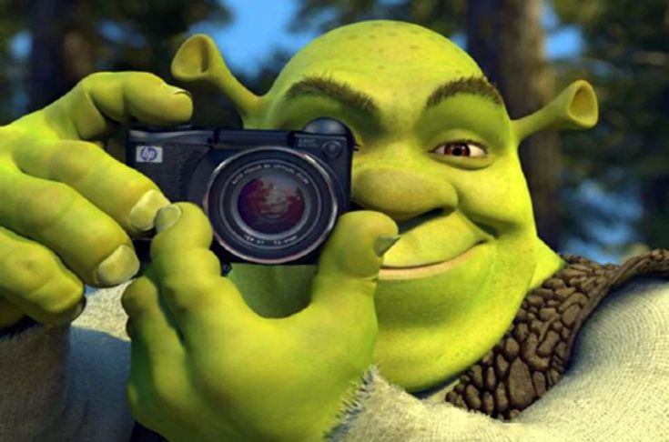 unknown, and discover the beauty of our diverse planet!