





**[TIP SHEET: UNDERSTAND](http://centre.humdata.org)ING DATA ECOSYSTEMS [OCHA CENTRE FOR HUMANITARIAN DATA](http://centre.humdata.org)**

**INTRODUCTION**

A data ecosystem consists of the data management activities and related data, infrastructure, tools, processes, stakeholders and applicable guidance in a context. Understanding how the different components of a data ecosystem relate to one another and how data moves within and between organizations helps to ensure that data is managed in a responsible way.

There are three steps to understanding data ecosystems in a humanitarian response:

• **Developing an organization-level data management registry and activity diagrams.**

• **Compiling registries at the cluster/sector-level and system-wide level.**

• **Developing data ecosystem maps.**

This tip sheet offers instructions and templates for completing these steps in line with the IASC Operational Guidance on Data Responsibility in Humanitarian Action.1

**STEP 1: DEVELOPING AN ORGANIZATION-LEVEL DATA MANAGEMENT REGISTRY AND ACTIVITY DIAGRAMS**

The first step to understanding a data ecosystem is documenting each of the data management activities led by your organization in the context. Examples of data management activities include needs assessments, displacement tracking, beneficiary registration and enrollment, protection case management, community perception surveys, and response monitoring and evaluation, among others.

Organizations should document these activities in a **data management registry**, which typically includes the following details:

• **Activity description,** including type (e.g. registration, needs assessment, survey), purpose, location and sensitivity of the data being managed.

• **Timeframe and status,** including whether the activity is one-off or recurring, and whether it is ongoing, completed or planned.

• **Actors and responsibilities,** including the lead actor, collaborators, roles, and relevant cluster and sub-cluster/working group/area of responsibility.

• **Infrastructure and tools** used for collecting, receiving, storing, analyzing and destroying the data.

• **Data disaggregation,** such as by admin level, sex, age or disability, and if relevant, the methodology used.

• **Data sharing,** including the websites, reports and information products the data management activity will contribute to.

• **Guidance and governance,** including Standard Operating Procedures for the activity, applicable legislation and regulations, and applicable Information Sharing Protocols or similar documents.

1 For reference see the [IASC Operational Guidance on Data Responsibility in Humanitarian Action](https://interagencystandingcommittee.org/operational-response/iasc-operational-guidance-data-responsibility-humanitarian-action).

|  |  |  |
| --- | --- | --- |
| **JULY 2022** | **[OCHA CENTRE FOR HUMANITARIAN DATA](https://centre.humdata.org/)** | **1** |
| **[centre.humdata.org](https://centre.humdata.org/)** |

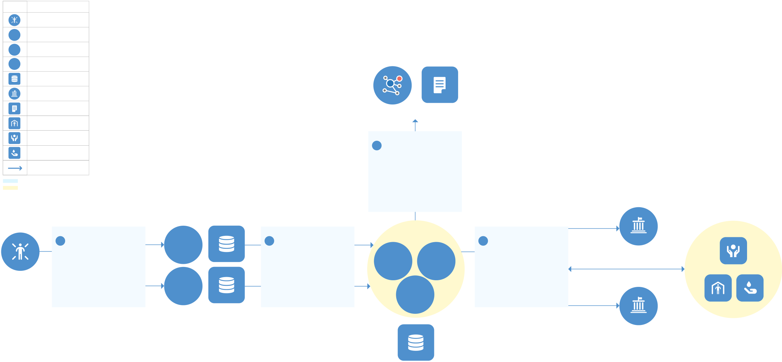

Use the **[Data Management Registry Template](https://docs.google.com/spreadsheets/d/1IH-OSfo0XnzYzQU_fTrlBW8I_H3_GVYJridd0g7WSt0/edit#gid=0)** to develop and maintain the registry for your organization.

The details of each data management activity can also be visualized in a **data management diagram**. A diagram offers a [visual understanding of an activity and](https://docs.google.com/document/d/1qK9Mcu5uB75Hbgtc2WngTjL8eYJBamUiyA8ml6MuPrE/edit) can help identify gaps in data sharing, infrastructure or guidance.

Use the **[Data Management Diagram Template](https://docs.google.com/document/d/1qK9Mcu5uB75Hbgtc2WngTjL8eYJBamUiyA8ml6MuPrE/edit)** to develop the diagram. The organization-level registry and diagram[s serve as the basis for step two descri](https://docs.google.com/document/d/1qK9Mcu5uB75Hbgtc2WngTjL8eYJBamUiyA8ml6MuPrE/edit)bed below.

The data management diagram below shows the steps of a hypothetical Multi-Sector Needs Assessment (MSNA).

1. Two NGOs collect data from affected people after obtaining consent using the MSNA Informed Consent Form. The NGOs store the data locally on servers in their offices in line with the MSNA Terms of Reference (ToR) and local data protection legislation.

2. The NGOs share the data with the Assessment Working Group (AWG), which consists of two UN entities and an International Organization. The AWG compiles the data and stores it in the cloud.

3. The AWG shares disaggregated data with the clusters for analysis, which the clusters share back with the AWG once complete. The AWG also shares aggregated data with the local government and a donor government in line with the Information Sharing Protocol (ISP).

4. The AWG synthesizes the clusters’ analysis and publishes a needs assessment report. It also shares the underlying aggregated data on the Humanitarian Data Exchange.

**DATA MANAGEMENT DIAGRAM: A MULTI-SECTOR NEEDS ASSESSMENT**

**Symbols Entity or Object**

Afected People

**UN**  UN

**IO**  Other IO

**NGO**  NGO

Infrastructure

Government

|  |  |  |
| --- | --- | --- |
| Publication | **HDX** | **REPORT** |

Shelter

|  |  |
| --- | --- |
| Protection  Wash  Data Transfer  Governance / Guidance | **4 PUBLICATION**  **MSNA Terms of Reference;**  **Information Sharing**  **Protocol** |

Group / Cluster

|  |  |  |  |  |  |  |  |  |  |  |
| --- | --- | --- | --- | --- | --- | --- | --- | --- | --- | --- |
| **AFFECTED** | **1 COLLECT & STORE** | **NGO** | **LOCAL STORAGE** | **2 SHARE** | **Assessment**  **Working Group** | | **3 SHARE** | Aggregated Data | **Clusters** | |
| **MSNA Terms of Reference; Local Data Protection**  **Legislation; Informed**  **Consent Form** | **MSNA Terms of Reference; Information Sharing**  **Protocol** | **UN** | **UN** | **MSNA Terms of Reference; Information Sharing**  **Protocol; Local Data**  **Protection Legislation** | **LOCAL GOVERNMENT** | **PROTECTION** | |
| **NGO** | **IO** | | Disaggregated Data | **SHELTER** | **WASH** |
| **PEOPLE** |
| Aggregated Data |

**DONOR GOVERNMENT**

**CLOUD STORAGE**

|  |  |  |
| --- | --- | --- |
| **JULY 2022** | **[OCHA CENTRE FOR HUMANITARIAN DATA](https://centre.humdata.org/)** | **2** |
| **[centre.humdata.org](https://centre.humdata.org/)** |



**STEP 2: COMPILING REGISTRIES AT THE CLUSTER/SECTOR-LEVEL AND SYSTEM-WIDE LEVEL**

The second step to understanding data ecosystems involves sharing the organization-level data management registry and diagrams with relevant clusters/sectors and with the Information Management Working Group (IMWG) or similar coordination group for compilation. This helps identify data gaps and duplication at the cluster/sector-level and system-wide level. It also enables prioritization and strategic decision-making on responsible data management.

Clusters/sector leads should maintain a cluster/sector-level registry of the data management activities led by their members and relevant to their thematic area of focus. For example, a health cluster data management registry might include activities such as disease monitoring, health facility tracking, distribution of medical supplies. The cluster/sector-level registry should be developed based on the Data Management Registry Template.

At the system-wide level, a registry should contain all data management activities in a response, categorized by lead orga[nization and cluster. In most cases, the](https://docs.google.com/spreadsheets/d/1IH-OSfo0XnzYzQU_fTrlBW8I_H3_GVYJridd0g7WSt0/edit#gid=0) registry would be compiled by OCHA on behalf of the IMWG, again using the **[Data Management Registry Template](https://docs.google.com/spreadsheets/d/1IH-OSfo0XnzYzQU_fTrlBW8I_H3_GVYJridd0g7WSt0/edit#gid=0)**.

Registries should be shared publicly to ensure transparency around data management activities.2 In some response environments — notably in conflict settings — the fact that a given data management activity is taking place or specific details about the activity may need to be kept confidential. Any risk associated with sharing the registry should be considered by the lead organization for the activity and in consultation with the relevant cluster/sector partners and OCHA.

**STEP 3: DEVELOPING DATA ECOSYSTEM MAPS**

The third step is developing data ecosystem maps. A data ecosystem map is a visualization of the various ways that data flows between and among actors in multiple data management activities. OCHA should develop a data ecosystem map at the system-wide level, in consultation with the IMWG and ICCG.

Given the complexity of data ecosystems, it may be best to use a white-board or flip chart to sketch out the priority data management activities in your response. If useful, you can then create a digital version using the visualization tools and software designed for this purpose.3 Some details may be excluded to reduce complexity and improve the legibility of the data ecosystem map.

The data ecosystem map below represents a data ecosystem in which four hypothetical data management activities are taking place. These include a mobility tracking activity, a needs assessment, internal displacement tracking, and response monitoring. Visualizing these data management activities together helps gain a quick understanding of the actors involved in data management across the response, how data flows between those actors and where there is room for improving the data ecosystem.

2 For example [OCHA’s 2021 Assessment Registry for Palestine](https://www.humanitarianresponse.info/en/document/assessment-registry-2021).

3 Tools include the [Open Data Institute Data Ecosystem Mapping tool](https://theodi.org/article/data-ecosystem-mapping-tool/), the [Protection Information Management Training Resource Pack](http://pim.guide/uncategorized/pim-training-resource-pack/) (see package 4 from

page 163) or the template provided in Annex D of the [IASC Operational Guidance on Data Responsibility in Humanitarian Action](https://docs.google.com/document/d/1b5gZ15IduAvOdLxkNelvbkHWAKH--9Jdd-ZobAfbzpw/edit?usp=sharing). [Microsoft Visio](https://www.microsoft.com/en-us/microsoft-365/visio/flowchart-software) is a suitable

tool to visualize data ecosystem maps. Free online tools should be used with caution given data security risks.

|  |  |
| --- | --- |
| **[OCHA CENTRE FOR HUMANITARIAN DATA](https://centre.humdata.org/)**  **[centre.humdata.org](https://centre.humdata.org/)** | **3** |

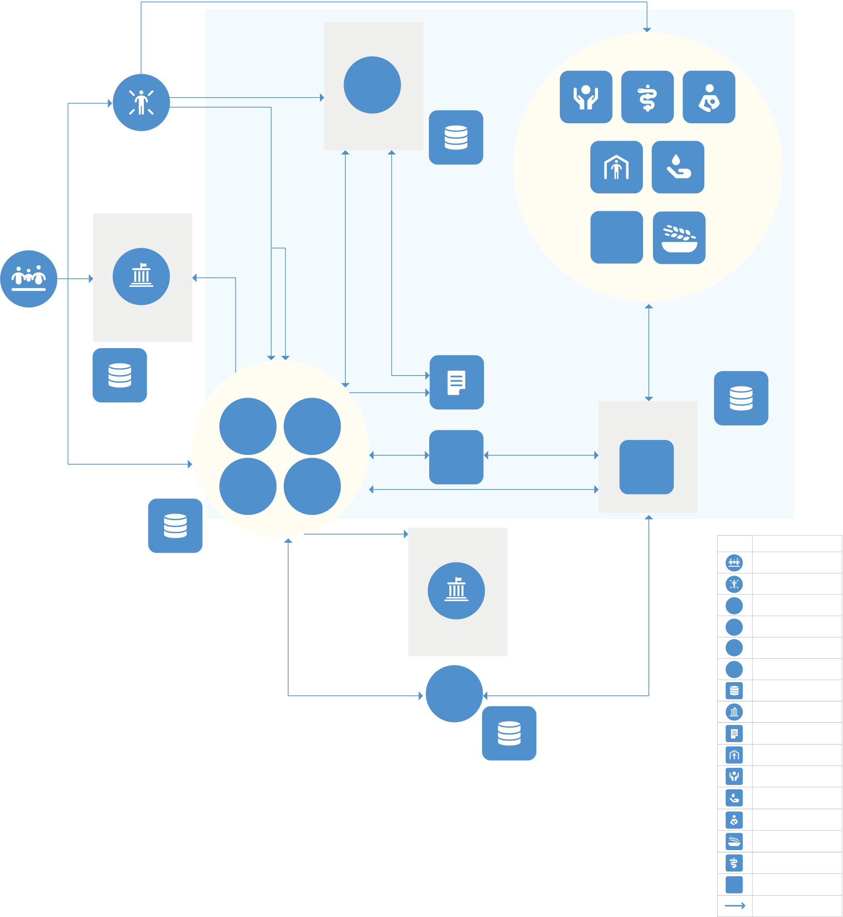

**POPULATION, ASSESSMENT, INTERNAL DISPLACEMENT & RESPONSE MONITORING ECOSYSTEM MAP**

Response data

|  |  |
| --- | --- |
| **Information Sharing**  **Protocol** | **IDP Guiding**  **Principles** |

**UN**

|  |  |  |  |  |  |  |  |  |
| --- | --- | --- | --- | --- | --- | --- | --- | --- |
| **POPULATION** | **AFFECTED POPULATION** | Needs | Displacement | **IOM-DTM** | **LOCAL & CLOUD** | **PROTECTION** | **HEALTH** | **NUTRITION** |
| **Census Data**  **Protocol** | **STORAGE** | **SHELTER** | | **WASH** |
| **NFI** | | |
| **HAC** | data | data | **FOOD SECURITY** | | |
| **LINE MINISTRIES** |

**IA Assessment**   
**Groups**

|  |  |  |  |  |  |  |  |
| --- | --- | --- | --- | --- | --- | --- | --- |
| **LOCAL STORAGE** | **UN** | **IO** | **PUBLICATION** | | **Data Management Protocols** | **LOCAL & CLOUD** | |
| **ISCG** | 3/4Ws data |
| **STORAGE** | |
| Population data SADD | **NGO** | **CBO** | **IMWG** | | **SECTORS** | **Symbols Entity or Object** | |
| Population, Assessment, Displacement data | |
| **Data Protection**  **Legislation** | |
| **LOCAL & CLOUD** | **DONOR** | | Population | |
| **STORAGE** | Afected Population | |
| **UN** | UN |
| **IO** | Other IO |
| **GOVERNMENT** | | **NGO** | NGO |
| **FTS** | | **CBO** | CBO |
| Infrastructure | |

Government   
 Publication   
 Shelter   
**CLOUD STORAGE**  Protection   
 Wash   
 Nutrition   
 Food Security   
 Health   
 **NFI**  NFI   
 Data Transfer   
 Information Sharing Protocol   
 Applicable Guidance   
 Group / Cluster

|  |  |
| --- | --- |
| **[OCHA CENTRE FOR HUMANITARIAN DATA](https://centre.humdata.org/)**  **[centre.humdata.org](https://centre.humdata.org/)** | **4** |



Data ecosystem maps should be completed and updated annually by OCHA in consultation with the IMWG and ICCG. They can be shared publicly unless they contain data management activities that should be kept confidential. They should also be shared with the Humanitarian Country Team for reference.

**CONCLUSION**

The development of data management registries, diagrams and data ecosystem maps improves the transparency of data management in humanitarian response. Following the three steps presented in this tip sheet can lead to a better understanding of the actors, data flows and opportunities for improving data management across a data ecosystem. The OCHA Centre for Humanitarian Data is available for advisory support to offices and organizations interested in developing these outputs.

COLLABORATORS: **[JOINT IDP PROFILING SERVICE (JIPS)](https://www.jips.org/)**.

|  |
| --- |
| The**[Centre for Humanitarian Data](https://centre.humdata.org)**('the Center'), together with key partners, is publishing a series of guidance notes and [tip sheets on Data Responsibility i](https://centre.humdata.org)n Humanitarian Action over t[he course of 2022 and 2023. The guidance note series](https://interagencystandingcommittee.org/operational-response/iasc-operational-guidance-data-responsibility-humanitarian-action) [continues work initiated in 2019 and 2020. It also complements](https://interagencystandingcommittee.org/operational-response/iasc-operational-guidance-data-responsibility-humanitarian-action) the **[Inter-Agency Standing Committee Operational Guidance on Data Responsibility in Humanitarian Action](https://interagencystandingcommittee.org/operational-response/iasc-operational-guidance-data-responsibility-humanitarian-action)** and the **[OCHA Data Responsibility Guidelines](https://interagencystandingcommittee.org/operational-response/iasc-operational-guidance-data-responsibility-humanitarian-action)**, [which were published in February 2021 and October 2021](https://interagencystandingcommittee.org/operational-response/iasc-operational-guidance-data-responsibility-humanitarian-action) respect[ively. Through the series, the Centre ai](https://centre.humdata.org/the-ocha-data-responsibility-guidelines/)ms to provide additional guidance on specific issues, processes and tools for data responsibility in practice. The guidance notes and tip sheets published in 2022-2023 have been made possible with the support of the Government of Switzerland. |

|  |  |
| --- | --- |
| **[OCHA CENTRE FOR HUMANITARIAN DATA](https://centre.humdata.org/)**  **[centre.humdata.org](https://centre.humdata.org/)** | **5** |