

**THE CENTRE FOR HUMANITARIAN DATA** Connecting people and data to improve lives

**DECEMBER 2016**

Overview

—

The United Nations Office for the Coordination of Humanitarian Affairs (OCHA) is establishing a Centre for Humanitarian Data in the Netherlands. It will be operational by early 2017 for an initial three years.

The Centre’s mission is to increase the use and impact of data in the humanitarian sector. The vision is to create a future where all people involved in a humanitarian situation have access to the data they need, when and how they need it, to make responsible and informed decisions.

The Centre will support humanitarian partners and OCHA staff in the field and at headquarters with their data efforts. It will be part of the city of The Hague’s Humanity Hub, a dedicated building for organizations working on data and innovation in the social sector. The location offers OCHA and partners a new, neutral setting where a hybrid culture can be created around data collaboration.

The Centre is a key contribution towards the Secretary-General’s Agenda for Humanity under core commitment four -- changing the way we work to end need. The Centre’s activities will accelerate the changes required for the humanitarian system to become data driven.

**“**  
HDX and the new Centre are a leading

innovation in the trustworthy use of data

for humanitarian outcomes. They are

a tremendous example of putting the

principles of trust, accountability and

action into practice.

-Bill Hoffman, World Economic Forum

**”**

Objectives  
—  
The Centre will have four objectives:

- 1 -  
Increase the   
interoperability of   
humanitarian data through   
shared standards and   
integrated systems.

- 3 -  
Increase the capability   
of people to access and   
use data in support of   
humanitarian efforts.

- 2 -  
Increase the trust and   
cooperation across   
organizations sharing data in   
humanitarian response.

- 4 -  
Engage existing and new   
partners in data problem-  
solving and awareness-  
raising.

Principles  
—

The Center will adhere to the following high-level principles:

|  |  |  |  |  |  |  |  |
| --- | --- | --- | --- | --- | --- | --- | --- |
| Human-centered |  | Open |  | Networked |  | Agile |  |
| We will use a | | The Centre will be open to | | The Centre will not be ‘the | | The Centre will be run with | |
| human-centered design | | collaboration with a wide | | centre’ of anything but part | | a start-up mindset. We will | |
| approach to our activities. | | variety of partners, including | | of a network of data-focused | | adapt to demand and new | |
| We exist to help people | | through shared working | | partners. Entities with a | | innovations. Projects will be | |
| use data more effectively | | spaces, where feasible. | | comparative advantage in | | developed in an incremental | |
| to improve lives and | | Software and standards | | specific fields will be asked | | and iterative manner. We will | |
| reduce suffering. All user | | will be open source with | | to lead aspects of the work | | be flexible in our approach | |
| groups will be considered | | all code made available | | rather than trying to do | | to delivering on our mission | |
| when designing solutions, | | in public repositories and | | everything ourselves. We | | and objectives. | |
| products and services. | | supported through developer | | will seek expertise across | |
| communities. Data will be | | disciplines and industries | |
| open to the extent that | | to ensure that we are | |
| partners wish for it to be | | understanding problems | |
| open and as long as it does | | and solutions from different | |
| not infringe on the privacy or | | perspectives. | |
| security of individuals. | |

**3**

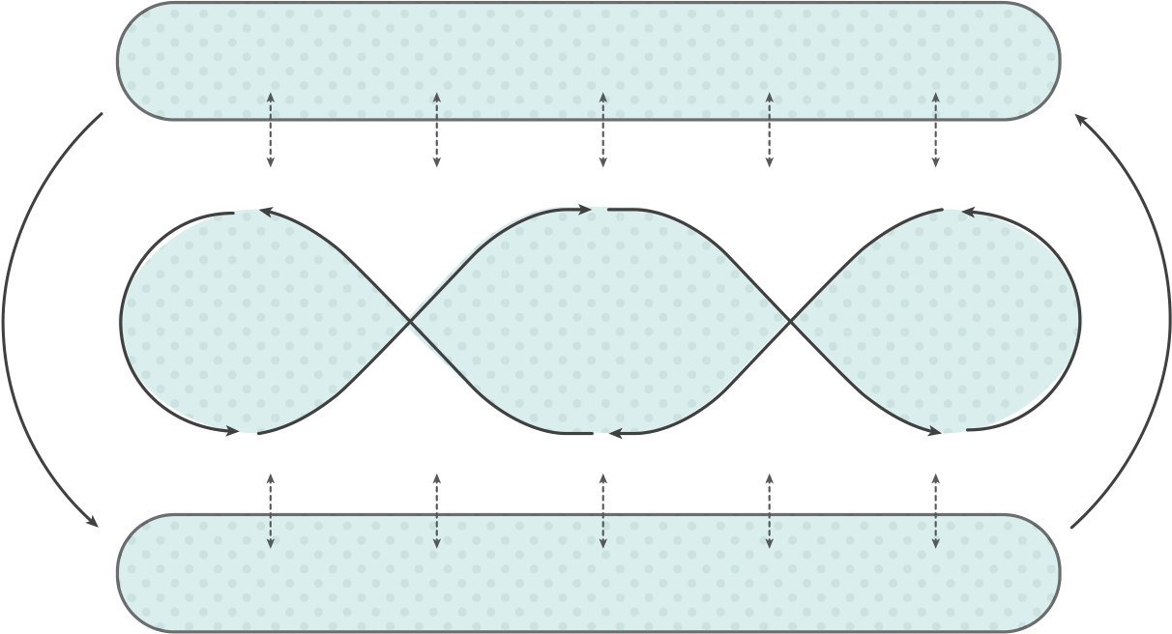

Focus Areas

—

The Centre will focus its activities across four areas: 1) data services; 2) data policy; 3) data literacy; and 4) network engagement. The Centre will also have an internal focus on strategy.

**STRATEGY**

|  |  |  |
| --- | --- | --- |
| **DATA** | **DATA** | **DATA** |
| **LITERACY** | **SERVICES** | **POLICY** |

**NETWORK ENGAGEMENT**

|  |  |  |  |
| --- | --- | --- | --- |
| Data Services |  | Data Literacy |  |
| — | — |

The Centre’s data services work will include: a) direct management of the Humanitarian Data Exchange and   
support to other platforms; b) data standards adoption, including for the Humanitarian Exchange Language and the International Aid Transparency Initiative; and c) data visualization and reporting.

The Centre will offer in-person and   
remote training programmes for   
technical and non-technical users of data. The Centre will also manage a data fellows programme that will place data scientists and design researchers in partner organizations and OCHA   
offices to work alongside staff to build capacity.

|  |  |  |  |
| --- | --- | --- | --- |
| Data Policy |  | Network Engagement |  |
| — | — |

The Centre will lead OCHA’s data policy work and offer support to partners on using data responsibly. Safeguarding privacy and ensuring sensitive data   
is handled appropriately are critical issues for the humanitarian community as it becomes more data driven.

The Centre will further build and   
engage an active community in   
support of its mission and objectives.

We will do this by creating physical and virtual spaces to work together on data challenges and creating a   
transparent collaboration model for people, organizations and companies to engage with us.

**4**

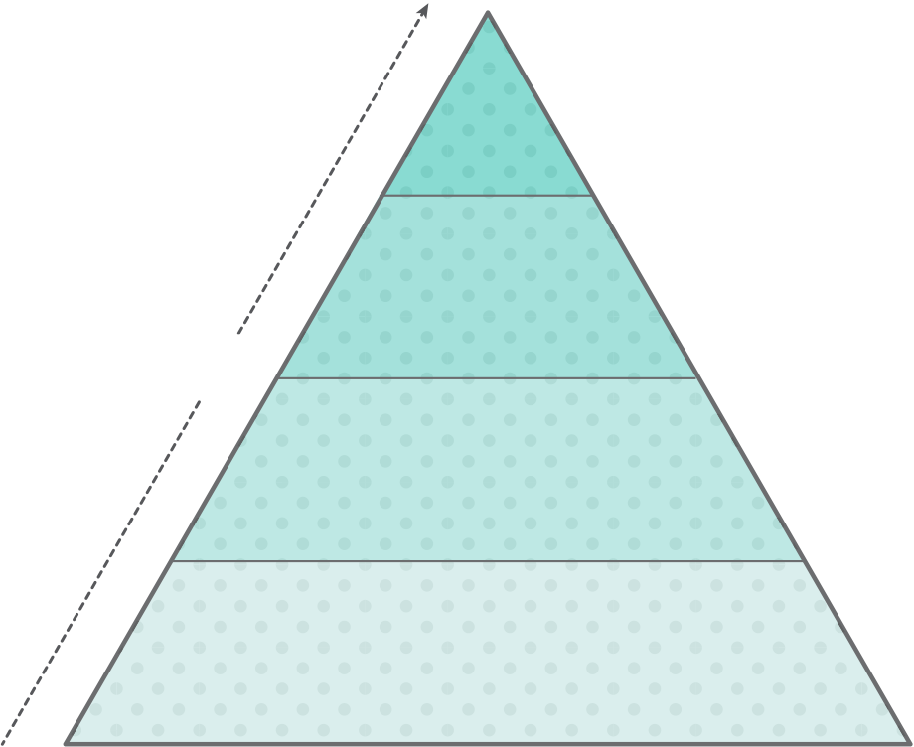

Collaboration Model

—

There will be a number of ways for partners to collaborate with the Centre. This includes information sharing, projects and placement of staff into the Centre. The level of trust increases as the collaboration becomes more direct.

**Second-**  
**ments**

**Direct projects**

**Trust**

**3rd party projects**

**Information sharing**

Collaboration examples include:

Level 1   
An individual visits the Centre website to find out about community projects and to learn about upcoming events and trainings.

Level 2   
An organization shares information with the Centre about a project that needs support and the Centre connects the organization with a partner who can help.

Level 3   
A data manager in the field contacts the Centre with a request to clean data and build a visualization and the Centre creates a project, team and timeline to deliver on the request.

Level 4   
An organization wants to support the Centre’s data science activities and seconds a staff member for 6 months to work on a range of activities in The Hague.

**5**



Timeline

—

|  |  |
| --- | --- |
| 2016 | The Centre is a work in progress. We expect it to be operational by the first or second quarter of 2017. The exact timing is dependent on the finalization of legal and financial agreements. You can get the latest updates on our timeline through the Centre’s website: **centre.humdata.org** |

**MAY 2016**   
World Humanitarian Summit   
OCHA and the Netherlands **[announced](http://reliefweb.int/report/world/humanitarian-data-centre-netherlands-will-increase-data-use-and-impact-humanitarian)** their intention to establish a new [Centre for Humanitar](http://www.agendaforhumanity.org/)ian Data in The H[ague as a c](http://reliefweb.int/report/world/humanitarian-data-centre-netherlands-will-increase-data-use-and-impact-humanitarian)oncrete commitment towards the **[Agenda for Humanity](http://www.agendaforhumanity.org/)**.

**OCTOBER 2016**   
Design Workshop in The Hague   
Over forty partners came together to give feedback on the Centre’s business plan and to explore areas of collaboration.

**NOVEMBER 2016**

|  |  |
| --- | --- |
| 2017 | Design Workshop in New York  Over twenty-five partners met to think through various aspects of the Centre’s business plan and to explore areas of collaboration. |

**MARCH 2017**   
Centre for Humanitarian Data in The Hague   
An initial team is based in The Hague to set up the Centre and begin working with partners.

**AUGUST 2017**   
The Humanity Hub Opens   
The city of The Hague establishes the Humanity Hub, a collaborative space for groups working on data and innovation in the social sector.

**OCTOBER 2017**   
Official Launch of the Centre   
Public event to formally launch the Centre for Humanitarian Data within the Humanity Hub in The Hague.

Contact

—

Send feedback or questions to **[hdx@un.org](mailto:hdx@un.org)** or **[@humdata](https://twitter.com/humdata)**. We look forward to hearing from you.

|  |  |
| --- | --- |
| **6** |  |

December 2016