**August 5, 2013**



East Building, PHH-30 U.S. Department 1200 New Jersey Avenue S.E.

of Transportation Washington, D.C. 20590

**Pipeline and Hazardous**

**Materials Safety Administration**

DOT-SP 13544   
(FIFTH REVISION)

(FOR RENEWAL, SEE 49 CFR § 107.109)

|  |  |
| --- | --- |
| 1. | GRANTEE: (See individual authorization letter) |
| 2. | PURPOSE AND LIMITATIONS: |
|  |  |

a. This special permit authorizes the transportation in commerce of DOT Specification 4BA240 cylinders containing liquefied petroleum gas (LPG) and/or residue of LPG without hazard warning labels when transported by a motor vehicle that is placarded. This special permit provides no relief from the Hazardous Materials Regulations (HMR) other than as specifically stated herein. The most recent revision   
supersedes all previous revisions.

b. The safety analyses performed in development of this special permit only considered the hazards and risks   
associated with transportation in commerce. The safety analyses did not consider the hazards and risks associated with consumer use, use as a component of a transport vehicle or other device, or other uses not associated with   
transportation in commerce.

c. Unless otherwise stated herein, this special permit consists of the special permit authorization letter issued to the grantee together with this document.

|  |  |
| --- | --- |
| 3. | REGULATORY SYSTEM AFFECTED: 49 CFR Parts 106, 107 and 171- |

180.

|  |  |
| --- | --- |
| 4. | REGULATIONS FROM WHICH EXEMPTED: 49 CFR § 172.301(a) in |

that the proper shipping name and identification number need not be marked on each package, § 172.301(c) in that marking of the special permit number on each package is not required and § 172.401 in that each cylinder must be labeled, except as provided herein.

Continuation of DOT-SP 13544 (5th Rev.) Page 2 **August 5, 2013**

|  |  |
| --- | --- |
| 5. | BASIS: This special permit is based on the application of |

Carlson Logistics dated March 7, 2013 and additional information dated July 23, 2013, submitted in accordance with § 107.105 and the public proceeding thereon.

|  |  |
| --- | --- |
| 6. | HAZARDOUS MATERIALS (49 CFR § 172.101): |
|  |  |

|  |  |  |  |
| --- | --- | --- | --- |
| **Hazardous Materials Description** | | | |
| **Proper Shipping Name** | **Hazard**  **Class/**  **Division** | **Identi-** **fication**  **Number** | **Packing Group** |
| Liquefied petroleum gas | 2.1 | UN1075 | N/A |
| Propane | 2.1 | UN1978 | N/A |

|  |  |
| --- | --- |
| 7. | SAFETY CONTROL MEASURES: |
|  |  |

a. PACKAGING – Prescribed packagings are DOT Specification 4BA240 steel cylinders.

|  |  |
| --- | --- |
| b. | OPERATIONAL CONTROLS: |
|  |  |

(1) The cylinders must be transported on a motor vehicle that is placarded with “FLAMMABLE GAS” placards.

(2) Shipping papers must reflect a correct current accounting of all cylinders both full and expended.

(3) Cylinders must be secured in the vehicle in accordance with § 177.834(a).

|  |  |
| --- | --- |
| 8. | SPECIAL PROVISIONS: A current copy of this special permit |

must be maintained at each facility where the package is offered for transportation.

|  |  |
| --- | --- |
| 9. | MODES OF TRANSPORTATION AUTHORIZED: Motor vehicle. |
|  |  |

10. MODAL REQUIREMENTS: None as a requirement of this special permit.

Continuation of DOT-SP 13544 (5th Rev.) Page 3 **August 5, 2013**

11. COMPLIANCE: Failure by a person to comply with any of the following may result in suspension or revocation of this special permit and penalties prescribed by the Federal hazardous materials transportation law, 49 U.S.C. 5101 et seq:

|  |  |
| --- | --- |
| o | All terms and conditions prescribed in this special |

permit and the Hazardous Materials Regulations, Parts 171-180.

o Persons operating under the terms of this special permit must comply with the security plan requirement in Subpart I of Part 172 of the HMR, when applicable.

|  |  |
| --- | --- |
| o | Registration required by § 107.601 et seq., when |

applicable.

Each “Hazmat employee”, as defined in § 171.8, who performs a function subject to this special permit must receive training on the requirements and conditions of this special permit in addition to the training required by §§ 172.700 through 172.704.

No person may use or apply this special permit, including display of its number, when the special permit has expired or is otherwise no longer in effect.

Under Title VII of the Safe, Accountable, Flexible,   
Efficient Transportation Equity Act: A Legacy for Users (SAFETEA-LU)- 'The Hazardous Materials Safety and Security Reauthorization Act of 2005' (Pub. L. 109-59), 119 Stat.

1144 (August 10, 2005), amended the Federal hazardous   
materials transportation law by changing the term   
“exemption” to “special permit” and authorizes a special permit to be granted up to two years for new special permits and up to four years for renewals.

Continuation of DOT-SP 13544 (5th Rev.) Page 4 **August 5, 2013**

12. REPORTING REQUIREMENTS: Shipments or operations conducted under this special permit are subject to the Hazardous Materials Incident Reporting requirements specified in 49 CFR §§ 171.15 - Immediate notice of certain hazardous materials incidents, and 171.16 - Detailed hazardous   
materials incident reports. In addition, the grantee(s) of this special permit must notify the Associate Administrator for Hazardous Materials Safety in writing, of any incident involving a package, shipment or operation conducted under terms of this special permit.

Issued in Washington, D.C.

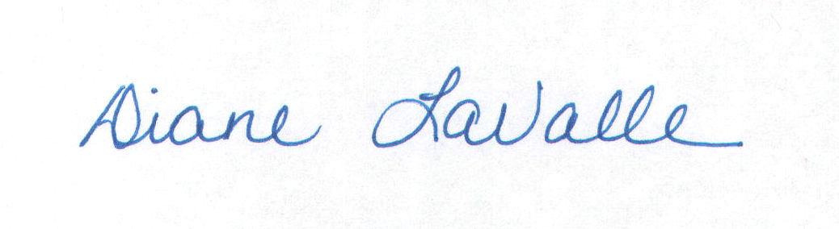

for Dr. Magdy El-Sibaie

Associate Administrator for Hazardous Materials Safety

Address all inquiries to: Associate Administrator for Hazardous Materials Safety, Pipeline and Hazardous Materials Safety   
Administration, Department of Transportation, Washington, D.C. 20590. Attention: PHH-31.

Copies of this special permit may be obtained by accessing the Hazardous Materials Safety Homepage at   
http://hazmat.dot.gov/sp_app/special_permits/spec_perm_index.htm Photo reproductions and legible reductions of this special permit are permitted. Any alteration of this special permit is   
prohibited.

PO: bmoore