Redler Loader description.

* Loader Placed in SECTOR A.
* Parameters in SECTOR B.
* Main program: SECTORS: C,D,E,F,G,H.

Main features:

1. Fast flash procedure.
2. PC waits for unit to be ready, send "A" every 100 ms.
3. Driver waits for PC to be ready, capable to restart if halted (garbage communication).
4. Power loss protection (after erase) => restart boot loader.

Communication loss (1 sec timeout) => restart boot loader.

1. After successful flash => run main program.
2. After Failed flash => restart boot loader.
3. Sector select inside txt file - Default erase C,D,E,F,G,H.
4. User can flash sector A –( without Power/ Communication protections)

Loader flash

Flash Checksum Protection

The flash checksum is protection for flash corruption duo failed programming.

Each boot the driver will test flash, in case of flash corruption the driver will enter to loader mode and wait in this state until user will load successfully new firmware.

**To enable flash checksum protection:**

1. Compile and burn main program into DSP.
2. Via UART Read flash checksum 62[10] in hex format
3. Under Descriptor file: **#define** PROG_CHECKSUM 0x12345678

Instet 12345678 use “flash checksum” from step 2.

1. Burn again the new firmware verify whit UART that flash checksum 62[10], is the same.

**To disable:**

For debug use 0x00000000 this will skip test completely, Just remember to Enable under SW release.

Setup of hex utility inside CCS

1. 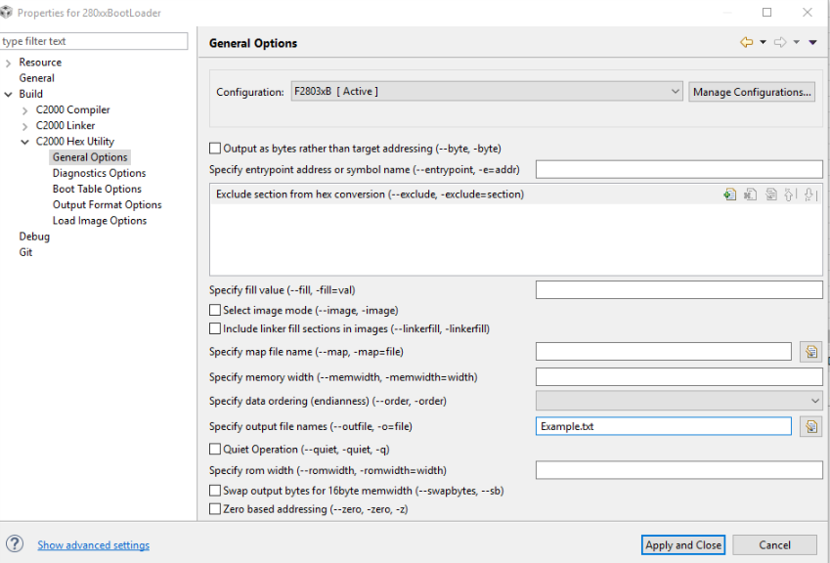Change file name to “Name”.txt
2. Select file options

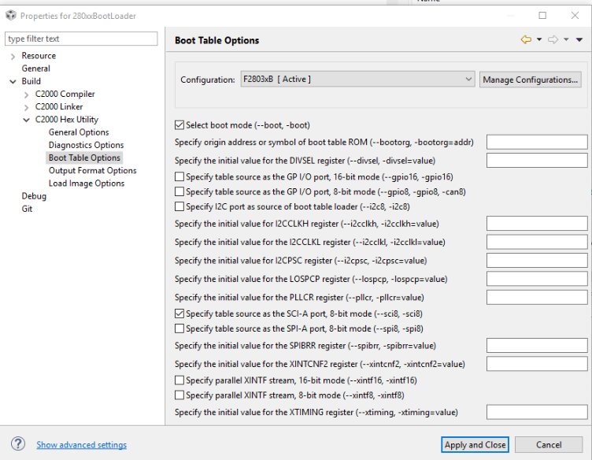

1. 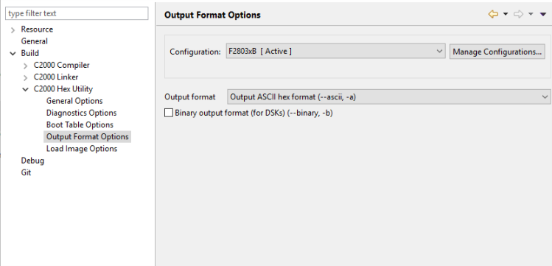Select ASCII format

Loader flow

Text file:

AA 08 00 00 00 00 00 00 00 00 00 00 00 00 00 00 00 00 3F 00 E5 67 02 00

1. Baud lock procedure: “A” 0x41
2. Send Key value: AA 08
3. Send Reserved: 00 00 00 00 00 00 00 00 00 00 00 00 00 00 00 00
4. Send Entry Address: 3F 00 E5 67
5. Driver returns Checksum
6. Send block size
7. Send data
8. Driver returns Checksum (go to 6 until empty)

|  |  |  |  |
| --- | --- | --- | --- |
| Fail | Pass | Screen | Stage |
| Failed to connect {stop} | Pass | Connecting to com “COM” port | 1 |
| Failed {Go to stage 7} | Pass “Baud rate” | Autobaud with unit (send 1[0]) | 2 |
| {Go to stage 4} | SN | SN Ver 62[1] | 3 |
| {Go to stage 5} | FW | FW Ver 62[3] | 4 |
| {Go to stage 6} | HW | HW Ver 62[2] | 5 |
| Fail {retry x3, Go to stage 7} | Pass | Sending loader command | 6 |
| Failed to change baud | Pass | Change baud rate to flash baud |  |
| Failed {retry x3, Stop} | Pass | Loader Baud lock “Flash Baud” | 7 |
| Failed, cannot erase sector A {if Sector A selected in txt} | “text file” | Erasing sectors: | 9 |
| Failed, no response {wait 10 sec, stop} | Finished | {Progress bar 500ms, 20 jumps} (terminate when checksum) | 10 |
| Failed, no response { | Load success | Loading new firmware,  {progress bar each checksum} | 11 |
|  |  | Resetting driver | 12 |
| Loading new firmware failed {retry x3, Stop} | “FW” | FW Ver | 13 |
|  |  | New firmware loaded successfully | 14 |

1. Sent reset command

## GUI Stage and reports

Sectors to Erase

Sector to erase (A to H): Third byte Inside *.txt file:

AA 08 00 00 00 00 00 00 00 00 00 00 00 00 00 00 00 00 3F 00 E5 67 02 00

Byte marked with 00 is flash sector to erase.

00 00 is a safety key to allow erase of sector A, set 5A 00 to allow loader firmware update, Do not enable Key under normal main firmware upgrade.

00= erase ALL sectors except sector A and sector B, **default**. (C,B,D,E,F,G,H)

BIT0 = erase sector A

BIT1 = erase sector B

BIT3 = erase Sector C

… ect

Use OR to select multiple sectors:

03 = erase sector A and B

Note:

A – LOADER

B – Parameters

C,D,E,F,G,H – Main program

How to create bootloader.txt file for sector A

Caution!

Please do not change the boot-loader if not necessary. The boot-loader in sector A is special case in which checksum protection will not work. Failure while flashing can cause the unit to stop functioning, after boot-loader failure boot-loader file can only be flashed via Jtag.

1. Compile the programs and create *.txt file.
2. Run: Get_file_flash_kernel
3. Change Flash select byte (Third byte) to 01, for example:

AA 08 01 00 5A 00 00 00 00 00 00 00 00 00 00 00 00 00 3F 00 E5 67 02 00

How to load firmware into driver

1. Loader must be present in sector A
2. Open “Rayon Serial programmer”
3. select file.txt
4. Select unit “cmd Baud” - baud rate for loader command
5. Select “Flash Baud“ - baud rate in loader stage
6. Press “start”

