

AHU CONTROLLER TEST DATA SHEET

P/N: N/A Date: 09/03/2018 Time: 10:18

S/N: N_A Tested by: jhg

Hardware Rev: BLDC_60A_V6 Approved by: jhg

Software Rev: N/A

Tester Software Version: 1.2a

Equipments Used

Equipments Model No Serial No

Power Supply

Digital Multimeter

CAN Interface

Resistance Decade Box

PC

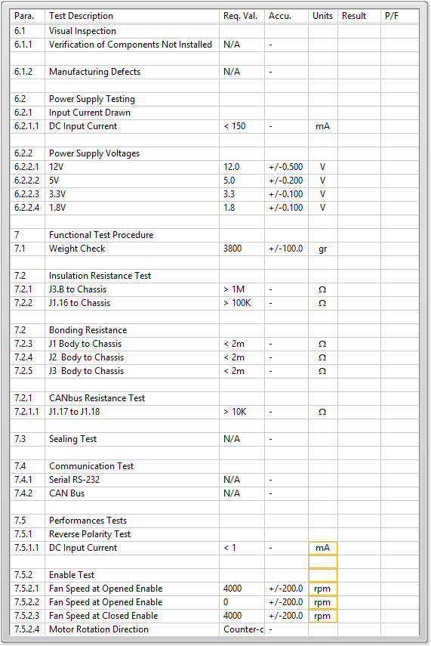

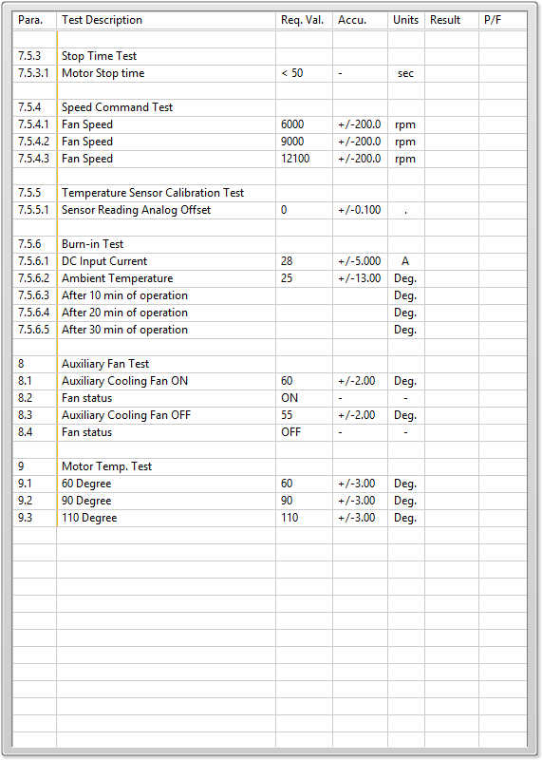

General result:

Test-Operator:____ jhg_________ Q.A.:__________________________