

EBAY CONTROLLER TEST DATA SHEET

P/N: EBAY 414-8005 Date: 08/03/2018 Time: 17:46

S/N: 999 Tested by: jhgf

Hardware Rev: BLDC_60A_V6 Approved by: jhgf

Software Rev:

Tester Software Version: 1.2

Equipments Used

Equipments Model No Serial No

Power Supply

Digital Multimeter

CAN Interface

Resistance Decade Box

PC

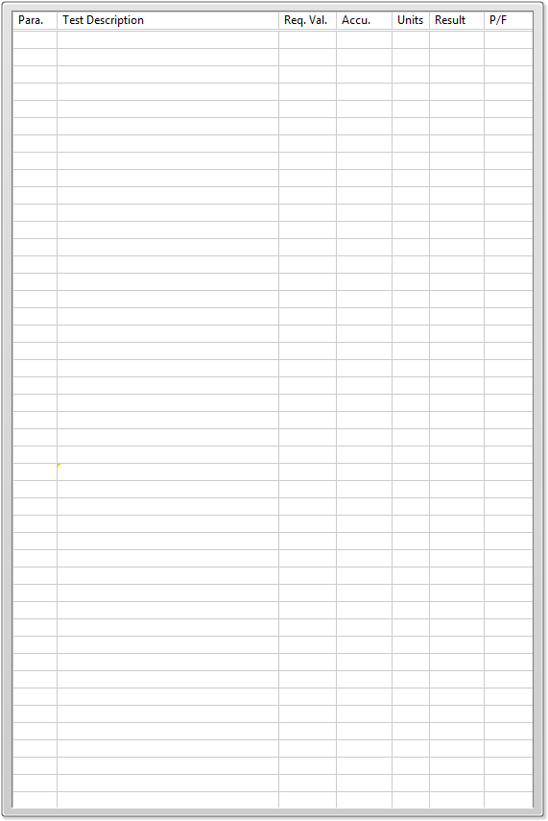

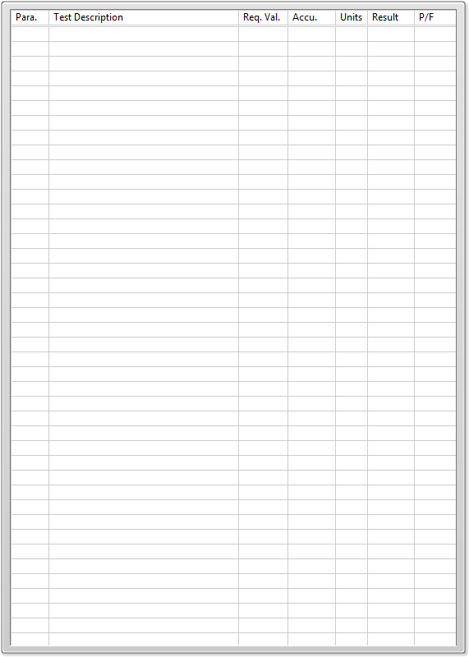

General result:

Test-Operator:____ jhgf_________ Q.A.:__________________________