

AHU CONTROLLER TEST DATA SHEET

P/N: N/A Date: 08/03/2018 Time: 18:03

S/N: N_A Tested by: nb

Hardware Rev: BLDC_60A_V6 Approved by: nb

Software Rev: N/A

Tester Software Version: 1.2

Equipments Used

Equipments Model No Serial No

Power Supply

Digital Multimeter

CAN Interface

Resistance Decade Box

PC

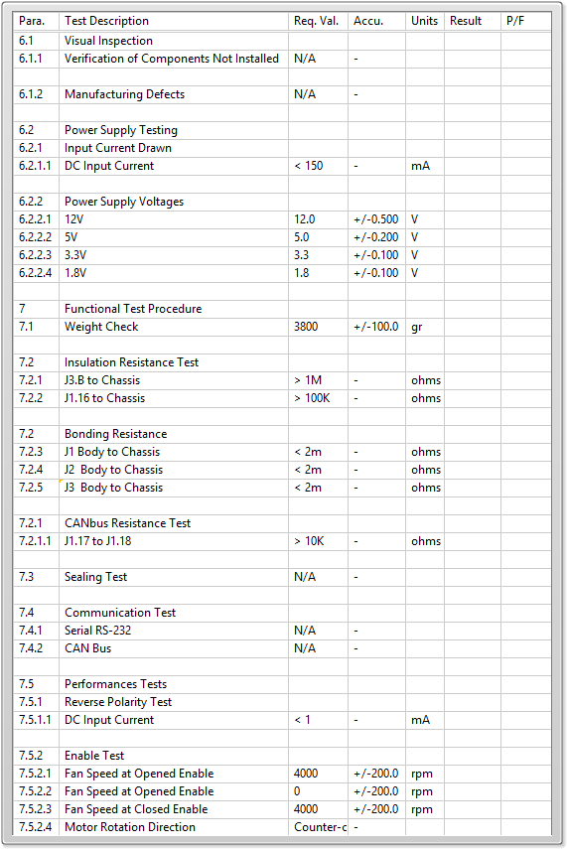

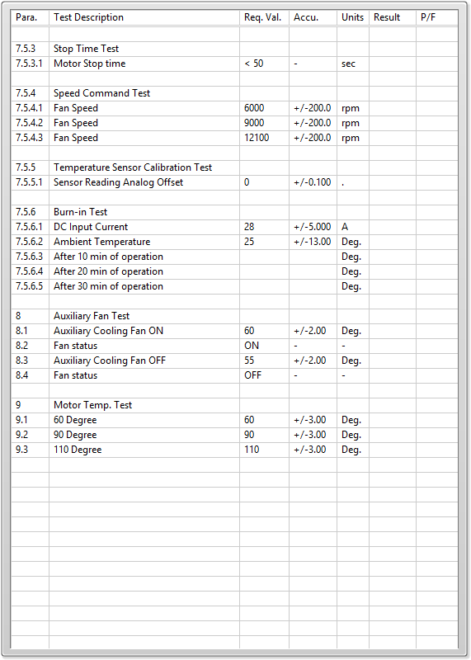

General result:

Test-Operator:____ nb_________ Q.A.:__________________________