1. Acceptance Test Report

PN. 500490 SN. ________ DSP S.N. ________ Driver S.N. ________

|  |  |  |  |  |
| --- | --- | --- | --- | --- |
| **#** | **Test Name** | **Under Tset** | **Result** | **Pass/Fail** |
| 9.1 | ***Conductivity Test*** | J1 to CHASIS < 2[mΩ] |  |  |
| J2 to CHASIS < 2[mΩ] |  |  |
| J3 to CHASIS < 2[mΩ] |  |  |
| 9.2 | ***Insulation Resistance*** | J2_A to CHASIS > 500[KΩ] |  |  |
| J2_C to CHASIS > 500[KΩ] |  |  |
| J3_A to CHASIS > 500[KΩ] |  |  |
| J3_C to CHASIS > 500[KΩ] |  |  |
| J3_E to CHASIS > 500[KΩ] |  |  |
| 9.3 | ***Torque Test*** | Torque wrench by DIN Standard & manufacturer's instructions for nut Torque. | |  |
| 9.4 | ***Blower Calibration*** | Motor Speed = 3700 ± 100 [RPM]  DRIVER CURRENT = 27 ± 3[A] |  |  |
| 9.5 | ***Functional Test*** | Connect the setup according the figure in parag.7 and Follow procedure presented in the PC according to (P/N – RD-TESTER-0001) 60A DRIVER TESTER test sw.  At the end, add the test file. | |  |
| 9.6 | ***Leak Test*** | Leak Test - 5± 0.2 psig | No bubbles for 2 minutes. |  |

====================================================

|| Functional and Performance Test For MOTOR DRIVER

|| P/N manufacturer :RD500590

|| P/N:108014650 S/N: 000000

|| Date:14/12/2017 Time: 11:03 Test-Conductor: Eli

|| Tester P/N: RD-14000000-01 Tester S/W Ver.1.18f

||

|| Notes:

=====================================================

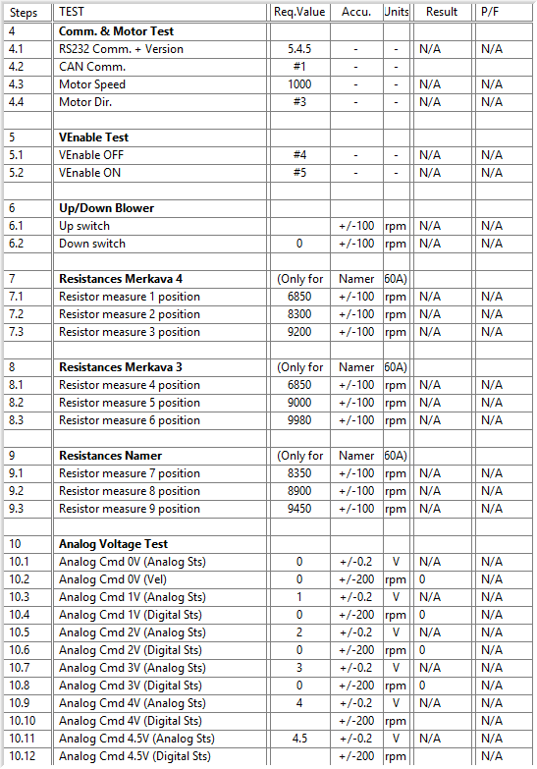

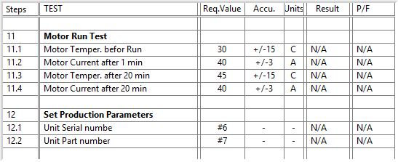

General result:



|  |  |  |  |  |
| --- | --- | --- | --- | --- |
|  | **Name** | **Signature** | **Date** | |
| **Tested By:** | |  | | --- | | ____ **Eli Talias** __ | |  | | ___ **Eli.T** _____ | _________________ | |
|  |  |  |  | |
| **Quality Inspector:** | ___ **Evgeny. A** ___ | ____ **Evgeny. A** _ | _________________ | |
|  |  |  | **Pass** |  |
| **Stamp:** |  |  |  |
|  |  | Fail |  |