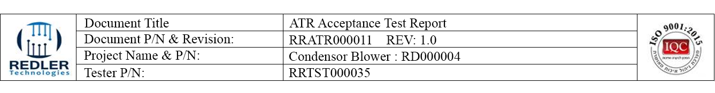

PN. RD000004 SN. __________ DSP SN. __________ Driver SN. __________

Filter SN. ________________ Capacitor SN. ________________

|  |  |  |  |  |
| --- | --- | --- | --- | --- |
| # | Test Name | Under Test | Result | Pass/Fail |
| 1 | Blower Calibration | Motor Speed = 8000 +/- 100 [RPM]  DRIVER CURRENT = 40 +/- 3 [A] |  |  |

|  |  |  |  |
| --- | --- | --- | --- |
| 2 | Functional Test | Connect the setup according to the figure in paragraph 7 and follow procedure presented in the PC according to (P/N - RRTST000035) CONDENSER DRIVER TESTER test sw.  At the end, add the test file. |  |
| 3 | Cable length |  |  |



**Condenser Tester Generate Report and Approval Test**

|  |  |  |
| --- | --- | --- |
| General Test Result: Pass |  | Date: 11/09/2019 |
| P/N Manufacturer: RD000004 |  | Time: 16:36 |
| P/N Consumer: CR053100-03 |  | Technician name: Guy |
| S/N: 302 |  | Approved by: MICHAL |
| Tester Software Version: 1.18g |  |  |
| Parameters Ver. RRPAR000004 VERSION 0.3 |  |  |

