

BLDC 30A CONTROLLER TEST DATA SHEET

|  |  |  |  |
| --- | --- | --- | --- |
|  | P/N: RD000002 |  | Date: 17/12/2019 |
|  | DRIVER S/N: 261 |  | Time: 11:54 |
|  | Product Rev.: 2B |  | Tested by: GABRIEL |
|  | Software Ver.: 5.4.5 |  | Approved by: GIDI |
|  | Parameters Ver.: 0.3 |  |  |
|  | Tester Software Ver.: V0.1.e |  |  |
|  | Tester HW Rev.: V0.1 |  |  |
|  | DSP BOARD S/N: LA19310014 |  |  |
|  | POWER BOARD S/N: LA19270071 |  |  |
|  |  |  |  |
|  |  |  |  |
|  |  |  |  |
|  |  |  |  |
|  |  |  |  |

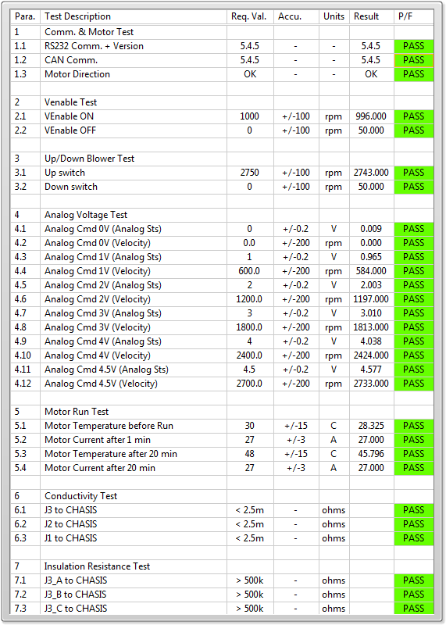

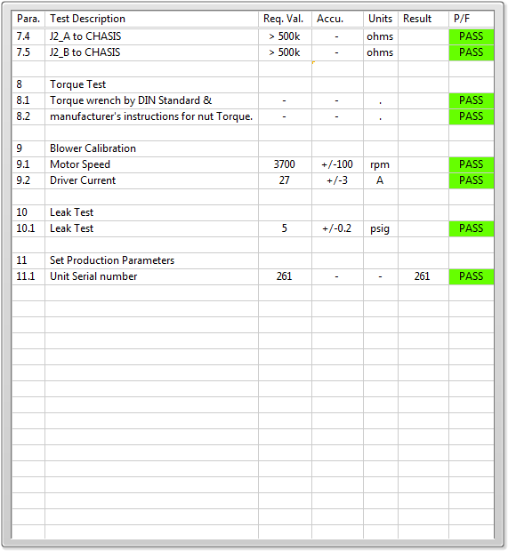

General result:

Test-Operator: ____ GABRIEL_________

Q.A.: _______GIDI____________