

BLDC 60A CONTROLLER TEST DATA SHEET

|  |  |  |  |
| --- | --- | --- | --- |
|  | P/N: RD000001 |  | Date: 01/08/2019 |
|  | DRIVER S/N: 79 |  | Time: 10:16 |
|  | Product Rev.: 2C |  | Tested by: guy |
|  | Software Ver.: 5.4.8 |  | Approved by: GIDI |
|  | Parameters Ver.: 0.4 |  |  |
|  | Tester Software Ver.: V0.1.e |  |  |
|  | Tester HW Rev.: V0.1 |  |  |
|  | DSP BOARD S/N: 1 |  |  |
|  | POWER BOARD S/N: 1 |  |  |
|  |  |  |  |
|  |  |  |  |
|  |  |  |  |
|  |  |  |  |
|  |  |  |  |

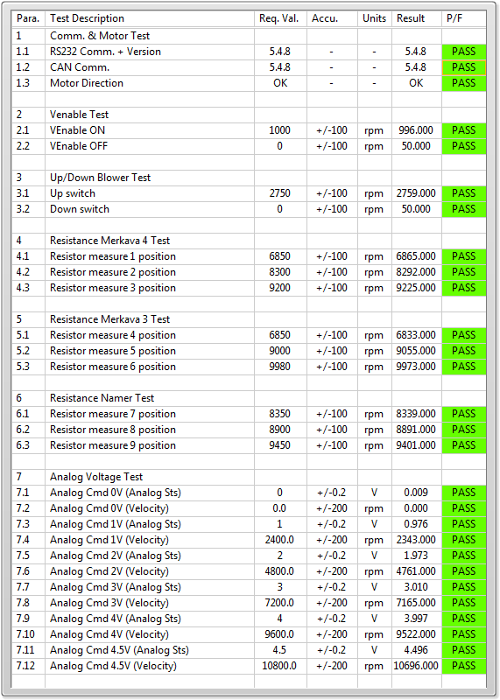

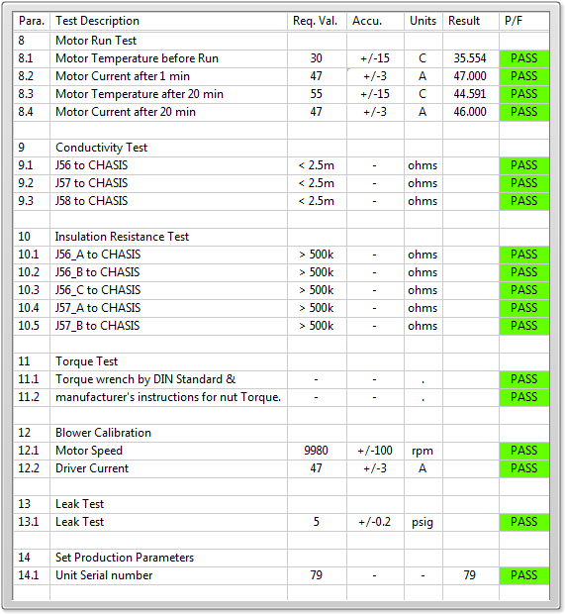

General result:

Test-Operator: ____ guy_________

Q.A.: _______GIDI____________