=====================================================

|| Functional and Performance Test For MOTOR DRIVER

|| P/N manufacture :RD5310003

|| P/N:CR053100-03 S/N: 000000

|| Date:26/11/2017 Time: 16:11 Test-Conductor: Eli

|| Tester P/N: RD-14000000-01 Tester S/W Ver.1.18f

||

|| Notes:

=====================================================

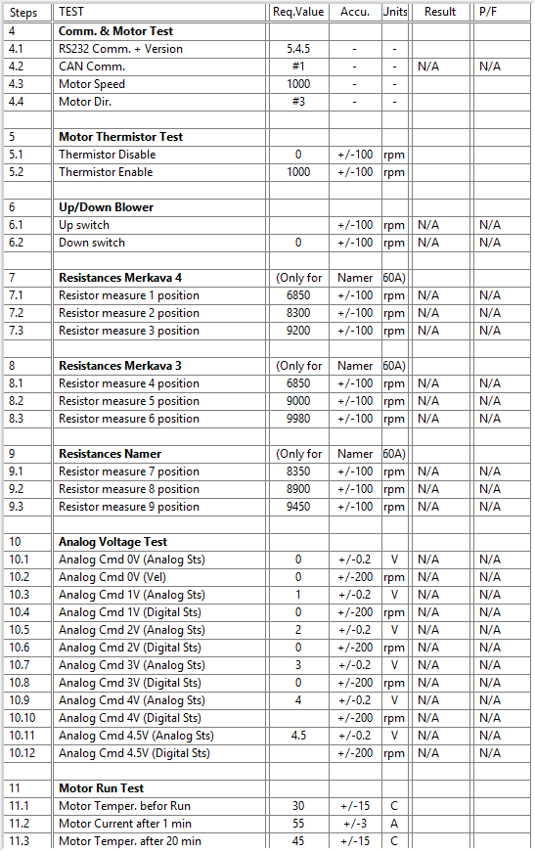

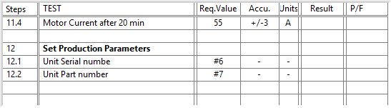

General result:

Test-Operator:____ Eli_________ Q.A.:_________Eli_____________________