=====================================================

|| Functional and Performance Test For MOTOR DRIVER

|| P/N manufacture :RD5310003

|| P/N:CR053100-03 S/N: 000000

|| Date:26/11/2017 Time: 09:01 Test-Conductor: Eli

|| Tester P/N: RD-14000000-01 Tester S/W Ver.1.17f

||

|| Notes:

=====================================================

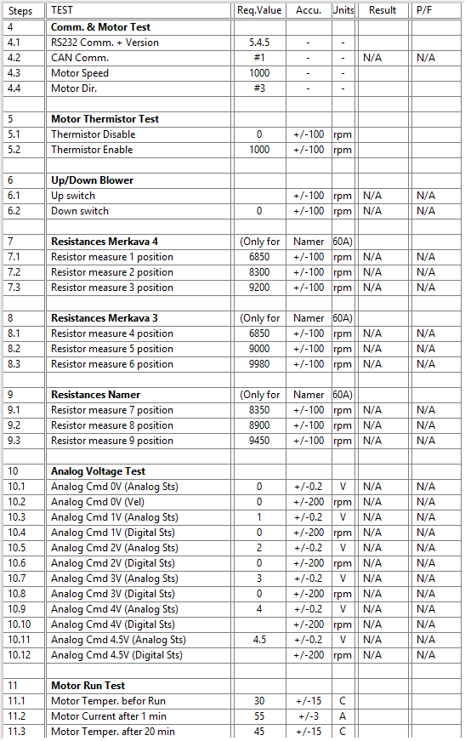

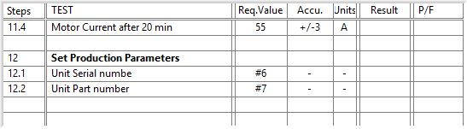

General result:

Test-Operator:____ =====================================================

|| Functional and Performance Test For MOTOR DRIVER

|| P/N manufacture :RD5310003

|| P/N:CR053100-03 S/N: 000000

|| Date:26/11/2017 Time: 09:01 Test-Conductor: Eli

=====================================================_________ Q.A.:__________________________

1.  Acceptance Test Report

PN. 500490 SN. ________ DSP S.N. ________ Driver S.N. ________

|  |  |  |  |  |  |  |  |  |  |  |
| --- | --- | --- | --- | --- | --- | --- | --- | --- | --- | --- |
| **#** | | **Test Name** | | **Under Tset** | | **Result** | | | **Pass/Fail** | |
| 9.1 | | ***Conductivity Test*** | | J1 to CHASIS < 2[mΩ] | |  | | |  | |
| J2 to CHASIS < 2[mΩ] | |  | | |  | |
| J3 to CHASIS < 2[mΩ] | |  | | |  | |
| 9.2 | | ***Insulation Resistance*** | | J2_A to CHASIS > 500[KΩ] | |  | | |  | |
| J2_C to CHASIS > 500[KΩ] | |  | | |  | |
| J3_A to CHASIS > 500[KΩ] | |  | | |  | |
| J3_C to CHASIS > 500[KΩ] | |  | | |  | |
| J3_E to CHASIS > 500[KΩ] | |  | | |  | |
| 9.3 | | ***Torque Test*** | | Torque wrench by DIN Standard & manufacturer's instructions for nut Torque. | | | | |  | |
| 9.4 | | ***Blower Calibration*** | | Motor Speed = 3700 ± 100 [RPM]  DRIVER CURRENT = 27 ± 3[A] | |  | | |  | |
| 9.5 | | ***Functional Test*** | | Connect the setup according the figure in parag.7 and Follow procedure presented in the PC according to (P/N – RD-TESTER-0001) 60A DRIVER TESTER test sw.  At the end, add the test file. | | | | |  | |
| 9.6 | | ***Leak Test*** | | Leak Test - 5± 0.2 psig | | No bubbles for 2 minutes. | | |  | |
|  | | **Name** | | **Signature** | | **Date** | | |
| **Tested By:** | | |  | | --- | | ____ **Eli Talias** __ | |  | | | ___ **Eli.T** _____ | | _________________ | | |
|  | |  | |  | |  | | |
| **Quality Inspector:** | | ___ **Evgeny. A** ___ | | ____ **Evgeny. A** _ | | _________________ | | |
|  | |  | |  | | **Pass** |  | |
| **Stamp:** | |  | |  | |  | |
|  | |  | | Fail |  | |