**GENERAL EMPLOYMENT APPLICATION FORM:**

**SIMPLIFYING JOB APPLICATION FORMS AND**

**IMPROVING DATA MANAGEMENT**

A System Proposal presented to the

Faculty of the College of Computer and Information Sciences,

Polytechnic University of the Philippines

In partial fulfillment for the course

COMP 20093 - Information Management

Agarin, Jerome Zaidee P.

Lozada, Luen P.

Porlares, Alexander S.

Roncales, Jallane E.

BSIT 2-1

***Proponents***

**TABLE OF CONTENTS**

**I. Overview of the Project**

**II. Softcopy of the Manual Form**

**III. Normalization**

**IV. Entity Relationship Diagram (ERD)**

**V. Data Dictionary**

**VI. User Interface**

**VII. SQL Codes**

**VIII. Sample Data**

1. **Overview of the Project**

Designing a database for an employee application form involves careful consideration of several factors to ensure that the database's result is efficient, scalable, and well-structured. To create an efficient database, a crucial process must be done which is the normalization of the data and the creation of the Entity-Relationship Diagram (ERD) that shows the relationship between the entities.

Normalizing is a process of organizing data in a database to minimize data redundancy, improve data consistency, and ensure data quality. It involves breaking down of the data into well-structured tables, then reducing or removing the redundancies, and establishing the relationships between the entities. It is essential in database design because it enables efficient data retrieval, eliminates inconsistencies, and reduces the possibilities of data errors.

While the Entity-Relationship Diagram (ERD) plays a critical role in the database design, it helps to visualize the relationships between entities in a graphical representation, identifying the primary keys and foreign keys, and ensuring the database is designed to meet the requirements of the business rules.

With this said, the researchers are going to show you the process on how they normalized and created an ERD for the employee application form. This will be beneficial to the individuals or group that is involved in the database designing, including those database developers, and analysts in the Nexatech Company and enables them to create an efficient, robust, and scalable database in the future.

1. 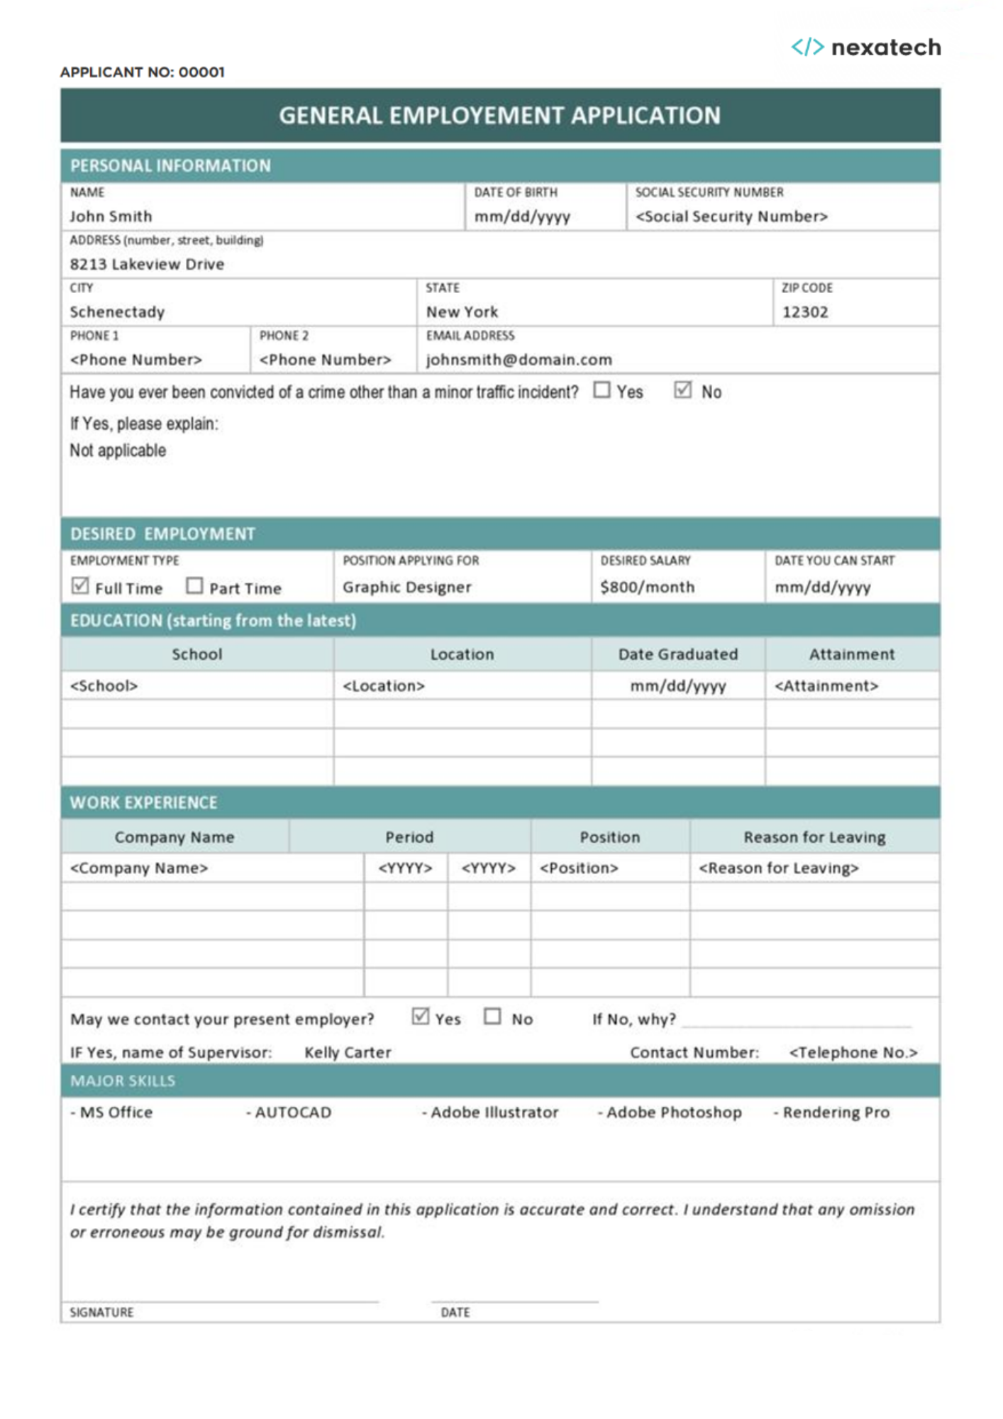**M****anual Form**
2. **Normalization**

**Excel Link:** [Normalization_NovaTech.xlsx](https://pupedu-my.sharepoint.com/:x:/g/personal/jeromezaideepagarin_iskolarngbayan_pup_edu_ph/EX5gw0nWx_ZDl3Ct3Ax7LVwBkqNvde9JyM6FvBKrVEcfng?e=KJiuga)

**Attributes:** (applicantNo, name, dateOfBirth, SSS_ID, address, city, province, zipcode, phoneNumber, emailAddress, employmentType, jobPosition, desiredSalary, startingDate, applicationDate, {school_ID, school, schoolAddress, dateGraduated, educAttainment, employeeHistory_ID, companyName, workPeriod, reasonForLeaving, skillCode, skillName})

**1ST NORMAL FORM:**

**APPLICANT** = (**applicantNo**, name, dateOfBirth, SSS_ID, address, city, province, zipcode, phoneNumber, emailAddress, employmentType, jobPosition, desiredSalary, startingDate, applicationDate, school_ID, school, schoolAddress, dateGraduated, educAttainment, employeeHistory_ID, companyName, workPeriod, workPosition, reasonForLeaving, skillCode, skillName)

**PARTIAL DEPENDENCIES:**

* **applicantNo ->** name, dateOfBirth, SSS_ID, address, city, province, zipcode, phoneNumber, emailAddress, employmentType, jobPosition, desiredSalary, startingDate, applicationDate
* **applicantNo, school_ID ->** school, schoolAddress, dateGraduated, educAttainment, skillCode, skillName
* **applicantNo, employeeHistory_ID ->** companyName, workPeriod, workPosition, reasonForLeaving
* **applicantNo, skillCode ->** skillName

**2ND NORMAL FORM:**

* **APPLICANT_DETAILS** -> **applicantNo**, name, dateOfBirth, SSS_ID, address, city, province, zipcode, phoneNumber, emailAddress, employmentType, jobPosition, desiredSalary, startingDate, applicationDate
* **SCHOOL ->** **applicantNo**, **school_ID**, school, schoolAddress, dateGraduated, educAttainment, skillCode, skillName
* **WORK_EXPERIENCE ->** **applicantNo**, **employeeHistory_ID**, companyName, workPeriod, workPosition, reasonForLeaving
* **MAJOR_SKILL ->** **applicantNo**, **skillCode**, skillName

**3RD NORMAL FORM:**

NO TRANSITIVE DEPENDENCIES

**RELATIONSHIP:**

* **APPLICANT_DETAILS** -> **applicantNo**, name, dateOfBirth, SSS_ID, address, city, province, zipcode, phoneNumber, emailAddress, employmentType, jobPosition, desiredSalary, startingDate, applicationDate
* **SCHOOL ->** **applicantNo**, **school_ID**, school, schoolAddress, dateGraduated, educAttainment, skillCode, skillName
* **WORK_EXPERIENCE ->** **applicantNo**, **employeeHistory_ID**, companyName, workPeriod, workPosition, reasonForLeaving
* **MAJOR_SKILL ->** **applicantNo**, **skillCode**, skillName

[**Full Process of Normalization with Data Encoding**](https://pupedu-my.sharepoint.com/:x:/g/personal/jeromezaideepagarin_iskolarngbayan_pup_edu_ph/EX5gw0nWx_ZDl3Ct3Ax7LVwBkqNvde9JyM6FvBKrVEcfng?e=Wlyytc)

1. **Entity Relationship Diagram (ERD)**

**List of Entities:**

1. APPLICANT_DETAILS
2. SCHOOL
3. WORK_EXPERIENCE
4. MAJOR_SKILLS

**Attributes in every Entity**

1. **APPLICANT_DETAILS**

* **- applicantNo**  
  - name  
  - dateOfBirth  
  - SSS_ID  
  - address  
  - city  
  - province  
  - zipcode  
  - phoneNumber  
  - emailAddress  
  - employmentType  
  - jobPosition

-desiredSalary

-startingDate

-applicationDate

1. **SCHOOL**  
   - **applicantNo**  
   **- school_ID**  
   - schoolName  
   - schoolAddress  
   - dateGraduated  
   - educationAttainment
2. **WORK_EXPERIENCE**  
   - **applicantNo**  
   - **employmentHistory_ID**  
   - companyName  
   - workPeriod  
   -workPosition  
   - reasonForLeaving
3. **Major Skills**

* **applicantNo**
* **skillCode**
* skillName

**Application Form Rule:**

1. Each applicant must provide their personal details in the applicant details section.
2. Every applicant must have one or more work experience listed. While each work experience entry is unique to a specific applicant.
3. Every applicant must have at least one or more educational attainment. And the educational attainment must be from one applicant.
4. Every applicant must list one or more major skills that show their best interest, and each major skill entry must be from a specific applicant.

**Entity Relationship Diagram (ERD)**

Legend:

**Primary Key**

**Foreign Key**

1. **Data Dictionary**

**APPLICANT DETAILS TABLE**

|  |  |  |  |  |  |  |
| --- | --- | --- | --- | --- | --- | --- |
| *Data Item* | |  | *Value* | | |  |
| Name | Type | Length | Min | Max | Allowable Values | Description |
| applicantNo | Integer | 6 |  |  |  | Application number of the applicant |
| name | Varchar | 50 |  |  |  | Name of the person |
| dateOfBirth | date |  |  |  |  | Date of birth |
| SSS_ID | Integer | 10 |  |  |  | SSS number |
| address | Varchar | 100 |  |  |  | Address of the person |
| city | Varchar | 30 |  |  |  | City of the person |
| province | Varchar | 30 |  |  |  | State of the person |
| zipcode | Integer | 4 |  |  |  | Zip code of the person |
| phoneNumber | Varchar | 12 |  |  |  | Phone number/s of the person |
| emailAddress | Varchar | 40 |  |  |  | Email address of the person |
| employementType | char | 9 |  |  | full-time, part-time | Type of employment (e.g., full-time, part-time) |
| jobPosition | Varchar | 30 |  |  |  | Position applying for |
| desiredSalary | Integer | 7 |  |  |  | Desired salary for the work |
| startingDate | Date |  |  |  |  | Date when the person can start working |
| applicationDate | Date |  |  |  |  | Date of submitting the job application |

**SCHOOL DETAILS TABLE**

|  |  |  |  |  |  |  |
| --- | --- | --- | --- | --- | --- | --- |
| *Data Item* | |  | *Value* | | |  |
| Name | Type | Length | Min | Max | Allowable Values | Description |
| school_ID | Varchar | 8 |  |  |  | A unique number assigned to any school in the Philippines. |
| schoolName | Varchar | 80 |  |  |  | Name of the school |
| schoolAddress | Varchar | 100 |  |  |  | School address |
| dateGraduated | Date | 8 |  |  |  | Date of graduation |
| educationAttainment | char | 3 |  |  | JHS, SHS, CO | Highest academic attainment of the applicant |

**WORK EXPERIENCE TABLE**

|  |  |  |  |  |  |  |
| --- | --- | --- | --- | --- | --- | --- |
| *Data Item* | |  | *Value* | | |  |
| Name | Type | Length | Min | Max | Allowable Values | Description |
| employmentHistory_ID | Varchar | 7 |  |  |  | A unique ID for each company in work experience |
| companyName | Varchar | 50 |  |  |  | Name of the company |
| workStarted | Date |  |  |  |  | Starting period of employment |
| workEnded | Date |  |  |  |  | Ended period of employment |
| workPosition | Varchar | 30 |  |  |  | Position held in the company |
| reasonforLeaving | Varchar | 200 |  |  |  | Reason for leaving the company |

**MAJOR SKILLS**

|  |  |  |  |  |  |  |
| --- | --- | --- | --- | --- | --- | --- |
| *Data Item* | |  | *Value* | | |  |
| Name | Type | Length | Min | Max | Allowable Values | Description |
| skillCode | Varchar | 7 |  |  |  | A code for each skillname. |
| skillName | Varchar | 50 |  |  |  | Skills possessed by the person |

**VI. USER INTERFACE**



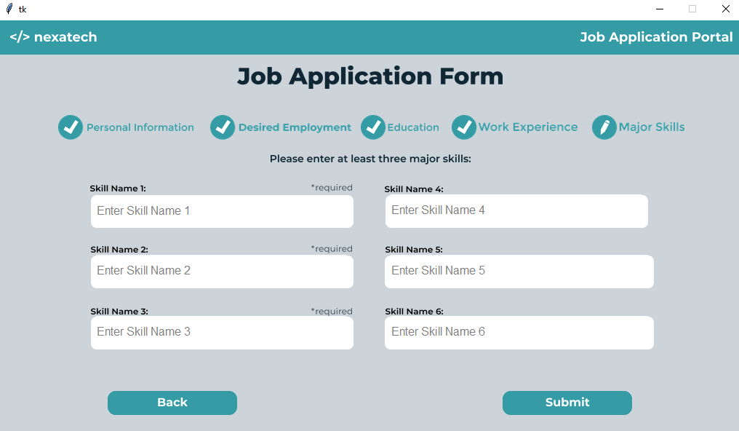

**VII. SQL CODES**

**EASY**

1. **Display applicantNo, name, SSS_ID, emailAddress, and desired salary of applicants. Sort with desiredSalary in ascending order.**

SELECT applicantNo, name, SSS_ID, emailAddress, desiredSalary

FROM applicant_details

ORDER BY desiredSalary ASC;

1. **Select and list applicantNo,name of applicant who chose Full-time as their employment type.**

SELECT applicantNo, name

FROM applicant_details

WHERE employmentType = 'Full-time';

1. **Select and list applicantNo,name of applicant who chose Part-time as their employment type.**

SELECT applicantNo, name

FROM applicant_details

WHERE employmentType = 'Part-time';

1. **List all applicants who have a job position with “IT Support Specialist”. Display their applicantNo, name, employmentType and desiredSalary.**

SELECT applicantNo, name, employmentType, desiredSalary

FROM applicant_details

WHERE jobPosition = 'IT Support Specialist';

1. **Get the total count of applicants who are living in Manila.**

SELECT COUNT(*) AS 'Living in Manila'

FROM applicant_details

WHERE province LIKE '%Manila%';

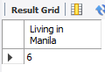

**MEDIUM**

1. **Count the number of applicants in each school entry and display their school_ID and schoolName.**

SELECT school_ID AS 'School ID', schoolName AS 'School Name', COUNT(applicantNo) AS 'Number'

FROM school

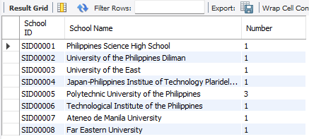GROUP BY school_ID, schoolName;

1. **Display the number of applicants who have work experience in each Company. Display also the company name.**

SELECT companyName, COUNT(*) AS 'Number'

FROM work_experience

GROUP BY companyName;

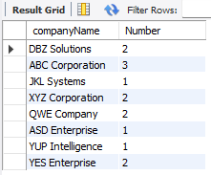

1. **Display the total count of each skill and group them by skillCode and skillName. You should display the skillCode and skillName first.**

SELECT skillCode, skillName, COUNT(*)

FROM major_skill

GROUP BY skillCode, skillName;

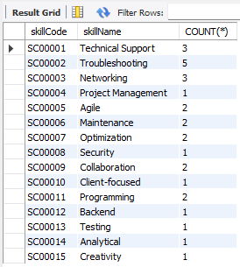

1. **Count the number of applicants graduated from each school or university. Display also the educational attaintment.**

SELECT school_ID, schoolName, educationAttainment, COUNT(*)

FROM school

GROUP BY school_ID, schoolName, educationAttainment;

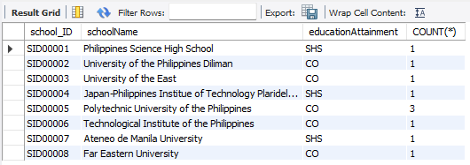

1. **Count the applicants that selected full-time and part-time and group them by employment type.**

SELECT employmentType, COUNT(*) AS 'Applicants'

FROM applicant_details

GROUP BY employmentType;

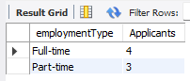

**HARD**

1. **Display the applicantNo, name of applicants, and years worked of those who graduated from Polytechnic University of the Philippines and have 3 or more years of work experience.**

SELECT A.applicantNo, A.name, S.schoolName, TIMESTAMPDIFF(YEAR, E.workStarted, E.workEnded) AS 'Years Worked'

FROM applicant_details AS A

JOIN school AS S ON A.applicantNo = S.applicantNo

JOIN work_experience AS E ON S.applicantNo = E.applicantNo

WHERE S.schoolName = 'Polytechnic University of the Philippines'

AND TIMESTAMPDIFF(YEAR, E.workStarted, E.workEnded) >= 3;

1. **List the applicants with have 30 years or older and have a skill or “Networking” and “Troubleshooting” and is graduated for PUP or UP. Display the applicantNo, name, and age.**

SELECT A.applicantNo, A.name, TIMESTAMPDIFF(YEAR, A.dateOfBirth, CURDATE()) AS Age

FROM applicant_details AS A

JOIN major_skill AS M ON A.applicantNo = M.applicantNo

JOIN school AS S ON A.applicantNo = S.applicantNo

WHERE TIMESTAMPDIFF(YEAR, A.dateOfBirth, CURDATE()) >= 30

AND M.skillName IN ('Networking', 'Troubleshooting')

AND S.schoolName IN ('Polytechnic University of the Philippines', 'University of the Philippines Diliman')

GROUP BY A.applicantNo, A.name;

1. **List down applicants who is 40 years or older then count each school and work experience. Display applicantName, age, distinct school count and work count.**

SELECT A.applicantNo,

TIMESTAMPDIFF(YEAR, A.dateOfBirth, CURDATE()) AS Age,

COUNT(DISTINCT S.school_ID) AS SchoolCount,

COUNT(DISTINCT E.employmentHistory_ID) AS EmploymentHistoryCount

FROM applicant_details AS A

JOIN school AS S ON A.applicantNo = S.applicantNo

JOIN work_experience AS E ON S.applicantNo = E.applicantNo

WHERE TIMESTAMPDIFF(YEAR, A.dateOfBirth, CURDATE()) >= 40

GROUP BY A.applicantNo;

1. **Display the applicantNo, name, jobPosition of applicant that has 3 or more years of work experience and specialized in Networking and Troubleshooting.**

SELECT A.applicantNo, A.name, A.jobPosition

FROM applicant_details AS A

JOIN work_experience AS E ON A.applicantNo = E.applicantNo

JOIN major_skill AS M ON E.applicantNo = M.applicantNo

WHERE TIMESTAMPDIFF(YEAR, E.workStarted, E.workEnded) >= 3 AND skillName IN ('Networking', 'Troubleshooting')  
GROUP BY applicantNO;

1. **Count the applicants that has Maintenance skill and is graduated from Polytechnic University of the Philippines and University of the Philippines Diliman. Group them by their school’s name.**

SELECT S.schoolName,COUNT(*) AS 'Applicant'

FROM school AS S

JOIN major_skill AS M ON S.applicantNo = M.applicantNo

WHERE skillName = 'Maintenance' AND schoolName IN ('Polytechnic University of the Philippines', 'University of the Philippines Diliman')

GROUP BY S.schoolName;

**VIII. SAMPLE DATA**

**applicant_details**

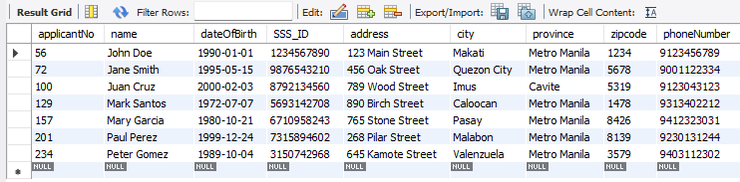

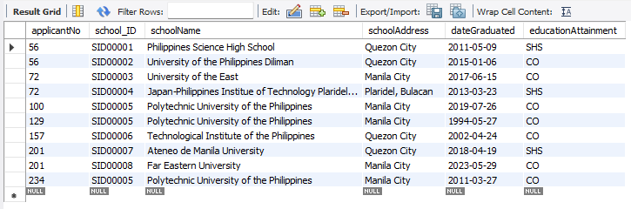**school**

**work_experience**

**major_skill**

