**COMMUNICATION PROTOCOLS FOR IOT**

MAC protocols for the Wireless Sensors Networks



Introduction

Today, as the number of IoT smart devices keeps growing, the number of nodes increases exponentially as well. This might cause significant collisions that require the device to re-send the previous messages. On top of that, let us remember that the first goal of WSN is to reduce the power consumption and energy consumption as much as possible since the nodes are also battery-powered with a certain limited longevity. However, many sources of energy waste coexist on the Medium Access Control such as the collisions, the overhearing, the passive hearing, and idle listening which consumes 50% to 100% of the energy to receive packets. Besides this, the MAC layer is at the interface between the Physical layer (Radio communication) and the LLC layer. The physical layer is also well-known for its high consumption of energy and here again, the MAC layer is at stake in order to try to counter-balance the waste of energy. Hence why today, the wireless sensor networks need to implement a Medium Access Control which considers several aspects: the reduction of energy consumption as well as the main functions initially ensured by the MAC layer : **avoid collisions, adapt to the network topology and the number of users, the throughput (which is the well transmission and reception of datas within a determined amount of time), the fairness (make sure that every device is considered for transmission), and the latency.**

Throughout this report, we will tackle six different MAC protocols used in the WSN: S-MAC, T-MAC, DS-MAC, W-MAC, TRAMA and D-MAC. For each, we will also answer several questions such as the use of clock synchronization, the precision, the localization capability, the security mechanisms, and the nodes mobility. Eventually, we will try to classify them with their respective Medium Access Control techniques.

Table of contents

Introduction 1

I. Sensor Medium Access Control (S-MAC). 3

II. Timeout Medium Access Control (T-MAC). 3

III. Dynamic Sensor Medium Access Control (DS-MAC). 4

IV. Wise Medium Access Control (W-MAC) 5

V. TRaffic Adaptive Medium Access Control (TRAMA) 5

VI. Directional Medium Access Control (D-MAC) 6

CONCLUSION: 6

Comparison of MAC protocols and their techniques 7

SOURCES 8

# I. Sensor Medium Access Control (S-MAC).

This protocol has been made at the Los Angeles California university to answer the issue of energy waste due to passive listening. This is one of the main sources of energy waste. Devices are constantly listening even when they are not addressed. To overcome it, the idea with S-MAC is to use nodes within an alternance of sleeping mode and active mode. While sleeping, nodes turn off the radio to save energy and they neither transmit nor receive. The corresponding period of each mode is based **on a fixed duty cycle** (Tactive/Tactive + Tsleep).

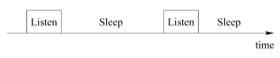

Tactive

Tactive must be necessarily defined previously between the “neighbor” nodes through a SYNC packet that synchronizes the schedule of sleeping and active modes. When the node is active and has not received any SYNC packet yet, it takes the lead and broadcasts its schedule to its neighbors. However, if the node was listening and received an incoming SYNC packet, then it will align itself and retransmits to the other neighbor the schedule. A third case also exists when the node has already set its synchronizing time but still receives an incoming SYNC request. In this specific case, the node must adapt by setting up two synchronizing times and by retransmitting in only one packet this new schedule (including both synchronizations) to the other neighbor. To maintain synchronization, the schedules are periodically broadcasted to the neighbors. More precisely, the listening time is divided in two portions: one for SYNC packet and one for Data packet. Finally, the S-MAC also avoids the issue of “hidden nodes” thanks to CTS and RTS packets. These packets oblige the immediate neighbors to instantly sleeps to avoid interferences and collisions. To summarize: S-MAC has clock synchronization that enables the coordination of schedules. The nodes can also adapt to add a second synchronization to their table. Thanks to these mechanisms, the nodes are mobile. However, it does not have a localization or security mechanism. Although S-MAC is a good way to save energy, it does not avoid idle listening and latency issues.

# II. Timeout Medium Access Control (T-MAC).

T-MAC is the protocol that derives from S-MAC in which the non-sleep and sleep are fixed. Although S-MAC reduces the idle listening time, fixed duty cycle does not provide optimality because messages’ rate usually varies by time and location. In a protocol that uses fixed duty cycle as a solution, T-MAC proposes to dynamically determine the length of the active time to reduce the idle listening and save energy***.*** In T-MAC, nodes listen and transmit when they are in an active period. When there is no activation event ***for a time TA (Time Activity)***, the activation period ends. The node returns to sleep mode. Activation events happen on a periodic timer reset, on a data reception, or end-of-transmission:

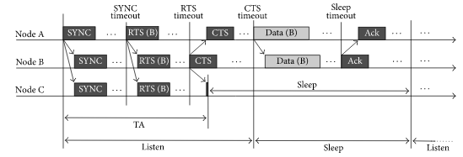

This enables to adapt the duty cycle and more specifically the active period according to the traffic loads. Therefore, T-MAC protocol has the same performances than S-MAC protocol during constant traffic loads but saves more energy during variable traffic loads. However, the main issue with T-MAC concerns the loss of packets. After the time out, the node starts sleeping and incoming packets can still arrive but will not be received because the node sleeps although it was supposed to be active. The synchronization is then broken with neighbor nodes. This is called the “extended sleep” issue. To conclude with T-MAC, this protocol is synchronized but this synchronization might be broken because of extended sleep and time out.

# III. Dynamic Sensor Medium Access Control (DS-MAC).

As we saw so far, the S- and T-MAC protocols aim at reducing the energy waste by mainly using a sleeping mode that is synchronized between nodes. Nevertheless, this “inactive” time (whether it is short or long sleep) very often causes delay in the data delivery from one node to the other. The fixed duty cycle is not optimal because messages ‘rate varies over time and the buffers get overloaded. The main purpose of DS-MAC which is a synchronized protocol is to reduce the high latency due to the traffic loads by using a **dynamic duty cycle:** As all nodes share their one-hop latency values, every node calculates the average value. If this value is too high, a node will decide to shorten the sleep time and announce this in the SYNC period. The major aim in this extension is to decrease the latency for delay-sensitive applicationseach node. When the latency is too high, the nodes can double their active time. When the latency decreases, the nodes increase lower their active time. In each case, the SYNC packet is shared between every node to synchronize the duty cycle and avoid packets loss.

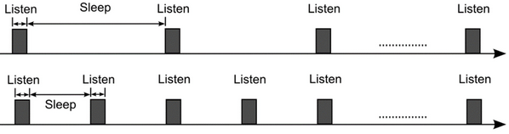

However, in contrast to the initial S-MAC, frequent sleep periods increase the idle listening and the additional announcements in the SYNC period increase the overhead.

# IV. Wise Medium Access Control (W-MAC)

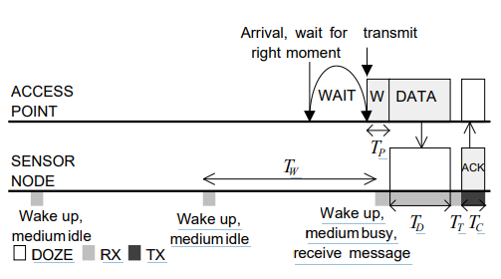In this protocol, the nodes are periodically (constant period Tw) switching from active to idle state which is a very low power mode. When being active, the nodes sample (e.g listen) the medium to check for activity (reception of packets, idle state etc..). The sampling activity of each node is scheduled independently with a constant offset. It is asynchronous. The access point node learns those schedules to interface the local nodes to the rest of the network. Once the schedules have been set up, the access point can handle the transmission of packets to the intended receiver: the access point knowing exactly the wake-up schedule of the receiver, will first wait and then send **a wake-up preamble** packet (size of the sampling period Tw) within a short amount of time Tp to start the transmission to the receiver:

The access point keeps updating its table with the sampling schedule of sensor nodes. The sampling schedule information is included in ACK packets of the remaining time until the next

sampling. The preamble sampling remains the main drawback of W-MAC protocol wasting energy since it can be variable.

# V. TRaffic Adaptive Medium Access Control (TRAMA)

It is a TDMA technique protocol trying to lower energy consumption as much as possible by avoiding collision when transmitting. There are several mechanisms: the Neighbor Protocol which asks for information to immediate nodes, the Schedule Exchange Protocol which exchanges information about two-hop neighbors and their schedule, the Adaptive Election Algorithm which selects nodes’ role (transmitting or receiving) for the upcoming loop using neighborhood and schedule information. The receiving nodes are chosen basing off the schedules of the transmitting nodes since those schedules are regularly exchanged. The nodes which are not concerned about transmission or reception, will remain in low power mode to reduce energy consumption. To proceed these mechanisms there are time slots:

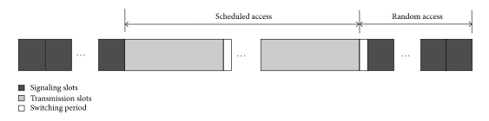

# VI. Directional Medium Access Control (D-MAC)

Close to TRAMA, the D-MAC protocol is the most frequent communication model used for the Wireless Sensors Networks. As we so saw up to now, most protocols are based on several nodes constantly interacting, either to synchronize or exchange information. It often implies a topology including a coordinator (called the Sink node) and underlying nodes. In this protocol, the sink node uses unidirectional tree, and the time is divided into small slots.

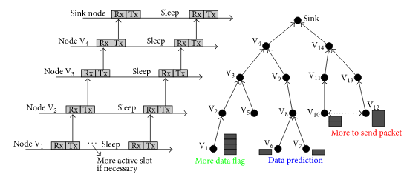

A multi-hop transmission through the tree requires that the node’s path to the sink (e.g., V2, V3, and V4) has bigger transmitting intervals as these are additionally forwarding previous neighbor’s data. Using the more data flag, a node can inform the next node that the duty cycle is bigger; either its buffer is not empty, or it has received a packet from the previous hop. A node which is a father of two children (e.g., V8) cannot forward data from these two nodes concurrently. This problem is solved by data prediction scheme which let the nodes schedule an additional receiving slot to forward both data packets separately.

# CONCLUSION:

To summarize, the Wireless Sensors Networks can deploy a variety of different MAC protocols, essentially deriving from the S-MAC protocol. Thanks to the alternance of sleeping and active states, S-MAC properly handles the energy harvesting. However, these states are defined with a fixed duty cycle which is inappropriate for the delay, packets’ loss, and traffic loads issues. T-MAC integrates a Time Out Activity which is even more efficient to save energy because it avoids idle listening, but the Activity Time out is also fixed which does not solve the problem of latency. Hence why DSMAC uses a dynamic duty cycle which has good adaptivity to the traffic and therefore a smaller delay. Likewise, The Wise MAC protocol also reduces latency by periodically sampling the medium although the wake-up preambles are energy-consuming. Wise MAC is asynchronous and also vulnerable to collisions. Finally, TRAMA and DMAC introduce energy-efficient and collision-free channel access. They require time synchronization which increases the transmission delay but make them more efficient and increase the throughput. The choices of the appropriate MAC protocol depend on the application. The two main techniques used are CSMA and TDMA which are described below.

# Comparison of MAC protocols and their techniques

|  |  |
| --- | --- |
| **Access type** | **MAC Protocol** |
| CSMA **(Carrier Sense Multiple Access)**  It is a protocol whereby a station with information to transmit first listens to the medium to ensure it is clear. If it is, it transmits the information; otherwise, it waits. It relies on the behavior “first-come, first-served”. However, there are slightly different behaviors we can distinguish. The behavior when the channel is busy determines the persistence of CSMA: A persistent or 1-persistent CSMA will try to transmit as soon as the channel is clear, a non-persistent or 0-persistent CSMA will retry after a randomly selected time determined by a distribution of probability. More generally, a p-persistent CSMA behaves persistently with a p probability and non-persistently with a 1-p probability. In general, when there is a large load, non-persistent CSMA provides better performance. **There are two main variations of CSMA: CSMA/CD – Carrier Sense Multiple Access with Collision Detection and CSMA/CA – Collision Avoidance.** | **S-MAC** |
| **T-MAC** |
| **DSMAC** |
| **Wise MAC** |
| TDMA **(Time Division Multiple Access)**  This technique of canal access is divided in time slots fully dedicated to each node. When transmitting, the nodes can use the full bandwidth and the radio frequency is the same for everyone, but they will not transmit at the same moment. It’s temporal multiplexing. It’s impossible for users to transmit on the same time slot which enables the collision avoidance. | **TRAMA** |
| **DMAC** |

Comparative illustration of another technique (FDMA)

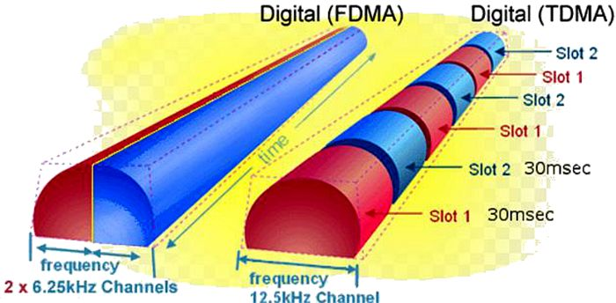

# SOURCES

* Ye W, Heidemann J, Estrin D. ***“An energy-efficient MAC protocol for wireless sensor networks”***. Proceedings of the 21st International Annual Joint Conference of the IEEE Computer and Communications Societies, INFOCOM ’02; New York, NY, USA. 23–27 June 2002; pp. 1567–1576.
* Rajendran V, Obraczka K, Garcia-luna-aceves JJ. Energy-efficient, “***collision-free medium access control for wireless sensor networks”***. Proceedings of the 1st ACM Conference on Embedded Networked Sensor Systems, SENSYS’ 03; Los Angeles, CA, USA. 5–7 November 2003; pp. 181–192.
* Ahn GS, Hong SG, Miluzzo E, Campbell AT, Coumo F. Funneling-MAC: “***A localized, sink-oriented MAC for boosting fidelity in sensor networks”***. Proceedings the 4th ACM Conference on Embedded Networked Sensor Systems, SENSYS ’06; Boulder, CO, USA. 31 October–3 November 2006; pp. 293–306.
* Research paper | “ ***WiseMAC :*** ***An Ultra-Low Power MAC Protocol for the Downlink of Infrastructure Wireless Sensor Networks”*** A. El-Hoiydi and J.-D. Decotignie :<https://lectures.tik.ee.ethz.ch/lpsd/further_reading/3_Networked_embedded_systems/elhoyidi_iscc2004_wisemac.pdf?fbclid=IwAR3oEHb_uwGyq2XzLeUgfWOpSm7WajN-ApV-BfD97Pkj1m7WRSxcnxg3_Jc>
* Research Article | Open Access | Volume 2017 **|** Viktor Richert, Biju Issac, Nauman Israr***, "Implementation of a Modified Wireless Sensor Network MAC Protocol for Critical Environments"***, *Wireless Communications and Mobile Computing*, vol. 2017, Article ID 2801204, 23 pages, 2017 : Implementation of a Modified Wireless Sensor Network MAC Protocol for Critical Environments : <https://www.hindawi.com/journals/wcmc/2017/2801204/>
* Article : ***“Wireless Sensor Network MAC Protocol: SMAC & TMAC”* :** <https://www.researchgate.net/publication/284800861_Wireless_sensor_network_mac_protocol_Smac_and_tmac/fulltext/57aa5a3d08ae42ba52ac4010/Wireless-sensor-network-mac-protocol-Smac-and-tmac.pdf>