|  |
| --- |
|  |
| DATAML300 Computer Vision |
| Exercise 1 |

|  |
| --- |
| Miska Romppainen  H274426 |

# Task 1 - Homogeneous coordinates (Pen & paper exercise)

As stated in the exercise ” You are free to use Matlab for calculations.”

The following calculations were done using MATLAB and the code is imported from MATLAB:

% Task 1. Homogeneous coordinates. (Pen & paper exercise) (1 point)

% Converting points:

% from cartesian -> homogeneous

% x1 = (2, -1) -> (2, -1, 1)

% x2 = (1, -2) -> (1, -2, 1)

% x3 = (1, 1) -> (1, 1, 1)

% x4 = (-1, 0) -> (-1, 0, 1)

x1 = [2; -1; 1]

x1 = 3×1

2

-1

1

x2 = [1; -2; 1]

x2 = 3×1

1

-2

1

x3 = [1; 1; 1]

x3 = 3×1

1

1

1

x4 = [-1; 0; 1]

x4 = 3×1

-1

0

1

% Line(ij) = point(i) x point(j) (Cross product)

l1 = cross(x1, x2) % Cross product from points x1 and x2

l1 = 3×1

1

-1

-3

l2 = cross(x3, x4) % Cross product from points x3 and x4

l2 = 3×1

1

-2

1

% point(kl) = Line(k) x Line(l) (Cross product)

x = cross(l1,l2) % Cross product from lines l1 and l2

x = 3×1

-7

-4

-1

% Conversion back to Cartesian

% p = [u, v, w] -> (u/w, v/w)

% Therefore:

intersection_point = [x(1)/x(3), x(2)/x(3)]

intersection_point = 1×2

7 4

# Task 2 - Image denoising (Programming exercise)

Original image:

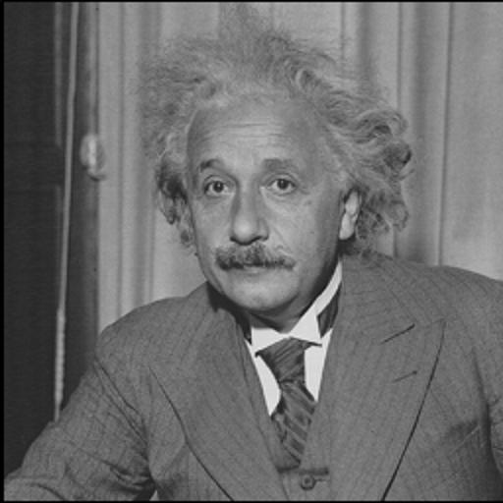

Figure . Image of Albert Einstein

1. Gaussian filtering:
2. Median filtering:
3. Bilateral filtering: