Coffee, Cake and Culture

To have another language is to possess a second soul - Charlemagne

# Hypothesis

People with a second language have a broader concept of coffee and cake, because they combine their concepts from both languages.

## Why Choose Coffee and Cake?

It is a cross-cultural experience which has an imprecise definition. Thus it is open to interpretation by participants in the study.

## The Approach

An experimenter supervised questionnaire was administered to 14 volunteer participants. The questionnaire was supervised to ensure a reasonable completion rate and to ensure the participants understood the questions being asked. In in the event some of the questions were challenging for the participants to understand. If a similar questionnaire were to be administered without supervision it would need further refinement to allow the participants to complete it successfully.

The questionnaire consisted of 3 parts.

1. Rating Scales - participants were asked to rate their coffee and cake experience on 7 arbitrary scales.
2. Word Assignment - participants were asked to indicate which words from a list (7 positive, 7 negative and 7 neutral) could be applied to their coffee and cake experience.
3. A Cloze Procedure - participants were asked to fill in the blanks in a sentence from Tolstoy’s ‘Anna Karenina’.

# The Participants

The participants were all volunteers selected from the experimenter’s friends and family. This is an undoubtedly biased sample, but using an entirely randomly selected sample would have been too complicated and costly.

## Age

Average age is 59.4. So the sample is largely middle aged and post retirment.

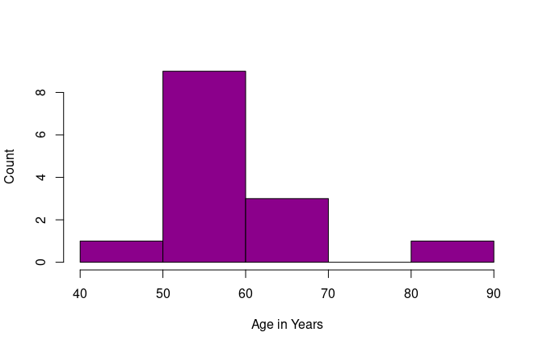

## Gender

The sample was intended to be gender balanced, but ended up with more females.

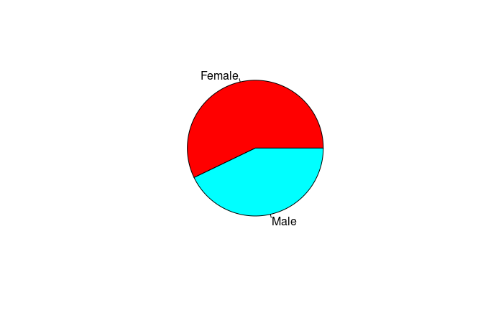

## Second Language

A total of 14 participants took part in the study, 7 of whom spoke only English and 7of whom spoke English and one other language.

Mostly North European languages with strong coffee and cake cultures. Half the participants were bilingual and half were monolingual. Unsurprisingly given that the study was conducted in England, the second languages spoken were all from Northern European nations.

##   
## French German Norwegian Spanish Swedish   
## 7 1 2 2 1 1

# Do the two groups have different concepts of coffee and cake?

The data were split the data into those who speak a second language and those that do not.

## Difference in Rating

Participants found rating their coffee and cake experience on a set of arbitrary scales challenging. Some of the scales made no obvious sense to the participants so placing a numerical value against that scale was equally non-sensical. It was necessary to encourage participants to attempt an ‘intuitive’ or ‘gut feeling’ response.

The hypothesis was that participants with a second language would have a broader concept of their coffee and cake experience. This would be expected to show up with the participants with a second language, providing more variable ratings for their coffee and cake experience. Whilst those with a single language might consistently rate their coffee and cake experience at one end of the scale.

### Hot Cold

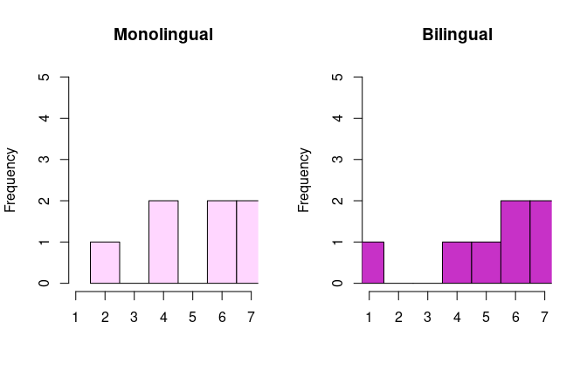

##   
## F test to compare two variances  
##   
## data: monolinguals$cold.hot and bilinguals$cold.hot  
## F = 0.7766, num df = 6, denom df = 6, p-value = 0.7667  
## alternative hypothesis: true ratio of variances is not equal to 1  
## 95 percent confidence interval:  
## 0.1334413 4.5195982  
## sample estimates:  
## ratio of variances   
## 0.7765957

### Fat Thin

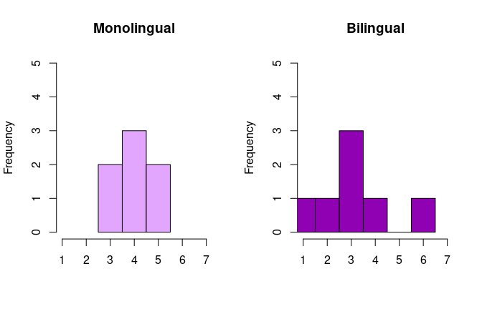

##   
## F test to compare two variances  
##   
## data: monolinguals$fat.thin and bilinguals$fat.thin  
## F = 0.26923, num df = 6, denom df = 6, p-value = 0.1353  
## alternative hypothesis: true ratio of variances is not equal to 1  
## 95 percent confidence interval:  
## 0.04626152 1.56685754  
## sample estimates:  
## ratio of variances   
## 0.2692308

### Funny Sad

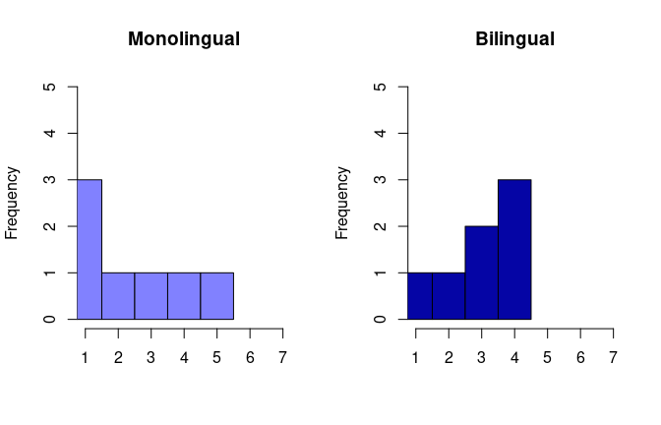

##   
## F test to compare two variances  
##   
## data: monolinguals$funny.sad and bilinguals$funny.sad  
## F = 1.9643, num df = 6, denom df = 6, p-value = 0.4317  
## alternative hypothesis: true ratio of variances is not equal to 1  
## 95 percent confidence interval:  
## 0.3375203 11.4316647  
## sample estimates:  
## ratio of variances   
## 1.964286

### Red Green

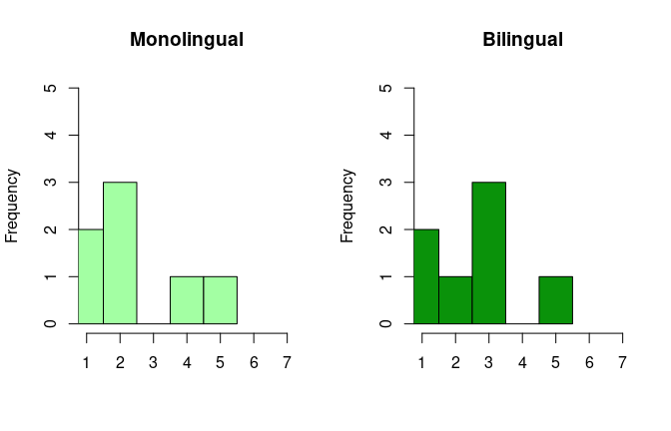

##   
## F test to compare two variances  
##   
## data: monolinguals$red.green and bilinguals$red  
## F = 1.1707, num df = 6, denom df = 6, p-value = 0.8531  
## alternative hypothesis: true ratio of variances is not equal to 1  
## 95 percent confidence interval:  
## 0.2011651 6.8133736  
## sample estimates:  
## ratio of variances   
## 1.170732

### Horrible Fantastic

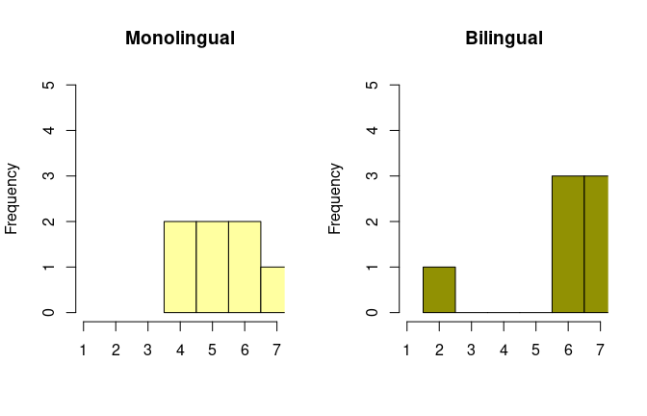

##   
## F test to compare two variances  
##   
## data: monolinguals$horrible.fantastic and bilinguals$horrible.fantastic  
## F = 0.39394, num df = 6, denom df = 6, p-value = 0.2817  
## alternative hypothesis: true ratio of variances is not equal to 1  
## 95 percent confidence interval:  
## 0.06769001 2.29263138  
## sample estimates:  
## ratio of variances   
## 0.3939394

### Stupid Intellectual

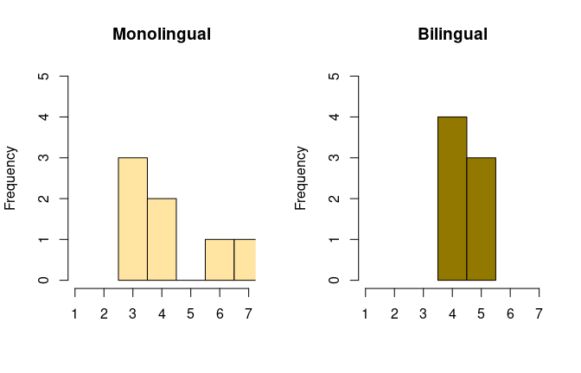

##   
## F test to compare two variances  
##   
## data: monolinguals$stupid.intellectual and bilinguals$stupid.intellectual  
## F = 9, num df = 6, denom df = 6, p-value = 0.01712  
## alternative hypothesis: true ratio of variances is not equal to 1  
## 95 percent confidence interval:  
## 1.546456 52.377809  
## sample estimates:  
## ratio of variances   
## 9

### Sparkling Still

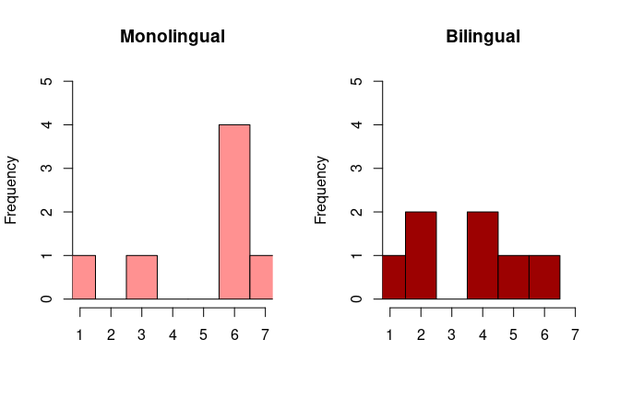

##   
## F test to compare two variances  
##   
## data: monolinguals$sparkling.still and bilinguals$sparkling  
## F = 1.4203, num df = 6, denom df = 6, p-value = 0.6809  
## alternative hypothesis: true ratio of variances is not equal to 1  
## 95 percent confidence interval:  
## 0.2440463 8.2657412  
## sample estimates:  
## ratio of variances   
## 1.42029

There is no significant difference in how monolinguals and bilinguals rated their coffee and cake experience.

## Difference in Totals

If the hypothesis is correct that bilinguals have a broader concept of coffee and cake, then one would expect them to select more words from the constrained word list. The expectation is that the bilingual mean will be greater, so this is a one-tailed test.

##   
## Welch Two Sample t-test  
##   
## data: bilinguals$total_selected and monolinguals$total_selected  
## t = 2.1706, df = 10.61, p-value = 0.0268  
## alternative hypothesis: true difference in means is greater than 0  
## 95 percent confidence interval:  
## 0.3882355 Inf  
## sample estimates:  
## mean of x mean of y   
## 8.857143 6.571429

Indeed there is a significant difference between the monolinguals and the bilinguals, in the total number of words selected. Bilinguals choosing an expanded list.

The words were grouped into positive, negative and neutral words. The difference in the number of words selected was not significant for the negative and neutral words, but was for the positive words.

##   
## Welch Two Sample t-test  
##   
## data: bilinguals$total_selected_positive and monolinguals$total_selected_positive  
## t = 0.4714, df = 7.7484, p-value = 0.3252  
## alternative hypothesis: true difference in means is greater than 0  
## 95 percent confidence interval:  
## -0.8461038 Inf  
## sample estimates:  
## mean of x mean of y   
## 5.000000 4.714286

This is what drives the significant difference in the total number of words selected.

## Word clouds

## ── Attaching packages ─────────────────────────────────────── tidyverse 1.3.1 ──

## ✓ ggplot2 3.3.3 ✓ purrr 0.3.4  
## ✓ tibble 3.1.1 ✓ dplyr 1.0.5  
## ✓ tidyr 1.1.3 ✓ stringr 1.4.0  
## ✓ readr 1.4.0 ✓ forcats 0.5.1

## ── Conflicts ────────────────────────────────────────── tidyverse_conflicts() ──  
## x dplyr::filter() masks stats::filter()  
## x dplyr::lag() masks stats::lag()

### For Pick a Word

Word cloud from the multiple select list. Showing consistently selecting the positive words.

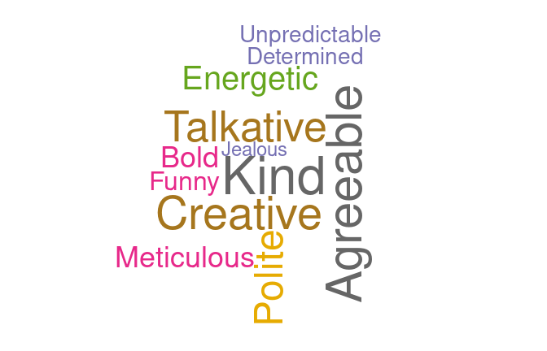

### For Cloze Procedure

Word cloud from the Anna Karenina extract.



The only word that was repeated was Red.