
Mini project report on

FOOD WASTE REDISTRIBUTION PLATFORM
Submitted in partial fulfilment of the requirements for the award of degree of

Bachelor of Technology
in
Computer Science & Engineering
UE24CSS351A – DBMS Project
Submitted by:
Venkata Srivaibhav Nukaraju  Vaishnavi Goyal | PES2UG24CS579  PES2UG24CS571
under the guidance of

Nivedita Kasturi
Assistant Professor
PES University

AUG - DEC 2026
DEPARTMENT OF COMPUTER SCIENCE AND ENGINEERING
FACULTY OF ENGINEERING
PES UNIVERSITY
(Established under Karnataka Act No. 16 of 2013)
Electronic City, Hosur Road, Bengaluru – 560 100, Karnataka, India

PES UNIVERSITY

(Established under Karnataka Act No. 16 of 2013)
Electronic City, Hosur Road, Bengaluru – 560 100, Karnataka, India

CERTIFICATE

This is to certify that the mini project entitled

Food Waste Redistribution Platform

is a bonafide work carried out by

Venkata Srivaibhav Nukaraju  Vaishnavi Goyal | PES2UG24CS579  PES2UG24CS571
In partial fulfilment for the completion of fifth semester DBMS Project (UE24CSS351A) in the Program of Study -Bachelor of Technology in Computer Science and Engineering under rules and regulations of PES University, Bengaluru during the period AUG. 2026 – DEC. 2026. It is certified that all corrections / suggestions indicated for internal assessment have been incorporated in the report. The project has been approved as it satisfies the 5th semester academic requirements in respect of project work.

Signature
Nivedita Kasturi
Assistant Professor

DECLARATION

We hereby declare that the DBMS Project entitled Food Waste Redistribution Platform has been carried out by us under the guidance of Nivedita Kasturi, Assistant Professor and submitted in partial fulfilment of the course requirements for the award of degree of Bachelor of Technology in Computer Science and Engineering of PES University, Bengaluru during the academic semester AUG – DEC 2026.

Venkata Srivaibhav Nukaraju  Vaishnavi Goyal | PES2UG24CS579  PES2UG24CS571 | <Signature>  <Signature>

ACKNOWLEDGEMENT

I would like to express my gratitude to Nivedita Kasturi, Department of Computer Science and Engineering, PES University, for her continuous guidance, assistance, and encouragement throughout the development of this UE24CSS351A - DBMS Project.
I take this opportunity to thank Dr. Sandesh B J, C, Professor, ChairPerson, Department of Computer Science and Engineering, PES University, for all the knowledge and support I have received from the department.
I am deeply grateful to Prof. Jawahar Doreswamy, Chancellor – PES University, Dr. Suryaprasad J, Vice-Chancellor, PES University for providing to me various opportunities and enlightenment every step of the way. Finally, this DBMS Project could not have been completed without the continual support and encouragement I have received from my family and friends.

ABSTRACT
Restaurants discard edible surplus food every day, while NGOs that feed people rarely hear about it in time. The Food Waste Redistribution Platform connects restaurants, NGOs and volunteers through one database. A restaurant lists a surplus batch as a donation. The database ranks the eligible NGOs and accepts exactly one request in a single transaction. It then tracks pickup and delivery until the NGO confirms receipt.
MySQL 8 holds 14 tables in third normal form with 19 foreign keys, 16 UNIQUE and 8 CHECK constraints. A stored procedure, three triggers, a stored function and six views enforce the donation lifecycle and compute every statistic. MongoDB keeps semi-structured handling notes for each donation. A Next.js application gives four roles their own dashboards and checks the role of every request on the server. A database test suite passes 13 checks and an end-to-end API test passes 23 checks.

TABLE OF CONTENTS
Chapter No. | Title | Page No.
 | INTRODUCTION | 11
 | PROBLEM DEFINITION | 13
 | ER MODEL | 15
 | ER TO RELATIONAL MAPPING | 18
 | DDL STATEMENTS | 24
 | DML STATEMENTS | 33
 | QUERIES (SIMPLE QUERY AND UPDATE AND DELETE OPERATION, CORRELATED QUERY AND NESTED QUERY) | 41
 | STORED PROCEDURE, FUNCTIONS AND TRIGGERS | 46
 | FRONT END DEVELOPMENT | 55
 | CONCLUSION AND FUTURE ENHANCEMENTS | 63
REFERENCES/BIBLIOGRAPHY |  | 64
APPENDIX A DEFINITIONS, ACRONYMS AND ABBREVIATIONS |  | 65

LIST OF TABLES
Table No. | Title | Page No.
Table 1 | Objectives and the database features that meet them | 11
Table 2 | Technology stack | 11
Table 3 | Coordination failures and the database rule that prevents each one | 13
Table 4 | Functions per role | 13
Table 5 | Legal donation status transitions | 13
Table 6 | Entity types | 15
Table 7 | Relationship types | 16
Table 8 | Mapping steps applied to this model | 18
Table 9 | Data dictionary | 19
Table 10 | Constraint summary | 31
Table 11 | Secondary indexes and the query each one serves | 31
Table 12 | Rows inserted per table | 33
Table 13 | Matching score components | 45
Table 14 | Steps of sp_accept_donation_request | 47
Table 15 | Triggers | 49
Table 16 | Views | 50
Table 17 | Collection donation_operational_notes | 53
Table 18 | Main API endpoints | 55
Table 19 | Test results | 62
Table 20 | Future enhancements | 63
LIST OF FIGURES
Figure No. | Title | Page No.
Figure 1 | ER diagram in Chen notation | 17
Figure 2 | Relational schema with all 19 foreign keys | 19
Screenshot 1 | Client login, prompt and database creation | 24
Screenshot 2 | CREATE TABLE users | 24
Screenshot 3 | CREATE TABLE locations | 25
Screenshot 4 | CREATE TABLE restaurants | 25
Screenshot 5 | CREATE TABLE ngos | 26
Screenshot 6 | CREATE TABLE volunteers | 26
Screenshot 7 | CREATE TABLE food_categories | 26
Screenshot 8 | CREATE TABLE food_items | 27
Screenshot 9 | CREATE TABLE food_batches | 27
Screenshot 10 | CREATE TABLE donations | 28
Screenshot 11 | CREATE TABLE ngo_food_categories | 28
Screenshot 12 | CREATE TABLE donation_requests | 29
Screenshot 13 | CREATE TABLE pickups | 29
Screenshot 14 | CREATE TABLE deliveries | 30
Screenshot 15 | CREATE TABLE audit_logs | 30
Screenshot 16 | Tables and constraint counts from information_schema | 31
Screenshot 17 | INSERT INTO users and its rows | 34
Screenshot 18 | INSERT INTO locations and its rows | 34
Screenshot 19 | INSERT INTO restaurants and its rows | 35
Screenshot 20 | INSERT INTO ngos and its rows | 35
Screenshot 21 | INSERT INTO volunteers and its rows | 35
Screenshot 22 | INSERT INTO food_categories and its rows | 36
Screenshot 23 | INSERT INTO ngo_food_categories and its rows | 36
Screenshot 24 | INSERT INTO food_items and its rows | 37
Screenshot 25 | INSERT INTO food_batches and its rows | 37
Screenshot 26 | INSERT INTO donations and its rows | 38
Screenshot 27 | INSERT INTO donation_requests and its rows | 39
Screenshot 28 | INSERT INTO pickups and its rows | 39
Screenshot 29 | INSERT INTO deliveries and its rows | 40
Screenshot 30 | GROUP BY, HAVING and aggregate functions | 41
Screenshot 31 | UPDATE on ngos and volunteers | 42
Screenshot 32 | DELETE and a delete blocked by a foreign key | 42
Screenshot 33 | Correlated subqueries with COUNT and NOT EXISTS | 43
Screenshot 34 | Nested subqueries with a scalar value and NOT IN | 44
Screenshot 35 | Donation provenance across six tables | 44
Screenshot 36 | Ranked eligible NGOs for donation 1 | 45
Screenshot 37 | Creating the routines, triggers and views | 46
Screenshot 38 | Routines, triggers and views in information_schema | 47
Screenshot 39 | fn_haversine_km from Spice Garden to every NGO | 47
Screenshot 40 | Procedure rejects an expired batch, low capacity and a wrong owner | 48
Screenshot 41 | Procedure accepts request 1 and rejects the competing requests | 49
Screenshot 42 | Trigger rejects illegal donation and request transitions | 50
Screenshot 43 | Expiry sweep and the audit rows written by the trigger | 50
Screenshot 44 | Querying three of the views | 51
Screenshot 45 | Claim transaction rolled back | 52
Screenshot 46 | Claim transaction committed and a second claim rejected | 52
Screenshot 47 | Database test suite with the concurrent acceptance test | 53
Screenshot 48 | Collection, indexes and the notes of donation 10 | 54
Screenshot 49 | Aggregation pipeline and a document rejected by the validator | 54
Figure 3 | Application architecture | 55
Screenshot 50 | Login page with the demo accounts | 57
Screenshot 51 | Restaurant dashboard with ranked requests for donation 1 | 58
Screenshot 52 | NGO dashboard with matched donations and deliveries | 59
Screenshot 53 | Volunteer dashboard with open and own pickups | 60
Screenshot 54 | Admin dashboard with analytics, audit log and users | 61
Screenshot 55 | End-to-end API test over the full donation lifecycle | 62

1. INTRODUCTION

1.1 BACKGROUND
Restaurants, hotels and caterers produce surplus cooked food every day. Most of it stays safe to eat for only a few hours. NGOs, shelters and orphanages need this food but rarely learn about it before it spoils. Volunteers can carry it, yet nobody assigns them a pickup.
The platform moves this coordination into a database. Restaurants list surplus batches, NGOs request them and volunteers carry them. The database decides which NGO is eligible, accepts one request atomically and records every status change.

1.2 OBJECTIVES

Table 1: Objectives and the database features that meet them
Objective | Database feature
Store every party and address once | Normalised schema of 14 tables with primary, foreign and unique keys
Reject invalid data when it is written | CHECK constraints, ENUM columns, NOT NULL and RESTRICT foreign keys
Accept exactly one NGO per donation, also under concurrent clicks | Stored procedure with SELECT ... FOR UPDATE row locks
Allow only legal status changes and keep a history | BEFORE and AFTER UPDATE triggers that write audit_logs
Rank eligible NGOs in a way a user can check | Matching query with a Haversine distance function
Report impact without stored totals | Six views computed from live rows
Keep free-form handling notes per donation | MongoDB collection with a $jsonSchema validator

1.3 SCOPE
The system has four roles: restaurant, NGO, volunteer and admin. It covers registration, listing, matching, request review, pickup, delivery, confirmation and analytics. Payments, live GPS tracking, ratings and notifications are outside the scope. Expiry is a manual admin action, so no scheduler runs in the background.

1.4 TECHNOLOGY STACK

Table 2: Technology stack
Layer | Technology | Use in the project
Relational database | MySQL 8.0, InnoDB, utf8mb4 | All structured data, constraints, triggers, procedure, views
Document database | MongoDB 7 | Operational notes with a varying metadata shape
Application | Next.js 16, React 19, TypeScript | Route handlers for the API and the four dashboards
Database access | mysql2, MongoDB Node.js driver | Parameterised SQL written by hand, no ORM
Security | bcryptjs, jose (JWT), zod | Password hashing, sessions, input validation
Runtime | Docker Compose | Runs MySQL and MongoDB with the SQL files loaded on start

1.5 DATABASE CHOICE AND JUSTIFICATION
Donations, requests, pickups and deliveries are related records with strict rules between them. A relational database enforces such rules with keys, constraints, transactions and triggers, so MySQL holds this data. Operational notes differ in shape for each author and need no joins or cross-record rules. A document store keeps each note whole without sparse columns, so MongoDB holds the notes. No feature searches by similarity, so a vector database adds nothing to this problem.

2. PROBLEM DEFINITION

2.1 PROBLEM STATEMENT
Surplus food has a short, fixed life. A donation helps only if a suitable NGO receives it before the batch expires. Coordination by phone and chat groups fails in the ways that the next table lists.

Table 3: Coordination failures and the database rule that prevents each one
Failure | Rule enforced by the database
Two NGOs both believe they received the same food | One request per donation becomes ACCEPTED; the others become REJECTED in the same transaction
An NGO accepts more food than it can store | Acceptance compares the batch with capacity minus food already committed to that NGO
An NGO receives a category it cannot handle, such as dairy | The NGO must list the category in ngo_food_categories
Expired food is still collected | The procedure and the trigger reject a batch past expires_at
Nobody knows who changed a status, or when | A trigger writes an audit row with the actor for every status change

The goal is a system where these rules live in the database itself. The application calls the database but is never the only guard.

2.2 USERS AND FUNCTIONS

Table 4: Functions per role
Role | Functions
Restaurant | Register, add menu items, list a surplus batch, review ranked requests, accept or reject, cancel, add handling notes, view impact
NGO | Register with capacity and accepted categories, view matched donations, request or withdraw, confirm receipt, add delivery notes
Volunteer | View accepted donations without a pickup, claim a pickup, mark it picked up and delivered, add pickup notes
Admin | View users, deliveries, the audit log and system analytics, run the expiry sweep

2.3 DONATION LIFECYCLE

Table 5: Legal donation status transitions
Current status | Allowed next status
AVAILABLE | ACCEPTED, EXPIRED, CANCELLED
ACCEPTED | PICKUP_ASSIGNED, CANCELLED
PICKUP_ASSIGNED | PICKED_UP, CANCELLED
PICKED_UP | DELIVERED
DELIVERED | COMPLETED
COMPLETED, EXPIRED, CANCELLED | None. These states are final

A request has a separate lifecycle. It starts as PENDING and changes once, to ACCEPTED, REJECTED or WITHDRAWN.

3. ER MODEL

3.1 ENTITY TYPES
The conceptual model uses Chen notation. It has 12 entity types and 17 binary relationship types. FOOD_BATCH is the only weak entity. A batch number such as B-01 identifies a batch only inside its food item. The identifying relationship HAS_BATCH gives FOOD_BATCH the full key FOOD_ITEM + batch_no.

Table 6: Entity types
Entity | Type | Key | Descriptive attributes
USER | Strong | user_id | full_name, email, password_hash, phone, role, is_active, created_at, updated_at
LOCATION | Strong | location_id | address_line1, address_line2, city, state, postal_code, latitude, longitude
RESTAURANT | Strong | restaurant_id | business_name, contact_name, created_at, updated_at
NGO | Strong | ngo_id | organization_name, capacity_kg, is_available, created_at, updated_at
VOLUNTEER | Strong | volunteer_id | availability_status, vehicle_type, created_at, updated_at
FOOD_CATEGORY | Strong | category_id | name, description
FOOD_ITEM | Strong | food_item_id | name, is_vegetarian, description
FOOD_BATCH | Weak | batch_no (partial) | quantity_kg, prepared_at, expires_at, packaging_note
DONATION | Strong | donation_id | status, created_at, accepted_at, cancel_reason
PICKUP | Strong | pickup_id | status, assigned_at, picked_up_at
DELIVERY | Strong | delivery_id | status, delivered_at, confirmed_at
AUDIT_LOG | Strong | audit_id | entity_type, entity_id, action, old_status, new_status, created_at

3.2 RELATIONSHIP TYPES

Table 7: Relationship types
Relationship | Between | Ratio | Total participation
HAS | USER - RESTAURANT | 1:1 | RESTAURANT
HAS | USER - NGO | 1:1 | NGO
HAS | USER - VOLUNTEER | 1:1 | VOLUNTEER
CREATES | USER - AUDIT_LOG | 1:N | AUDIT_LOG
LOCATED_AT | RESTAURANT - LOCATION | 1:1 | RESTAURANT
LOCATED_AT | NGO - LOCATION | 1:1 | NGO
OFFERS | RESTAURANT - FOOD_ITEM | 1:N | FOOD_ITEM
CLASSIFIES | FOOD_CATEGORY - FOOD_ITEM | 1:N | FOOD_ITEM
HAS_BATCH (identifying) | FOOD_ITEM - FOOD_BATCH | 1:N | FOOD_BATCH
CREATES | FOOD_BATCH - DONATION | 1:0..1 | DONATION
ACCEPTS | NGO - FOOD_CATEGORY | M:N | None
REQUESTS | NGO - DONATION | M:N | None
RECEIVED_BY | DONATION - NGO | N:0..1 | None
HAS | DONATION - PICKUP | 1:0..1 | PICKUP
ASSIGNED_TO | VOLUNTEER - PICKUP | 1:N | PICKUP
RESULTS_IN | PICKUP - DELIVERY | 1:0..1 | DELIVERY
CONFIRMS | USER - DELIVERY | 1:N | None

REQUESTS carries its own attributes: status, requested_at and reviewed_at. ACCEPTS and REQUESTS are the only many-to-many relationships.

3.3 ER DIAGRAM

Figure 1: ER diagram in Chen notation
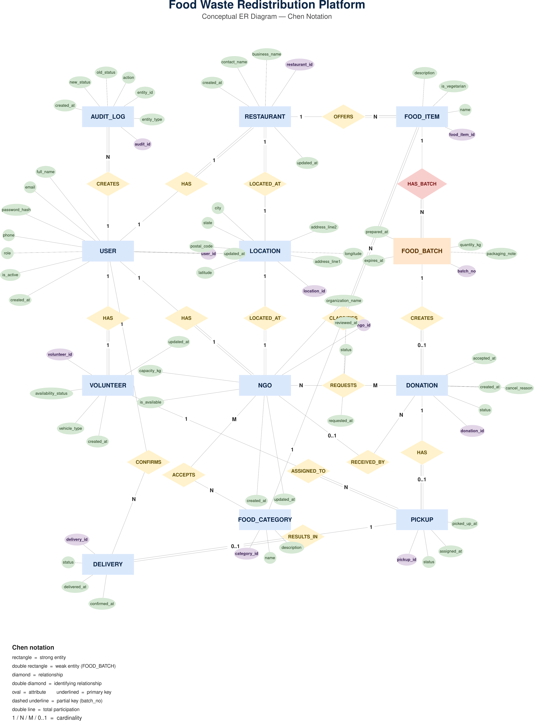

4. ER TO RELATIONAL MAPPING

4.1 STEPS OF ALGORITHM FOR CHOSEN PROBLEM
The seven-step ER-to-relational mapping algorithm converts the conceptual model into 14 relations.

Table 8: Mapping steps applied to this model
Step | Rule | Result in this schema
1. Strong entities | Each strong entity becomes a relation; its key becomes the primary key | users, locations, restaurants, ngos, volunteers, food_categories, food_items, donations, pickups, deliveries, audit_logs
2. Weak entities | The owner key becomes a foreign key; with the partial key it identifies the row | food_batches with UNIQUE (food_item_id, batch_no); a surrogate batch_id is the physical key
3. Binary 1:1 | Foreign key on the total-participation side, declared UNIQUE | restaurants.user_id, restaurants.location_id, ngos.user_id, ngos.location_id, volunteers.user_id, donations.batch_id, pickups.donation_id, deliveries.pickup_id
4. Binary 1:N | Foreign key on the N side | food_items.restaurant_id, food_items.category_id, food_batches.food_item_id, donations.recipient_ngo_id, pickups.volunteer_id, deliveries.confirmed_by_user_id, audit_logs.actor_user_id
5. Binary M:N | New relation keyed by both foreign keys | ngo_food_categories (ngo_id, category_id); donation_requests with UNIQUE (donation_id, ngo_id)
6. Multivalued attributes | New relation per attribute | None. Accepted categories are the M:N relationship ACCEPTS
7. N-ary relationships | New relation keyed by all participants | None. All 17 relationships are binary

donations stores no accepted request id. The accepted NGO is donations.recipient_ngo_id, so donation_requests depends on donations and no reverse dependency exists.

4.2 COMPLETE DIAGRAM OF RELATIONAL MAPPING
Underlined columns are primary keys and italic columns are foreign keys. Each arrow points from a foreign key to the primary key it references.

Figure 2: Relational schema with all 19 foreign keys
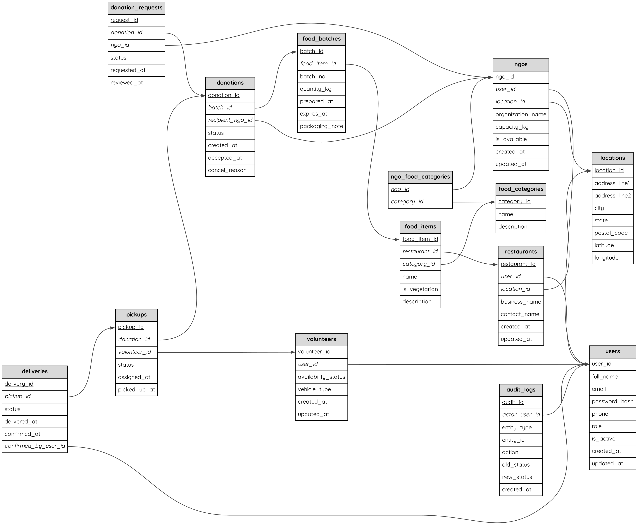

4.3 REFERENTIAL ACTIONS AND NORMAL FORM
All 19 foreign keys use ON UPDATE RESTRICT. Deletes are RESTRICT, with two exceptions. deliveries.confirmed_by_user_id and audit_logs.actor_user_id use SET NULL, so delivery and audit history outlive a deleted account.
Every non-key attribute depends on the whole key and on nothing else. Addresses exist once, in locations. Quantity, expiry and category exist once, in food_batches and food_items, and never in donations. Remaining capacity, totals and match scores come from views and queries. The schema is therefore in third normal form.

4.4 DATA DICTIONARY
The data dictionary lists every column of the 14 tables, as declared in the DDL of chapter 5.

Table 9: Data dictionary
Table | Column | Type | Null | Key / constraint
users | user_id | BIGINT UNSIGNED | No | PK
users | full_name | VARCHAR(120) | No
users | email | VARCHAR(255) | No | UNIQUE
users | password_hash | VARCHAR(255) | No
users | phone | VARCHAR(25) | Yes | UNIQUE
users | role | ENUM(RESTAURANT, NGO, VOLUNTEER, ADMIN) | No
users | is_active | BOOLEAN | No | CHECK; default TRUE
users | created_at | DATETIME | No | default CURRENT_TIMESTAMP
users | updated_at | DATETIME | No | default CURRENT_TIMESTAMP
locations | location_id | BIGINT UNSIGNED | No | PK
locations | address_line1 | VARCHAR(180) | No
locations | address_line2 | VARCHAR(180) | Yes
locations | city | VARCHAR(100) | No
locations | state | VARCHAR(100) | No
locations | postal_code | VARCHAR(20) | No
locations | latitude | DECIMAL(9, 6) | No | CHECK
locations | longitude | DECIMAL(9, 6) | No | CHECK
restaurants | restaurant_id | BIGINT UNSIGNED | No | PK
restaurants | user_id | BIGINT UNSIGNED | No | FK to users.user_id; UNIQUE
restaurants | location_id | BIGINT UNSIGNED | No | FK to locations.location_id; UNIQUE
restaurants | business_name | VARCHAR(160) | No | UNIQUE
restaurants | contact_name | VARCHAR(120) | No
restaurants | created_at | DATETIME | No | default CURRENT_TIMESTAMP
restaurants | updated_at | DATETIME | No | default CURRENT_TIMESTAMP
ngos | ngo_id | BIGINT UNSIGNED | No | PK
ngos | user_id | BIGINT UNSIGNED | No | FK to users.user_id; UNIQUE
ngos | location_id | BIGINT UNSIGNED | No | FK to locations.location_id; UNIQUE
ngos | organization_name | VARCHAR(160) | No | UNIQUE
ngos | capacity_kg | DECIMAL(10, 2) | No | CHECK
ngos | is_available | BOOLEAN | No | CHECK; default TRUE
ngos | created_at | DATETIME | No | default CURRENT_TIMESTAMP
ngos | updated_at | DATETIME | No | default CURRENT_TIMESTAMP
volunteers | volunteer_id | BIGINT UNSIGNED | No | PK
volunteers | user_id | BIGINT UNSIGNED | No | FK to users.user_id; UNIQUE
volunteers | availability_status | ENUM(AVAILABLE, UNAVAILABLE) | No | default 'AVAILABLE'
volunteers | vehicle_type | VARCHAR(60) | Yes
volunteers | created_at | DATETIME | No | default CURRENT_TIMESTAMP
volunteers | updated_at | DATETIME | No | default CURRENT_TIMESTAMP
food_categories | category_id | BIGINT UNSIGNED | No | PK
food_categories | name | VARCHAR(80) | No | UNIQUE
food_categories | description | VARCHAR(255) | Yes
food_items | food_item_id | BIGINT UNSIGNED | No | PK
food_items | restaurant_id | BIGINT UNSIGNED | No | FK to restaurants.restaurant_id; UNIQUE (restaurant_id, name)
food_items | category_id | BIGINT UNSIGNED | No | FK to food_categories.category_id
food_items | name | VARCHAR(140) | No | UNIQUE (restaurant_id, name)
food_items | is_vegetarian | BOOLEAN | No | CHECK; default TRUE
food_items | description | VARCHAR(255) | Yes
food_batches | batch_id | BIGINT UNSIGNED | No | PK
food_batches | food_item_id | BIGINT UNSIGNED | No | FK to food_items.food_item_id; UNIQUE (food_item_id, batch_no)
food_batches | batch_no | VARCHAR(40) | No | UNIQUE (food_item_id, batch_no)
food_batches | quantity_kg | DECIMAL(10, 2) | No | CHECK
food_batches | prepared_at | DATETIME | No
food_batches | expires_at | DATETIME | No | CHECK
food_batches | packaging_note | VARCHAR(255) | Yes
donations | donation_id | BIGINT UNSIGNED | No | PK
donations | batch_id | BIGINT UNSIGNED | No | FK to food_batches.batch_id; UNIQUE
donations | recipient_ngo_id | BIGINT UNSIGNED | Yes | FK to ngos.ngo_id
donations | status | ENUM(AVAILABLE, ACCEPTED, PICKUP_ASSIGNED, PICKED_UP, DELIVERED, COMPLETED, EXPIRED, CANCELLED) | No | default 'AVAILABLE'
donations | created_at | DATETIME | No | default CURRENT_TIMESTAMP
donations | accepted_at | DATETIME | Yes
donations | cancel_reason | VARCHAR(255) | Yes
ngo_food_categories | ngo_id | BIGINT UNSIGNED | No | PK; FK to ngos.ngo_id
ngo_food_categories | category_id | BIGINT UNSIGNED | No | PK; FK to food_categories.category_id
donation_requests | request_id | BIGINT UNSIGNED | No | PK
donation_requests | donation_id | BIGINT UNSIGNED | No | FK to donations.donation_id; UNIQUE (donation_id, ngo_id)
donation_requests | ngo_id | BIGINT UNSIGNED | No | FK to ngos.ngo_id; UNIQUE (donation_id, ngo_id)
donation_requests | status | ENUM(PENDING, ACCEPTED, REJECTED, WITHDRAWN) | No | default 'PENDING'
donation_requests | requested_at | DATETIME | No | default CURRENT_TIMESTAMP
donation_requests | reviewed_at | DATETIME | Yes
pickups | pickup_id | BIGINT UNSIGNED | No | PK
pickups | donation_id | BIGINT UNSIGNED | No | FK to donations.donation_id; UNIQUE
pickups | volunteer_id | BIGINT UNSIGNED | No | FK to volunteers.volunteer_id
pickups | status | ENUM(ASSIGNED, PICKED_UP) | No | default 'ASSIGNED'
pickups | assigned_at | DATETIME | No | default CURRENT_TIMESTAMP
pickups | picked_up_at | DATETIME | Yes
deliveries | delivery_id | BIGINT UNSIGNED | No | PK
deliveries | pickup_id | BIGINT UNSIGNED | No | FK to pickups.pickup_id; UNIQUE
deliveries | status | ENUM(IN_TRANSIT, DELIVERED, CONFIRMED) | No | default 'IN_TRANSIT'
deliveries | delivered_at | DATETIME | Yes
deliveries | confirmed_at | DATETIME | Yes
deliveries | confirmed_by_user_id | BIGINT UNSIGNED | Yes | FK to users.user_id, ON DELETE SET NULL
audit_logs | audit_id | BIGINT UNSIGNED | No | PK
audit_logs | actor_user_id | BIGINT UNSIGNED | Yes | FK to users.user_id, ON DELETE SET NULL
audit_logs | entity_type | VARCHAR(50) | No
audit_logs | entity_id | BIGINT UNSIGNED | No
audit_logs | action | VARCHAR(80) | No
audit_logs | old_status | VARCHAR(30) | Yes
audit_logs | new_status | VARCHAR(30) | Yes
audit_logs | created_at | DATETIME | No | default CURRENT_TIMESTAMP

5. DDL STATEMENTS

5.1 DATABASE CREATION
All statements run in the MySQL 8.0 command-line client inside the Docker container. The prompt shows the SRN, the MySQL user and the current database.

Screenshot 1: Client login, prompt and database creation
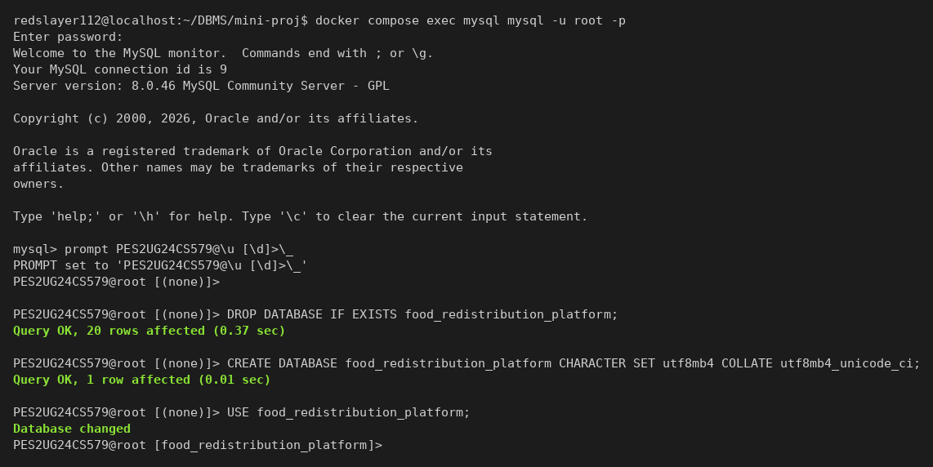

5.2 TABLE CREATION
The tables are created in foreign-key order, so every referenced table already exists. Every table uses InnoDB and utf8mb4.

Screenshot 2: CREATE TABLE users
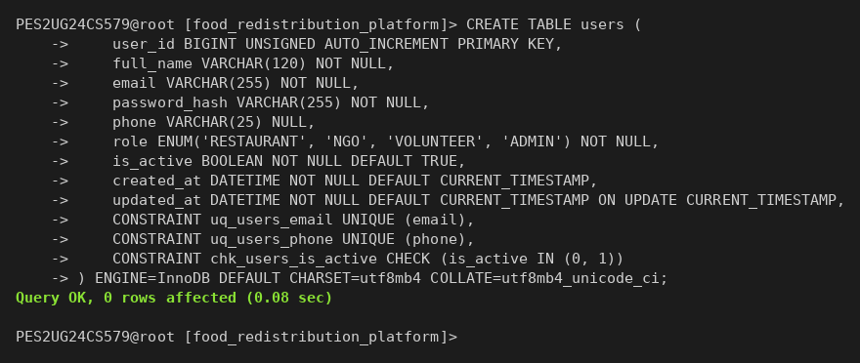

Screenshot 3: CREATE TABLE locations
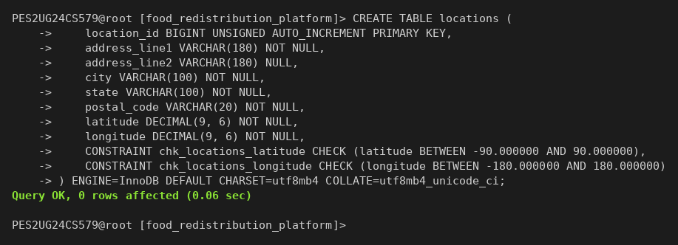

Screenshot 4: CREATE TABLE restaurants
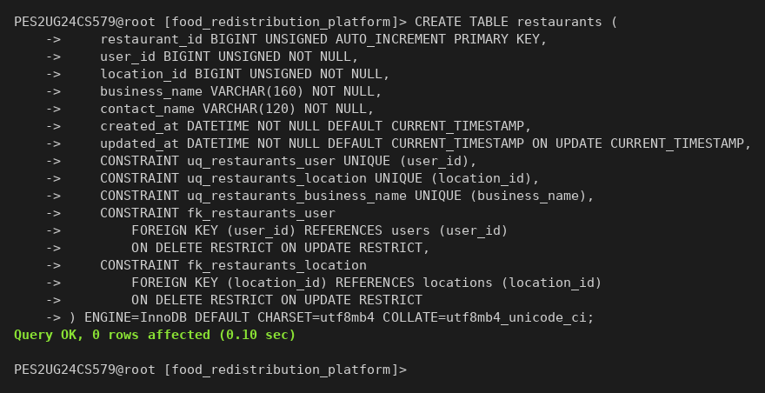

Screenshot 5: CREATE TABLE ngos
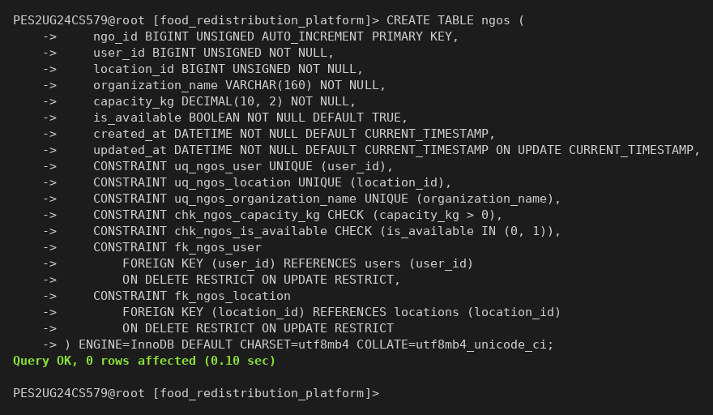

Screenshot 6: CREATE TABLE volunteers
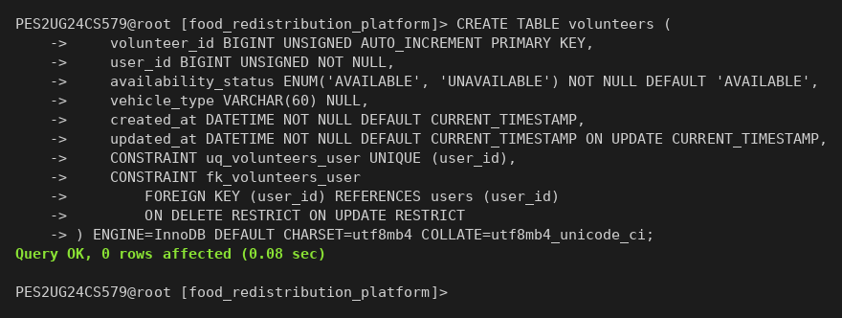

Screenshot 7: CREATE TABLE food_categories
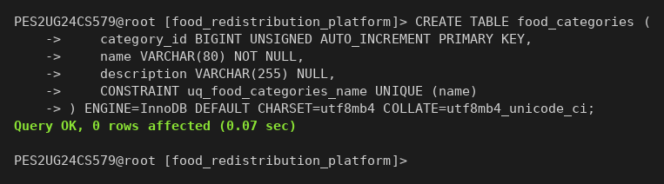

Screenshot 8: CREATE TABLE food_items
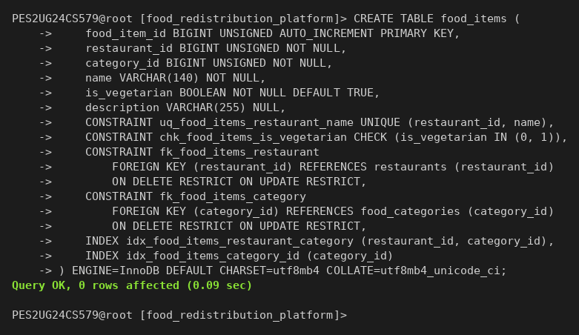

Screenshot 9: CREATE TABLE food_batches
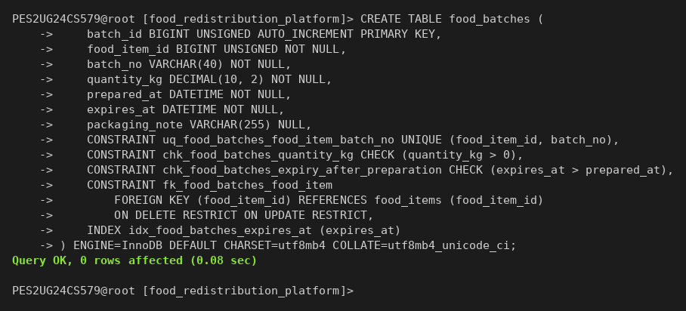

Screenshot 10: CREATE TABLE donations
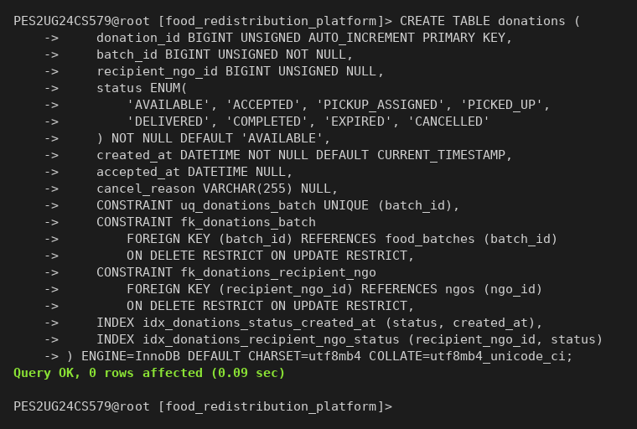

Screenshot 11: CREATE TABLE ngo_food_categories
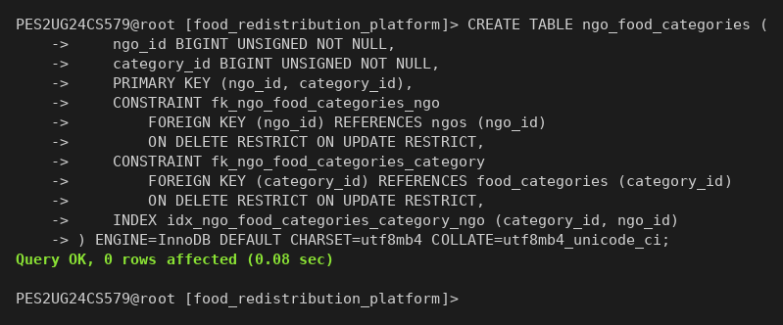

Screenshot 12: CREATE TABLE donation_requests
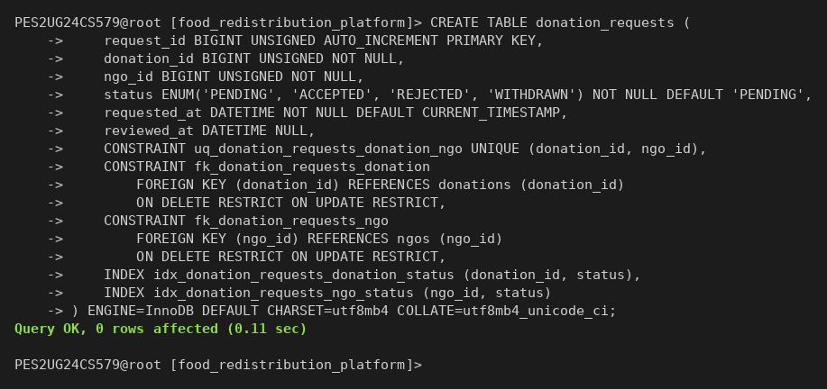

Screenshot 13: CREATE TABLE pickups
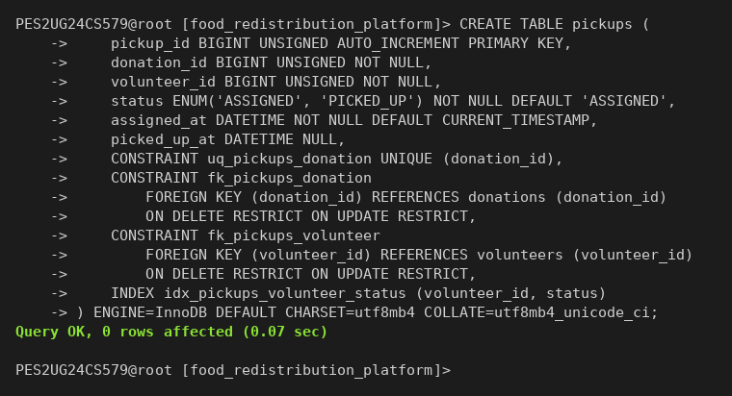

Screenshot 14: CREATE TABLE deliveries
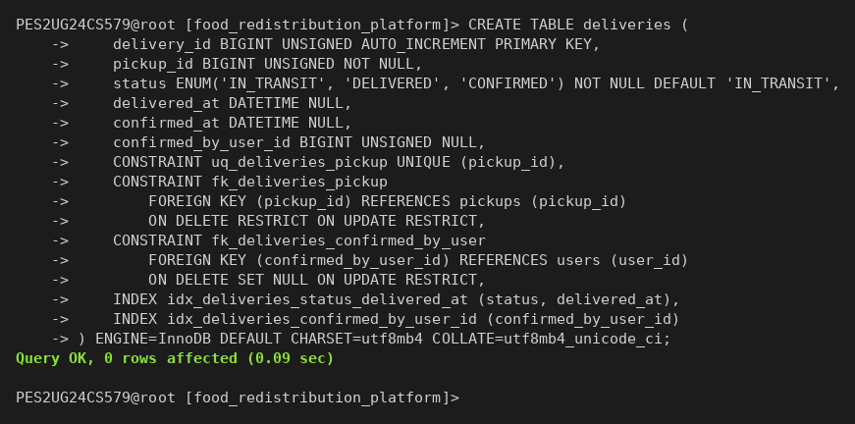

Screenshot 15: CREATE TABLE audit_logs
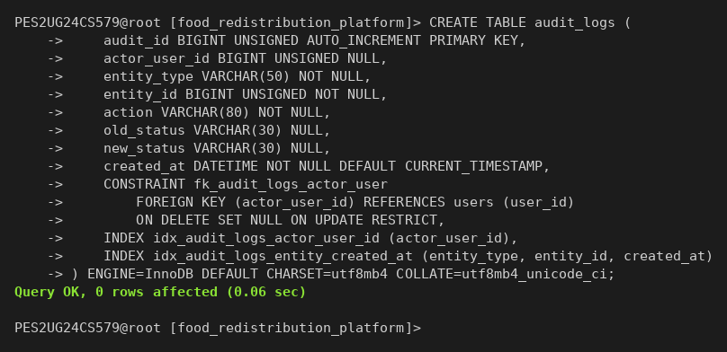

5.3 CONSTRAINTS AND INDEXES

Screenshot 16: Tables and constraint counts from information_schema
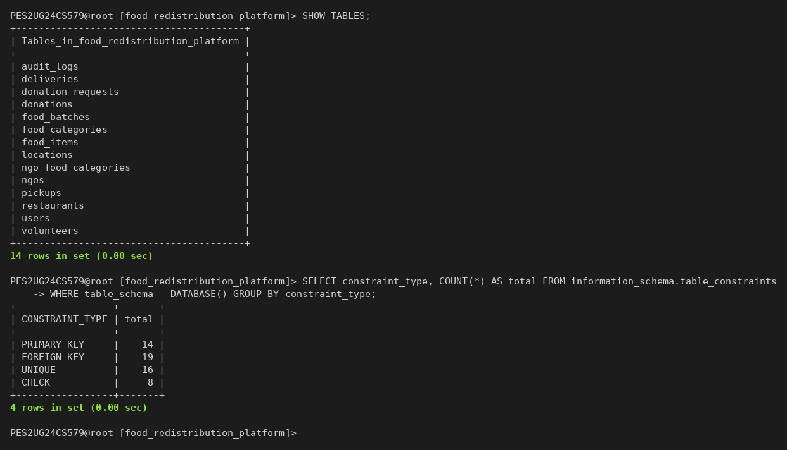

Table 10: Constraint summary
Constraint | Count | Examples
PRIMARY KEY | 14 | One per table; ngo_food_categories has a composite key
FOREIGN KEY | 19 | All with explicit ON DELETE and ON UPDATE actions
UNIQUE | 16 | email, phone, business_name, (food_item_id, batch_no), (donation_id, ngo_id)
CHECK | 8 | quantity_kg > 0, capacity_kg > 0, expires_at > prepared_at, latitude and longitude bounds
ENUM columns | 6 | role, availability_status and the four status columns

Table 11: Secondary indexes and the query each one serves
Index | Table | Query served
idx_food_items_restaurant_category | food_items | A restaurant's menu filtered by category
idx_food_items_category_id | food_items | Items of one category; foreign key support
idx_food_batches_expires_at | food_batches | Batches close to expiry; the expiry sweep
idx_donations_status_created_at | donations | AVAILABLE donations, newest first
idx_donations_recipient_ngo_status | donations | An NGO's donations by status; committed capacity
idx_ngo_food_categories_category_ngo | ngo_food_categories | NGOs that accept a category, used by matching
idx_donation_requests_donation_status | donation_requests | Pending requests for one donation
idx_donation_requests_ngo_status | donation_requests | One NGO's request history
idx_pickups_volunteer_status | pickups | A volunteer's active pickups
idx_deliveries_status_delivered_at | deliveries | Delivery throughput analytics
idx_deliveries_confirmed_by_user_id | deliveries | Foreign key support for SET NULL
idx_audit_logs_actor_user_id | audit_logs | Foreign key support for SET NULL
idx_audit_logs_entity_created_at | audit_logs | History of one record in time order

6. DML STATEMENTS

6.1 SEED DATA DESIGN
The seed data uses timestamps relative to NOW(), so the demo always has live and expired batches. Every password is a bcrypt hash and no plaintext password exists in the database. The 17 donations cover all eight lifecycle states. Two pending requests exist only to fail: one on an expired batch, one above an NGO's capacity.

Table 12: Rows inserted per table
Table | Rows
users | 13
locations | 8
restaurants | 4
ngos | 4
volunteers | 4
food_categories | 5
ngo_food_categories | 14
food_items | 12
food_batches | 17
donations | 17
donation_requests | 18
pickups | 8
deliveries | 7

6.2 INSERT STATEMENTS AND INSERTED ROWS

Screenshot 17: INSERT INTO users and its rows
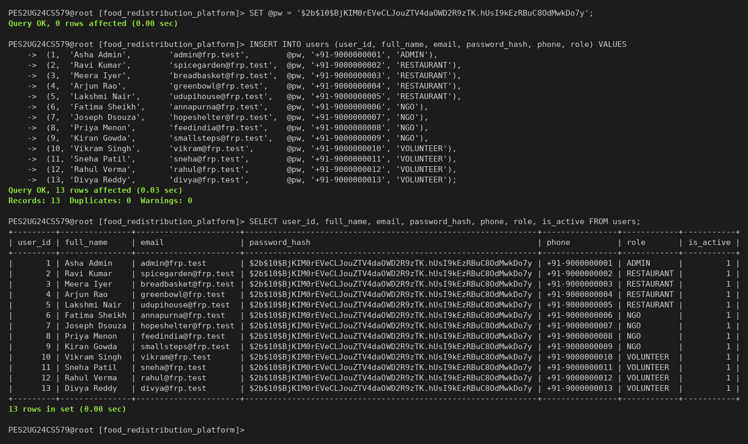

Screenshot 18: INSERT INTO locations and its rows
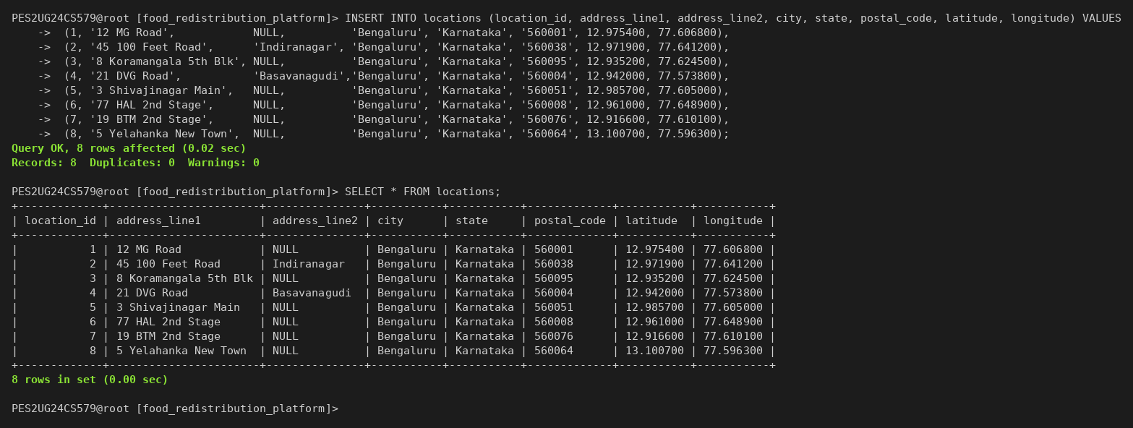

Screenshot 19: INSERT INTO restaurants and its rows
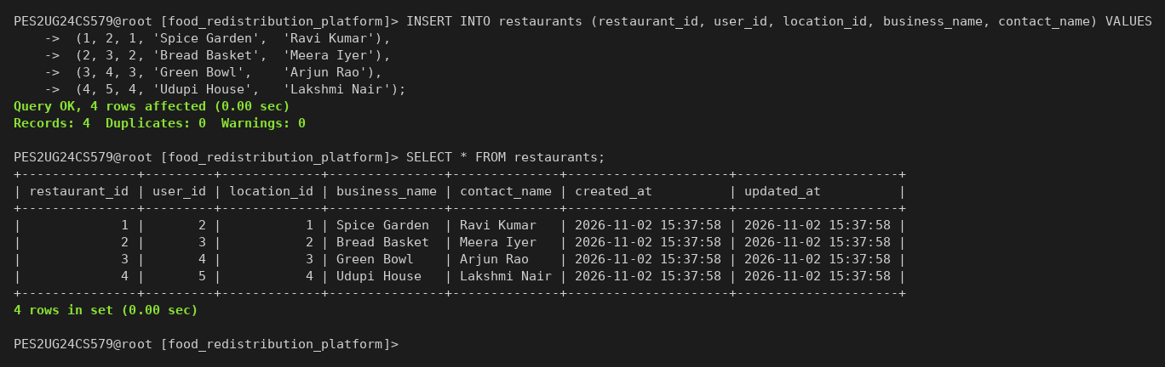

Screenshot 20: INSERT INTO ngos and its rows
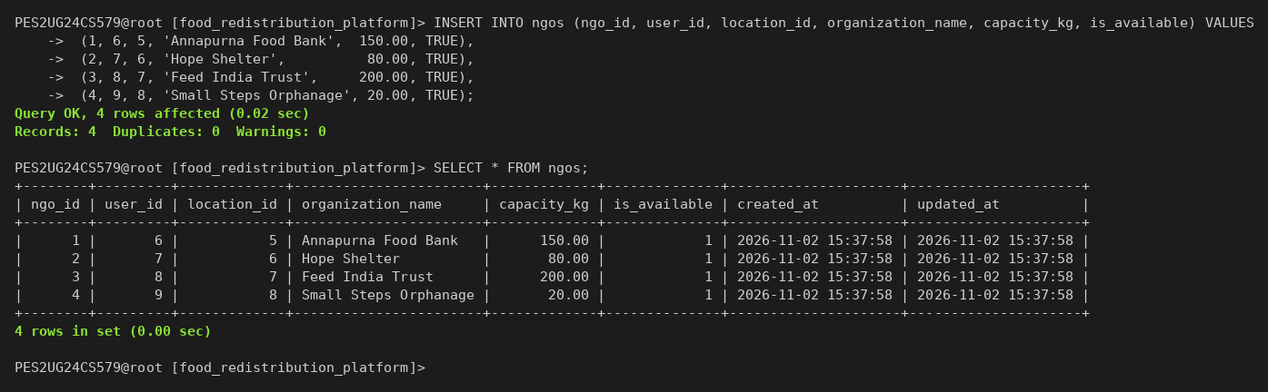

Screenshot 21: INSERT INTO volunteers and its rows
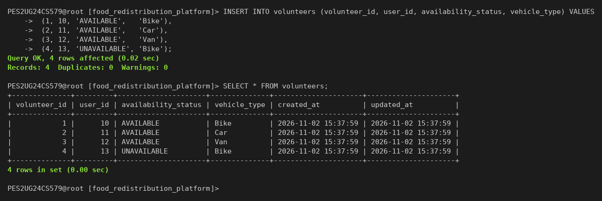

Screenshot 22: INSERT INTO food_categories and its rows
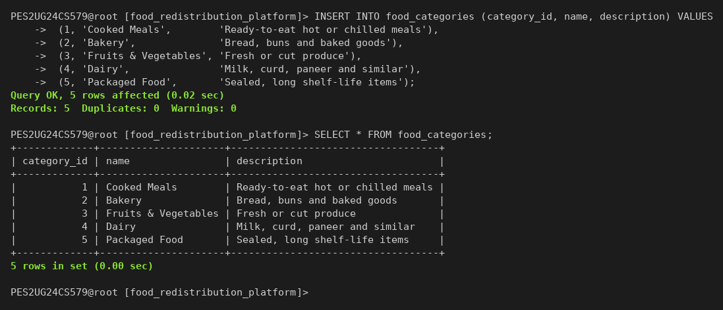

Screenshot 23: INSERT INTO ngo_food_categories and its rows
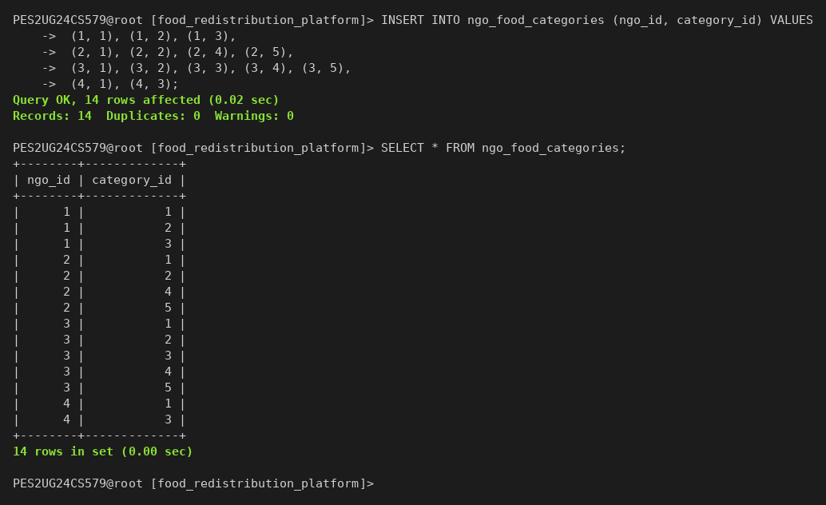

Screenshot 24: INSERT INTO food_items and its rows
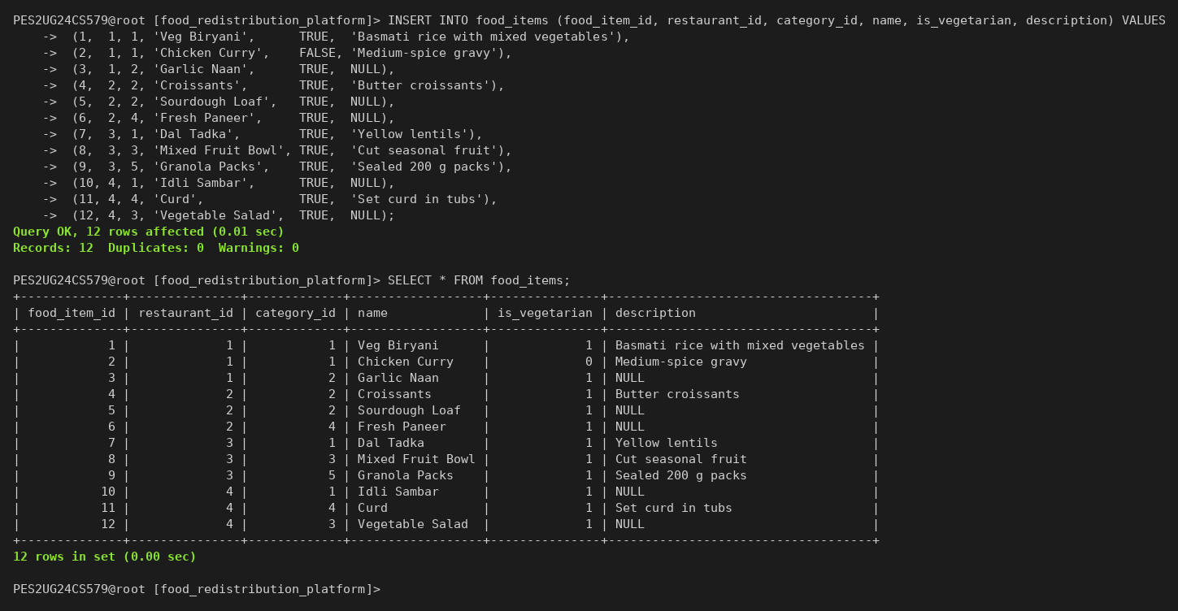

Screenshot 25: INSERT INTO food_batches and its rows
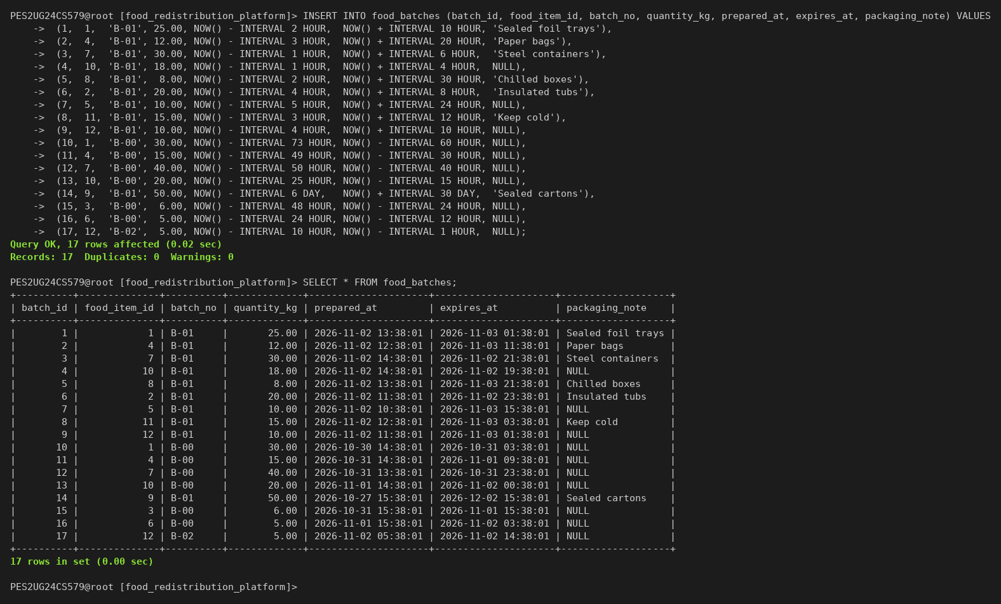

Screenshot 26: INSERT INTO donations and its rows
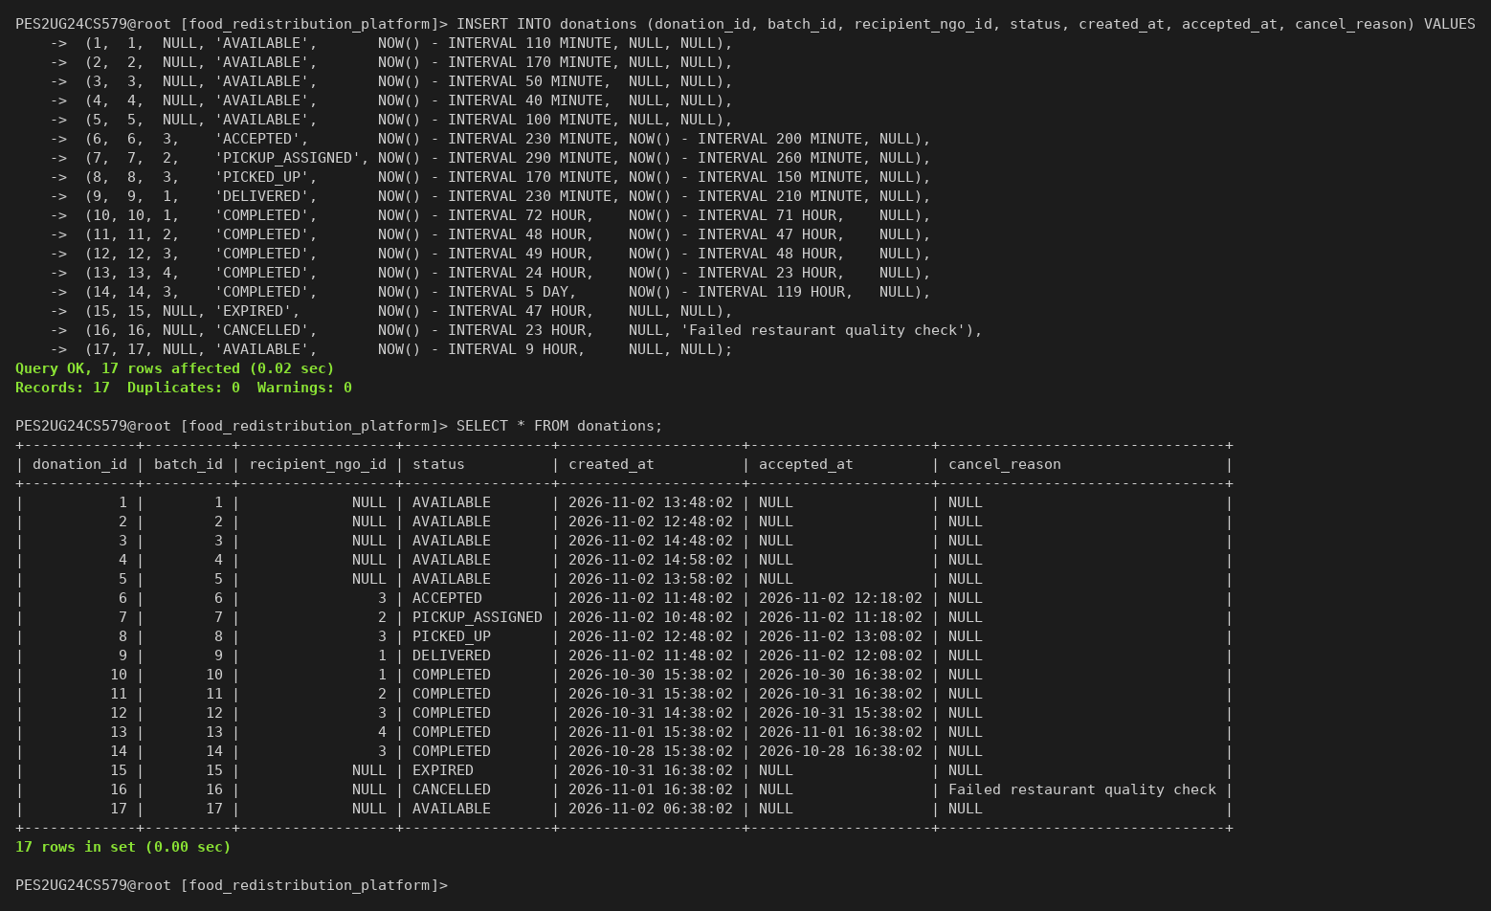

Screenshot 27: INSERT INTO donation_requests and its rows
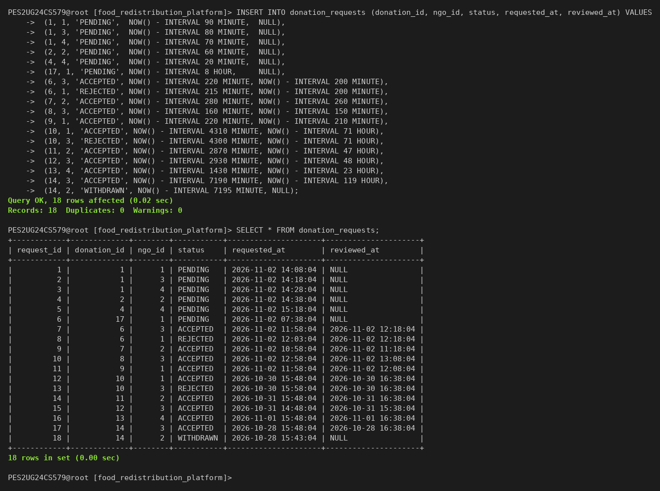

Screenshot 28: INSERT INTO pickups and its rows
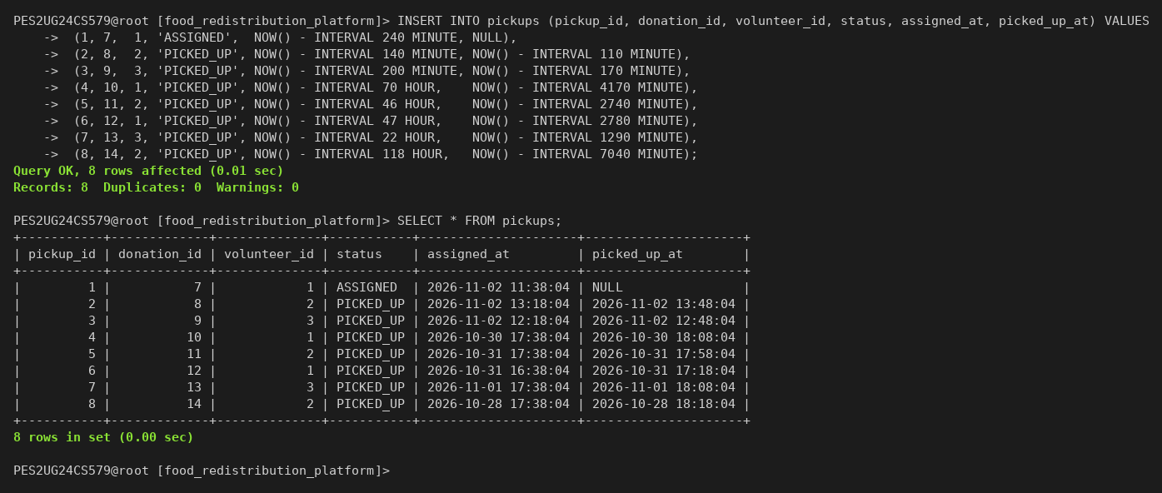

Screenshot 29: INSERT INTO deliveries and its rows
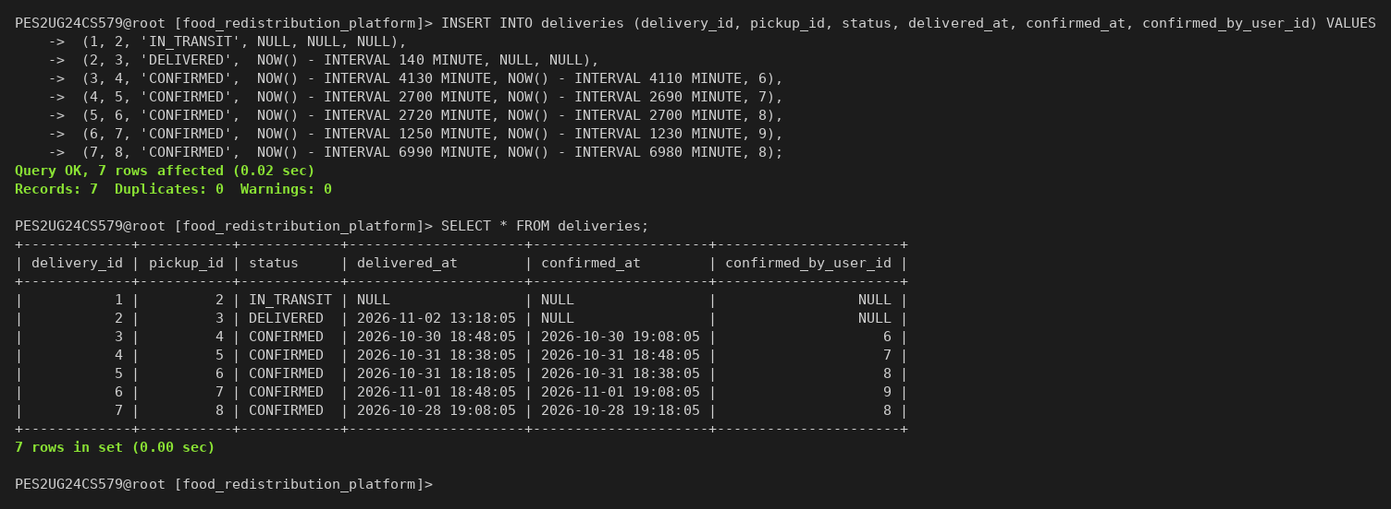

7. QUERIES

7.1 SIMPLE QUERY WITH GROUP BY, AGGREGATE
The first query counts donations per status. The second keeps only restaurants with more than 40 kg completed, using HAVING. The third reports batch size statistics per category with AVG, MIN and MAX.

Screenshot 30: GROUP BY, HAVING and aggregate functions
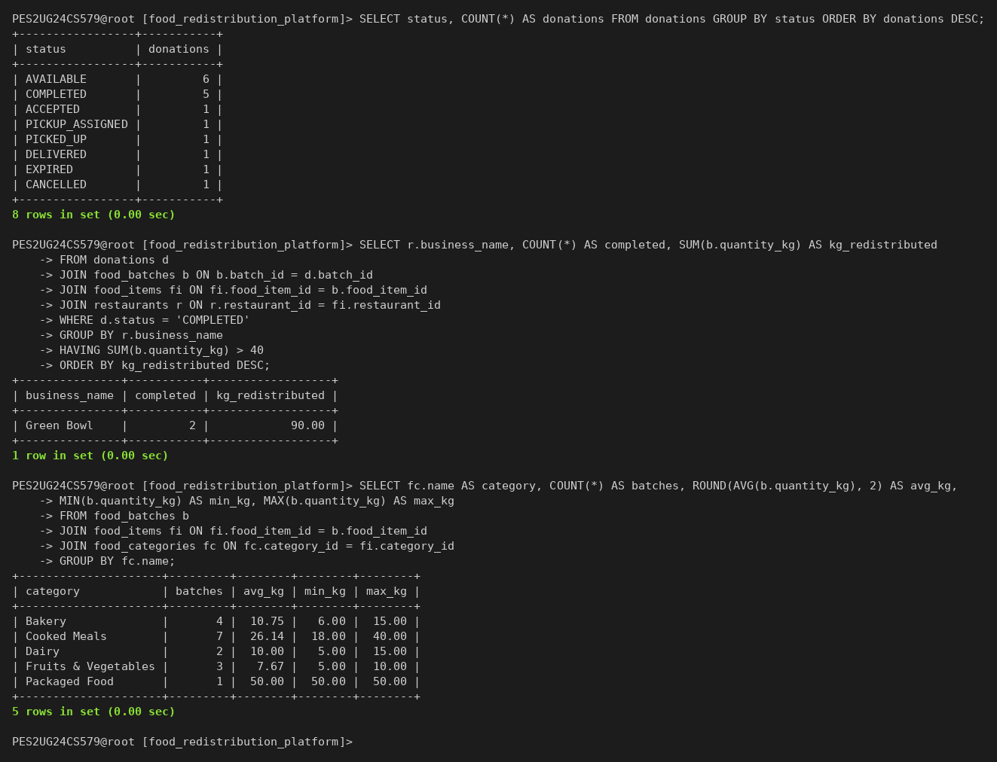

7.2 UPDATE OPERATION
An NGO raises its capacity from 150 kg to 180 kg, and a volunteer becomes available again. Each SELECT before and after shows the changed row.

Screenshot 31: UPDATE on ngos and volunteers
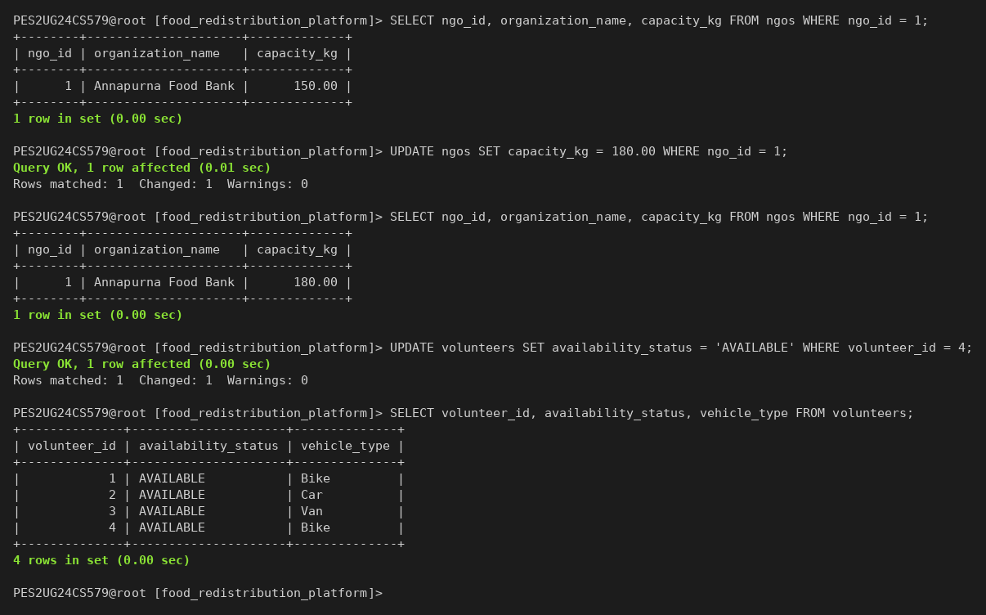

7.3 DELETE OPERATION
Hope Shelter stops accepting packaged food, so its row in ngo_food_categories is deleted. Deleting a restaurant that still owns food items fails with error 1451, because the foreign key uses ON DELETE RESTRICT.

Screenshot 32: DELETE and a delete blocked by a foreign key
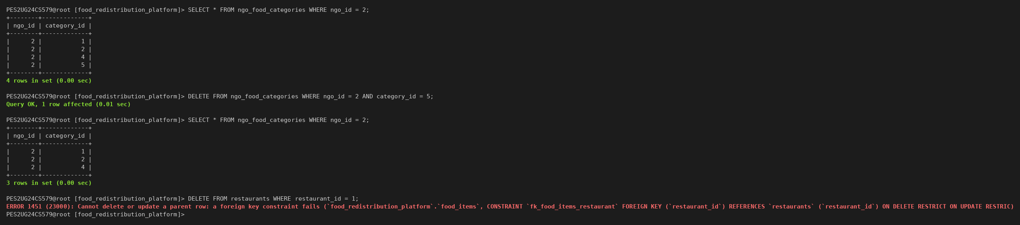

7.4 CORRELATED QUERY
The inner query runs once per outer row. The first query counts the pending requests of each available donation. The second uses NOT EXISTS to find available donations that no NGO has requested.

Screenshot 33: Correlated subqueries with COUNT and NOT EXISTS
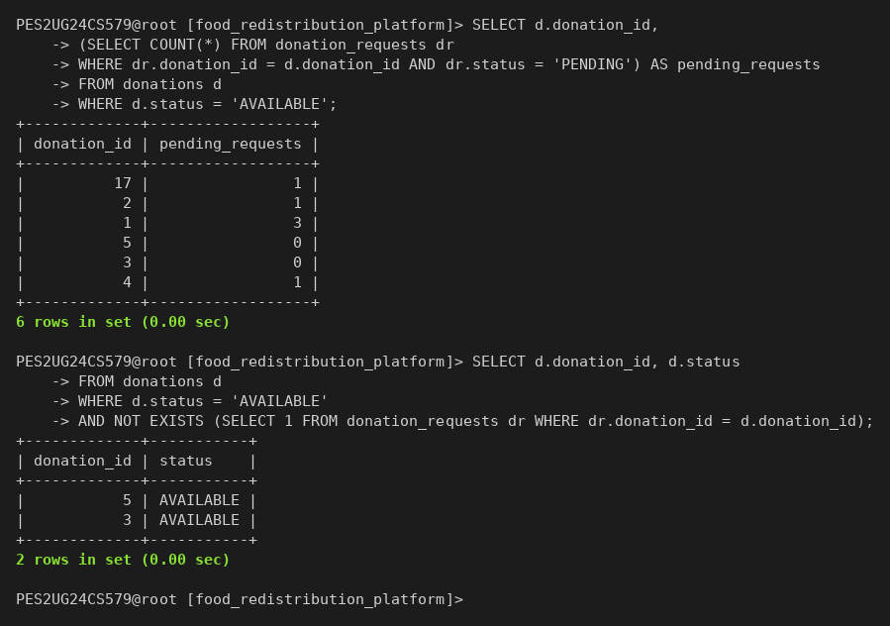

7.5 NESTED QUERY
The first query compares each donation with the average batch size from a scalar subquery. The second uses NOT IN to list NGOs that have never had a request rejected.

Screenshot 34: Nested subqueries with a scalar value and NOT IN
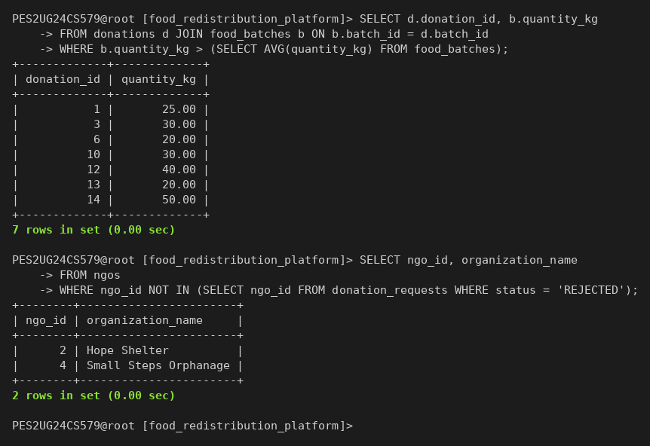

7.6 MULTI-TABLE JOIN
Five inner joins and one left join give the full provenance of every donation. The left join keeps donations that have no recipient yet.

Screenshot 35: Donation provenance across six tables
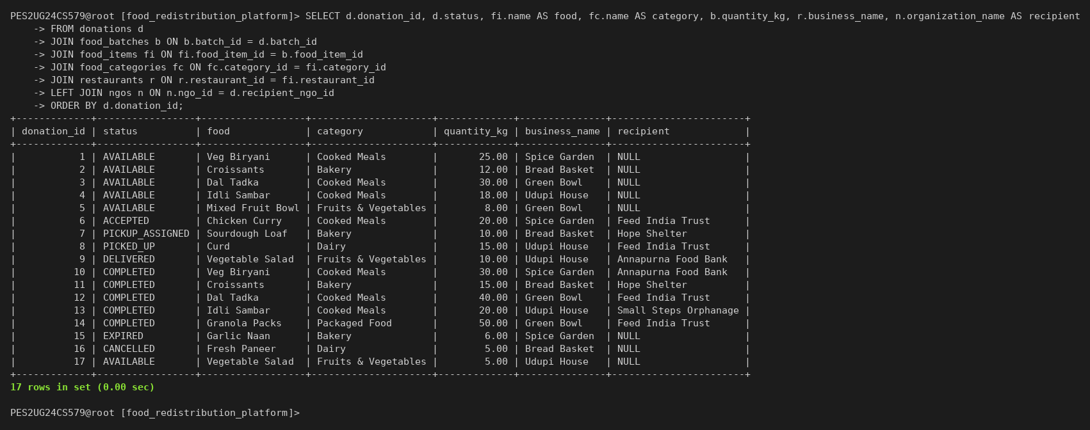

7.7 MATCHING QUERY
The matching query ranks the NGOs that may receive a donation. A common table expression keeps only eligible NGOs: available, accepting the category and with enough remaining capacity. Each score component is visible, so a user can check the ranking.

Table 13: Matching score components
Component | Maximum | Formula
Category fit | 30 | Always 30, because category acceptance is an eligibility condition
Capacity fit | 25 | 25 x min(1, remaining kg / (2 x batch kg))
Expiry urgency | 25 | 25 x max(0, 1 - hours left / 48)
Proximity | 20 | 20 x max(0, 1 - distance km / 50), with Haversine distance

Ties go to the higher total, then the shorter distance, then the larger remaining capacity, then the lower NGO id. No score is stored.

Screenshot 36: Ranked eligible NGOs for donation 1
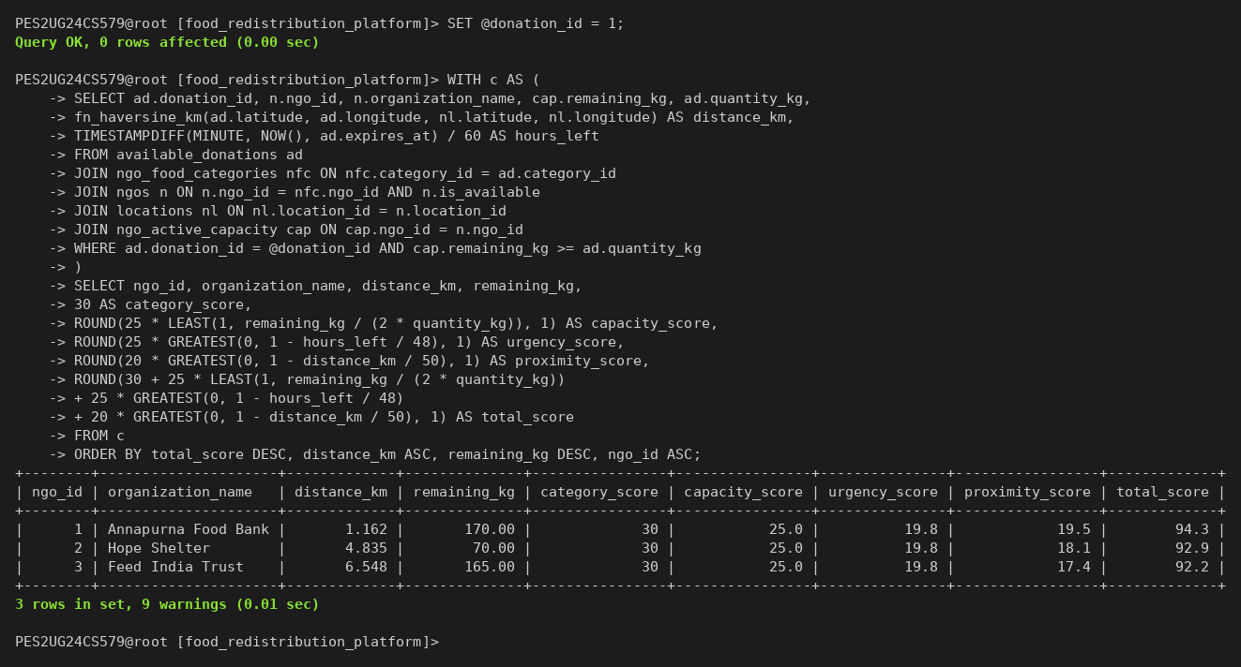

8. STORED PROCEDURES, FUNCTIONS AND TRIGGERS

8.1 STORED PROCEDURES OR FUNCTIONS
One script creates the function, the three triggers, the procedure and the six views. The client runs it with the source command.

Screenshot 37: Creating the routines, triggers and views
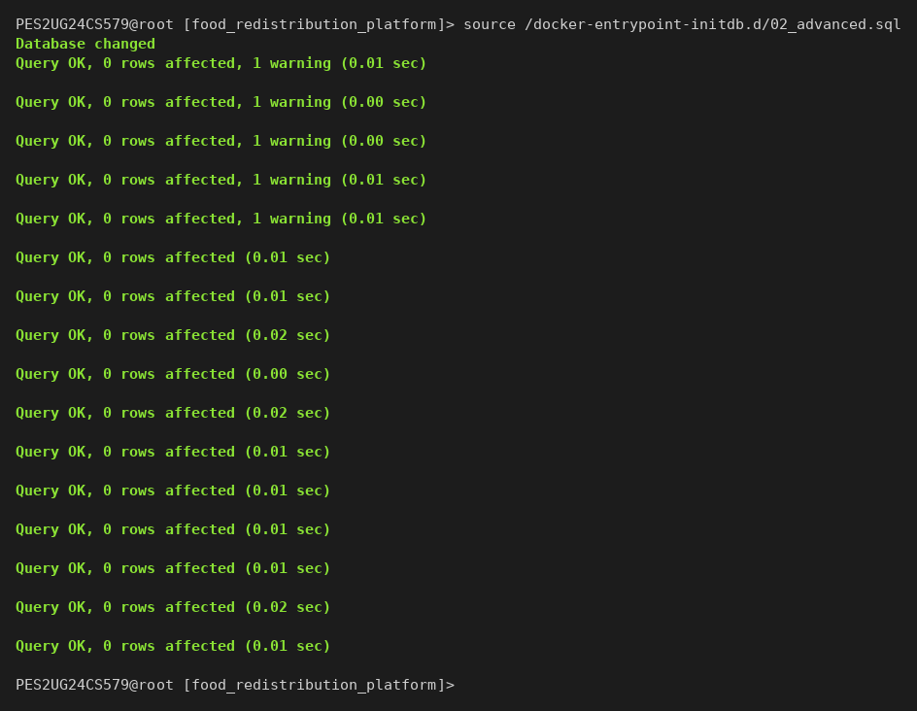

Screenshot 38: Routines, triggers and views in information_schema
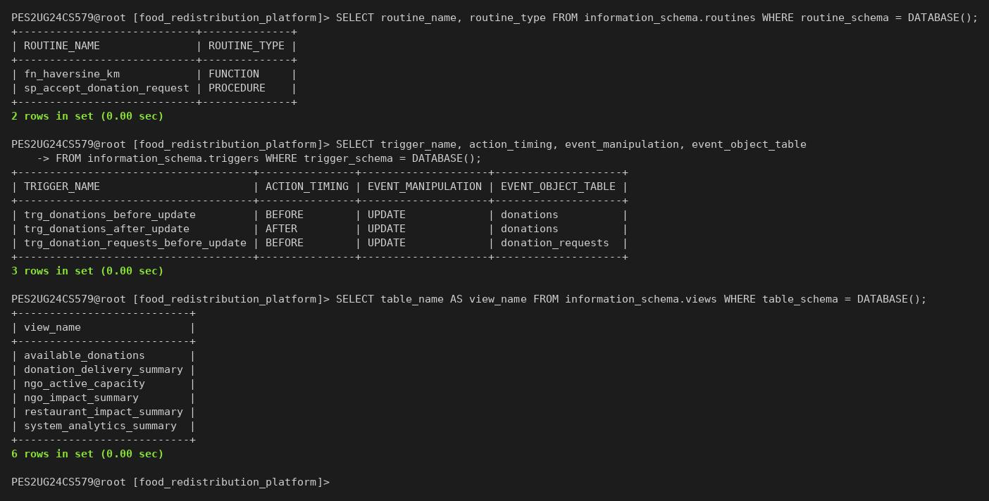
fn_haversine_km returns the great-circle distance in kilometres between two coordinates. The matching query uses it for proximity.

Screenshot 39: fn_haversine_km from Spice Garden to every NGO
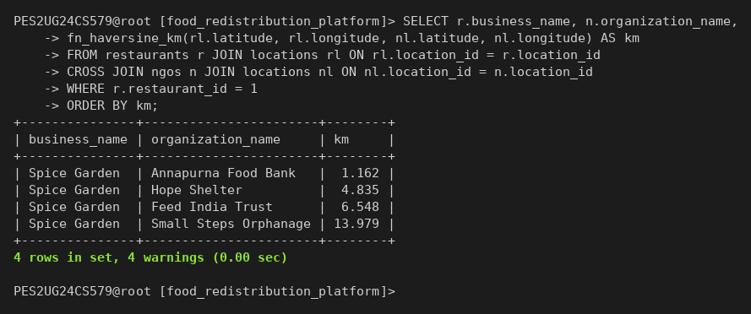
sp_accept_donation_request (request id, restaurant user id) accepts one NGO request. It runs every step inside one transaction and locks the rows it reads. Any failed check raises SQLSTATE 45000, and the exit handler rolls back and passes the error on.

Table 14: Steps of sp_accept_donation_request
Step | Check or action | Error on failure
1 | Lock the request row with SELECT ... FOR UPDATE | Request not found; Request is not PENDING
2 | Lock the donation, batch, item and restaurant rows | None
3 | Compare the owning restaurant with the caller | Only the owning restaurant can accept this request
4 | Check that the donation is AVAILABLE | Donation is no longer AVAILABLE
5 | Check that expires_at is later than NOW() | Food batch has expired
6 | Lock the NGO row and check that it is available | NGO is not available
7 | Check that the NGO accepts the category | NGO does not accept this food category
8 | Check capacity minus committed kg against the batch | NGO has insufficient remaining capacity
9 | Set the recipient, ACCEPTED and accepted_at | Checked again by the trigger
10 | Accept the request and reject the other pending requests, then COMMIT | None

The three failed calls below leave every request PENDING, which shows the rollback.

Screenshot 40: Procedure rejects an expired batch, low capacity and a wrong owner
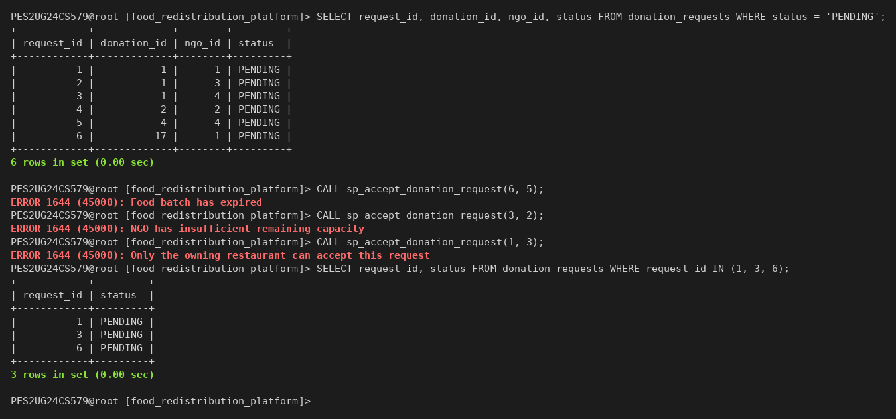

Screenshot 41: Procedure accepts request 1 and rejects the competing requests
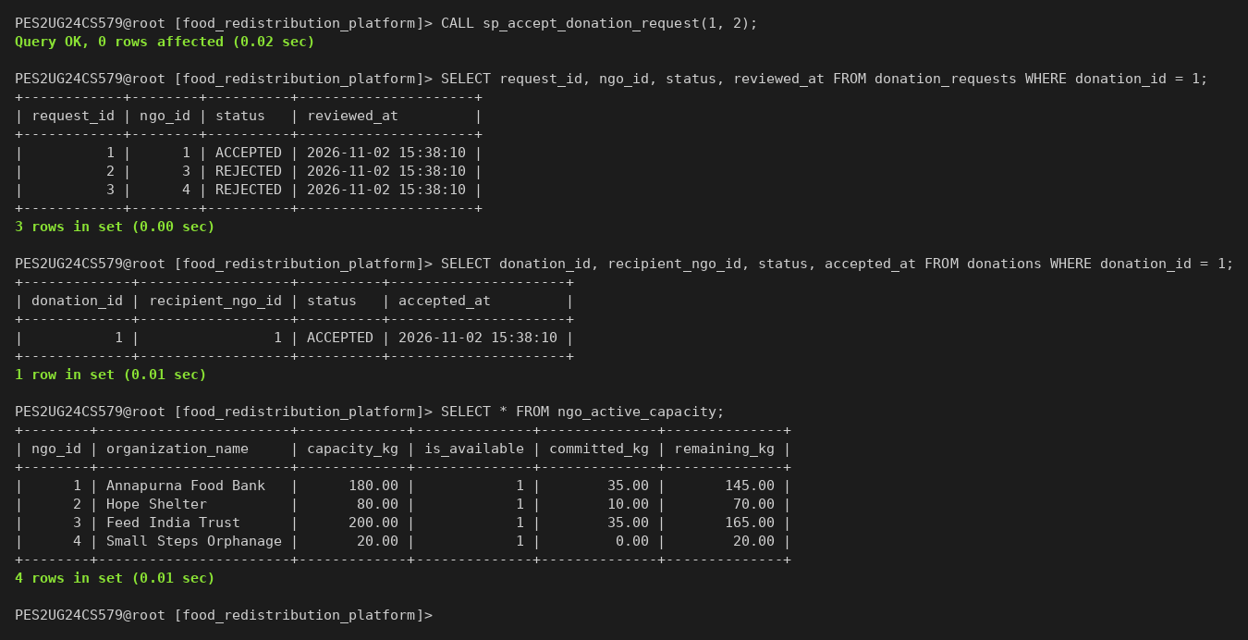

8.2 TRIGGERS

Table 15: Triggers
Trigger | Timing and event | Rule
trg_donations_before_update | BEFORE UPDATE on donations | Allows only legal transitions. ACCEPTED needs a recipient and an unexpired batch. PICKUP_ASSIGNED, PICKED_UP, DELIVERED and COMPLETED each need the matching pickup or delivery row
trg_donations_after_update | AFTER UPDATE on donations | Writes one audit_logs row per status change. The actor comes from the session variable @app_user_id
trg_donation_requests_before_update | BEFORE UPDATE on donation_requests | A request leaves PENDING only once and becomes ACCEPTED only for the donation recipient. Sets reviewed_at

The audit trigger runs AFTER the update, so a rejected update never leaves an audit row behind.

Screenshot 42: Trigger rejects illegal donation and request transitions
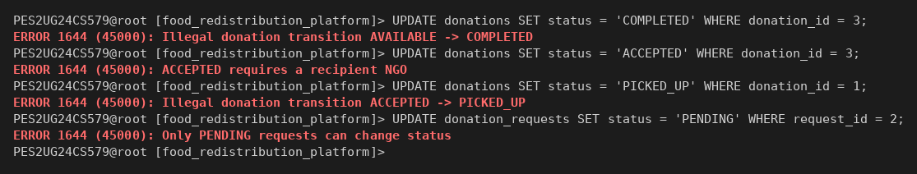

Screenshot 43: Expiry sweep and the audit rows written by the trigger
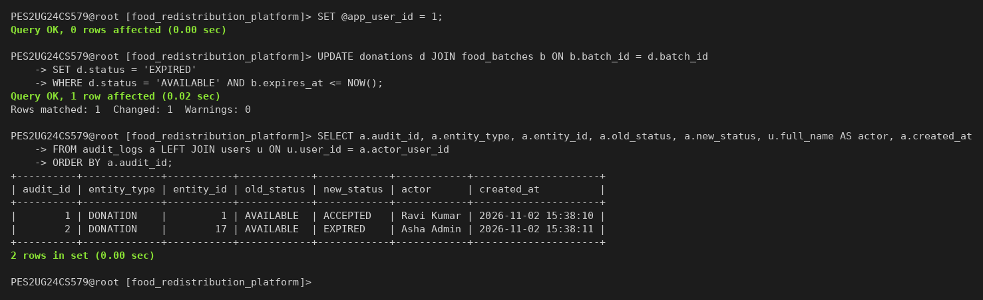

8.3 VIEWS

Table 16: Views
View | Result
available_donations | AVAILABLE, unexpired donations with food, category, restaurant and coordinates
ngo_active_capacity | capacity_kg minus the kg of donations still in progress for each NGO
restaurant_impact_summary | Donations, completed, lost, kg redistributed and success rate per restaurant
ngo_impact_summary | Requests, donations received, completed and kg received per NGO
donation_delivery_summary | Pickup, delivery and end-to-end time in minutes per donation
system_analytics_summary | One row of system figures for the admin dashboard

Screenshot 44: Querying three of the views
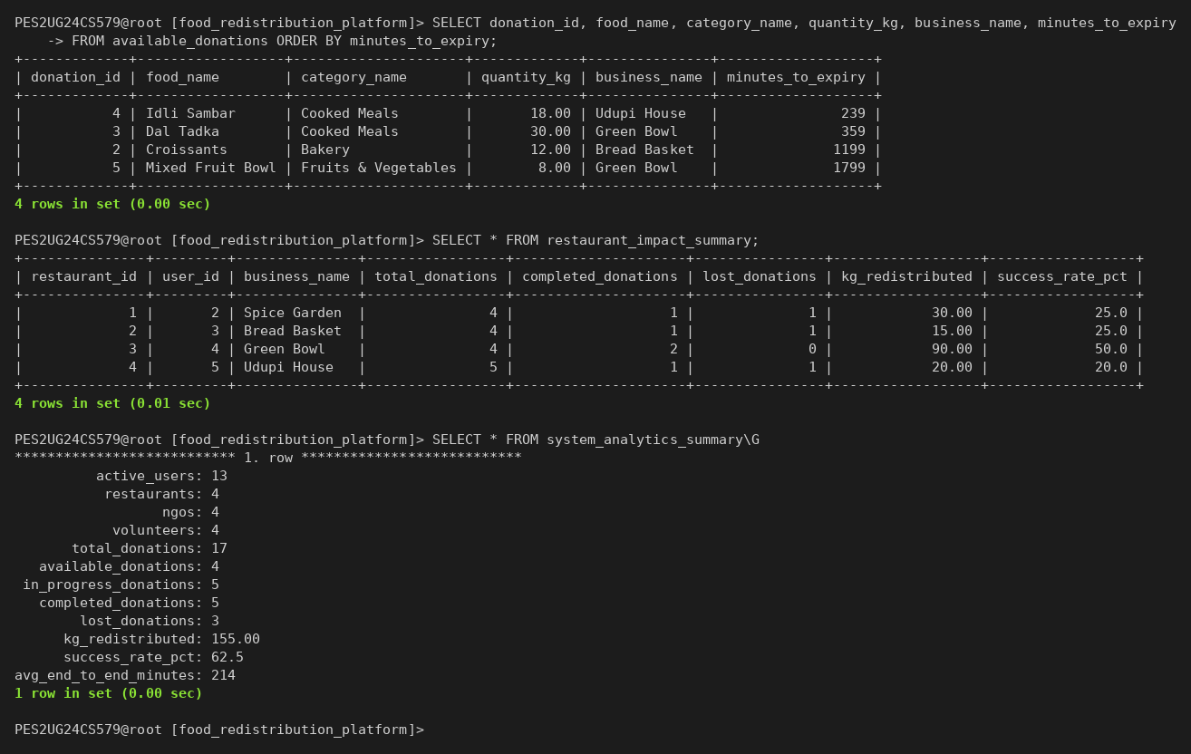

8.4 TRANSACTIONS AND CONCURRENCY
A volunteer claim inserts a pickup and moves the donation to PICKUP_ASSIGNED. Both writes form one transaction. After ROLLBACK, neither write remains. After COMMIT, both remain, and UNIQUE (donation_id) blocks a second claim.

Screenshot 45: Claim transaction rolled back
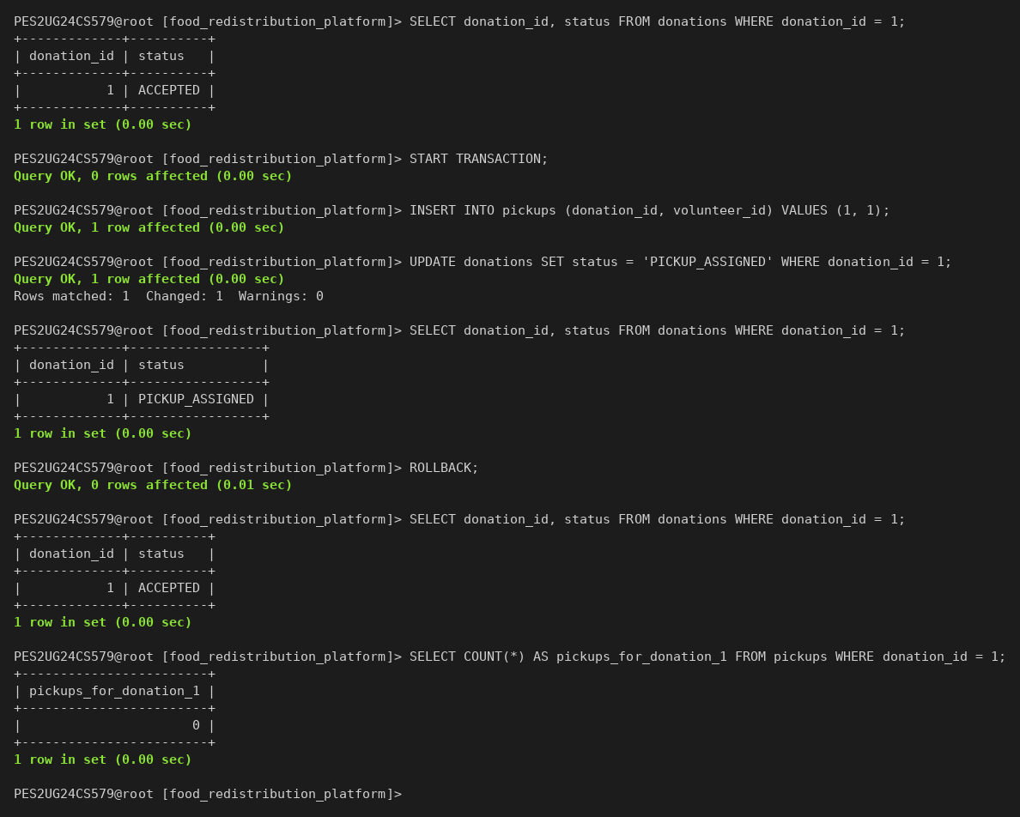

Screenshot 46: Claim transaction committed and a second claim rejected
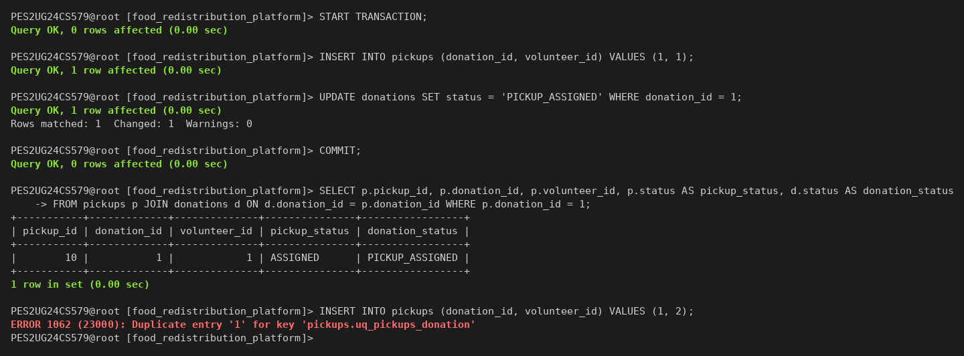
The database test suite opens two connections and calls the procedure for two different requests at the same moment. Exactly one call succeeds. The row lock on the donation makes the second call see ACCEPTED and fail.

Screenshot 47: Database test suite with the concurrent acceptance test
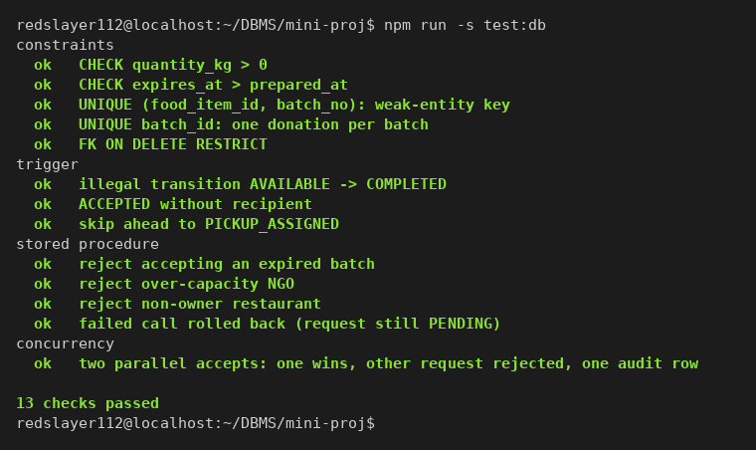

8.5 MONGODB OPERATIONAL NOTES
A pickup note records containers and temperature, and a delivery note records servings. MySQL decides who may read or write the notes of a donation. MongoDB holds only references to MySQL ids, never copies of rows.

Table 17: Collection donation_operational_notes
Field | Type | Meaning
donationId | int | Reference to donations.donation_id in MySQL
eventType | enum | HANDLING_NOTE, PICKUP_NOTE or DELIVERY_NOTE
authorUserId | int | Reference to users.user_id in MySQL
createdAt | date | Time of the note
note | string, at most 1000 characters | Free text
metadata | object | Shape depends on eventType

The index { donationId: 1, createdAt: -1 } serves the notes of one donation. The index { eventType: 1, createdAt: -1 } serves analytics by type. The aggregation pipeline groups notes by type and counts handling flags. The validator rejects a document with an unknown eventType.

Screenshot 48: Collection, indexes and the notes of donation 10
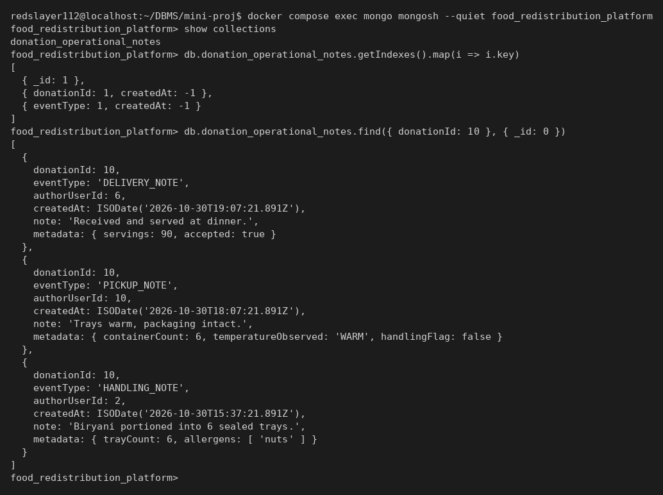

Screenshot 49: Aggregation pipeline and a document rejected by the validator
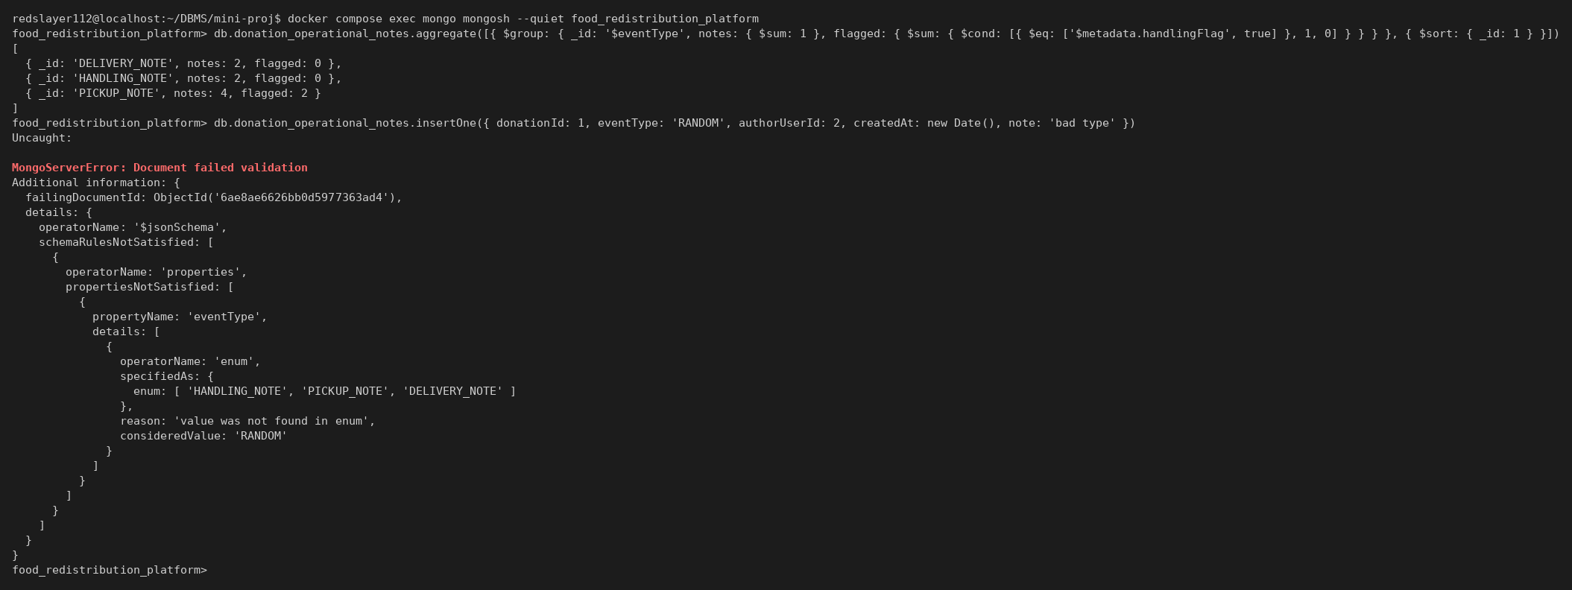

9. FRONT END DEVELOPMENT

9.1 ARCHITECTURE
The browser talks only to Next.js route handlers. Each handler checks the session and the role, validates the input and runs parameterised SQL. Workflow steps run as explicit transactions. Before each transaction the handler sets @app_user_id, so the audit trigger records the real actor.

Figure 3: Application architecture
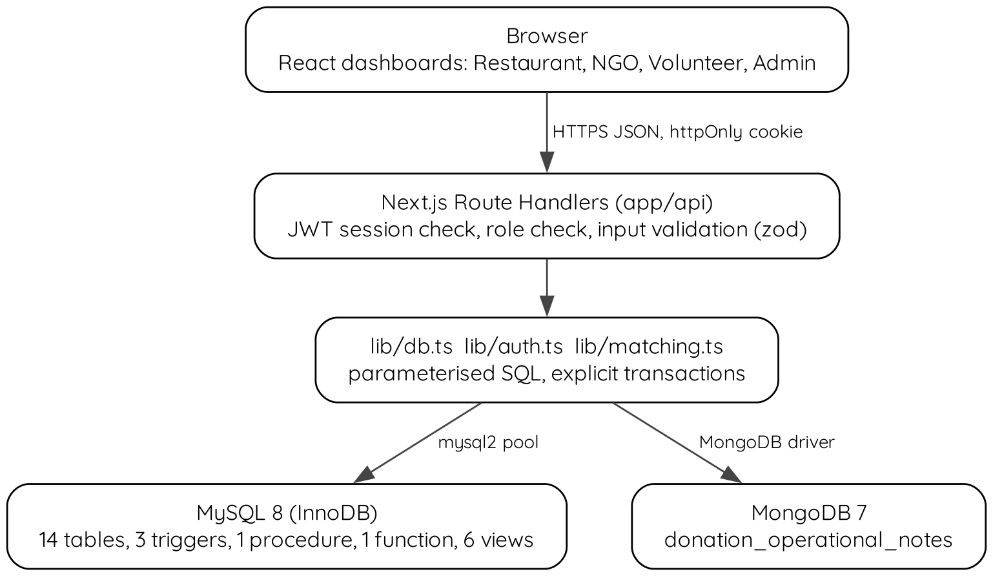

9.2 SECURITY
Passwords are stored as bcrypt hashes with cost 10. A login issues a JWT signed with HS256 in an httpOnly cookie that expires after 8 hours. Every API route checks the role on the server; hiding a button is never the only guard. zod validates every request body, and all SQL uses placeholders. Database credentials and the JWT secret come from a .env file that git ignores.

9.3 API ENDPOINTS

Table 18: Main API endpoints
Endpoint | Role | Database work
POST /api/auth/register | Public | One transaction: user, location, profile and categories
POST /api/auth/login | Public | bcrypt comparison, then a JWT cookie
POST /api/donations | Restaurant | One transaction: food batch and donation
GET /api/donations/{id}/matches | Restaurant, Admin | Matching query
POST /api/donations/{id}/requests | NGO | Eligibility check, then INSERT
POST /api/donation-requests/{id}/accept | Restaurant | CALL sp_accept_donation_request
POST /api/donations/{id}/cancel | Restaurant | Cancel the donation and reject its pending requests
POST /api/pickups/{id}/claim | Volunteer | Insert a pickup and set PICKUP_ASSIGNED
POST /api/pickups/{id}/mark-picked-up | Volunteer | Update pickup and donation, open a delivery
POST /api/pickups/{id}/mark-delivered | Volunteer | Set the delivery and donation to DELIVERED
POST /api/deliveries/{id}/confirm | Recipient NGO | Confirm the delivery and complete the donation
GET, POST /api/donations/{id}/notes | Participants | MongoDB find and insertOne
GET /api/analytics | Any role | Role-specific views and the MongoDB aggregation
POST /api/admin/expire | Admin | Expiry UPDATE, audited by the trigger

9.4 USER INTERFACE
Each role has one dashboard. The screenshots come from a headless browser session on the seed data.

Screenshot 50: Login page with the demo accounts
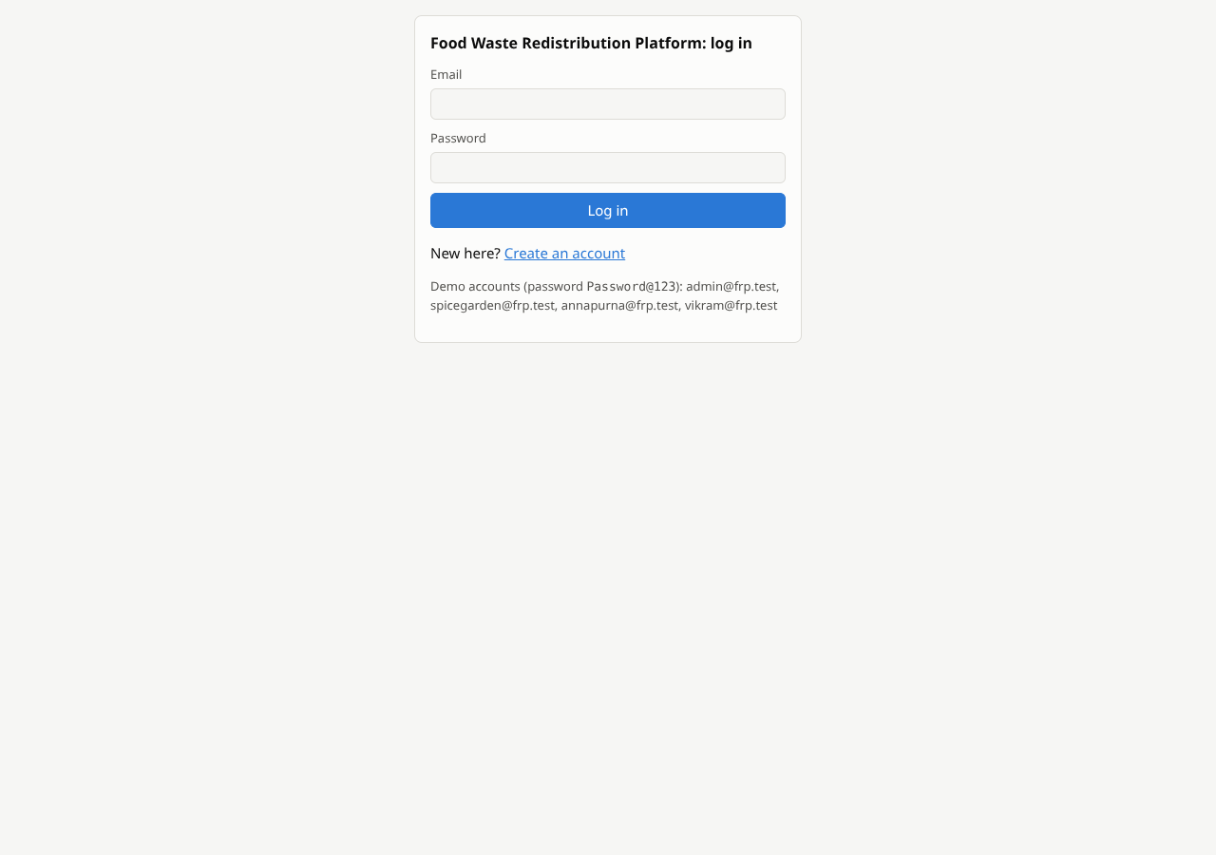

Screenshot 51: Restaurant dashboard with ranked requests for donation 1
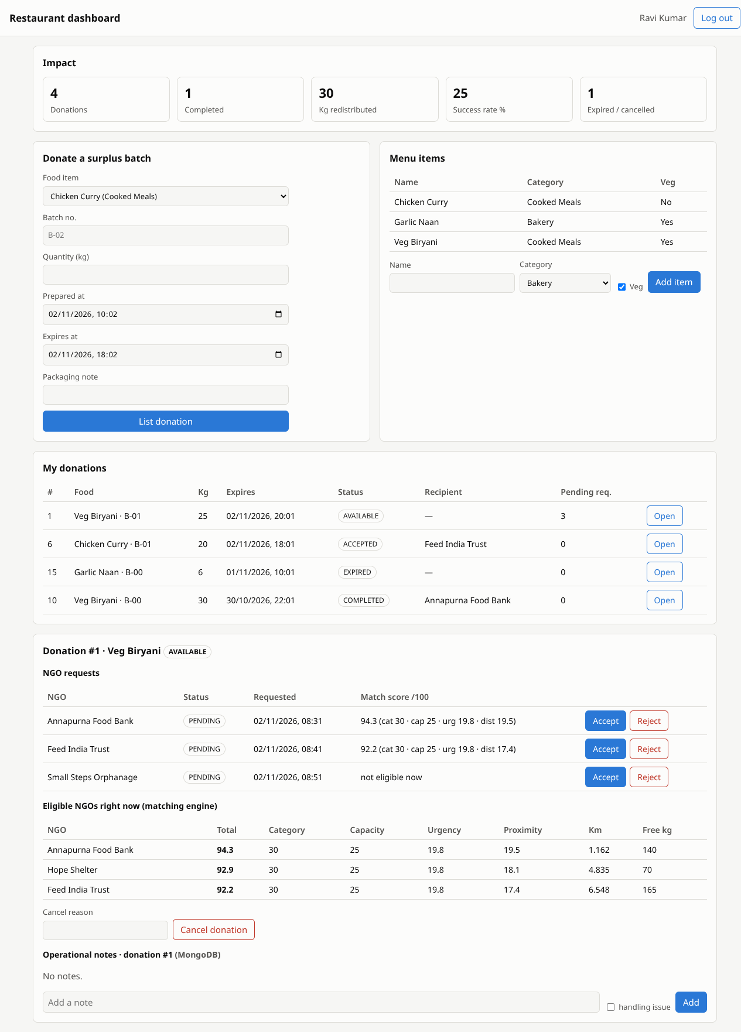

Screenshot 52: NGO dashboard with matched donations and deliveries
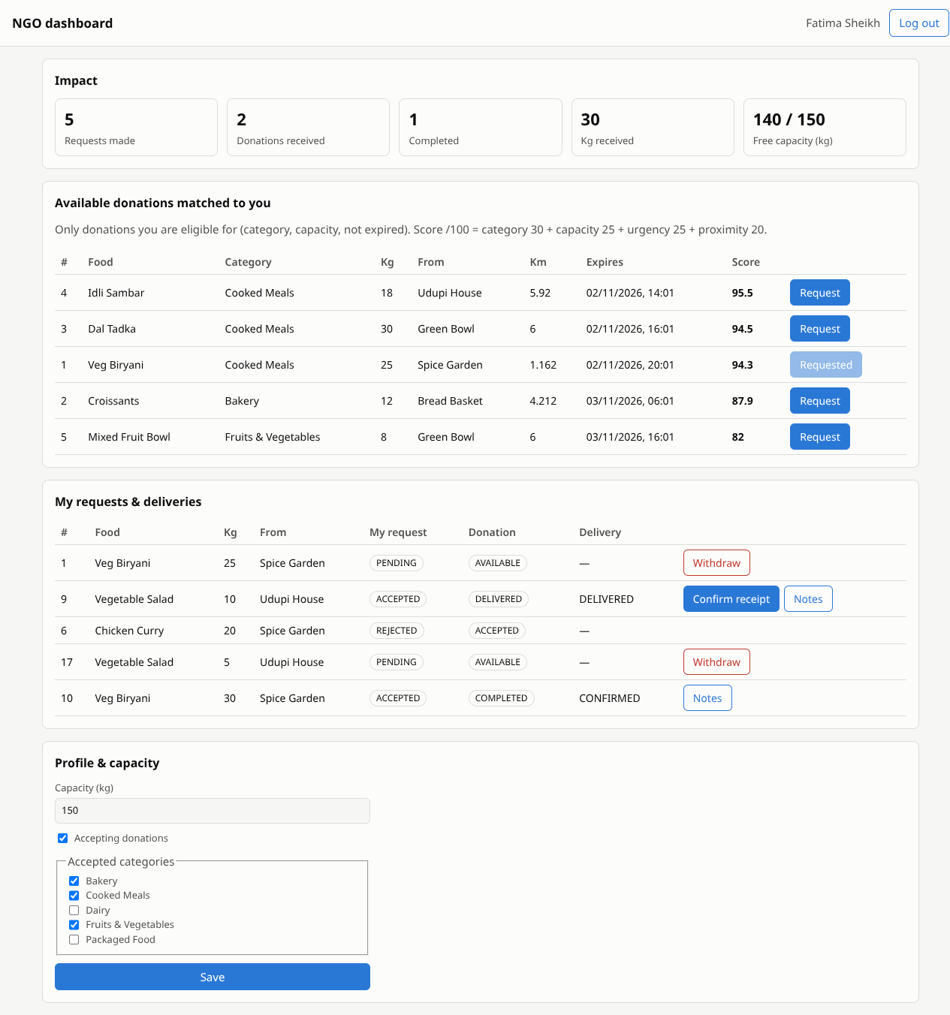

Screenshot 53: Volunteer dashboard with open and own pickups
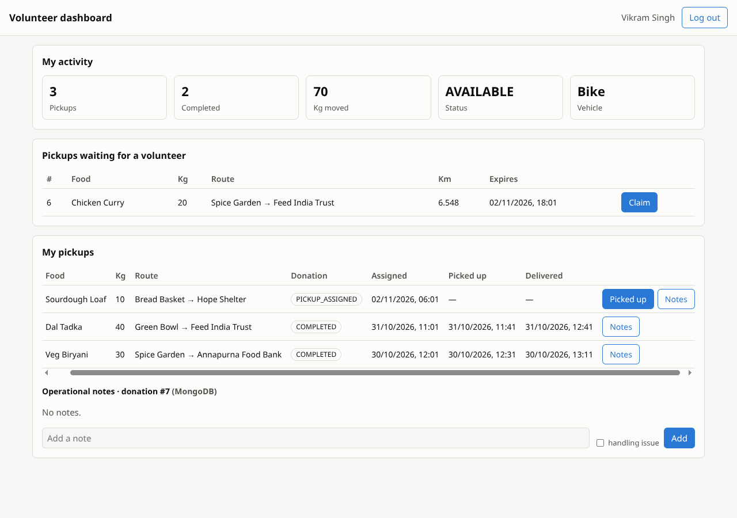

Screenshot 54: Admin dashboard with analytics, audit log and users
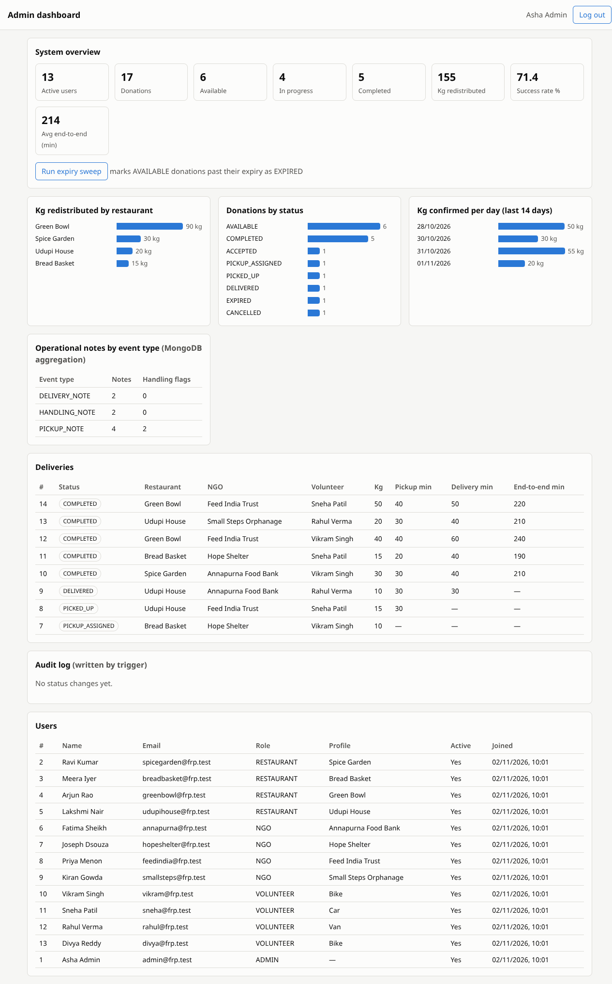

9.5 TESTING

Table 19: Test results
Suite | Checks | Coverage | Result
Database (tests/db.test.mjs) | 13 | Constraints, trigger, procedure, rollback, concurrent acceptance | All passed
End to end (tests/e2e.test.mjs) | 23 | Authentication, role checks, full lifecycle over HTTP, notes, analytics | All passed

Screenshot 55: End-to-end API test over the full donation lifecycle
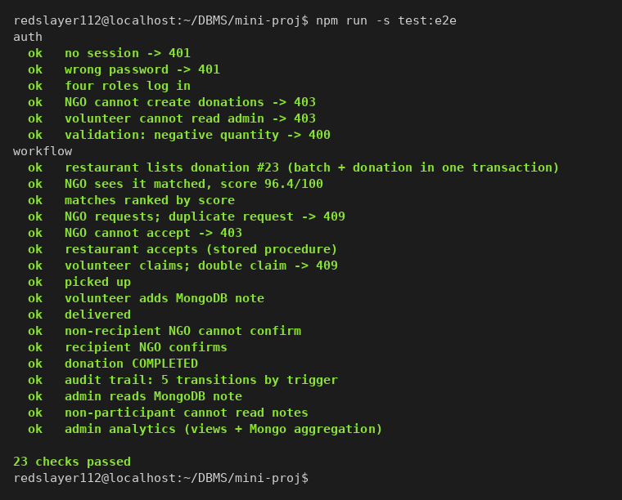

10. CONCLUSION AND FUTURE ENHANCEMENTS

10.1 CONCLUSION
The platform keeps every redistribution rule inside the database. The stored procedure accepts exactly one NGO per donation, also when two restaurants act at the same moment. Triggers block illegal status changes and log each change with its actor. Views compute every statistic from live rows, so no total goes stale. MongoDB holds the notes whose shape varies, while MySQL controls who may read them.

10.2 FUTURE ENHANCEMENTS

Table 20: Future enhancements
Enhancement | Database work
Automatic expiry | A MySQL event runs the expiry UPDATE every 15 minutes, still audited by the trigger
Partial acceptance of a batch | A new relation splits one donation into quantities for several NGOs
Volunteer routing | A location for each volunteer, and pickups ranked with fn_haversine_km
Notifications | An outbox table filled by a trigger and read by a background worker
Trend reports | Monthly summary tables refreshed from the existing views

REFERENCES
[1] R. Elmasri and S. B. Navathe, Fundamentals of Database Systems, 7th ed. Pearson, 2016. Chapter 9: Relational Database Design by ER-to-Relational Mapping.
[2] Oracle, MySQL 8.0 Reference Manual. https://dev.mysql.com/doc/refman/8.0/en/
[3] MongoDB, Inc., MongoDB Manual: Schema Validation. https://www.mongodb.com/docs/manual/core/schema-validation/
[4] Vercel, Next.js Documentation: Route Handlers. https://nextjs.org/docs/app/api-reference/file-conventions/route
GitHub Link: https://github.com/Redslayer112/DBMS-miniproject

APPENDIX A: DEFINITIONS, ACRONYMS AND ABBREVIATIONS
Term | Meaning
3NF | Third normal form: no non-key attribute depends on another non-key attribute
API | Application programming interface
bcrypt | Slow, salted password hashing function
CTE | Common table expression, the WITH clause of SQL
DDL | Data definition language: CREATE, ALTER, DROP
DML | Data manipulation language: INSERT, UPDATE, DELETE, SELECT
ER | Entity-relationship
FK | Foreign key
Haversine | Formula for the great-circle distance between two coordinates
InnoDB | MySQL storage engine with transactions, row locks and foreign keys
JWT | JSON Web Token, a signed session token
NGO | Non-governmental organisation
PK | Primary key
SQLSTATE 45000 | User-defined error state raised with SIGNAL

