SE Lab 4: Vibe Coding (Battleship vs AI)
Name: Venkata Srivaibhav Nukaraju
SRN: PES2UG24CS579
Section: 5 J
Course: UE24CS341A Software Engineering

1. Links
Item | Link
Assigned repo | https://github.com/SETAPESU26/19_battleship
GitHub repo (submission) | https://github.com/Redslayer112/SELAB/tree/main/Lab-4
ChatGPT chat history | https://chatgpt.com/share/6ad07296-98d0-83ec-a4dd-e59007d04197

2. Defects and Changes
The original AI returns 1-based strings, and the game reads them as 0-based tuples. Every AI shot lands one row and one column off, so the AI reports false hits. The ship counter subtracts the wrong shot set, so it never drops. The game loop stops after the AI shot and never records it on the player board.
Prompt | Task | Change
1 | Task 1: coordinates | AI returns 0-based tuples; AI shots hit the player board; counter and loss check fixed
2 | Task 2: fleet and win | Three ships per side (3, 2, 2); per-ship damage; sunk messages; game ends when a fleet sinks
3 | Tasks 3 and 4: AI and feedback | AI targets untried neighbours of hits; returns None on a full board; one message per real shot

3. Updated Code

main.py
from game import Battleship
if __name__ == "__main__":
Battleship().run()

game.py
from board import Board
from ai import AI
class Battleship:
def __init__(self):
self.player = Board()
self.enemy = Board()
self.ai = AI()
self._setup()
def _setup(self):
# All positions are 0-based (row, col).
# Player fleet: sizes 3, 2, 2.
self.player.place_ship({(0, 0), (0, 1), (0, 2)})
self.player.place_ship({(2, 0), (2, 1)})
self.player.place_ship({(4, 3), (4, 4)})
# Enemy fleet: sizes 3, 2, 2.
self.enemy.place_ship({(1, 1), (1, 2), (1, 3)})
self.enemy.place_ship({(3, 0), (3, 1)})
self.enemy.place_ship({(5, 3), (5, 4)})
def show(self):
print("\nYour shots are coordinates like 2,3.")
print("Enemy ship cells remaining:", self.enemy.remaining_cells())
def _report_shot(self, result, shooter):
status, sunk_size = result
if status == "miss":
print(f"{shooter}: MISS!")
elif status == "hit":
print(f"{shooter}: HIT!")
elif status == "sunk":
print(f"{shooter} sank a ship of size {sunk_size}.")
elif status == "repeat":
print("Already fired there.")
def run(self):
print("Battleship")
while True:
self.show()
raw = input("> ").strip().lower()
if raw == "q":
return
try:
r, c = map(int, raw.split(","))
pos = (r - 1, c - 1)
except ValueError:
print("Use row,col.")
continue
if not (
0 <= pos[0] < Board.SIZE
and 0 <= pos[1] < Board.SIZE
):
print("Outside board.")
continue
if pos in self.enemy.shots:
print("Already fired there.")
continue
# Player's shot: resolve and report exactly once.
result = self.enemy.fire(pos)
self._report_shot(result, "You")
if self.enemy.all_sunk():
print("You sank the entire enemy fleet. You win!")
return
# AI chooses a coordinate without printing anything.
ai_pos = self.ai.choose()
if ai_pos is None:
print("AI has no remaining shots.")
continue
print(f"AI fired at {ai_pos[0] + 1},{ai_pos[1] + 1}")
# Resolve the actual shot before informing the AI.
result = self.player.fire(ai_pos)
self.ai.observe(ai_pos, result)
# Only game.py reports the result.
self._report_shot(result, "AI")
if self.player.all_sunk():
print("Your entire fleet has been sunk. AI wins!")
return

board.py
class Board:
SIZE = 6
def __init__(self):
self.ships = []
self.shots = set()
def place_ship(self, cells):
cells = set(cells)
if not cells:
raise ValueError("A ship must contain at least one cell.")
for r, c in cells:
if not (0 <= r < self.SIZE and 0 <= c < self.SIZE):
raise ValueError("Ship cell is outside the board.")
for ship in self.ships:
if cells & ship["cells"]:
raise ValueError("Ships cannot overlap.")
self.ships.append({
"cells": cells,
"hits": set()
})
def fire(self, pos):
# Return (status, sunk_size).
# status: "miss", "hit", "sunk", or "repeat".
if pos in self.shots:
return ("repeat", None)
self.shots.add(pos)
for ship in self.ships:
if pos in ship["cells"]:
ship["hits"].add(pos)
if ship["hits"] == ship["cells"]:
return ("sunk", len(ship["cells"]))
return ("hit", None)
return ("miss", None)
def remaining_cells(self):
return sum(
len(ship["cells"] - ship["hits"])
for ship in self.ships
)
def all_sunk(self):
return all(
ship["hits"] == ship["cells"]
for ship in self.ships
)

ai.py
import random
class AI:
def __init__(self, size=6):
self.size = size
self.tried = set()
self.hits = set()
def choose(self):
# Never choose a coordinate that was already tried.
options = [
(r, c)
for r in range(self.size)
for c in range(self.size)
if (r, c) not in self.tried
]
if not options:
return None
# Prefer untried cells adjacent to previous hits.
targets = set()
for r, c in self.hits:
for nr, nc in (
(r - 1, c),
(r + 1, c),
(r, c - 1),
(r, c + 1),
):
if (
0 <= nr < self.size
and 0 <= nc < self.size
and (nr, nc) not in self.tried
):
targets.add((nr, nc))
candidates = list(targets) if targets else options
pos = random.choice(candidates)
# Reserve the coordinate immediately to prevent repeats.
self.tried.add(pos)
return pos
def observe(self, pos, result):
# Called only after the actual shot has been resolved.
status, _ = result
if status == "hit":
self.hits.add(pos)
elif status == "sunk":
# The current hit completed a ship.
self.hits.discard(pos)

4. Output Screenshots
Both runs use random seed 10, so the AI draws the same first cell. Before the fix, the AI shot at 1,3 counts as a hit on an empty cell. After the fix, the same shot is a real hit on the new fleet.

Screenshot 1: Before, false AI hit and stuck counter
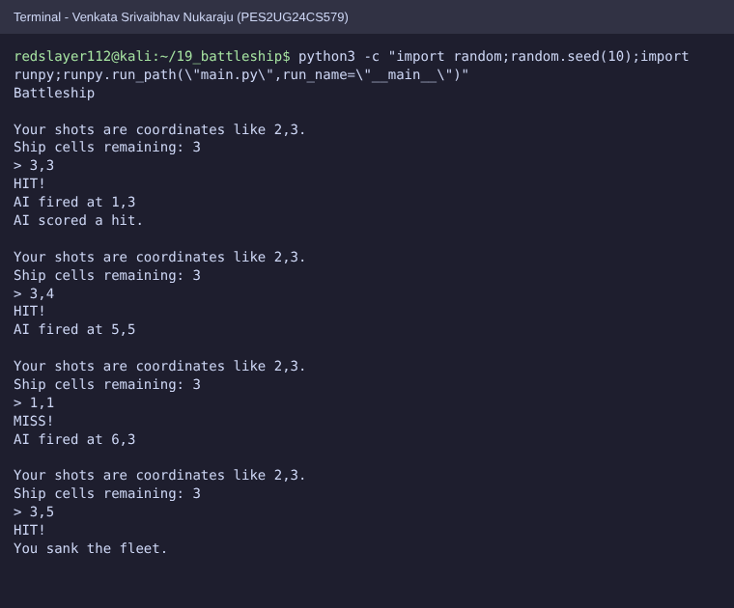

Screenshot 2: After, full game with sunk ships and AI adjacent targeting
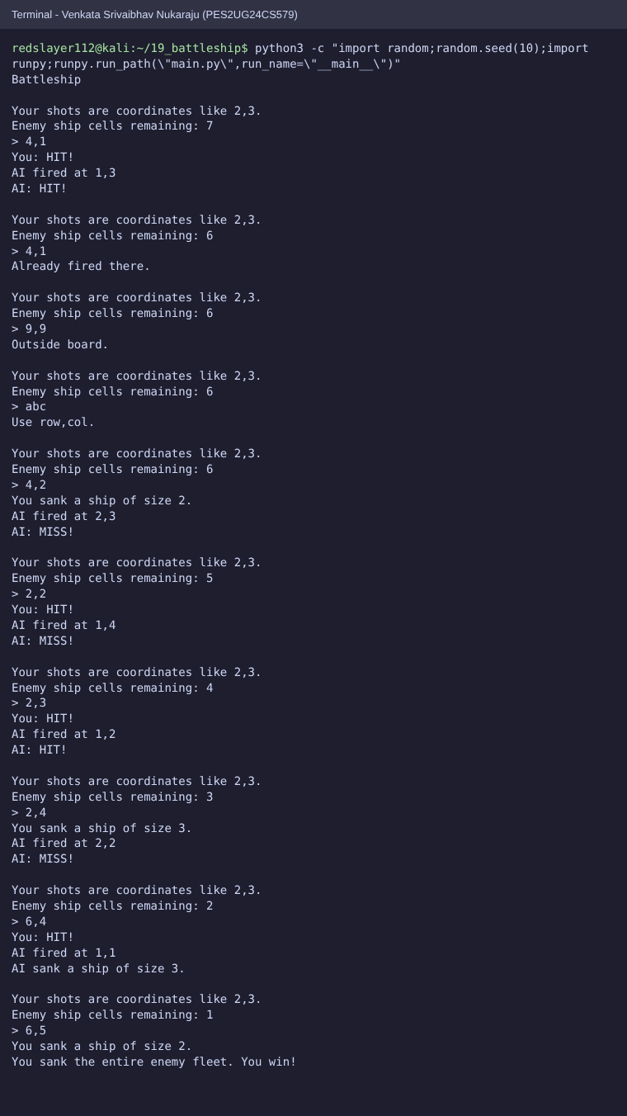

Screenshot 3: After, invalid input and quit
