SE Lab 5: Static Code Analysis
Name: Venkata Srivaibhav Nukaraju
SRN: PES2UG24CS579
Section: 5 J
Course: UE24CS341A Software Engineering

1. Links
Assigned repository: https://github.com/SETAPESU26/L5_19_music_catalog
Script: music_catalog.py. The program stores songs in SQLite, rates popularity, picks a random song and saves playlists.
Three commits fix the findings of Bandit, Pylint and Flake8, one commit per tool.
Commit | Tool | Change
c549d7a | Bandit | Parameterised SQL, JSON instead of pickle, secrets.choice
5792ba0 | Pylint | Docstrings, snake_case names, mutable default, bare except, main guard
5d9aea5 | Flake8 | Line wrapping, final reports, issue table, reflection

2. Issue Table
Issue | Type | Line(s) | Description | Fix Approach
SQL injection (B608) | Security, Medium | 10 | addSong builds the INSERT with % formatting, so a title such as x'); DROP TABLE songs;-- alters the query | Use ? placeholders and pass a parameter tuple
Unsafe pickle load (B301) | Security, Medium | 33 | pickle.loads runs arbitrary code from untrusted bytes | Store playlists as JSON with json.dumps and json.loads
Pickle import (B403) | Security, Low | 1 | Import of pickle flagged | Remove the import and use json
Weak random (B311) | Security, Low | 17 | random.choice is not a secure generator | Use secrets.choice
Mutable default arg (W0102) | Bug | 9 | playlist=[] is shared across calls, so unrelated playlists mix | Default to None and create a new list in the function
Bare except (W0702, E722) | Bug | 39 | except: hides every error, including KeyboardInterrupt | Catch sqlite3.Error
Naming (C0103) | Style | 9, 15, 28, 32, 36 | camelCase function names break PEP 8 | Rename to add_song, shuffle_pick, save_playlist, load_playlist, total_plays
Missing docstrings (C0114, C0116) | Style | 1, 9, 15, 20, 28, 32, 36, 43 | Module and functions have no docstring | Add one-line docstrings
Unnecessary else (R1705) | Style | 22 | else follows a return | Remove the else and de-indent
Ambiguous name (E741) | Style | 47 | Variable l looks like 1 | Rename to loaded
Multiple statements (E701, C0321) | Style | 48 | if and print share one line | Put print on its own line
Line too long (E501, C0301) | Style | 6, 10, 21, 49 | Lines exceed 79 characters | Wrap the lines
F-string suggestion (C0209) | Style | 10 | % formatting on a regular string | Resolved by the parameterised query
Import-time run | Design | 52 | main() runs on import | Guard with if __name__ == "__main__":

3. Results
Tool | Before | After
Pylint score | 4.57/10 | 10.00/10
Pylint messages | 19 | 0
Bandit issues (Medium / Low) | 2 / 2 | 0 / 0
Flake8 violations | 7 | 0

The program prints the same output before and after the fixes, apart from the random song id.
The before and after reports are in the repository: before/ holds the first run and the root folder holds the final run.

4. Output Screenshots
The screenshots are rendered headless from the real command output, so the window focus stays unchanged.

Screenshot 1: Program run before the fixes

Screenshot 2: Pylint before the fixes
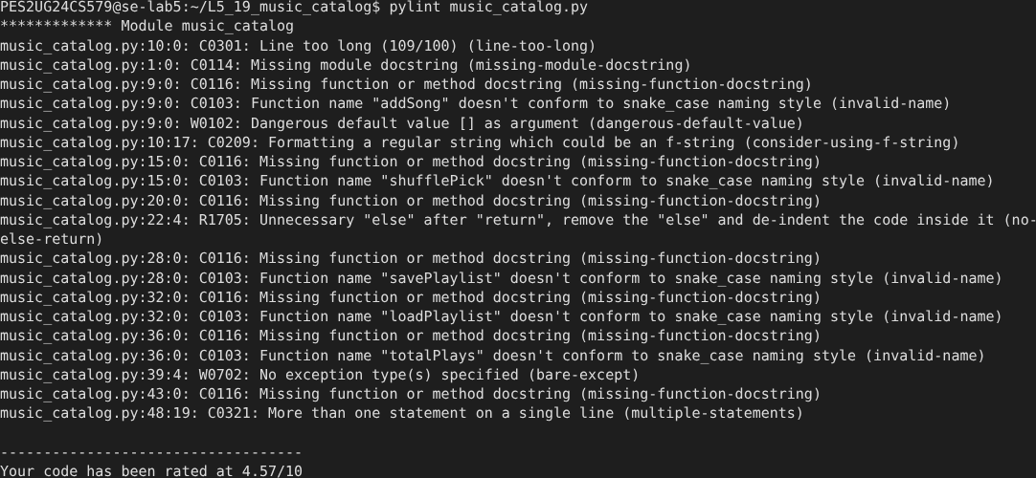

Screenshot 3: Bandit before the fixes
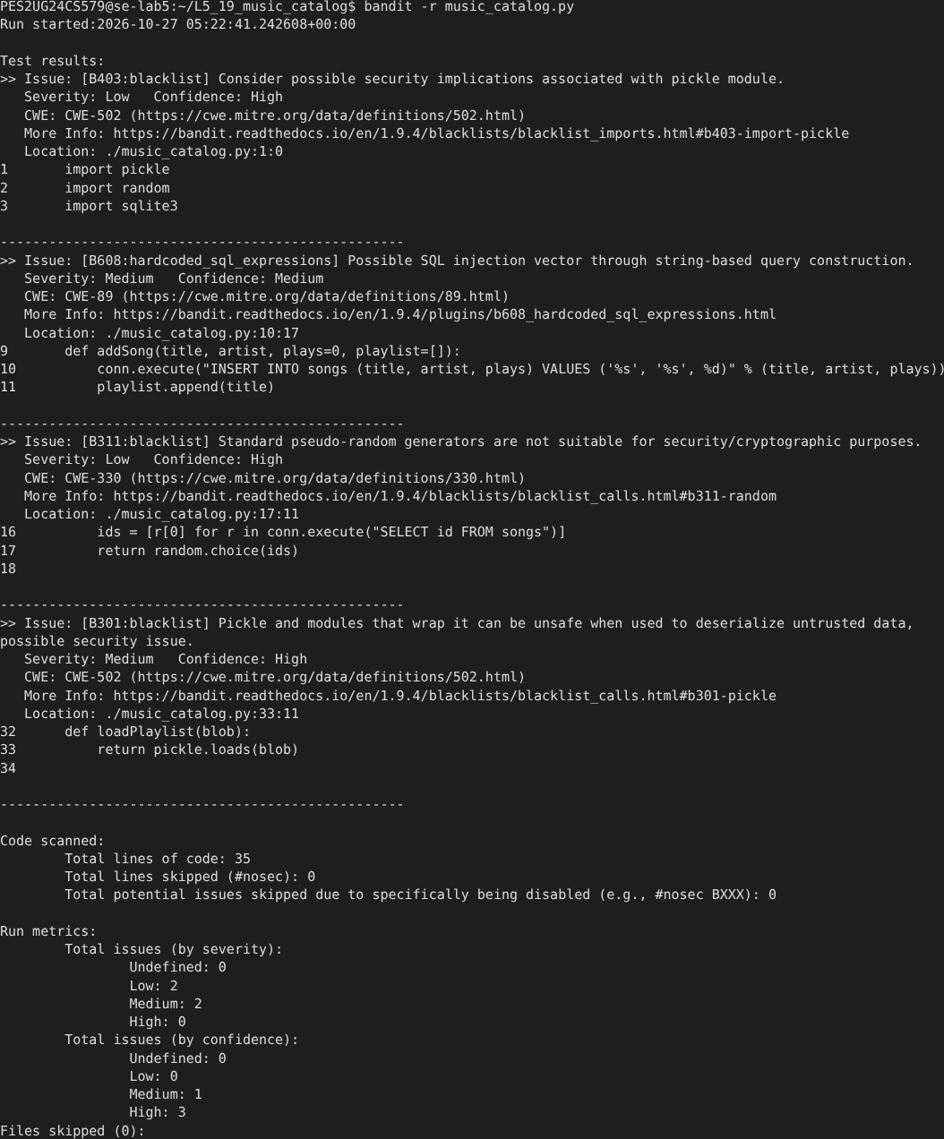

Screenshot 4: Flake8 before the fixes
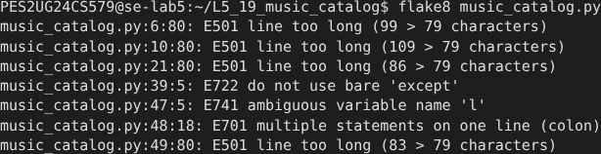

Screenshot 5: Program run after the fixes

Screenshot 6: Pylint after the fixes

Screenshot 7: Bandit after the fixes
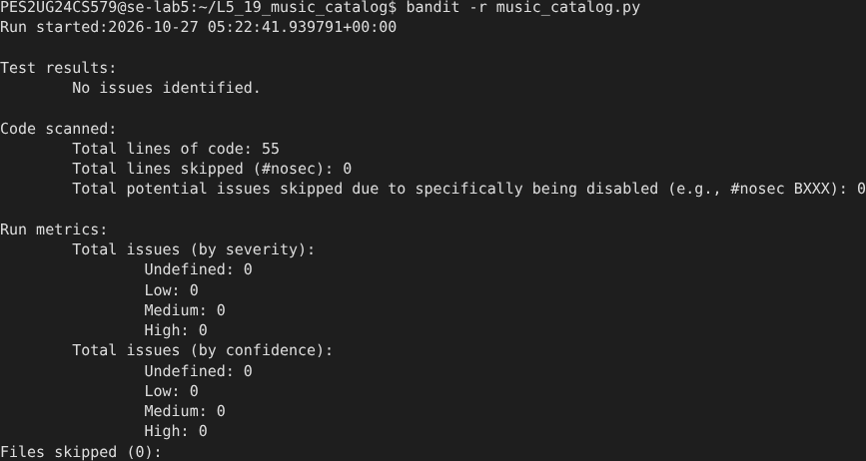

Screenshot 8: Flake8 after the fixes

Screenshot 9: Git log with the three fix commits
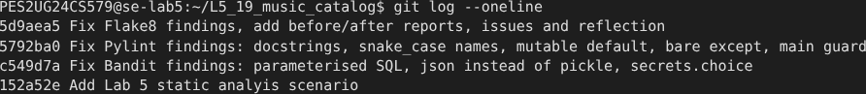

5. Reflection

1. Which issues did the tools find that manual inspection could miss?
Bandit flagged the pickle load and the string-built SQL at once. Pylint found the shared mutable default `playlist=[]`. A quick read shows working output, so these defects stay hidden until a second call or hostile input exposes them.

2. Which tool gave the most useful findings?
Bandit gave the most serious findings, because it reported two Medium security issues. Pylint gave the widest coverage and a score. Flake8 reported only style, but its rules are strict and fast to apply.

3. Were there false positives or low-value findings?
The Low findings for the `pickle` import and for `random` need context. A music shuffle is not a security use. The change to `secrets.choice` costs nothing, so the fix stays. The docstring and naming messages improve readability but do not change behaviour.

4. How does static analysis change the development workflow?
The tools run in seconds and give a repeatable check before review. A team can run them in a commit hook or in continuous integration. Reviewers then spend time on logic instead of style. The tools do not replace tests, because they cannot prove that the program is correct.

