SE Lab 6: Code and Branch Coverage
Name: Venkata Srivaibhav Nukaraju
SRN: PES2UG24CS579
Section: 5 J
Course: UE24CS341A Software Engineering

1. Links
Assigned repository: https://github.com/SETAPESU26/L6_L7_19_parking_fee
Module: parking_fee.py. The module computes parking fees, assigns slots and prices monthly passes.
Test files: CodeCoverageTest_PES2UG24CS579_parking_fee.py and BranchCoverageTest_PES2UG24CS579_parking_fee.py.
Two commits add the test files and the screenshots, one commit per coverage stage.

2. Coverage Results
Test stage | Tests | Line coverage | Branch coverage | Missing
Starter tests | 2 | 44% | 40% | 6, 8, 12-15, 17, 19, 25, 27, 29, 34-42
Code coverage tests | 11 | 100% | 98% | 13->15
Branch coverage tests | 18 | 100% | 100% | None
The figures apply to parking_fee.py, which holds 34 statements and 24 branches.

3. Analysis
The starter tests reach only the free-stay path and the default slot. The code coverage tests add one test for each missed line, including both ValueError paths. One test with 90 minutes, an EV and a lost ticket runs lines 12 to 19.
Line coverage reaches 100%, but branch coverage stays at 98%. Branch 13->15 shows that the condition minutes % 60 != 0 never evaluates to False. Every charged test uses a partial hour, so the exact-hour path never runs. The 120-minute test closes this gap.
The branch tests also check the 30 and 31 minute boundary and the EV truck case. Another test checks a full lot with a disabled driver. Coverage.py counts a compound condition as one branch, so the EV truck test does not change the number. It still confirms that a truck gets no EV discount.

4. Output Screenshots
The screenshots are rendered headless from the real command output, so the window focus stays unchanged.

Screenshot 1: Line coverage with the code coverage tests
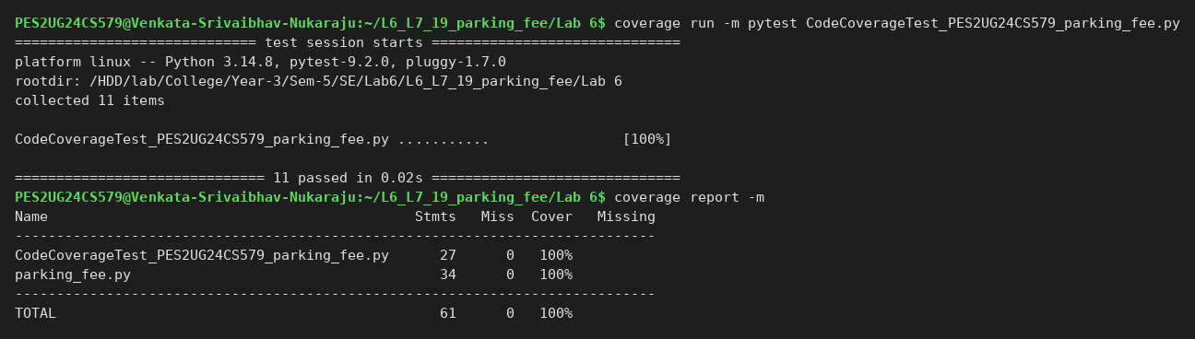

Screenshot 2: Branch coverage with the code coverage tests
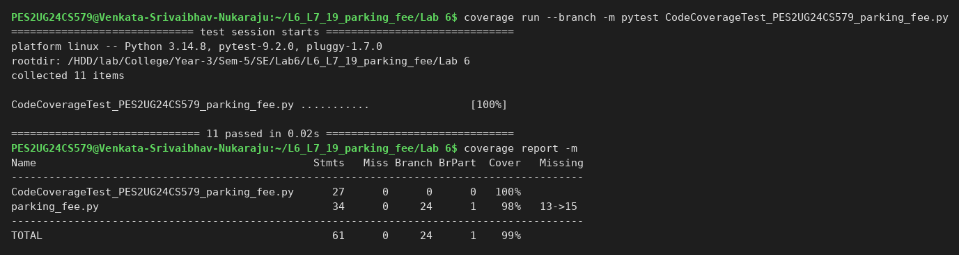

Screenshot 3: Line coverage with the branch coverage tests
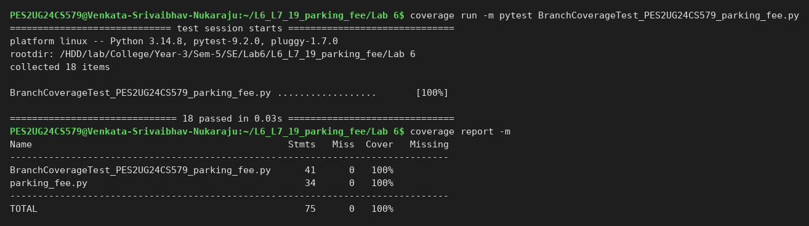

Screenshot 4: Branch coverage with the branch coverage tests
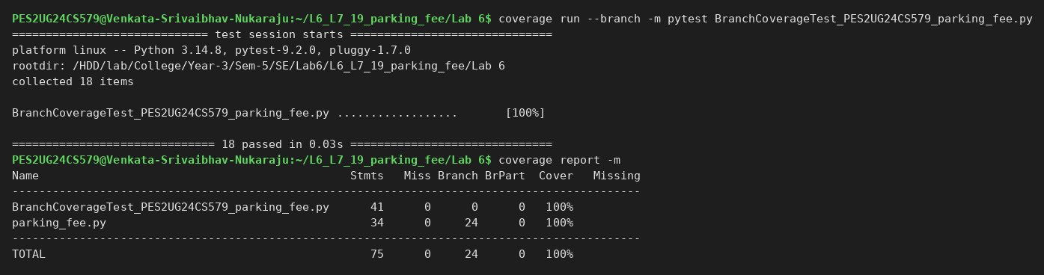

Screenshot 5: Git log with the two coverage commits


