Software Requirements Specification
Traffic Management System (Simulation)
Document control | Value
Course | Software Engineering UE24CS341A
Institution | PESU
Document edition | 1.1 - consolidated to Baseline Amendment v1.1
Normative baseline | SRS normative baseline 1.0 (as designated by the approved amendment)
Revision date | 6 November 2026
Authors | Venkata Srivaibhav Nukaraju (PES2UG24CS579); V Vyas (PES2UG24CS569); Vikas N Naik (PES2UG24CS583); Vikhyath Bharadwaj K S (PES2UG24CS586)
Status | Consolidated for submission; approval claims limited to recorded team decision

Revision history
Edition | Date | Change | Approval
0.2 | 2026-09-07 | Simplified SRS finalized for implementation and review; retained as history. | Pending in original record
1.0 | 27 October 2026 | Approved baseline decisions; authoritative SRS revision designated 1.0. | Team decision recorded
1.1 | 6 November 2026 | Consolidated edition incorporating Baseline Amendment v1.1; does not claim new faculty approval. | No new approval claimed

Course Coordinator approval is not recorded in the source documents reviewed.

1 Introduction

1.1 Purpose and scope
This specification defines requirements for TMS-Sim, a software-only microscopic road-traffic simulator for designing and evaluating fixed-time signal strategies. It covers interactive network modelling, fixed-time signals, seeded traffic demand, fixed-step simulation, 2D visualization, metrics, run comparison and export, and a local scenario library. The application is local and single-Analyst for v1.
Out of scope: real traffic signals, sensors or field hardware; 3D and distributed simulation; advanced lane changing; calibration against field measurements; public transport, pedestrian or cyclist micro-simulation. User accounts, roles, administration and an audit log are deferred and out of scope for v1.

1.2 Audience and terms
Readers are the development team, Project Guide, Course Coordinator, evaluators, future maintainers, QA/testers and traffic analysts. FR/NFR mean functional/non-functional requirement; RTM is Requirements Traceability Matrix; MOE is Measure of Effectiveness; PRNG/seed is pseudo-random generator/initial value; FPS is visualization frames per second; real-time factor is simulated seconds per wall-clock second.
Term | Definition
Delay | Extra travel time versus free-flow travel on the same path.
Throughput | Vehicles completing their assigned route during the simulated period.
Free-flow time | Route distance divided by each segment's speed limit.
Reference hardware | 4-core Intel Core i5-11400H at 2.70 GHz, 16 GB RAM.

1.3 References
- IEEE Std 830-1998; UE24CS341A requirements engineering material and SRS template.
- Treiber, Hennecke and Helbing (2000), Congested traffic states in empirical observations and microscopic simulations.
- Approved team decision: Decision Record 0001; amendment: Baseline Amendment v1.1.

2 Overall description

2.1 Product and user
TMS-Sim is a self-contained desktop workbench. The Analyst edits networks, configures signals and demand, runs simulations and interprets results. The Simulation Engine is an internal component, not a user role.

2.2 Environment and constraints
- Windows 10/11; keyboard, mouse or trackpad; display at least 1366 x 768.
- Python 3.11 + PySide6; local SQLite through stdlib sqlite3 for scenarios and completed runs.
- Versioned JSON schema_version 1.0 for scenario exchange; CSV for summary export; no internet needed for normal use.
- One documented car-following model, a simple gap-acceptance rule, 2D only, single-machine execution; safe signal validation; one seedable PRNG.
- Users may provide network data or use bundled scenarios; correctness is against the documented model, not field data.

3 External interfaces

3.1 User interface
One workbench window has a central network canvas, inspector, toolbox, simulation controls (start/pause/step/reset/speed/clock) and dockable results dashboard. Direct manipulation edits intersections, segments and properties. Validation issues appear in a list and can highlight the affected element. The dashboard shows live time-series charts and post-run summary tables/charts.

3.2 Hardware, software and communications
Interface | Requirement
Hardware | Standard PC, display, keyboard and pointing device; no traffic field devices; discrete GPU optional.
Local data | SQLite for library and runs; JSON full-scenario import/export; CSV summary export.
Communications | No network communication is required.

4 System features
The retained identifiers match docs/rtm_draft.csv and docs/test_catalogue.md. TMS-F-021 and TMS-F-031 are retired with no requirement text; no replacement requirements are created.

4.1 Network modelling
Requirement / test | Requirement and acceptance criteria
TMS-F-010 / TC-NET-01 | Create/edit a directed graph of intersections and road segments. Segments carry length, lane count, direction and speed limit. AC-010: save/reload preserves every element and attribute.
TMS-F-011 / TC-NET-02 | Assign intersection control as signalized, stop, yield or uncontrolled and define permitted turns per approach. AC-011: only defined movements are available.
TMS-F-012 / TC-NET-03 | Validate before run and block disconnected graphs, zero-length/zero-lane segments and turns without receiving lanes; list every error. AC-012: specific located errors and disabled Run action.
TMS-F-013 / TC-NET-04 | Import/export complete network, signal plans and demand as one version-tagged JSON scenario. AC-013: export/import on a clean installation reproduces the scenario.

4.2 Signal configuration
Requirement / test | Requirement and acceptance criteria
TMS-F-020 / TC-SIG-01 | Define ordered fixed-time phases for each signalized intersection with green, yellow and all-red durations. AC-020: editor shows each phase and timing value.
TMS-F-022 / TC-SIG-02 | Reject invalid phase timings or movements conflicting while green. AC-022: each seeded error is reported and the invalid plan cannot be used.

4.3 Traffic demand
Requirement / test | Requirement and acceptance criteria
TMS-F-030 / TC-DEM-01 | Specify entry-segment arrival rates in vehicles/hour and turning ratios. Schema: demand.arrival_rates_vehicles_per_hour maps entry segment to rate >= 0; demand.turning_ratios maps movement id to ratio, summing to 1 within 1e-6 per entry. AC-030: generated entry counts are reasonably consistent; the approved baseline does not define a numeric tolerance, so the test procedure must state it before evaluation.
TMS-F-032 / TC-DEM-02 | Use one seedable pseudo-random stream. AC-032: same scenario and seed produce identical vehicle arrivals and metrics.

4.4 Simulation and controls
Requirement / test | Requirement and acceptance criteria
TMS-F-040 / TC-SIM-01 | Advance fixed steps and update vehicles using the documented model. IDM parameters: v0=segment speed limit, a_max=1.5 m/s2, b=2.0 m/s2, s0=2.0 m, T=1.5 s, braking floor=9 m/s2; vehicle length=5.0 m; trapezoidal position update. Only green is green; yellow/all-red are red, except a vehicle physically unable to stop may clear on yellow. Stop/yield gap=3.0 s. AC-040: follow these rules and do not cross a red signal.
TMS-F-041 / TC-SIM-02 | Provide start, pause, step, reset and speed controls. Implemented baseline multipliers are 0.5x, 1x, 2x and 4x (Issue #7 scope); original draft 8x/unbounded values are not retained. AC-041: pause freezes, step advances one step, reset returns t=0.
TMS-F-042 / TC-SIM-03 | Set total simulated duration; stop automatically at the configured time and finalize metrics. AC-042: stop within one step and persist metrics exactly once.
TMS-F-043 / TC-SIM-04 | Render top-down 2D network, vehicles, signals and queues with pan/zoom. AC-043: view matches engine state and pan/zoom work.

Conflict/coordinate constraints: crossing or merging paths conflict. Same-approach exception is only for different receiving segments; different approaches into one receiving segment conflict. Missing position is a located validation error. Traffic is left-hand; model coordinates y-up and the UI converts screen coordinates.

4.5 Metrics, results and reporting
Requirement / test | Requirement and acceptance criteria
TMS-F-050 / TC-MET-01 | Compute average/maximum vehicle delay, average queue per approach, throughput, average speed and average travel time for completed runs. Operational definitions aligned with docs/issue10_acceptance.md: delay is max(0, travel minus speed-limit free-flow time) for completed trips only; queue means speed below 0.5 m/s; throughput is completed unique trips per simulated hour. AC-050: independent recomputation agrees within documented rounding; unavailable differs from zero.
TMS-F-051 / TC-MET-02 | Display key live metrics and post-run summary. AC-051: live values update and final dashboard matches final metrics.
TMS-F-052 / TC-MET-03 | Persist each completed run with scenario, seed, configuration and metrics. AC-052: reload and display the run.
TMS-F-053 / TC-MET-04 | Select and compare two completed runs. AC-053: show both metric values and differences.
TMS-F-054 / TC-MET-05 | Export run summary to CSV. AC-054: CSV contains headers and displayed metrics.

4.6 Scenario library
Requirement / test | Requirement and acceptance criteria
TMS-F-060 / TC-LIB-01 | Save, list, load, rename and delete named scenarios. AC-060: list reflects each operation and survives restart.

5 Non-functional requirements
The approved amendment sets the measurable run definitions below. Where operational pass details are absent, the gap is stated rather than filled with an invented criterion.
ID / test | Requirement and measurable basis
TMS-NF-001 / TC-PERF-01 | On reference hardware, run fixtures/valid/performance_10_intersections.json (up to 10 intersections, configured 500 veh/h) for one simulated hour. Average FPS over the complete hour >=15. The catalogue uses seed 42, 1x and paint interval formula (frames-1)/wall seconds between first and last paint.
TMS-NF-002 / TC-REL-01 | Three clean one-hour runs per approved Issue #1 decision. 'Clean' is not operationally defined in the amendment; mode, seeds and interruption handling remain for clarification.
TMS-NF-003 / TC-UX-01 | Moderated new-user test. Participant count, tasks, duration, assistance and pass threshold are not specified in the baseline. Automated tests are not human usability evidence.
TMS-NF-004 / TC-PORT-01 | Clean runs on Windows 10 and Windows 11. Exact builds and clean-install procedure are not specified.

6 Quality and acceptance
- Correctness/reproducibility against documented model; same seed/scenario gives identical output.
- Performance target is >=15 FPS average over the full one-hour reference run.
- Usability requires moderated new-user evidence; threshold remains unspecified.
- Portability requires Windows 10 and 11 evidence.
- Maintainability and testability depend on separation of UI, simulation, storage and metrics.

6.1 Exit criteria and suites
- High-priority functional acceptance tests pass; all four NFRs have evidence meeting approved criteria; TMS-F-032 passes; every retained requirement is traceable; no Critical/High defect remains.
- Unresolved criteria or absent human/platform evidence stay blocked, not passed.
Suite | Requirements
Network | TMS-F-010..013
Signals | TMS-F-020, 022
Demand | TMS-F-030, 032
Simulation/rendering | TMS-F-040..043
Metrics/reporting | TMS-F-050..054
Library | TMS-F-060
NFR | TMS-NF-001..004

7 System models

7.1 Context
Analyst use cases: Build/Edit Network, Configure Signal Plan, Define Traffic Demand, Run Simulation, View Results, Compare Runs, Export Results and Manage Scenario Library. The Engine is an internal component.
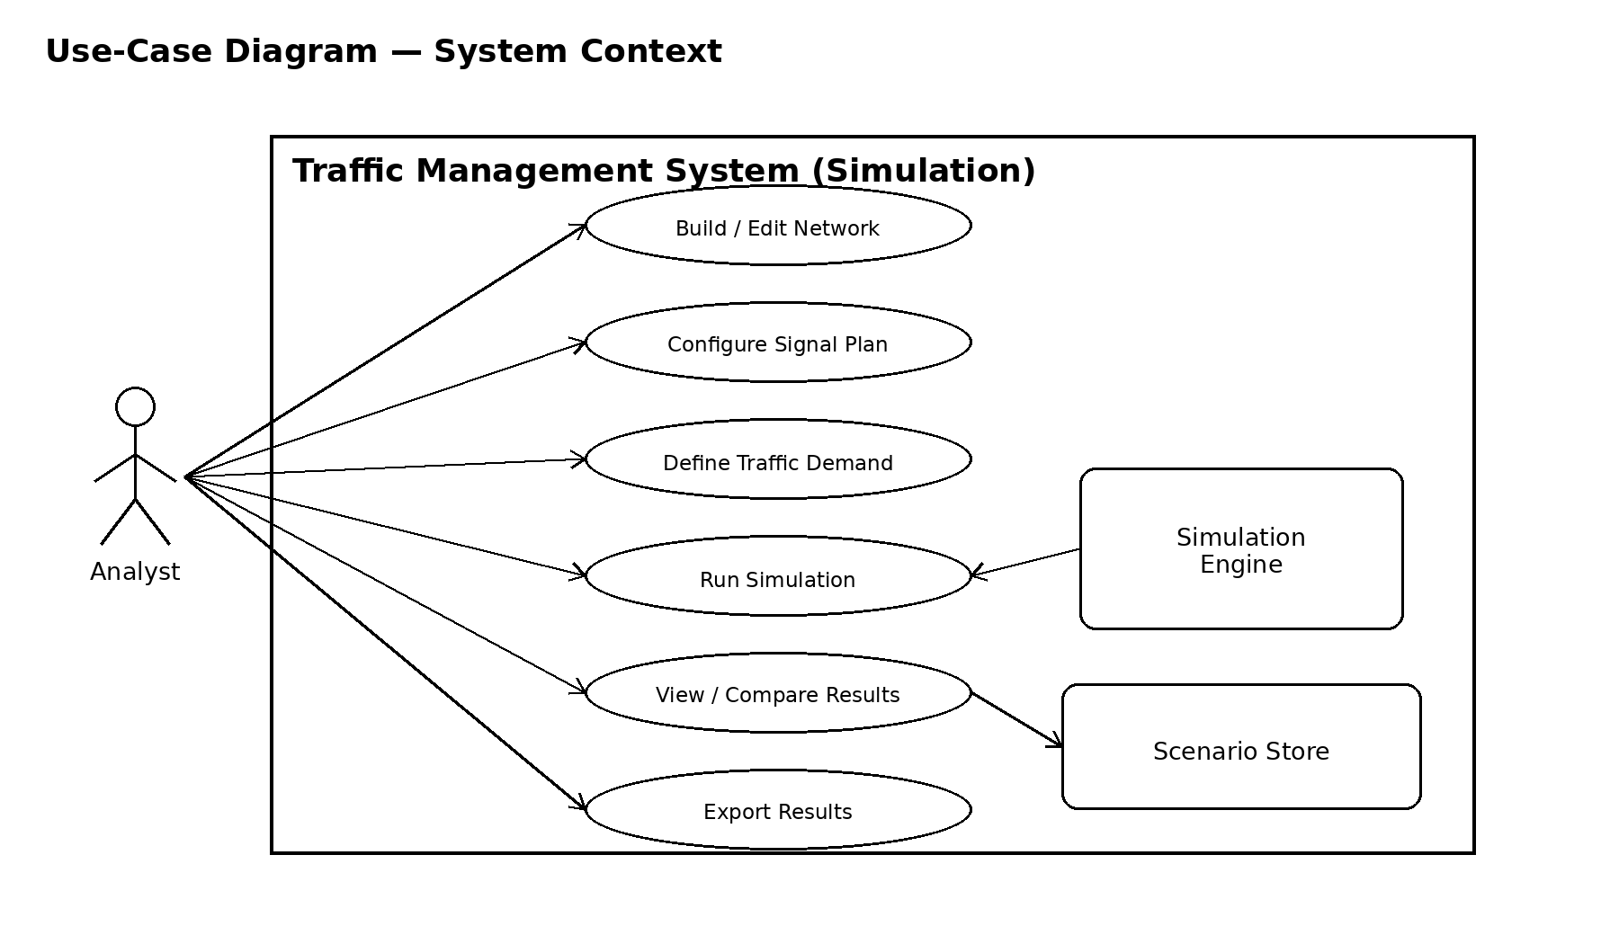
Figure 1. UML use-case diagram - system context.

7.2 Run flow
Validate Network; Validate Signal Plan; Initialise Vehicles; Run Simulation; Record Metrics. Optional controls: Pause, Single-Step, Adjust Speed and Reset.
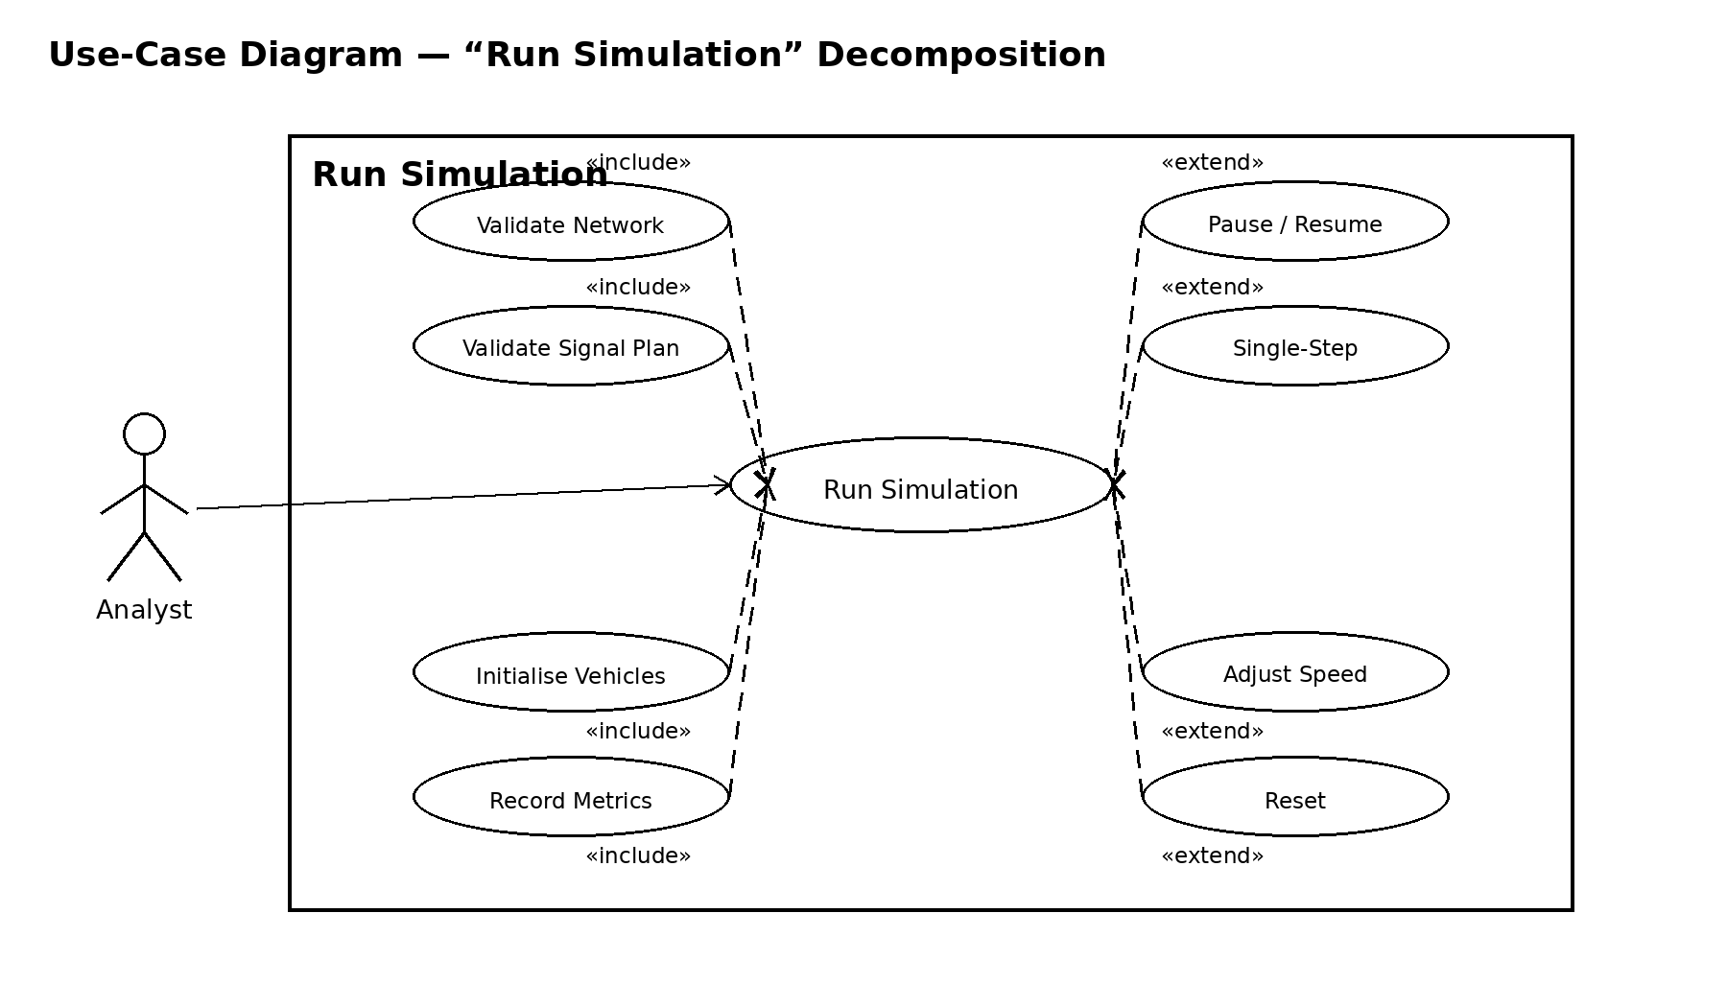
Figure 2. Run Simulation use-case decomposition.

8 Traceability
docs/rtm_draft.csv supersedes the original embedded RTM and is the authoritative mapping/status file. The test references below match its current requirement rows and docs/test_catalogue.md; a mapping alone does not prove a test passed.
Requirement | Test
TMS-F-010 | TC-NET-01
TMS-F-011 | TC-NET-02
TMS-F-012 | TC-NET-03
TMS-F-013 | TC-NET-04
TMS-F-020 | TC-SIG-01
TMS-F-022 | TC-SIG-02
TMS-F-030 | TC-DEM-01
TMS-F-032 | TC-DEM-02
TMS-F-040 | TC-SIM-01
TMS-F-041 | TC-SIM-02
TMS-F-042 | TC-SIM-03
TMS-F-043 | TC-SIM-04
TMS-F-050 | TC-MET-01
TMS-F-051 | TC-MET-02
TMS-F-052 | TC-MET-03
TMS-F-053 | TC-MET-04
TMS-F-054 | TC-MET-05
TMS-F-060 | TC-LIB-01
TMS-NF-001 | TC-PERF-01
TMS-NF-002 | TC-REL-01
TMS-NF-003 | TC-UX-01
TMS-NF-004 | TC-PORT-01

9 Security and baseline control
Security in v1 is limited to validating scenario schema/version before use and keeping data locally. Accounts, roles, administration and audit log are deferred. TMS-F-021 and TMS-F-031 are retired without requirement text. Issue #1 decision record says the team approved its baseline decisions on 27 October; the working RTM/catalogue still mark NFR interpretation gaps. This document preserves the approved wording and flags missing operational detail for reconciliation.

Appendix A Source records
Original Part 1 SRS, SAD and STP PDFs are preserved unchanged. See Baseline Amendment v1.1, Decision Record 0001, DEVIATIONS.md, docs/rtm_draft.csv, docs/test_catalogue.md and docs/test_execution_record.md.

