Kyle Kirtland

<https://github.com/Redster11/CS_3700/tree/master/HW4>

**Rock Paper Scissors Everyone Verses Everyone**

Shows fighters creation and a few Wins/ Ties

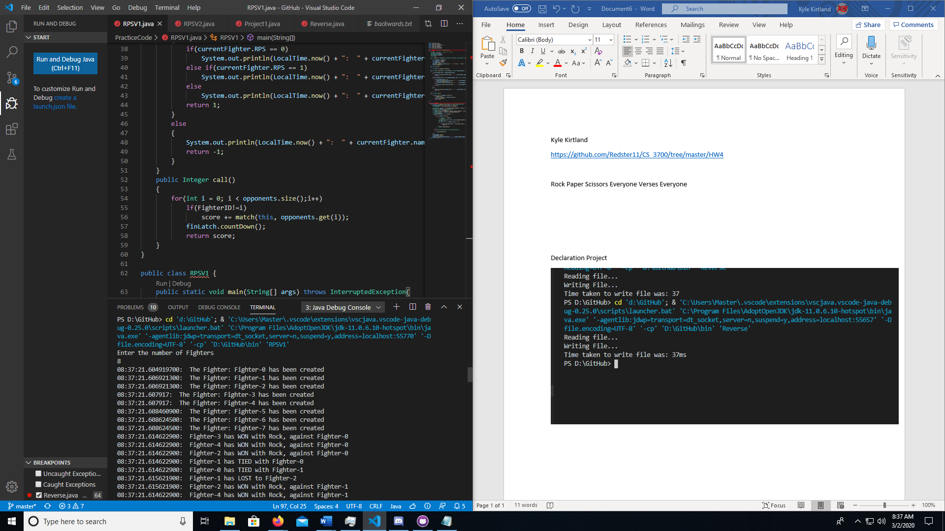

Shows Losing and the Champion Thread

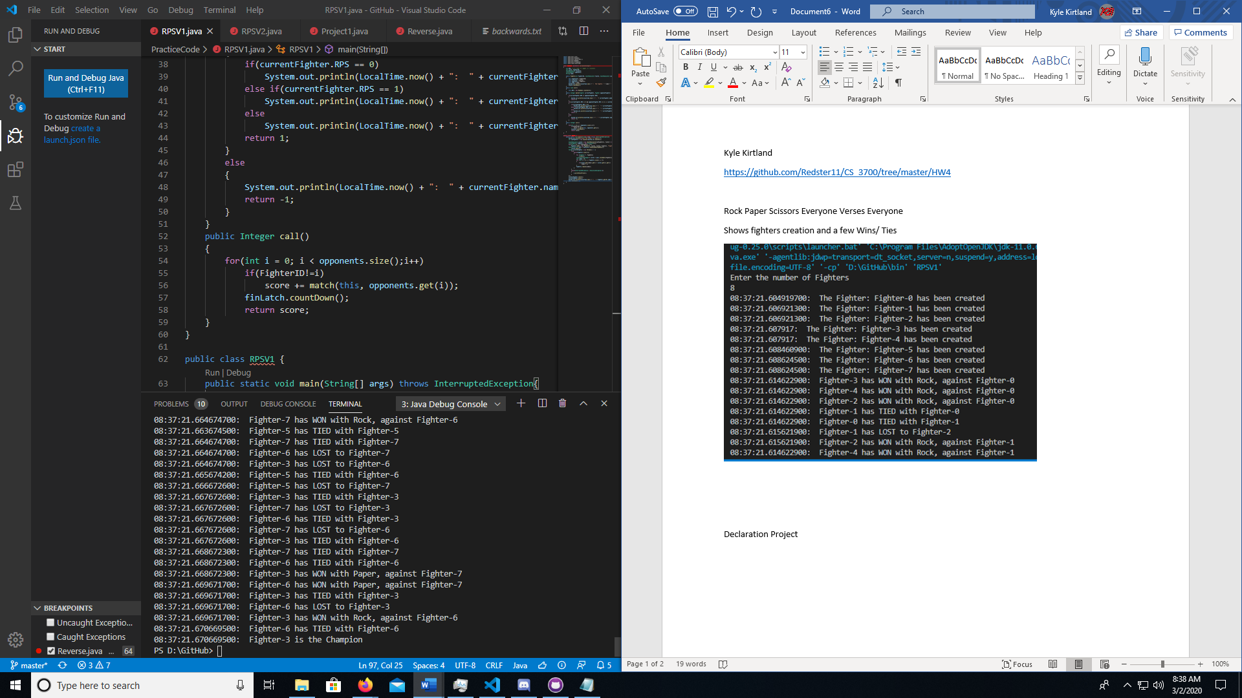

**Rock Paper Scissors Bracket game**

Shows the creation and fights that happened and then the final winner Thread

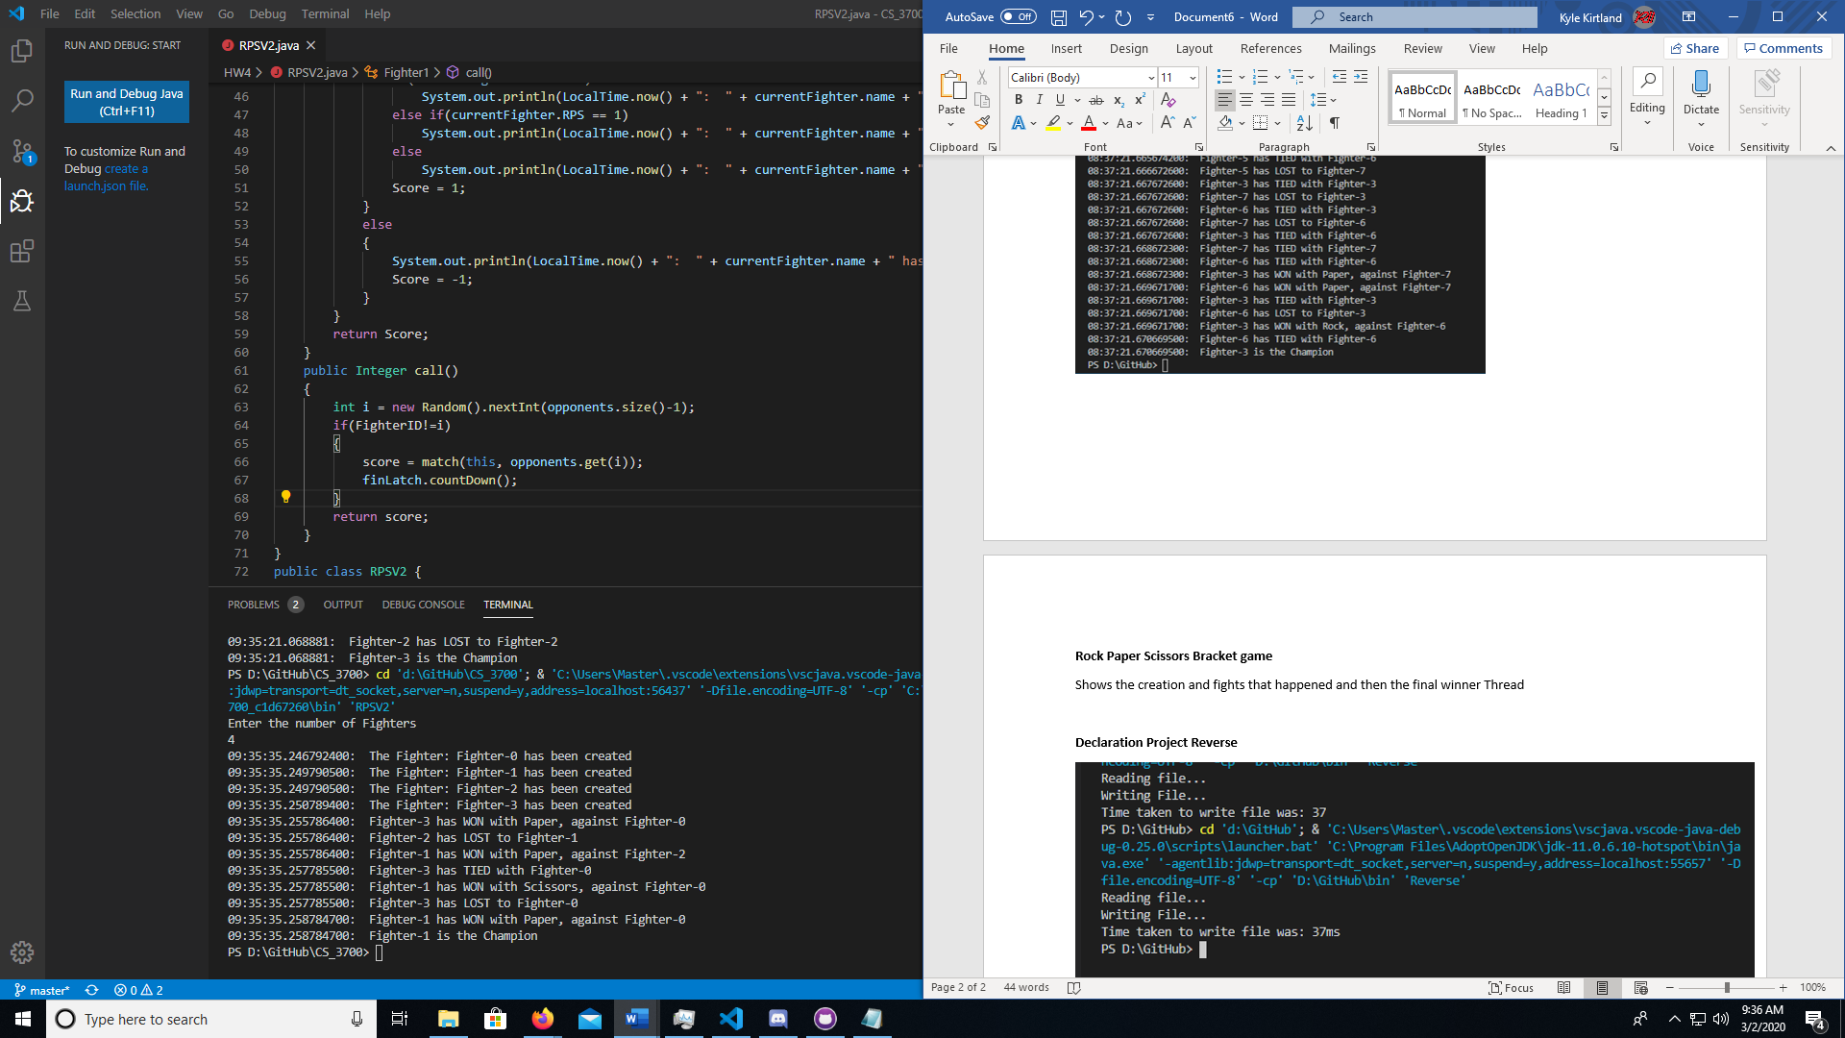

This is the second implementation of the bracket System

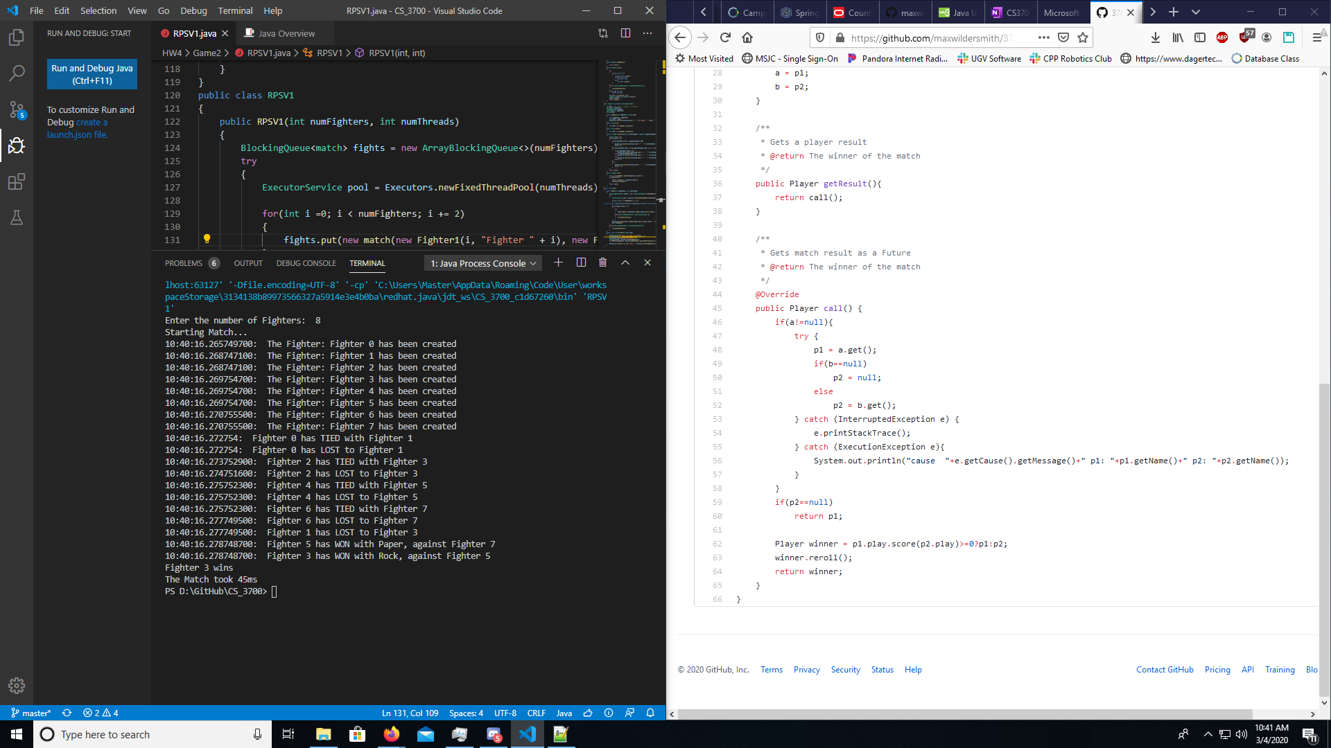

**Declaration Project Reverse**

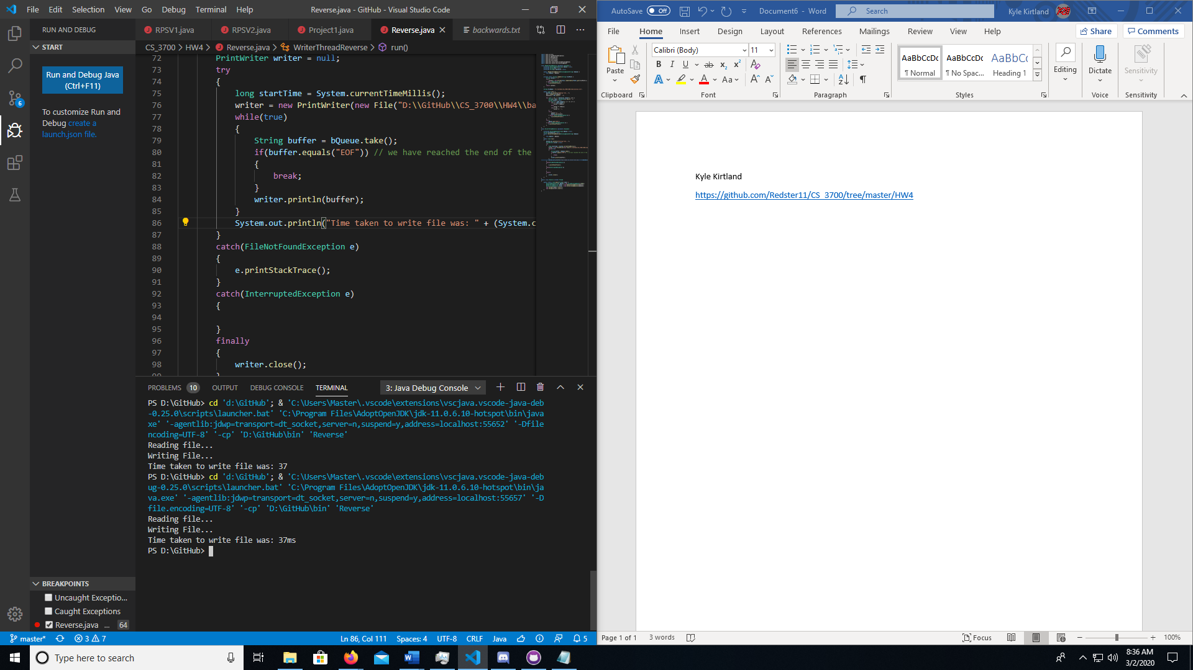

Sample Output

