Kyle Kirtland

010860720

CS 4350 Final Project: JDBC

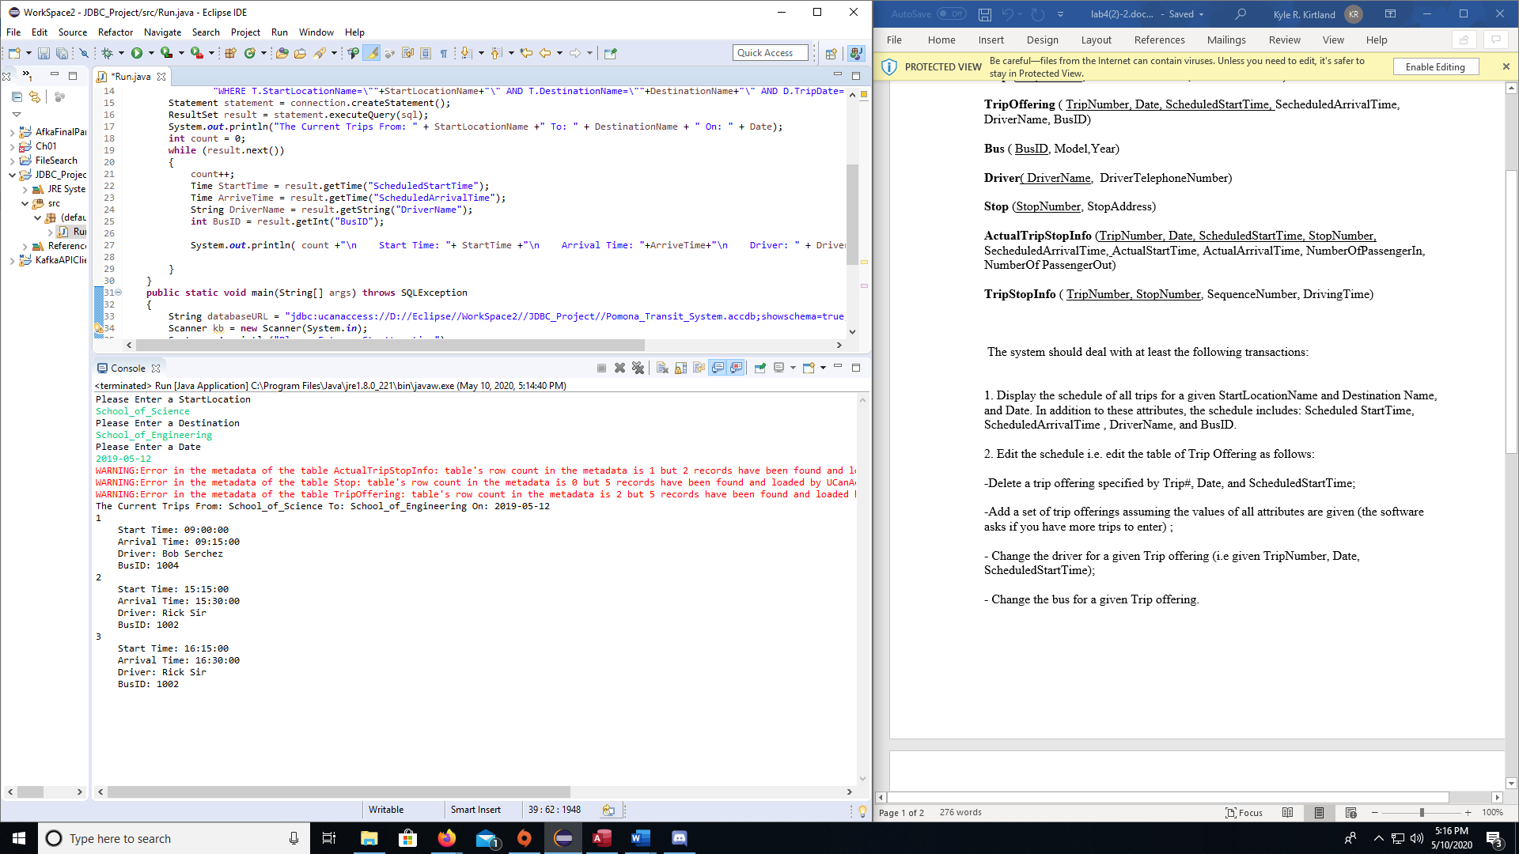

This Grabs the Schedule for busses that go from one location to the next.

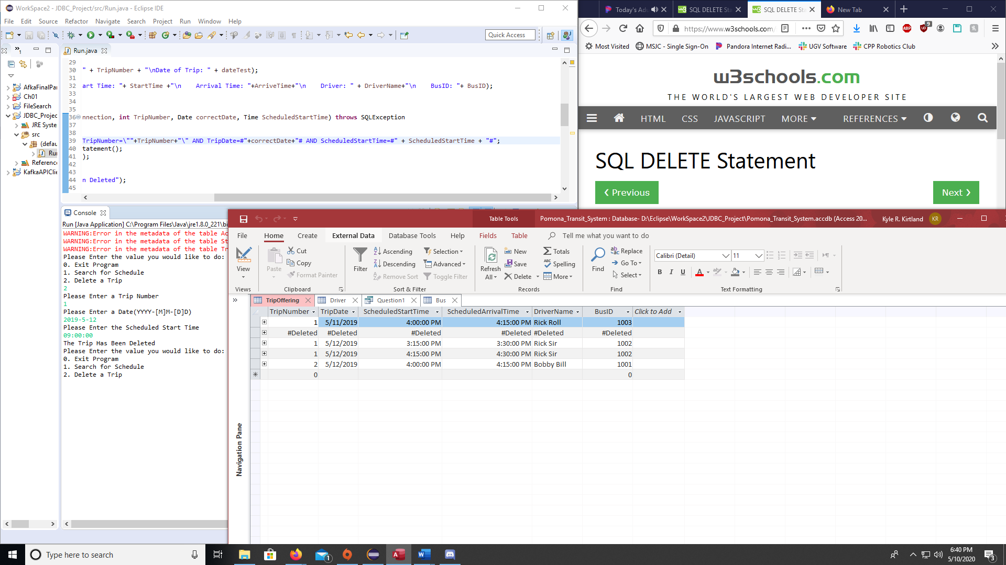

This Deletes a Trip

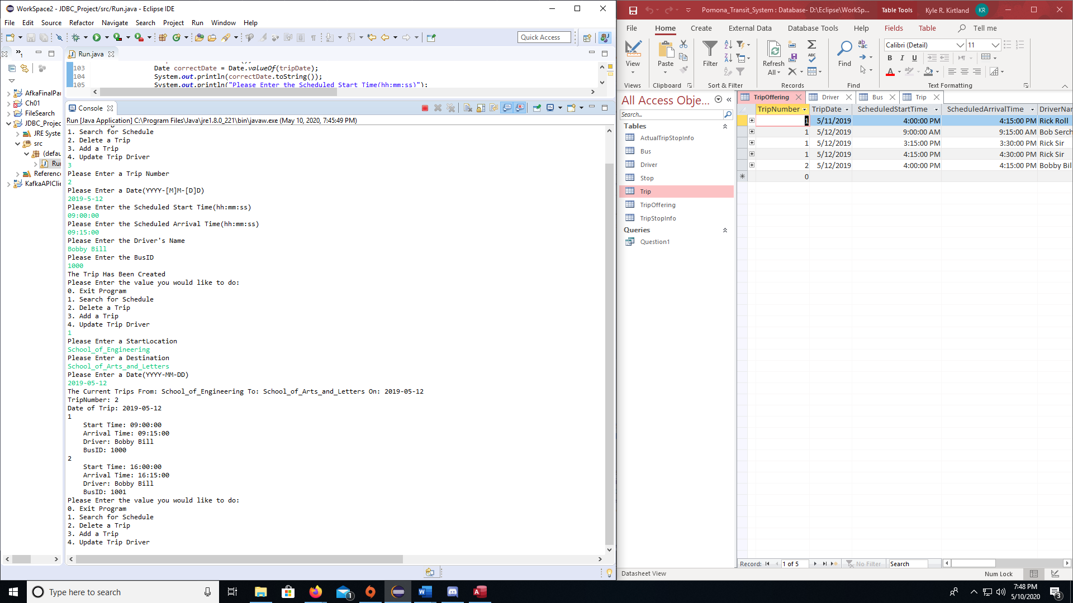

Updates the driver of a Trip

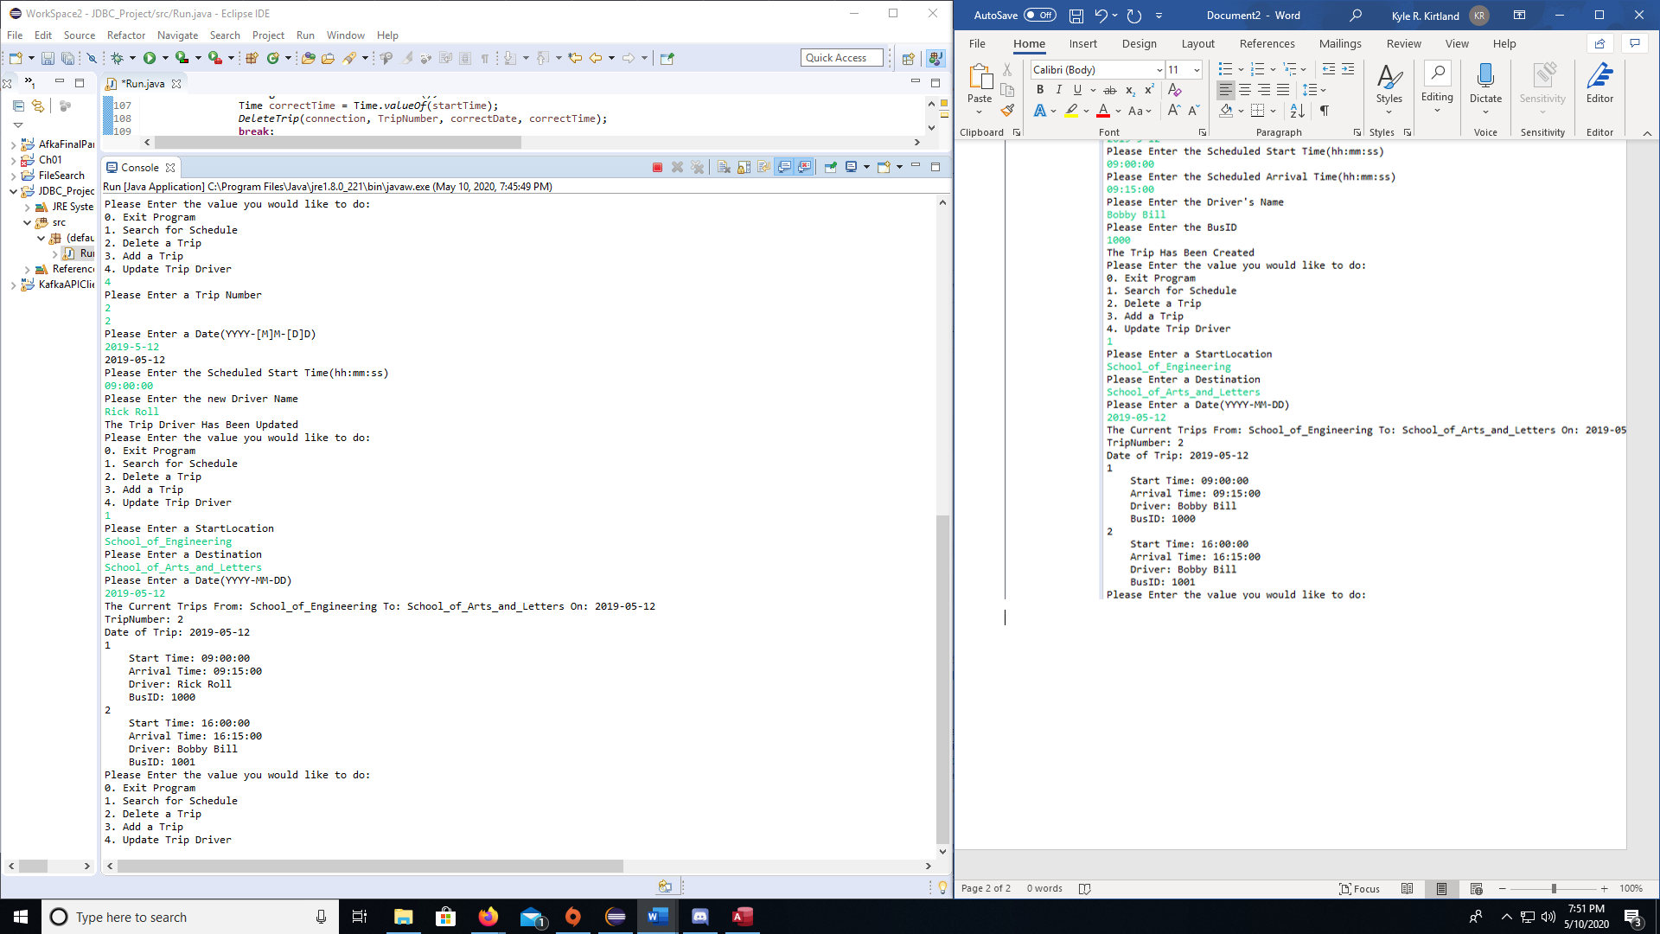

Creates a new Trip

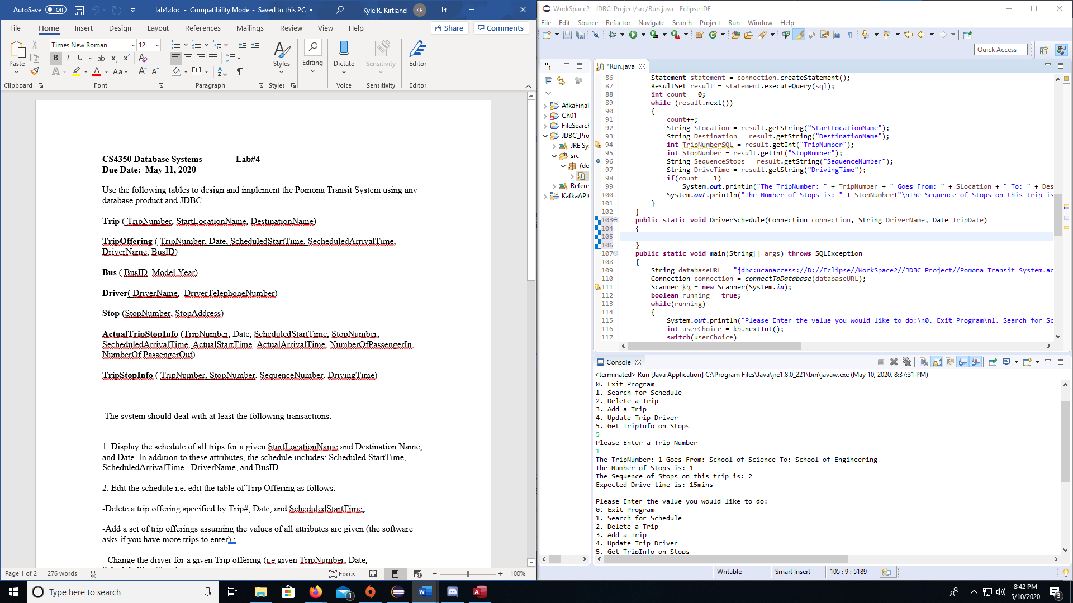

Gives you trip info based on a Trip Number

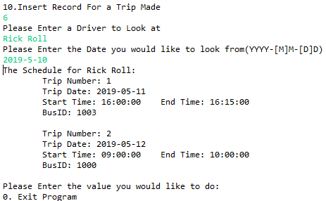

This gives a Drivers Schedule Based on the Drivers name and the Date given in this case Rick Roll only has 2 scheduled drives for the next 7 days from May 10, 2019.

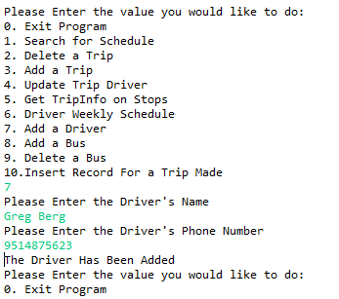

This Adds a Driver to the Database

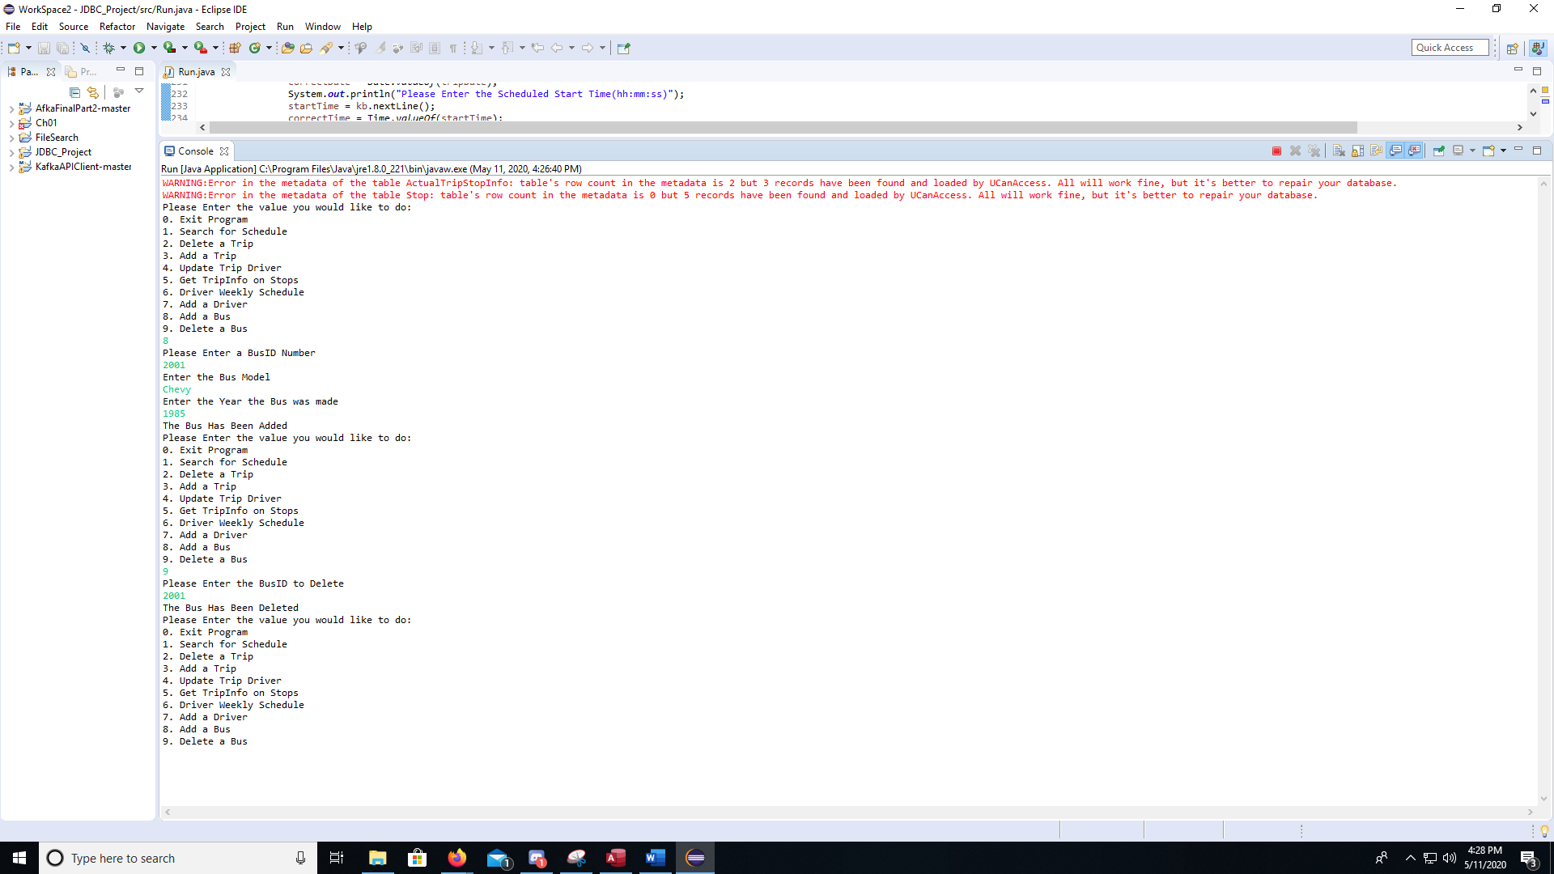

This places a Bus and then we delete it off of the database just to show that it is working

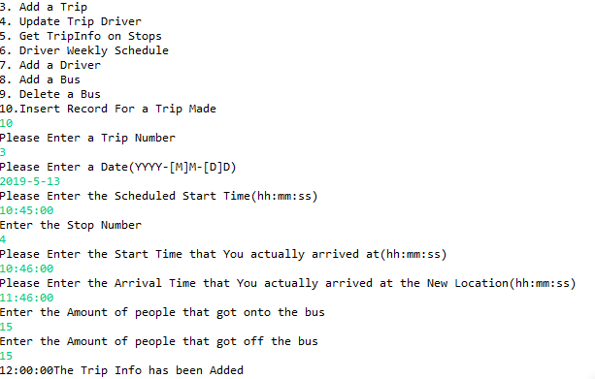

This is updating the Actual Trip Information table with the Drivers current standings.

In this we look for a Key into the Current Offered Trips so that we can make sure that the Driver is inputting for a trip that is already on their route. Then they provide the trips information that actual happened.

Findings:

Through this project I found that the SQL that we learn in class is very easily transferred into the JDBC programs. The hardest part was figuring out how to have the JDBC program used to accept user input. After some research I found that to get this to work you need to make sure that all input values are written as if it were in a fully written DML style. This being said in order for a values that we are trying to set an attribute equal to a value in DML it requires a quotation marks around the value that we are looking for in JDBC it also requires this so on all of the values it requires the Programmer to use \”” +variable_name + “\” as a way to insert the variable into the DML statement.

USES:

This project uses ucanaccess as the JDBC Driver.