CS 419: Secure Web Application
SECURITY DESIGN DOCUMENT
Secure Document Sharing System

Spring 2026 | CS 419

A. Architecture Overview

A.1 System Architecture
The application is a single-process Flask web server. All security decisions are made inside the application process before any filesystem access occurs. The trust boundary is clean: the browser may only reach the filesystem through Flask, and Flask enforces authentication, authorization, and input validation on every route.

Browser (Client)
↕ HTTPS / TLS (port 5000)
Flask Application (app.py)
Routes & Jinja2 Templates — URL dispatch, HTML rendering
require_auth / require_role decorators — Authentication & RBAC gate
get_current_session() — Session validation & timeout
EncryptedStorage (Fernet) — Encrypt/decrypt all documents
SecurityLogger / AccessLogger — Structured JSON event logging
is_rate_limited(ip) — In-memory IP rate limiting
set_security_headers() — CSP, HSTS, X-Frame-Options, etc.
↕ Filesystem I/O
data/users.json — bcrypt password hashes, roles, lockout state
data/sessions.json — Server-side session tokens & timestamps
data/<uuid>.enc — Fernet-encrypted document blobs (base64)
logs/security.log — Auth, access denied, lockout events
logs/access.log — Normal document operations
secret.key — Fernet symmetric key (local file)

A.2 Data Flow Diagrams
The system’s data flows are presented as standard DFD diagrams, followed by step-by-step flow details.

A.2.1 Context-Level DFD
The context-level DFD shows the system boundary, external entities, and all data stores.
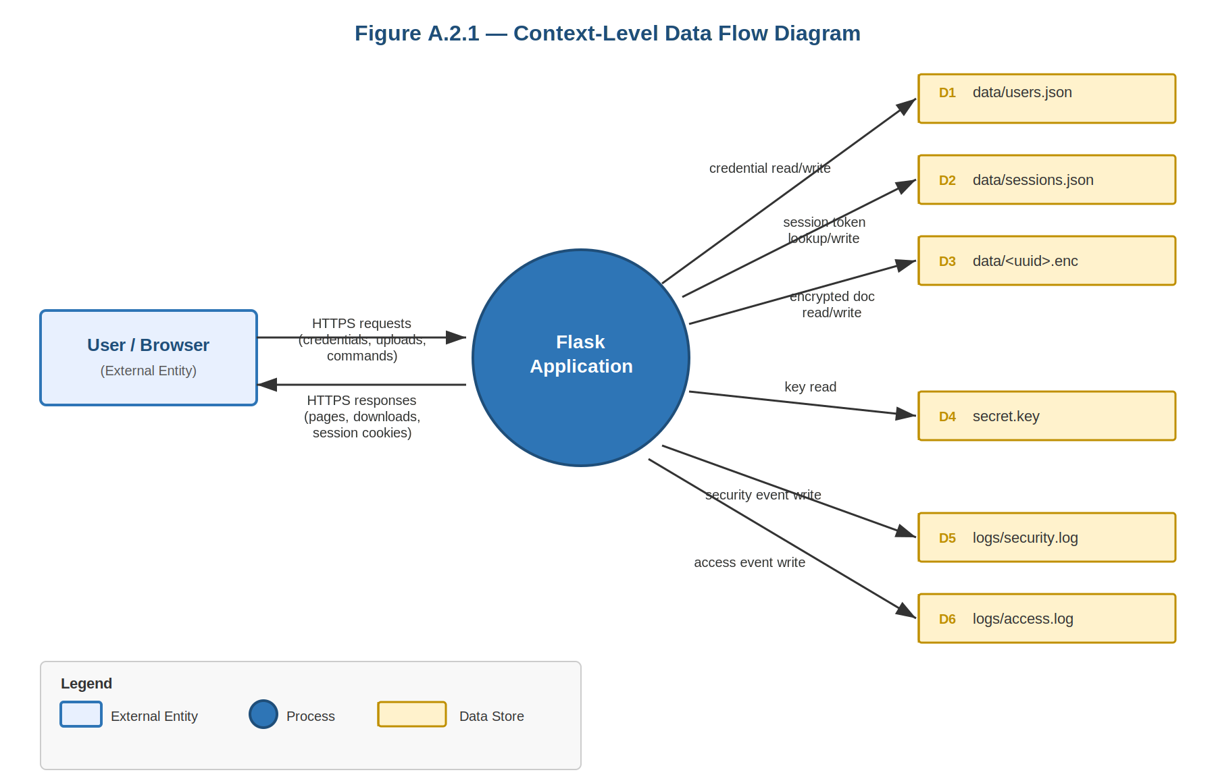

A.2.2 Level-1 DFD
The Level-1 DFD decomposes the Flask Application process into the five security-sensitive flows: Login, Upload, Download, Share, and Change Password.

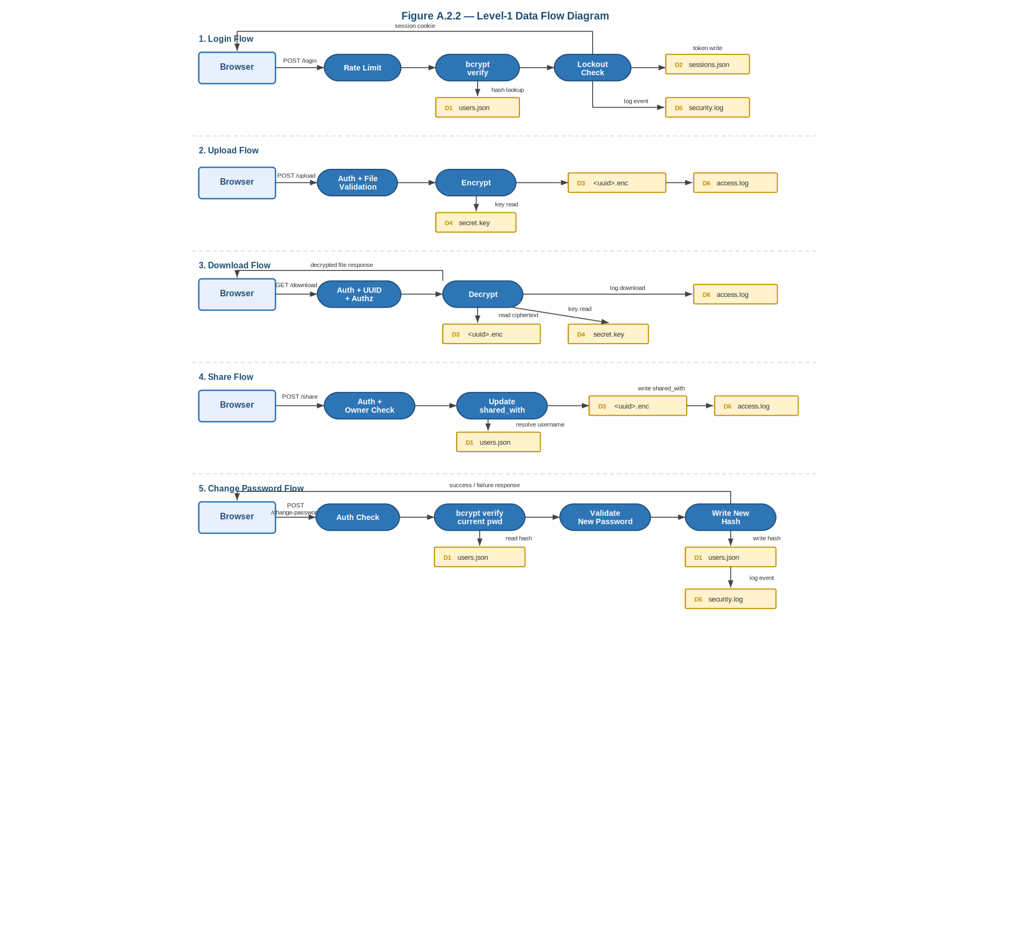

A.2.3 Step-by-Step Flow Details
The five security-sensitive data flows are described step by step below.

Flow | Steps
Upload | 1. Browser → POST /documents/upload (multipart, HTTPS) 2. Flask validates extension + MIME + size 3. File bytes base64-encoded then Fernet-encrypted 4. Ciphertext written to data/<uuid>.enc 5. Metadata (owner, timestamps, shared_with, versions) stored inside same .enc blob 6. Access log entry written
Download | 1. Browser → GET /documents/download/<uuid> 2. Flask validates UUID format + path confinement 3. Session & document-level authorization checked (owner / editor / admin) 4. .enc file decrypted by EncryptedStorage 5. Raw bytes streamed as attachment; access logged
Login | 1. Browser → POST /login 2. IP rate-limit check (10/min in-memory) 3. bcrypt.checkpw() against stored hash 4. On success: secrets.token_urlsafe(32) created, stored in sessions.json, token placed in signed Flask session cookie 5. On failure: failed_attempts incremented; lockout after 5 failures (15 min)
Share | 1. Browser → POST /documents/share/<uuid> 2. Ownership verified (only owner can share) 3. Target username resolved to user_id 4. shared_with[user_id] = 'editor'|'viewer' written to .enc blob
Change Password | 1. Browser → POST /change-password 2. Flask validates active session 3. Current password checked with bcrypt against users.json 4. New password validated against server-side policy 5. Password hash updated in users.json 6. PASSWORD_CHANGED or PASSWORD_CHANGE_FAILED logged to security.log 7. Response returned to browser

A.3 Component Descriptions

Component | Responsibility
app.py — Route layer | Handles all HTTP routing. Every route that touches user data is protected by @require_auth and, where applicable, @require_role.
EncryptedStorage | Wraps all document I/O. Every write calls Fernet.encrypt(); every read calls Fernet.decrypt(). Documents are never written to disk in plaintext.
StructuredLogger / SecurityLogger / AccessLogger | Two separate log streams: security.log for auth/access-control events; access.log for normal document operations. All entries are JSON-structured.
is_rate_limited(ip) | In-memory sliding-window counter. Allows a maximum of 10 login attempts per IP per 60-second window. Resets on server restart (acknowledged limitation).
require_auth decorator | Validates the Flask session cookie, looks up the token in sessions.json, and enforces a 30-minute inactivity timeout. Unauthenticated requests are redirected to /login.
require_role(role) decorator | Checks the role field on the current session. On mismatch, logs ACCESS_DENIED and returns HTTP 403.
securely_delete_file(path) | Overwrites a file with os.urandom(size) and calls fsync() before os.remove(). Best-effort on SSDs and journaling filesystems.
config.py | Centralises all tunable parameters: MAX_FAILED_ATTEMPTS, LOCKOUT_DURATION, RATE_LIMIT_MAX, SESSION_TIMEOUT, ALLOWED_EXTENSIONS, ALLOWED_MIME_TYPES, MAX_FILE_SIZE.

A.4 Technology Stack Justification

Choice | Justification
Python / Flask | Lightweight, well-documented framework. Jinja2 auto-escaping is on by default, reducing XSS risk. Large ecosystem of security libraries.
cryptography (Fernet) | Provides authenticated symmetric encryption (AES-128-CBC + HMAC-SHA256). Authentication means tampered ciphertext is detected at decryption time, not just at read time.
bcrypt (cost factor 12) | Deliberately slow KDF. Cost factor 12 makes offline brute-force attacks expensive.
JSON flat-file storage | Avoids an SQL injection surface entirely. No database parser to attack. Appropriate for project scale.
secrets.token_urlsafe(32) | Generates 256 bits of cryptographically random session tokens. Infeasible to guess or brute-force.
Flask signed session cookie | Used only to hold the server-side session token. The actual session data lives in sessions.json; the cookie is a pointer, not a payload.

B. Threat Model

B.1 Asset Identification

Asset | Sensitivity | Location
User credentials (password hashes) | High | data/users.json
Active session tokens | High | data/sessions.json
Uploaded document contents | High | data/<uuid>.enc (Fernet-encrypted)
User account metadata (email, role, lockout state) | Medium | data/users.json
Document sharing metadata | Medium | Inside each .enc blob
Document version history | Medium | Inside each .enc blob
Fernet encryption key | Critical | secret.key (local filesystem)
Security and access logs | Medium | logs/security.log, logs/access.log

B.2 Threat Enumeration

Threat | Category
Brute-force or credential-stuffing on /login | Authentication
Account enumeration via distinct registration error messages | Authentication / Information Disclosure
Session token theft via XSS or network sniffing | Session Hijacking
Replaying a session token after logout | Session Fixation / Replay
Normal user accessing another user's document by guessing doc_id (IDOR) | Horizontal Privilege Escalation
Normal user accessing /admin/dashboard or admin actions | Vertical Privilege Escalation
Path traversal via malformed doc_id to read arbitrary files | Input Validation / Path Traversal
Malicious file upload (executable, oversized, MIME spoofing) | File Upload Attack
XSS via stored or reflected user-controlled content | Cross-Site Scripting
CSRF — triggering state-changing actions from external sites | Cross-Site Request Forgery
Repeated guessing of current password on /change-password | Brute Force (authenticated)
Physical or forensic recovery of deleted document contents | Data Remanence
Theft of secret.key from compromised host | Key Compromise
DoS via resource exhaustion through rapid upload or login requests | Availability

B.3 Vulnerability Assessment

Threat | Likelihood | Impact
Brute-force on /login | Low (locked out after 5 attempts; IP rate-limited) | High if unchecked
Account enumeration via registration | Medium (distinct error messages exist in code) | Low-Medium
Session theft via XSS | Low (Jinja auto-escaping; HttpOnly cookie) | High if exploited
IDOR on document endpoints | Low (UUID validation + server-side ownership check) | High if exploited
Vertical privilege escalation | Low (@require_role checks on all admin routes) | High if exploited
Path traversal via doc_id | Low (UUID regex + abspath confinement) | High if exploited
Malicious file upload | Low (extension + MIME allowlist + 10 MB cap) | Medium
CSRF | Low (SameSite=Strict on session cookie) | Medium
No rate limit on /change-password | Medium (requires valid session first) | Low-Medium
Fernet key theft from disk | Conditional on host compromise | Critical

B.4 Attack Scenarios

Scenario 1 — Credential Stuffing
Attacker submits a list of known username/password pairs against /login. After 5 failures per account, the account locks for 15 minutes. After 10 attempts per minute from any one IP, further requests from that IP are rate-limited. The combination means a large-scale stuffing attack is slowed to roughly 10 attempts per minute across any number of accounts, and each individual account locks after 5 failures.

Scenario 2 — IDOR on Document Download
Attacker authenticates as a normal user and crafts a request to GET /documents/download/<uuid> using a document UUID they guessed or found in logs. The route first validates the UUID format with a regex, then checks file_data['user_id'] == user_id and shared_with.get(user_id) == 'editor'. Neither condition is true, so the request returns 403 and a WARNING is logged.

Scenario 3 — Path Traversal via doc_id
Attacker submits ../../etc/passwd as a doc_id. The route applies re.match(r'^[a-f0-9\-]{36}$', doc_id) — this does not match, so the request is immediately rejected with HTTP 400 and logged as PATH_TRAVERSAL_ATTEMPT.

Scenario 4 — Session Replay after Logout
Attacker captures a valid session cookie while authenticated, then waits for the user to log out. On logout, destroy_session(token) deletes the token from sessions.json. When the attacker replays the cookie, get_current_session() finds no matching token and returns None, so all protected routes redirect to login.

B.5 Risk Prioritisation

Risk | Priority | Status
Fernet key stored on disk without extra protection | High | Accepted (out of scope for class project; documented)
Account enumeration via registration errors | Low | Open — see Known Limitations
No rate limiting on /change-password | Low | Open — see Known Limitations
unsafe-inline in CSP | Low | Open — see Known Limitations
In-memory rate limiter resets on restart | Low | Accepted for project scope
No dedicated CSRF token | Low | Mitigated by SameSite=Strict + session validation
Secure deletion not guaranteed on SSDs | Informational | Mitigated by Fernet encryption as primary defense

C. Security Controls

C.1 User Authentication (15 pts)

C.1.1 Password Hashing
Passwords are hashed with bcrypt.hashpw(..., bcrypt.gensalt(rounds=12)) before storage. The plaintext password is never written to disk or logged. Cost factor 12 makes offline brute-force expensive.

C.1.2 Password Complexity
validate_password() enforces: minimum 12 characters, at least one uppercase letter, one lowercase letter, one digit, and one special character from !@#$%^&*. This check runs server-side on both registration and password change.

C.1.3 Account Lockout & Rate Limiting
- After 5 consecutive failed logins, locked_until is set to now + LOCKOUT_DURATION (15 minutes). Locked accounts cannot log in until the timer expires or an admin unlocks them.
- is_rate_limited(ip) maintains an in-memory sliding window: if an IP sends ≥ 10 login POSTs in 60 seconds, it is blocked for the remainder of that window.

C.1.4 Session Creation
Successful login calls secrets.token_urlsafe(32) (256 bits of entropy). The token is stored in sessions.json server-side and placed in a Flask signed session cookie configured with HttpOnly=True, Secure=True, SameSite='Strict'.

Testing: Submitted 6 consecutive wrong passwords → account locked. Submitted 11 rapid login attempts from same IP → rate-limit message returned. Captured cookie, logged out, replayed cookie → redirected to login.

C.2 Access Control (15 pts)

C.2.1 Role-Based Access Control
Three user roles are enforced (admin, user, guest), plus document-level permissions (owner, editor, viewer). The user roles and their base permissions are shown below.

Action | Admin | User | Guest
Register / log in | ✓ | ✓ | ✓
Create own content | ✓ | ✓ | ✗
View own content | ✓ | ✓ | ✗
Edit own content | ✓ | ✓ | ✗
Delete own content | ✓ | ✓ | ✗
Share own content | ✓ | ✓ | ✗
View shared content | ✓ | ✓ | ✓*
Edit shared content | ✓ | ✓ | ✗
View all content | ✓ | ✗ | ✗
Manage users | ✓ | ✗ | ✗

* Guests can view documents that have been explicitly shared with them (as viewer), but cannot create, edit, delete, or share content. Owner, editor, and viewer are document-level access permissions, not account roles.

C.2.2 Document-Level Authorization
Route-level RBAC is a necessary but not sufficient guard. Every document route also performs an object-level check: is the requesting user the owner, an admin, or listed in shared_with with the appropriate role? This prevents horizontal privilege escalation — a normal user cannot access another normal user's document even with a valid session.

Sharing is further restricted: only the document owner may call POST /documents/share/<uuid>. If the requesting user is not the owner, the request is denied and logged.

Testing: Logged in as user B and attempted GET /documents/download/<user A's doc UUID> → 403 returned, ACCESS_DENIED logged. Requested /admin/dashboard as normal user → 403 returned.

C.3 Input Validation & Injection Prevention (20 pts)

C.3.1 XSS Prevention
Jinja2 auto-escaping is enabled by default for all {{ }} template expressions. Usernames are further restricted to r'^\w{3,20}$' (letters, digits, underscores only), eliminating the most common XSS payloads from that field. The | safe filter is not used anywhere in the templates.

C.3.2 Path Traversal Prevention
All document routes validate the doc_id parameter with re.match(r'^[a-f0-9\-]{36}$', doc_id) before constructing the filesystem path. After construction, os.path.abspath(enc_path).startswith(os.path.abspath('data')) is checked as a second layer. If either check fails, HTTP 400 is returned and PATH_TRAVERSAL_ATTEMPT is logged.

C.3.3 Command Injection Prevention
No subprocess, os.system, popen, eval, or exec calls exist in the codebase. User input is never passed to shell commands. All file operations use Python's standard library with sanitized, validated paths.

C.3.4 File Upload Validation
allowed_file() checks both the file extension (ALLOWED_EXTENSIONS = {pdf, txt, docx, png, jpg, jpeg}) and the MIME type (ALLOWED_MIME_TYPES) reported by the browser. Files larger than MAX_FILE_SIZE = 10 MB are rejected before the content is processed. Rejected uploads are logged as UPLOAD_REJECTED.

C.3.5 Input Length and Format Limits
- Username: 3–20 characters, alphanumeric + underscore only (regex enforced server-side)
- Email: basic format validation via regex (presence of @ and domain dot)
- Password: minimum 12 characters with complexity requirements
- Sharing role: validated against a whitelist — only 'editor' or 'viewer' accepted

Testing: Submitted <script>alert(1)</script> as a username → rejected by regex. Attempted ../../etc/passwd as doc_id → HTTP 400, logged. Uploaded .exe file → rejected. Uploaded valid file over 10 MB → rejected.

C.4 Encryption (15 pts)

C.4.1 Data-at-Rest Encryption
The EncryptedStorage class wraps all document I/O. On write, Fernet.encrypt() produces an authenticated ciphertext (AES-128-CBC + HMAC-SHA256). The ciphertext is base64-encoded and stored as the data field inside each .enc file. On read, Fernet.decrypt() verifies the HMAC before returning the plaintext — tampered ciphertext raises an exception rather than returning garbage data.

The Fernet key is generated with Fernet.generate_key() on first run and persisted to secret.key. This file is loaded at application startup and never regenerated unless deleted.

C.4.2 Transport Encryption
The application runs with ssl_context=('cert.pem', 'key.pem'). The require_https() before_request hook redirects any HTTP request to HTTPS with a 301 redirect, unless app.debug or app.testing is True.

Testing: Opened a .enc file in a hex editor — confirmed only ciphertext visible, no plaintext filename or content. Modified one byte of the ciphertext, restarted app, and attempted to load the file — Fernet raised InvalidToken exception, the file was logged as FILE_LOAD_ERROR.

C.5 Session Management (15 pts)

C.5.1 Session Creation and Storage
On successful login, create_session(user) generates a 256-bit token via secrets.token_urlsafe(32). The token is stored server-side in data/sessions.json alongside the user_id, username, role, created_at, and last_activity timestamps. The token is placed in a signed Flask session cookie.

C.5.2 Session Validation and Timeout
Every protected route calls get_current_session(), which reads the token from the Flask session cookie, looks it up in sessions.json, and checks time.time() - last_activity > SESSION_TIMEOUT (1800 s). An expired session is deleted server-side and the client cookie is cleared. last_activity is updated on every valid request, implementing a sliding window.

C.5.3 Logout and Session Invalidation
Logout calls destroy_session(token), which removes the token from sessions.json, then calls session.clear() to remove the client-side cookie. Replaying the old token after logout finds no matching entry in sessions.json and returns None.

C.5.4 Cookie Security Flags
- HttpOnly=True — cookie is inaccessible to JavaScript, reducing XSS-based session theft
- Secure=True — cookie is only sent over HTTPS connections
- SameSite='Strict' — cookie is not sent on cross-site requests, providing CSRF protection without a dedicated token

Testing: Logged in, captured session token, logged out, replayed token in a fresh request → redirected to login. Confirmed session entry was absent from sessions.json after logout. Verified cookie flags in browser DevTools.

C.6 Security Headers (10 pts)
All responses include the following headers, set in the set_security_headers() after_request hook:

Header | Value and Purpose
Content-Security-Policy | default-src 'self'; script-src 'self' 'unsafe-inline'; style-src 'self' 'unsafe-inline'; img-src 'self' data:; font-src 'self'; connect-src 'self'; frame-ancestors 'none' Note: unsafe-inline is a known limitation (see Section C.8)
X-Frame-Options | DENY — prevents clickjacking via iframe embedding
X-Content-Type-Options | nosniff — prevents MIME-type sniffing attacks
X-XSS-Protection | 1; mode=block — legacy XSS filter for older browsers
Referrer-Policy | strict-origin-when-cross-origin — limits referrer leakage
Permissions-Policy | geolocation=(), microphone=(), camera=() — disables unused browser APIs
Strict-Transport-Security | max-age=31536000; includeSubDomains — enforces HTTPS for 1 year

C.7 Logging & Monitoring (10 pts)
Two separate loggers write JSON-structured entries to distinct log files:

Logger | Events Captured
SecurityLogger → logs/security.log | LOGIN_FAILED, LOGIN_BLOCKED, ACCOUNT_LOCKED, SESSION_CREATED, SESSION_DESTROYED, ACCESS_DENIED, UPLOAD_REJECTED, PATH_TRAVERSAL_ATTEMPT, PASSWORD_CHANGE_FAILED, PASSWORD_CHANGED, ADMIN_USER_LOCKED, ADMIN_USER_UNLOCKED, RATE_LIMITED, FILE_LOAD_ERROR
AccessLogger → logs/access.log | LOGIN_SUCCESS, LOGOUT, DASHBOARD_ACCESSED, DOCUMENTS_ACCESSED, ADMIN_DASHBOARD_ACCESS, FILE_UPLOADED, FILE_VERSION_UPLOADED, FILE_DOWNLOADED, FILE_VERSION_DOWNLOADED, FILE_VIEWED, FILE_VERSION_RESTORED, DOCUMENT_SHARED, DOCUMENT_DELETED, DOCUMENT_VERSIONS_ACCESSED

Each log entry is a JSON object containing: timestamp (UTC ISO-8601), event_type, user_id, ip_address, and a details dict. Severity levels map to Python logging levels: INFO, WARNING, ERROR, CRITICAL.

C.8 Known Limitations and Mitigations

Limitation | Risk Level | Mitigation / Notes
Fernet key in secret.key (no KMS) | High if host is compromised | Encryption still protects data at rest from disk theft. Move key to environment variable or secrets manager for any production deployment.
Account enumeration via registration (distinct error messages for username vs. email) | Low | Collapse to a single generic message: 'An account with that username or email already exists.'
No rate limiting on /change-password | Low (requires valid session) | Apply the same is_rate_limited() pattern already used on /login.
CSP allows unsafe-inline for scripts and styles | Low | Move all inline JS/CSS to external files and tighten the CSP. This is the standard path to a stricter policy.
In-memory rate limiter resets on server restart | Low | Move to a persistent store (Redis or a simple JSON counter) for production.
No dedicated CSRF token on forms | Low | SameSite=Strict mitigates most CSRF risk. A library such as Flask-WTF would add explicit token protection.
Secure deletion is best-effort on SSDs / journaling filesystems | Informational | Fernet encryption is the primary defense. Physical erasure guarantees are outside application scope.
Multiple concurrent sessions allowed per user | Informational | Acceptable for this project. Could add single-session enforcement by deleting old tokens on new login.

D. Data Protection

D.1 Data Classification

Data Type | Classification | Justification
Document file contents | Confidential | User-uploaded private documents. Highest protection required.
Password hashes | Confidential | Compromise enables offline cracking. Must never be transmitted or logged.
Active session tokens | Confidential | Equivalent to a password for the duration of the session.
Fernet encryption key | Secret / Critical | Compromise decrypts all stored documents. Requires strongest protection.
User metadata (email, role, lockout) | Sensitive | PII and account control data. Protected at rest in users.json.
Document sharing metadata | Sensitive | Reveals who has access to what. Stored inside the encrypted .enc blob.
Document version history | Sensitive | Previous document content. Also encrypted inside the .enc blob.
Security event logs | Internal | Contains IPs and usernames. Should not be publicly accessible.
Access logs | Internal | Normal operation records. Useful for audit; not secret but not public.

D.2 Encryption Methods

What | Algorithm | Implementation Detail
Document contents (at rest) | Fernet (AES-128-CBC + HMAC-SHA256) | EncryptedStorage.save_encrypted() — every write is a fresh encryption with a new IV. Authenticated encryption detects tampering.
Password storage | bcrypt (cost factor 12) | hash_password() — salted, slow KDF. Verification via bcrypt.checkpw() only; hash never logged.
Session token generation | CSPRNG — secrets.token_urlsafe(32) | 256 bits of entropy. Stored server-side; only token pointer sent to client.
Transport (in transit) | TLS via ssl_context=('cert.pem','key.pem') | Self-signed certificate for dev. Production deployment requires a CA-signed certificate.

D.3 Key Management

The Fernet key lifecycle is as follows:
- Generation: On first startup, Fernet.generate_key() produces a 32-byte URL-safe base64 key backed by os.urandom(). It is written to secret.key.
- Storage: The key is stored in secret.key in the project root. Access is controlled by OS filesystem permissions. The key is not committed to version control (secret.key is in .gitignore).
- Loading: At application startup, EncryptedStorage reads the key once and holds it in memory as self.key. The key is not re-read on every operation.
- Rotation: Manual only. Rotating the key requires re-encrypting all .enc files with the new key. No automated rotation is implemented for this project.
- Backup: None for the class project. In production, the key must be backed up securely — losing it makes all .enc files permanently unreadable.

Production recommendation: Replace the file-based key with a secret injected at runtime via an environment variable (FERNET_KEY) or a dedicated secrets manager. This removes the key from the filesystem entirely.

D.4 Secure Deletion Procedures
When a document is deleted via POST /documents/delete/<uuid>, the application calls securely_delete_file(path), which:

- Reads the current file size with os.path.getsize()
- Opens the file in read+write binary mode
- Overwrites the entire file with os.urandom(size)
- Calls f.flush() and os.fsync(f.fileno()) to push the overwrite to the OS
- Calls os.remove() to remove the directory entry

This approach provides reasonable protection on traditional magnetic hard drives. On SSDs and journaling filesystems, wear leveling and the filesystem journal may retain data in blocks outside the overwritten region. The primary defense against data exposure is therefore Fernet encryption: even if the raw bytes are recovered, they are ciphertext without the key.

Version history blobs are stored inside the same .enc file as the current document version. Deleting the document deletes all versions simultaneously.

For production deployments where stronger erasure guarantees are required, full-disk encryption or a hardware-backed key store is the recommended approach. Application-layer overwrite alone is insufficient on modern storage hardware.

