**CST-150 Activity 10 Code**

For example, say you have a program with the following:

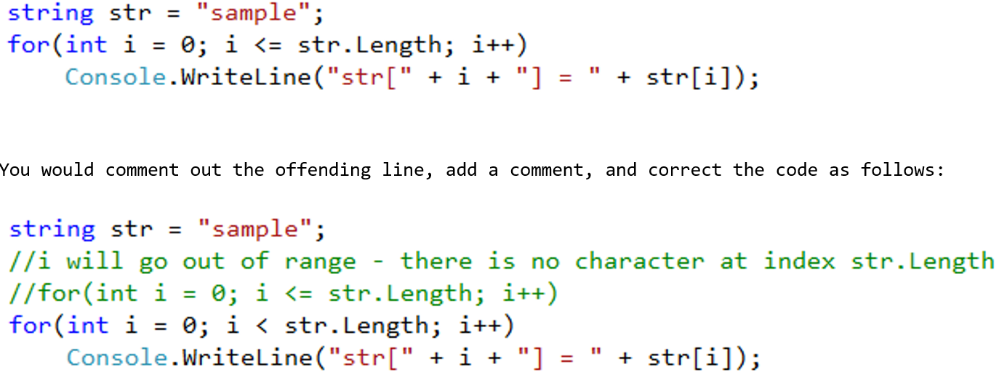

Submit the modified files and screenshots of any breakpoints you use. Include your name at the top as shown here:

//Corrected by <your name here>

**Program**

//use for IC08

//Lydia's code

using System;

using System.Collections.Generic;

using System.Linq;

using System.Text;

using System.Threading.Tasks;

namespace CST117_IC08_console

{

class Program

{

static void Main( string[] args )

{

//make some sets

Set A = new Set( );

Set B = new Set( );

//put some stuff in the sets

Random r = new Random( );

for(int i = 0; i < 10; i++)

{

A.addElement( r.Next( 4 ) );

B.addElement( r.Next( 12 ) );

}

//display each set and the union

Console.WriteLine("A: " + A);

Console.WriteLine("B: " + B);

Console.WriteLine("A union B: " + A.union(B));

//display original sets (should be unchanged)

Console.WriteLine("After union operation");

Console.WriteLine("A: " + A);

Console.WriteLine("B: " + B);

}

}

}

**Set**

Describe several debugging techniques and scenarios for their use.

using System;

using System.Collections.Generic;

using System.Linq;

using System.Text;

using System.Threading.Tasks;

//Lydia's code - find the errors!

namespace CST117_IC08_console

{

class Set

{

private List<int> elements;

public Set( )

{

elements = new List<int>( );

}

public bool addElement(int val )

{

if (containsElement( val )) return false;

else

{

elements.Add( val );

return true;

}

}

private bool containsElement(int val )

{

for(int i = 0; i < elements.Count; i++)

{

if (val == elements[ i ])

return true;

else

return false;

}

return false;

}

public override string ToString( )

{

string str = "";

foreach (int i in elements)

{

str += i + " ";

}

return str;

}

public void clearSet( )

{

elements.Clear( );

}

public Set union(Set rhs )

{

for(int i = 0; i < rhs.elements.Count; i++)

{

this.addElement( rhs.elements[ i ] );

}

return rhs;

}

}

}