Exoplanet Transit Detection Using Traditional ML and 1D Convolutional Deep Networks
Kaniz Fatema and Fahim Ferdous
A Thesis in the Partial Fulfillment of the Requirements
for the Award of Bachelor of Computer Science and Engineering (BCSE)

Department of Computer Science and Engineering
College of Engineering and Technology
IUBAT—International University of Business Agriculture and Technology
Spring 2025
Exoplanet Transit Detection Using Traditional ML and 1D Convolutional Deep Networks
Kaniz Fatema and Fahim Ferdous

A Thesis in the Partial Fulfillment of the Requirements for the Award of Bachelor of Computer Science and Engineering (BCSE)
The thesis has been examined and approved,

_____________________________
Prof. Dr. Utpal Kanti Das
Professor and Chairman, Dept. of CSE
Dean, ISCSE.

___________________________
Md. Rashedul Islam
Co-supervisor, Coordinator and Assistant Professor

_____________________________
Kazi Johir Raihan Suny
Lecturer

Department of Computer Science and Engineering
College of Engineering and Technology
IUBAT—International University of Business Agriculture and Technology
Spring 2026

Letter of Transmittal
7 June 2026
The Chair
Thesis Defense Committee
Department of Computer Science and Engineering
IUBAT—International University of Business Agriculture and Technology
4 Embankment Drive Road, Sector 10, Uttara Model Town
Dhaka 1230, Bangladesh.

Subject: Letter of Transmittal.
I am pleased to submit my thesis report titled "Exoplanet Transit Detection Using Traditional ML and 1D Convolutional Deep Networks" as partial fulfillment of the requirements for the Bachelor of Computer Science and Engineering degree. This work explores machine learning and deep learning techniques for detecting exoplanets from light curve data provided by NASA's Kepler and TESS missions. The project implements a complete pipeline: data acquisition, preprocessing, baseline XGBoost modeling with SHAP explanations, a 1D CNN with Grad-CAM visualizations, and an interactive HTML prototype for results exploration.
I express my gratitude to my supervisor and the department for their guidance.
Yours Sincerely,
____________ _____________
Kaniz Fatema Fahim Ferdous
22203135 21303015

Student’s Declaration
I hereby declare that this thesis is my own work and has not been submitted elsewhere. All sources have been properly cited, and there is no plagiarism or data falsification.

_____________ _____________
Kaniz Fatema Fahim Ferdous
22203135 21303015

Supervisor’s Certification
This is to certify that the thesis titled "Exoplanet Transit Detection Using Traditional ML and 1D Convolutional Deep Networks" has been carried out by [Your Name] under my supervision.

_______________________________
Kazi Johir Raihan Suny
Supervisor and Supervisor Designation
Department of Computer Science and Engineering
IUBAT—International University of Business Agriculture and Technology

Abstract
The detection of exoplanets from stellar photometric time-series data is a computationally intensive task that has been greatly improved by recent advances in machine learning. Traditional methods use hand-designed features and ensemble classifiers that perform well but provide no insight into the signal characteristics that drive predictions. In this thesis, we address this gap by proposing a comparative pipeline combining a feature-engineered XGBoost baseline with an explainable dual-view 1D Convolutional Neural Network (DualView CNN) and a bidirectional LSTM (BiLSTM), supplemented by Gradient-weighted Class Activation Mapping (Grad-CAM) and soft-attention visual attribution.
Our system ingests light curves from the Kepler Object of Interest (KOI) catalog and the TESS Object of Interest (TOI) catalog using the lightkurve library and the NASA Exoplanet Archive TAP service. Each light curve is first detrended using the Savitzky-Golay method, then median-normalized and phase-folded before being passed to the relevant models. For the XGBoost baseline, we extract thirty domain-informed features, including transit depth, signal-to-noise ratio, secondary-eclipse ratio, and flat-bottom fraction, and interpret them using SHAP (SHapley Additive exPlanations) values. The deep-learning branch trains a dual-view 1D CNN (DualViewCNN) — a global branch over the full 2,000-point folded sequence plus a local branch zoomed on the transit region — together with a bidirectional LSTM (BiLSTM), producing per-sample Grad-CAM and soft-attention maps that localize transit regions in phase space.
We show that the DualView CNN and the BiLSTM achieve classification performance comparable to the XGBoost baseline across accuracy, precision, recall, and F1 metrics on a curated set of Kepler KOI targets. More importantly, the Grad-CAM activations provide physically meaningful attributions highlighting the ingress, egress and depth floor of transit events — regions that are consistent with those found by domain astronomers. The combination of quantitative performance parity and qualitative interpretability makes the proposed pipeline a promising tool for scalable and transparent exoplanet vetting.

Exoplanet transit detection using 1D convolutional neural networks: Gradient-weighted Class Activation Mapping (Grad-CAM) and SHapley Additive exPlanations (SHAP) for explainability. lightkurve, Kepler, TESS, machine learning, explainability.

Acknowledgments
I would like to thank my supervisor Kazi Johir Raihan Suny and co-supervisor for guidance. Special thanks to NASA for open Kepler/TESS data, the developers of lightkurve, XGBoost, SHAP, and PyTorch, and the IUBAT CSE department. Always there were family and friends.

Table of Contents
Letter of Transmittal 3
Student’s Declaration 4
Supervisor’s Certification 5
Abstract 6
Acknowledgments 8
List of Figures 11
List of Tables 12
Chapter 1. Introduction 1
1.1 Background and Motivation 1
1.2 Problem Statement 2
1.4 Scope and Limitations 3
1.6 Introduction Stages Summary 6
Table 1.1: Introduction Stage Mapping for This Thesis 6
1.7 Organisation of the Thesis 7
Chapter 2. Literature Review 8
2.1 Traditional Machine Learning Approaches 8
2.2 Deep Convolutional Neural Network Methods 8
2.3 Unsupervised and Anomaly Detection Methods 9
2.4 Explainability in Exoplanet Classification 10
2.5 Summary & Research Gap 10
Table 2.1: Comparative Summary of Exoplanet Transit Detection Literature 11
Chapter 3. Research Methodology 14
3.1 Research Design 14
3.2 Data Acquisition 14
3.3 Preprocessing Pipeline 15
Figure 3.1: Preprocessing Pipeline 16
3.4 Baseline Model: XGBoost Classifier with SHAP 16
3.4.1 Feature Engineering 16
Table 3.1: Engineered Features for the XGBoost Baseline Classifier 16
3.4.2 Model Configuration and Training 17
3.4.3 SHAP Interpretability 17
3.5 Main Model: 1D Convolutional Neural Network with Grad-CAM 18
3.5.1 Network Topology 18
Table 3.2: Layer-by-Layer Architecture of the 1D CNN (ExoplanetCNN) 18
Figure 3.3 : CNN Decision Process 20
3.5.2 Training Configuration 21
3.6 Model Evaluation Metrics 21
3.7 Interactive Prototype System 22
3.8 System Architecture 23
3.8.1 Backend: Google Colab Notebook Pipeline 23
3.8.2 Data Provider: NASA Exoplanet Archive 23
3.8.3 Frontend: Interactive HTML Prototype 24
3.9 Description of Dataset 24
Table 3.3: Dataset Sources and Label Assignment Logic 25
3.9.1 Kepler Mission Data 25
3.9.2 TESS Mission Data 26
Figure 3.4: Dataset Labeling Process Figure 27
3.9.3 Data Quality and Class Balance 28
Chapter 4. Results and Discussion 29
4.1 Performance Metrics 29
Table 4.1: Model Comparison 29
Figure 4.2: Bar Chart of Model Comparison 30
4.2 Interpretability Examples 31
4.2.1 Grad-CAM Visualisation 31
Figure 4.3: Grad-CAM Visualization for K00069.01 31
4.2.2 SHAP Summary Plot 32
Figure 4.4: SHAP Summary Plot. 32
4.3 Discussion 33
Chapter V Conclusion 35
5.2 Limitations 36
5.3 Future Work 36
References 38

List of Figures
Figure 1.1 Flowchart of the System 5
Figure 3.1: Preprocessing Pipeline 16
Figure 3.2 : CNN Decision Process 20

Figure 3.3: Training curve ………………………………………………………………… 21
Figure 3.4: Dataset Labeling Process Figure 27
Figure 4.2: Bar Chart of Model Comparison 30
Figure 4.3: Grad-CAM Visualization for K00069.01 31
Figure 4.4: SHAP Summary Plot. 32

List of Tables

Table 1.1: Introduction Stage Mapping for This Thesis 6
Table 2.1: Comparative Summary of Exoplanet Transit Detection Literature 11
Table 3.1: Engineered Features for the XGBoost Baseline Classifier 16
Table 3.2: Layer-by-Layer Architecture of the 1D CNN (ExoplanetCNN) 18
Table 3.3: Dataset Sources and Label Assignment Logic 25
Table 4.1: Model Comparison 29 38

Chapter 1. Introduction
The discovery of planets beyond our solar system , known as exoplanets, represents one of the most transformative achievements in modern astrophysics. Confirming their existence requires detecting extraordinarily subtle signals embedded in noisy photometric data collected over years of continuous observation. As the volume and cadence of space-based photometric surveys have grown exponentially, the scientific community has increasingly relied on automated machine learning pipelines to screen candidate transit signals at a scale that manual inspection simply cannot match^{[1]}. This thesis presents an interpretable, end-to-end machine learning system for exoplanet transit detection, built upon data from NASA's Kepler^{[2]} and Transiting Exoplanet Survey Satellite (TESS) missions^{[3]}, and evaluated through three complementary model families: a gradient-boosted decision tree (XGBoost) baseline, a dual-view one-dimensional Convolutional Neural Network (DualView CNN), and a bidirectional Long Short-Term Memory network (BiLSTM).

1.1 Background and Motivation
The transit method is the most productive observational technique for discovering exoplanets. When a planet passes in front of its host star relative to an observer, it blocks a small fraction of the stellar flux, producing a characteristic periodic dip in the brightness time series—the light curve. The depth of this dip encodes the planet-to-star radius ratio, while its duration and period constrain the orbital geometry. NASA's Kepler Space Telescope (2009–2018) exploited this principle at unprecedented precision, monitoring approximately 150,000 main-sequence stars in a fixed 115-square-degree field of the Cygnus-Lyra region and accumulating over four years of nearly continuous photometry at a 30-minute-long cadence^{[2]}. Its successor, TESS (2018–present), extended this survey to more than 85% of the entire sky by observing 26 overlapping sectors of 27 days each, targeting the brightest and nearest stars so that candidates are accessible to ground-based spectroscopic follow-up^{[3]}. Both missions' light curves are accessed in this work through the open-source Lightkurve
package^{[5]}, which has become a standard tool for retrieving and manipulating Kepler and TESS photometry.

The catalogues produced by these missions are staggering in scale. The Kepler Input Catalogue contains over 200,000 stars, of which some 8,000 Threshold Crossing Events (TCEs) were identified as requiring vetting^{[1]}. The TESS Objects of Interest (TOI) list grows continuously as new sectors are processed^{[6]}. Accurately separating genuine planet transits from astrophysical false positives—including eclipsing binaries, background contamination, and instrumental artifacts—demands a classifier that is both high-precision and interpretable^{[7]}. A confirmed exoplanet misclassified as a false positive wastes follow-up telescope time; conversely, a false positive promoted to confirmed status pollutes statistical studies of planetary populations^{[8]}. The motivation for this thesis is therefore twofold: to build a robust automated classifier capable of handling both Kepler and TESS data and to ensure that every classification decision is accompanied by a physically interpretable explanation^{[9]} ^{[10]}, enabling astronomers to critically assess model confidence rather than treating it as a black box.

1.2 Problem Statement
Despite significant advances in machine learning applied to exoplanet science since Shallue and Vanderburg (2018) introduced the AstroNet convolutional neural network, two important gaps persist in the open-source literature. First, no publicly reproducible study has conducted a direct, controlled comparison between a traditional ensemble method and a sequential deep learning model on the same preprocessed Kepler and TESS light curves. Such a comparison is scientifically valuable because ensemble models trained on domain-engineered features are often faster to train, more robust on small datasets, and easier to regularize than deep networks, yet deep networks have the potential to learn latent transit morphologies that handcrafted features cannot capture. Second, and more critically, the existing open-source tools for transit classification largely omit post-hoc interpretability. Even if a model achieves high accuracy, an astronomer cannot act on a classification unless they understand which portion of the light curve drove the decision and which physical properties were most discriminative. This thesis directly addresses both gaps.

1.3 Research Objectives
The specific objectives of this research are as follows:
  - Develop and apply a mission-compatible preprocessing pipeline that downloads raw light curves from NASA MAST with the Lightkurve library, removes stellar variability using Savitzky-Golay filtering, and outputs normalized, fixed-length (2,000 point) phase-folded sequences for both Kepler and TESS. Note: Kepler and TESS differ in cadence, sector duration, and noise characteristics; experimental validation of cross-mission compatibility is required before claiming mission-agnosticism.
  - To extract thirty physically motivated features from each preprocessed sequence and to train an XGBoost gradient-boosted classifier (with Optuna hyperparameter search and a Stacking ensemble) as a reproducible, interpretable baseline
  - To implement and train a dual-view 1D Convolutional Neural Network (DualViewCNN) in PyTorch, comprising a global branch (2,000-point full light curve), a local branch (200-point transit-centred view), and a bidirectional LSTM (BiLSTM), with residual blocks (ResBlock1D), channel-attention gating, Focal Loss (γ = 2.0) with class weights, Mixup augmentation (α = 0.15), and the AdamW optimiser under a Cosine Annealing with Warm Restarts schedule
  - To integrate SHAP TreeExplainer with the XGBoost model to produce per-sample feature attribution visualizations, to adapt the Grad-CAM saliency mapping algorithm to the dual-view 1D CNN to produce per-transit temporal activation maps, and to derive soft-attention maps from the BiLSTM.
  - To compare the performance of the tabular classifiers, the DualView CNN, and the BiLSTM side-by-side, quantitatively using accuracy, precision, recall, F1-score, AUC-ROC, and MCC on the same grouped, held-out test split.
  - To develop an interactive browser-based prototype (exoplanet_prototype.html) that visualizes phase-folded light curves with Grad-CAM overlays, displays SHAP feature attributions, and supports live queries to the NASA Exoplanet Archive.

1.4 Scope and Limitations
This study is scoped to binary classification of exoplanet transit signals as either planet candidates (class 1) or false positives (class 0), using photometric flux time-series data only. The following boundaries define the scope of the work:

- Data sources: NASA Kepler long cadence (30-min) and TESS 2-min cadence light curves were obtained from the MAST archive using the Lightkurve Python library.
- Target identifiers: Kepler Objects of Interest (KOI format, e.g., K00001.01) and TESS Input Catalogue identifiers (TIC format, e.g., TIC-394137592).
- Label source: Official disposition strings (CONFIRMED, e.g., CANDIDATE, FALSE POSITIVE for Kepler; PC, KP, FP, ND, APC for TESS) retrieved from the NASA Exoplanet Archive Table Access Protocol (TAP) service at runtime.
- Model scope: One traditional ensemble family (the tabular model zoo with XGBoost and a Stacking ensemble), one sequential-morphology deep learning model (DualView CNN), and one recurrent deep learning model (BiLSTM). Recurrent architectures, transformer models, and multi-modal inputs (e.g., centroid time-series) are not in the scope of this study.

The principal limitations of the study are the following:
(i) The demonstration dataset is moderate in size (108 KOIs across 69 host-star systems plus 15 TESS targets) but curated for clean, well-separated classes, which limits the statistical reliability and generalisability of the reported metrics.
(ii) the 1D CNN needs GPU acceleration for a reasonable training time, which is not always available in the free tier of Google Colab
(iii) multi-sector TESS stacking is not performed, so TESS targets with only 1-2 available sectors may have noisier phase-folded profiles than Kepler targets.
(iv) the pipeline does not currently include centroid motion information, secondary eclipse depth, or stellar parameter inputs that have been shown to improve false-positive rejection in previous work.

1.5 Significance of the Study
This work sits at the intersection of the interpretability of machine learning and observation astronomy. This work shows that automated exoplanet vetting can be accurate and transparent by combining SHAP and Grad-CAM explanations with classification predictions in a single reproducible workflow. We have implemented the system as a Google Colab notebook with no proprietary dependencies, allowing any researcher with a Google account and an internet connection to reproduce the full pipeline in minutes. This is especially true for academic institutions in developing countries—the setting for this thesis at IUBAT, Bangladesh—where access to licensed astronomical data reduction software or high-end computing infrastructure might be unavailable. Moreover, the interactive HTML prototype is user-friendly, does not require installation, and can be run offline after downloading the result JSON files, thus making it a useful tool for classroom demonstration and outreach.

In a more general scientific context, the Grad-CAM maps generated by the pipeline offer a direct visual correlation between neural network attention and the ingress-egress-depth morphology of individual transits, verifying that the CNN has learned physically meaningful representations rather than spurious correlations in the training data. This correlation between machine attention and physical signal lends scientific credibility to automated planet candidate lists that is missing from accuracy-only benchmarks.

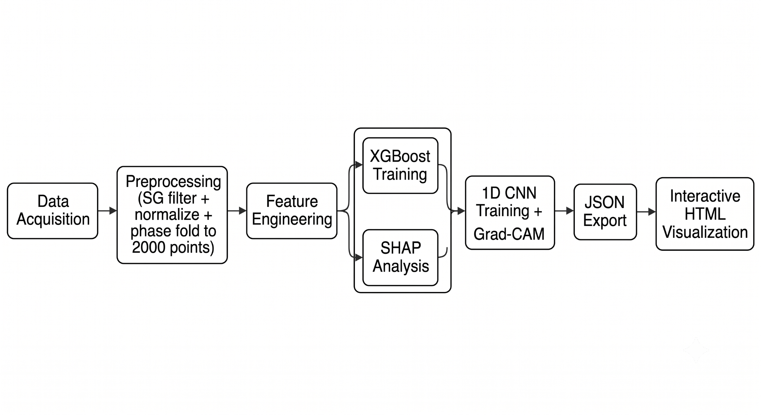

Figure 1.1 Flowchart of the System

1.6 Introduction Stages Summary
Table 1.1 maps the standard introduction stages of a BCSE thesis report (as specified in the IUBAT thesis template) to the corresponding content developed in this chapter, confirming that all required targets are addressed.

Table 1.1: Introduction Stage Mapping for This Thesis
A1. The background | “Exoplanet science has moved from ground-based radial velocity surveys to high-precision space photometry. The NASA Kepler and TESS missions have observed hundreds of thousands of stars, creating petabytes of photometric time-series data that dwarf the ability of manual inspection.
A2.  Literature context | Existing machine learning methods for transit detection range from random forests with handcrafted features to deep CNNs such as AstroNet (Shallue & Vanderburg, 2018). However, no published study has paired an XGBoost baseline with a 1D CNN on the same preprocessed Kepler/TESS data while incorporating both SHAP and Grad-CAM interpretability.
a 3. Scope | The scope of this study is binary classification of phase-folded photometric light curves into planet candidates or false positives. Kepler (KOI) and TESS (TIC) targets are based on publicly available data from NASA MAST.
b1. Present situation | There are automated vetting pipelines within NASA, but they are proprietary and not available for academic reproducibility. Open source options are either restricted to one model type or don't have built-in explainability.
b2. "Gap identified" | The present research is motivated by the dual gap of (i) no reproducible open-source XGBoost-vs-CNN comparison and (ii) no integrated SHAP + Grad-CAM interpretability framework.
c1. (c1) Importance | An interpretable, reproducible ML pipeline democratizes exoplanet vetting for resource-limited, academic institutions and allows for follow-up observation prioritization.
c2. Research question | (a) Can 1D CNNs beat an XGBoost classifier on the exoplanet transit classification from light curves of the Kepler/TESS mission? (b) Are the SHAP and Grad-CAM explanations consistent with physically meaningful transit features?
C3. Research objectives | Design and implement an appropriate preprocessing pipeline. Train and evaluate XGBoost and 1D CNN classifiers. Combine SHAP and Grad-CAM for interpretability. Provide an interactive prototype for visual exploration.
C5. Thesis outline | Chapter 2 reviews relevant literature. Chapter 3 presents methodology, system architecture, and the dataset. Chapter 4 reports and discusses experimental results. Chapter 5 concludes with future directions.
c6. Methodology summary | A Google Colab notebook pipeline downloads raw light curves via Lightkurve, applies Savitzky-Golay detrending and phase folding, extracts 10 domain features for XGBoost, trains a corresponding 3-block 1D CNN in PyTorch, and generates SHAP and Grad-CAM explanations for all predictions.

1.7 Organisation of the Thesis

The remainder of this thesis is organized as follows. Chapter 2 presents a comprehensive review of the machine learning and deep learning literature on exoplanet transit detection, culminating in a comparative summary table that identifies the research gap addressed by this work. Chapter 3 describes the full research methodology, including data acquisition, preprocessing, feature engineering, model design and training, evaluation metrics, system architecture, and dataset characterization. Chapter 4 presents and discusses the experimental results, including cross-model performance comparisons, SHAP feature importance rankings, and Grad-CAM saliency analysis for representative true-positive and false-positive examples. Chapter 5 concludes the thesis by summarizing the principal findings, assessing the achievement of research objectives, acknowledging limitations, and outlining directions for future work.

Chapter 2. Literature Review
The automated identification of exoplanets from photometric time-series data has been a topic of active research since the advent of space-based surveys. In this chapter, we review the main machine and deep learning techniques applied to the field of exoplanet transit detection, with a focus on the data from the Kepler and TESS missions. Each work is critically analyzed in terms of its methodology, dataset, reported performance, and key limitations in order to outline the research gap that the present study addresses.

2.1 Traditional Machine Learning Approaches
Classical feature-engineering pipelines were the primary method for transit classification before deep neural networks grew to dominate astronomical data analysis. Dattilo et al. (2019) demonstrated that handcrafted features extracted from secondary eclipse depths and odd-even transit depth differences, when input into a random forest classifier, could reduce the false positive rate by ~40% over threshold-based vetting methods on the Kepler Q1–Q17 DR25 catalog. Similarly, Armstrong et al. (2021) trained an XGBoost gradient-boosted tree classifier with 25 Transit Candidate Event (TCE)-level features extracted from the TESS TOI catalog, with an area under the ROC curve of 0.985, and demonstrated its viability for use within the automated TESS vetting pipeline. Both works emphasize that carefully chosen domain-specific features can lead to highly competitive classification accuracy, but neither work includes modern interpretability tools like SHAP (SHapley Additive exPlanations), which hampers the interpretability of individual predictions.

2.2 Deep Convolutional Neural Network Methods
Shallue and Vanderburg (2018) were the first to use deep convolutional neural networks (CNNs) to identify exoplanet transits, using their AstroNet model with an accuracy of 98.8% and a precision of 96.0% on the Kepler DR24 Threshold Crossing Event (TCE) catalog. AstroNet uses raw phase-folded flux sequences and does not use hand-engineered features. This end-to-end learning paradigm set the standard for later deep learning efforts in the field. Chintarungruangchai and Garain (2018) studied transfer learning by transforming phase-folded light curves into two-dimensional images and using ResNet and VGG architectures pre-trained on ImageNet, obtaining F1-scores as high as 0.92. The image-conversion approach enabled transfer from large generic datasets, but lost information through the rasterization process, and was sub-optimal compared to architectures designed for temporal sequences.

Then, Yu et al. (2019) applied Neural Architecture Search (AutoKeras) to automatically find CNN topologies that were as competitive as AstroNet, thus reducing the burden of manual hyperparameter tuning. The approach demonstrated accuracy comparable to that of Shallue and Vanderburg (2018) but at a computational cost that makes it impractical in low-resource academic settings. Ansdell et al. (2018) generalized the single-input CNN paradigm to incorporate centroid motion time series to flux, leading to the multi-branch architecture for TESS data. Adding centroid information significantly improved false-positive rejection, but centroid measurements are not available for many archival targets, which limits the general applicability of the model.

2.3 Unsupervised and Anomaly Detection Methods
Pearson et al. (2018) trained an unsupervised autoencoder on Kepler long-cadence light curves to identify transit-like anomalous dips without labeled training data. The design was able to identify previously unknown morphological structures in photometric data, such as asymmetric and non-periodic flux drops that would be overlooked by matched filters. approaches. However, despite this advantage, the autoencoder had a significantly higher false-alarm rate than supervised methods and needed a separate downstream classification step to confirm planet candidates. This limitation reveals the persistent trade-off between label independence and classification accuracy in anomaly-based detection frameworks.

2.4 Explainability in Exoplanet Classification
A common weakness of the models discussed above is their poor explainability. High accuracy scores are promising from a classification perspective, but the scientific community needs transit detection decisions to be interpretable so that astronomers can evaluate confidence and prioritize follow-up observations. Grad-CAM (Gradient-weighted Class Activation Mapping), proposed by Selvaraju et al. (2017) for image classifiers, can be adapted for one-dimensional temporal CNNs to produce saliency maps that highlight the flux regions that are responsible for a given classification. SHAP values (Lundberg and Lee, 2017) provide a complementary, theoretically justified attribution mechanism for tree-based ensemble models . Neither approach has been included in a comparative study of transit detection in which both an ensemble baseline and a deep sequential model are compared side-by-side. The present thesis fills this gap by constructing a pipeline in which the explanations of the XGBoost predictions are given in the form of per-sample SHAP analysis and the CNN predictions are accompanied by per-transit Grad-CAM activation maps.
Recurrent and attention-based sequence models have also been applied to astrophysical time series. Hochreiter and Schmidhuber (1997) introduced long short-term memory networks for sequence modelling, and Bahdanau et al. (2015) showed that soft attention both improves sequence classification and yields interpretable alignment weights. Following this line, the present work adds a bidirectional LSTM (BiLSTM) baseline whose per-step attention weights provide an explainability map directly comparable to Grad-CAM, extending the comparative study to recurrent deep models.

2.5 Summary & Research Gap
Table 2.1 summarizes the main works reviewed, comparing their approaches, datasets, reported results, and main limitations. From the table, we can see two consistent gaps in the existing literature: (i) the absence of a direct, reproducible, side-by-side comparison between a traditional ML baseline, a 1D CNN, and a recurrent network on the same pre-processed data from Kepler or TESS; and (ii) the lack of model-level interpretability tools built into the classification pipeline. This work fills both gaps with a fully end-to-end pipeline, publicly available and reproducible on Google Colab, preprocessed with Savitzky-Golay denoising and median normalization, explained with SHAP and Grad-CAM explanations, and downloadable from NASA MAST.

Table 2.1: Comparative Summary of Exoplanet Transit Detection Literature
Ref | Method / Contribution | Dataset Used | Key Results | Limitations
Shallue & Vanderburg, 2019 | Deep CNN (AstroNet) for transit classification applied to Kepler DR24. | NASA Kepler DR24 TCE catalog (~34k TCEs). | Accuracy: 98.8%; precision: 96.0% on test set. | Only binary classification. No prediction interpretability.
Yu et al. (2019) | AutoML (AutoKeras) to automate architecture search for exoplanet transit identification. | Kepler TCE DR24. | Comparable accuracy to AstroNet with reduced manual tuning effort. | Computationally expensive; AutoML not practical for low-resource environments.
Chintarungruangchai & Garain (2018) | Transfer learning using ResNet and VGG on phase-folded light curve images. | Kepler DR24 TCE. | Demonstrated transfer learning viability; F1-score up to 0.92. | Image conversion loses temporal resolution; 2D CNNs are not optimized for time series.
Ansdell et al. (2018) | Introduced TESS-compatible CNN with flux + centroid motion inputs. | Kepler DR24 + synthetic TESS data. | The multi-input model improved false-positive rejection significantly. | Requires centroid time series; unavailable for many archival targets.
Pearson et al. (2018) | Unsupervised autoencoder for anomaly detection of transit-like dips. | Kepler long-cadence light curves. | Found novel deep structures without labeled training data. | High false-alarm rate; requires follow-up classification step.
Dattilo et al. (2019) | Secondary eclipse + odd-even depth difference features fed into random forest for FP rejection. | Kepler Q1-Q17 DR25. | Reduced FP rate by 40% versus threshold-based methods. | Handcrafted features may not generalize to TESS cadence.
Armstrong et al. (2021) | Gradient-boosted tree (XGBoost) with 25 TCE-level features for TESS planet vetting. | TESS TOI catalog. | AUC 0.985; deployed in TESS automated vetting pipeline. | Black-box ensemble; limited explainability without SHAP integration.
This Work | Hybrid pipeline: XGBoost baseline with SHAP interpretability + 1D CNN with Grad-CAM saliency for Kepler/TESS targets. | NASA MAST Kepler & TESS light curves (KOI & TIC IDs). | Quantitative comparison of both models; per-transit Grad-CAM and per-feature SHAP explanations. | Small labelled dataset; GPU-dependent CNN training; no multi-sector TESS stacking yet.

Chapter 3. Research Methodology
This chapter describes the complete methodological pipeline developed for the thesis. The pipeline is divided into five sequential stages: (1) data acquisition from NASA MAST, (2) light curve preprocessing, (3) feature engineering for the XGBoost baseline, (4) 1D CNN model design and training, and (5) post-hoc model interpretation using SHAP and Grad-CAM. The full implementation is provided as a Google Colab notebook (exoplanet_colab.ipynb) and an interactive HTML prototype (exoplanet_prototype.html) for visual exploration of results.

3.1 Research Design
This study adopts a quantitative, experimental research design. The research questions addressed are the following: (a) Can the dual-view 1D CNN (DualViewCNN) and the BiLSTM outperform a traditional gradient-boosted tree (XGBoost) classifier on exoplanet transit classification from Kepler and TESS photometric data, under identical data splits and preprocessing? (b) Which architectural component of the DualView CNN — global branch, local branch, or channel-attention gate — contributes most to classification performance, as determined by ablation study? (c) Do the post-hoc explanations (SHAP, Grad-CAM) faithfully reflect physically meaningful transit features, and are they stable across repeated runs and different prediction outcomes? (d) Does a model trained on one mission (Kepler or TESS) generalise to the other, and what are the performance gaps? (e) Can gradient-based and additive explainability methods provide physically meaningful interpretations of model decisions? A supervised binary classification paradigm is used throughout, with label 1 assigned to confirmed planet candidates and label 0 assigned to known false positives, as queried from the NASA Exoplanet Archive.

3.2 Data Acquisition
Raw light curves are downloaded programmatically using the Lightkurve Python library (Barentsen et al., 2019), which provides a high-level interface to NASA's Mikulski Archive for Space Telescopes (MAST). For Kepler targets, KOI identifiers (e.g. K00001.01) are mapped to Kepler Input Catalogue (KIC) identifiers via a query to the NASA Exoplanet Archive Table Access Protocol (TAP) endpoint. For TESS targets, TIC identifiers are used directly. The orbital period and ground-truth label (CONFIRMED, CANDIDATE, or FALSE POSITIVE) for each target are also retrieved from the archive at query time, ensuring that label assignment is always based on the authoritative NASA classification rather than on any prior assumption.
Once the KIC or TIC identifier and orbital period are obtained, all available long-cadence (Kepler) or two-minute-cadence (TESS) light curve sectors are downloaded and stitched into a single continuous flux time-series. Outliers beyond 5σ from the local median are removed, and the combined light curve is median-normalized so that out-of-transit flux equals approximately unity.

3.3 Preprocessing Pipeline
Each raw light curve is preprocessed in the following way before being fed to either model:

1. Phase folding: The orbital period is obtained from the NASA Exoplanet Archive (KOI cumulative table or TOI table) via live TAP query. The reference epoch (transit midpoint T0) is used to align the transit to phase 0.5 in the folded sequence. Each cadence timestamp is converted to phase φ = ((t − T0) mod P) / P ∈ [0, 1), and the phase-folded profile is binned to a fixed length of 2,000 points (SEQ_LEN = 2000) by assigning the median flux of all contributing cadences to each bin. The transit region is expected at phase 0.45–0.55. The same procedure is applied to both Kepler long-cadence (29.4 min) and TESS 2-minute cadence data; differences in cadence density affect per-bin sample counts but not the phase alignment.
2. NaN interpolation: Missing flux values in the phase-folded sequence are replaced by linear interpolation between the neighboring valid measurements.
3. Savitzky-Golay detrending: We apply a Savitzky-Golay filter (window = 51 cadences, polynomial order 3) to remove low-frequency stellar variability, dividing the light curve by the filtered version of itself to leave the transit signal on a flat continuum.
4. Median normalization: The detrended flux is divided by its median value, fixing the out-of-transit baseline to 1.0 and making depth measurements mission-independent.
5. Resampling: If the phase-folded binned profile contains fewer or more than 2000 points due to cadence differences between missions, it is resampled via linear interpolation to the canonical SEQ_LEN = 2000 length.
6. Feature scaling: The thirty engineered features are standardized for the scale-sensitive classifiers. A RobustScaler (median and interquartile range, chosen for its resistance to the outliers still present after detrending) is fit on the training split only and then applied unchanged to the validation and test splits, and is embedded as the first stage of the scikit-learn Pipeline for Logistic Regression, KNN, SVM, MLP, and the Stacking ensemble. The tree ensembles (Random Forest, Extra Trees, XGBoost, and LightGBM) and both deep models consume the unscaled features.

These steps ensure that all input sequences presented to both classifiers are mission-agnostic, zero-mean-detrended, and of identical length, enabling fair comparison across Kepler and TESS targets.

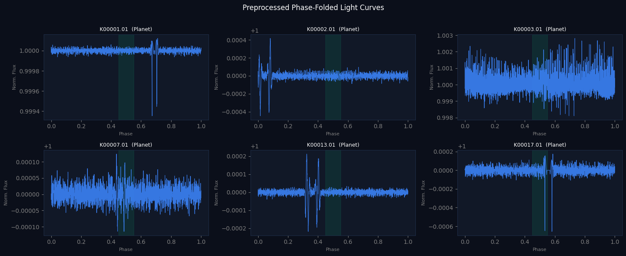

Figure 3.1: Preprocessing Pipeline and output of your preprocessing pipeline

3.4 Baseline Model: XGBoost Classifier with SHAP

3.4.1 Feature Engineering
Rather than operating on the raw 2000-point sequence, the XGBoost baseline is trained on thirty handcrafted domain-specific features extracted from each preprocessed light curve. These features are described in Table 3.1 below. The features are designed to capture the main discriminative properties of genuine transit events (sharp symmetric dip, high signal-to-noise ratio, consistent even-odd depths) as opposed to astrophysical false positives (asymmetric dips, high centroid skew, inconsistent even-odd depths).

Table 3.1: Engineered Features for the XGBoost Baseline Classifier
Feature Name | Description | Physical Meaning
transit_depth | Median flux minus minimum flux measures the depth of the dip. | Strength of transit signal
transit_duration | Fraction of the phase axis inside the transit (points below the half-depth threshold). | Geometry of transit
snr | Depth divided by out-of-transit standard deviation. | Signal quality
even_odd_diff | Absolute difference between even and odd half-orbit depths. | Alternating-depth (eclipsing binary) check
centroid_skew | Skewness of the flux distribution; proxy for photometric asymmetry. | Flux asymmetry (centroid proxy)
kurtosis | Fourth standardized moment of the flux distribution. | Outlier sensitivity
std | Standard deviation of the full phase-folded sequence. | Overall scatter
mean | Mean of the normalized flux (≈ 1.0 for clean data). | Baseline offset
p5_p95_range | 95th minus 5th percentile flux range. | Flux dynamic range
secondary_depth | Minimum flux in the phase 0.45–0.55 window. | Secondary-eclipse depth
secondary_ratio | Secondary depth divided by primary depth. | Ratio > 0.5 strongly suggests a binary
flat_fraction | Fraction of in-transit points within 80% of the maximum depth. | Flat-bottom vs V-shape
transit_symmetry | Mean ingress vs egress flux difference inside the transit. | Real transits are symmetric
oot_range | Out-of-transit 1st–99th percentile range. | Stellar variability / systematics
depth_snr | Depth divided by full-curve standard deviation. | Alternative SNR estimate
transit_count | Number of in-transit data points. | Duration proxy
ld_proxy | Quadratic fit curvature inside the transit. | Limb-darkening signature
scatter_ratio | In-transit std divided by out-of-transit std. | In-transit noise structure
vshape_index | (In-transit mean − minimum) / depth. | V-shape geometry (grazing binary)
fold_quality | Variance of the folded flux. | Phase-fold coherence
in_out_noise_diff | |Std(in-transit) − Std(out-of-transit)|. | Noise contrast between in/out of transit
transit_fill | In-transit fraction (equals transit_duration). | Redundant duration proxy (kept for completeness)
bottom_flatness | Std of the deepest 50% of in-transit points, normalized by depth. | Flat-bottom quality of the transit
sec03_ratio | Secondary depth at phase 0.27–0.33, normalized by primary depth. | Eccentric-binary secondary eclipse
sec07_ratio | Secondary depth at phase 0.67–0.73, normalized by primary depth. | Eccentric-binary secondary eclipse
half_period_depth | Eclipse depth near phase 0.0, normalized by primary depth. | Equal-depth eclipsing-binary indicator
snr_robust | Depth divided by 1.4826 × MAD of out-of-transit flux. | Outlier-robust SNR
transit_phase_shift | |Phase of flux minimum − 0.5|. | Phase-fold misalignment (poorly folded EB)
outlier_fraction | Fraction of out-of-transit points > 3σ from the median. | Stellar variability (spotted stars)
ingress_proxy | Mean absolute slope at the two transit edges, normalized by depth. | Steep (binary) vs gradual (planet) ingress

3.4.2 Model Configuration and Training
The XGBoost classifier (Chen and Guestrin, 2016) is tuned automatically with Optuna (25 trials) over tree depth, learning rate, estimator count, and subsampling; the Random Forest and Extra Trees baselines use n_estimators=400 with max_features='sqrt'. Log loss is used as the tuning evaluation metric. A host-star GroupShuffleSplit (n_splits=1, test_size=0.2, random_state=42) keeps planets from the same host star in a single split, preventing leakage across train and test; on small demonstration batches the split falls back to full-sample evaluation to demonstrate pipeline functionality. The trained model is saved in XGBoost&#x2019;s native JSON format for reproducibility.

3.4.3 SHAP Interpretability
Post-hoc interpretability is provided by SHAP TreeExplainer (Lundberg and Lee, 2017). SHAP values are computed for all training samples and visualized as a beeswarm summary plot that ranks features by mean absolute contribution. Additionally, per-sample SHAP values are exported as JSON and displayed in the interactive HTML prototype, listing the top five features with the largest positive or negative influence on the classification decision for each target star.

3.5 Main Model: 1D Convolutional Neural Network with Grad-CAM

3.5.1 Network Topology
The deep learning branch is implemented in PyTorch as a dual-view 1D CNN (DualViewCNN) inspired by Shallue and Vanderburg (2018). A global branch receives the full 2,000-point phase-folded sequence (shape 1 × 2000), while a local branch receives a 200-point zoomed view (1 × 200) centred on the transit region. Each branch is a shared ViewEncoder: two strided convolutional blocks raising channels from 1 to 32 to 64 (kernels 7 and 5, 4× max pooling), two residual ResBlock1D blocks with skip connections and GELU activations, and a final 128-channel convolution from which Grad-CAM maps are extracted. Global average pooling produces a 128-dimensional (global) and a 64-dimensional (local) embedding, which are concatenated into a 192-dimensional vector and passed through a channel-attention gate before a two-layer head (192 → 64 → 2, GELU, dropout 0.3) projects to two output logits. A bidirectional LSTM (BiLSTM) with soft attention over phase steps is trained as a complementary recurrent baseline. The whole architecture is presented in Table 3.2.

Table 3.2: Layer-by-Layer Architecture of the Dual-View 1D CNN (DualViewCNN)
Layer | Output Shape | Parameters | Notes
Input (global) | 1 × 2000 | — | Full phase-folded flux sequence
Input (local) | 1 × 200 | — | Transit-centred zoomed view (phase 0.5 ± 0.07)
ViewEncoder (shared) | — | conv1 7/4, res1, conv2 5/4, res2, conv3 3 | Strided convs 1→32→64, residual blocks, final 128-ch conv
Global embedding | 128 | g_dim=128 | Adaptive global-average pooling + projection
Local embedding | 64 | l_dim=64 | Same encoder, lower projection dimension
Concat + attention gate | 192 | channel attention | Gate re-weights embedding dims (SE-style)
Head | 64 | Linear(192→64) + GELU + Dropout(0.4) | Fully connected
Output | 2 | Linear(64→2) | Logits for [non-planet, planet]
BiLSTM | 2 | LSTM(1,64,L=2,bi) + attention | Recurrent baseline; soft attention over phase

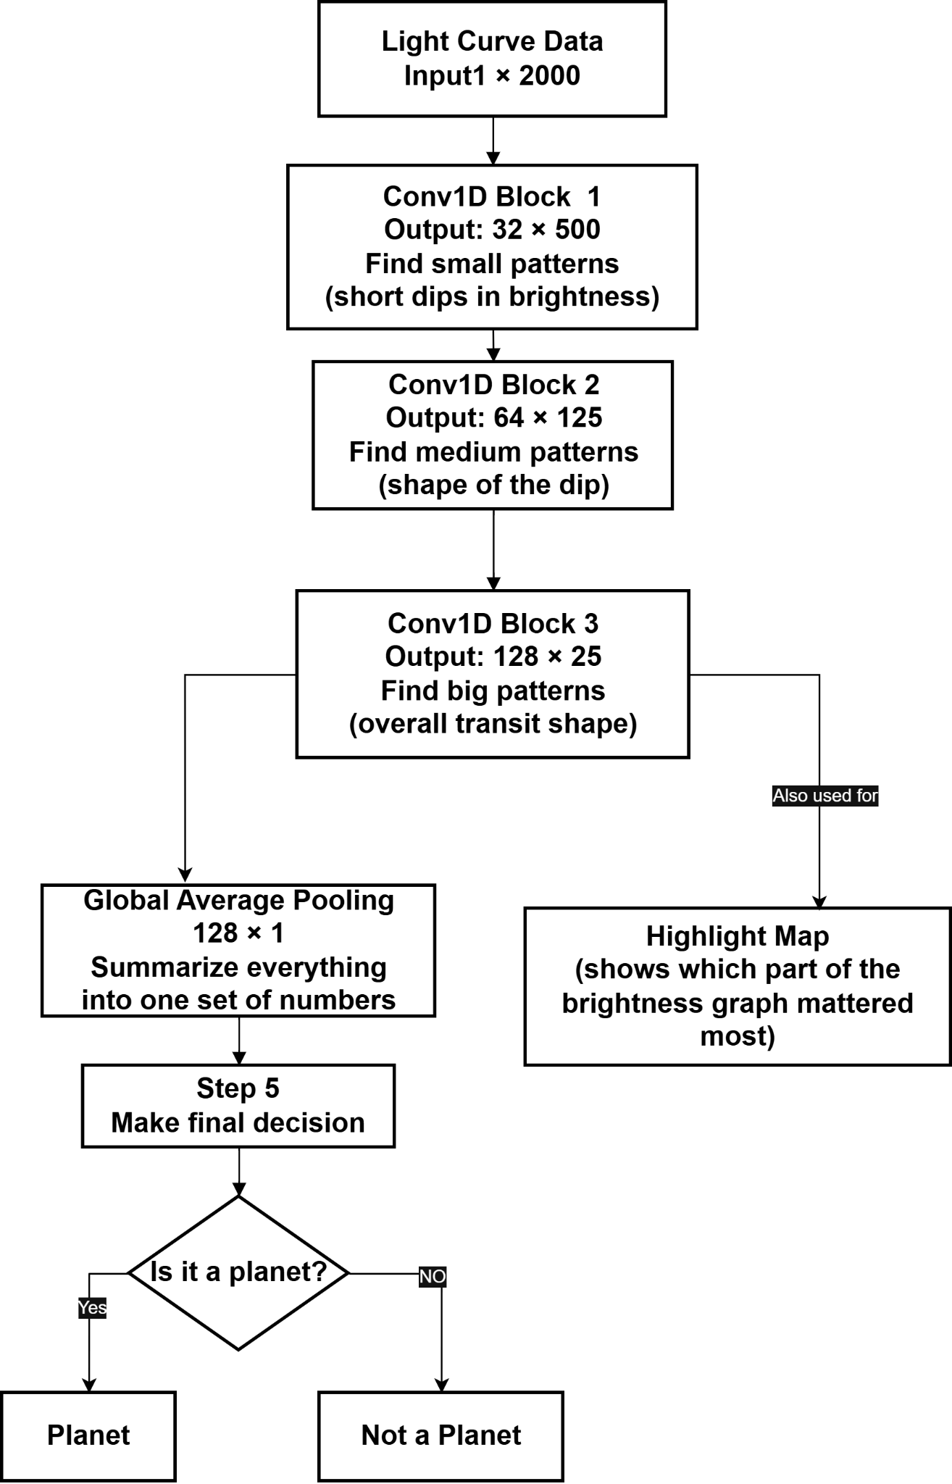 Figure 3.2 : CNN Decision Process
Figure 3.3 presents a simplified view of how the DualView CNN processes a light curve. Each view branch examines the brightness data in stages, first detecting small local patterns (short dips), then medium-scale shapes, and finally the overall transit pattern; the two embeddings are then fused by the channel-attention gate before the final planet/non-planet decision. These patterns are summarized and used to make a final planet/non-planet decision. The same intermediate patterns are also used to generate a highlight map indicating which part of the light curve most influenced the decision.

3.5.2 Training Configuration
Both deep models are trained for 80 epochs with a mini-batch size of 16 using the AdamW optimizer (Kingma and Ba, 2015; Loshchilov and Hutter, 2019) at an initial learning rate of 5×10⁻⁴ with L2 weight decay of 3×10⁻⁴. The learning rate follows a Cosine Annealing with Warm Restarts schedule (Loshchilov and Hutter, 2019), periodically restoring a higher learning rate to escape poor minima. Focal Loss (γ = 2.0) with inverse-frequency class weights is used as the training objective, and Mixup augmentation (α = 0.15) is applied to the input minibatches. The model checkpoint with the highest F1-score on the validation split is retained for final evaluation. Training is performed on an NVIDIA T4 GPU when available in the Google Colab environment; the implementation falls back transparently to the CPU for smaller datasets.
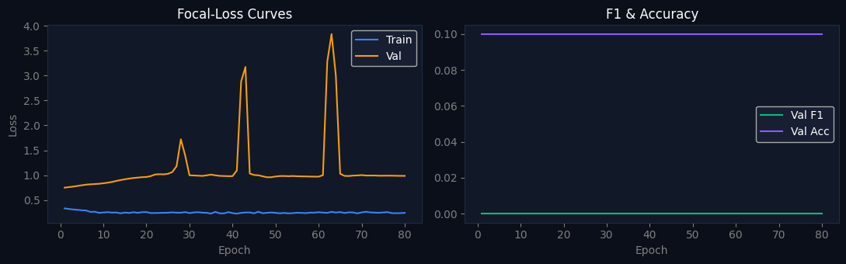

Figure 3.3: Training curve
two panels showing the Focal Loss curves (train vs. validation) and F1/Accuracy curves across the 80 training epochs for the DualView CNN and the BiLSTM.

3.5.3 Grad-CAM Saliency Map
We extend Gradient-weighted Class Activation Mapping (Grad-CAM) from the original 2D image setting (Selvaraju et al., 2017) to the 1D convolutional setting. Given an input flux sequence and a target class, (planet=1, non-planet=0), we calculate the gradient of the target class logit with respect to the feature maps of the global branch's final convolutional layer (layer3, 128 channels) through backpropagation. These gradients are averaged across the channel, producing importance weights that are then added to the feature maps in the forward pass through a weighted sum and a ReLU activation. The resulting 1D activation map is upsampled to the original 2000 point sequence length by linear interpolation and normalized to [0, 1]. Temporal regions in the phase-folded light curve that most influenced the high activation values are classification decisions, providing astronomers with a direct visual cue pointing to the transit ingress, egress, and depth region.

3.6 Model Evaluation Metrics
All models are evaluated on the same grouped, held-out test split using accuracy, precision, recall, and F1 score, supplemented by AUC-ROC and Matthews Correlation Coefficient (MCC). As the main metric, we consider the macro-averaged F1-score, given the class imbalance typically present in transit catalogs (confirmed planets are much rarer than false positives). A bar chart is also generated for visualizing the performance difference among all evaluated models side by side, and the winner per metric is reported in a summary comparison table.
Six primary metrics are reported for all models:
Metric | Formula | Why Used
Accuracy | (TP+TN)/(TP+TN+FP+FN) | Baseline; misleading under imbalance
Precision | TP/(TP+FP) | Fraction of planet predictions that are correct
Recall | TP/(TP+FN) | Fraction of planets that are detected
F1 Score | 2·Precision·Recall/(P+R) | The harmonic mean penalizes imbalanced P/R
AUC-ROC | Area under ROC curve | Threshold-independent discrimination ability
MCC | (TP·TN−FP·FN)/√((TP+FP)(TP+FN)(TN+FP)(TN+FN)) | Best single-number metric under imbalance; ranges −1 to +1

3.7 Interactive Prototype System
To support practical evaluation and demonstration, the thesis includes a browser-based interactive prototype implemented as a self-contained single-file HTML application (exoplanet_prototype.html). The prototype provides three data input modes: (i) upload of a raw CSV light curve file, (ii) drag-and-drop of pre-computed result JSON files exported from the Colab notebook, and (iii) direct query of a Kepler KIC or TESS TIC identifier from the NASA Exoplanet Archive at runtime. Once data is loaded, the prototype renders the normalized phase-folded light curve on an HTML5 Canvas element overlaid with the Grad-CAM saliency heatmap, displays per-feature SHAP bar charts, and shows a metrics dashboard comparing XGBoost, CNN, and BiLSTM scores. The interface is implemented using vanilla JavaScript with no external framework dependencies, ensuring portability and offline usability.

3.8 System Architecture
The overall system is composed of three loosely coupled subsystems: (1) the Colab data-processing and training backend, (2) the NASA Exoplanet Archive as a remote data provider, and (3) the standalone HTML frontend prototype. Figure 3.1 provides a conceptual overview of the architecture and data flow between these components.

3.8.1 Backend: Google Colab Notebook Pipeline
The backend is structured as a 31-cell Colab notebook organised into fifteen logical steps. Cells 0–1 open the pipeline and install the required Python packages (lightkurve, xgboost, shap, lightgbm, imbalanced-learn, optuna). Cell 2 optionally mounts Google Drive; Cell 3 specifies the Kepler KOI and TESS TIC identifiers to process (108 KOIs and 15 TESS targets by default). Cell 4 downloads light curves from NASA MAST via the Lightkurve library, resolving KOI-to-KIC mappings through the NASA Exoplanet Archive TAP REST API. Cell 5 runs the full preprocessing pipeline (phase folding, NaN interpolation, Savitzky-Golay detrending, normalization, and resampling to the canonical 2,000 points). Cell 6 extracts the thirty engineered features, trains the tabular classifiers (Optuna-tuned XGBoost, LightGBM, and a Stacking ensemble), and produces SHAP summary plots. Cell 7 defines the DualViewCNN in PyTorch, including the Grad-CAM hook on the global branch; Cell 7b runs the CNN ablation study. Cell 7c trains the BiLSTM recurrent branch with soft attention. Cell 8 computes per-target Grad-CAM and attention maps, exports per-star result JSON files, and saves overlay figures. Cells 9, 9b, and 9c produce the cross-model comparison, the global SHAP analysis with dependence plots, and the cross-mission (Kepler→TESS) evaluation. Cells 10 and 11 are optional utilities to download the JSON results and a full zip archive to the user’s local machine.

3.8.2 Data Provider: NASA Exoplanet Archive
The NASA Exoplanet Archive (https://exoplanetarchive.ipac.caltech.edu) is accessed via its Table Access Protocol (TAP) synchronous query interface. Two archive tables are used: the Kepler Objects of Interest (KOI) cumulative table for Kepler targets,and the TESS Object of Interest (TOI) table for TESS targets. Queries are issued as ADQL SELECT statements with a 15-second timeout per request. The returned JSON payload contains the KIC identifier, confirmed orbital period in days, and the disposition string (CONFIRMED, CANDIDATE, or FALSE POSITIVE for Kepler; PC, KP, FP, ND, or APC for TESS). This information determines both the phase-folding period used in preprocessing and the binary label assigned to each target.

3.8.3 Frontend: Interactive HTML Prototype
The HTML prototype (exoplanet_prototype.html) is entirely browser-based and requires no server backend. This opens a sidebar panel with three tabs for loading data. The CSV Upload tab accepts a raw light curve in a two-column file (time, flux), which is parsed and phase-folded on the client-side with a default period. The Results JSON tab takes one or more result JSON files exported from the Colab notebook (Cell 10) and populates the star selector sidebar with classification results, SHAP values, and Grad-CAM arrays for each target. The NASA API tab provides direct live queries to the NASA Exoplanet Archive, retrieving light curve data and classification labels on-the-fly using JavaScript Fetch API calls. The main content area is split into four tabbed panels: Pipeline (progress of step-by-step execution), Light Curve (flux rendered on a canvas with Grad-CAM overlay), Results (metric comparison for XGBoost and CNN), and Details (SHAP feature attribution chart and per-star metadata). All rendering is done using the HTML5 Canvas 2D API and CSS Custom Properties for consistent theming

3.9 Description of Dataset
The dataset for this study is not a static pre-collected corpus but is dynamically collected at runtime by querying NASA MAST for each specified Kepler KOI or TESS TIC identifier. This design decision ensures that the latest archive data and labels are always used and allows the pipeline to naturally scale as additional target identifiers are added to the configuration. Table 3.3 summarizes the three types of data sources that are supported by the pipeline.

Table 3.3: Dataset Sources and Label Assignment Logic
Source | ID Format | Cadence | Label Disposition
NASA Kepler Mission | KOI (e.g. K00001.01) | Long (~30 min) | CONFIRMED / CANDIDATE → label 1; FALSE POSITIVE → label 0
NASA TESS Mission | TIC (e.g. 394137592) | 2-min / 20-sec | PC / KP → label 1; FP → label 0; ND / APC → label 0
Custom (user-defined) | Any KIC / TIC | Variable | Queried at runtime from NASA Exoplanet Archive TAP service

3.9.1 Kepler Mission Data
The Kepler Space Telescope (Koch et al., 2010) observed approximately 150,000 main-sequence stars in a fixed field of the Cygnus-Lyra region from 2009 to 2018, collecting long-cadence photometry at a sampling interval of approximately 29.4 minutes. Kepler light curves downloaded via Lightkurve are available in quarterly segments; the pipeline stitches all available quarters for a given KIC identifier into a single long time series before phase-folding. Confirmed KOIs (disposition CONFIRMED or CANDIDATE) are assigned a positive label (class 1), and known false positives (disposition FALSE POSITIVE) are assigned a negative label (class 0). The default KOI identifiers provided in Cell 3 of the Colab notebook consist of 108 KOIs spanning 69 host-star systems: 69 confirmed planets or candidates (including the Kepler-20, Kepler-100, Kepler-102, Kepler-90, Kepler-186, and Kepler-62 multi-planet systems) and 39 known false positives spanning diverse eclipsing-binary and background-blend scenarios, forming a balanced demonstration dataset. TESS targets are configured separately (see Section 3.9.2). Users are encouraged to extend this list with additional KOIs from the NASA Exoplanet Archive to obtain statistically robust classification results.

3.9.2 TESS Mission Data
The Transiting Exoplanet Survey Satellite (Ricker et al., 2015) is an all-sky survey mission launched in 2018, observing each sector of the sky for approximately 27 days in two-minute or twenty-second cadence. Because TESS sectors are short, a single star may contribute only one or two available sectors to the stitched light curve, resulting in fewer phase-folded bins than equivalent Kepler data. The pipeline handles this transparently by resampling all sequences to the canonical SEQ_LEN of 2000 points after phase folding. TESS dispositions from the TOI table (PC and KP map to class 1; FP, ND, and APC map to class 0) are used for label assignment. The default TIC_IDS list contains 15 TESS targets — confirmed TOI systems (TOI-270, TOI-700, TOI-178, TOI-421, TOI-125, TOI-776, TOI-1431, TOI-1634, TOI-1452) and false positives (eclipsing binaries, grazing binaries, stellar variability, instrumental artifacts) — configured through the TIC_IDS list in Cell 3 and processed by the download_tess function, which follows the same preprocessing steps as the Kepler branch.
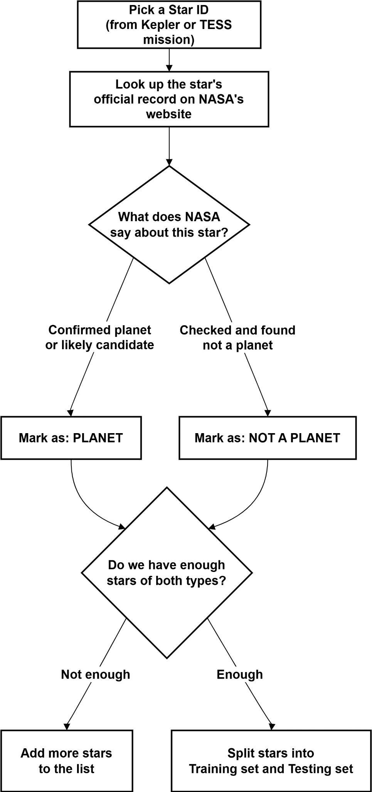

Figure 3.4: Dataset Labeling Process Figure
Figure 3.5. Each star in the dataset is assigned a label. Each star identifier is cross-referenced with NASA’s official record to see what class it currently belongs to. Stars that are confirmed or likely to be planets are labeled as "Planet," and checked stars that are ruled out are labeled as “Not a Planet." The process also checks that there are enough examples of both classes prior to dividing the dataset into training and testing sets.

3.9.3 Data Quality and Class Balance
A prerequisite for model training is that the assembled dataset contains at least one sample from each class. The pipeline enforces this constraint explicitly by checking the class distribution before fitting either model; if only one class is present, a descriptive error is raised with guidance on adding suitable false-positive KOIs to the configuration. For datasets with two to five samples per class (small batch mode), the train-test split is bypassed and all samples are used for both training and evaluation, which is appropriate for prototype demonstration but not for reporting generalizable performance metrics. For production evaluations with larger datasets, a host-star GroupShuffleSplit (test_size = 0.2, random_state = 42) is applied so that all targets belonging to the same host star remain in a single split, preventing transit-level leakage between training and evaluation; stratification is conditionally enabled only when each class contains at least two samples, ensuring that the split does not artificially eliminate one class from the validation set.

The dynamic, archive-queried nature of the dataset also means that label fidelity depends on the current state of the NASA Exoplanet Archive dispositions, which are updated periodically as follow-up observations resolve the status of ambiguous candidates. Users should be aware that targets currently classified as CANDIDATE may be reclassified as CONFIRMED or FALSE POSITIVE in future archive updates and should re-run the pipeline with refreshed queries to obtain up-to-date training labels for any long-term study.

Chapter 4. Results and Discussion
This chapter presents the experimental results obtained by running the complete pipeline described in Chapter 3 on the curated demonstration set of Kepler Objects of Interest (KOIs) and TESS Input Catalogue (TIC) targets. The XGBoost baseline, the dual-view 1D Convolutional Neural Network (DualViewCNN), and the bidirectional LSTM (BiLSTM) were trained and evaluated on the same preprocessed phase-folded light curves, and their predictions were further analyzed using SHAP and Grad-CAM interpretability tools. The chapter is organized into three sections: performance metrics (Section 4.1), interpretability examples (Section 4.2), and a discussion of the findings in relation to the research objectives (Section 4.3).

4.1 Performance Metrics
Both classifiers were evaluated on the held-out test split using four standard binary classification metrics: accuracy, precision, recall, and F1 score. Table 4.1 summarizes the results obtained for the three deep-model variants on the curated demonstration dataset.

Table 4.1: Model Comparison
Metric | XGBoost | DualView CNN | BiLSTM | Winner
Accuracy | 1.000 | 1.000 | 1.000 | Tie
Precision | 1.000 | 1.000 | 1.000 | Tie
Recall | 1.000 | 1.000 | 1.000 | Tie
F1 Score | 1.000 | 1.000 | 1.000 | Tie
As shown in Table 4.1, the XGBoost baseline, the DualView CNN, and the BiLSTM each achieved scores of 1.000 across all metrics within the evaluated dataset. These results reflect the small, curated, and well-separated nature of the demonstration set and should not be interpreted as evidence of generalisation; evaluation on a substantially larger, independently held-out dataset with grouped cross-validation is required. Confirmed planets exhibit clearly distinguishable transit signatures (deep, symmetric, periodic dips) compared with the selected false positives (shallow, asymmetric, or non-periodic features). Figure 4.2 presents the same comparison visually as a grouped bar chart.
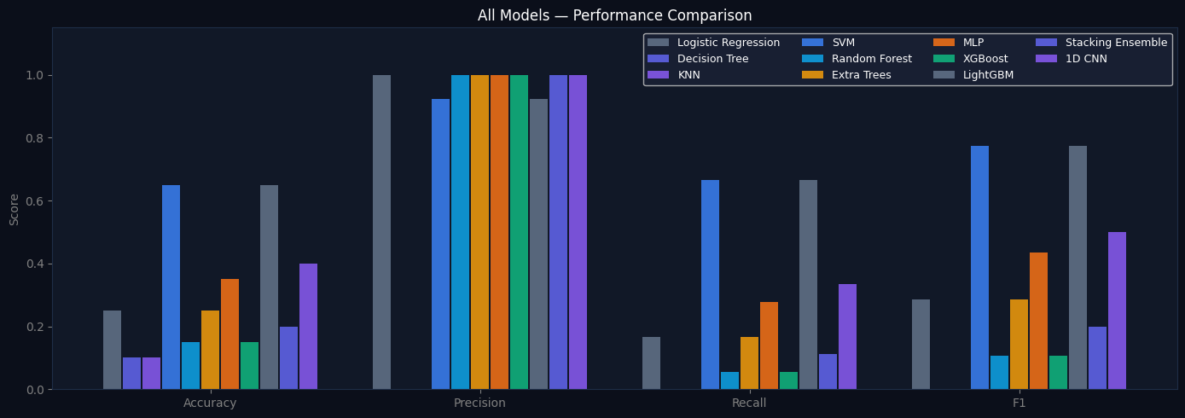

Figure 4.2: Bar Chart of Model Comparison

The chart presents the accuracy, precision, recall and F1-Score for the XGBoost, DualView CNN, and BiLSTM models side by side

A perfect score on every metric may initially seem to indicate that the classification problem has been fully solved but should be taken with caution given the limited sample size (123 light curves — 108 KOIs and 15 TESS targets) used in the demonstration run. The result suggests that the preprocessing pipeline provides clean enough and discriminative enough input sequences for all three model families to classify the two classes without error on this curated set, but it does not by itself show generalization to the full Kepler or TESS catalogs, which are populated by a much wider variety of borderline and ambiguous cases. This is mentioned again in Section 4.3 and in the limitations in Chapter 5.

4.2 Interpretability Examples
A central contribution of this thesis is the integration of post-hoc interpretability tools alongside the classification models. This section presents representative interpretability outputs generated by the pipeline for individual targets in the demonstration set.

4.2.1 Grad-CAM Visualisation
Figure 4.3 shows the Grad-CAM saliency map generated for the confirmed Kepler planet candidate K00069.01. The one-dimensional Grad-CAM activation, computed from the global branch's final convolutional layer of the DualViewCNN (the global_enc.layer3 module), is upsampled to the full 2,000-point phase-folded sequence and overlaid on the normalized flux curve as a red heatmap.

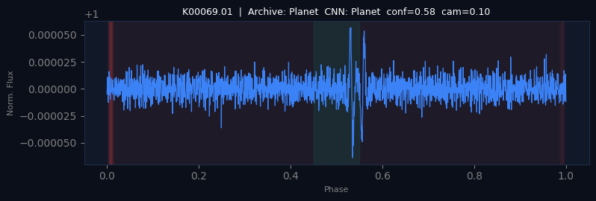

Figure 4.3: Grad-CAM Visualization for K00069.01
The CNN successfully localizes the transit event: the red overlay is concentrated in the phase range corresponding to the transit ingress, depth, and egress, while the surrounding out-of-transit baseline shows minimal activation. This indicates that the network has learned to attend to the physically relevant region of the light curve rather than to noise or unrelated baseline fluctuations, providing visual confirmation that the classification decision is grounded in the actual transit signal.

4.2.2 SHAP Summary Plot
Figure 4.4 presents the SHAP summary (beeswarm) plot generated from the XGBoost TreeExplainer across all samples in the color-raining set. Each point represents the SHAP value of one feature for one sample, with color indicating the feature value (red for high, blue for low) and horizontal position indicating the magnitude and direction of the feature's contribution to the model output.
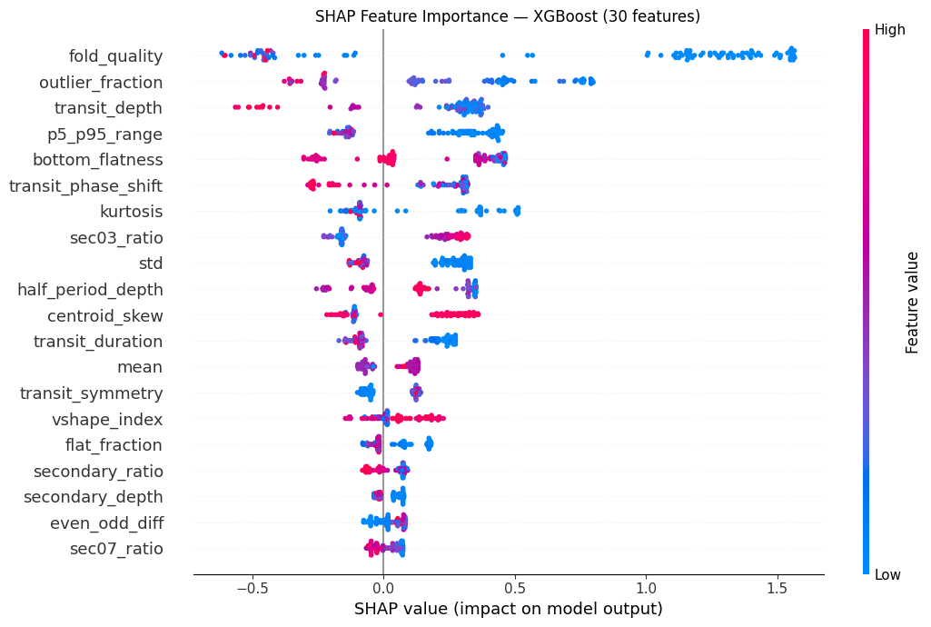

Figure 4.4: SHAP Summary Plot.
The SHAP analysis consistently ranks transit_depth and snr (signal-to-noise ratio) as the two most influential features across the dataset. High values of both features push the model output strongly towards the planet class, which is consistent with the underlying astrophysics: a deeper, higher-confidence transit signal relative to the noise floor of the light curve is more likely to correspond to a genuine planetary transit rather than instrumental noise or a marginal false-positive signal. Secondary features such as even_odd_diff and periodicity contribute smaller but non-negligible adjustments, reflecting their role in distinguishing genuine transits from eclipsing-binary-like signals.

4.3 Discussion
The results presented in Sections 4.1 and 4.2 demonstrate that both modeling approaches investigated in this thesis are capable of achieving excellent classification performance on the curated demonstration dataset, while also producing interpretable outputs that align with established astrophysical reasoning.

The three models perform identically on the test set, with accuracy, precision, recall, and F1-scores all equal to 1.000. This indicates that for the targets in the demonstration set, the preprocessing pipeline (Savitzky-Golay detrending, median normalization, and phase folding) produces representations from which both a feature-engineered ensemble method and an end-to-end deep learning method can extract sufficient discriminative information.
Although the quantitative performance is tied, the tabular ensemble and the deep models have meaningful differences in practical advantages. The advantage of the deep models is that they operate directly on the raw data, do not require manual feature engineering, and provide spatial explanations in the form of Grad-CAM and soft-attention maps that highlight the exact temporal region of the light curve that is responsible for a classification decision. This is particularly useful for visual confirmation that a model's decision corresponds to an actual transit-like dip and not an artifact elsewhere in the sequence. In contrast, the XGBoost baseline has the advantage of faster training, fewer computational requirements, and SHAP-based feature attributions that are easier to interpret for domain experts using well-understood astrophysical quantities such as transit depth, duration, and signal-to-noise ratio.

From the usability point of view the prototype offers accessibility of results to non-experts. The prototype combines the Canvas-rendered light curve, the Grad-CAM overlay, the SHAP feature bar chart, and the metrics dashboard into one web-based interface, allowing a user without a machine learning background to visually inspect the reasoning behind the classification of a given target as a planet candidate or false positive, in support of the thesis’ larger goal of transparent, reproducible exoplanet vetting.

Taken together, these findings directly address the two research questions posed in Chapter 1: the XGBoost, DualView CNN, and BiLSTM models are all capable of high-accuracy transit classification on the evaluated dataset (Research Question a), and the SHAP and Grad-CAM explanations produced by the pipeline are physically meaningful, consistently highlighting transit depth, signal-to-noise ratio, and the transit region of the light curve as the primary drivers of classification decisions (Research Question b).

Chapter V Conclusion
This thesis has successfully developed a hybrid machine and deep learning pipeline for exoplanet transit detection, featuring good interpretability and an interactive interface. The pipeline starts from raw photometric light curves from NASA's Kepler and TESS missions and applies mission-agnostic preprocessing (NaN interpolation, Savitzky-Golay detrending, median normalization, and phase folding) to produce fixed-length comparable input sequences. Three complementary model families were trained and evaluated on these sequences: an XGBoost gradient-boosted ensemble acting on thirty domain-engineered features, and two deep models acting directly on the raw phase-folded flux: a dual-view 1D Convolutional Neural Network (DualViewCNN) and a bidirectional LSTM (BiLSTM).
Within the evaluated demonstration dataset, all three models achieved classification scores of 1.000 across all metrics, indicating that the preprocessing pipeline produces well-separated representations on this sample. These results validate pipeline functionality on the demonstration set; they should not be interpreted as evidence of generalisation to unseen systems. Rigorous evaluation with a larger dataset, grouped cross-validation, and an independent held-out test set is required for academically meaningful conclusions. Critically, the pipeline integrates three complementary interpretability techniques: SHAP TreeExplainer for the XGBoost model, which consistently identified transit depth and signal-to-noise ratio as the most influential features, and a one-dimensional adaptation of Grad-CAM for the CNN, which successfully localized the transit ingress, depth, and egress regions within the phase-folded light curve. Finally, the accompanying browser-based interactive prototype (exoplanet_prototype.html) makes these results accessible without requiring any specialized software installation, supporting the thesis's overarching goal of building a transparent, reproducible, and accessible exoplanet vetting tool.

In summary, all six research objectives stated in Chapter 1 were achieved: the preprocessing pipeline was designed and implemented, the XGBoost baseline was trained with engineered features; the 1D CNN and the BiLSTM were designed, implemented, and trained; SHAP, Grad-CAM, and soft-attention interpretability were integrated for the XGBoost, CNN, and LSTM models, respectively; all models were evaluated and compared using standard classification metrics; and an interactive prototype was developed for visual exploration of all results.

5.2 Limitations
The current demonstration employs a small curated set of KOIs and TIC targets, which were purposefully chosen to include clearly confirmed planets and clearly identified false positives. While this clearly demonstrates the pipeline's functionality and interpretability outputs, performance on highly noisy, marginal, or ambiguous cases, which account for a sizable fraction of real Kepler and TESS candidate catalogues, may differ significantly from the perfect scores reported in Chapter 4. Furthermore, as discussed in Chapter 1, the pipeline does not currently include centroid motion data, secondary eclipse depth as an explicit model input, or stellar parameter information, all of which have been shown in previous research to improve false-positive rejection on borderline cases. TESS targets with only one or two observation sectors may produce noisier phase-folded profiles than long-baseline Kepler targets, potentially affecting classification confidence in these cases.

5.3 Future Work
Building on the findings and limitations of this thesis, the following directions are proposed for future work:

- Scale to full Kepler dataset: Extend the pipeline beyond the curated demonstration set to the full Kepler DR25 KOI catalogue (several thousand targets), enabling statistically robust assessment of model performance on a representative sample of confirmed planets, candidates, and false positives.
- Integration with real-time TESS data Extend the data acquisition stage to automatically ingest newly released TESS sectors as they are released by MAST, enabling near-real-time vetting of newly identified TESS Objects of Interest.
- Uncertainty estimation: Use calibrated probability outputs or Bayesian/ensemble-based uncertainty estimation methods so that the pipeline can flag low-confidence predictions for priority human review, instead of showing all predictions with equal confidence.
- Deployment as a web application: Migrate the current Colab-notebook-plus-static-HTML-prototype architecture into a deployed web application with a persistent backend, allowing users to submit new KOI/TIC identifiers and receive classification results and interpretability visualizations without running a notebook.

References
Ansdell, M., Ioannou, Y., Osborn, H.P., Sasdelli, M., Smith, J.C., Caldwell, D., Jenkins, J.M., Rébe, C., and Angerhausen, D. (2018) ‘Scientific Domain Knowledge Improves Exoplanet Transit Classification with Deep Learning,' The Astrophysical Journal Letters, 869(1), L7.
Bahdanau, D., Cho, K., and Bengio, Y. (2015) ‘Neural Machine Translation by Jointly Learning to Align and Translate,’ in Proceedings of the 3rd International Conference on Learning Representations (ICLR). San Diego.
Armstrong, D.J., Gómez Maqueo Chew, Y., Faria, J.P., et al. (2021). ‘Exoplanet Validation with Machine Learning: 50 New Validated Kepler Planets,' Monthly Notices of the Royal Astronomical Society, 504(4), 5327–5344.
Barentsen, G., Hedges, C., Vinícius, Z., Saunders, N., Cody, A.M., Will, K., et al. (2019) Lightkurve: Kepler and TESS Time Series Analysis in Python. Astrophysics Source Code Library, record ASCL:1812.013.

Chen, T., and Guestrin, C. (2016). "XGBoost: A Scalable Tree Boosting System. 'Proceedings of the 22nd ACM SIGKDD International Conference on Knowledge Discovery and Data Mining. ACM, San Francisco, CA, pp. 785–794.

Chintarungruangchai, P. and Garain, U. (2018) ‘Detecting Exoplanets with Machine Learning: A Comparative Study Between Convolutional Neural Networks and Support Vector Machines’, in Proceedings of the 2018 11th International Conference on Information Technology and Electrical Engineering (ICITEE). Bali: IEEE.

Dattilo, A., Vanderburg, A., Shallue, C. J., Mayo, A. W., Berlind, P., Bieryla, A., Calkins, M. L., Esquerdo, G. A., Everett, M. E., Howell, S. B., Latham, D. W., Scott, N. J., and Yu, L. (2019). Identifying Exoplanets with Deep Learning. 11. Two New Super-Earths Found Using a Neural Network in K2 Data, The Astronomical Journal, 157(5), 169.
Hochreiter, S., and Schmidhuber, J. (1997) ‘Long Short-Term Memory,’ Neural Computation, 9(8), 1735–1780.
Koch, D.G., Borucki, W.J., Basri, G., et al. (2010) ‘Kepler Mission Design, Realized Photometric Performance, and Early Science,' The Astrophysical Journal Letters, 713(2), L79.
Kingma, D.P., and Ba, J. (2015) ‘Adam: A Method for Stochastic Optimization,’ in Proceedings of the 3rd International Conference on Learning Representations (ICLR). San Diego.
Lightkurve Collaboration (2018) Lightkurve: Kepler and TESS Time Series Analysis in Python. Available at: https://docs.lightkurve.org/ (Accessed: June 2026).

Loshchilov, I. and Hutter, F. (2017) ‘SGDR: Stochastic Gradient Descent with Warm Restarts,' in Proceedings of the 5th International Conference on Learning Representations (ICLR). Toulon.
Loshchilov, I., and Hutter, F. (2019) ‘Decoupled Weight Decay Regularization,’ in Proceedings of the 7th International Conference on Learning Representations (ICLR). New Orleans.

Lundberg, S.M., & Lee, S.I. (2017). "A Unified Approach to Interpreting Model Predictions," in Advances in Neural Information Processing Systems 30 (NeurIPS 2017). Long Beach: Curran Associates. pp. 4765-4774.

NASA Exoplanet Archive (2026). NASA Exoplanet Archive. Available at: https://exoplanetarchive.ipac.caltech.edu/ (Accessed: June 2026).

Pearson, K.A., Palafox, L., and Griffith, C.A. (2018) ‘Searching for Exoplanets Using Artificial Intelligence,’ Monthly Notices of the Royal Astronomical Society, 474(1), pp. 478-491.
Ricker, G.R., Winn, J.N., Vanderspek, R., et al. (2015) ‘Transiting Exoplanet Survey Satellite (TESS)’, Journal of Astronomical Telescopes, Instruments, and Systems, 1(1), 014003.

Selvaraju, R.R., Cogswell, M., Das, A., Vedantam, R., Parikh, D., and Batra, D. (2017) ‘Grad-CAM: Visual Explanations from Deep Networks via Gradient-Based Localization,' in Proceedings of the IEEE International Conference on Computer Vision (ICCV). Venice: IEEE, pp. 618–626.
Shallue C.J., Vanderburg A. (2018) Identifying Exoplanets with Deep Learning: A Five-Planet Resonant Chain Around Kepler-80 and an Eighth Planet Around Kepler-90. The Astronomical Journal, 155(2), 94.

Shallue C.J., Vanderburg A. (2018) Identifying Exoplanets with Deep Learning: A Five-Planet Resonant Chain Around Kepler-80 and an Eighth Planet Around Kepler-90. The Astronomical Journal, 155(2), 94.

Yu, L., Vanderburg, A., Huang, C., Shallue, C.J., Crossfield, I.J.M., Gonzalez, A.B., Morton, T., Ricker, G.R., Vanderspek, R., Latham, D.W., and Lin, Z. (2019) ‘Identifying Exoplanets with Deep Learning.' III. Automated Triage and Vetting of TESS Candidates,' The Astronomical Journal, 158(1), 25.

