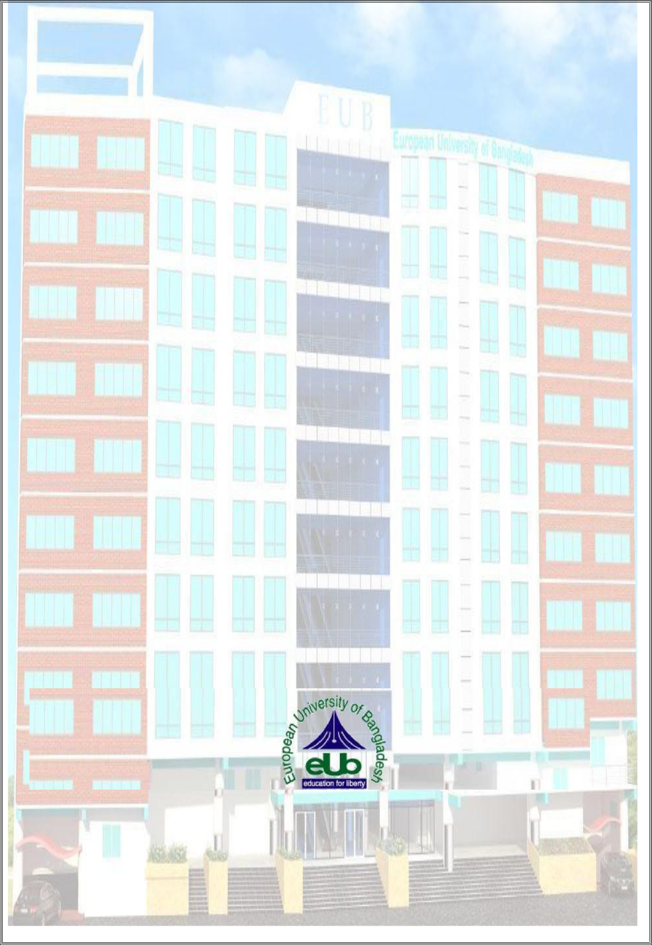**Project Report**

**On**

**“Smart Notice Board Application”**

**Submitted By**

**Student Name: Mili Akter**ID: 180322036

**Student Name: Asfaque Ahmed Bhuiyan**ID: 180322100

**Student Name: Taslim Anwar**ID: 180222040

**Student Name: Tasfia Akter Dolon**ID: 180222059

**Supervised by**

**Jasmin Akter**

Lecturer

Department of Computer Science and Engineering

**A project submitted in partial fulfillment of the requirements for the degree of Bachelor of Science in Computer Science and Engineering.**

**Department of Computer Science and Engineering**

**European University of Bangladesh**

2/4, Gabtoli, Mirpur, Dhaka-1216

September 2021

**CANDIDATES DECLARATION**

This is to certify that the work presented in this project, titled, “**Smart Notice Board Application**”, has been done by us under the supervision of Supervisor Name.

We also declare that neither this project nor any part of this project has been submitted anywhere else for the award of any degree, diploma or other qualifications.

Signature

-------------------- Mili Akter  
ID: 180322036

Signature

------------------------  
Asfaque Ahmed Bhuiyan  
ID: 180322100

Signature

--------------------  
Taslim Anwar  
ID: 180222040

Signature

------------------------  
Tasfia Akter Dolon  
ID: 180222059

**CERTIFICATE OF APPROVAL**

This project titled, **“Smart Notice Board Application”**, submitted by the group as mentioned in the candidates’ declaration page has been accepted as satisfactory in partial fulfillment of the requirements for the degree B.Sc. in Computer Science and Engineering in 25thOctober 2021.

**Signature of Supervisor**

**---------------------------------------**

**Jasmin Akter**

**Lecturer**

**Department of Computer Science and Engineering**

**European University of Bangladesh, Dhaka, Bangladesh.**

**Signature of Chairman**

**---------------------------------------------**

**Md. Obaidur Rahman**

**Associate Professor and Chairman**

**Department of Computer Science and Engineering**

**European University of Bangladesh, Dhaka,**

**Bangladesh**

**ACKNOWLEDGEMENT**

We would like to express our gratitude and appreciation to all those who gave use the opportunity to complete this report. A special thanks to our final year project coordinator, **Jasmin Akter, Lecturer, Department of CSE, European university of Bangladesh**, whose help, stimulating suggestions and encouragement, helped us to coordinate our project especially in writing this report. We would also like acknowledge with much appreciation the crucial role of the staff of computer science and engineering lab, who gave the permission to use all required machinery and necessary material to complete the project. Last but not least many thanks go to the head of the project, **Md. Obaidur Rahman, Associate Professor and Chairman, Department of CSE, European University of Bangladesh**, who have given his full effortguiding the team in achieving the goal as well as his encouragement to maintain our progress in track. We would like to appreciate the guidance given by other supervisor as well as plan especially in our project presentation that has improved our presentation skills by their comment and tip.

Table of Contents

|  |  |  |
| --- | --- | --- |
| SL No. | Chapter Name | Page No. |
| 01 | Project Details Front Page | 1 |
| 02 | Candidates Declaration | 2 |
| 03 | Certificate of Approval | 3 |
| 04 | Acknowledgement | 4 |
| 05 | Table of Contents | 5 |
| 06 | List of Figures | 6 |
| 07 | Abstract | 7 |
| **Chapter 1: Introduction** | | |
| 1.1 | Introduction | 8 |
| 1.2 | Motivation | 9 |
| 1.3 | Objective | 9 |
| 1.4 | Expected Outcome | 9 |
| **Chapter 2: Background** | | |
| 2.1 | Introduction | 10 |
| 2.2 | Related Works | 10 |
| 2.3 | Comparative Studies | 10 |
| 2.4 | Scope of the Problem | 11 |
| 2.5 | Challenges | 11 |
| **Chapter 3: Requirement Specification** | | |
| 3.1 | Business Process Modeling | 12 |
| 3.2 | Requirement Collection Analysis | 13 |
| 3.3 | Use Case Modeling and Description | 13 |
| 3.4 | Logical Data Model | 14 |
| 3.5 | Design Requirements | 14 |
| **Chapter 4: Design Specification** | | |
| 4.1 | Front-End Design | 15 |
| 4.2 | Back-End Design | 16 |
| 4.3 | Interaction Design and UX | 16 |
| 4.4 | Implementation Requirements | 17 |
|  |  |  |
|  |  |  |
| 21SL No. | Chapter Name | Page No. |
| **Chapter 5: Implementation and Testing** | | |
| 5.1 | Implementation of Database | 17 |
| 5.2 | Implementation of Front-end Design | 17-29 |
| **Chapter 6: Impact on Society, Environment and Sustainability** | | |
| 6.1 | Impact on Society | 30 |
| 6.2 | Limitation | 30 |
| 6.3 | Obstacles & Achievements | 30 |
| **Chapter 7: Conclusion and Future Scope** | | |
| 7.1 | 1 Discussion and Conclusion | 31 |
| 7.2 | Scope for Further Developments | 31 |
| References | | 32 |

List of Figures

|  |  |  |
| --- | --- | --- |
| SL No. | Figure Name | Page No. |
| 3.1.1 | Business Process Modeling | 12 |
| 3.2.1 | Requirement Collection and Analysis | 13 |
| 3.3.1 | Use Case Modeling and Description | 13 |
| 3.4.1 | Logical Data Model | 14 |
| 4.4.1 | Front-End Design | 15 |
| 4.3.1 | Interaction Design and UX | 16 |
| 5.2.1 | Selecting Account Type Before Sign Up in Login View | 18 |
| 5.2.2 | Sign Up View for Teachers (Left) and Students (Right). | 19 |
| 5.2.3 | Login View for both teacher and student. | 20 |
| 5.2.4 | Home View. | 21 |
| 5.2.5 | Add Notice View | 22 |
| 5.2.6 | Notice Details View | 23 |
| 5.2.7 | Navigation Drawer | 24 |
| 5.2.8 | Specific Department Wise Notice View. | 25 |
| 5.2.9 | User Profile Details View | 26 |
| 5.2.10 | Reset Password View | 27 |
| 5.2.11 | Upload Photo View | 28 |
| 5.2.12 | About View | 29 |

**ABSTRACT**

Communication is an important issue in every society, be it in the first world countries or the developing countries. Bangladesh is a developing country and we have already dreamt of ‘Digital Bangladesh’ where everything will be handled by technology. Technology has become part and parcel of our daily life. Especially the availability of smartphone gave us the opportunity to carry advanced technology in our pocket. Almost every person checks their phone after waking up and plug the charger to charge the phone before sleeping. Because of technology, every single thing is becoming automated. Everything is becoming online from offline. Now a days, we are doing courses online, shopping via online and so on. The Smart Noticeboard Application will be an online notice board maker where administration, teachers can create notice and students will be able to view them. Notice board has always been the place where staff/teachers/students gather to get their latest update of institution news. This smart notice board app will help to access notices on phone.

**Chapter 1**

**Introduction**

* 1. **Introduction**

In the modern society, many people even school students have access to modern technology. Therefore, the wall notice board is outdated and has many limitations. They are: Insufficient space leading to overlapping posts, hard to know the latest posts, cannot know how many people viewed the post, don’t have direct access to the people who post, exhausting to keep checking the notice board for new posts, not easily accessible. The need to adopt the proposed Smart Notice Board Application is necessary so as to digitize the normal notice board and make it online hence taking care of the limitations that comes with the offline notice board. This System is intended for institutions where information sharing on regular basis plays vital role in the performance. The proposed system will act as an online notice board which will make use of the modern communication methodologies and techniques for information flow. The system is planned to consist of various useful features for the said purpose.

The proposed system aims to create a platform for issuing notice and sharing information between the members of the institution. Different users shall have different level of access to the content. There shall be two users of the software: student, teachers. The administrator/teacher shall be able to issue notice. The students shall be able to view notices.

**1.2 Motivation**

Following are some of the motivations for this Smart Notice Board System:

1. Access easily, even at your home.

2. Well organized notice board.

3. No need to check the offline notice board over and over again.

**1.3 Objective**

Technology has changed everything. People want everything within their grasp. We hope that our project will help provide support in education sector. Because by using this app, teachers can create notices and the students will be able to view them. So, the communication gap will be reduced to a greater extent.

**1.4 Expected Outcome**

Through the application, teachers can create/update/delete notices and students can access them from anywhere, anytime.

**Chapter 2**

**Background**

**2.1 Introduction**

Internet has changed the world in a significant way. In this modern world, we are becoming more and more dependent on online based technology. We rely on the internet for each and everything in life. We have tried to make an android application named “Smart Noticeboard” which will help teachers to manage and create notices very easily, also for students this application will help them to be notified about new notices.

**2.2 Related Works**

Smart Noticeboard is an android application which is implemented to provide service in education sector. In Bangladesh, some of the examples of similar applications of Smart Noticeboard are: Notice Board (**নোটিশ বোর্ড).**

**2.3 Comparative Studies**

Usually, an application is made to fulfill a certain objective. Most comparison able applications like Kids Solutions are described below:

|  |  |  |
| --- | --- | --- |
| Name | Their Work Principle | Our Work Principle |
| Notice Board (**নোটিশ বোর্ড)** | Create/View job related notices. | Create/view notices for educational institutions, |

**2.4 Scope of the Problem**

Young generation which means school/college students usually use smartphones for entertainment. So, it might be an issue in this platform. Also, it will be quite interesting if they accept an android application for their learnings.

**2.5 Challenges**

Every task has challenges. Some of the main challenges Smart Noticeboard are:

1. Lack of internet connection might be our main challenge as Smart Noticeboard is an online application.

2. We should build our application properly and make sure it works smoothly and also user friendly.

3. Making our system fully secured.

4. Data privacy and maintenance is one of the most challenging issue for us.

**Chapter 3**

**Requirement Specification**

**3.1 Business Process Modeling**

In this section, we will discuss the main structure by the business process model of the Smart Noticeboard which defines the workflow of the application.

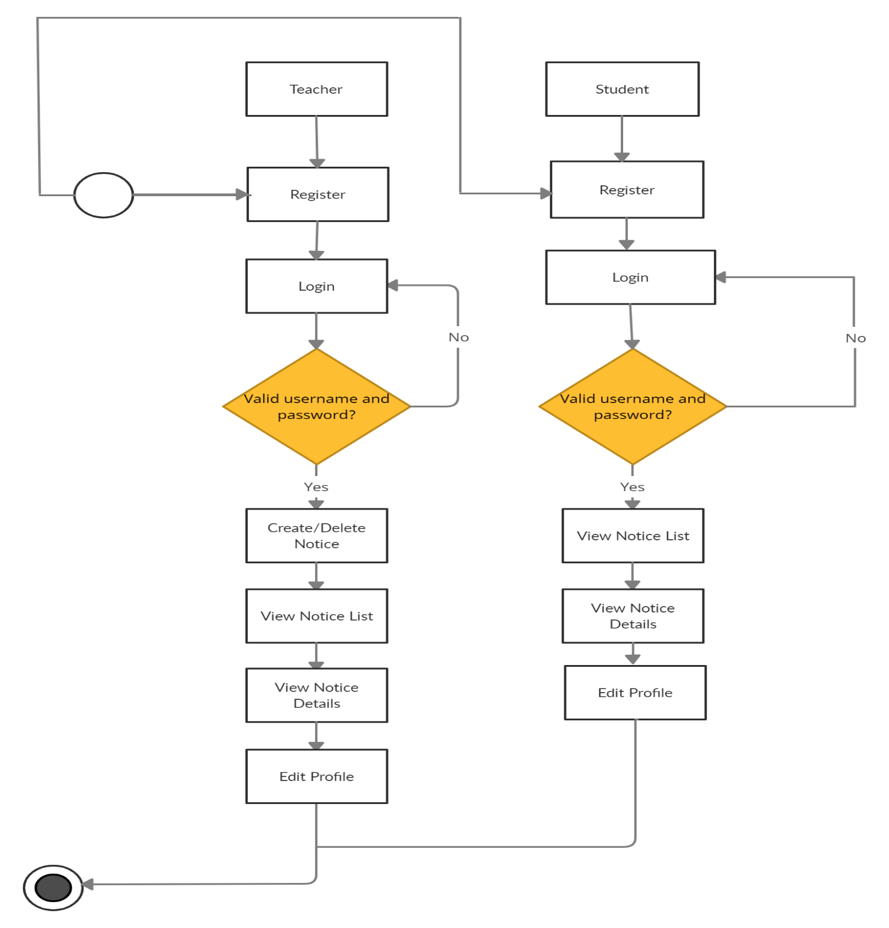

Figure 3.1.1: Business Process Modeling

**3.2 Requirement Collection Analysis**

Administration/Teacher is the one with the highest power. He can create create/delete notices. A student can view notices.

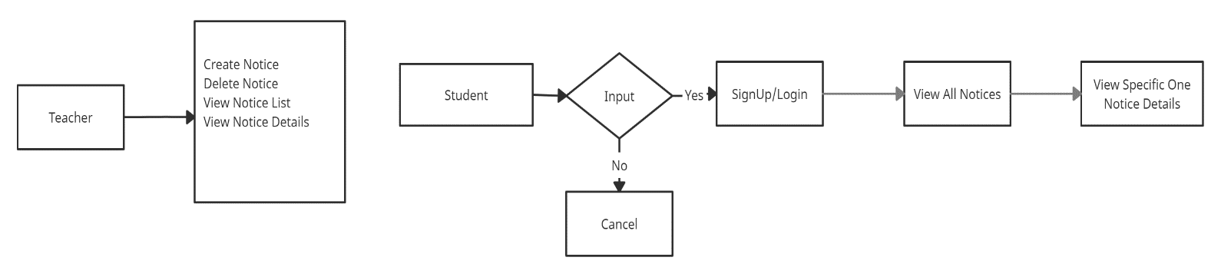

Figure 3.2.1: Requirement Collection and Analysis.

**3.3 Use Case Modeling and Description**

A use-case model is a model of how different types of users interact with the system to solve a problem. First of all, a teacher has to create an account, then he might add notice. A student has to create an account to notice list.

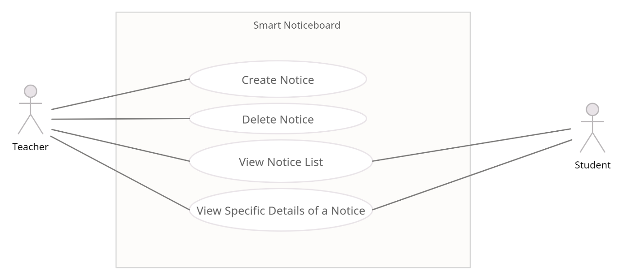

Figure 3.3.1: Use Case Modeling and Description

**3.4 Logical Data Model**

All the data will have to be in the database which is shown in Logical Data Model figure and it will be the current time responsible. Data will transfer from database to android application.

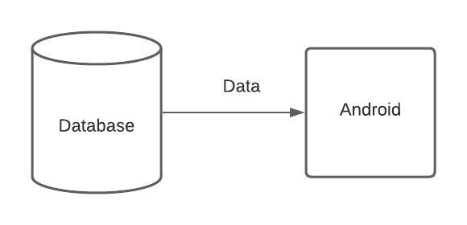

Figure 3.4.1: Logical Data Model

**3.5 Design Requirements**

Design requirements are very important for mobile application. It attracts the user to use. So, to complete the design, we must have mobile application design skills. For this, we have to know the various types of computer programming languages and design tools like adobeXd. Market analysis can be a good trick for the design. We have to give proper attention to design the database so that it works appropriately and easily.

**CHAPTER 4**

**Design Specification**

**4.1 Front-End Design**

Front-End is the place where the user interacts. So, considering this factor, we have created a user friendly and smooth design. Every user can easily use this application.

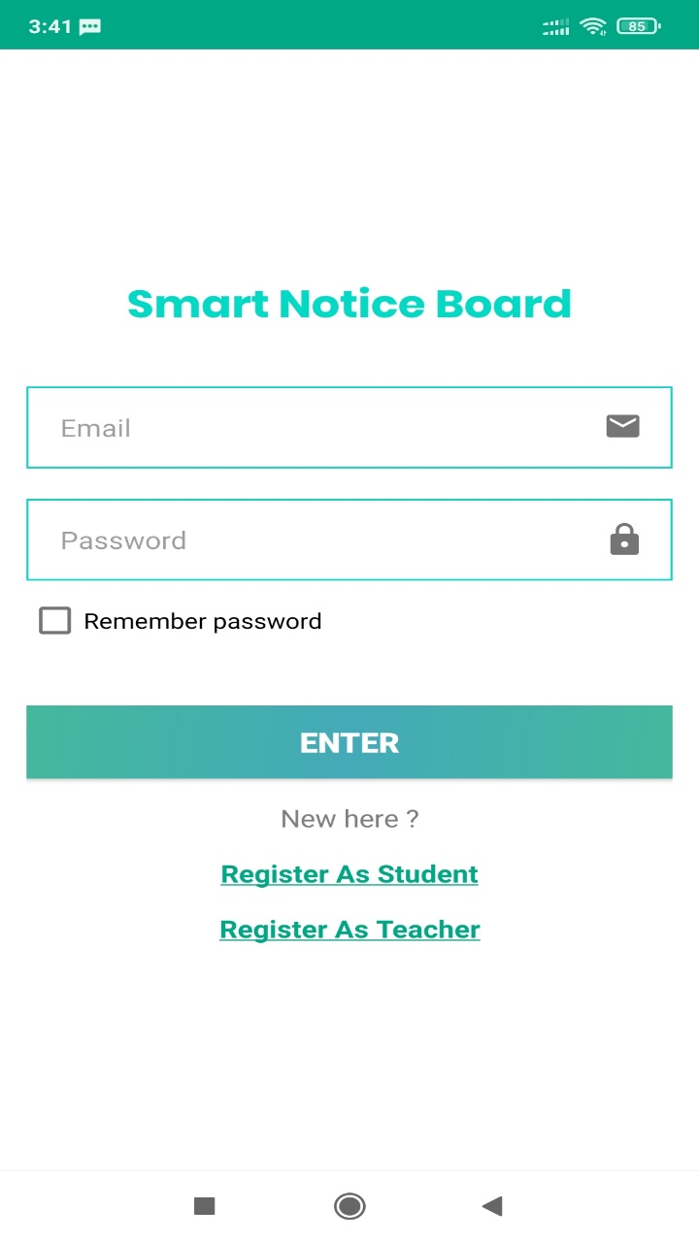

Figure 4.1.1: Front-End Design.

**4.2 Back-End Design**

Basically, in software development back-end means rendering server side. Usually, the backend programming consists of three parts: application, server and database. For database we have used Firebase Realtime Database and other implemented back-end technologies that are Java, Firebase Cloud Messaging, Android Networking libraries.

**4.3** **Interaction Design and UX**

We have tried to make our project UX design as simple as possible. Because we have researched on the internet and visit various site, used various android applications. Then we made the UX design of our application.

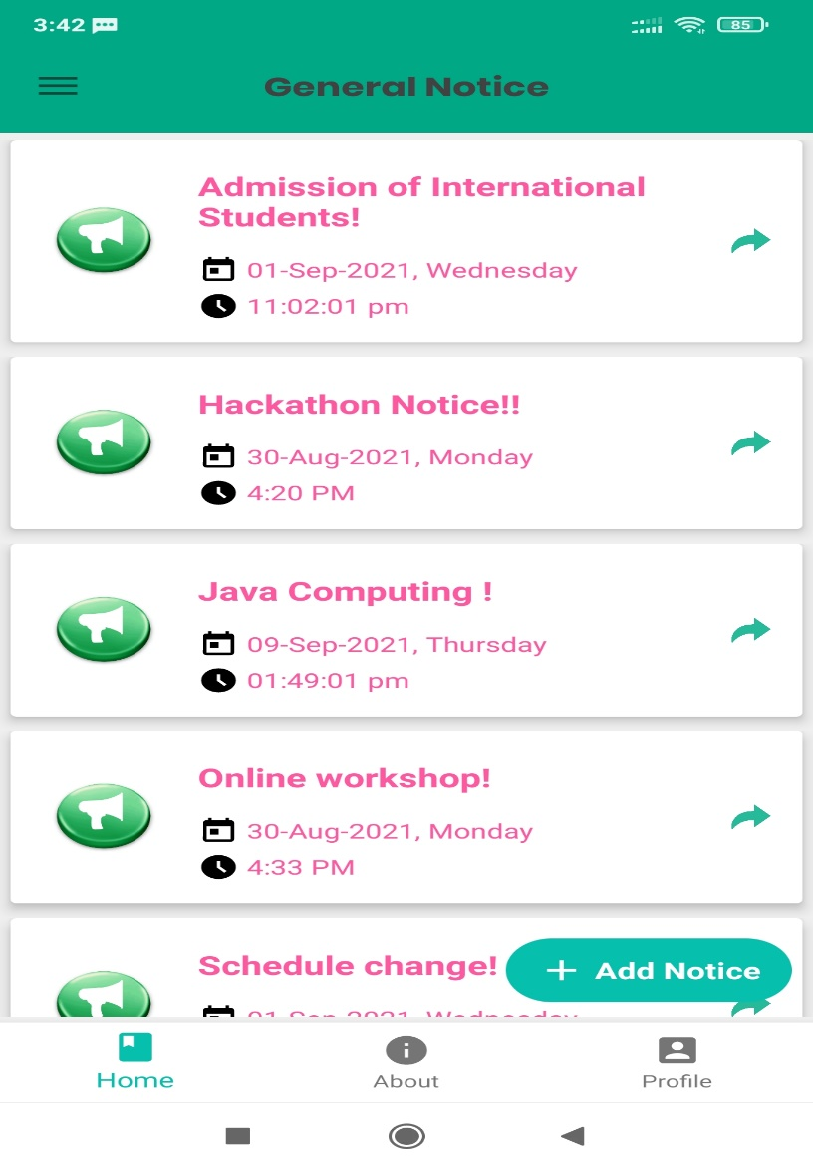

Figure 4.3.1: Interaction Design and UX

**4.4 Implementation Requirements**

It was our first education platform related work. So, we had to learn a lot of new technologies and spent a huge time to fulfill all the requirements.

**Chapter 5**

**Implementation and Testing**

**5.1 Implementation of Database**

Design and implementation of the database are fundamentals for data storage of any kind of

software application. In this project, we have used Firebase Database which is a cloud-hosted NoSQL database that lets developer store and sync data between users in real time. The database collects too much data for its data model.

**5.2 Implementation of Front-end Design**

Front-end design is very essential because of its visualization to the users. Developing a design for an application, we have to consider user friendly and smooth front end. It is very difficult to make the perfect design that attracts all.

**SignUp View**

There are two kinds of users: Teacher and Student. If anyone wants to sign up, he has to select the account type. In the signup view, we have some fields for taking signup information, radio buttons and a signup button.

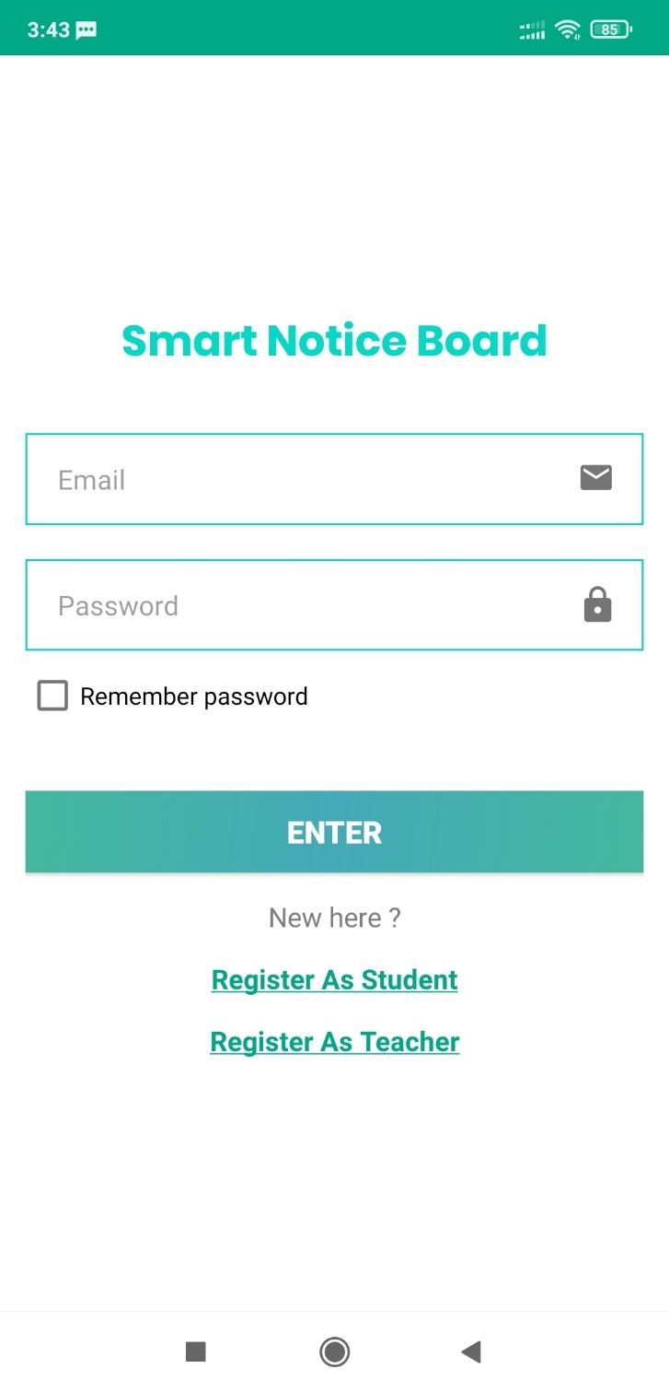

Figure 5.2.1: Selecting Account Type Before Sign Up in Login View.

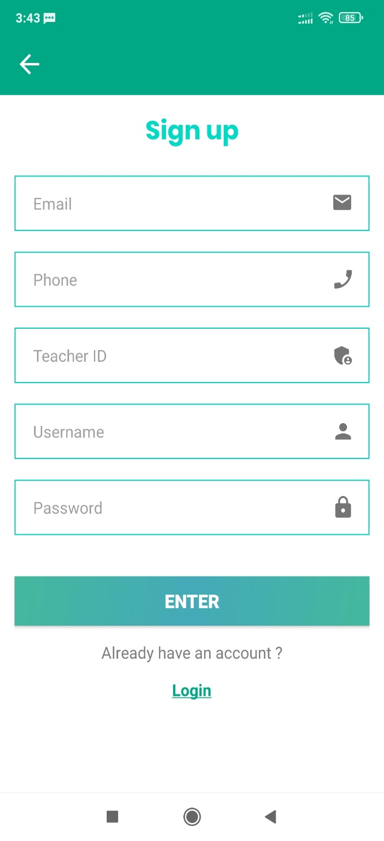 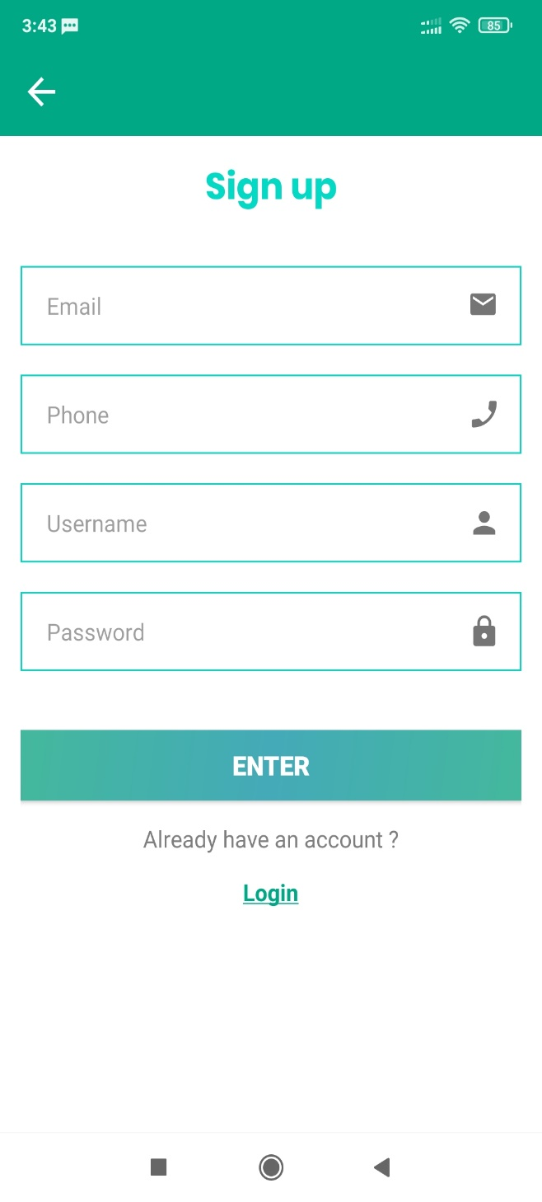

Figure 5.2.2: Sign Up View for Teachers (Left) and Students (Right).

**Login View**

In the login view (for both teachers and students), we have some fields for taking login information and a login button.

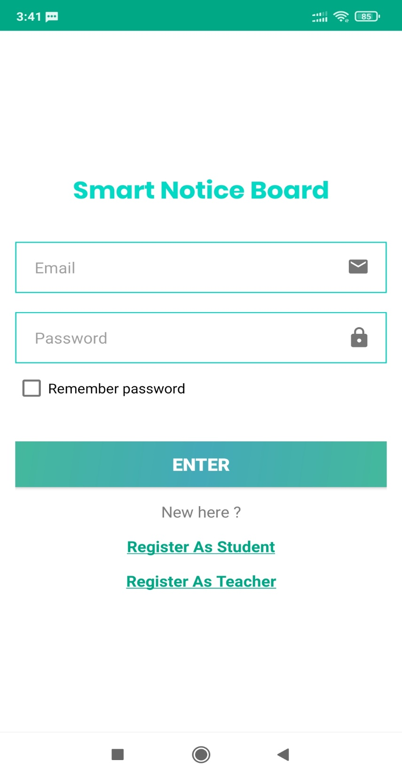

Figure 5.2.3: Login View for both teacher and student.

**Home View**

Home view shows all the general notices of the institutions. User can see classes, notices, about, user profile button from home page.

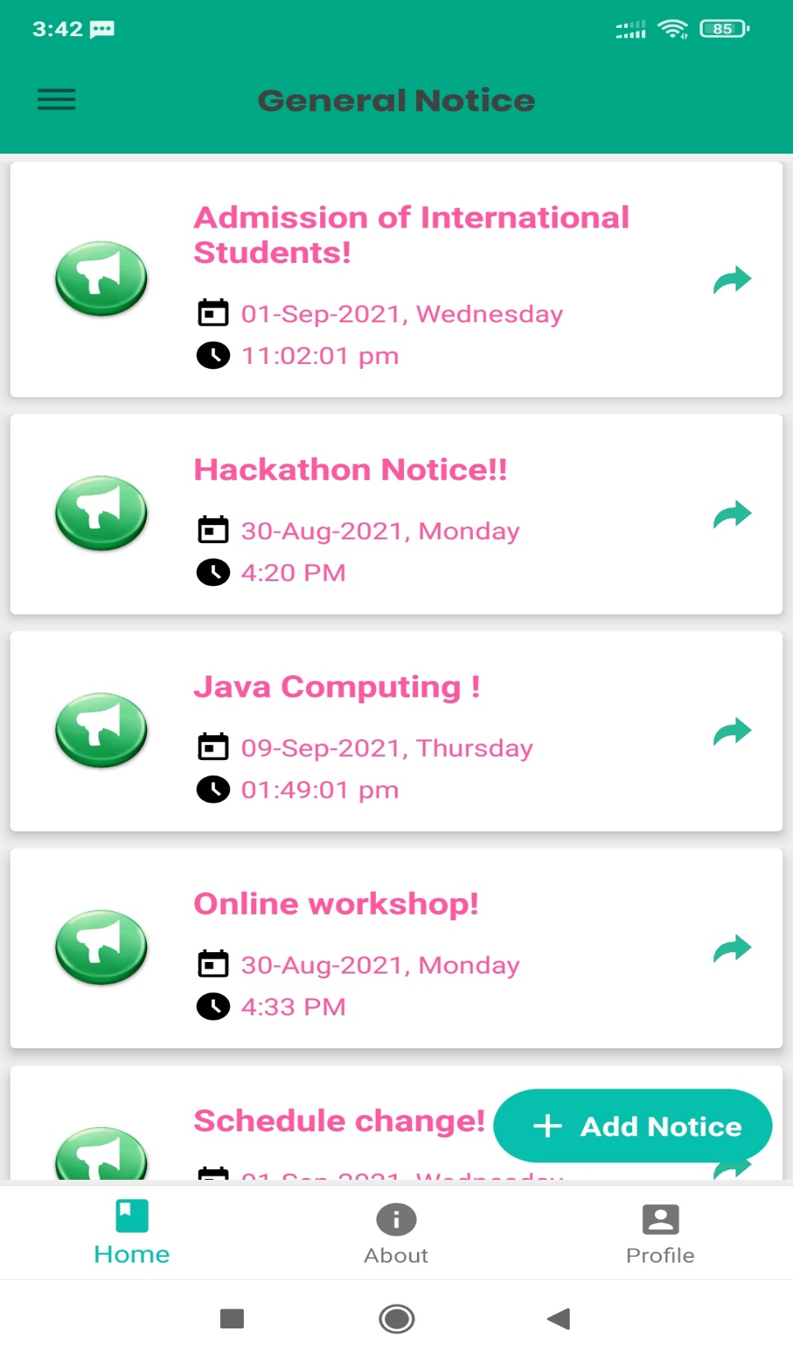

Figure 5.2.4: Home View.

**Add Notice View**

Add Notice View comes up as a dialogue view when add notice button is pressed from the home view. It contains two input fields; one spinner and a save and a close button.

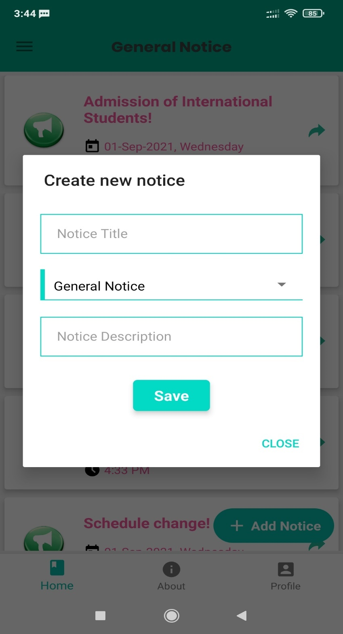

Figure 5.2.5: Add Notice View.

**Notice Details View**

Notice Details View contains a specific notice detail. If the user is an admin, he can also delete the notice.

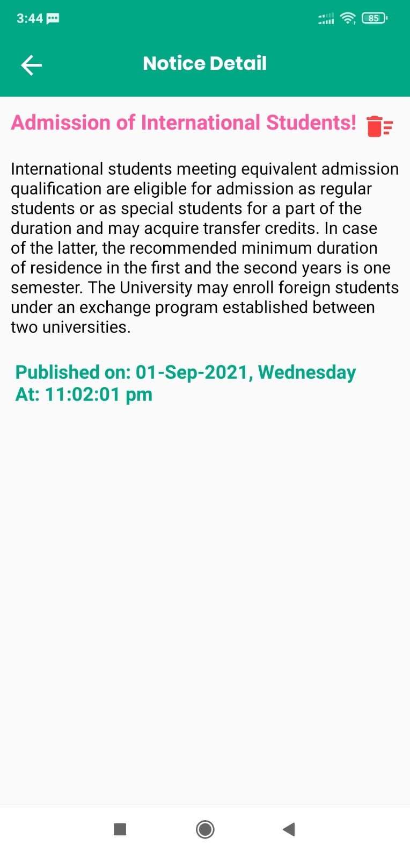

Figure 5.2.6: Notice Details View.

**Navigation Drawer**

On top left, there is a navigation drawer which directs to specific department wise notice.

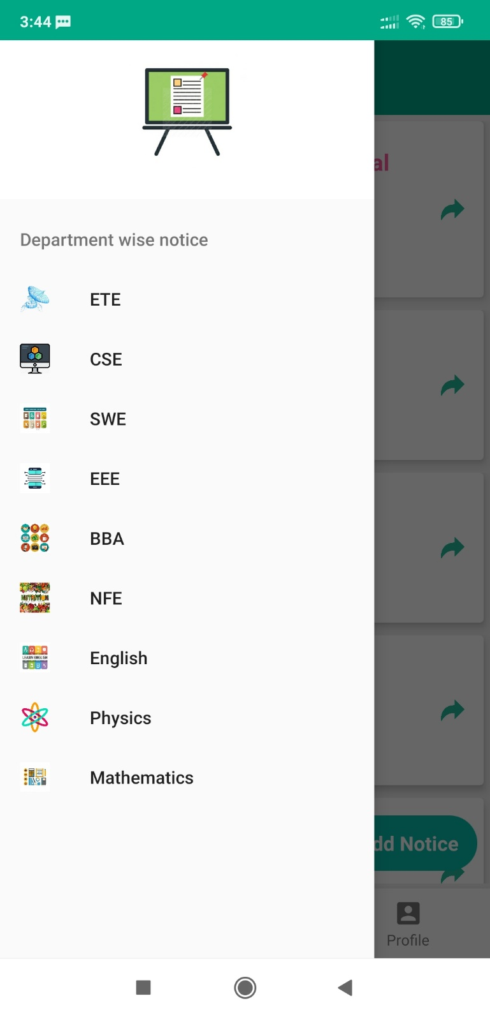

Figure 5.2.7: Navigation Drawer.

**Specific Department Wise Notice View**

Specific department wise notice view contains a specific department wise notice.

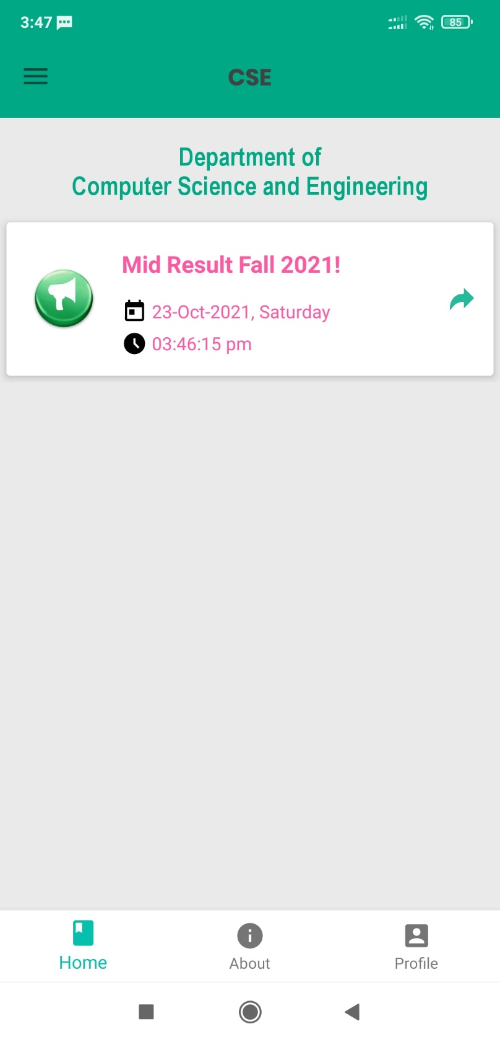

Figure 5.2.8: Specific Department Wise Notice View.

**Profile Details View**

Profile detail’s view contains a specific user detail.

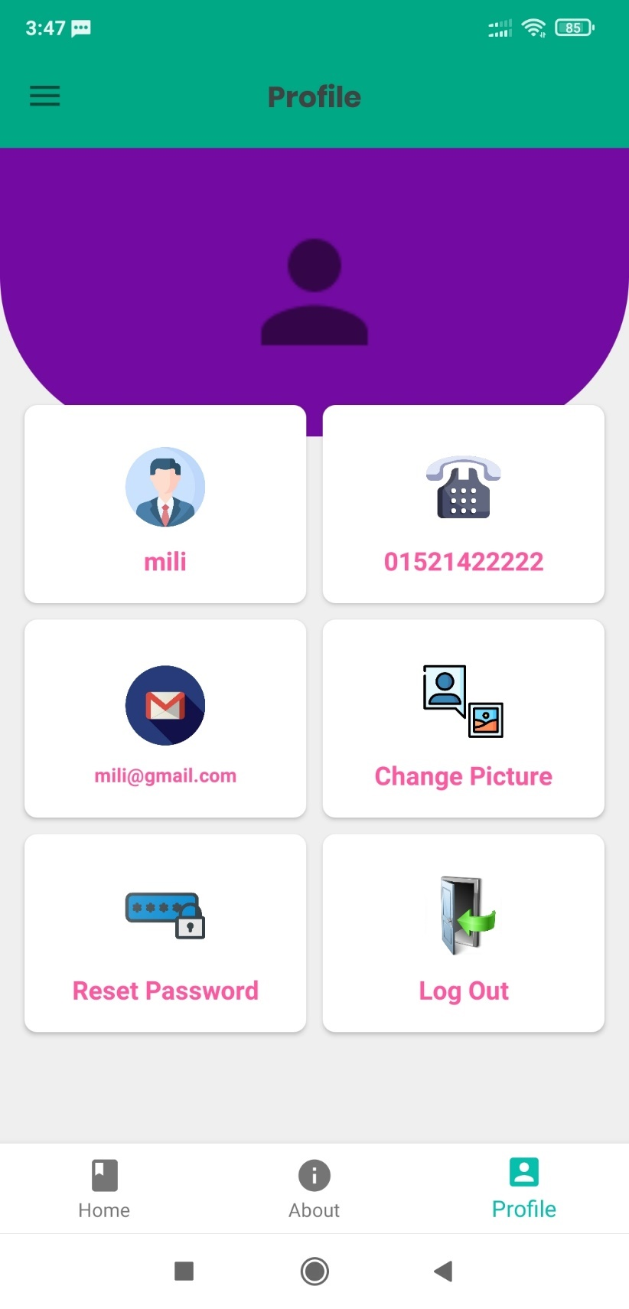

Figure 5.2.9: User Profile Details View.

**Reset Password View**

Reset password view comes up when reset password button is clicked from user detail’s view. Reset Password view contains two input fields: old and new password and two buttons: no (cancel) and reset button.

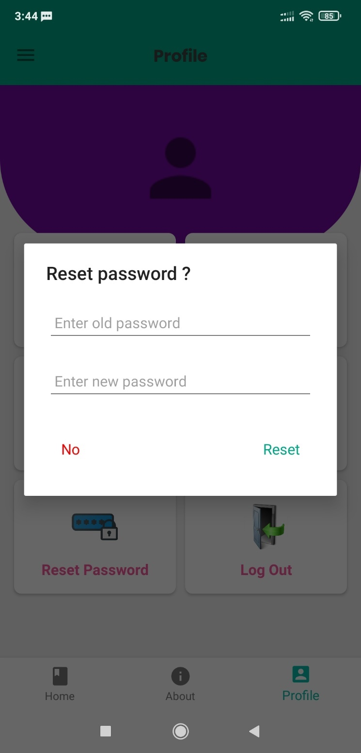

Figure 5.2.10: Reset Password View.

**Add/Change Picture View**

Add/Change Picture view comes up when change photo button is clicked from user detail’s view. User can select photo and it will be selected as the user’s profile photo.

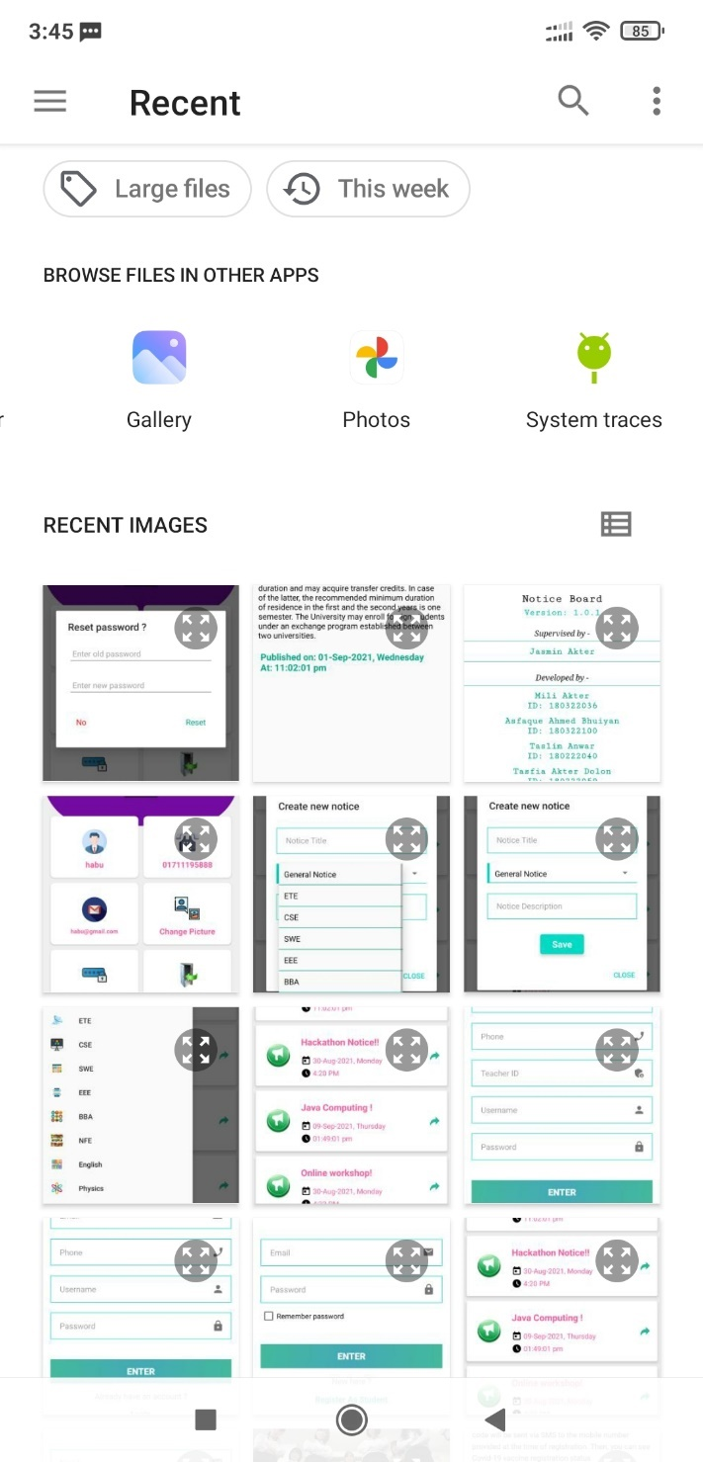

Figure 5.2.11: Upload Photo View.

# **About Us**

About view contains the information of the honorable supervisor and the students who developed this application.

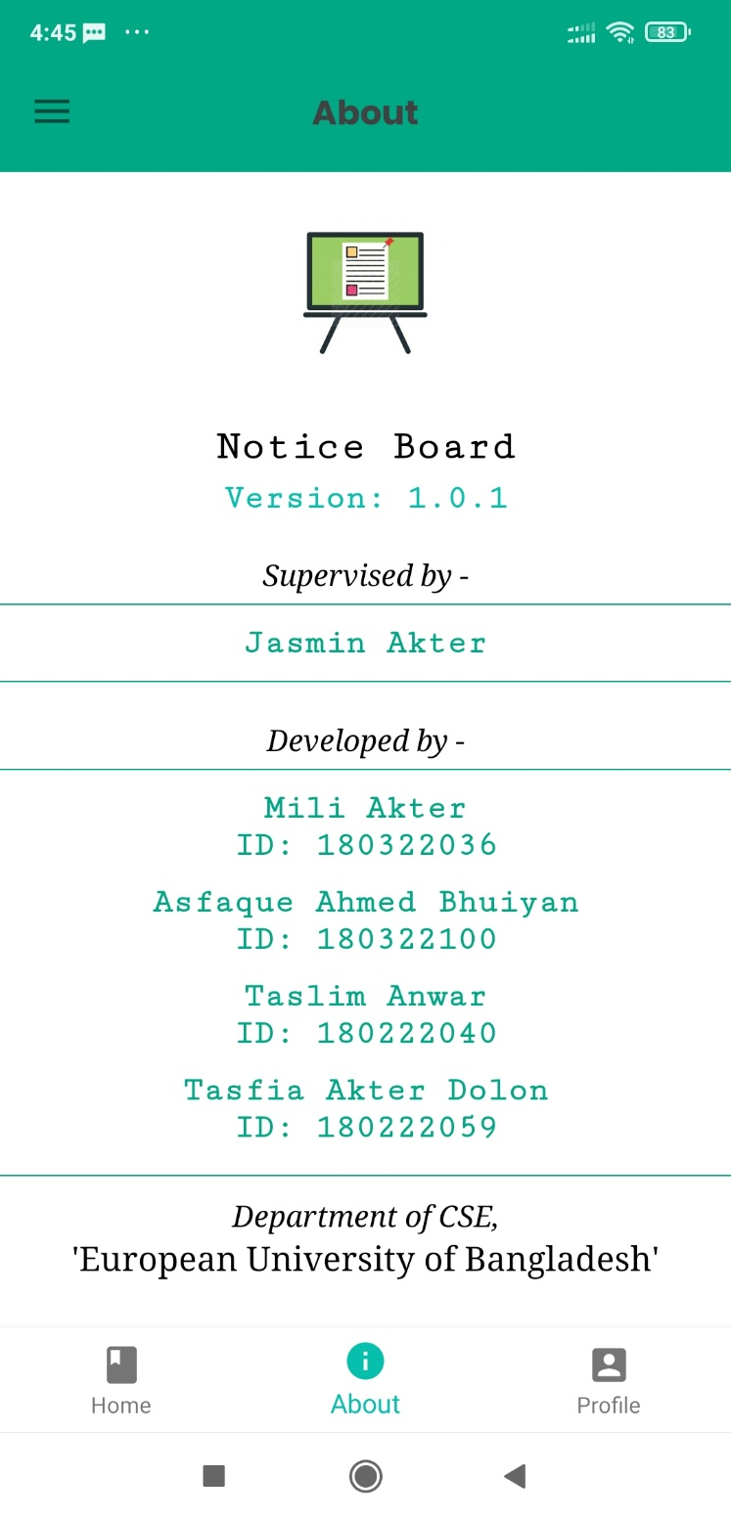

Figure 5.2.12: About View.

**CHAPTER 6**

**Impact on Society, Environment and Sustainability**

**6.1** **Impact on Society**

This application will be beneficial for the members of the institutions. Administration/Teachers can easily manage noticeboard. Students can also be notified about the new notices easily through the app.

**6.2 Limitation**

No application is perfect. Every system has some limitations. The limitations of our project are written below:

* Database limitation of 1GB.
* Can register with fake emails.

**6.3 Obstacles & Achievements**

During the development of the application, we have faced a lot of obstacles and successfully overcame most of them. Some of the obstacles were:

* Firebase Handling for authentication and other information e.g., classes.
* Image Upload System.

Finally, after developing the project, we have successfully achieved:

* Smart Noticeboard System for institutions.

**CHAPTER 7**

**Conclusion and Future Scope**

**7.1 Discussion and Conclusion**

To become a developed country, the country must rely on technology. Using technology in education makes a nation on step forward to become a developed nation. If an institution uses smart online based noticeboard, we will no longer need the offline wall noticeboard. And we all know and have already discussed the benefits of the smart noticeboard system.

**7.2 Scope for Further Developments**

Due to limitation of time, knowledge and experience, we couldn’t develop some features of our project. In future, we want to develop those features one by one. Those features are:

* Push Notification to let the student know whether a new notice is posted.
* Publish the app on Play Store.

**References**:

[1] Stackoverflow for solving bugs, available at << >>, last accessed on 05-10-2021 at 12:00 P.M.

[2] Youtube for Android Tutorial at << <https://www.youtube.com/> >>, last accessed on 05-10-2021 at 10:00 P.M.

[3] Firebase documentation, available at << <https://firebase.google.com/docs> >>, last accessed on 23-08-2021 at 01:00 A.M .

[4] Material Design for Android, available at << <https://material.io/develop/android> >>, last accessed on 10-08-2021 at 12:00 A.M.