# KIDS SOLUTION FOR ONGOING SCHOOL CHILDREN

#### BY

**Name: Md. Saiful Islam Id: 172-15-10074**

**&**

**Name: Amdadul Haque Id: 172-15-9819**

This Report Presented in Partial Fulfillment of the Requirements for the Degree of Bachelor of Science in Computer Science and Engineering

Supervised By

**Mr. Md. Abbas Ali Khan** Senior Lecturer Department of CSE

Daffodil International University Co-Supervised By

**Ms. Rubaiya Hafiz** Senior Lecturer Department of CSE

## Daffodil International University



**DAFFODIL INTERNATIONAL UNIVERSITY**

#### DHAKA, BANGLADESH SEPTEMBER 9, 20

**APPROVAL**

This Project titled “**KIDS SOLUTION FOR ONGOING SCHOOL CHILDREN**”, submitted by **Md. Saiful Islam**, Id No: **172-15-10074** and **Amdadul Haque,** Id No: **172-15-9819** to the Department of Computer Science and Engineering, Daffodil International University, has been accepted as satisfactory for the partial fulfillment of the requirements for the degree of B.Sc. in Computer Science and Engineering and approved as to its style and contents. The presentation has been held on 9th September, 2021.

**BOARD OF EXAMINERS**

|  |  |
| --- | --- |
| **Dr. Touhid Bhuiyan Professor and Head**  Department of Computer Science and Engineering Faculty of Science & Information Technology Daffodil International University | **Chairman** |
| https://lh5.googleusercontent.com/oXwCtng22E_G-0_zfMqG0vWQyJdIlNFjMnSz6-_OpZDz2A3E2wxIL29JtexaG1T6DrBc5gwi49KAeqBh8EAcvUGiRSd7NrN3u75EUzNZMd4_y0N7StHr-i9NqiiJuA=s0  **Md. Sadekur Rahman Assistant Professor**  Department of Computer Science and Engineering Faculty of Science & Information Technology Daffodil International University | **Internal Examiner** |
| https://lh6.googleusercontent.com/2ToDAfUObp01BQ8PZI7aTPeypL4eiTLOsbYymkujQY7NUl8SUsNEv1uMWnjNkqYLVN1S3OkZu21h6jjizTWFm_BcOygMzcd9TXGjxIx446ZQrImzAOli_pJPWXrQKw  **Gazi Zahirul Islam Assistant Professor**  Department of Computer Science and Engineering Faculty of Science & Information Technology Daffodil International University | **Internal Examiner** |
| **Shah Md. Imran**  **Industry Promotion Expert**  LICT Project, ICT Division, Bangladesh | **External Examiner** |

i

# DECLARATION

We hereby declare that, this project has been done by us under the supervision of **Mr. Md. Abbas Ali Khan, Senior Lecturer, Department of CSE** Daffodil International University. We also declare that neither this project nor any part of this project has been submitted elsewhere for award of any degree or diploma.

#### Supervised by:



**Mr. Md. Abbas Ali Khan** Senior Lecturer Department of CSE

Daffodil International University

#### Co-Supervised by:



**Ms. Rubaiya Hafiz** Senior Lecturer Department of CSE

Daffodil International University

#### Submitted by:

**Md. Saiful Islam**

ID: 172-15-10074

Department of CSE

Daffodil International University

#### Amdadul Haque

ID: 172-15-9819

Department of CSE

Daffodil International University

# ACKNOWLEDGEMENT

Firstly, we express our heartiest thanks and gratefulness to almighty Allah for His divine blessing makes us possible to complete the final year project successfully.

We really grateful and wish our profound our indebtedness to Mr. Md. Abbas Ali Khan**, Senior Lecturer**, Department of CSE Daffodil International University, Dhaka. Deep Knowledge & keen interest of our supervisor in the field of “*Information Management System for Educational Institutions*” to carry out this project. His endless patience, scholarly guidance, continual encouragement, constant and energetic supervision, constructive criticism, valuable advice, reading many inferior draft and correcting them at all stage have made it possible to complete this project.

We would like to express our heartiest gratitude to **Dr. Touhid Bhuiyan, Professor** and Head**,** Department of CSE, for his kind help to finish our project and also to other faculty member and the staff of CSE department of Daffodil International University.

We would like to thank our entire course mate in Daffodil International University, who took part in this discuss while completing the course work.

Finally, we must acknowledge with due respect the constant support and patients of our parents.

# ABSTRACT

Education is one of the most important things for both self-development and a country’s development. It is one of the basic needs of every human being. It is often comparted to light as it removes the darkness of ignorance. Technology has become part and parcel of our daily life. Especially the availability of smartphone gave us the opportunity to carry advanced technology in our pocket. Almost every person checks their phone after waking up and plug the charger to charge the phone before sleeping. Because of technology, every single thing is becoming automated. With the help of Education Management System, getting education has become easier too. Basically, Education Management System (EMS) is such a service which provides all services for an educational institute. Kids Solution is an android application where a teacher can create class, homework, notice, take attendance etc. and a guardian can join a class, see assigned homework’s, notices etc. It is a very light weight and quite handy application for our country’s perspective.

# TABLE OF CONTENTS

**CONTENTS PAGE**

## Approval ⅰ

Declaration ⅱ

ⅲ

Acknowledgement

Abstract

ⅳ

Table of Content ⅴ

List of Figures ix

**CHAPTERS**

**Chapter 1: Introduction**

* 1. Introduction
  2. Motivation
  3. Objectives
  4. Expected Outcome
  5. Report Layout

**Chapter 2: Background**

* 1. Introduction
  2. Related Works
  3. Scope of the Problem
  4. Challenges

**1-2**

1

1

1

2

2

# 3-4

3

3

3

4

# Chapter 3: Requirement Specification

* 1. Business Process Modeling
  2. Requirement Collection and Analysis
  3. Use Case Modeling and Description
  4. Logical Data Model
  5. Design Requirements

**Chapter 4: Design Specification**

* 1. Front-end Design
  2. Back-end Design
  3. Interaction Design and UX
  4. Implementation Requirements

**Chapter 5: Implementation and Testing**

* 1. Implementation of Database
  2. Implementation of Front-end Design
  3. Testing Implementation

**Chapter 6: Impact on Society, Environment and Sustainability**

* 1. Impact on Society
  2. Limitation
  3. Obstacles & Achievements

**Chapter 7: Conclusion and Future Scope**

* 1. Discussion and Conclusion
  2. Scope for Further Developments References Appendices

**5-8**

5

6

7

8

8

**9-11**

9

10

10

11

### 11-29

11

11

12

**30**

30

30

30

**31**

**31**

**31**

**References 32**

#### LIST OF FIGURES

**Figures Page**

Figure 3.1.1: Business Process Modeling 5

Figure 3.2.1: Requirement Collection and Analysis 6

Figure 3.3.1: Use Case Modeling and Description 7

Figure 3.4.1: Logical Data Model 8

Figure 4.1.1: Front-End Design. 9

Figure 4.3.1: Interaction Design and UX 10

Figure 5.2.1: Sign Up View 12

Figure 5.2.2: Login View 13

Figure 5.2.3: Home View 14

Figure 5.2.4: Class List 15

Figure 5.2.5: About 16

Figure 5.3.1: User Profile 17

Figure 5.3.2: Add Image View 18

Figure 5.3.3: Create Class 19

Figure 5.3.4: Add Image View 20

Figure 5.3.5: Notice Board View 20

Figure 5.3.6: Add Notice 21

Figure 5.3.7: Edit Notice 22

Figure 5.3.8: Homework View 23

Figure 5.3.9: Create Homework 24

Figure 5.3.10: Attendance 25

Figure 5.3.11: Talk with Guardian 26

Figure 5.3.12: Joining a Class 27

Figure 5.3.13: Talk with Teacher 28

Figure 5.3.14: Send Message View 29

**Chapter 1 Introduction**

* 1. **Introduction**

Education is endless. Each and every person is constantly learning from birth till last breath. People understand the necessity of education and know that very well that the education is the key to success. Also, those who are educated, are trying their best to make the education more practical, interesting and easier. That’s how the Education Management System, Online Learning Platform etc. came in. According to countrymeters. The current population of Bangladesh is 167,086,979 and there are around 56,818,009 young people under 15 years old. Due to the popularity of online based education system, Kids Solution can be a solid application for managing the classes of a certain school. With the advancement in information technology, smart mobile devices can be used to take advantage to provide homework, announce a new notice, manage attendance etc. This application is easily accessible on mobile phones at anytime and anywhere.

# Motivation

At present, the current situation of education is very critical in our country. Because of the pandemic, most of the schools and colleges are shut down since 2019. As a result, children are staying at home and barely getting any education. A very few institutes are trying to take classes online but having a very rough time. To solve this issue, our app/work will help institutes, students to be connected with each other for educational purpose.

# Objective

Technology has changed everything. People want everything within their grasp. We hope that our project will help provide support in education sector. Because by using this app, teachers can create classes, make announcements, provide homework’s, take attendances and students/guardians will be able to join classes, view announcements and assigned tasks to be done.

# Expected Outcome

Through the application, teachers can create classes, assign homework’s, make announcements and manage attendances and students can enroll in a class, view homework’s and all the announcements that are made.

# Report Layout

## Chapter 1: Introduction

This chapter describes work inspiration, motivation, project objective and outturn of the program.

## Chapter 2: Background

The background is important and this chapter discusses the background related work such as comparison with other projects and finds out the problem of the project, the challenges which are face to do the project.

## Chapter 3: Requirement Specification

This chapter defines many important things of the project are requirements such as the use case model, business process modeling and the logical database.

## Chapter 4: Design Specification

The purpose of this chapter is the design of the project. Two types of design which are front-end design and back-end design for this project. The proper implementation of the design is very important which describes this chapter in detail.

## Chapter 5: Implementation and Testing

This chapter shows the implementation and testing system of the project by the project screenshot. After completion of any project, testing data and its success tell is the project ready to live.

## Chapter 6: Impact on Society, Environment and Sustainability

This chapter discusses on the impact of the project in our society, obstacle, achievements and limitations of the project.

## Chapter 7: Conclusion and Future Scope

Every project has some limitation and how it can be overcome and also the future implementation scope is discussed in this chapter.

# CHAPTER 2

**Background**

* 1. **Introduction**

Internet has changed the world in a significant way. In this modern world, we are becoming more and more dependent on online based technology. We rely on the internet for each and everything in life. We have tried to make an android application named Kids Solutions which will help teachers to manage and teach a class very easily, also for students this application will help them to be taught.

# Related Works

Kids Solution is an android application which is implemented to provide service in education sector. In Bangladesh, some of the examples of similar applications of Kids Solution are: School Management System, Bangla Notice etc.

# Comparative Studies

Usually, an application is made to fulfill a certain objective. Most comparison able applications like See in Me are described below:

|  |  |  |
| --- | --- | --- |
| Name | Their Work Principle | Our Work Principle |
| School Management System | Create class, take attendance of students and stuffs, mark  test, fee management etc. | Create class, take attendance, make announcement, create homework’s. |
| Bangla Notice | Create notice/announcements. |

# Scope of the Problem

Some of the guardians are busy with job or business and don’t have enough time to be with their children. In order to teach their children, they send them to school, coaching centers, assign home tutors. So, it might be an issue in this learning platform. Also, most of the children are not eager to study and usually use smartphones for entertainment. It will be quite interesting if they accept an android application for their learnings.

# Challenges

Every task has challenges. Some of the main challenges of Kids Solution are:

1. Lack of internet connection might be our main challenge as Kids Solution is an online application.
2. We should build our application properly and make sure it works smoothly and also user friendly.
3. Making our system fully secured.
4. Data privacy and maintenance is one of the most challenging issue for us.

# Chapter 3 Requirement Specification

* 1. **Business Process Modeling**

In this section, we will discuss the main structure by the business process model of the Kid’s Solution which defines the workflow of the application.

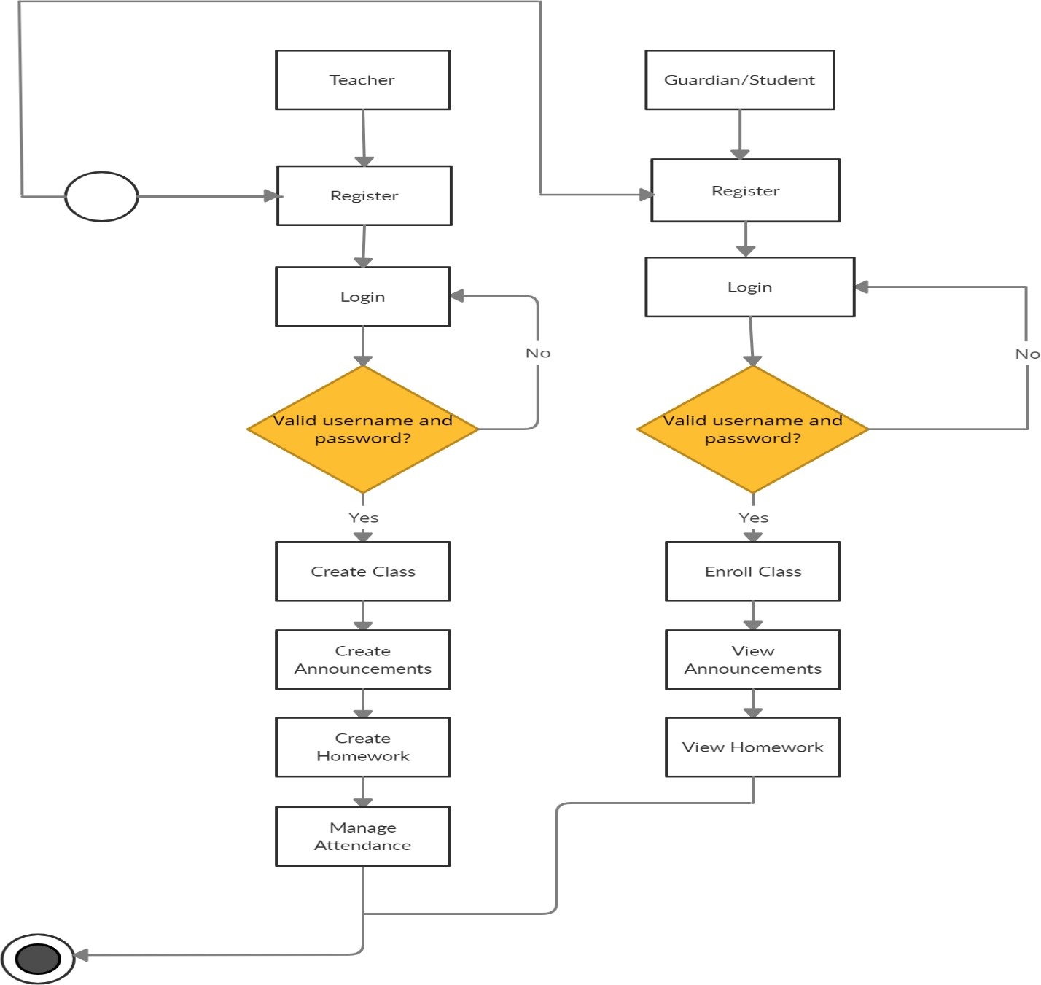

Figure 3.1.1: Business Process Modeling

# Requirement Collection Analysis

Teacher is the one with the highest power. He can create classes, make announcements, manage attendances and assign homework’s. A guardian/student can enroll in classes, view announcements, homework’s.

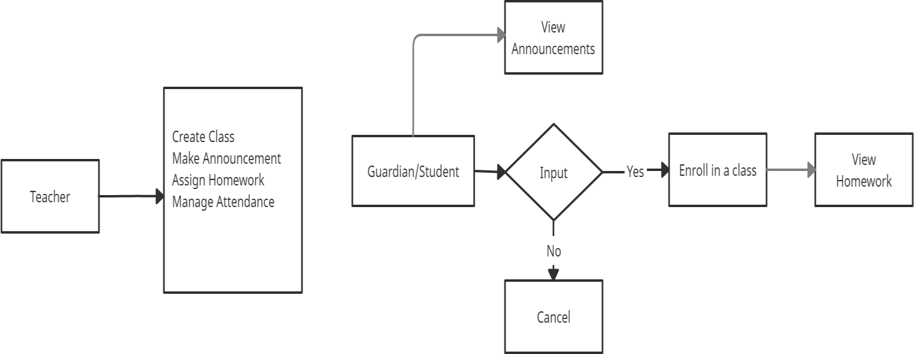

Figure 3.2.1: Requirement Collection and Analysis

# Use Case Modeling and Description

A use-case model is a model of how different types of users interact with the system to solve a problem. First of all, a teacher has to create an account, then he might add class, assign homework, take attendance, post an announcement. A guardian/student has to create an account to enroll in a class and view announcements and homework’s.

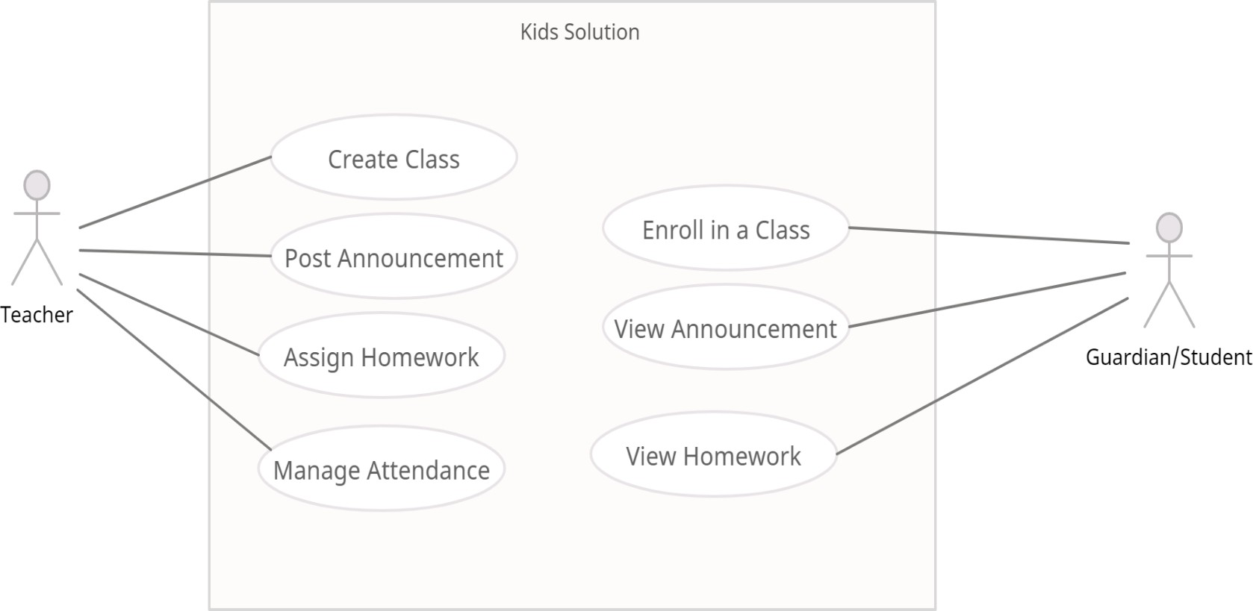

Figure 3.3.1: Use Case Modeling and Description

# Logical Data Model

All the data will have to be in the database which is shown in Logical Data Model figure and it will be the current time responsible. Data will transfer from database to android application.

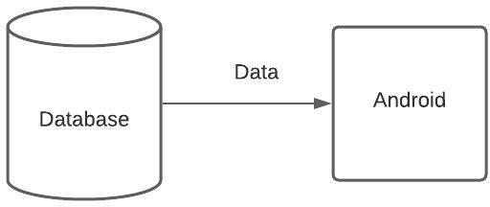

Figure 3.4.1: Logical Data Model

# Design Requirements

Design requirements are very important for mobile application. It attracts the user to use. So, to complete the design, we must have mobile application design skills. For this, we have to know the various types of computer programming languages and design tools like adobeXd. Market analysis can be a good trick for the design. We have to give proper attention to design the database so that it works appropriately and easily.

# CHAPTER 4

**Design Specification**

* 1. **Front-End Design**

Front-End is the place where the user interacts. So, considering this factor, we have created a user friendly and smooth design. Every user can easily use this application.

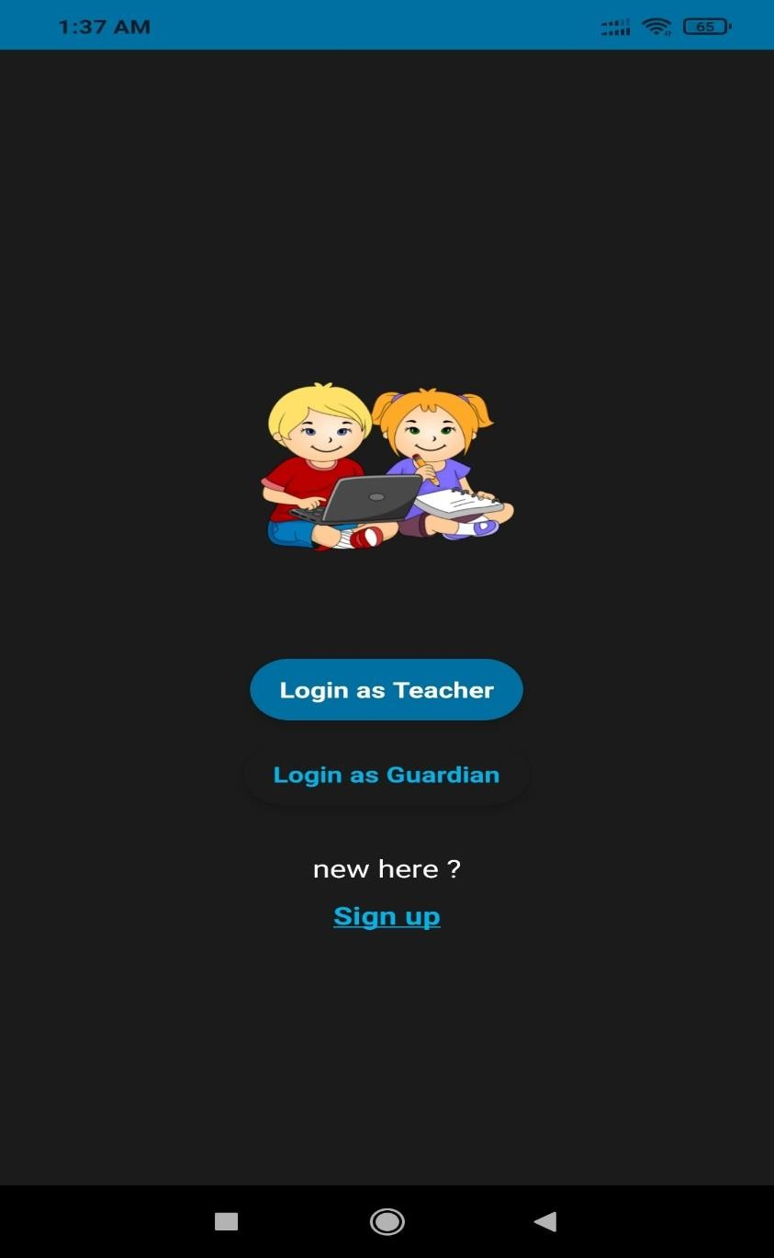

Figure 4.1.1: Front-End Design.

# Back-End Design

Basically, in software development back-end means rendering server side. Usually, the backend programming consists of three parts: application, server and database. For database we have used Firebase Realtime Database and other implemented back-end technologies that are Java, Firebase Cloud Messaging, Android Networking libraries.

# Interaction Design and UX

We have tried to make our project UX design as simple as possible. Because we have researched on the internet and visit various site, used various android applications. Then we made the UX design of our application.

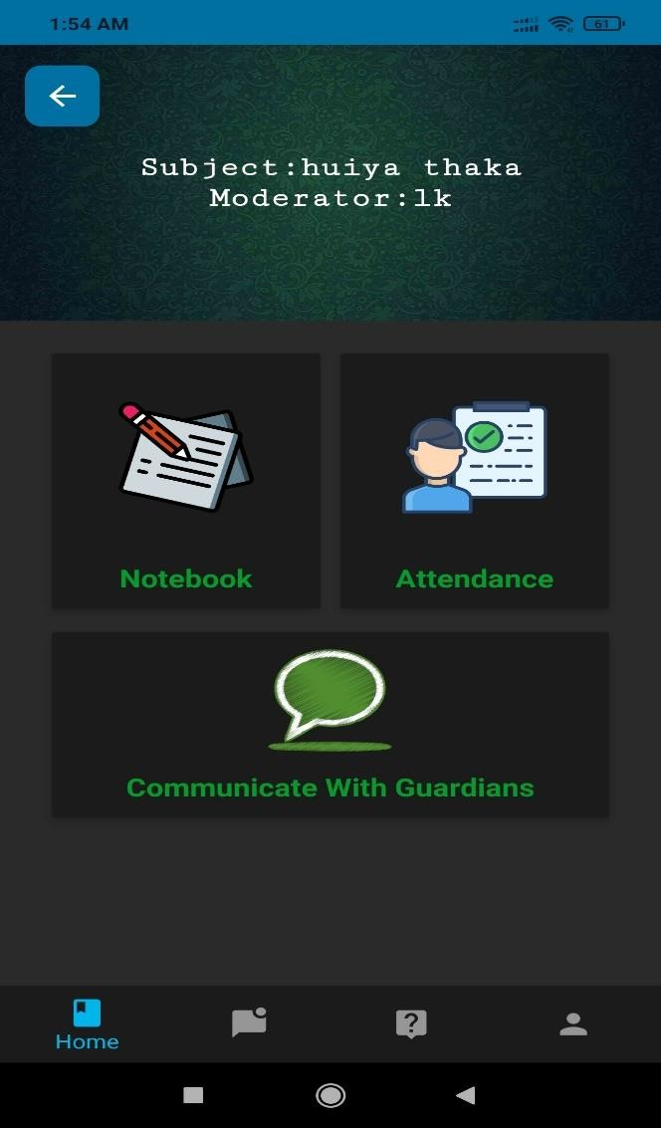

Figure 4.3.1: Interaction Design and UX

# Implementation Requirements

It was our first education platform related work. So, we had to learn a lot of new technologies and spent a huge time to fulfill all the requirements.

# Chapter 5 Implementation and Testing

* 1. **Implementation of Database**

Design and implementation of the database are fundamentals for data storage of any kind of software application. In this project, we have used Firebase Database which is a cloud-hosted NoSQL database that lets developer store and sync data between users in real time. The database collects too much data for its data model.

# Implementation of Front-end Design

Front-end design is very essential because of its visualization to the users. Developing a design for an application, we have to consider user friendly and smooth front end. It is very difficult to make the perfect design that attracts all.

# SignUp View

In the signup view, we have some fields for taking signup information, radio buttons and a signup button.

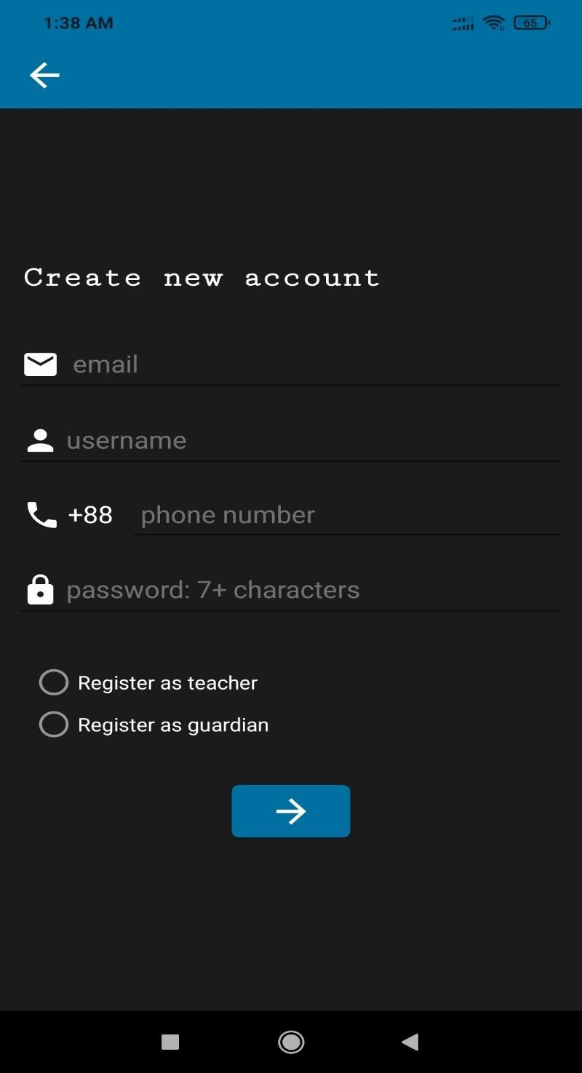

Figure 5.2.1: Sign Up View.

# Login View

In the login view (for both teacher and guardian), we have some fields for taking login information and a login button.

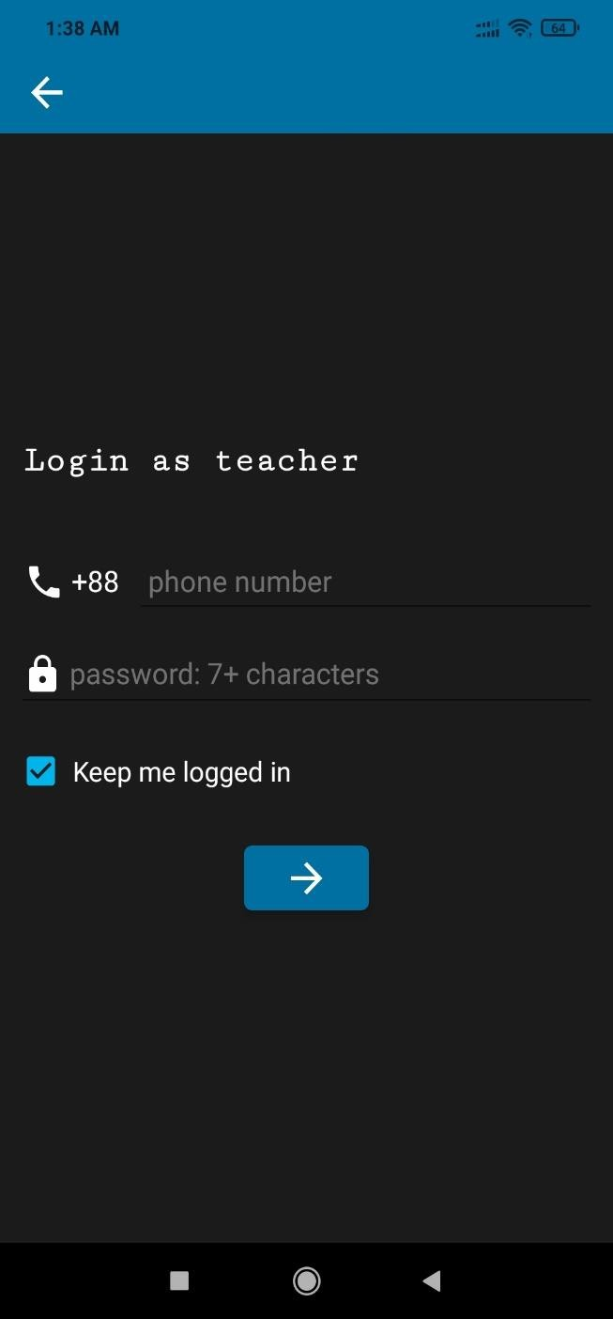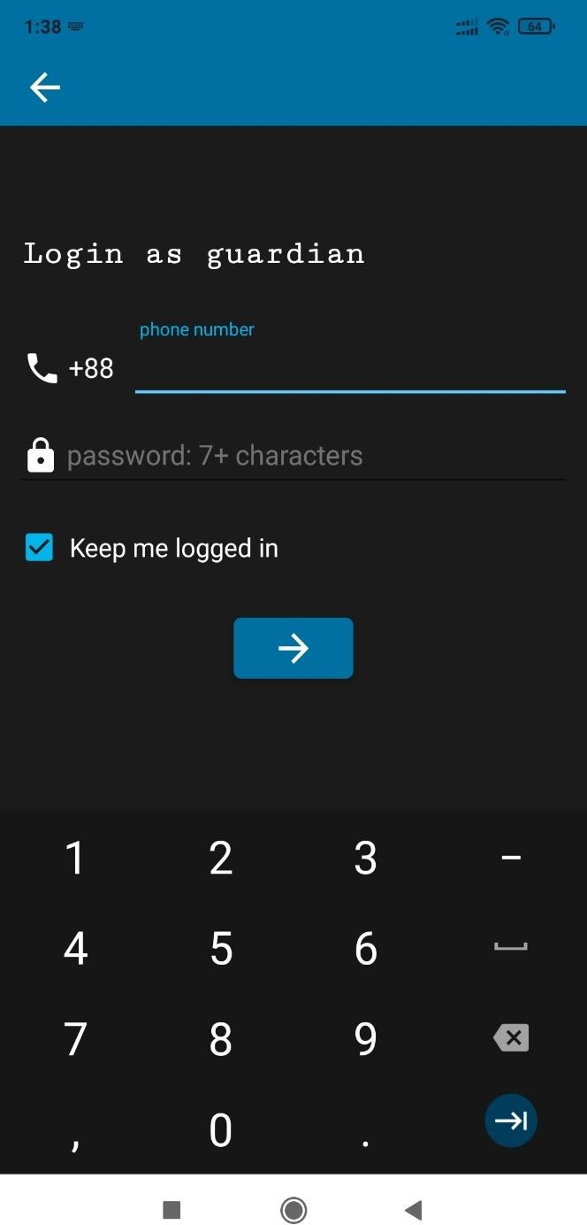

Figure 5.2.2: Login View for both teacher and guardian.

# Home View

Home view shows all the features of the app. User can see classes, notices, about, user profile button from home page.

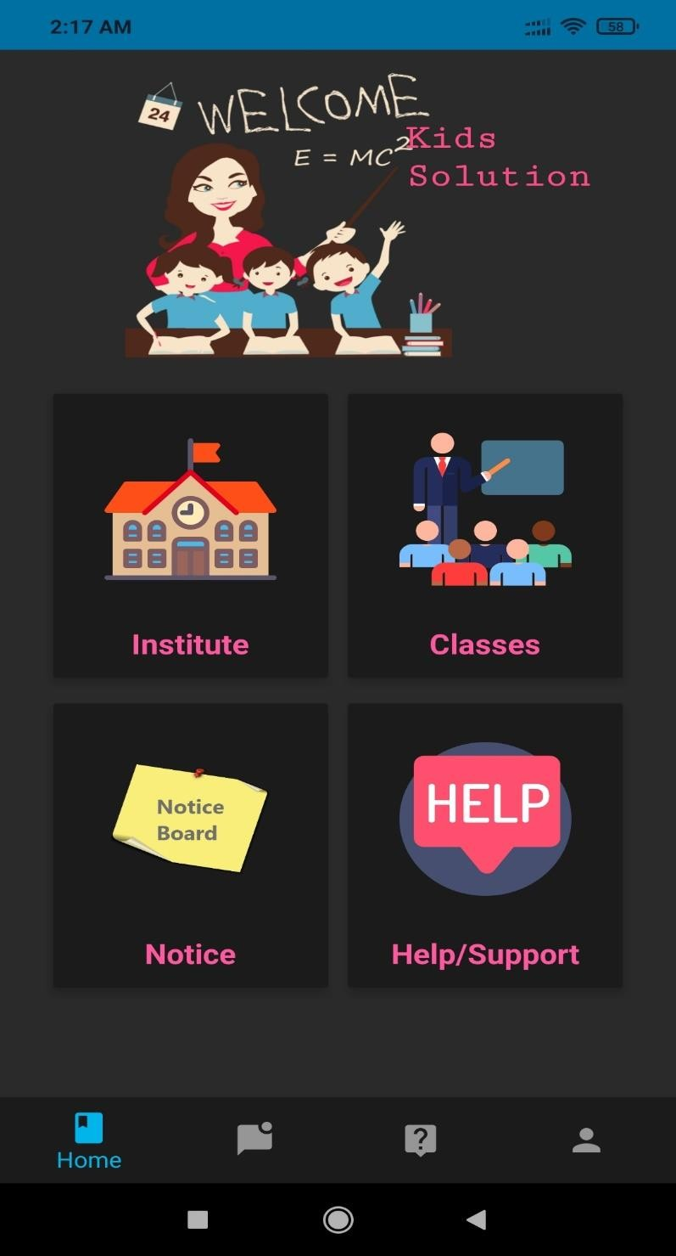

Figure 5.2.3: Home View.

# Class List

Class view contains the list of all classes and create class button (teacher end).

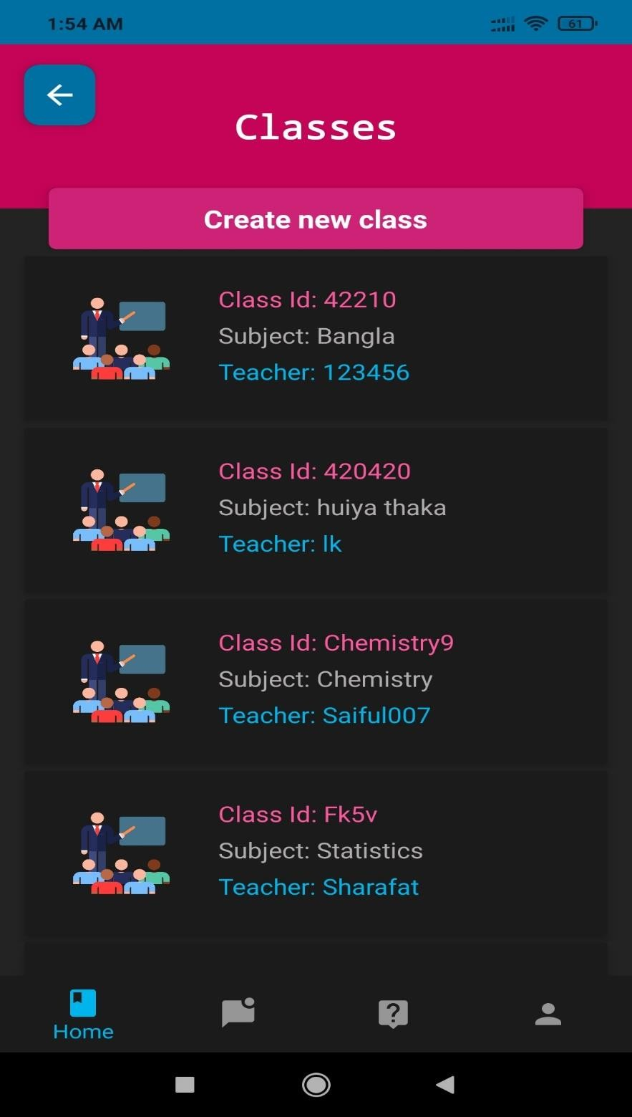

Figure 5.2.4: Class List.

# About

About view contains the description and version no. of the application.

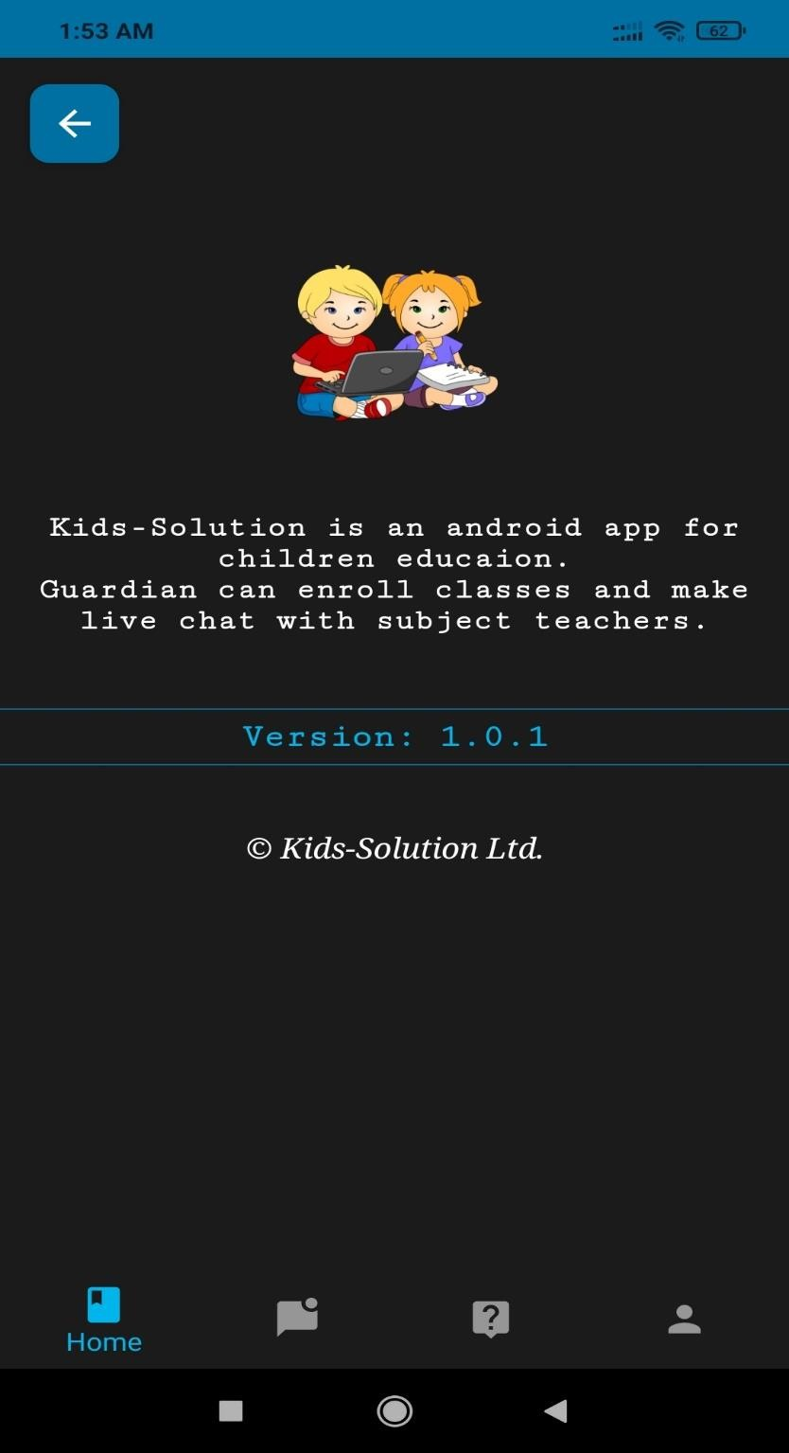

Figure 5.2.5: About.

# Testing Implementation

**User Profile**

User profile section contains information about the user, logout button and image.

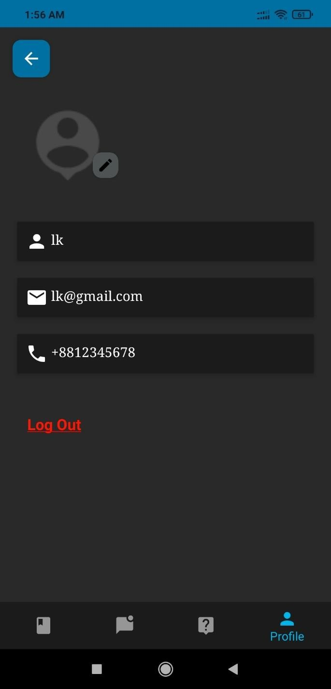

Figure 5.3.1: User Profile.

# Add Image View

This section contains user’s selected choice of browsing for photos.

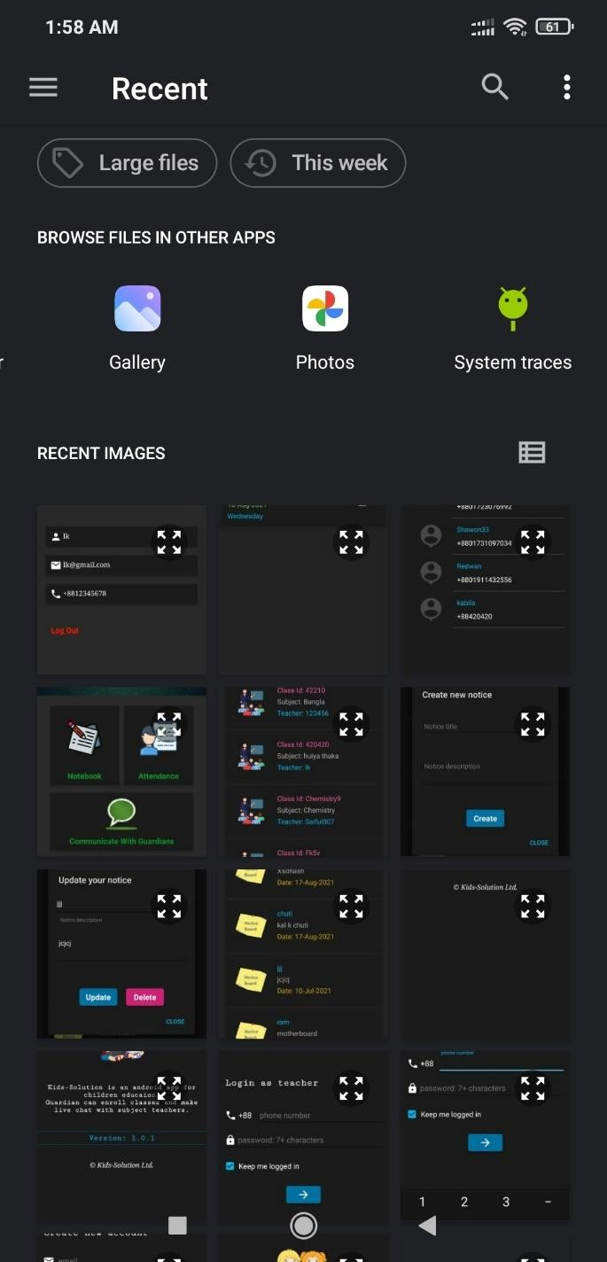

Figure 5.3.2: Add Image View.

# Create Class

Feature for creating class in classes view.

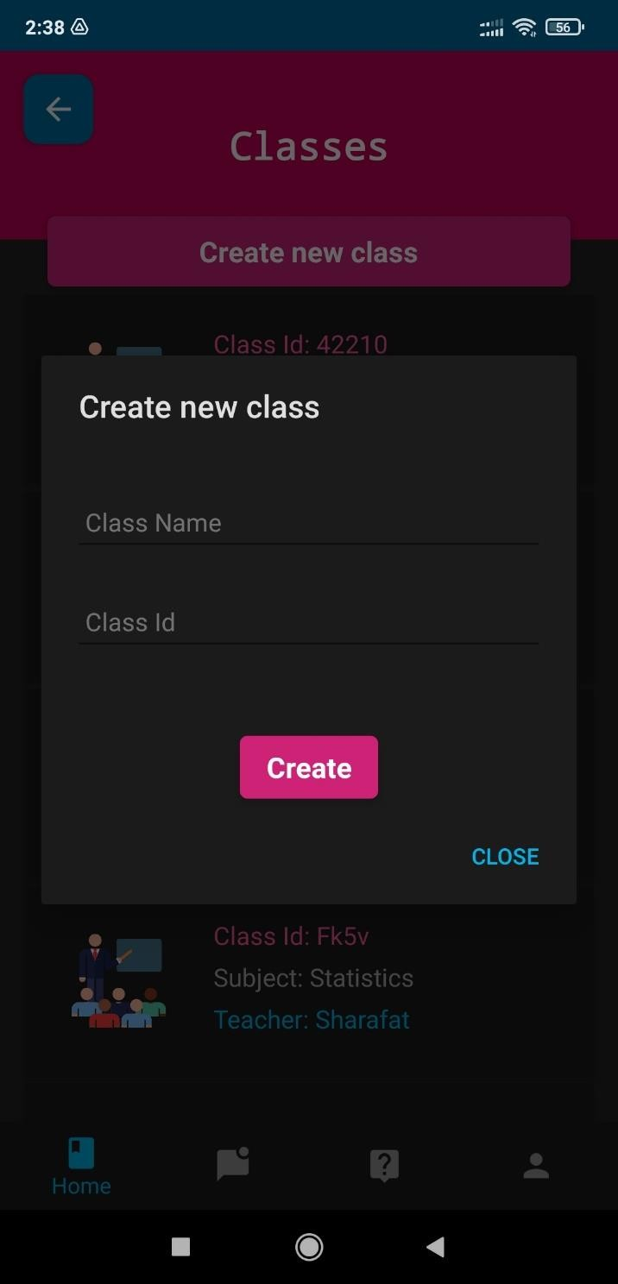

Figure 5.3.3: Create Class.

# Notice Board View

In notice board view, user can find important information. Only teachers can create a notice.

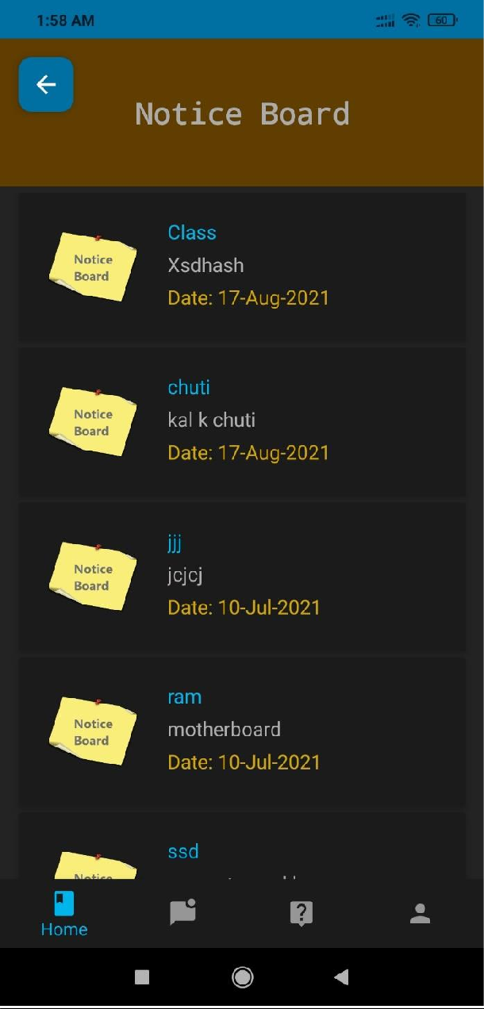

Figure 5.3.4: Notice Board View.

# Add Notice

In notice board view, teacher can create a new notice.

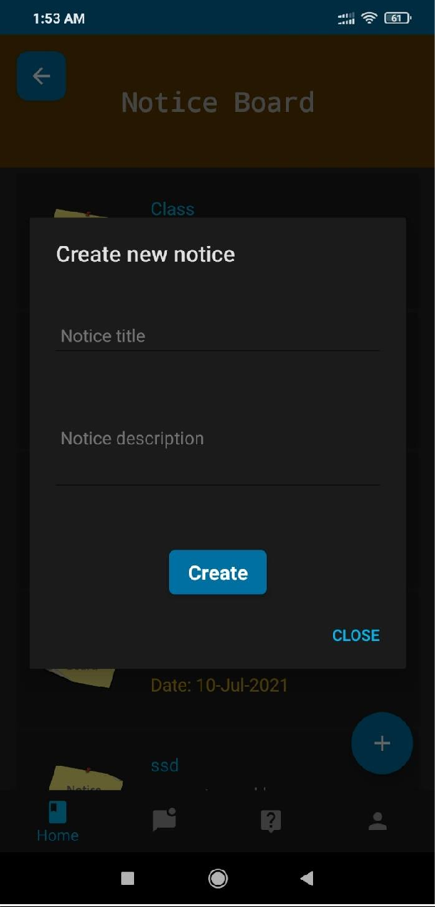

Figure 5.3.5: Add Notice.

# Edit Notice

In notice board view, teacher can edit notice.

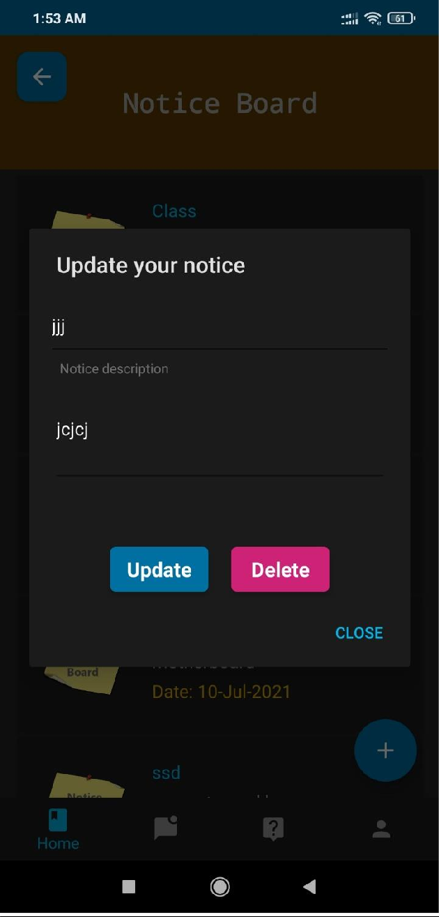

Figure 5.3.6: Edit Notice.

# Homework View

Both teachers and guardians can see assigned homework’s.

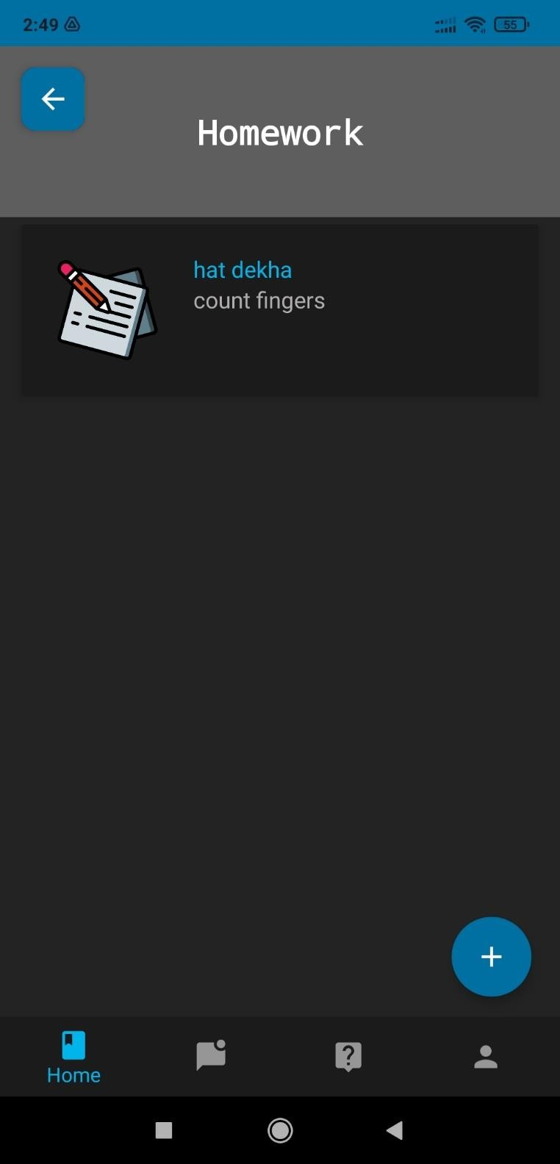

Figure 5.3.7: Homework View.

# Create Homework

Only teachers can assign homework.

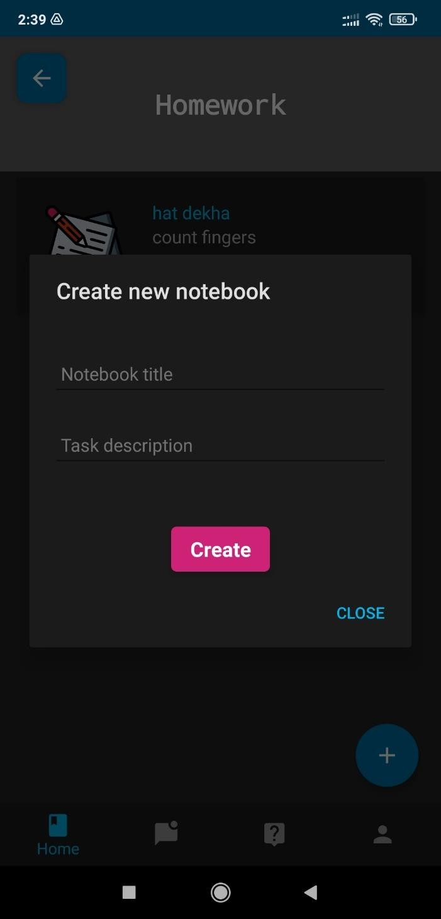

Figure 5.3.8: Update Homework.

# Attendance

Teacher manages the attendance of the enrolled students.

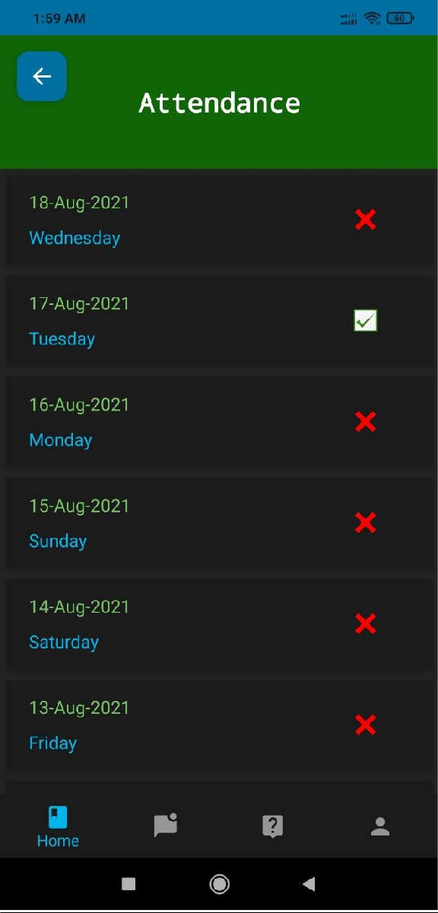

Figure 5.3.9: Attendance View.

# Talk with Guardian

From talk with guardian view, teachers can see guardians contact info.

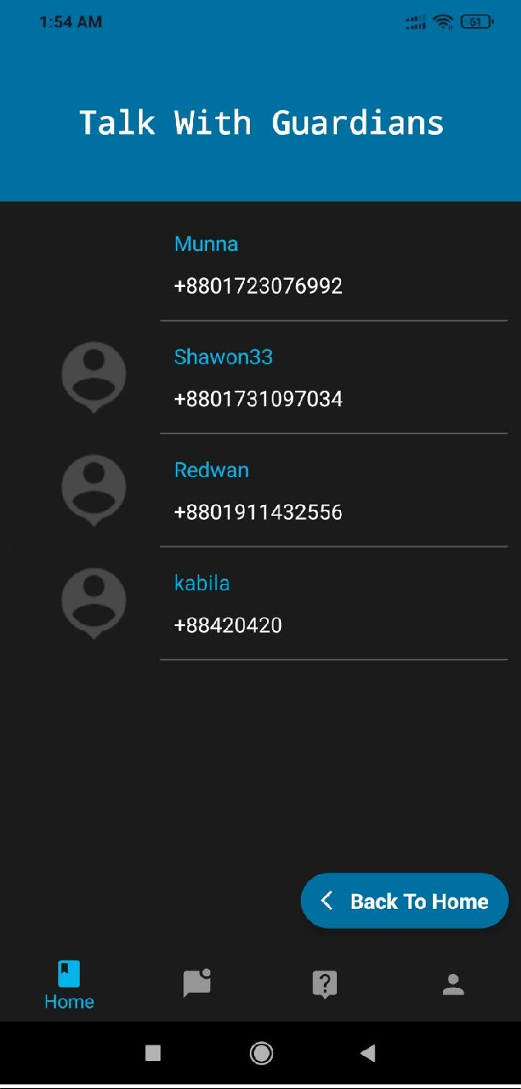

Figure 5.3.10: Talk with Guardian View.

# Joining a Class

From classes view, guardian class enroll in a class.

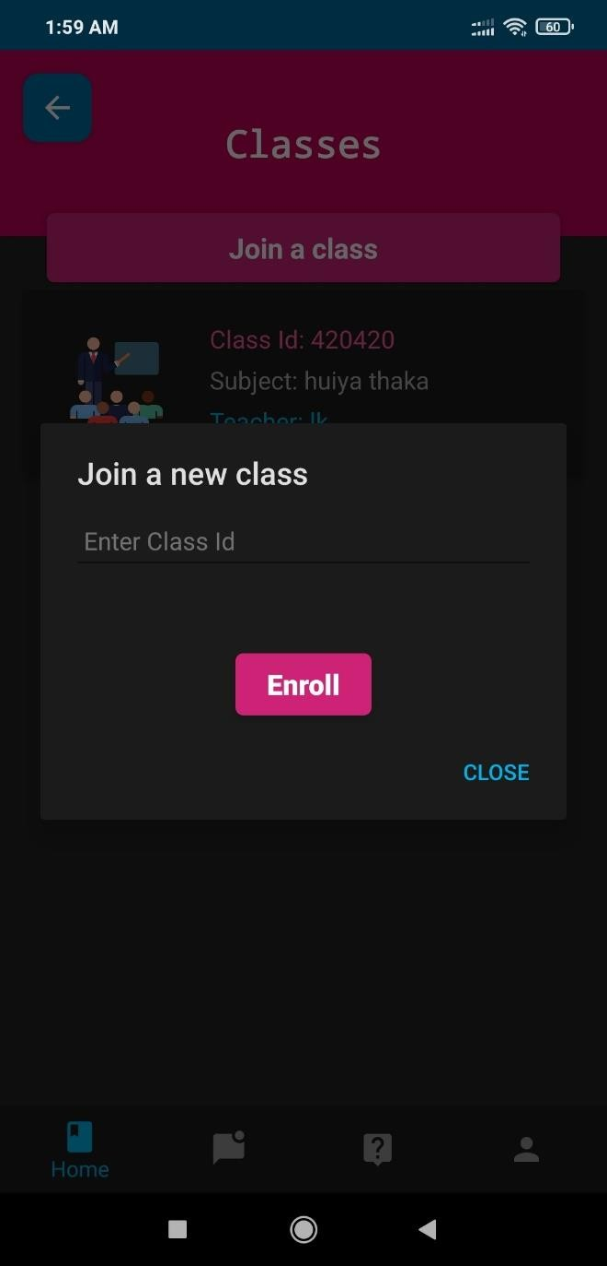

Figure 5.3.11: Joining a Class.

# Talk with Teacher

From talk with teacher view, guardians can see teachers contact info.

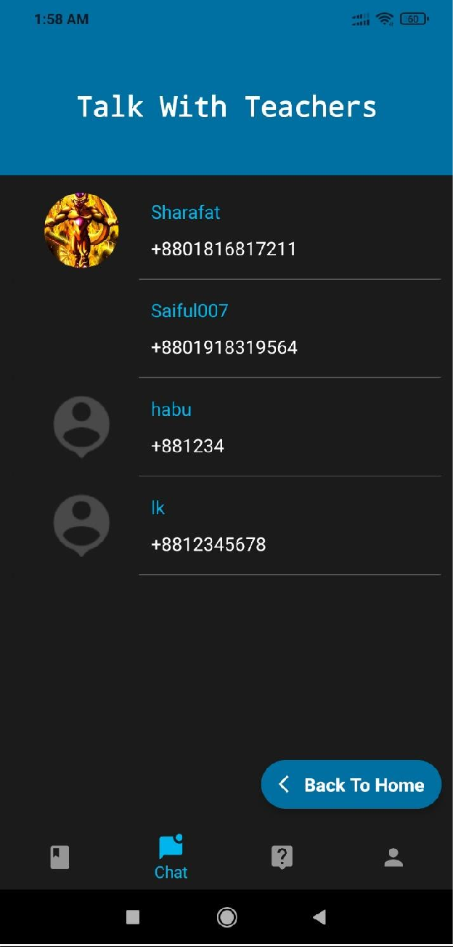

Figure 5.3.12: Talk with Teacher View.

# Send Message View

In send message view, guardian and teacher can communicate with each other.

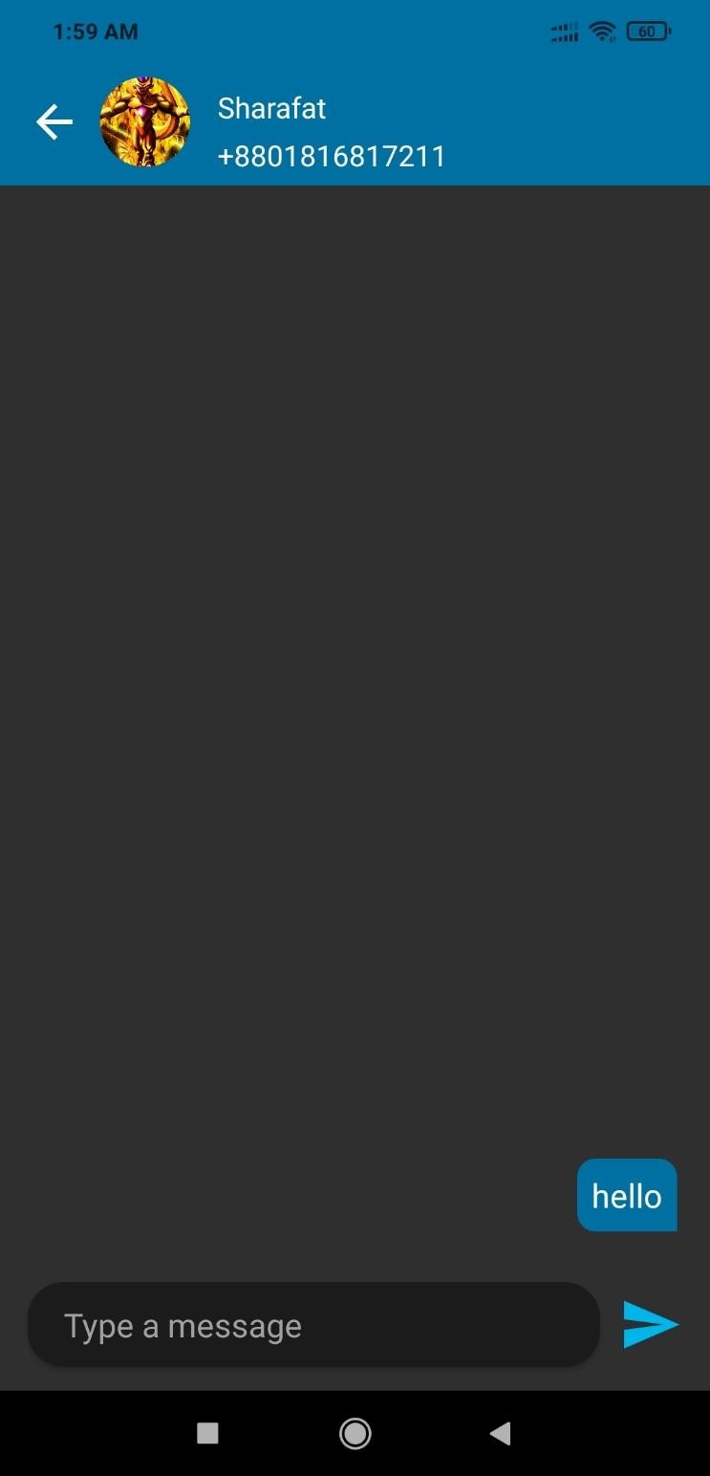

Figure 5.3.13: Send Message View.

# CHAPTER 6

**Impact on Society, Environment and Sustainability**

* 1. **Impact on Society**

This application will be beneficial for the people, for the country. Teachers can easily manage students, assign homework’s and give necessary notices. Guardians can also know about the tasks given to the students and execute them. This application will be very helpful especially for the primary schools.

# Limitation

No application is perfect. Every system has some limitations. The limitation of our projects are written below:

* + - Database limitation of 1GB.
    - Can register with fake emails.

# Obstacles & Achievements

During the development of the application, we have faced a lot of obstacles and successfully overcame most of them. Some of the obstacles were:

* + - Firebase Handling for authentication and other information e.g., classes.
    - Image Upload System.

Finally, after developing the project, we have successfully achieved:

* + - Advanced education system for both student and teachers.

# CHAPTER 7

**Conclusion and Future Scope**

* 1. **Discussion and Conclusion**

People loves to have pets because whenever nobody is there for them,

The nation cannot be locked in a room, it has to step forward. In order to step forward, education is a must. For children of our country, Kids Solution can be the best solution for education. Teachers can keep track of their students update and children will also get some information. Overall, this app will be beneficial to rich, poor, all.

# Scope for Further Developments

Due to limitation of time, knowledge and experience, we couldn’t develop some features of our project. In future, we want to develop those features one by one. Those features are:

* + - Attendance history for a month.
    - Video class feature.
    - Publish the app on Play Store.

# References

1. Stack overflow for solving bugs, available at << >>, last accessed on 05-08-2021 at 12:00 P.M.
2. YouTube for Android Tutorial at << https://[www.youtube.com/](http://www.youtube.com/) >>, last accessed on 05-08-2021 at 10:00 P.M.
3. Firebase documentation, available at << https://firebase.google.com/docs >>, last accessed on 23-07-2021 at 01:00 A.M.
4. Material Design for Android, available at << https://material.io/develop/android >>, last accessed on 10- 08-2021 at 12:00 A.M.
5. Bangla Notice App for related works comparison, available at << https://play.google.com/store/apps/details?id=com.dev.banglanotice/ >>, last accessed on 24-07-2021 at

11:00 A.M.

1. School Management System for related works comparison, available at << https://play.google.com/store/apps/details?id=com.hqdevs.schoolmanagementsystem/ >>, last accessed on

28-07-2021 at 2:00 P.M

