

AMERICAN INTERNATIONAL UNIVERSITY–BANGLADESH (AIUB)
FACULTY OF SCIENCE & TECHNOLOGY

INTRODUCTION TO DATABASE

Spring 2023-2024 Section: U Group: 01
Project Title

FARMING MANAGEMENT SYSTEM

Supervised By
SYEEDA SHARMIN RAHMAN

Submitted By

Name | ID | Contribution
- Nusrat Jahan Raina | 23-50416-1
- Emon Biswas | 23-50174-1
- Md. Redwanul Hoque | 23-50057-1
- Dipu Roy | 23-50420-1
- Dip Khastagir | 23-50346-1

TABLE OF CONTENTS
TOPICS
- Cover Page 01
- Table of Contents 02
- Introduction 03
- Scenario 03
- ER Diagram 04
- Normalization 05
- Finalization 14
- Optimization 15
- Table Creation 16
- Data Insertion 25
- Query Writing 35
13. Conclusion 40

INTRODUCTION:
In an era marked by rapid technological advancements, the realm of agriculture stands as a cornerstone of global sustenance and economic stability. Our project, the Farming Management System, embodies a visionary approach aimed at revolutionizing agricultural operations with efficiency and precision. Rooted in the concept of modernization, this system endeavors to establish a unified platform for the comprehensive management of farming activities. Through the creation of a centralized database, the Farming Management System intends to streamline the intricate processes involved in agricultural endeavors, encompassing crop cultivation, livestock management, resource allocation, and logistical coordination. By seamlessly integrating crucial elements such as land utilization, crop rotation schedules, irrigation systems, and inventory tracking, this innovative solution aspires to empower farmers with the tools necessary to optimize yields, minimize wastage, and foster sustainable agricultural practices. Embracing this paradigm shift promises not only heightened productivity and profitability but also facilitates greater resilience in the face of evolving environmental and market challenges. Through the successful implementation of the Farming Management System, the agricultural sector stands poised to harness the transformative potential of technology, ensuring a bountiful harvest for generations to come.

SCENARIO:
In a farming management system of Bangladesh, an argicultural company can lease farming lands for farming from landowners. On the other hand, the company can also buy farming lands for their company. All of these farming lands has a specific volume and serial number. The company is owned by many owners. Owner is uniquely identified by owner ID and name. The agricultural company divides into several branches. This company has a registration number in Bangladesh. Every branch contains a branch ID and address. A branch manager manages a particular branch of this company. Every manager has their manager ID, name, e-mail, phone number. The company has different types of employees. Employee can be classified as agriculturist and farmer. Employee can be specified by employee ID, name and phone number. Company sells their farming product to the people. Farming products can be classified as miscellaneous crops, poultry and cattle, dairy products. Product has a product code and price. Customer can buy farming products from the company. Every customer can be identified by customer ID, name, phone number, price and manufacture date of farming products.

ER DIAGRAM:
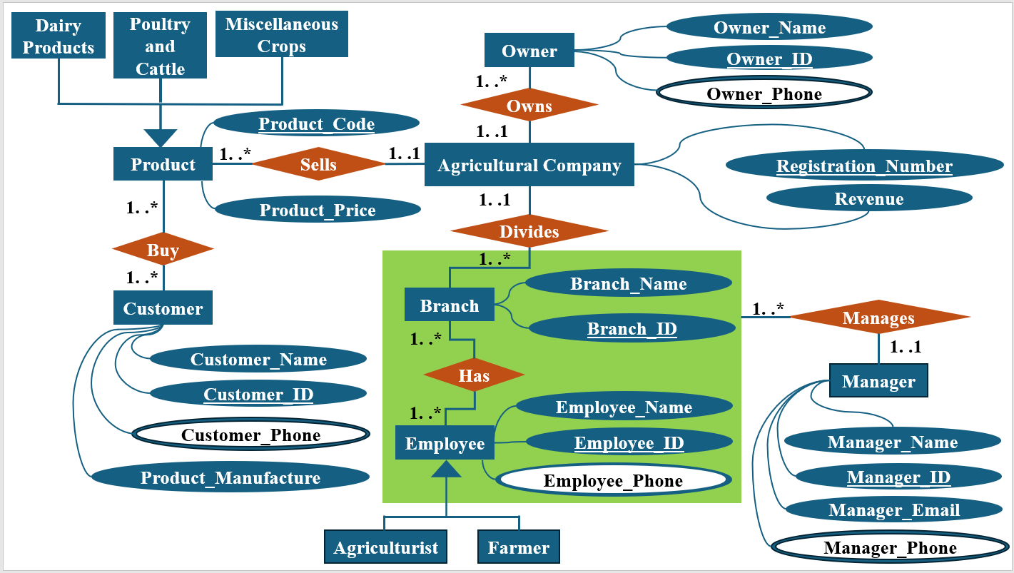

NORMALIZATION:
- Owner – owns – Agricultural Company

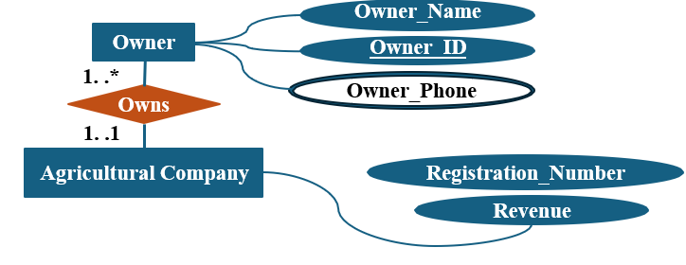

Relation: Many to One
UNF: Owner_Name, Owner_ID, Owner_Phone, Registration_Number, Revenue
1NF: Owner_Phone, Owner_Name, Owner_ID, Registration_Number, Revenue

2NF: 1) Owner_ID (Primary Key), Owner_Name, Owner_Phone,
Registration_Number (Foreign Key)
2) Registration_Number (Primary Key), Revenue

3NF: 1) Owner_ID (Primary Key), Owner_Name, Owner_Phone,
Registration_Number (Foreign Key)
2) Registration_Number (Primary Key), Revenue

- Agricultural Company – divides – Branch
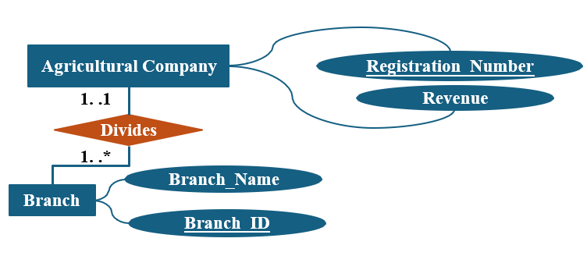

Relation: One to Many
UNF: Registration_Number, Revenue, Branch_ID, Branch_Name
1NF: Registration_Number, Revenue, Branch_ID, Branch_Name

2NF: 1) Registration_Number (Primary Key), Revenue
2) Branch_ID (Primary Key), Branch_Name, Registration_Number (Foreign
Key)

3NF: 1) Registration_Number (Primary Key), Revenue
2) Branch_ID (Primary Key), Branch_Name, Registration_Number (Foreign
Key)

- Branch – manages – Manager
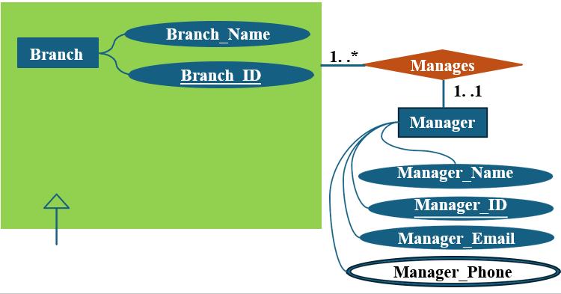

Relation: One to Many

UNF: Branch_ID, Branch_Name, Manager_Name, Manager_ID, Manager_Email, Manager_Phone, Employee_ID, Employee_Name, Employee_Phone.

1NF: Branch_ID, Branch_Name, Manager_Name, Manager_ID, Manager_Email, Manager_Phone, Employee_ID, Employee_Name, Employee_Phone.

2NF: 1) Manager_ID (Primary Key), Manager_Name, Manager_Email,
Manager_Phone.
2) Branch_ID (Primary Key), Branch_Name, Employee_ID, Employee_Name,
Employee_Phone, Manager_ID (Foreign Key)

3NF: 1) Manager_ID (Primary Key), Manager_Name, Manager_Email,
Manager_Phone.
2) Branch_ID (Primary Key), Branch_Name, Employee_ID, Employee_Name,
Employee_Phone, Manager_ID (Foreign Key)

- Branch – has – Employee

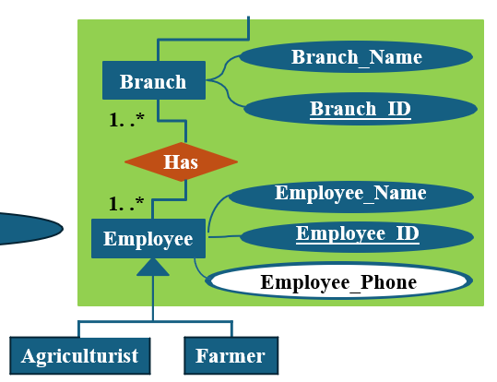

Relation: Many to Many
UNF: Branch_ID, Branch_Name, Employee_ID, Employee_Name, Employee_Phone
1NF: Branch_ID, Branch_Name, Employee_ID, Employee_Name, Employee_Phone

2NF: 1) Branch_ID (Primary Key), Branch_Name
2) Employee_ID (Primary Key), Employee_Name, Employee_Phone
3) Branch_ID (Primary Key), Employee_ID (Foreign Key)
3NF: 1) Branch_ID (Primary Key), Branch_Name
2) Employee_ID (Primary Key), Employee_Name, Employee_Phone
3) Branch_ID (Primary Key), Employee_ID (Foreign Key)

- Agricultural Company – sells – Product

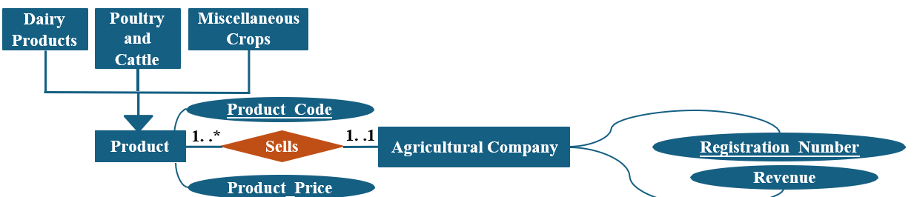

Relation: One to Many

UNF: Registration_Number, Revenue, Product_Code, Product_Price
1NF: Registration_Number, Revenue, Product_Code, Product_Price

2NF: 1) Product_Code (Primary Key), Product_Price, Registration_Number
(Foreign Key)
2) Registration_Number (Primary Key), Revenue

3NF: 1) Product_Code (Primary Key), Product_Price, Registration_Number
(Foreign Key)
2) Registration_Number (Primary Key), Revenue

- Customer – buy - Product

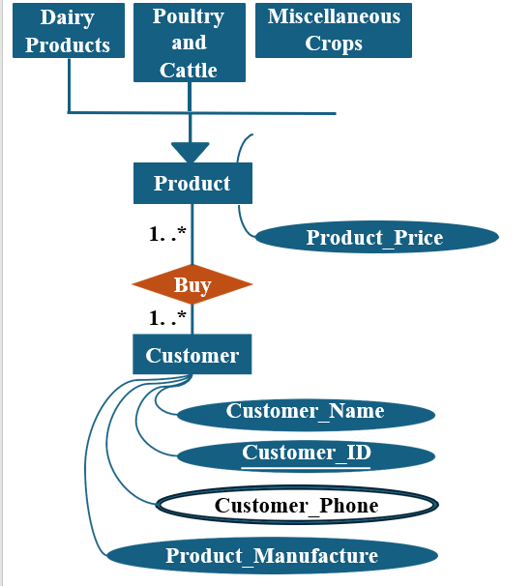

Relation: Many to Many

UNF: Product_Code, Product_Price, Product_Manufacture, Customer_Phone, Customer_Name, Customer_ID.

1NF: Product_Code, Product_Price, Product_Manufacture, Customer_Phone, Customer_Name, Customer_ID.

2NF: 1) Customer_ID (Primary Key), Product_Manufacture, Customer_Phone,
Customer_Name.
2) Product_Code (Primary Key), Product_Price.
3) Customer_ID (Primary Key), Product_Code (Foreign Key)

3NF: 1) Customer_ID (Primary Key), Product_Manufacture, Customer_Phone,
Customer_Name.
2) Product_Code (Primary Key), Product_Price.
3) Customer_ID (Primary Key), Product_Code (Foreign Key

FINALIZATION:

    - Owner_ID (Primary Key), Owner_Name, Owner_Phone,
Registration_Number (Foreign Key).
    - Registration_Number (Primary Key), Revenue.
    - Registration_Number (Primary Key), Revenue.
    - Branch_ID (Primary Key), Branch_Name, Registration_Number (Foreign Key).
    - Branch_ID (Primary Key), Branch_Name.
    - Manager_ID (Primary Key), Manager_Name, Manager_Email,
Manager_Phone.
    - Branch_ID (Primary Key), Branch_Name, Employee_ID,
Employee_Name, Employee_Phone, Manager_ID (Foreign Key)
    - Employee_ID (Primary Key), Employee_Name, Employee_Phone.
    - Branch_ID (Primary Key), Employee_ID (Foreign Key).
    - Customer_ID (Primary Key), Product_Manufacture, Customer_Phone,
Customer_Name.
    - Product_Code (Primary Key), Product_Price.
    - Customer_ID (Primary Key), Product_Code (Foreign Key).
    - Product_Code (Primary Key), Product_Price, Registration_Number (Foreign Key).
    - Registration_Number (Primary Key), Revenue.

OPTIMIZATION:

- Owner_ID (Primary Key), Owner_Name, Owner_Phone, Registration_Number (Foreign Key) – (Owns)
- Registration_Number (Primary Key), Revenue – (Agricultural Company)
- Branch_ID (Primary Key), Branch_Name, Registration_Number (Foreign Key) – (Divides)
- Branch_ID (Primary Key), Branch_Name – (Branch)
- Manager_ID (Primary Key), Manager_Name, Manager_Email, Manager_Phone – (Manager)
- Employee_ID (Primary Key), Employee_Name, Employee_Phone – (Employee)
- Branch_ID (Primary Key), Branch_Name, Employee_ID, Employee_Name, Employee_Phone, Manager_ID (Foreign Key) – (Manages)
- Branch_ID (Primary Key), Employee_ID (Foreign Key) – (Has)
- Customer_ID (Primary Key), Product_Manufacture, Customer_Phone,
Customer_Name – (Customer)
- Product_Code (Primary Key), Product_Price – (Product)
- Customer_ID (Primary Key), Product_Code (Foreign Key) – (Buy)
- Product_Code (Primary Key), Product_Price, Registration_Number (Foreign Key) – (Sells).

TABLE CREATION:

Table: Agricultural Company

CREATE TABLE Agricultural_Company (

Registration_Number NUMBER PRIMARY KEY,

Revenue NUMBER

);

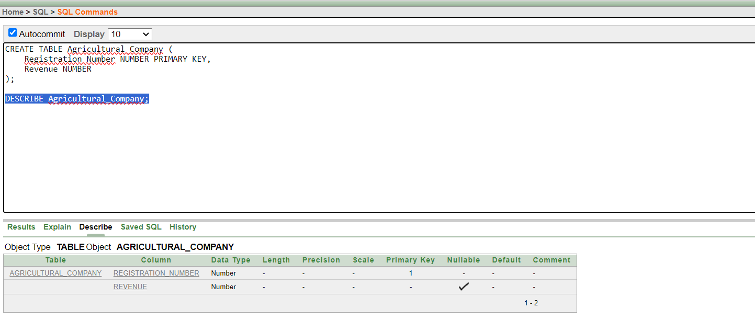

Table : Owns

CREATE TABLE Owns (
Owner_ID NUMBER PRIMARY KEY,
Owner_Name VARCHAR2(100),
Owner_Phone VARCHAR2(20),
Registration_Number NUMBER,
FOREIGN KEY (Registration_Number) REFERENCES Agricultural_Company(Registration_Number)
);

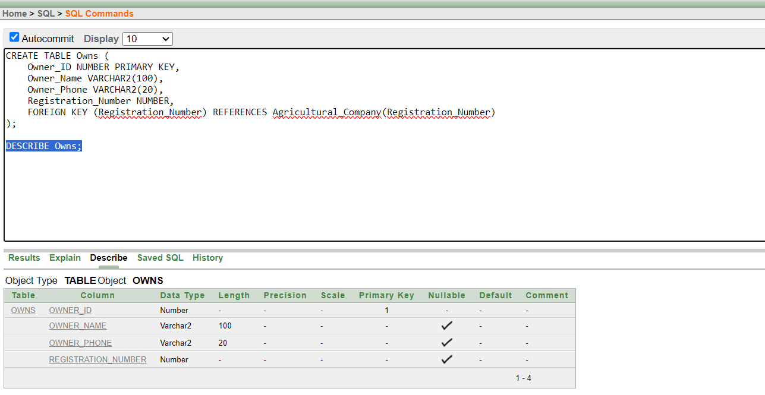

Table : Branch

CREATE TABLE Branch (
Branch_ID NUMBER PRIMARY KEY,
Branch_Name VARCHAR2(100)
);

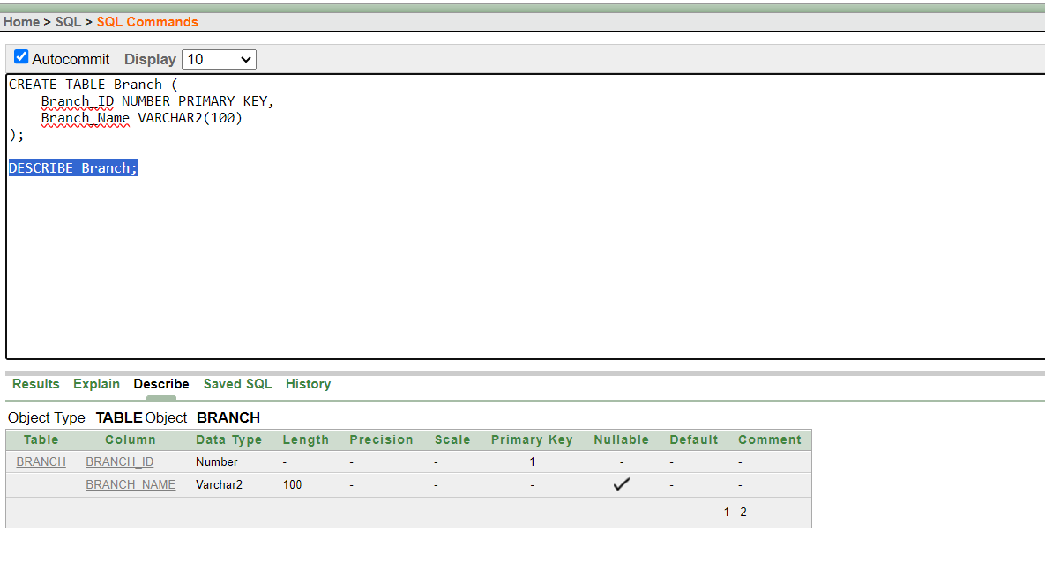

Table : Divides

CREATE TABLE Divides (
Branch_ID NUMBER PRIMARY KEY,
Branch_Name VARCHAR2(100),
Registration_Number NUMBER,
FOREIGN KEY (Registration_Number) REFERENCES Agricultural_Company(Registration_Number)
);

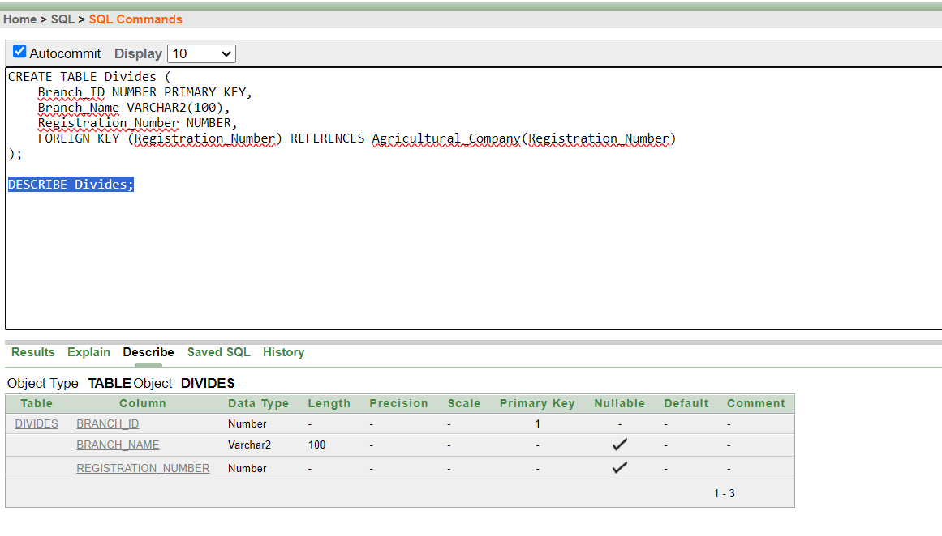

Table : Manager

CREATE TABLE Manager (
Manager_ID NUMBER PRIMARY KEY,
Manager_Name VARCHAR2(100),
Manager_Email VARCHAR2(100),
Manager_Phone VARCHAR2(20)
);

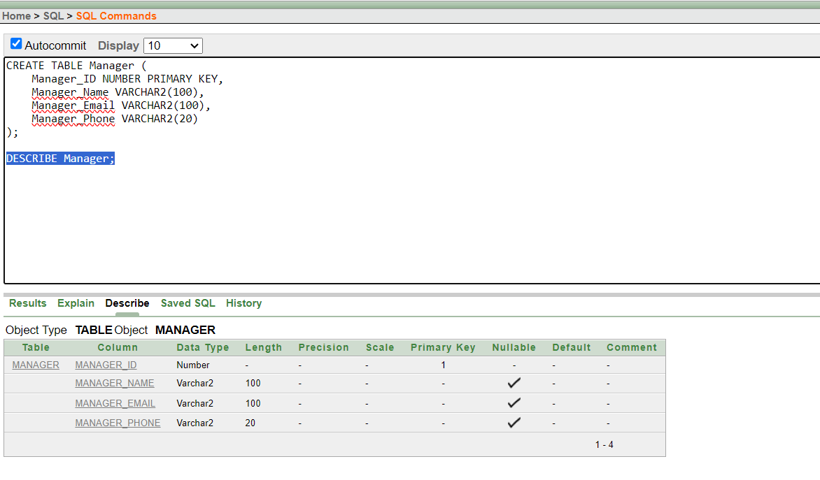

Table : Employee

CREATE TABLE Employee (
Employee_ID NUMBER PRIMARY KEY,
Employee_Name VARCHAR2(100),
Employee_Phone VARCHAR2(20)
);

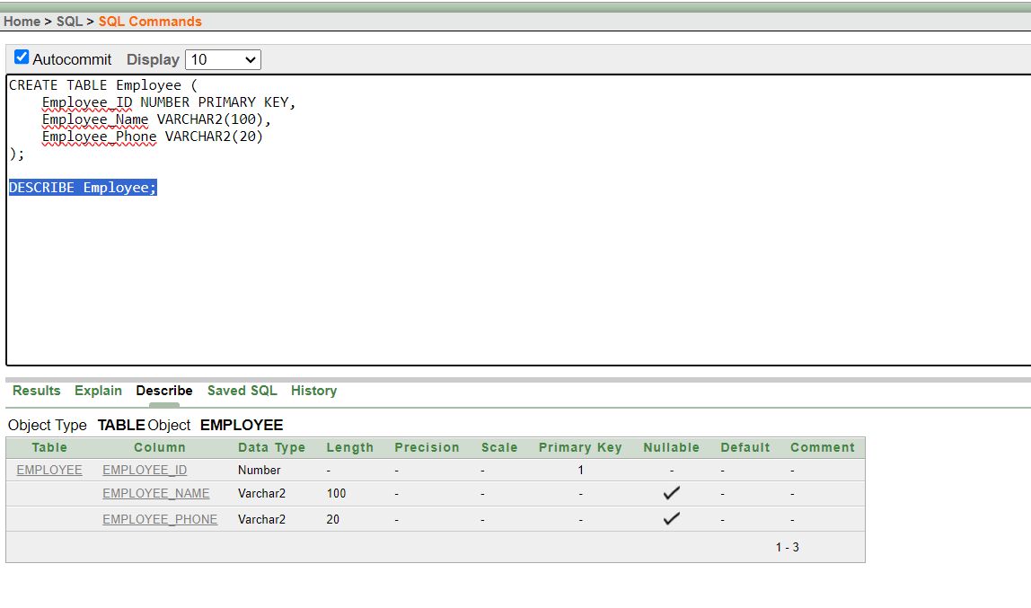

Table : Manages

CREATE TABLE Manages (
Branch_ID NUMBER PRIMARY KEY,
Branch_Name VARCHAR2(100),
Employee_ID NUMBER,
Employee_Name VARCHAR2(100),
Employee_Phone VARCHAR2(20),
Manager_ID NUMBER,
FOREIGN KEY (Manager_ID) REFERENCES Manager(Manager_ID)
);
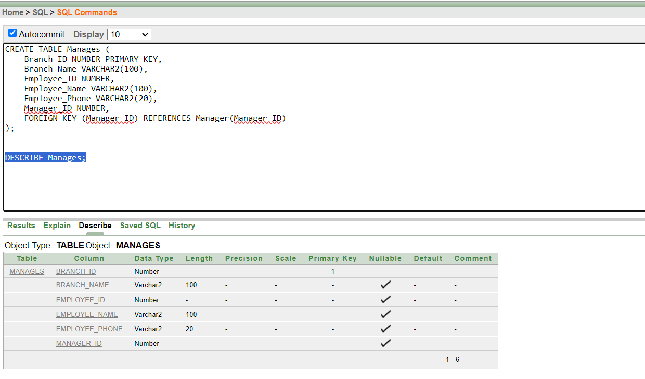

Table : Has

CREATE TABLE Has (
Branch_ID NUMBER PRIMARY KEY,
Employee_ID NUMBER,
FOREIGN KEY (Branch_ID) REFERENCES Branch(Branch_ID),
FOREIGN KEY (Employee_ID) REFERENCES Employee(Employee_ID)
);
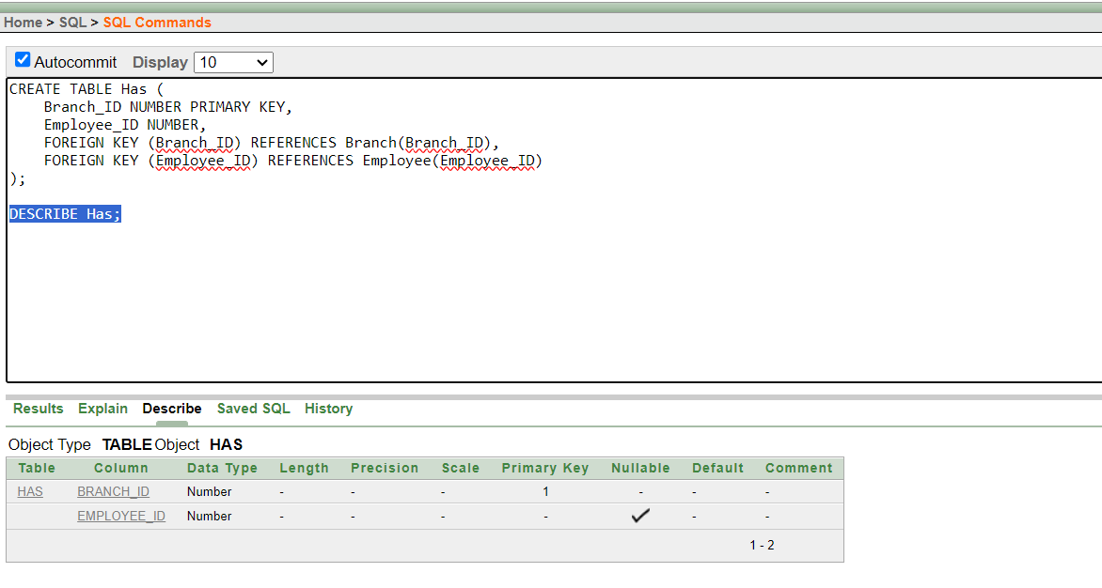

Table : Customer

CREATE TABLE Customer (
Customer_ID NUMBER PRIMARY KEY,
Product_Manufacture VARCHAR2(100),
Customer_Phone VARCHAR2(20),
Customer_Name VARCHAR2(100)
);
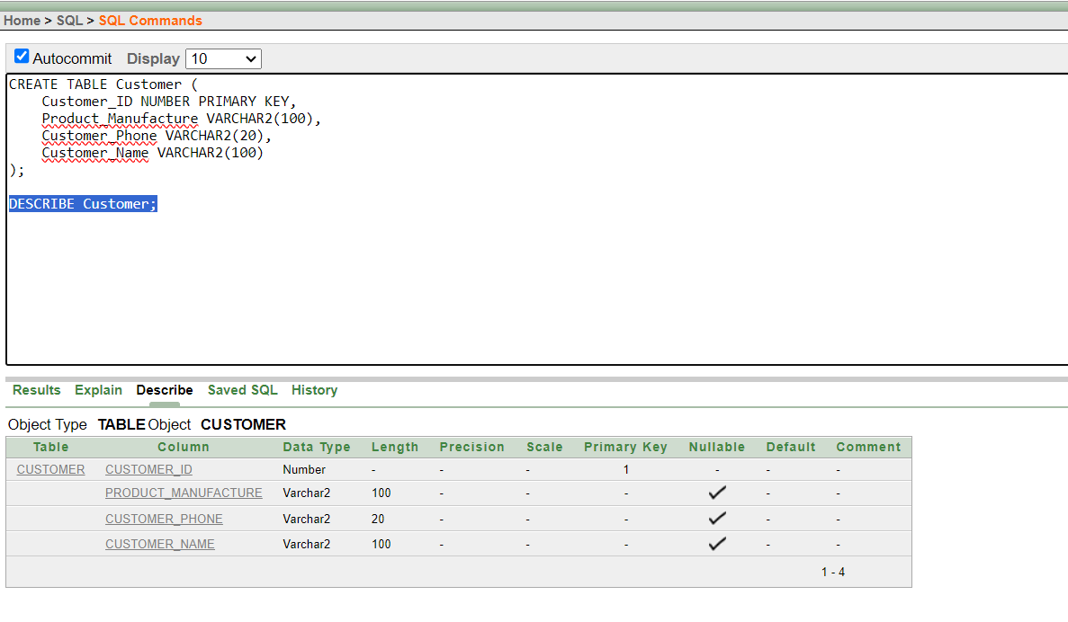

Table : Product

CREATE TABLE Product (

Product_Code NUMBER PRIMARY KEY,

Product_Price NUMBER
);
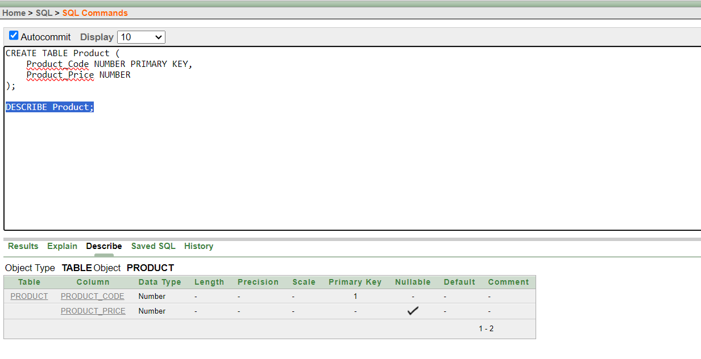

Table: Buy

CREATE TABLE Buy (
Customer_ID NUMBER,
Product_Code NUMBER,
FOREIGN KEY (Customer_ID) REFERENCES Customer(Customer_ID),
FOREIGN KEY (Product_Code) REFERENCES Product(Product_Code)
);

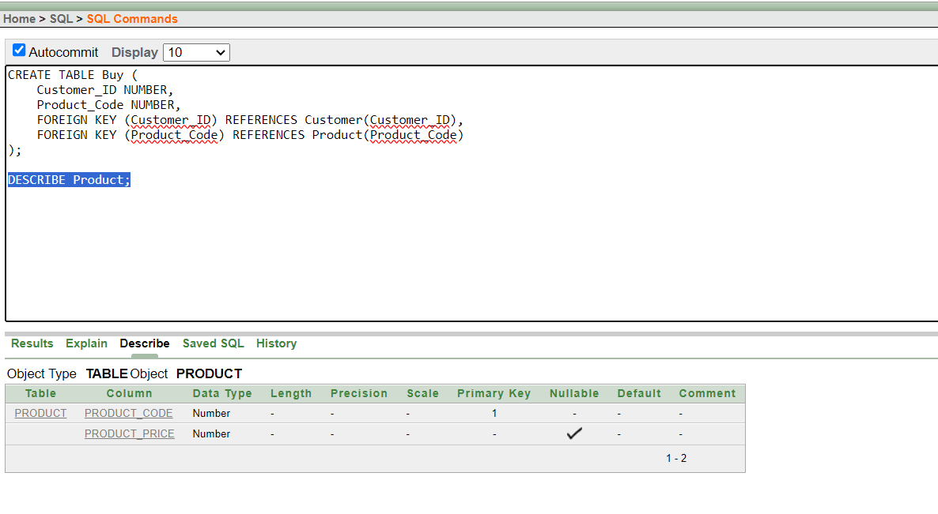

Table : Sells

CREATE TABLE Sells (
Product_Code NUMBER PRIMARY KEY,
Product_Price NUMBER,
Registration_Number Varchar2(20),
FOREIGN KEY (Registration_Number) REFERENCES Agricultural_Company(Registration_Number)
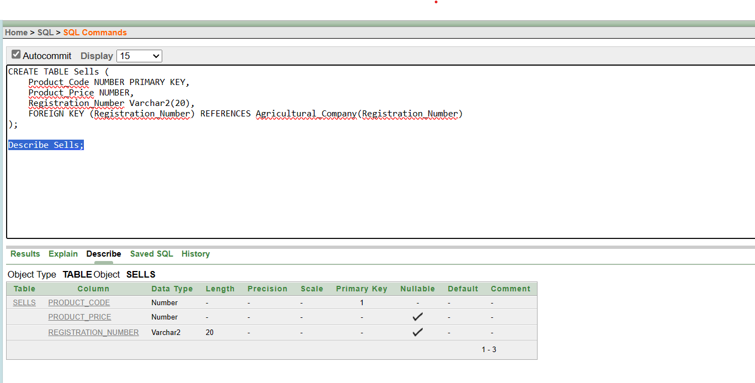
);

DATA INSERTION:

Information: Agricultural Company

INSERT INTO Agricultural_Company (Registration_Number, Revenue) VALUES (100190, 500000);

SELECT * FROM Agricultural_Company;

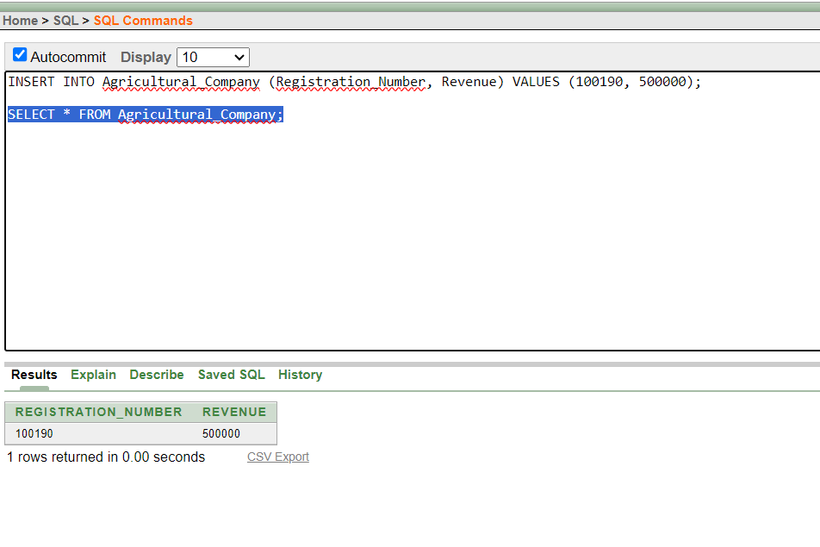

Information: Owns

INSERT INTO Owns (Owner_ID, Owner_Name, Owner_Phone, Registration_Number) VALUES (9001, 'DIPU ROY', '01316-008929', 100190);

INSERT INTO Owns (Owner_ID, Owner_Name, Owner_Phone, Registration_Number) VALUES (9002, 'EMON BISWAS', '01615-229455', 100191);

INSERT INTO Owns (Owner_ID, Owner_Name, Owner_Phone, Registration_Number) VALUES (9003, 'NUSRAT JAHAN RAINA', '01893-314782', 100192);

INSERT INTO Owns (Owner_ID, Owner_Name, Owner_Phone, Registration_Number) VALUES (9004, 'MD. REDWANUL HAQUE', '01308-767726', 100193);

INSERT INTO Owns (Owner_ID, Owner_Name, Owner_Phone, Registration_Number) VALUES (9005, 'DIP KHASTAGIR', '01575-078902', 100194);

SELECT * FROM Owns;

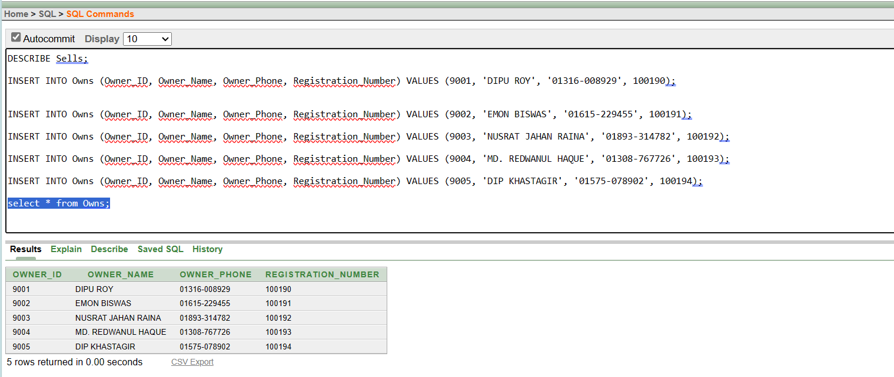

Information: Divides

INSERT INTO Divides (Branch_ID, Branch_Name, Registration_Number) VALUES (101, 'RAJSHAHI', 100190);

INSERT INTO Divides (Branch_ID, Branch_Name, Registration_Number) VALUES (102, 'MAGURA', 100190);

INSERT INTO Divides (Branch_ID, Branch_Name, Registration_Number) VALUES (103, 'MUNSHIGANJ', 100190);

INSERT INTO Divides (Branch_ID, Branch_Name, Registration_Number) VALUES (104, 'FENI', 100190);

INSERT INTO Divides (Branch_ID, Branch_Name, Registration_Number) VALUES (105, 'CHITTAGONG', 100190);

SELECT * FROM Divides;

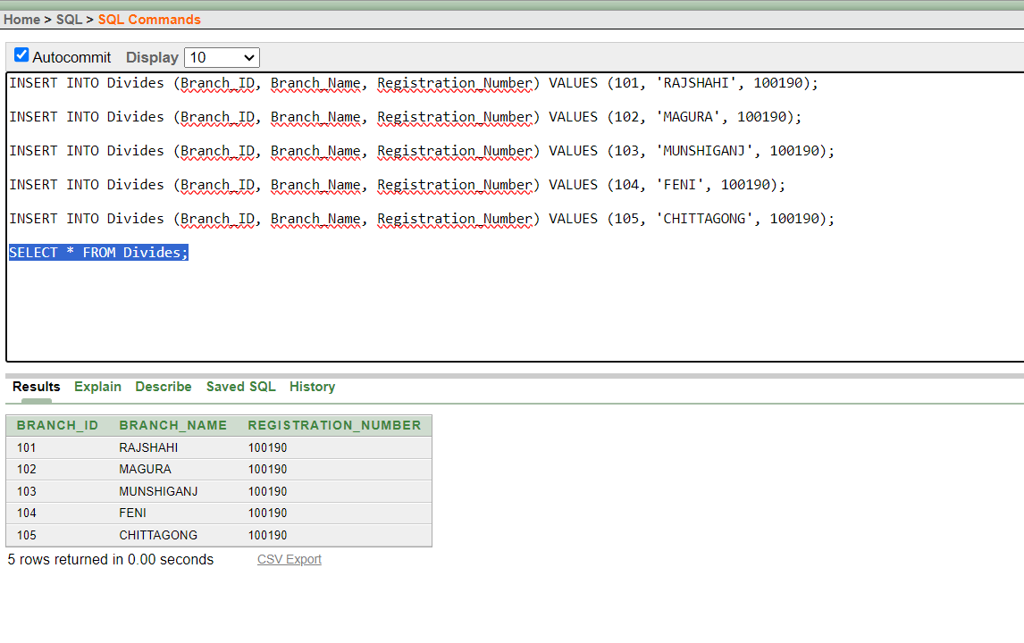

Information: Branch

INSERT INTO Branch (Branch_ID, Branch_Name) VALUES (101, 'RAJSHAHI');

INSERT INTO Branch (Branch_ID, Branch_Name) VALUES (102, 'MAGURA');

INSERT INTO Branch (Branch_ID, Branch_Name) VALUES (103, 'MUNSHIGANJ');

INSERT INTO Branch (Branch_ID, Branch_Name) VALUES (104, 'FENI');

INSERT INTO Branch (Branch_ID, Branch_Name) VALUES (105, 'CHITTAGONG');

SELECT * FROM Branch;

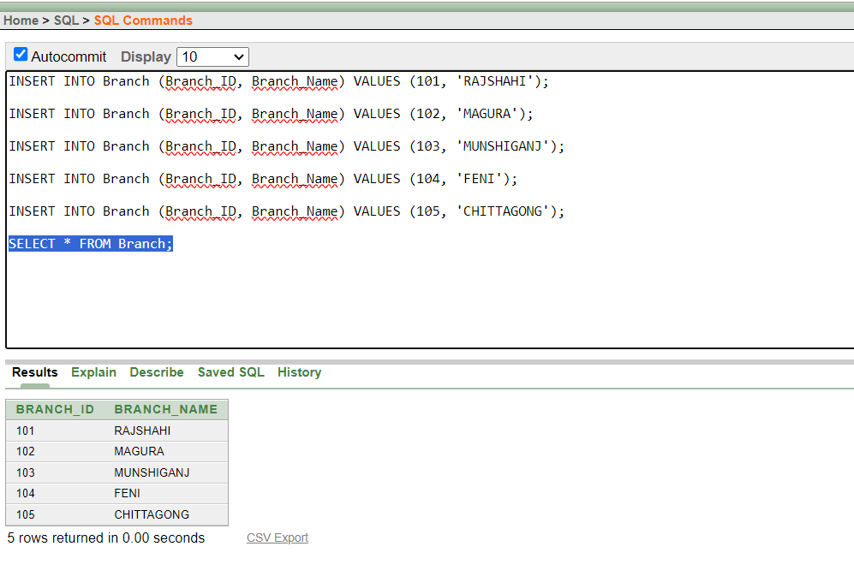

Information: Manager

INSERT INTO Manager (Manager_ID, Manager_Name, Manager_Email, Manager_Phone) VALUES (101, 'David Wilson ', 'david@example.com', '01388-445978');

INSERT INTO Manager (Manager_ID, Manager_Name, Manager_Email, Manager_Phone) VALUES (102, 'David Wilson', 'david@example.com', '01388-445978');

INSERT INTO Manager (Manager_ID, Manager_Name, Manager_Email, Manager_Phone) VALUES (103, 'David Wilson', 'david@example.com', '01388-445978');

INSERT INTO Manager (Manager_ID, Manager_Name, Manager_Email, Manager_Phone) VALUES (201, 'Tonmoy Sarkar', 'tonmay@.com', '01866-445535');

INSERT INTO Manager (Manager_ID, Manager_Name, Manager_Email, Manager_Phone) VALUES (202, 'David Wilson', 'david@example.com', '01388-445978');

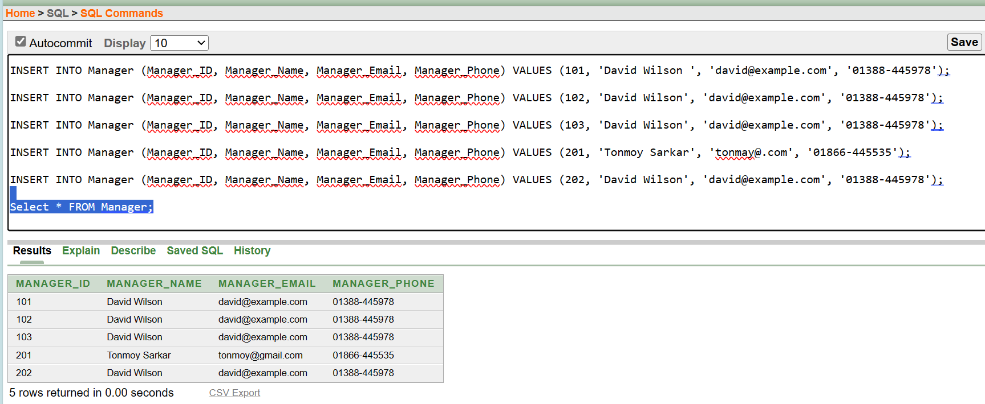
Select * FROM Manager;

Information: Employee

INSERT INTO Employee (Employee_ID, Employee_Name, Employee_Phone) VALUES (3010001, 'Michael Johnson', '01789-345909');

INSERT INTO Employee (Employee_ID, Employee_Name, Employee_Phone) VALUES (3010002, 'Rachel White', '01234-456984');

INSERT INTO Employee (Employee_ID, Employee_Name, Employee_Phone) VALUES (3010003, 'Daniel Davis', '01345-226778');

INSERT INTO Employee (Employee_ID, Employee_Name, Employee_Phone) VALUES (3010004, 'Olivia Taylor', '01987-348229');

INSERT INTO Employee (Employee_ID, Employee_Name, Employee_Phone) VALUES (3010005, 'Matthew Martinez', '01892-493111');

INSERT INTO Employee (Employee_ID, Employee_Name, Employee_Phone) VALUES (3010006, 'Debojit Khastagir', '01937-348229');

INSERT INTO Employee (Employee_ID, Employee_Name, Employee_Phone) VALUES (3010007, 'Amit Sarkar', '01899-493511');

INSERT INTO Employee (Employee_ID, Employee_Name, Employee_Phone) VALUES (3010008, 'Anamul Haque', '01987-3487356');

INSERT INTO Employee (Employee_ID, Employee_Name, Employee_Phone) VALUES (3010009, 'Md. Golam Rabbani', '01892-493381');

INSERT INTO Employee (Employee_ID, Employee_Name, Employee_Phone) VALUES (3010010, 'Anika Tabassum', '01767-348221');

INSERT INTO Employee (Employee_ID, Employee_Name, Employee_Phone) VALUES (3010011, 'Nirjhor Rahman', '01882-873111');

SELECT * FROM Employee;
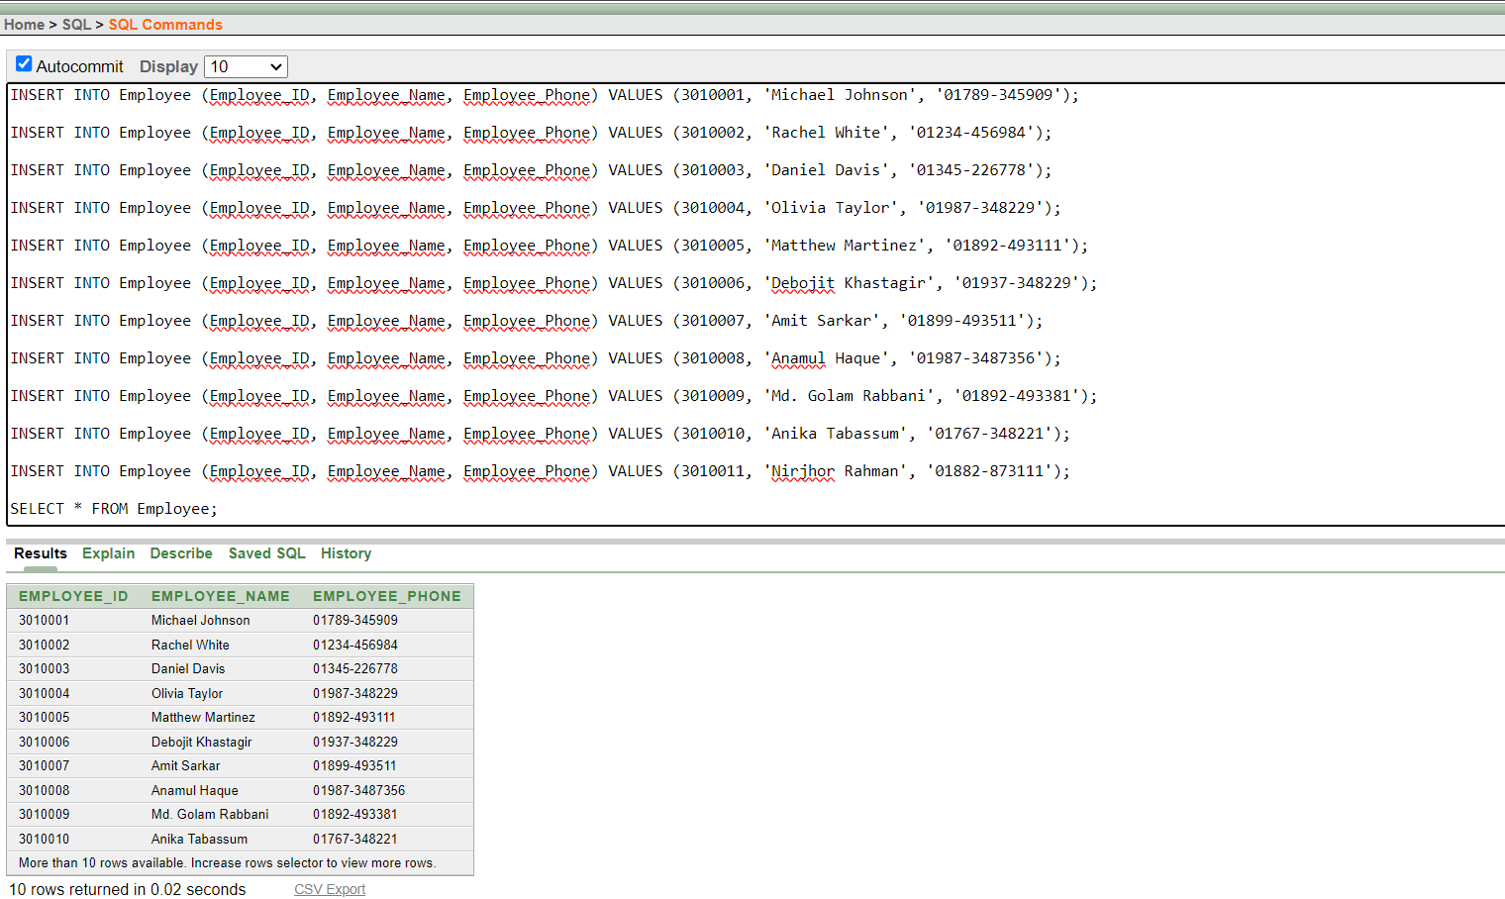

Information: Manages

INSERT INTO Manages (Branch_ID, Branch_Name, Employee_ID, Employee_Name, Employee_Phone, Manager_ID) VALUES (108, 'RAJSHAHI', 3010011, 'Nirjhor Rahman', '01882-873111', 101);

INSERT INTO Manages (Branch_ID, Branch_Name, Employee_ID, Employee_Name, Employee_Phone, Manager_ID) VALUES (109, 'MAGURA', 3010001, 'Michael Johnson', '01789-345909', 102);

INSERT INTO Manages (Branch_ID, Branch_Name, Employee_ID, Employee_Name, Employee_Phone, Manager_ID) VALUES (110, 'MAGURA', 3010002, 'Rachel White', '01234-456984', 103);

INSERT INTO Manages (Branch_ID, Branch_Name, Employee_ID, Employee_Name, Employee_Phone, Manager_ID) VALUES (101, 'RAJSHAHI', 3010002, 'Debojit khastagir', '01937-348229', 201);

INSERT INTO Manages (Branch_ID, Branch_Name, Employee_ID, Employee_Name, Employee_Phone, Manager_ID) VALUES (102, 'RAJSHAHI', 3010008, 'Anamul Haque', '01987-3487356', 201);

INSERT INTO Manages (Branch_ID, Branch_Name, Employee_ID, Employee_Name, Employee_Phone, Manager_ID) VALUES (103, 'RAJSHAHI', 3010009, 'Md. Golam Rabbani', '01892-493381', 201);

INSERT INTO Manages (Branch_ID, Branch_Name, Employee_ID, Employee_Name, Employee_Phone, Manager_ID) VALUES (105, 'RAJSHAHI', 3010011, 'Nirjhor Rahman', '01882-873111', 201);

Select * FROM Manages;

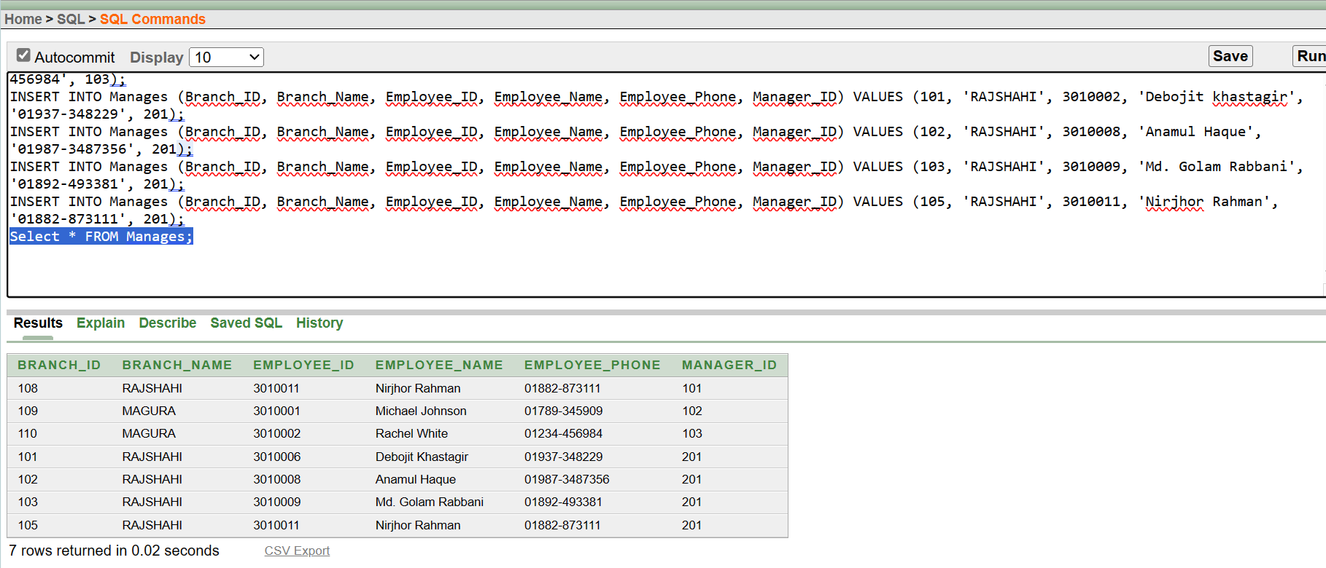

- Information: HAS

INSERT INTO Has (Branch_ID, Employee_ID)
VALUES (101, 3010001);

INSERT INTO Has (Branch_ID, Employee_ID)
VALUES (103, 3010003);

INSERT INTO Has (Branch_ID, Employee_ID)
VALUES (104, 3010004);

INSERT INTO Has (Branch_ID, Employee_ID)
VALUES (102, 3010005);

INSERT INTO Has (Branch_ID, Employee_ID)
VALUES (105, 3010007);

select * from Has;
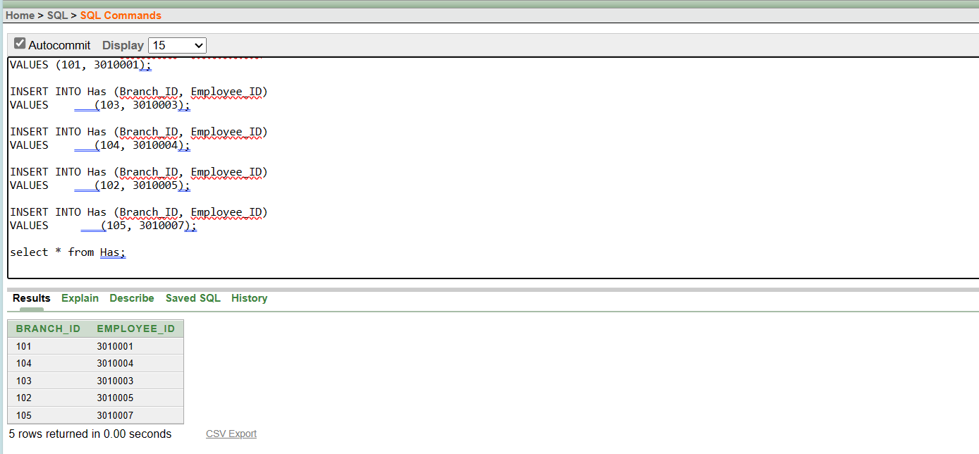

- Information: Customer

INSERT INTO Customer (Customer_ID, Product_Manufacture, Customer_Phone, Customer_Name)
VALUES (401, 'Garlic', '1112223333', 'Pial');

INSERT INTO Customer (Customer_ID, Product_Manufacture, Customer_Phone, Customer_Name)
VALUES (402, 'Onion', '4445556666', 'Dipu');

INSERT INTO Customer (Customer_ID, Product_Manufacture, Customer_Phone, Customer_Name)
VALUES (403, 'Corn', '7778889999', 'Rakib');

INSERT INTO Customer (Customer_ID, Product_Manufacture, Customer_Phone, Customer_Name)
VALUES (404, 'Pepper', '8889990000', 'Nimon');

INSERT INTO Customer (Customer_ID, Product_Manufacture, Customer_Phone, Customer_Name)
VALUES (405, 'Potatoes', '3334445555', 'Nishan');

select * from Customer;
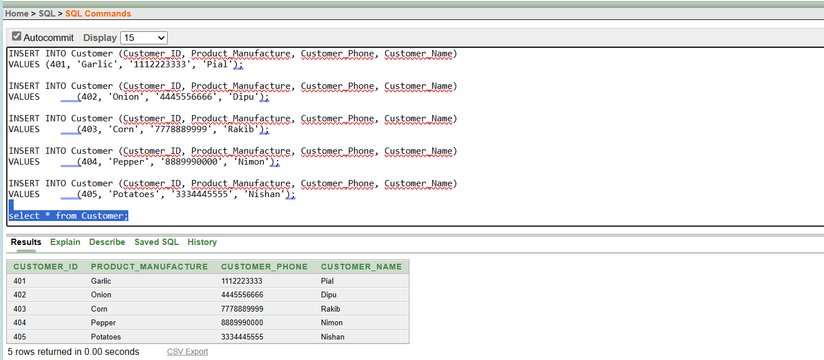

10. Information Product

INSERT INTO Product (Product_Code, Product_Price)
VALUES (501, 50);
INSERT INTO Product (Product_Code, Product_Price)
VALUES (502, 60);
INSERT INTO Product (Product_Code, Product_Price)
VALUES (503, 70);
INSERT INTO Product (Product_Code, Product_Price)
VALUES (504, 80);
INSERT INTO Product (Product_Code, Product_Price)
VALUES (505, 90);

select * from Product;

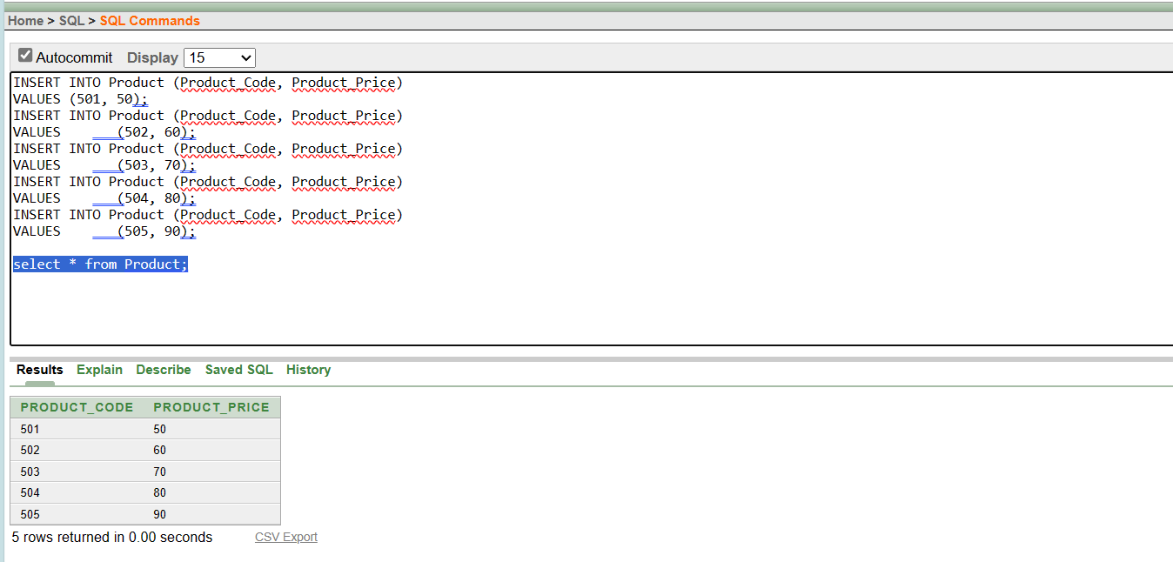

11. Information Buy

INSERT INTO Buy (Customer_ID, Product_Code)
VALUES (401, 501);
INSERT INTO Buy (Customer_ID, Product_Code)
VALUES (402, 502);
INSERT INTO Buy (Customer_ID, Product_Code)
VALUES (403, 503);
INSERT INTO Buy (Customer_ID, Product_Code)
VALUES (404, 504);
INSERT INTO Buy (Customer_ID, Product_Code)
VALUES (405, 505);
select * from Buy;
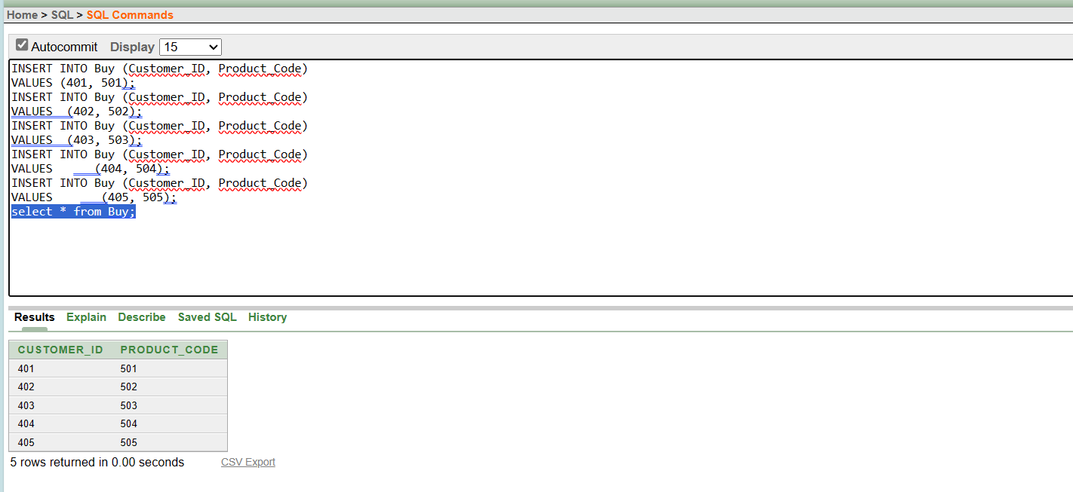

12. Information Sells

INSERT INTO Sells (Product_Code, Product_Price, Registration_Number)
VALUES (501, 50, 100190);
INSERT INTO Sells (Product_Code, Product_Price, Registration_Number)
VALUES (502, 60, 100190);
INSERT INTO Sells (Product_Code, Product_Price, Registration_Number)
VALUES (503, 70, 100190);
INSERT INTO Sells (Product_Code, Product_Price, Registration_Number)
VALUES (504, 80, 100190);
INSERT INTO Sells (Product_Code, Product_Price, Registration_Number)
VALUES (505, 90, 100190);

select * from Sells;

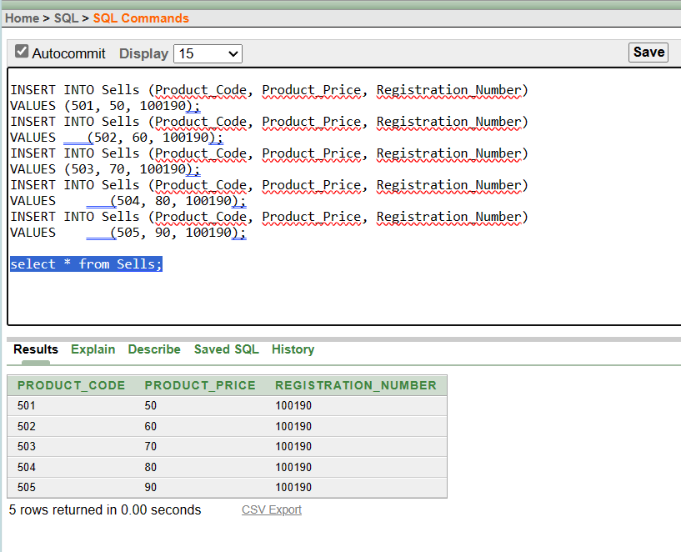

Query Test

1. Simple Query

- Show id, name, phone and registration number from Owns table.
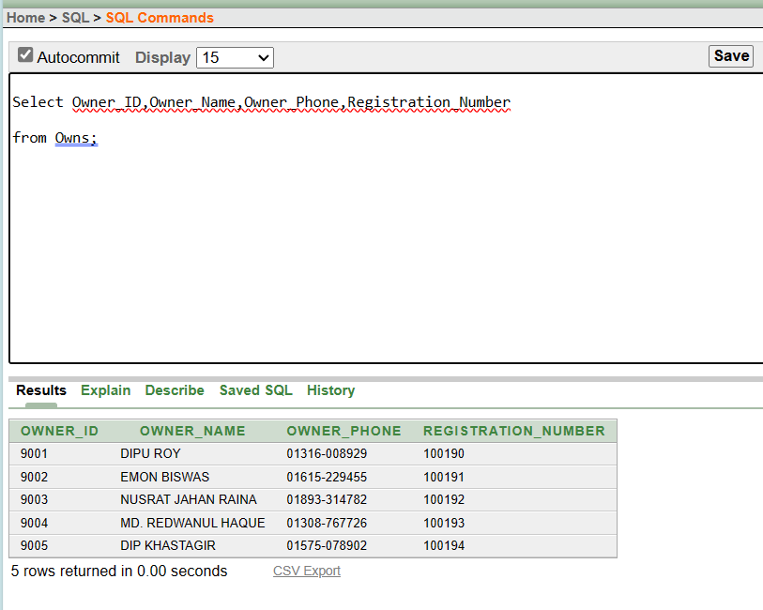

2.Single Row Function

- Show name, id, phone number in the Customer table where id is 403.

Ans:
Select Customer_Name,Customer_ID,Customer_Phone from Customer
where Customer_ID = 403;

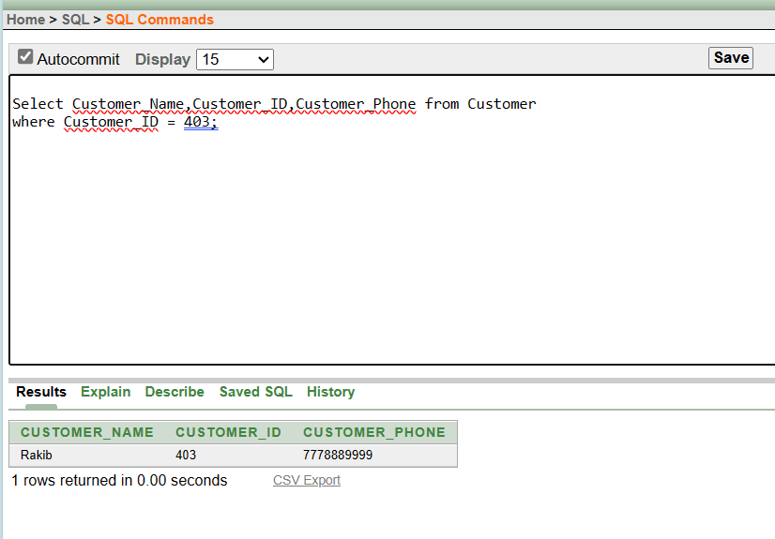
3. Multiple Row Function

- Count the number of names from the Employee table.

Ans: select count (Employee_Name) from Employee;

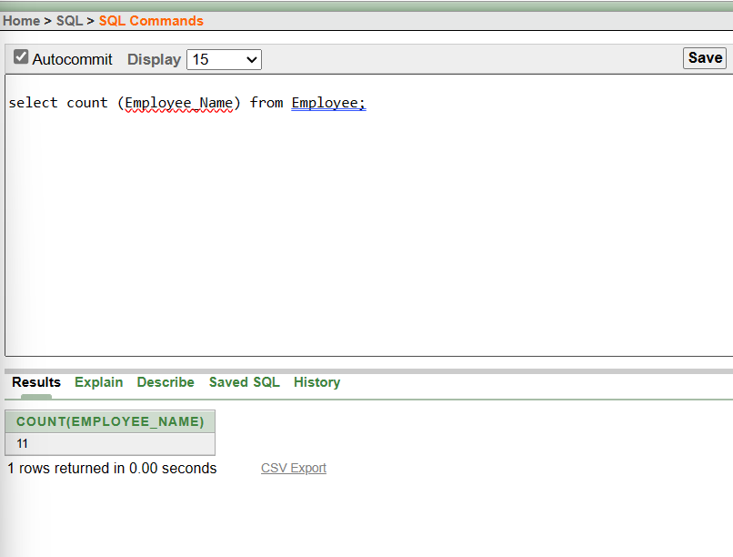

4. Single Row Subquery

- Show the name of the customer who purchased the product from a product table where the product code is 501
Ans:
SELECT Customer_Name
FROM Customer
WHERE Customer_ID = (SELECT Customer_ID FROM Buy WHERE
Product_code = 501;

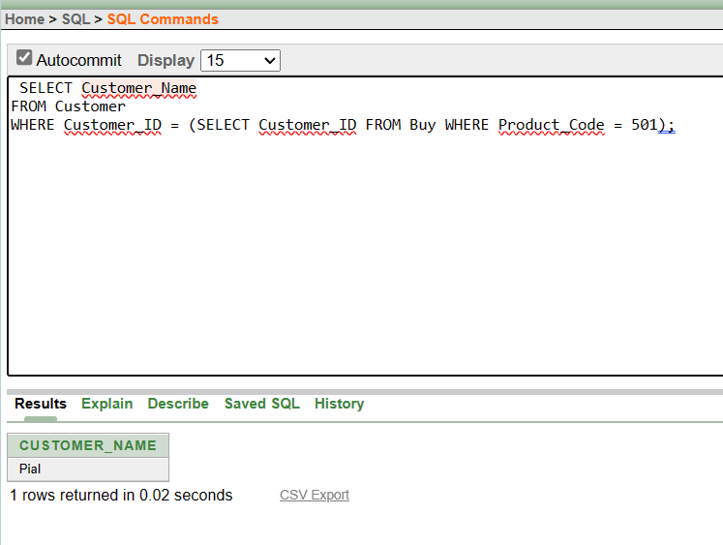
5. Multiple Row Subquery

- Show the customers that have made purchases and share the same customer ID as customer 405
Ans:
SELECT Customer_Name
FROM Customer
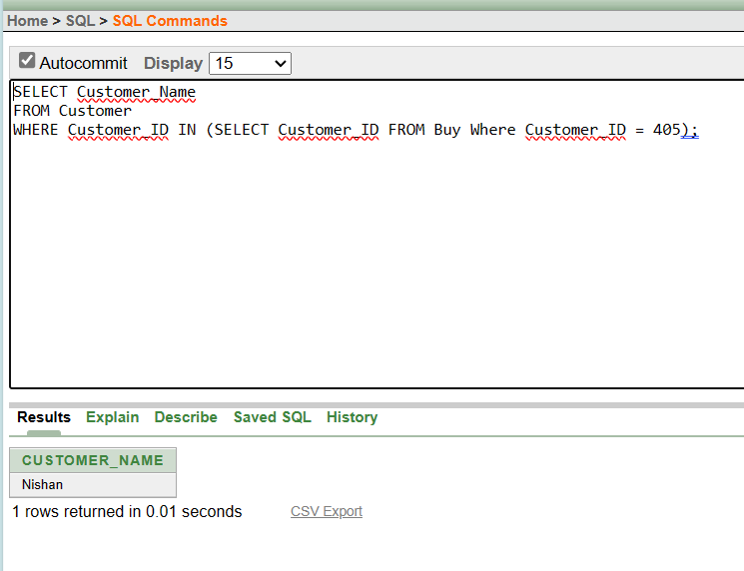
WHERE Customer_ID IN (SELECT Customer_ID FROM Buy Where Customer_ID = 405);

6. Self-Join

- Who are the managers and what are the names of the branches they are responsible for managing (Show the Self-Joining)?
Ans:
SELECT b.Branch_Name, m.Manager_Name
FROM Branch b
LEFT JOIN Manages mg ON b.Branch_ID = mg.Branch_ID
LEFT JOIN Manager m ON mg.Manager_ID = m.Manager_ID;

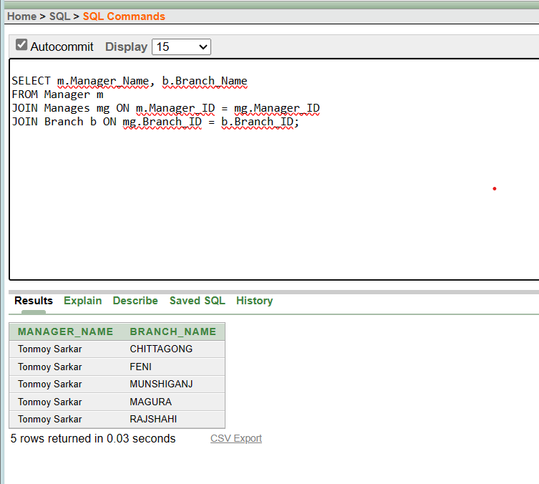

7. Outer Join

- Which branch, along with its manager's name and phone number, is listed in the database, considering that some branches might not have an assigned manager?
Ans:
SELECT a.BRANCH_NAME , b.EMPLOYEE_NAME , b.EMPLOYEE_PHONE
FROM Branch a , Manages b
where a.BRANCH_ID = b.MANAGER_ID(+)
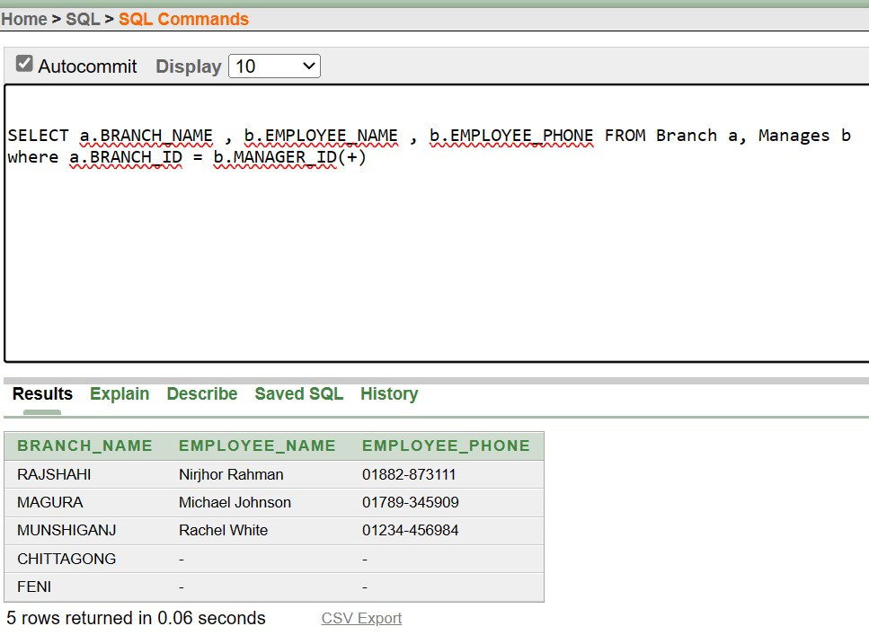

8. Simple view

- Create a simple view and show the branch name, employee ID, and employee name for the employees managing the branch with ID 102?
Ans:
create VIEW sview as select BRANCH_NAME , EMPLOYEE_ID ,
EMPLOYEE_NAME FROM MANAGES WHERE BRANCH_ID = 102;

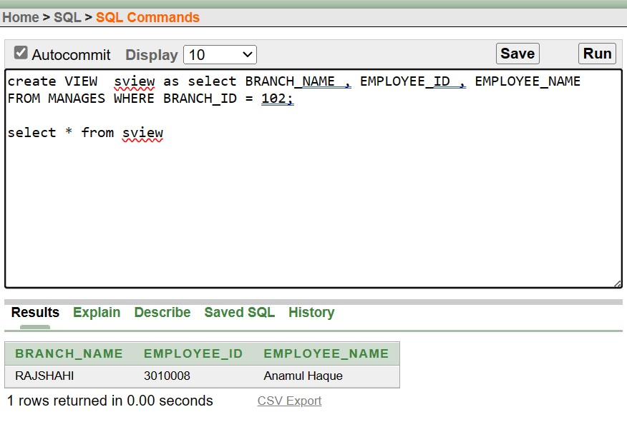
select * from Sview;

9. Complex View
- Create the complex view show the total sum of product prices for items whose product codes contain the digit 5 across all sales?
Ans:
create view cview (SUMPRICE) AS SELECT sum (PRODUCT_PRICE) FROM
Sells where PRODUCT_CODE like ‘%5%’

select * from cview;

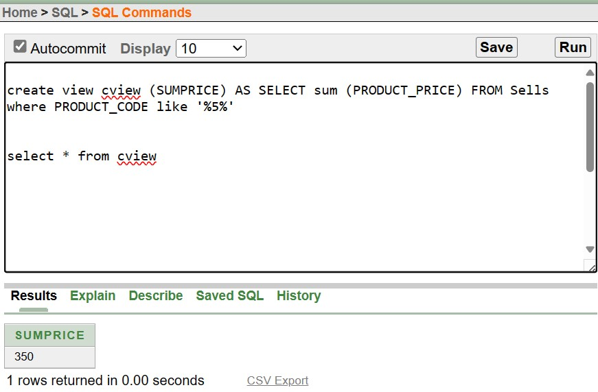

Conclusion:

The Agricultural Management System is a transformative tool designed to optimize farming operations through advanced technology integration. By leveraging features such as crop monitoring, inventory management, and market analysis, the system empowers farmers to make data-driven decisions, maximize productivity, and mitigate risks. Its real-time insights into crop health, soil conditions, and market trends enable proactive adjustments to cultivation strategies, ultimately contributing to food security, economic growth, and environmental sustainability. As technology continues to evolve, further enhancements to the system hold the promise of revolutionizing agriculture, driving innovation, and ensuring the resilience of farming practices in the face of emerging challenges.

