

DEPARTMENT OF INFORMATION & COMMUNICATION TECHNOLOGY
SESSION II 2022/2023

DFP40203
PYTHON PROGRAMMING

CONTINUOUS ASSESSMENT:
PROBLEM BASED TASK 1

NAME | MATRIX NUMBER
- MUHAMMAD REDZUAN BIN PARSIKUN | 03DDT21F1005
2. CHAIRIS A/L PUM | 03DDT21F1088

CLASS : DDT4A

LECTURER :
SITI NUR THAZLIAH BINTI MOHD THAZALI

- Introduction :

Our problem-based task is to create a program that allows admins to manage books in the library.

The program should allow admin to add new books to the library, search for books by title or author, display all books in the library, and delete books from the library. The program should store the library data in a text file for purpose admin to manage it.

- Coding :
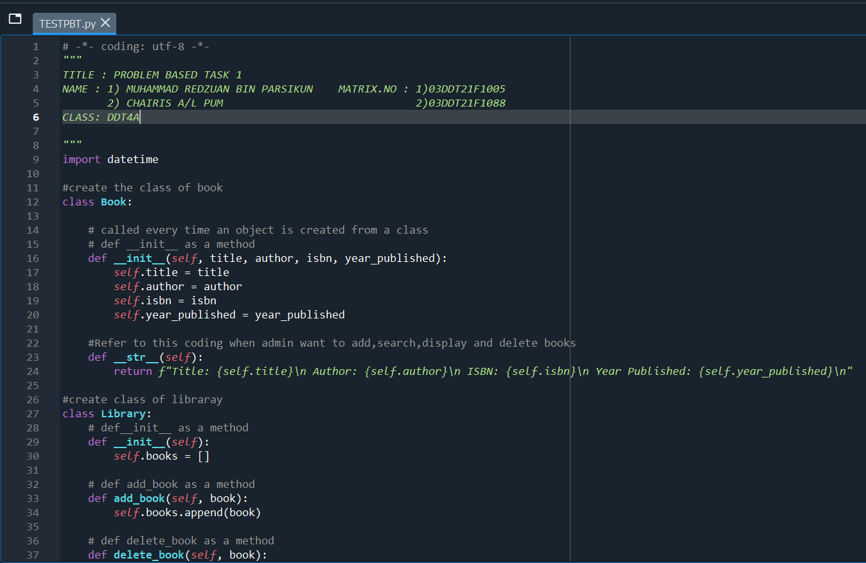
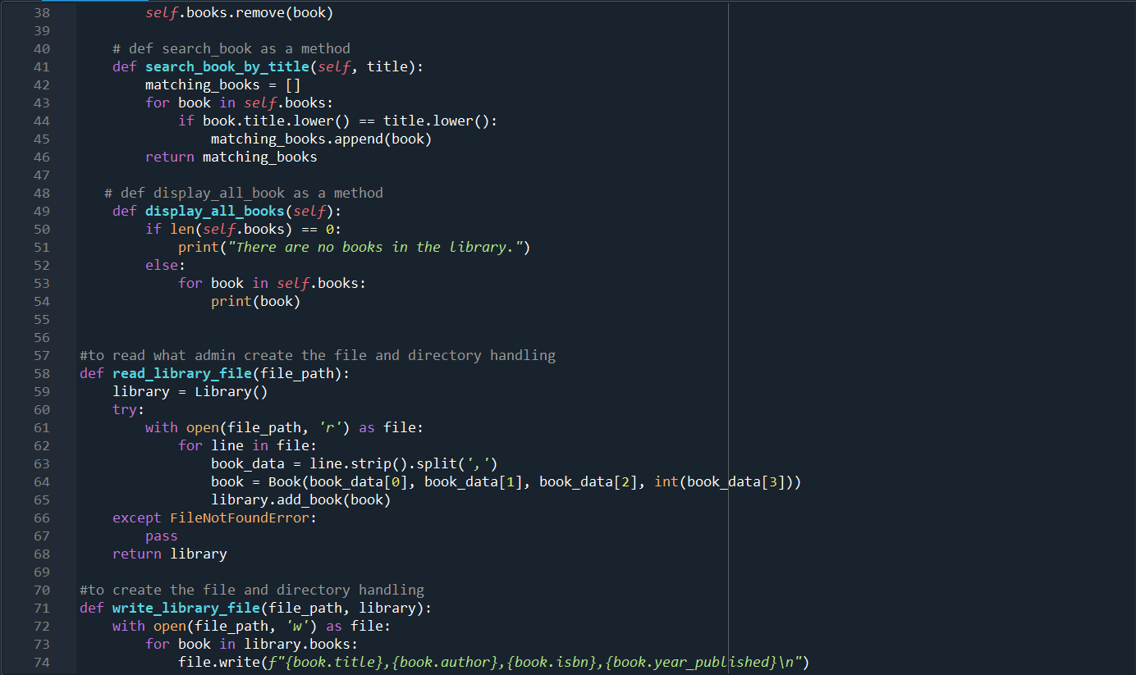
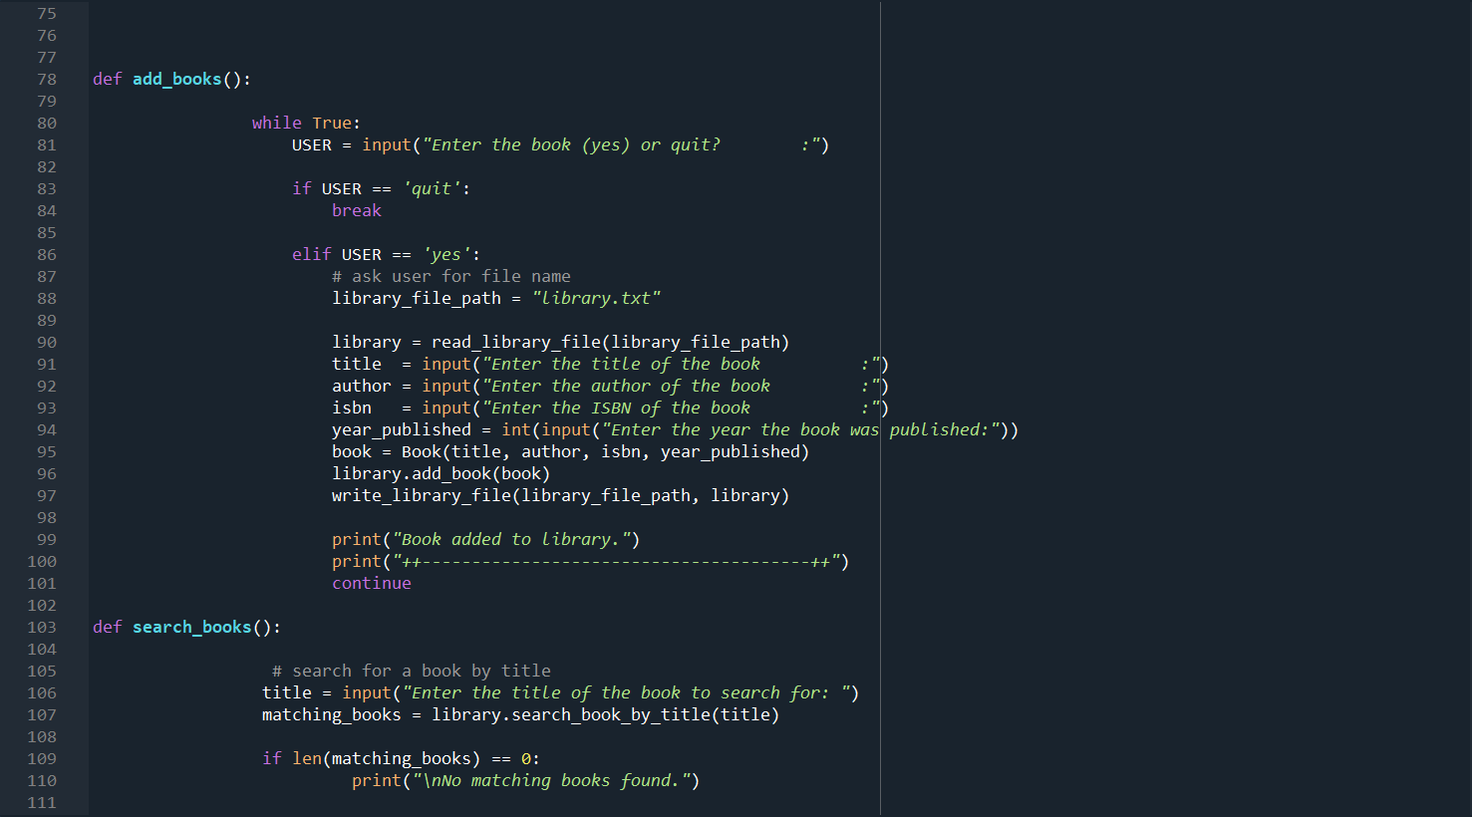
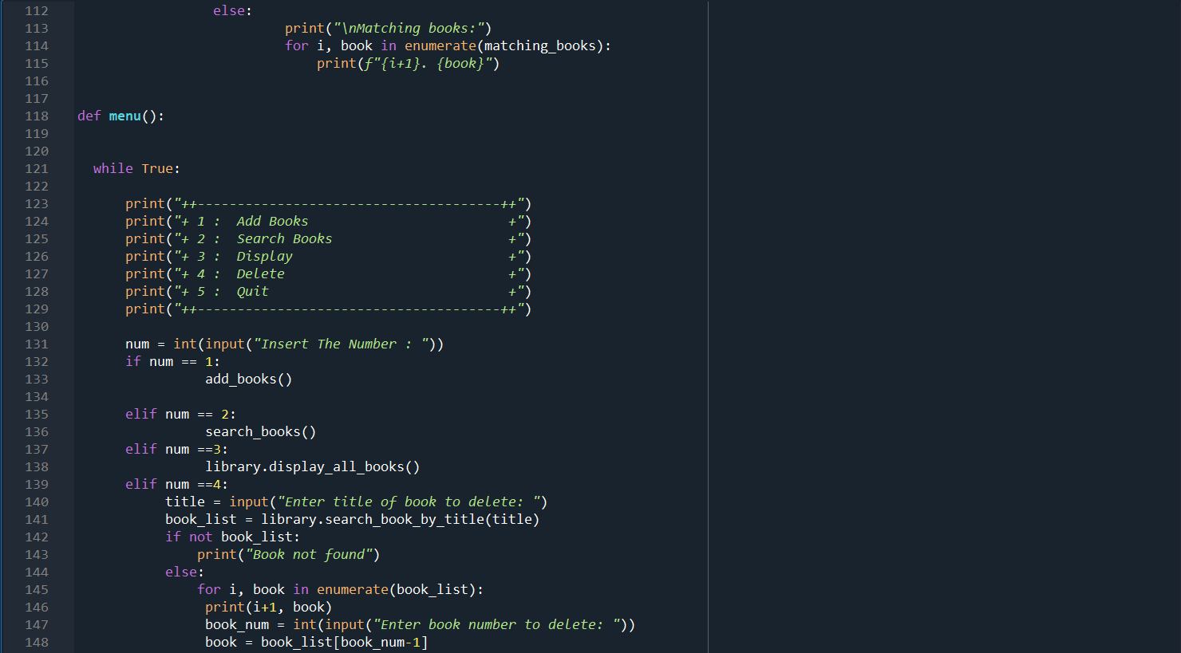
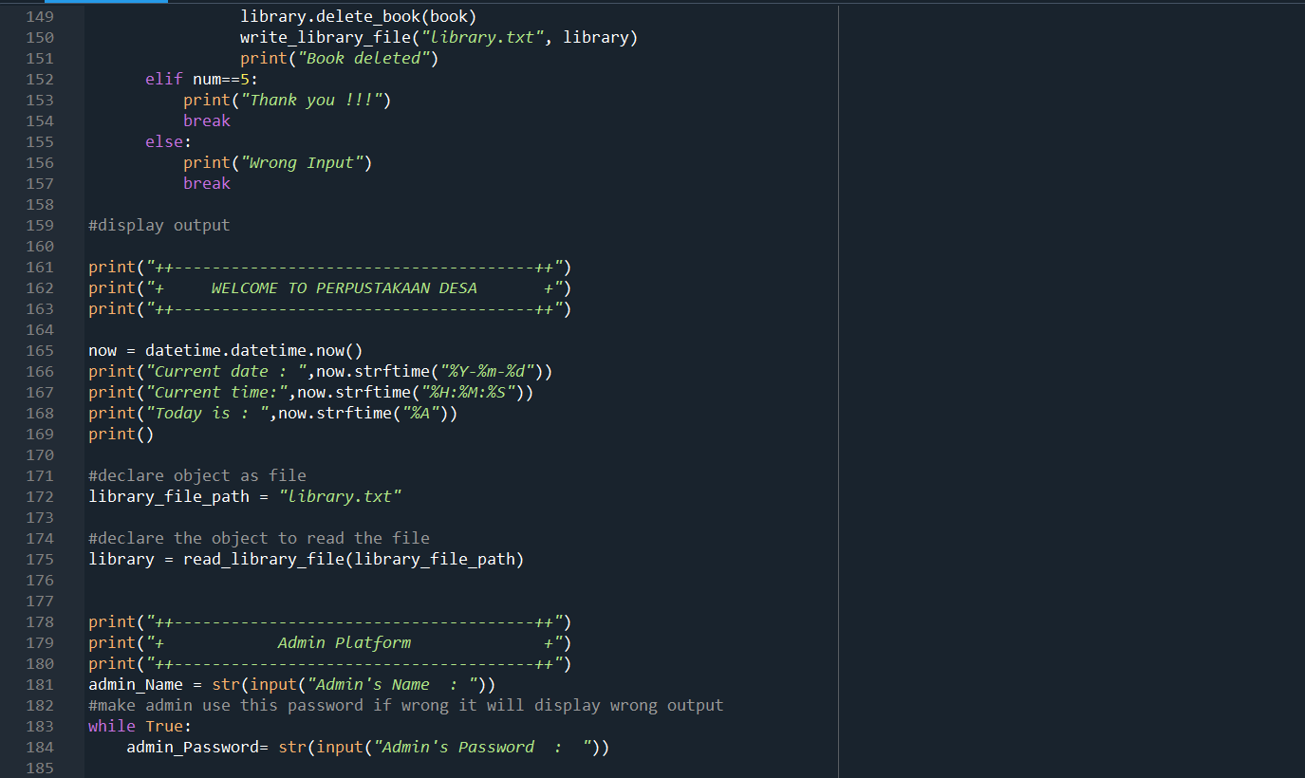
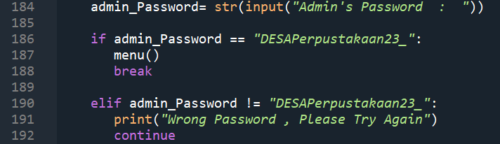

- Output :
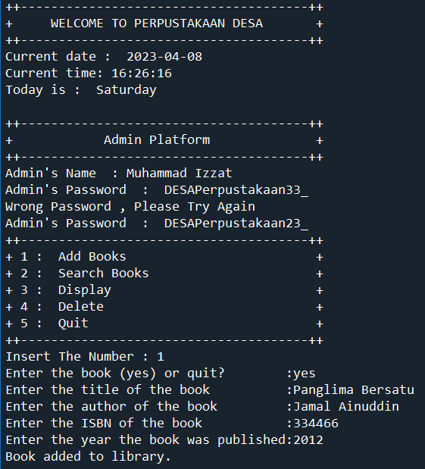
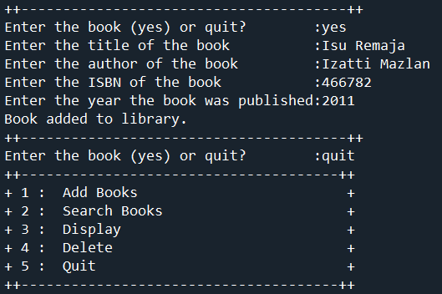
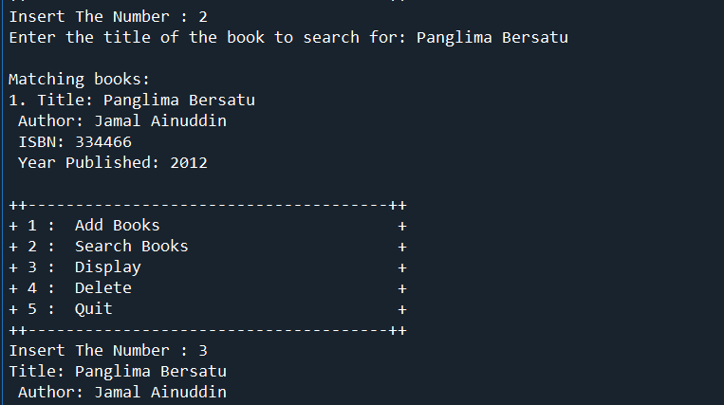
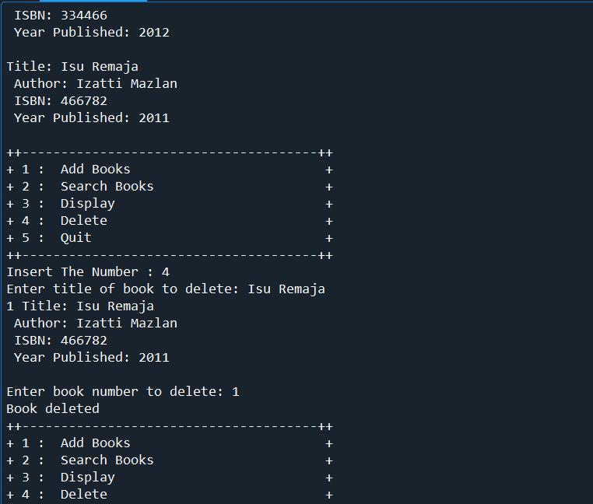
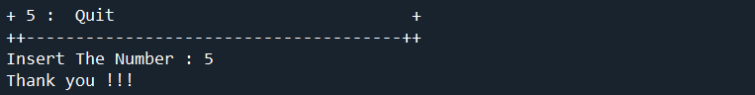

Library.txt
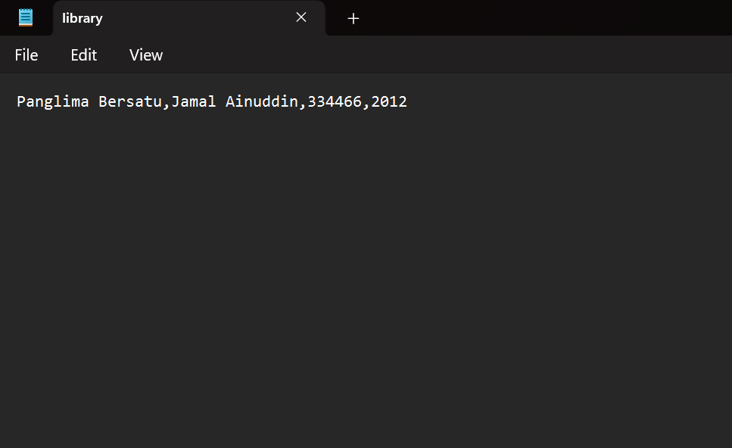

- Conclusion:

In conclusion, in this assignment, we can learn and understand file and directory handling with function and Object-Oreinted Programming (OOP) to develop project which is library management.

With file directory handling, the admin is able to use the system clearly because it can show the contents of the text files that the admin stores. In addition, admins are also able to search for book titles that they have saved. In addition, the admin can also show all the books in the file-directory. Finally, it can also delete the file-directory and make the data disappear.

