Lab Project Demo 1 Documentation
Alex Johnson – V00608901
Anjal Karki – V00919269
Jacob McKenzie – V00603453

Running Instructions:
The site can be accessed at https://reemcscree.github.io/DB_Lab/ or the source code can be extracted and each page opened in a browser.

HTML Design Screenshots:
Dashboard:
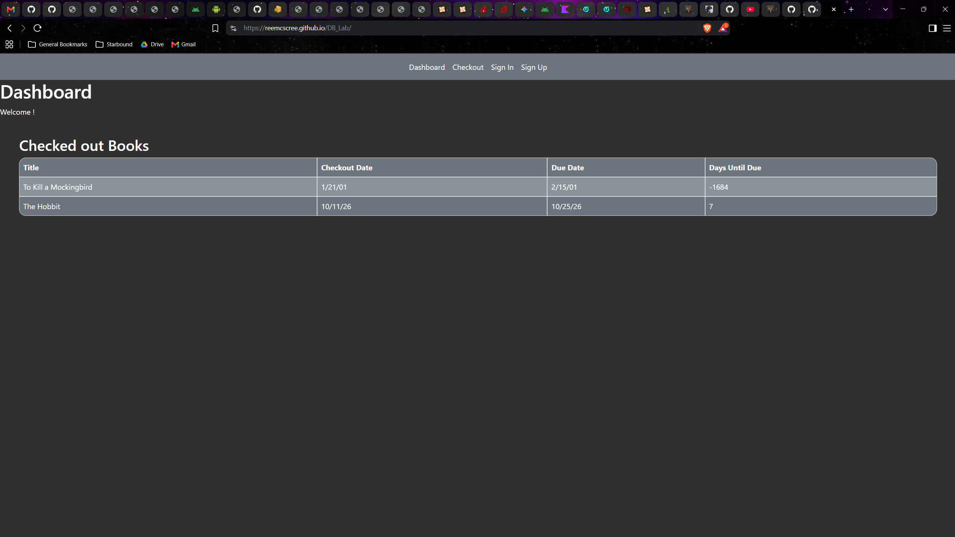
Checkout/search page:
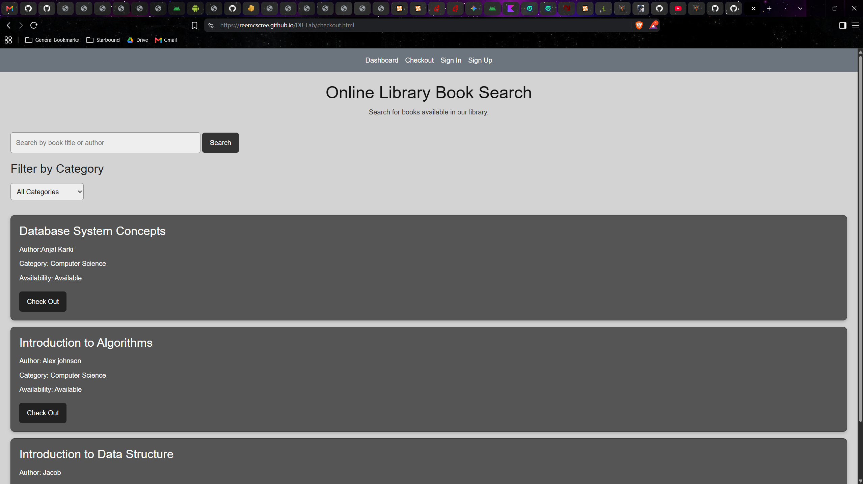
Sign in:
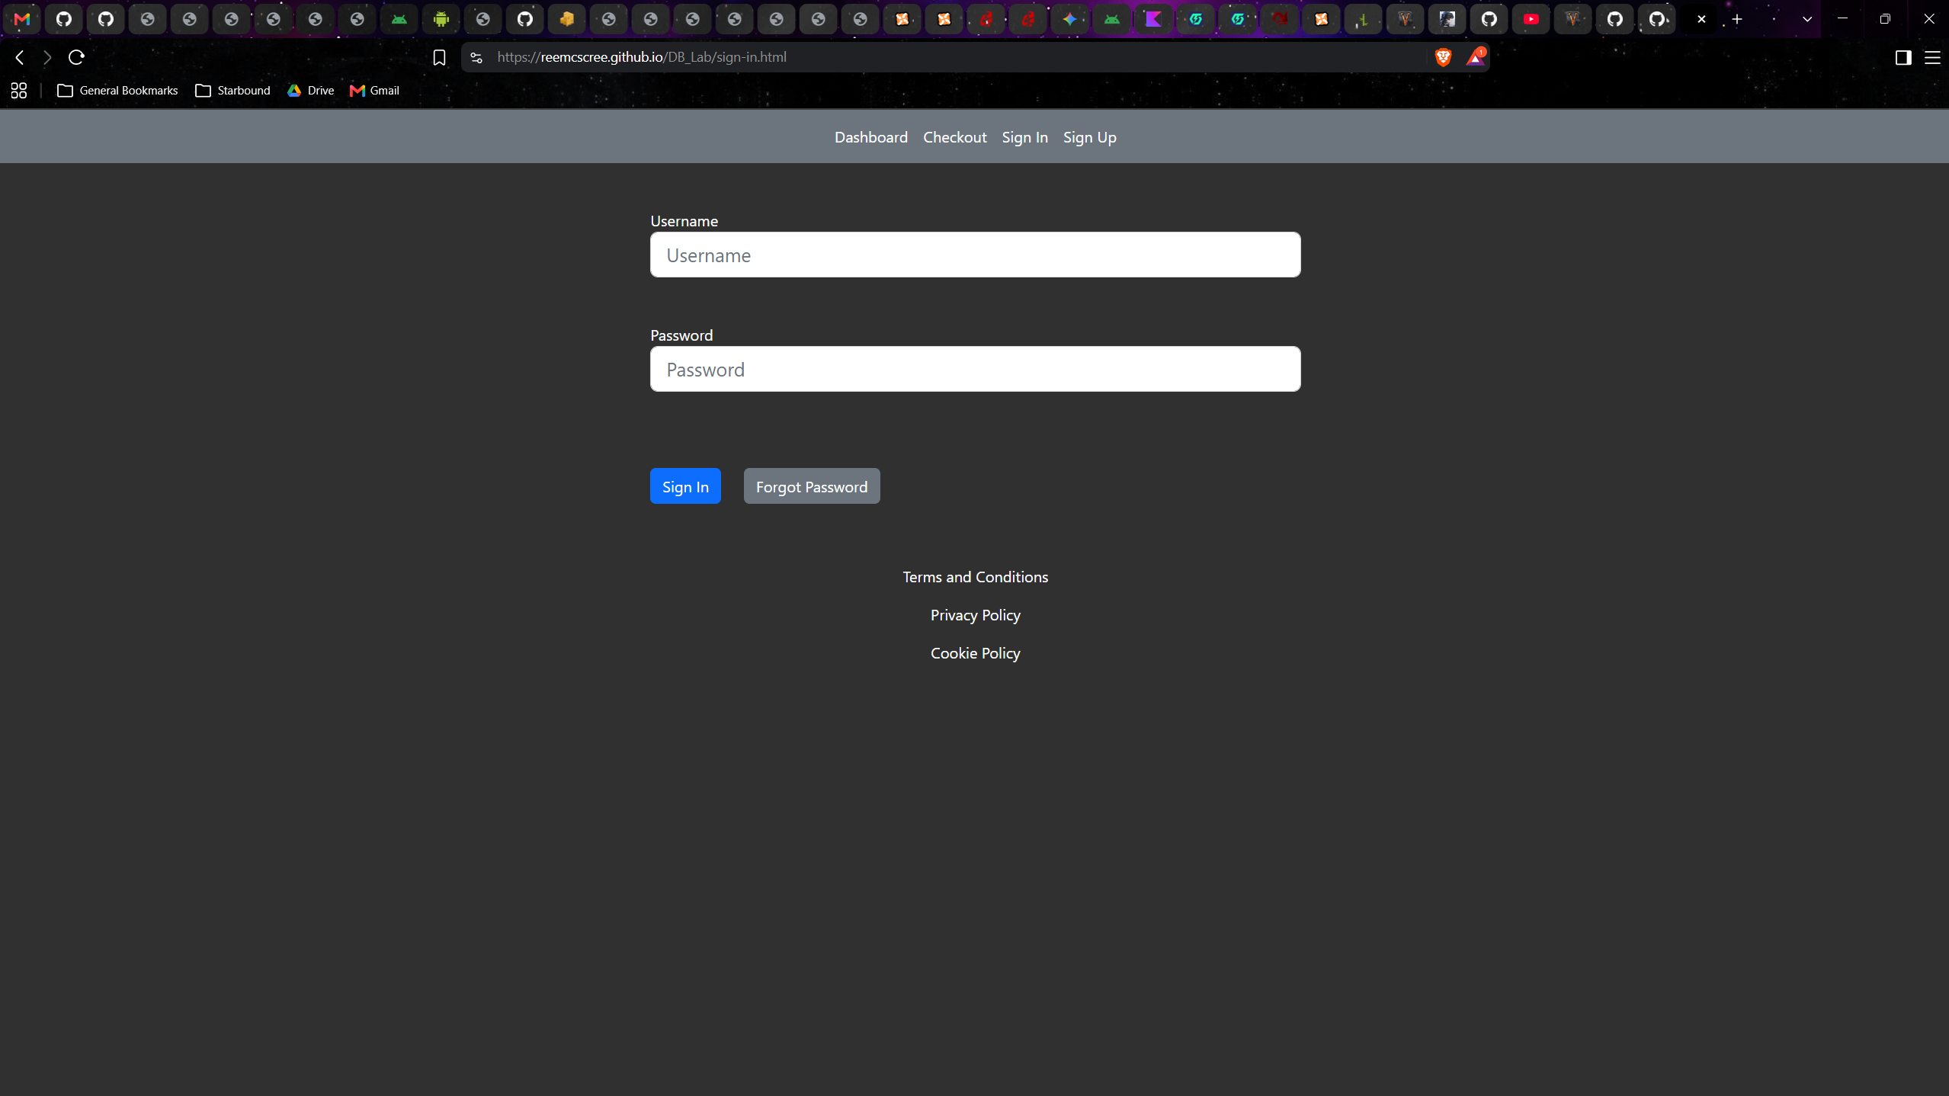
Sign up:
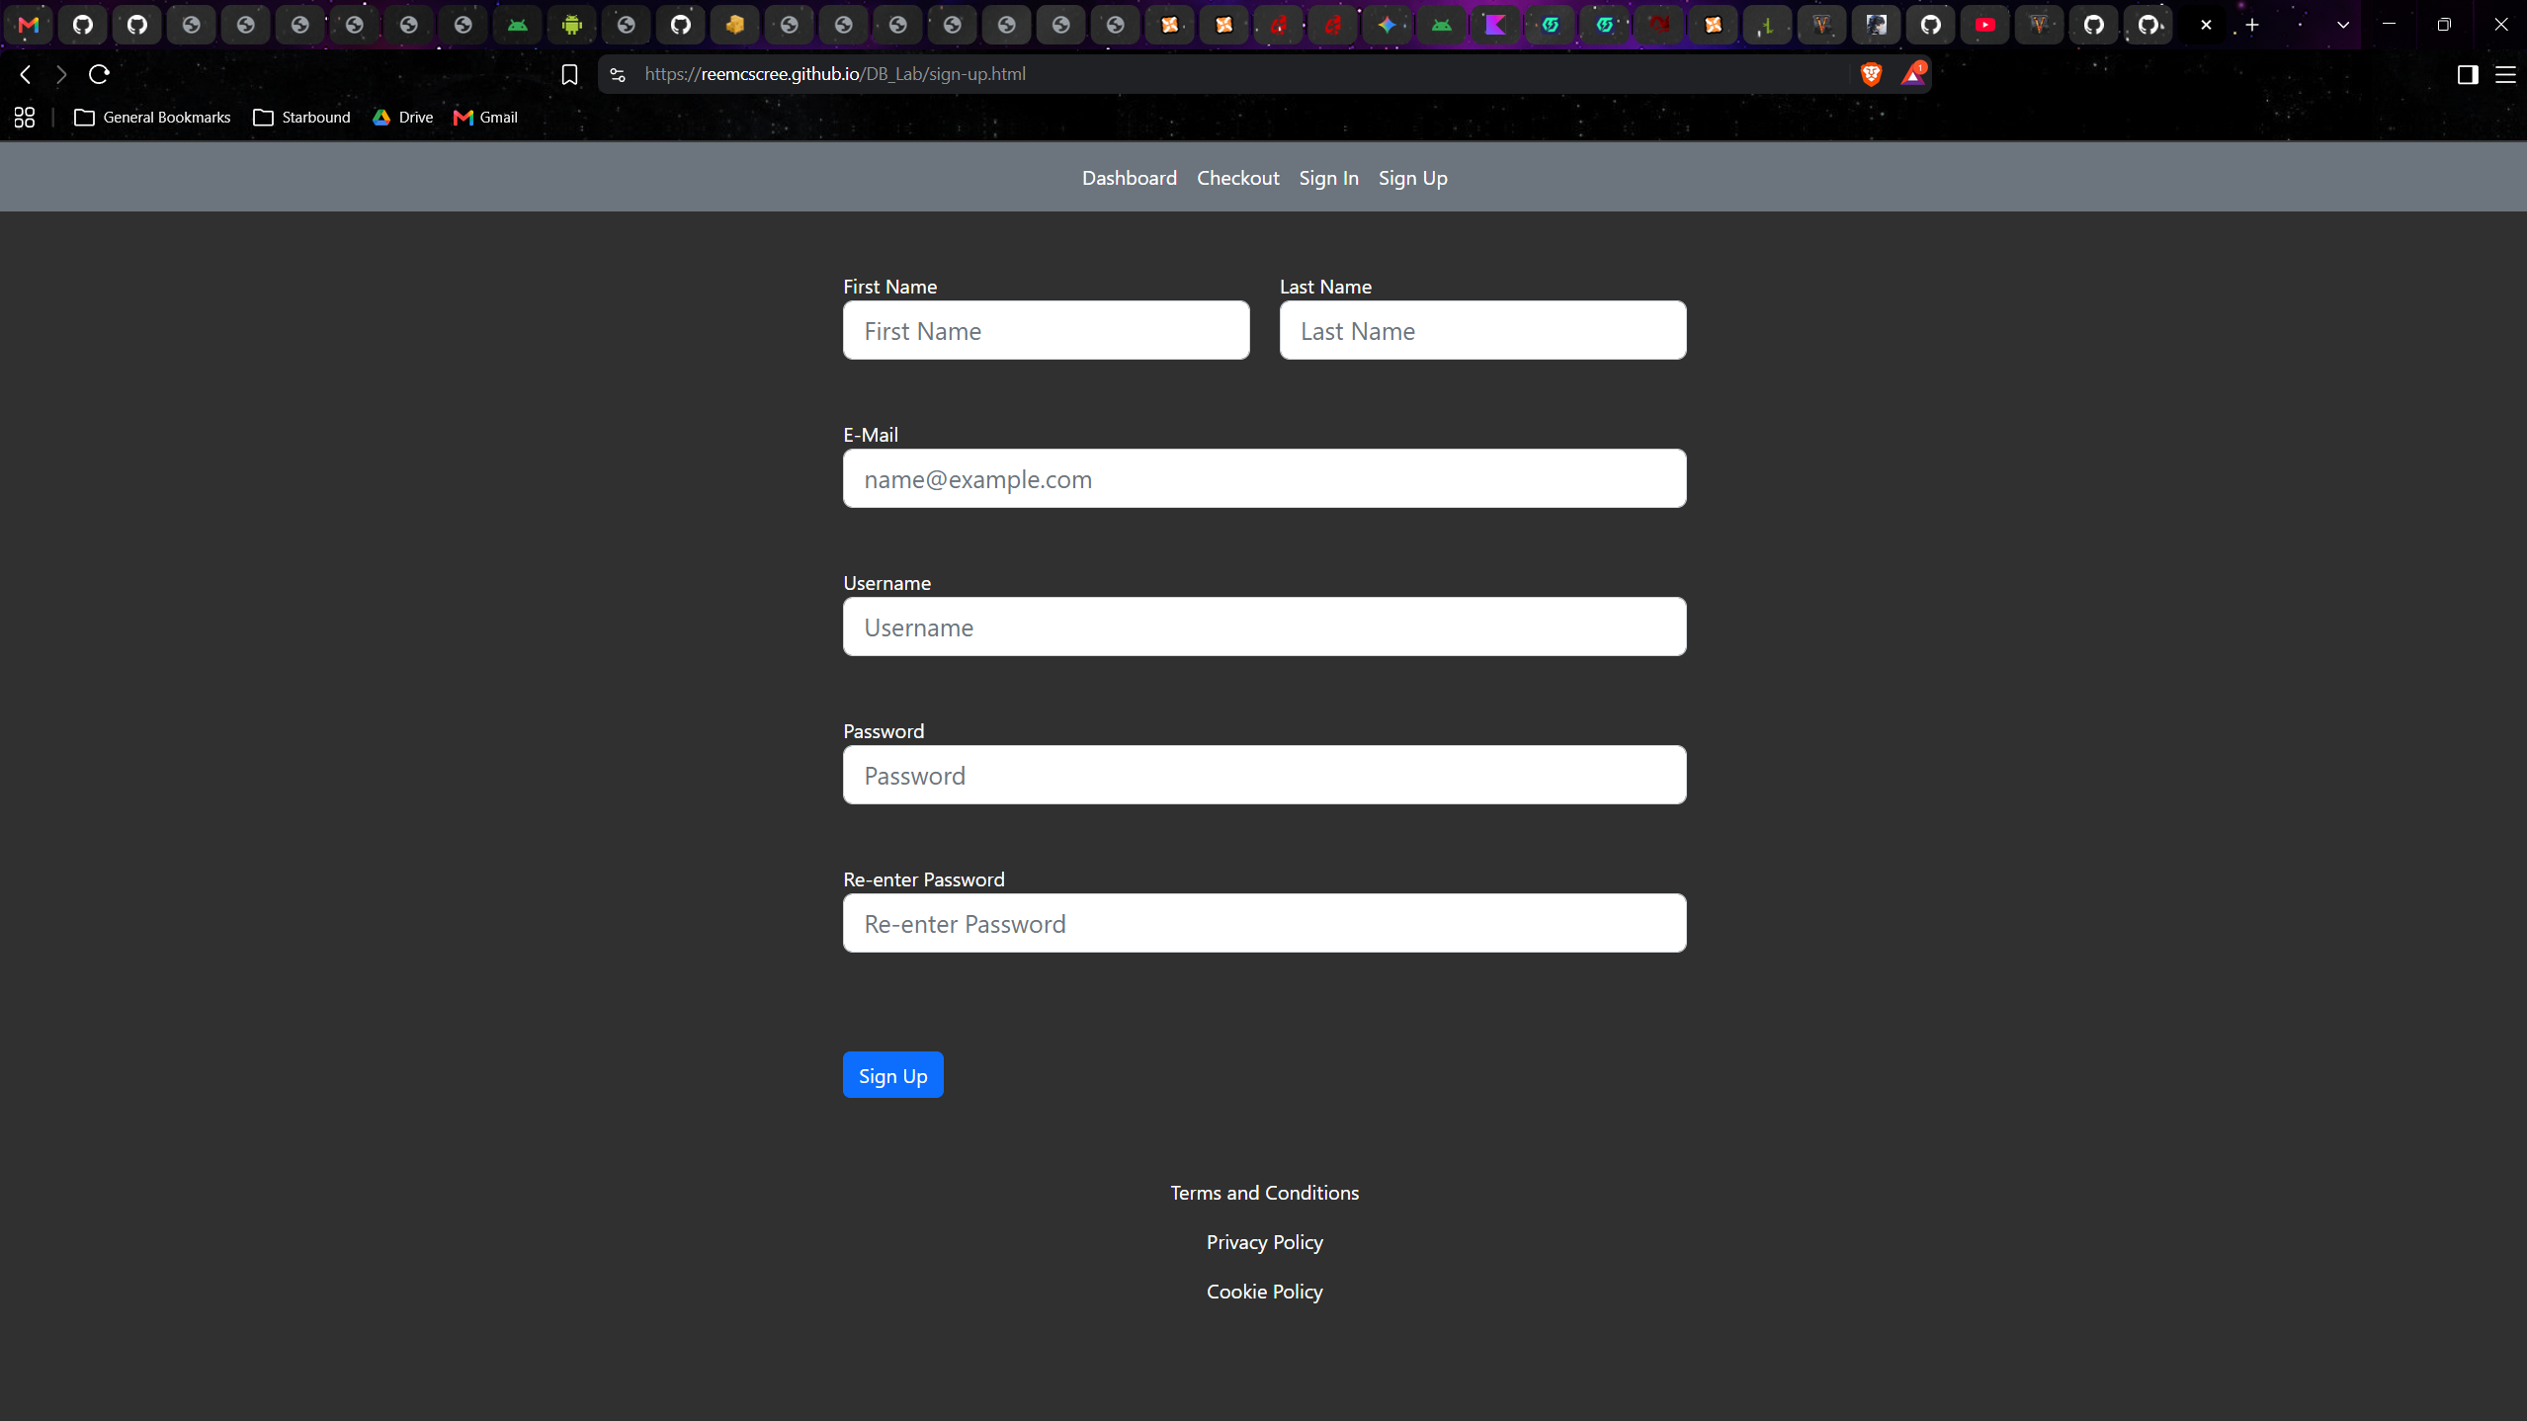

Database Materials:
We will use the XAMPP software stack for this project, so we will be using MariaDB. We will have 2 tables, users and books. Users will have a primary key of user_id, with other keys including username, password, first_name, last_name, and email. Books will have a primary key of book_id, and other keys will include title, author, category, and availability. There will also be a relationship between the two tables, called loans, with foreign keys user_id and book_id (these will constitute the primary key). Other keys will include checkout_date and due_date.

Project Details:
- Tools Used
  - HTML, CSS, Bootstrap, JavaScript used for front end design
  - Github used to manage project
  - Github Pages used to host demo
- Contributions
  - Alex Johnson
    - Dashboard page
    - PowerPoint presentation
    - Documentation
  - Anjal Karki
    - Checkout page
    - PowerPoint presentation
  - Jacob McKenzie
    - Sign In and Sign Up pages

