Forecasting of Martian Surface Temperature using REMS Data

Introduction and Background
Understanding temperature dynamics on Mars is essential for mission planning, rover operation, and long-term climate modeling. Surface temperature fluctuations directly influence energy consumption, instrument performance, and environmental interactions for exploration systems. The Rover Environmental Monitoring Station (REMS), part of NASA’s Mars Science Laboratory Curiosity rover mission, collects high-resolution atmospheric data including temperature, pressure, humidity, and wind measurements (New Mexico State University, 2024).
Martian surface temperature follows strong diurnal cycles driven by solar heating during the day and rapid radiative cooling at night due to the planet’s thin atmosphere (Viúdez-Moreiras et al., 2018). These predictable patterns make temperature data well-suited for time-series modeling. Machine learning techniques are particularly effective for capturing temporal dependencies and generating short-term forecasts from historical observations (Rani et al., 2021).
The objective of this project is to develop and evaluate machine learning models capable of predicting short-term Martian surface temperature using REMS data. The study investigates whether simple regression models can accurately capture the temporal behavior of Martian temperature variations.

Dataset Discussion
The dataset used in this project was obtained from the REMS instrument aboard the Curiosity rover. The selected dataset consisted of approximately 17,500 time-series samples, with surface temperature (measured in Kelvin) as the primary variable of interest. Additional features included relative humidity and engineered lag variables derived from previous temperature values.
Exploratory analysis of the dataset revealed a clear cyclical pattern corresponding to Martian day-night temperature changes. This periodic behavior confirmed that the dataset was appropriate for time-series modeling and short-term prediction.

Procedure
The dataset was imported and preprocessed using Python. Due to the raw format of the REMS data, preprocessing included handling missing values, selecting relevant numerical columns, and converting data into a structured format suitable for analysis. Visualization of the cleaned dataset confirmed the expected temporal patterns in temperature.
Feature engineering was then performed to construct lag variables from previous temperature values. These lag features provided the machine learning models with temporal context, allowing them to learn how temperature evolves over time.
The dataset was divided into training and testing sets using a time-series-safe split, where the first 80% of the data was used for training and the remaining 20% was used for testing. This approach preserved the chronological order of the data and prevented data leakage.
Three regression models were implemented using Python’s machine learning libraries:
- Linear Regression
- Decision Tree Regressor
- Random Forest Regressor
These models were trained using the engineered features, and predictions were generated for the test dataset using the trained models.

Validation Process
Model performance was evaluated using Mean Squared Error (MSE), Root Mean Squared Error (RMSE), and the coefficient of determination (R²). These metrics were computed by comparing predicted temperature values to the actual observed values in the test dataset.
In addition to numerical evaluation, residual analysis was performed to assess model accuracy and reliability. Residuals, defined as the difference between actual and predicted values, were analyzed over time and through their distribution. This process allowed for identification of any bias or systematic error in the model predictions.

Results and Discussion
The results of the machine learning models indicated that Linear Regression achieved the best performance, producing the lowest RMSE and an R² value very close to 1. This demonstrates that the model was highly effective at predicting short-term Martian surface temperature.
Figure 1 presents the model performance and residual analysis generated from the Python implementation. The left plot shows the comparison between actual and predicted temperature values, where the two curves closely overlap, indicating strong predictive accuracy. The middle plot shows residuals over time, which are small in magnitude and centered around zero, suggesting that the model does not exhibit systematic bias. The right plot displays the residual distribution, which is tightly concentrated near zero, confirming low variance and strong generalization performance.
The superior performance of the Linear Regression model can be explained by the smooth and continuous nature of Martian temperature changes. Since temperature evolves gradually over time, recent past values (captured through lag features) provide sufficient information for accurate prediction. In contrast, more complex models such as Decision Trees and Random Forests did not outperform the linear model, likely due to the relatively simple and predictable structure of the data.
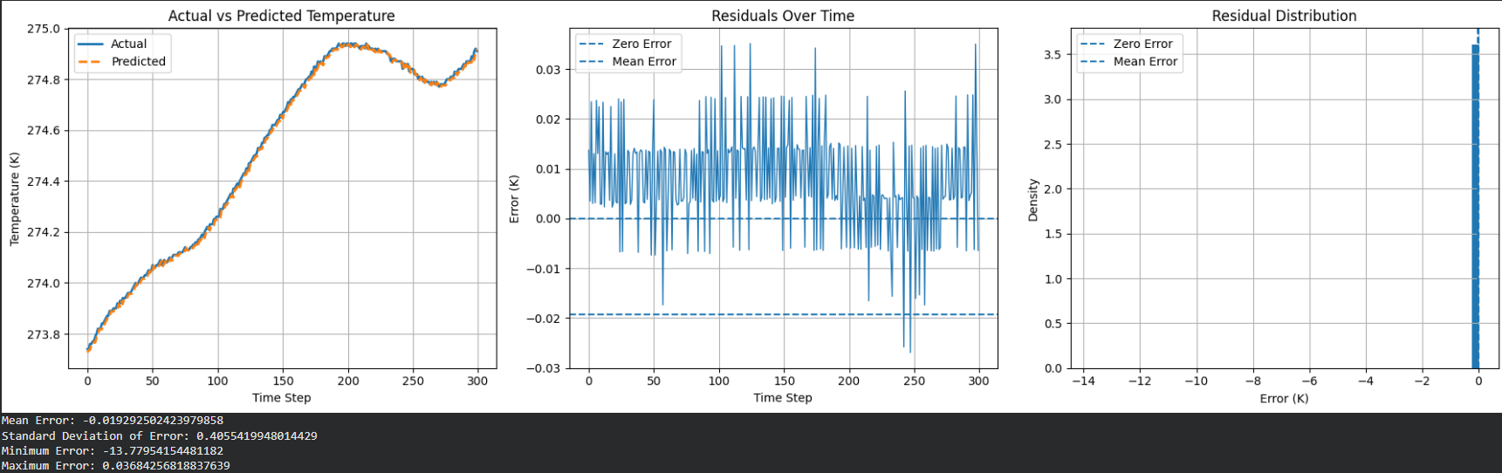
Figure 1. Model Performance and Residual Analysis
Conclusion
This project demonstrated that machine learning techniques can effectively predict short-term Martian surface temperature using REMS environmental data. By applying time-series feature engineering and regression modeling, the study showed that historical temperature measurements contain sufficient information for accurate forecasting.
Among the models tested, Linear Regression achieved the best performance, indicating that short-term Martian temperature variations follow predictable and smooth patterns driven by diurnal heating and cooling cycles. These results highlight the importance of selecting models that align with the underlying physical behavior of the system.
Future work could expand this analysis by incorporating additional environmental variables such as pressure and wind speed, or by exploring longer prediction horizons and more advanced time-series modeling techniques.

References
Mars Science Laboratory Rover Environmental Monitoring Station (REMS) Data Archive. New Mexico State University. Available from:
https://atmos.nmsu.edu/data_and_services/atmospheres_data/MARS/curiosity/rems.html
Rani M, et al. 2021. Mars weather data analysis using machine learning techniques. Earth Science Informatics. https://link.springer.com/article/10.1007/s12145-021-00643-0
Viúdez-Moreiras D, Gómez-Elvira J, Newman CE, et al. 2018. Gale surface wind characterization based on the Mars Science Laboratory REMS dataset. Icarus. https://www.sciencedirect.com/science/article/pii/S001910351730790X

