Concurrent Network Applications
Reece Clifford | c014617i
Multithreaded Networked Application
Reece Clifford – c014617i
2020
Contents
User Guide (300 Words) 2
Feature Overview – General Instructions 2
Connecting and Disconnecting 2
Setting a Nickname 2
Talking to other clients 2
Current Client List 2
Higher and Lower Game 2
Tanks Game 2
Design (700 Words) 2
Concurrency Network Diagram 2
Class Diagrams 3
Functionality of the Program 3
Core Program Concepts 3
Explanation of strategy (400 Words) 3
TCP vs UDP 3
Multi-Threading 3
Race Conditions 3
Critical Evaluation (600 Words) 3
Appendix 3
References 3

User Guide (300 Words)

Feature Overview – General Instructions
The Program itself is a C#.net based application, it will have a single server where multiple instances of clients can join the server and take part in a couple of different styles of games as well as just general discussion in the chat. The Program will utilise multithreading and different uses of transport protocols in order to optimise performance.

Connecting and Disconnecting
Once the client side application is open, the user is able to connect and disconnect via the appropriate buttons when they require to do so, the connect button is located on the top left of the form and the disconnect is on the top right, the user also has the option to disconnect from the application by just closing the form altogether if they wish to do so.

Setting a Nickname
Before connecting to the right of the connect button the user is able to add a nickname, the user must do this in order to connect, you will not be able to connect to the application unless you have chosen a nickname, once the nickname is chosen simply click connect, if you wish to change the nickname at any point you will have to disconnect and change the nickname and then reconnect after the new nickname is chosen.

Current Client List
Once connected the client will update itself on the right hand side there will be a list box, this will be constantly updating in the program and will also force itself to update whenever a new client connects, this will be used for the users to see which clients are currently connected to the server to talk to.

Talking to other clients
Once connected the user will see more on the form as a lot of it is hidden away until you connect, there will be an input box at the bottom of form, where the user can input the text, they want upon pressing submit this is then sent to the server which will then distribute the message to everyone currently connected.

Higher and Lower Game
The application has a text based game, if you type “!HL” the server will create a random number, users can then guess numbers until they get it right the server will be constantly responding with either higher or lower, its worth noting that chat still functions whilst this game is being played.

Tanks Game
The Graphical component game in this application is controlled by all users each user, will have a tank and a bomb which they can move freely around the screen, WASD are the keys which will be used for the tank and then the around keys are used to move the bomb around the scene.

Design (700 Words)
- Class Diagrams (Program Flow)
- Functionality of the Program
- Any Concepts (More detail to User guide)

Concurrency Network Diagram
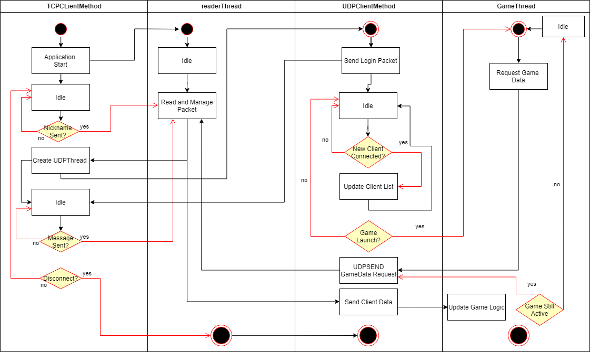
Figure 1.0 Concurrency Network Diagram

Class Diagrams
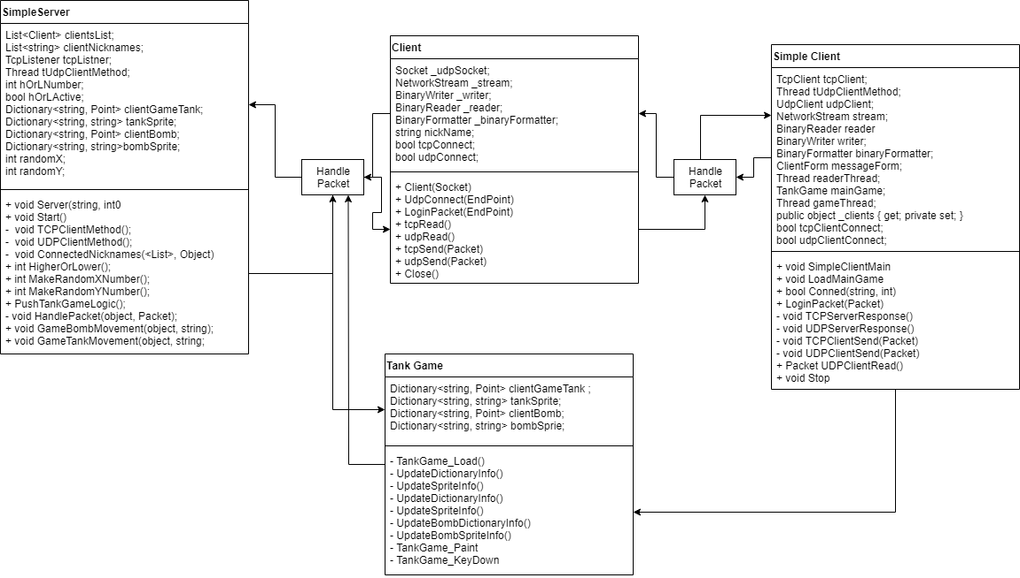
Figure 2.0 Program Flow / Class Diagram

Functionality of the Program

Core Program Concepts

Explanation of strategy (400 Words)

TCP vs UDP
TCP (Transmission Control Protocol) is one of the protocols used in my application, the TCP protocol

Multi-Threading

Race Conditions

Critical Evaluation (600 Words)
- Discuss main challenge firstly being TCP and UDP setup, how I overcame this
- Discuss Challenge of nickname, first implementation was poor
- Possibly talk about challenges with the game
  - Check Assignment Brief Reflection Methodologies

Appendix
Figure 1.0; This is a diagram showing the Threads in the application created through a concurrency network diagram.

References
Resource Type | Format | Bibliography Example | In Text Example

