# Database

## Requirements

* Questions have to be grouped by **subject**. Have **one** correct **answer** and **three** incorrect **answers**. A **difficulty** out of 5.
* Players need to have a username and a password.
* Scores need to be able to hold a player’s total correct answers score for that subject.

Questions (subject, question, answer, wrong_1, wrong_2, wrong_3, difficulty)

Players (ID, username, password)

Scores (player_ID, subject, score)

**Scores**

player_ID

subject

score

**Players**

ID

username

password

**Questions**

question

answer

wrong_1

wrong_2

wrong_3

difficulty

# Prototype design and user feedback

First of all, I designed a few prototypes for the game’s interfaces and logic. Using these prototype designs, I will interview users and gather feedback about positive aspects and any potential improvements.

### page2image1104913600Falling Character Game

* The character is constantly falling.
* Character gradually speeds up making the collection of correct answers harder.
* Player has to move the character and ‘collect’ the correct answers.
* Wrong answers cause the player to lose a life 🡪 ends the game.

### page2image1104913600Simple Q&A Interface

* Simple interface with the question and four answers.
* Wrong answers cause the player to lose a life 🡪 ends the game.

### Space Invader Style Game

* 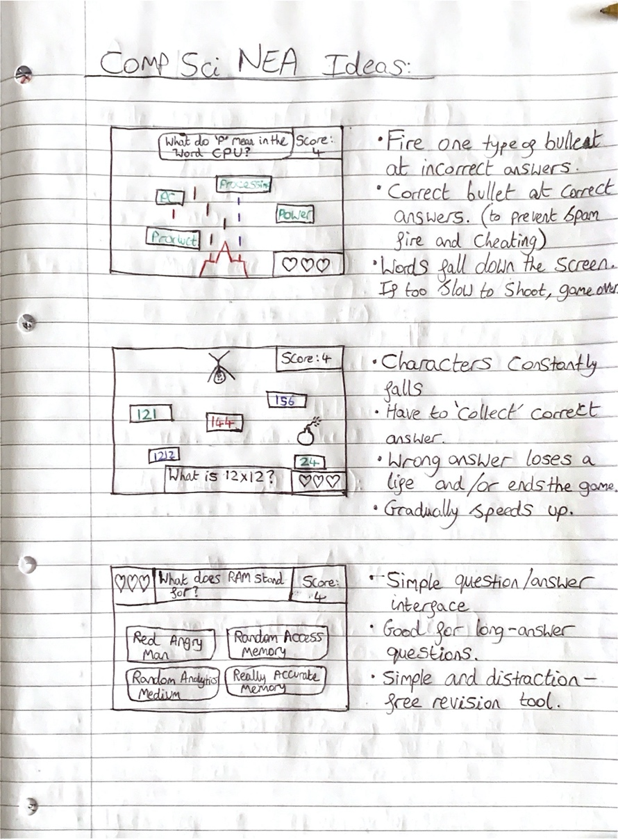Answers fall down towards you, gradually speeding up.
* Fire bullets at incorrect answers to prevent them from falling into the ‘safe zone’.
* Allow the correct answer to fall into the ‘safe zone’ to score your points.
* Wrong answers cause the player to lose a life 🡪 ends the game.

## User feedback

Following on from the initial prototype designs, I researched the market and gathered information about and from the target market.

### The target market:

* School children / teenagers
* KS3 and GCSE students
* Males and females
* Pupils and teachers primarily in the UK education system

### Prototype feedback from target market users:

|  |  |
| --- | --- |
| Positives / what works well? | Negatives / improvements |
| Simple to understand | I want to customer the falling character |
| Great way of encouraging learning |  |
|  |  |