A-level Computer Science NEA

[Document subtitle]

Reece Nicholls

2019

Table of Contents

Project Outline 2

Objectives 2

Database Structure 2

Requirements 2

Prototype design and user feedback 3

Falling Character Game 3

Simple Q&A Interface 3

Space Invader Style Game 3

User feedback 3

The target markets 3

Prototype feedback from target market users 4

# Project Outline

The program will be a quiz game that give multiple choice questions and answers related to their school studies. The game gives the user a score based on their answers to the questions, users will be able to see each other’s scores on a leader board local to their school network and they will be able to compete against each other to get the best score.

## Objectives

1. Main menu where users can login to their personal account using a username and password.
2. When logged in, users can select to either play the game or check out the leader board.
3. User can select which subject they wish to be quizzed on.
4. The game will select a set of questions, randomise their order and present the user with the question and potential answers.
   1. Question positioned at the top of the screen, along with their lives remain and their current score for that game.
   2. The character is falling through the sky; hence the answers appear to move up the screen.
   3. The user must navigate the character along the x-axis to avoid any incorrect answers and collect correct answers.
5. Each question will have one correct answer, three incorrect answers, the subject and a difficulty rating from one to five. *More detail in the Database Structure section.*
   1. The scoring will be based on the question difficulty. For example, a question of difficulty three means the users score will have three added on to it.
6. The database will be stored on a server on the school’s LAN.
   1. This enables teachers to add questions specific to the curriculum taught at that school.
   2. Database will be run on a Postgres server.

# Database Structure

## Requirements

*Note: refer to the Project Outline objectives first.*

* Questions have to be grouped by **subject**. Have **one** correct **answer** and **three** incorrect **answers**. A **difficulty** rating out from 1 to 5.
* Players need to have a **username** and a **password**.
* Scores need to be able to hold a player’s **total correct answers** score for that **subject**, and their highest score per **single session**.

Questions (subject, question, answer, wrong_1, wrong_2, wrong_3, difficulty)

Players (ID, username, password)

Scores (player_ID, subject, score)

**Scores**

player_ID

subject

score

**Players**

ID

username

password

**Questions**

question

answer

wrong_1

wrong_2

wrong_3

difficulty

# Prototype design and user feedback

First of all, I designed a few prototypes for the game’s interfaces and logic. Using these prototype designs, I will interview users to gather feedback about positive aspects and any potential improvements and then use this research as the foundations to my project.

### page2image1104913600Falling Character Game

* The character is constantly falling.
* Character gradually speeds up making the collection of correct answers harder.
* Player has to move the character and ‘collect’ the correct answers.
* Wrong answers cause the player to lose a life 🡪 ends the game.

### page2image1104913600Simple Q&A Interface

* Simple interface with the question and four answers.
* Wrong answers cause the player to lose a life 🡪 ends the game.

### Space Invader Style Game

* 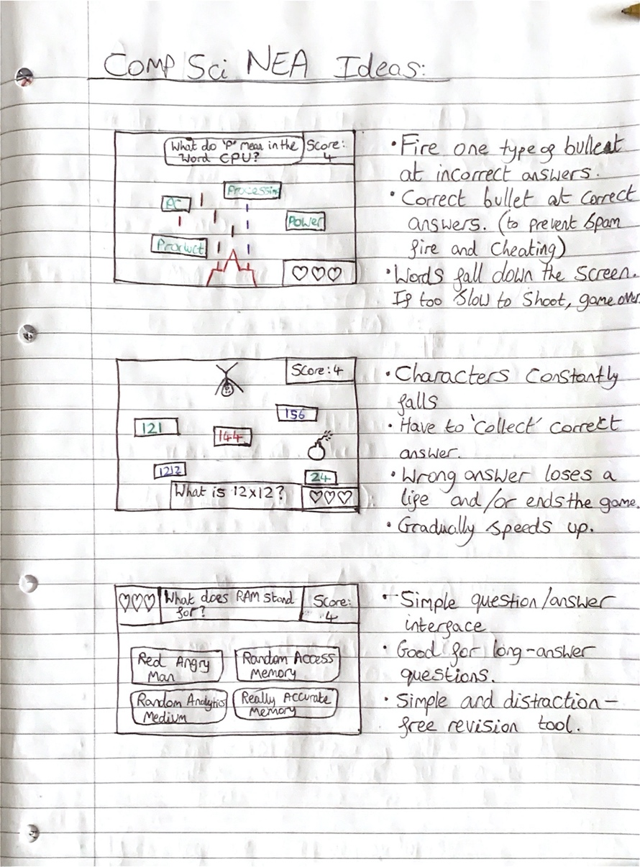Answers fall down towards you, gradually speeding up.
* Fire bullets at incorrect answers to prevent them from falling into the ‘safe zone’.
* Allow the correct answer to fall into the ‘safe zone’ to score your points.
* Wrong answers cause the player to lose a life 🡪 ends the game.

## User feedback

Following on from the initial prototype designs, I researched the market and gathered information about and from the target market.

### The target markets

* School children / teenagers
* KS3 and GCSE students
* Males and females
* Pupils and teachers primarily in the UK education system

### Prototype feedback from target market users

|  |  |
| --- | --- |
| Positives / what works well? | Negatives / improvements |
| Simple to understand games | I want to customise the falling character |
| Great way of encouraging me to learn/revise |  |
|  |  |