Splunk Enterprise Certified Administrator Study Guide

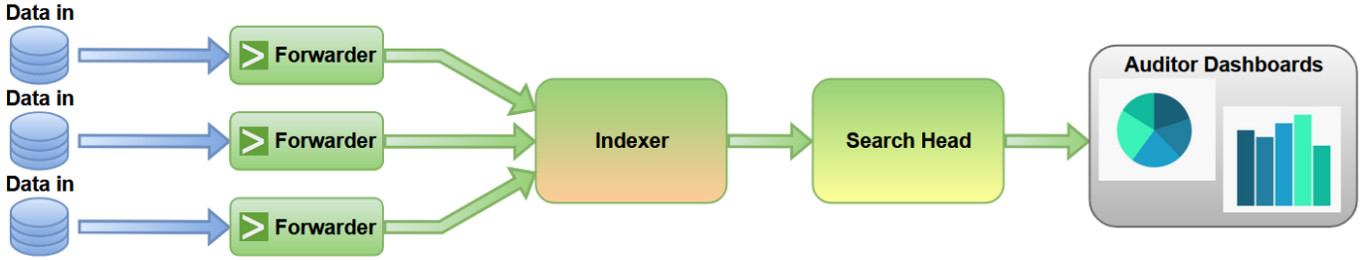

1.0 Splunk Admin Basics (5%)

1.1 Core Splunk Components and Their Roles
Splunk is comprised of several core components, each designed for specific functions in data collection, parsing, indexing, searching, and management.
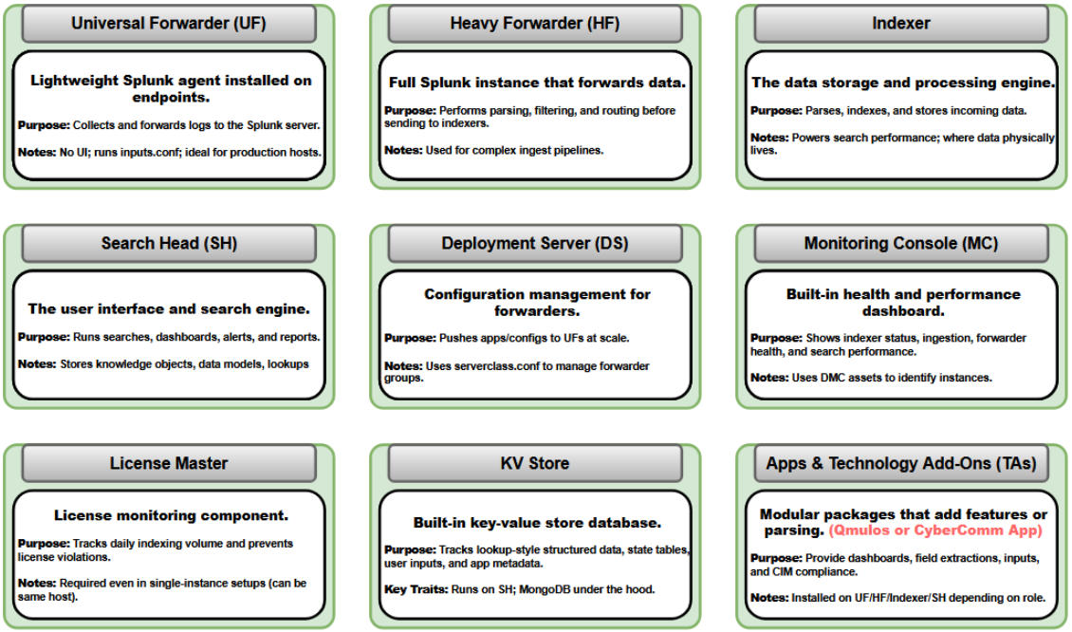
Indexer:
- Receives data from forwarders or other inputs.
- Parses and indexes data (unless parsing is performed on an intermediate heavy forwarder tier).
- Stores events in indexes (buckets).
- Executes the distributed portion of searches against local indexed data and returns results to the Search Head.
- Manages bucket lifecycle (hot, warm, cold, frozen) and (if clustered) replicates buckets across peers.
- Exam Tip: Indexers = data storage + distributed search execution; Search Heads orchestrate/merge results.

Search Head:
- Provides the user interface (Splunk Web), dispatches searches, and distributes searches to indexers (search peers).
- Aggregates/merges results returned by indexers.
- Hosts most knowledge objects (fields, tags, event types/eventtypes, lookups, saved searches, dashboards).
- Exam Tip: Search Head = brain/interface + search orchestration, not storage.

Universal Forwarder (UF):
- Lightweight data collection and forwarding agent with minimal resource usage.
- Forwards data to Splunk receivers (typically indexers or heavy forwarders).
- Does not index or provide search capabilities.
- Does not perform the full parsing pipeline typically associated with index-time props/transforms processing.
- Commonly used for local file/directory monitoring and Windows event log collection (for example, via the Splunk Add-on for Microsoft Windows).
- Exam Tip: UF = collect → forward → done.

Heavy Forwarder (HF):
- Full Splunk Enterprise instance used as a forwarding/intermediate tier.
- Can host receiver-style inputs and can perform parsing, filtering, routing, and transformations before sending data onward.
- Used when data modification/filtering is required before indexing, for certain network/agentless input scenarios, or for protocol/collection-tier needs.
- Exam Tip: HF = preprocessing/parsing + routing tier (when UF is insufficient).

Deployment Server:
- Centralized forwarder configuration management (Universal and Heavy Forwarders).
- Hosts deployment apps and server classes; forwarders check in and pull configurations.
- Commonly distributes forwarder-side configuration like inputs.conf, outputs.conf, and forwarder-side apps.
- Exam Tip: Deployment Server = forwarder configuration manager (pull model, not push).

License Manager:
- Controls licensing, tracks ingest usage, and issues warnings/violations based on license rules.
- In distributed environments: one license manager (master) with multiple license peers reporting usage.

Indexer Cluster Manager (formerly “Cluster Master”):
- Manages indexer clusters: bucket replication, peer health, and rebalancing.

Deployer (for Search Head Clusters):
- Pushes apps/configs to Search Head Cluster members.

Monitoring Console (MC):
- Central monitoring dashboards for indexer performance, search activity, forwarder health, and license usage.
- Exam Tip: MC monitors overall health.
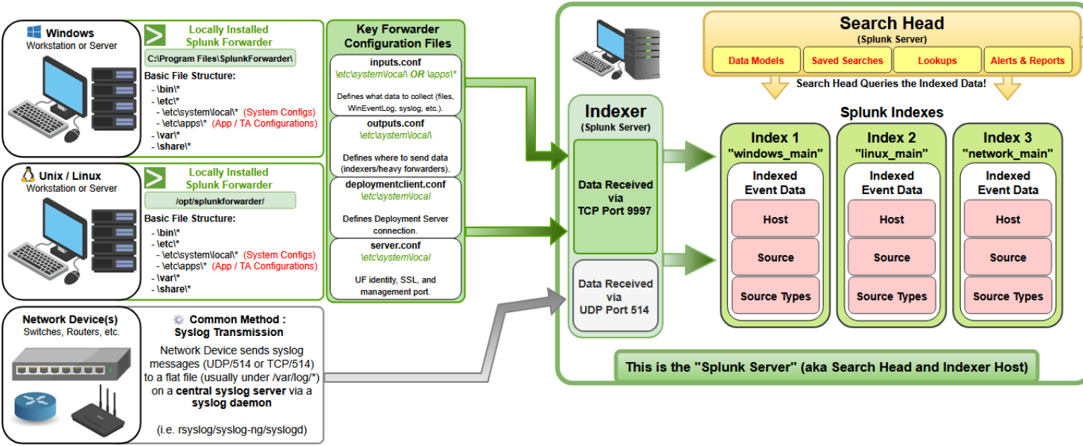

1.2 Data Flow Components and Pipeline Phases
Splunk’s data pipeline is commonly described as: Input → Parsing → Indexing → Search.
- Input: Data is collected by UF/HF/Indexer (depending on architecture and input type).
- Parsing: Event processing (event breaking, timestamping, transforms) typically occurs on HF or Indexer.
- Indexing: Indexer writes data to buckets and builds search-time metadata.
- Search: Search Head orchestrates searches; indexers execute the distributed search portion.
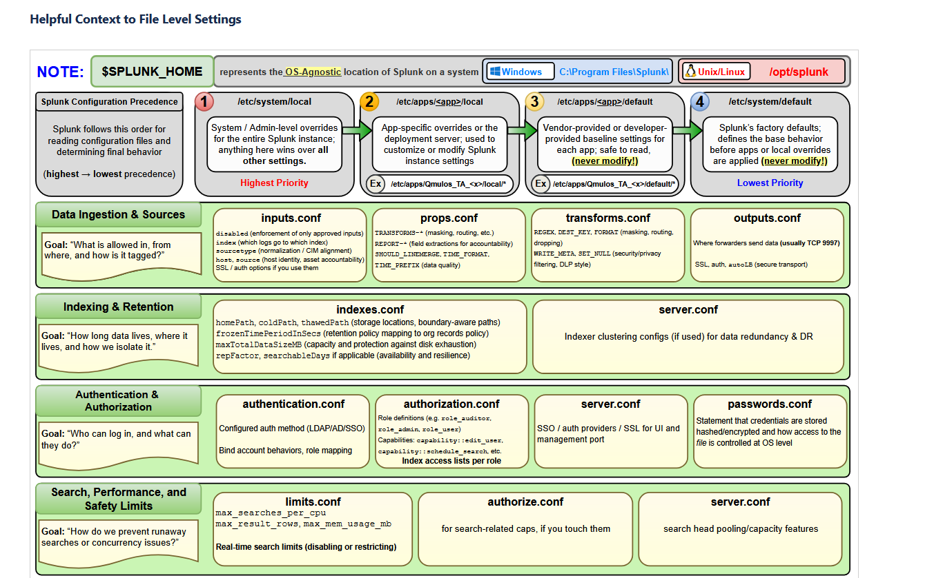
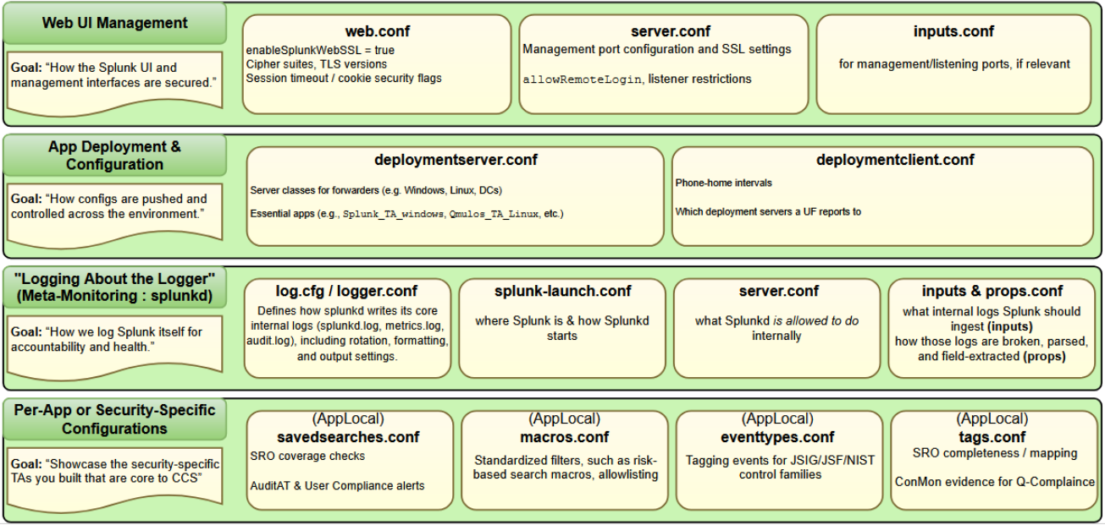

1.3 Distributed Architecture Roles
- Search Head: User interface and search orchestration.
- Search Peer: Indexer participating in distributed search.
- Indexer Cluster Manager: Manages indexer cluster operations.
- Search Head Cluster Captain: Coordinates a Search Head Cluster (SHC).
- Deployer: Pushes apps/configs to SHC members.

1.4 Apps vs Add-ons
- App: User-facing content (dashboards, saved searches, views, knowledge objects).
- Add-on (TA): Inputs and knowledge to support a data source (field extractions, sourcetypes, parsing rules, CIM mapping).

1.5 Knowledge Objects
- Fields, field extractions, tags, eventtypes, macros, lookups, saved searches, dashboards.
- Primarily live on Search Heads (especially in distributed environments).

1.6 Management Interfaces
- Web UI: https://hostname:8000
- CLI:

1.7 Common Splunk Ports
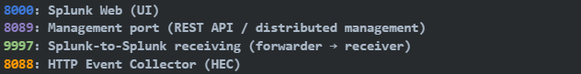

1.8 Splunk Instance Types
- Standalone: All-in-one instance.
- Distributed: Separate components (search heads, indexers, forwarders).
- Clustered: High availability via clustering (indexer clustering and/or search head clustering).

2.0 License Management (5%)

2.1 License Types
- Enterprise License: Production license based on daily indexing volume (GB/day). Counts raw data indexed; searches do not consume license. Forwarded data counts once at index time (on indexers).
- Free License: 500 MB/day indexing limit; limited functionality (for example, no distributed search and other advanced features).
- Trial License: Full Enterprise features for a limited time (commonly 60 days), then reverts if not replaced.
- Forwarder License: Universal Forwarders and Heavy Forwarders do not consume indexing license volume; indexers do.

2.2 License Warnings and Violations (High Yield)
The exact violation behavior depends on license type and (for Enterprise) licensed volume. Key exam idea: violations restrict searching, but indexing continues.
- Splunk Enterprise license stacks with licensed volume ≥ 100 GB/day: warnings can be issued for overages, but search is not disabled.
- Splunk Enterprise license stacks with licensed volume < 100 GB/day: 45 license warnings in a rolling 60-day period puts you in violation; search is disabled for the affected pool (and its members) while in violation. Indexing continues. Internal index searching (for troubleshooting) remains available.
- Splunk Enterprise Trial license: 5 or more warnings in a rolling 30-day period puts you in violation; you cannot search the data while in violation. Warnings persist for 14 days.
- Dev/Test license: 5 or more warnings in a rolling 30-day period puts you in violation; you cannot search while in violation. Warnings persist for 14 days.
- Broken communication edge case: if a license peer cannot contact the license manager for 72 hours or more, the peer is placed in violation and search is blocked until connectivity is restored.

3.0 Splunk Configuration Files (5%)

3.1 Configuration Directory Structure
- Root: $SPLUNK_HOME/etc/
- system/default: Splunk built-in configs. Never edit.
- system/local: Global admin overrides. Use for global changes.
- apps/<app>/default: App baseline configs. Avoid editing vendor defaults.
- apps/<app>/local: App overrides (recommended for app-scoped changes).
- users/<user>/<app>/local: User-specific knowledge objects (less common for admin config).
- Rule: Override in local, never edit default.

3.2 Configuration Layering
- Splunk merges configs at runtime: default (lower precedence) → local (higher precedence).
- local overrides default within the same scope.
- Benefit: safe upgrades, vendor separation, clean customization.

3.3 Configuration Precedence
- Precedence order (highest → lowest): system/local → apps/<app>/local → apps/<app>/default → system/default
- Memory: System Local > App Local > App Default > System Default
- User context for user-owned knowledge objects often includes: users/<user>/<app>/local above app scopes.

3.4 Using btool to Examine Configuration Settings
- Purpose: shows the effective configuration and where each setting came from.
- Syntax: splunk btool <conf_file> list --debug
- Examples:
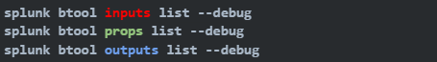
- Exam mindset: if a setting “isn’t working,” check precedence and confirm with btool.

4.0 Splunk Indexes (10%)

4.1 Index Structure
- Each index is a filesystem structure containing event data + metadata.
- rawdata (for example, journal.gz): compressed raw event data.
- tsidx files: indexed metadata for fast searching.
- Buckets: containers holding rawdata + tsidx.
- Storage paths (indexes.conf): homePath (hot/warm), coldPath (cold), thawedPath (restored data).

4.2 Index Bucket Types and Lifecycle
- Bucket lifecycle (core states): Hot → Warm → Cold → Frozen.
- Frozen data is removed from searchable storage (deleted or archived, depending on configuration).
- “Thawed” refers to restored frozen data (restored to thawedPath), making it searchable again; it is not a normal lifecycle stage that all buckets traverse.
- Rollover triggers: size-based (maxDataSize/maxHotBuckets) and/or time-based (maxHotSpanSecs).

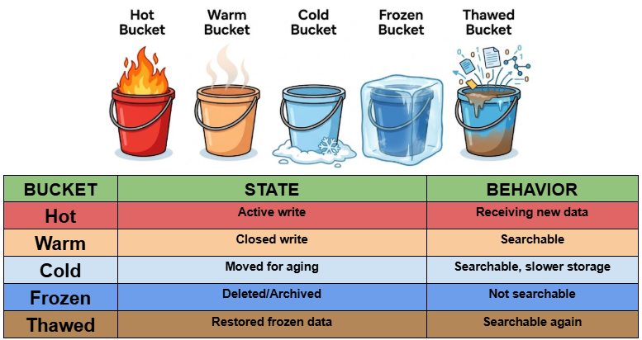

4.3 Index Data Integrity
- Tool: splunk fsck repair --all-buckets
- Use: detect/repair bucket and tsidx inconsistencies after storage issues.
- Memory: fsck = index integrity check/repair.

4.4 High-Yield indexes.conf Options
- homePath / coldPath / thawedPath
- frozenTimePeriodInSecs (time-based retention)
- maxTotalDataSizeMB (size-based retention)
- maxHotBuckets / maxDataSize
- coldToFrozenDir (archive frozen buckets instead of deleting)
- repFactor (indexer clustering replication)
- Exam Tip: retention is time OR size, whichever hits first.

4.5 Fishbucket
- Location: $SPLUNK_HOME/var/lib/splunk/fishbucket
- Purpose: tracks file monitoring checkpoints (CRC + offsets) to prevent duplicate ingestion.
- If fishbucket is deleted, monitored files can be re-ingested (duplicates).

4.6 Applying Data Retention
- Time-based retention: frozenTimePeriodInSecs.
- Size-based retention: maxTotalDataSizeMB.
- Archive vs delete: coldToFrozenDir for archiving frozen data.
- Retention is enforced when aging data from Cold → Frozen.

5.0 Splunk User Management (5%)

5.1 User Roles in Splunk
- Access model: User → Role(s) → Capabilities + Index access
- Role controls: capabilities (permissions), index access, default indexes, search limits.
- Built-in roles often include: admin, power, user (and other environment-specific roles).
- Role inheritance: roles can inherit from other roles and add additional permissions.

5.2 Creating a Custom Role
- UI: Settings → Access Controls → Roles → New Role
- Configure inheritance, allowed indexes, default indexes, capabilities, and search limits.
- Best practice: least privilege; use inheritance.

5.3 Adding Users
- UI: Settings → Access Controls → Users → New User
- Required: username, password, role(s), default app.
- Permissions are determined by roles (users do not receive permissions directly).
- Local vs external users: local Splunk users vs directory/SSO-backed users (LDAP/SAML).

6.0 Splunk Authentication Management (5%)

6.1 LDAP Integration
- Authentication = who you are; Authorization = what you can do (roles).
- LDAP provides centralized user authentication and can map directory groups to Splunk roles.
- Configured via UI (Settings → Authentication → LDAP) or authentication.conf.

6.2 Other Authentication Options
- Local authentication (default)
- LDAP / Active Directory
- SAML (SSO via an Identity Provider)
- Scripted authentication (external script)
- Proxy authentication

6.3 Multifactor Authentication (MFA)
- Splunk Enterprise does not provide built-in MFA enforcement.
- MFA is commonly achieved via SAML SSO with an external Identity Provider (IdP) that enforces MFA policies.
- Exam mindset: MFA is enforced at the IdP, not inside Splunk itself.

7.0 Getting Data In (5%)
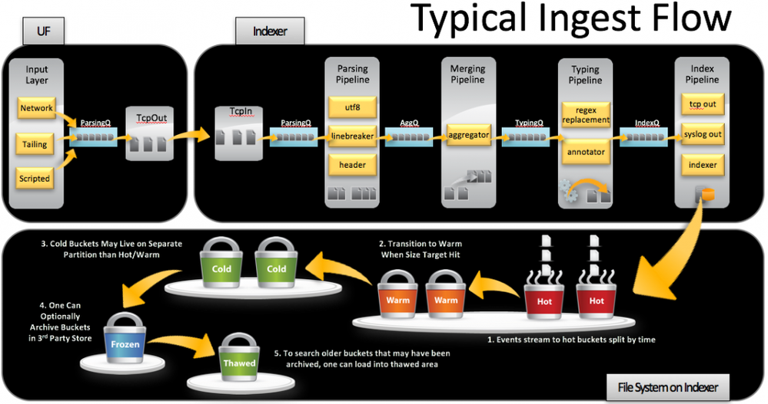

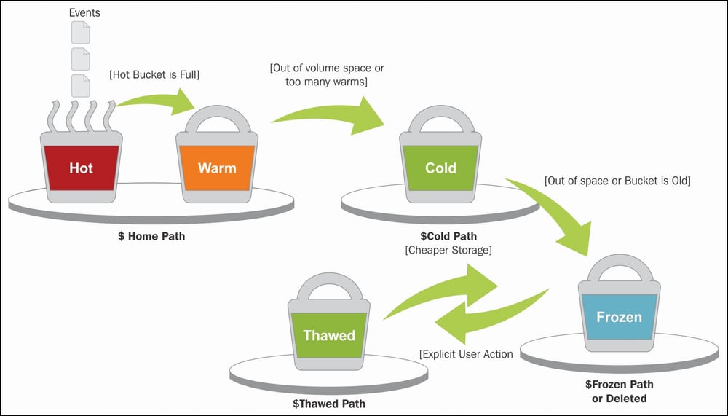

7.1 Basic Input Settings
- Data flow: Data Source → Input → Forwarder/Receiver → Indexer
- inputs.conf: what to collect / what to listen on
- outputs.conf: where to send data
- Core input fields: host, source, sourcetype, index, disabled.
- Common input types: monitor, tcp, udp, script, batch/oneshot, http (HEC), wmi.

7.2 Forwarder Types (UF vs HF)
Capability | UF | HF
Parsing | No (not a full parsing tier) | Yes (can act as parsing tier)
Filtering / Routing | Limited | Yes
Indexing | No | Optional (rare; typically forward-only)
Resources | Lower | Higher
Exam memory: UF = lightweight collection/forward HF = preprocessing/parsing/routing tier.

7.3 Configure Forwarding (outputs.conf)
Basic forwarding example:
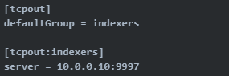

- Default Splunk-to-Splunk receiving port: 9997.

- Load balancing: list multiple servers (idx1:9997, idx2:9997).

7.4 Add a Monitor Input via CLI (UF example)
- Other useful:
- splunk list monitor
- splunk remove monitor <path>
- splunk restart

8.0 Distributed Search (10%)

8.1 How Distributed Search Works
- User submits search to the Search Head.
- Search Head distributes search to configured search peers (indexers).
- Indexers search local data and return results.
- Search Head merges/aggregates results and presents them to the user.
- Map/Reduce mental model: indexers do the distributed (map) portion; search head merges/aggregates (reduce).

8.2 Roles: Search Head vs Search Peer
- Search Head: UI, search dispatch, scheduling/alerts, result merging, hosts knowledge objects.
- Search Peer (Indexer): stores data and executes distributed search against local buckets.

8.3 Configure a Distributed Search Peer
- UI: Settings → Distributed Search → Search Peers → Add new
- Peer URI uses management port: https://indexer:8089
- Credentials and SSL settings must permit SH ↔ peer management connectivity.

8.4 Search Head Scaling Options
- Option 1 — Search Head Clustering (SHC): HA + knowledge object replication; Captain coordinates; Deployer pushes apps/configs.
- Option 2 — Load Balancer: basic scaling with multiple independent search heads; does not provide automatic knowledge object replication.

9.0 Getting Data In – Staging (5%)

9.1 Phases of Indexing
- Input: collect data + assign initial metadata.
- Parsing: event breaking, timestamp extraction, transforms.
- Indexing: write to buckets + build searchable metadata.
- Where parsing occurs (common exam focus): UF → Indexer (indexer parses); UF → HF → Indexer (HF parses); direct-to-indexer inputs (indexer parses).

9.2 Input Options and Component Capabilities
- File inputs: monitor (continuous), batch/oneshot (one-time).
- Network inputs: TCP, UDP, syslog-style (varies by configuration).
- Scripted/modular inputs: scripts and app-based collectors.
- HTTP input: HEC (8088).
- Windows/agentless: WMI, WinEventLog (collection method depends on component).

10.0 Configuring Forwarders (5%)

10.1 Forwarder Configuration (inputs.conf + outputs.conf)
- inputs.conf = what to collect (or what to receive/listen on).
- outputs.conf = where to forward.
- Default forwarding port: 9997.
Basic outputs.conf structure:

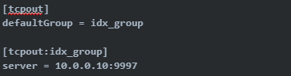

10.2 Additional Forwarder Options (High Yield)
- Indexer acknowledgment: useACK = true (receiver confirms receipt).
- SSL: sslCertPath / sslRootCAPath / sslPassword (encrypt UF/HF → receiver traffic).
- Compression: compressed = true.
- Indexer discovery (clustered environments): uses manager URI for discovery (management port 8089).
- Forwarder queues: forwarders buffer data when receivers are temporarily unavailable.

11.0 Forwarder Management (10%)

11.1 Deployment Management Purpose
- Deployment Server centrally manages forwarder-side configs and apps for UF/HF (inputs.conf, outputs.conf, forwarder-side apps).
- Deployment Server does NOT manage indexer clustering, search head clustering, or indexer-only index-time configs.
- Memory: Deployment Server = forwarder config distribution.

11.2 Deployment Server Details
- Deployment Server is a Splunk Enterprise instance with DS role enabled.
- Forwarder check-in occurs over the management port (8089).
- Deployment apps live under: $SPLUNK_HOME/etc/deployment-apps/

11.3 Deployment Apps
- Deployment app structure: deployment-apps/<app>/default and deployment-apps/<app>/local.
- Apps commonly include forwarder-side: inputs.conf, outputs.conf, limits.conf, and in some cases props.conf (forwarder-side scope).
- Forwarders pull updated apps at the next check-in interval.

11.4 Deployment Client Configuration (deploymentclient.conf)
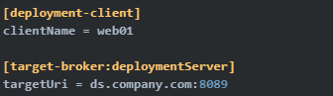
- Default phone-home interval is commonly 60 seconds (environment-dependent).
- Exam concept: DS does not push; forwarders pull.

11.5 Server Classes (Client Groups)
- Server classes group forwarders by hostname/IP/OS/machine type and use whitelists/blacklists to match clients.
- Apps are assigned to server classes to target config deployment.

11.6 Monitoring Forwarder Management
- UI: Settings → Forwarder Management.
- Shows connected forwarders, last check-in, server class membership, app deployment status, versions.
- Key files: deploymentclient.conf (forwarder), serverclass.conf and deployment-apps/ (deployment server).

12.0 Monitor Inputs (5%)

12.1 File and Directory Monitor Inputs
- Configured in inputs.conf.
- Monitor = continuous ingestion; reads new data as files grow.
- File rotation tracking uses CRC + fishbucket checkpoints to avoid duplicates.
Example:
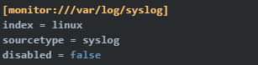

Directory example:

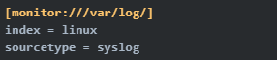

12.2 Optional Monitor Settings
- whitelist / blacklist: include/exclude files by pattern.
- recursive: control recursion into subdirectories.
- ignoreOlderThan: ignore old files.
- crcSalt: help uniquely track rotated files.
- followTail = true: start reading at end (collect only new data).

12.3 Deploy Remote Monitor Inputs
- Create deployment app with inputs.conf, then assign the app to a server class.
- Forwarder checks in to DS (8089) and pulls config.

13.0 Network and Scripted Inputs (5%)

13.1 Network Inputs (TCP/UDP)
- Configured in inputs.conf on HF or Indexer (typical).
- TCP is connection-oriented/reliable; UDP is connectionless/best-effort.
Examples:

13.2 Optional Network Input Settings
- Host assignment: connection_host = ip/dns or host = <static>.
- TCP limits: acceptFrom, connection_limit.
- Queue buffering: queueSize.
- TLS: enableSSL = true (TCP secure input).
- Metadata: index, sourcetype, disabled.

13.3 Scripted Inputs
- Scripted inputs run a command and ingest its STDOUT. Configured in inputs.conf.
- Script must be executable; runs on an interval.
Example:
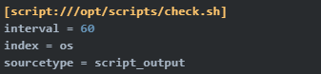

14.0 Agentless Inputs (5%)

14.1 WMI Inputs (Windows Management Instrumentation)
- Agentless concept: collect without installing a forwarder on the source system.
- WMI commonly configured on HF or Indexer.
- Requires WMI enabled, network access (RPC/DCOM), sufficient privileges, and firewall allowances.
- Often higher overhead and less scalable than installing forwarders.

Example of a WMI Input (Windows Management Instrumentation):
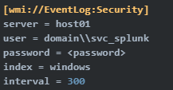

14.2 HTTP Event Collector (HEC)
- Receives data via HTTP/HTTPS (JSON or raw) using token-based auth.
- Default port: 8088.
- Architecture: Application → HTTP POST → HEC → Indexer (or HEC tier).
- Enable: Settings → Data Inputs → HTTP Event Collector → Enable; then create a token and send events with Authorization header.
Header example: Authorization: Splunk <token>

15.0 Fine Tuning Inputs (5%)

15.1 Default Input-Phase Processing
- During input phase, Splunk assigns or accepts metadata like host, source, sourcetype, and index.
- Fishbucket checkpoints prevent duplicate ingestion for monitored files.

15.2 Input-Phase Options (High Yield)
- Best practice: set correct sourcetype at input so parsing rules apply correctly.
- Character encoding: charset can be set to handle non-UTF-8 data (for example, ISO-8859-1).
- Host/source overrides can be applied when needed.
Example:
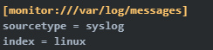

16.0 Parsing Phase and Data (5%)

16.1 Default Parsing Processing
- Parsing typically occurs on HF or Indexer (UF is not used as a full parsing tier).
- Parsing includes event breaking, timestamp extraction, time zone assignment, and applying props/transforms as configured.

16.2 Line Breaking
- Default behavior is newline-based event breaking.
- Key settings (props.conf): SHOULD_LINEMERGE, LINE_BREAKER, TRUNCATE.

16.3 Timestamp and Time Zone
- If Splunk cannot extract a timestamp from the event, it can fall back to index time.
- Key settings: TIME_PREFIX, TIME_FORMAT, MAX_TIMESTAMP_LOOKAHEAD, DATETIME_CONFIG.
- Time zone precedence commonly considered: TZ in props.conf → forwarder host TZ → indexer TZ (depends on where parsing occurs).

16.4 Data Preview
- UI: Settings → Add Data → Preview.
- Use to validate event breaking, timestamps, sourcetype detection, and field extraction preview before committing data.

17.0 Manipulating Raw Data (5%)

17.1 Transformations Model
- Two-file model: props.conf invokes transformations; transforms.conf defines the transformation logic.
- Index-time transformations occur during parsing and are permanent; search-time transformations are temporary.

17.2 Common Transformations (Examples)
- Mask sensitive data: modify _raw via transforms.
transforms.conf:
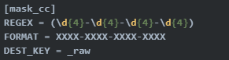

props.conf:


- Route events to a specific index:
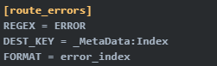

- Drop events before indexing (nullQueue):
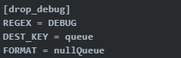

17.3 SEDCMD
- SEDCMD in props.conf provides simple regex-based replacements on raw data.
- Use SEDCMD for simple substitutions; use transforms.conf for routing/metadata/complex logic.

Appendix A: “Where Do I Configure This?” Mini-Map (Page 1)
- Forwarder sends data to indexers (destination, SSL, ACK, load balance) → outputs.conf on UF/HF
- Forwarder collects local files/directories → inputs.conf on UF/HF
- Indexer receives Splunk-to-Splunk data (listener on 9997) → inputs.conf on Indexer (or HF receiver tier)
- Network port listening (TCP/UDP/syslog-style collection) → inputs.conf on HF or Indexer (typically)
- HEC receiver (token-based HTTP ingestion) → enable + tokens in UI; receiver runs on Indexer/HF/HEC tier (8088)
- Parsing rules (line breaking, timestamps, time zone) → props.conf on parsing tier (HF or Indexer)
- Routing/dropping/masking at index-time (nullQueue, route to index, metadata rewrite) → props.conf calls transforms.conf on parsing tier
- Indexes/paths/retention (homePath/coldPath/thawedPath, frozenTimePeriodInSecs, maxTotalDataSizeMB) → indexes.conf on indexers
- Distributed search peers → UI on Search Head; distsearch.conf on Search Head
- Search Head Cluster app distribution → Deployer pushes to SHC members
- Deployment Server forwarder management → DS: serverclass.conf + deployment-apps/; Forwarder: deploymentclient.conf
- Licensing → License Manager (master) + license peers (indexers)
- Roles/users/capabilities/index access → UI (typically on Search Head); authorize.conf stores role definitions
- Troubleshooting “what is active?” → splunk btool <conf> list --debug on the affected instance

Appendix B: 10 High-Yield Admin Scenarios (Page 2)
- Scenario 1: “Forwarder is installed but no data is arriving” → verify forwarder running; outputs.conf target/port (9997); network/firewall; forwarder logs; receiver listening; index exists and not blocked.
- Scenario 2: “License violation: what breaks?” → depends on license type; violations can block searching while indexing continues; use Monitoring Console/_internal to troubleshoot.
- Scenario 3: “Data is arriving but going to the wrong index” → check inputs.conf index=; then props/transforms routing (DEST_KEY=_MetaData:Index) on parsing tier; confirm with btool.
- Scenario 4: “Drop noisy events before indexing” → props.conf calls transforms.conf with DEST_KEY=queue FORMAT=nullQueue on parsing tier; validate with preview/test counts.
- Scenario 5: “Timestamps are wrong (events out of order)” → correct TIME_PREFIX/TIME_FORMAT/MAX_TIMESTAMP_LOOKAHEAD/DATETIME_CONFIG; validate in Data Preview; confirm time zone behavior on parsing tier.
- Scenario 6: “Multiline events are broken” → adjust SHOULD_LINEMERGE and LINE_BREAKER (props.conf) for the sourcetype; test in Data Preview.
- Scenario 7: “Deployment Server change didn’t apply” → confirm deploymentclient.conf; check last phone-home; server class match; app assignment; reload/restart if required.
- Scenario 8: “Which config file is winning?” → run btool --debug on the affected instance; confirm precedence.
- Scenario 9: “Fishbucket deleted / duplicate ingestion happened” → expect re-ingestion due to lost checkpoints; avoid deleting fishbucket unless intentional.
- Scenario 10: “Distributed search peer shows down” → check SH ↔ indexer connectivity on 8089; credentials/certs; peer URI correctness; peer status in UI.

Technical Deployment and Networking Details
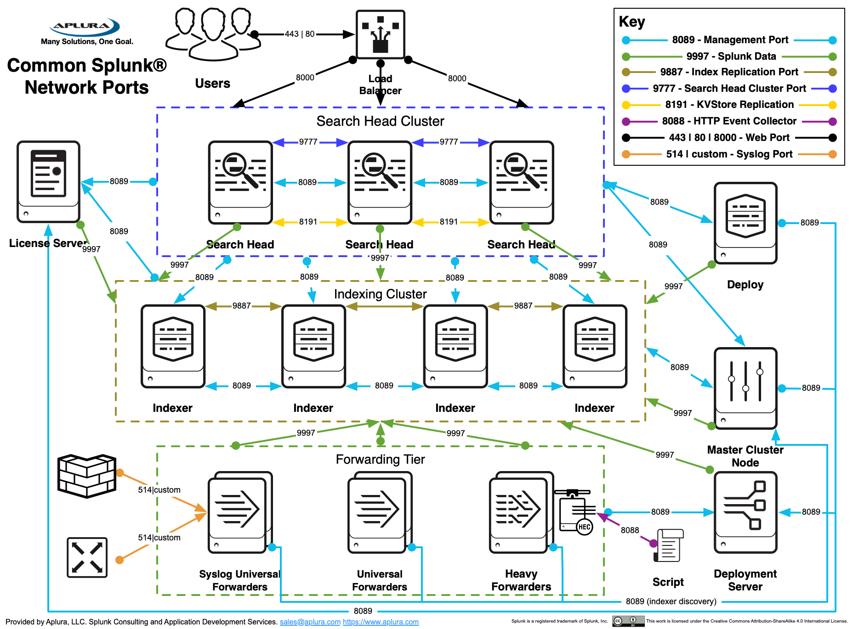

SPLUNK ENTERPRISE ADMIN - GOLDEN TAKEAWAYS
1) The Admin Troubleshooting Order (Most Important) Always think in this order!

LAYER | CHECK
DATA | UF running? inputs.conf? network? port 9997?
PARSING | props.conf / transforms.conf (timestamps, index routing)
INDEX | index exists? retention? license blocked?
SEARCH | SH ↔ Indexer on 8089
CONTROL | Deployment Server / License / Monitoring Console

2) Port Memory (High Frequency)
8000 | Web UI
8089 | Management + Distributed Search + DS + Cluster
9997 | Forwarder → Indexer (Data Stream Forwarding)
8088 | HEC

SPLUNK ENTERPRISE ADMIN - GOLDEN TAKEAWAYS
Configuration Precedence Matrix (HIGHEST → LOWEST)
system/local
app/local
app/default
system/default

If a setting isn’t working:
Run: splunk btool <conf> list --debug

4) Where Parsing Happens (Common Trap)
Architecture | Parsing Location
UF → Indexer | Indexer parses
UF → HF → Indexer | HF parses
Direct input on Indexer | Indexer parses
UF is not a parsing tier!

5) Bucket Lifecycle (Always Tested) Hot → Warm → Cold → Frozen → Thawed
- Frozen = deleted or archived
- Thawed = restored frozen (not a normal stage)
- Retention = TIME OR SIZE (whichever hits first)

Fishbucket Location: $SPLUNK_HOME/var/lib/splunk/fishbucket
- Purpose: Tracks file offsets and Prevents duplicates
- If deleted → data re-ingests

Index-Time vs Search-Time (Critical Concept)
Index-Time | Search-Time
props + transforms (parsing) | Field extractions
Permanent | Temporary
Performance impact | No reindex needed

Dropping data:
DEST_KEY = queue
FORMAT = nullQueue

Instant Scenario Triggers
Symptom | Likely Cause
No data arriving | outputs.conf / network / 9997
Wrong index | transforms routing
Bad timestamps | props TIME_FORMAT
Config ignored | precedence issue
Forwarder not updated | DS phone-home
Duplicate data | fishbucket reset
Search peer down | 8089 connectivity
Search disabled | license violation

