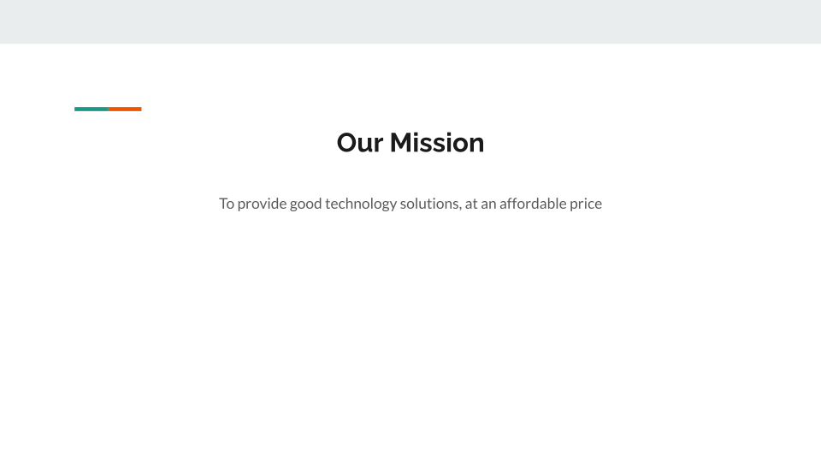

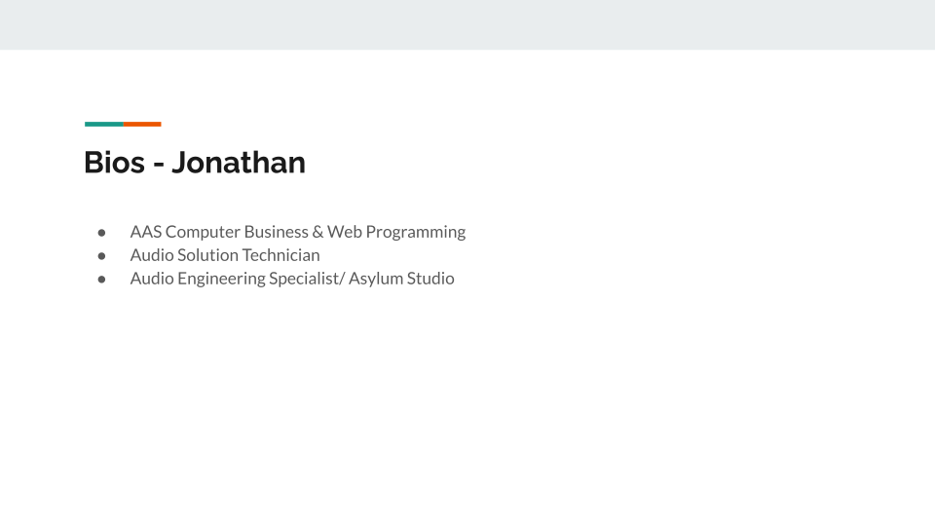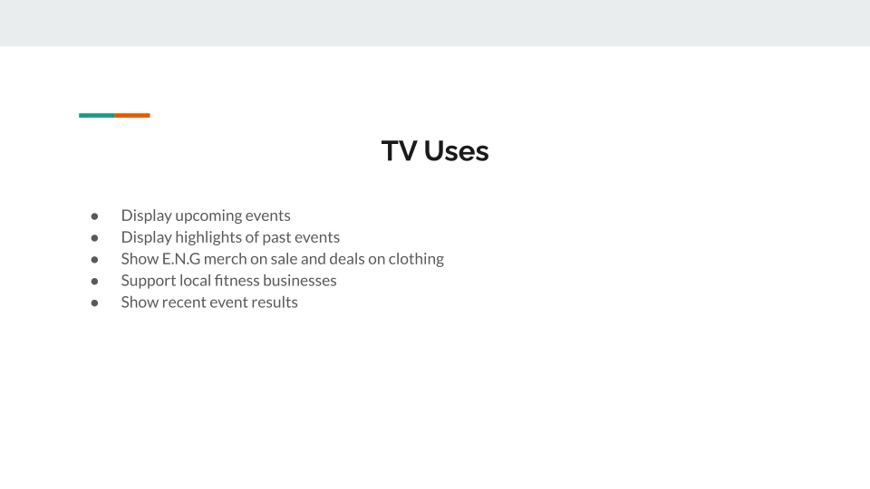

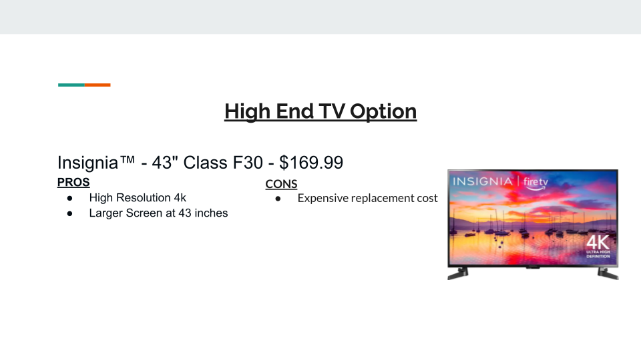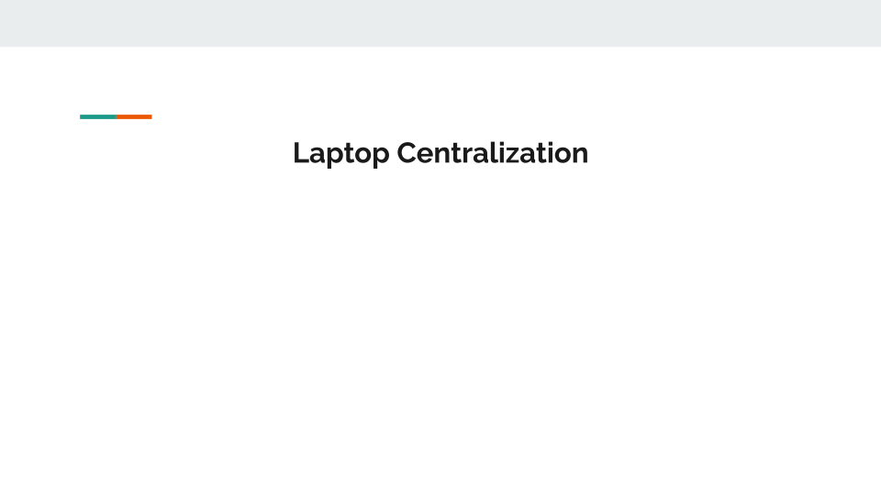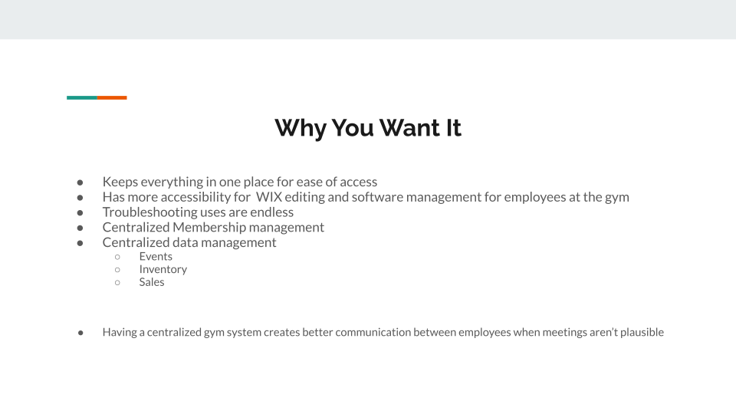

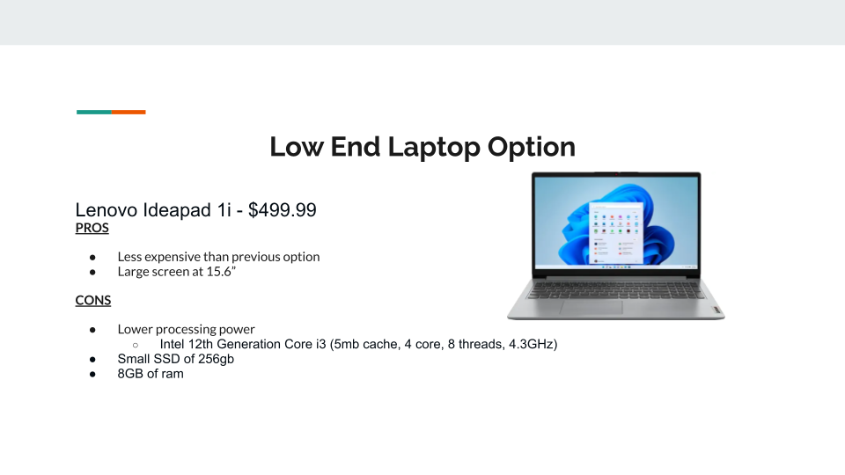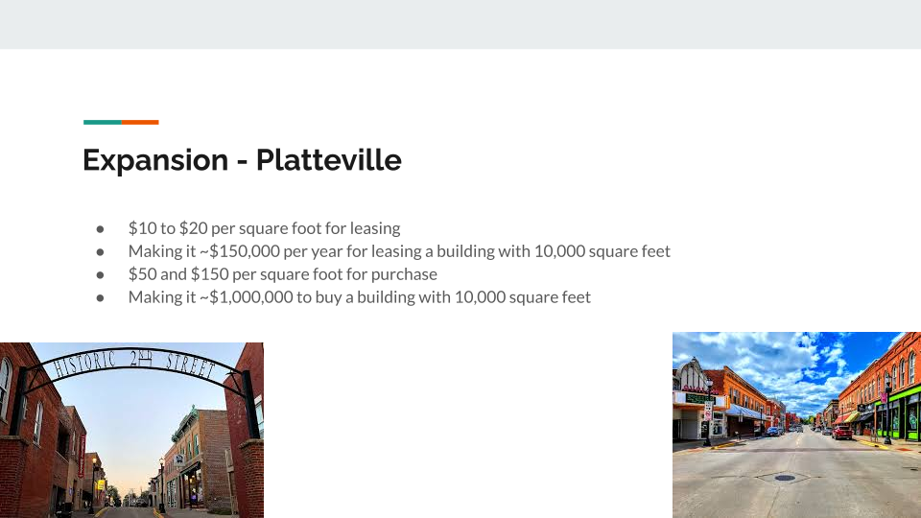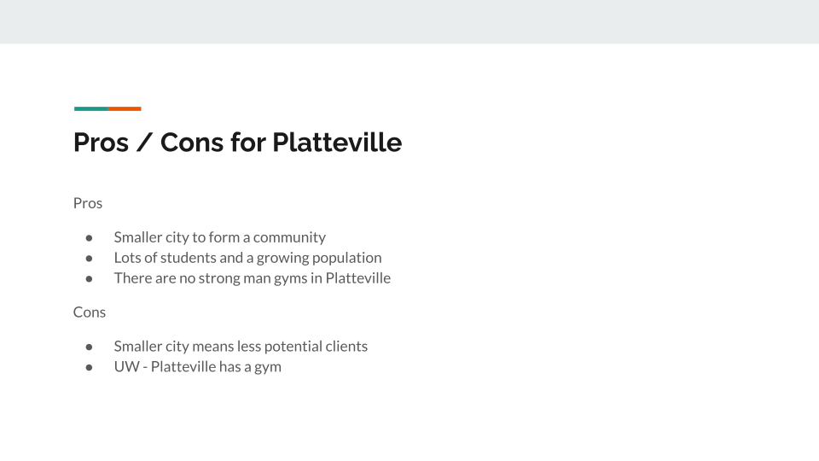

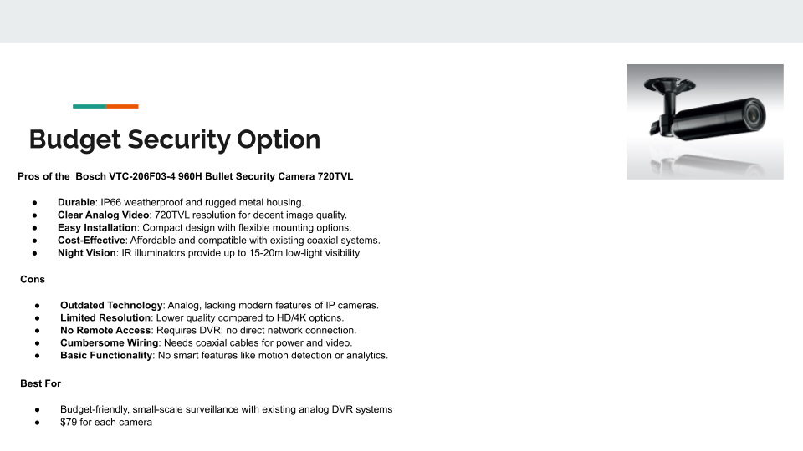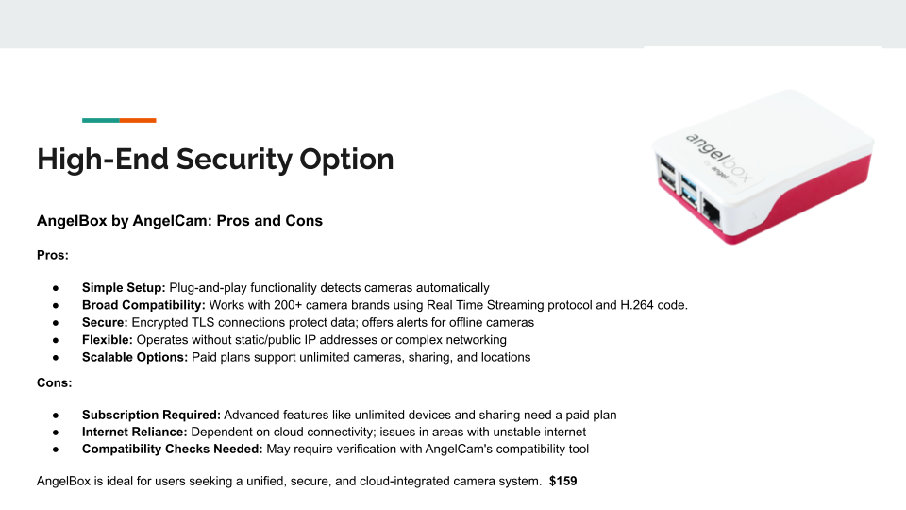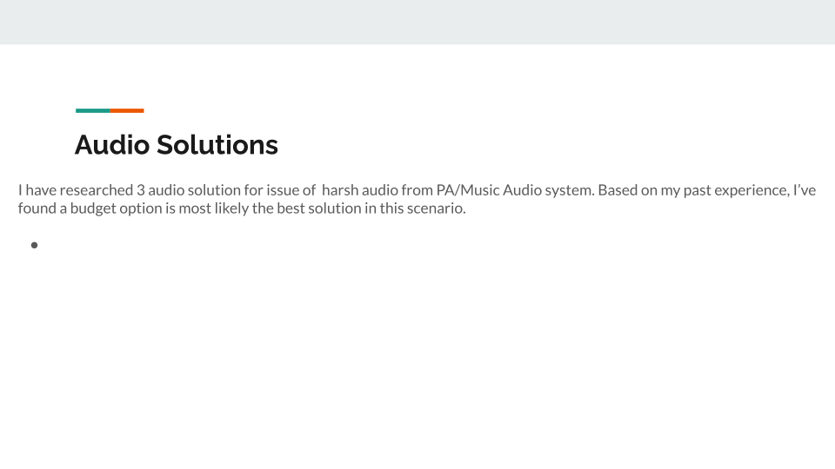

**Our Mission**

To provide good technology solutions, at an affordable price

**William Brown**

**Centralization and Hardware**

Computer Analyst and Web Programming

AAS at NICC

2nd Year at NICC

**Johnathan Ervin**

**Audio Solutions**

AAS Computer Business & Web Programming

Audio Engineering Specialist/ Asylum Studio

**Reece Reiger**

**Relocation / Visuals**

2nd year student

I am currently in school for Business Development and Web Programming and will be graduating in May

**Austin Kennedy**

**Networking/Wix Compatibility Consultant**

AA and AGS at NICC in 2021

2nd year in Networking at NICC

**Data Flow Diagram**

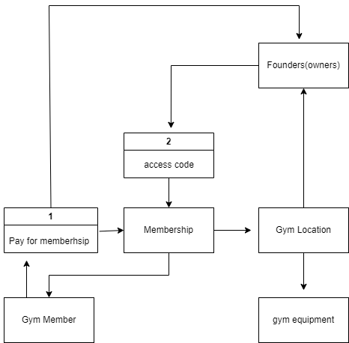

**Security Research**

**Getting Security Cameras Wix Compatible**

**iFrame Element on Wix**

To add an HTML iFrame element to a Wix site, you can:

1. Click Add Elements on the left side of the editor
2. Click Embed & Social
3. Select an element to add to the page
4. Choose whether to embed code or a site
5. Paste the code or web address into the iFrame

**Log in to your Wix account**

* Select Edit Site
* Click App market
* In the search form look for HTML iFrame/Embed
* Add it to the site
* A window pops up. Choose the Code radio button.
* Paste embed code from Angelcam Dashboard
* Update / Save & Publish

### **Steps to Use Security Cameras on Wix**

1. **Check Camera Compatibility:**Most cameras (e.g., Wyze, Ring, Nest) don’t directly integrate with Wix but can stream via URLs or third-party tools.
2. **Get the Stream or Video URL:**
   * **Wyze Cam:** Subscribe to *Cam Plus* or *Web View* for live stream links.
   * **Others:** Look for RTSP support or cloud services with shareable URLs.
3. **Embed the Stream in Wix:**
   * Add an **HTML Embed** element in the Wix editor.
   * Paste the iFrame or stream link   
     (e.g., <iframe src="your-stream-link"></iframe>).
   * Adjust size and position as needed.
4. **Upload Recordings:**
   * Download videos from your camera app.
   * Upload to Wix’s **Media Manager** and add a **Video Player** to display them.
5. **Use Third-Party Tools:**Host streams on platforms like **YouTube Live** or **Vimeo**, then embed their links in Wix.
6. **Test and Optimize:**Preview and test your site to ensure proper functionality on desktop and mobile

**Security Camera Options**

**High End Option(s)**

* **AngelBox** (<https://www.amazon.com/AngelBox-Compatibility-Security-Surveillance-Alternative/dp/B01CPIM9TE>) $**159**

**Log in to your Angelcam Dashboard**

* Click on Broadcasting App
* Go to Sharing tab and click to Show Embed code
* Select Using HTML only and copy the code into your clipboard

**Angelcam's cloud recording subscription costs**

**-**Essentials plan $30 yearly (<https://www.angelcam.com/essentials-plan>)

**AngelCamera One compatible for Wix (Camera)**

* <https://www.angelcam.com/angelcamera-one>
* <https://help.angelcam.com/en/articles/1114986-how-to-insert-your-camera-into-the-wix-page>
* $119 for one camera
* **Hikvision DS-HD2 1080p HD Outdoor Wi-Fi Smart Doorbell** (**AngelCam Compatible**)- $**109**

(<https://www.amazon.com/Hikvision-DS-HD2-1080p-Outdoor-Doorbell/dp/B0BTM52SN2/ref=asc_df_B0BTM52SN2?mcid=97af9d4f6c2430a1bb51377902450b5f&tag=hyprod-20&linkCode=df0&hvadid=693308325595&hvpos=&hvnetw=g&hvrand=18152478373709581023&hvpone=&hvptwo=&hvqmt=&hvdev=c&hvdvcmdl=&hvlocint=&hvlocphy=9018434&hvtargid=pla-1968427965076&psc=1> )

**Low End Option(s)**

* **Bosch VTC-206F03-4 960H Bullet Security Camera 720TVL** (<https://www.a2zsecuritycameras.com/bosch-vtc-206f03-4-960h-bullet-720tvl/?srsltid=AfmBOopMfCJDO-V5_QPjdv5loLXyT77MsHR8vr0Bc44rWNqIzKrww1ZrMP8>) $79
* **Wyze Cam v4 (compatible with Wix)**
* 3 pack for $105.94 (<https://www.wyze.com/products/wyze-cam?variant=44185510314146> )
* 2 pack for $51.96 ([https://www.google.com/url?sa=t&source=web&rct=j&opi=89978449&url=https://www.amazon.com/Security-Activated-Spotlight-Enhanced-Outdoor/dp/B0CJ9Z22L5&ved=2ahUKEwimz4jT3J6KAxViHjQIHVlMOLYQFnoECBoQAQ&usg=AOvVaw1gN1DsHPwd-c8GAeBtTuLd](https://www.amazon.com/Security-Activated-Spotlight-Enhanced-Outdoor/dp/B0CJ9Z22L5))
* Source for info for microSD for camera storage <https://forums.wyze.com/t/recommended-512gb-microsd-card-for-v4-camera/312643>
* Samsung Pro Endurance ~$35.00 <https://www.samsung.com/us/computing/memory-storage/memory-cards/pro-endurance-adapter-microsdxc-256gb-mb-mj256ka-am/?gQT=2&gRefinements=MEASURE:256+GB>
* <https://www.security.org/security-cameras/wyze/>

**Wifi Tuya Smart APP Video Door Phone RFID Card Keypad 1080P Home Outdoor Doorbell Camera Wifi Video Intercom Access Control -** $61.95

(<https://www.aliexpress.us/item/3256803990396605.html?src=google&gatewayAdapt=glo2usa> )

**Best Option**: Wyze Cam v4 due to not needing the AngelBox to have compatibility with Wix, as it can be done with Wyze’s software and being a high-end modern security camera with the least expense.