Reece Spragg

Massey University  158.212

Assignment 3 Documentation

Contents

Opening and Saving Files: 1

Opening Files: 1

Saving Files: 1

Adding New Players: 2

Adding New Teams: 2

Signing A Player: 3

Searching through players (Age/Region/Team): 3

Find who is on a team 4

## Opening and Saving Files:

Files containing players data can be imported and exported using the File Save/Open buttons in the menu strip at the top of the program.

### Opening Files:

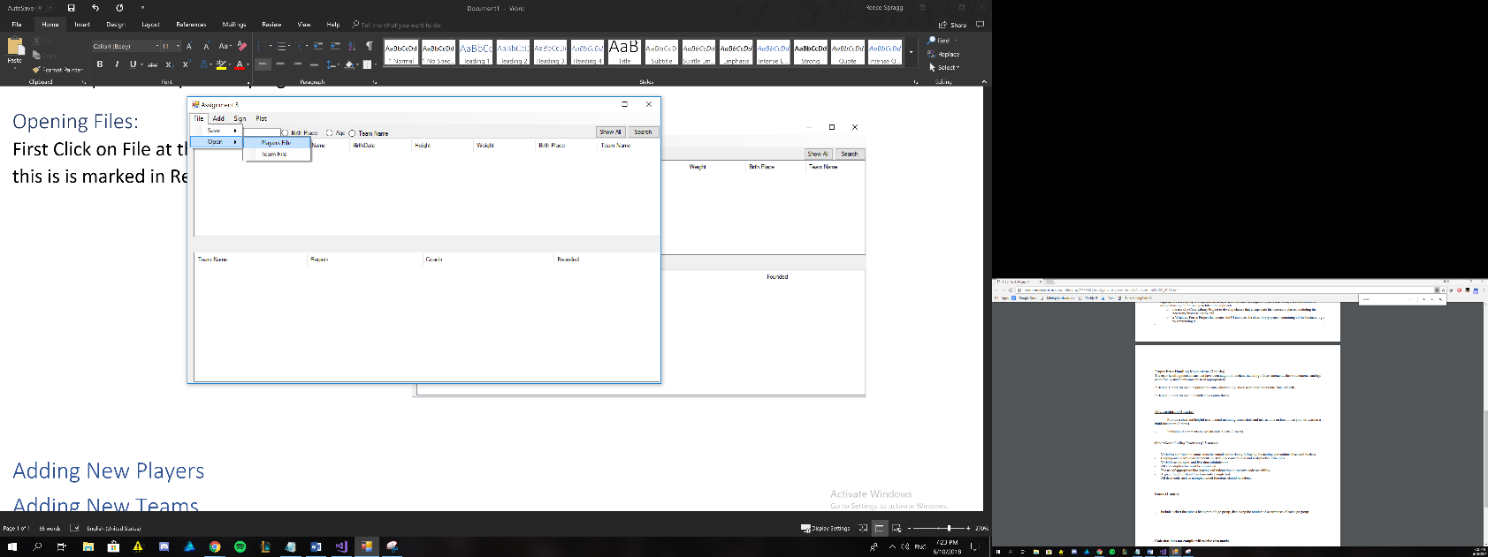First Click on File at the top of the program this is is marked in Red.Hover over the open menu, then choose from the list wether you would like to open a Players file or a Team file.

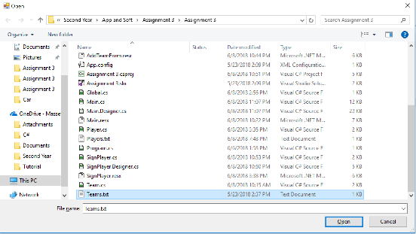After clicking on a file type, a Windows Open Box will appear. Locate your file using the menu located on the left (Covered in blue in the picture). Double clicking your file will open your file and load the contents into the program.

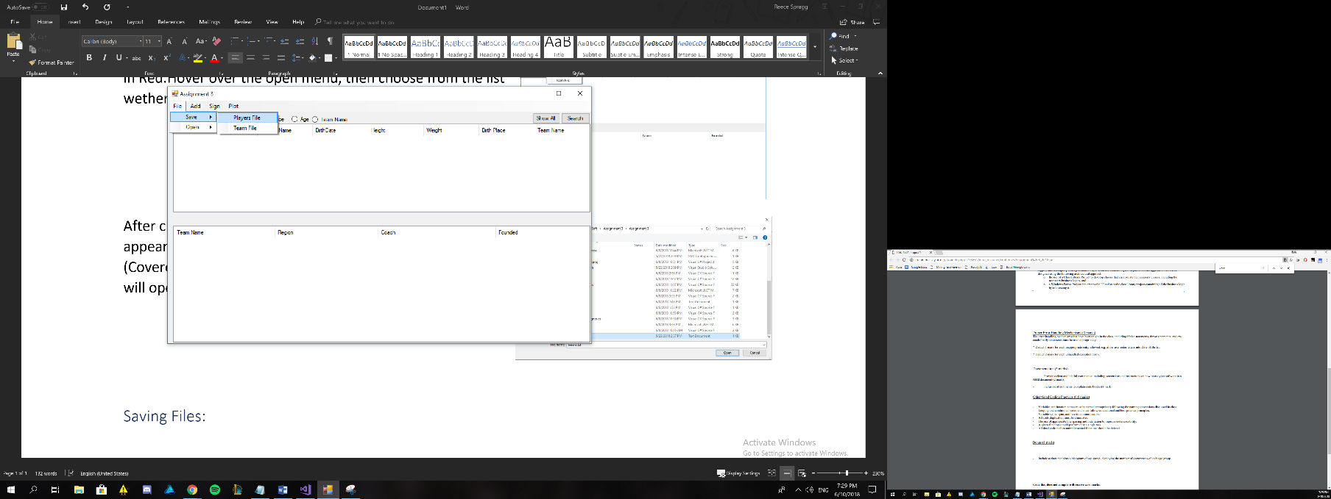

### Saving Files:

Similarly to opening files above, to save a file Click on the file button marked in red. Hover over the save button, then choose which file type you wished to save by clicking on that type. (Player files maintain the data related to which team a player may be signed to).

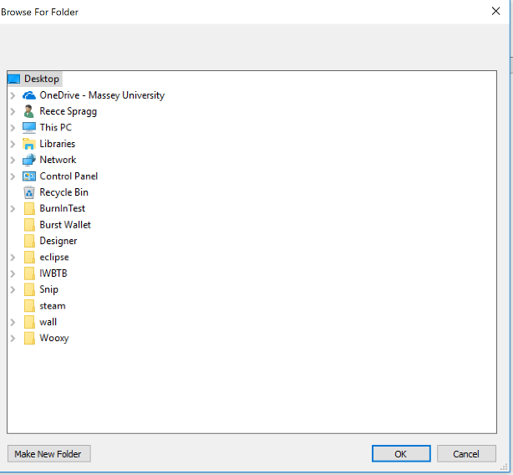

A menu, similar to the picture to the left will open. Locate the folder you wish to save your Files to and press Okay in the buttom right. This will save the contents of the program as a text file.

## Adding New Players:

To add a new player to the program, click on Add and then click on the “Add New Player” button.

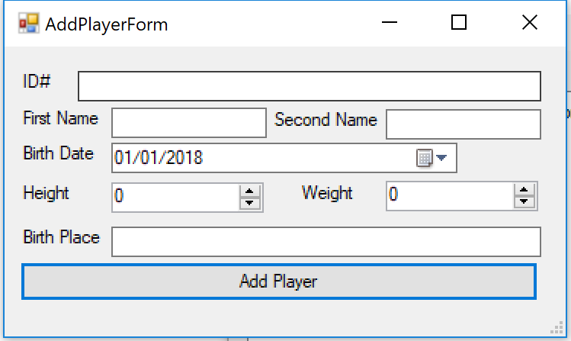

The menu to the right will appear. Simply fill out the Players data into this Window and click on Add Player. A new player will be added to the team. ID’s must be numerical, and all boxes must be complete in order to add the player into the program.

## Adding New Teams:

To add a new Team to the program, click on Add and then click on the “Add New Team” button.

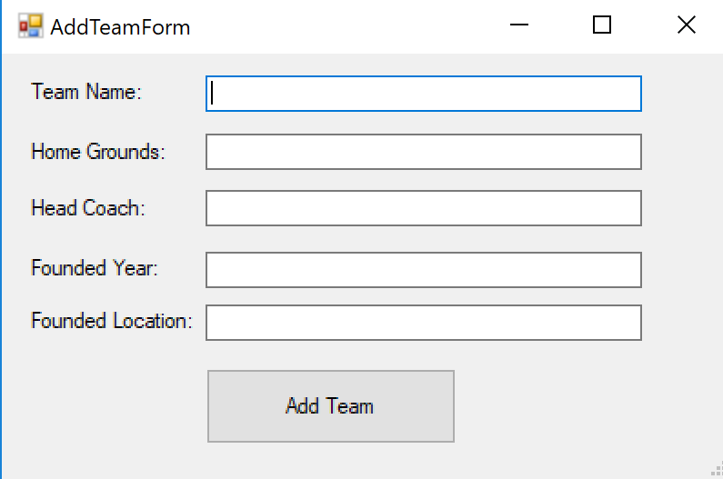

The menu to the right will appear. Simply fill out the Teams data into this Window and click on Add Team. A new Team will be added to the team. Foundation year must be numerical and all boxes must be complete in order to add the team into the program.

## Signing A Player:

To sign a player, the player must be loaded into the program and the team your wishing to sign the team player to must also be loaded in. Click on Sign and then click on “Sign A Player To A Team” button.

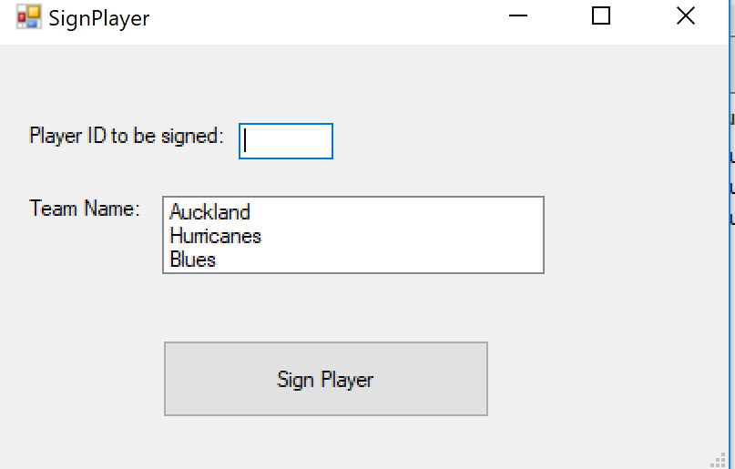

Enter the players ID and select the team you want the player to be signed to from the menu. Click on Sign Player.

## Searching through players (Age/Region/Team):

You can search through players by Age, Region and Team. In the search box highlighted in the picture, type in what you are searching for e.g “Auckland” and choose the type of search by clicking on one of the round buttons just to the right. Click Search (underlined in green) when ready. This will display the players matching the search criteria. When you have completed your search and wish to return to showing all players, click on the “Show All” button underlined in red.

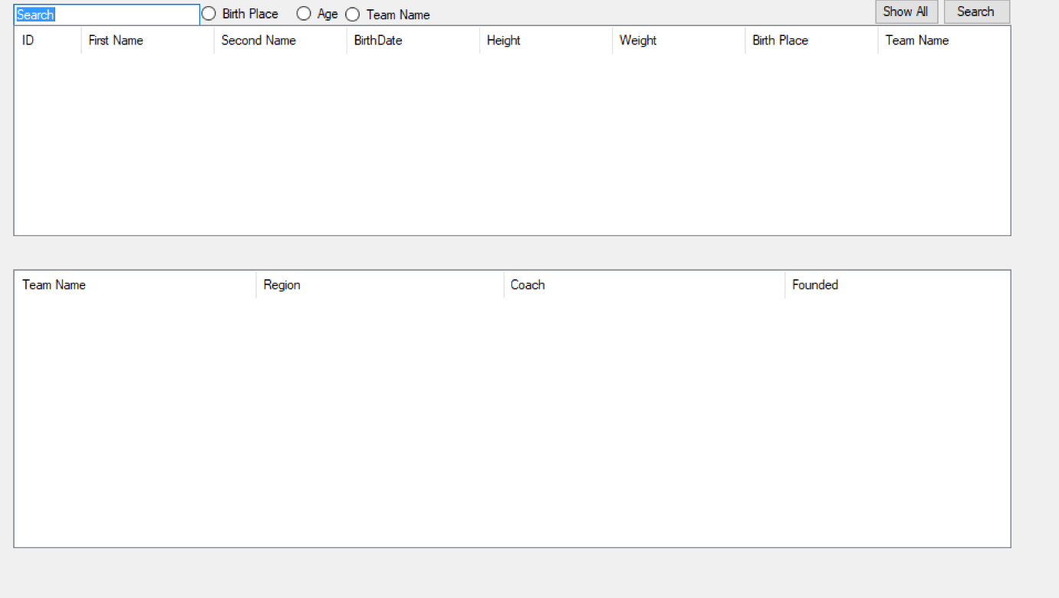

## Find who is on a team

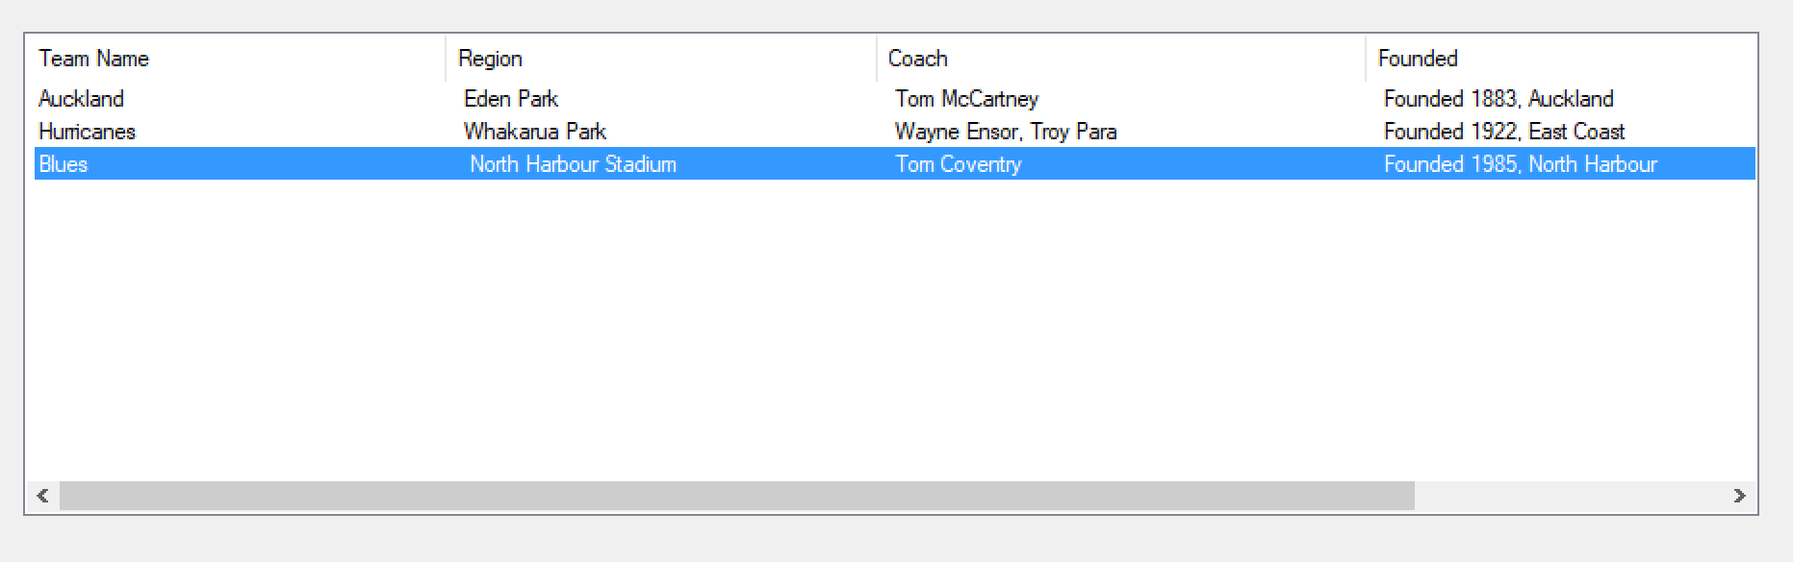To find out what players are on any given team, double click on any team in the team list located at the bottom of the program. This will automatically type the Team name in the search bar, select the Team Name button and search through players by Team Name. The results will be displayed in the player list located above the team list. When done with the results, click on the “Show All” button to return to viewing all players.