Methods
Given the 3D geometry (Cartesian coordinates) and the total charge of a TMC, Lewis-structure generation requires the assignment of bond orders, lone pairs, and formal charges that are mutually consistent with chemical electron-counting rules. Because these quantities are discrete and strongly coupled, the problem was formulated as an integer linear programming (ILP) model and solved globally over the full candidate bonding space.
The workflow comprises four stages: (1) preprocessing of the input 3D geometry, including construction of the raw connectivity graph and identification of conjugated systems; (2) definition of the ILP decision variables and hard constraints; (3) Assembly of the objective function and solution of the resulting ILP with the COIN-OR Branch-and-Cut solver; and (4) obtaining the optimal Lewis-structure solution and generating a bonding report for the metal center and ligands.
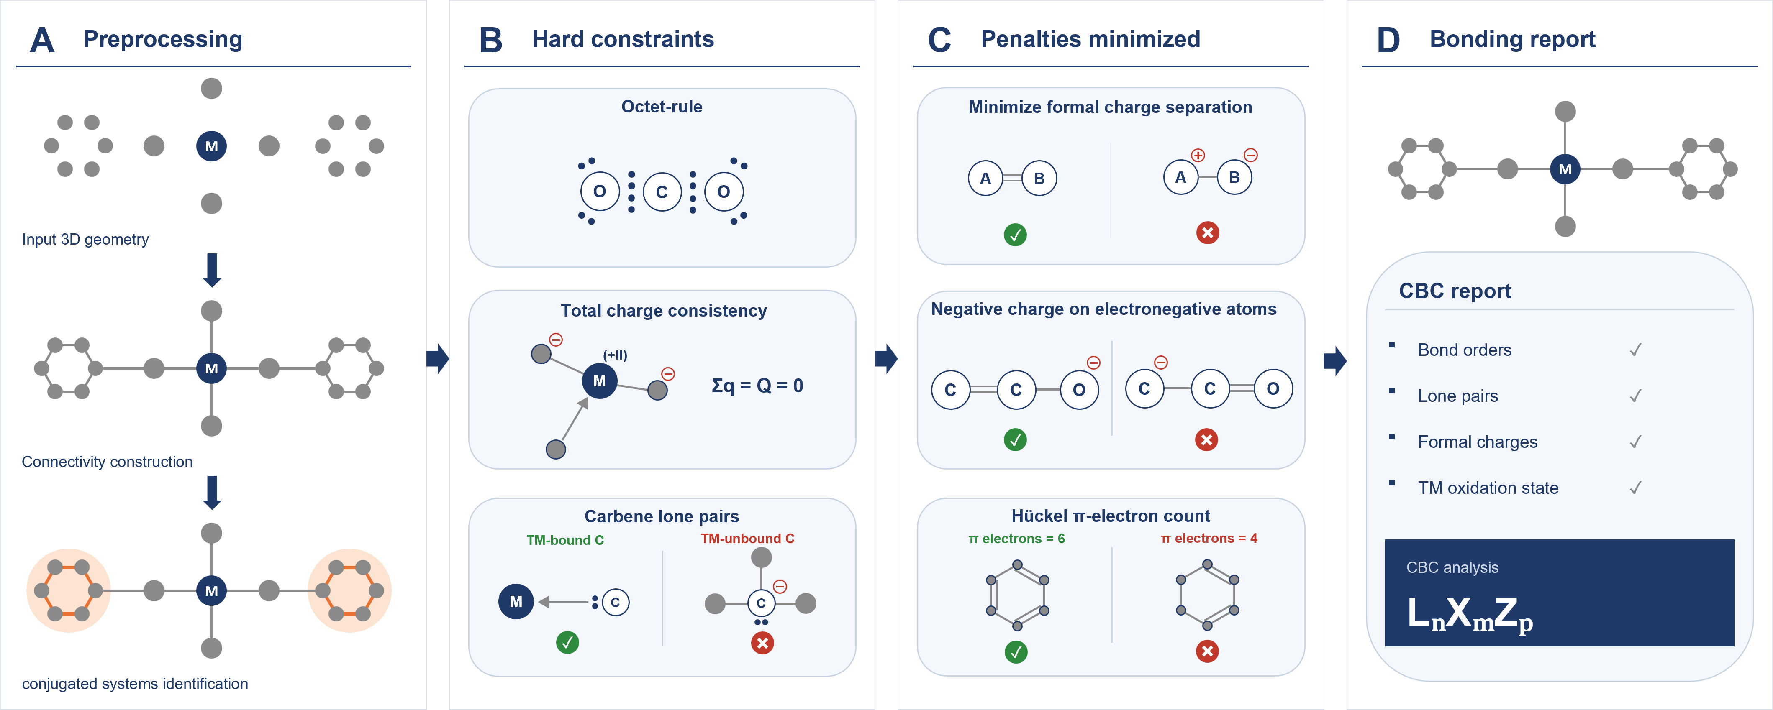
(1) The input XYZ geometry is first converted into a raw TMC graph $G^{raw}=(V,E^{raw})$, in which an edge $(i,j)$ is assigned whenever the interatomic distance $d_{ij}$ satisfies
$$d_{ij}<λ_{ij}\left(r_{i}^{cov}+r_{j}^{cov}\right),$$
where $r_{i}^{cov}$ is the covalent radius of atom $i$. In the present implementation, $λ_{ij}=1.30$ for general atom pairs, whereas $λ_{ij}=1.15$ for transition-metal–carbon pairs. These values provide flexibility in defining what distance constitutes a bond.
For conjugated system analysis, all simple cycles up to a prescribed maximum size are enumerated from the ring-detection graph, after which only minimal rings are retained. Each minimal ring is then subjected to a planarity test using the minimum root-mean-square distance to a candidate plane,
$${RMSD}_{plane}=\min_{Π}{\left(\frac{1}{n}\sum_{k=1}^{n}{d}(r_{k},Π)^{2}\right)}^{1/2},$$
where $n$ is the number of atoms in the ring, $r_{k}$ is the Cartesian coordinate of atom $k$, and $d(r_{k},Π)$ is the perpendicular distance from atom $k$ to candidate plane $Π$. Candidate planes $Π$ are generated from all non-collinear triplets of ring atoms, and the minimum RMSD over all such planes is taken as the planarity measure. A ring is retained as planar if
$${RMSD}_{plane}≤0.12 \text{Å}.$$
Here, 0.12 Å was used as the planarity tolerance.
Only planar minimal rings excluding hydrogen and transition-metal centers and containing at least four atoms from $\{C,N,O,S\}$ are retained as aromatic candidates. Fused aromatic systems are then assembled by merging rings that share an edge, and these systems are subsequently used in the aromaticity-related objective term.
(2) During the bond-order optimization process, for each candidate bond in ligand $(i,j)∈E^{raw}$, two binary upgrade variables are introduced,
$$u_{ij}^{(2)}, u_{ij}^{(3)}∈\{0,1\},$$
subject to
$$u_{ij}^{(3)}≤u_{ij}^{(2)},$$
such that the final bond order is
$$b_{ij}=1+u_{ij}^{(2)}+u_{ij}^{(3)}.$$
Thus, each candidate edge is constrained to be at least single and may be promoted to double or triple bond order.
For each candidate edge $\left(m, l\right)$between transition-metal center $m$and coordinating atom $l$, a binary variable
$d_{ml}∈\{0,1\}$,
distinguishes dative and covalent assignments, with $d_{ml}=1$for a dative bond and $d_{ml}=0$for a covalent bond. Two additional binary promotion variables,
$$u_{ml}^{\left(2\right)}, u_{ml}^{\left(3\right)}∈\{0,1\},$$
are introduced subject to
$$u_{ml}^{\left(3\right)}≤u_{ml}^{\left(2\right)},{ u}_{ml}^{\left(2\right)}≤1-d_{ml},{ u}_{ml}^{\left(3\right)}≤1-d_{ml},$$
and the corresponding covalent bond-order variable $b_{ml}$is constrained as
$$b_{ml}=\left\{\begin{matrix}0, & d_{ml}=1, \\ 1+u_{ml}^{\left(2\right)}+u_{ml}^{\left(3\right)}, & d_{ml}=0.\end{matrix}\right.$$
Thus, each $b_{ml}$ is assigned either as a dative interaction of Lewis bond order 0 or as a covalent bond of order 1, 2, or 3. For monatomic ligands $\{H, F, Cl, Br, I\}$, dative assignment and bond-order promotion are disallowed, and the $b_{ml}$ is fixed as a covalent single bond.
For each non-transition-metal atom $i$ with defined valence-electron bookkeeping, integer variables are introduced for lone-pair count ${lp}_{i}$, formal charge $q_{i}$, and the number of lone pairs $D_{i}$. If $N(i)$ denotes the set of bonded neighbors of atom $i$, the bond-order sum is
Bi=j∈N(i)​bij.
The assigned and local electron counts are defined as
$$e_{i}^{ass}=2{lp}_{i}+B_{i}+2D_{i}, e_{i}^{loc}=2{lp}_{i}+2B_{i}+2D_{i}.$$
With $v_{i}$ denoting the valence-electron count of atom $i$, the formal charge is defined by
$$q_{i}=v_{i}-e_{i}^{ass}.$$
Duet/octet satisfaction is imposed as a hard constraint through
$$e_{i}^{loc}=\left\{\begin{matrix}2, & \text{for H and Li}, \\ 8, & \text{otherwise}.\end{matrix}\right.$$
Ion-like $s$-block metals are treated through a simplified charge model without explicit lone-pair or octet variables, whereas transition metals are excluded from the standard octet-based electron-counting treatment. To correctly represent carbene-type donor ligands, such as N-heterocyclic or thiazolium-derived carbenes, nonzero carbon lone-pair counts are allowed only for carbon atoms bonded to a transition metal. Accordingly, the implementation imposes the hard constraint
$$lp_{i}=0, ∀i∈C_{nonTM},$$
with $C_{nonTM}$denoting the set of carbon atoms that are not bonded to any transition metal.
Global charge consistency is enforced through
$$\sum_{i}{q_{i}}+{ox}_{m}-\sum_{(m, l)}{b_{ml}}=Q_{mol},$$
where $Q_{mol}$ is the total TMC charge and ${ox}_{m}$is the oxidation state assigned to transition-metal center $m$, selected from a predefined allowed set for that metal. In addition, the oxidation-state sum is constrained by
$${ox}_{m}≥\sum_{(m, l)}{b_{ml}}.$$
(3) The hard constraints defined above are assembled into a single ILP model, after which auxiliary variables and objective terms are introduced to encode charge separation, electronegativity bias, and aromaticity consistency.
To linearize absolute formal charges, an auxiliary nonnegative variable $a_{i}$ is introduced for each atom $i$, subject to
$$a_{i}≥q_{i}, a_{i}≥-q_{i}, a_{i}≥0.$$
Another auxiliary nonnegative variable $q_{i}^{-}$ is introduced for each atom $i$ to represent the negative part of the formal charge, subject to
$$q_{i}^{-}≥-q_{i}, q_{i}^{-}≥0.$$
Under minimization, $q_{i}^{-}$ therefore represents the negative part of the formal charge on atom $i$, i.e.,
$$q_{i}^{-}=max(0,-q_{i}).$$
For each aromatic candidate system $s$, a Hückel-type $(4n+2)$ $π$-electron consistency term is introduced. Let $E_{s}$ denote the set of internal edges belonging to system $s$. The total $π$-electron count is defined as
πs=2(i,j)∈Es​uij(2)-uij(3)+2i∈s​his,
where $h_{is}∈\{0,1\}$ indicates whether one lone pair on heteroatom $i∈\{N,O,S\}$ contributes to the aromatic $π$-system. Thus, only internal double bonds and explicitly assigned heteroatom lone-pair contributions are counted toward $π_{s}$. Lone-pair contribution is permitted only when the atom possesses at least one lone pair and is not simultaneously involved in an internal double bond.
Deviation from a valid Hückel count is linearized as
$$π_{s}-(4k_{s}+2)=d_{s}^{+}-d_{s}^{-},$$
with $k_{s}$ an integer variable and $d_{s}^{+},d_{s}^{-}≥0$. The quantity $d_{s}^{+}+d_{s}^{-}$ therefore measures the mismatch from the nearest admissible $(4n+2)$ count.
The objective function is formulated as a weighted sum of penalties for absolute formal charge, unfavorable localization of negative charge, and aromaticity deviation:
minL=wfci​ai+wχi​αiqi-+waroms​ds++ds-.
Here, $w_{fc}$, $w_{χ}$, and $w_{arom}$ denote penalty weights associated with the corresponding objective terms. In addition,
$$α_{i}=max(0, 4.0-χ_{i})$$
weights negative-charge placement according to atomic electronegativity $χ_{i}$. The resulting ILP is solved using the COIN-OR Branch and Cut solver through the PuLP interface.
(4) After the globally optimal Lewis structure is obtained, a covalent bond classification (CBC) analysis is carried out to generate an interpretable bonding report for each metal center. In this step, based on the optimized bond orders, lone-pair occupations, formal charges, and local coordination topology to classify ligand interactions as L-type (dative), X-type (covalent), or Z-type (Lewis-acid) contributions.
Specifically, 1) coordinating atoms carrying available lone-pair and interacting with the metal through a dative bond are assigned as L-type donors; 2) coordinating atoms forming covalent metal–ligand bonds are assigned as X-type donors, and 3) electron-accepting ligands are assigned as Z-type fragments. For multiply bonded donor environments, such as terminal oxo/imido $M=O$and $M=N$fragments or $M-N=C$-type ligands, the analysis also permits an additional L-type contribution from the same donor atom when the local bonding pattern and geometry are consistent with retention of a donor lone pair, yielding an $LX$-type description where appropriate.
For $π$-bound ligands, contiguous metal-associated C/N donor atoms are first grouped into connected $π$-fragments using the optimal Lewis structure. Each $π$-fragments is then mapped to CBC ligand contributions by heuristic rules based on local bond pattern. For example, five-membered $π$-bound carbon rings, such as cyclopentadienyl ligands, are classified as $L_{2}X$fragments. This corresponds to the standard CBC decomposition of a six-electron $η^{5}$-bound ring into two $L$-type $π$-donor components and one $X$-type anionic carbon contribution. Six-membered $π$-systems are classified as $L_{3}$fragments because an $η^{6}$-arene ligand is represented in the CBC formalism as a neutral six-electron donor comprising three $L$-type two-electron donations.
The final output therefore comprises the complete bond-order assignment, lone-pair counts, formal charges, transition-metal oxidation-state assignments, and a center-specific bonding report, presented together with an NBO-style Lewis bond table and CBC designations of the form $L_{n}X_{m}Z_{p}$.

