Supporting Information:

TMC-LewisGen: Automated Generation of Lewis-like Structures for Transition-Metal Complexes
Farshad Shiri, ^{‡a} Jingyuan Zhu, ^{‡a} Sin Hang Tong,ª Liren Xiao,ª and Zhenyang Lin^{*a}
ªDepartment of Chemistry, The Hong Kong University of Science and Technology, Clear Water Bay, Kowloon, Hong Kong SAR, Hong Kong 999077, China
‡These authors contributed equally.
*Corresponding authors:
chzlin@ust.hk

Contents
Scope and applicability 3
Methodology 3
Preprocessing: graph construction and structural perception 3
ILP formulation: decision variables and hard constraints 8
Objective-function construction and ILP optimization 11
Postprocessing: CBC bonding analysis and SMILES generation 15
Algorithm efficiency 18
Comparison with xyz2mol_tm 19
Reproducibility and parameterization 23
SMILES string of the transition-metal complex 25
Formal Lewis-like structures of radical and redox non-innocent ligands 28
Failure cases 30
References 33

Scope and applicability
The current implementation of TMC-LewisGen is designed for mononuclear transition-metal complexes containing a single 3d, 4d, or 5d transition-metal center and having a conventional equilibrium geometry. Transition-state structures and strongly distorted or otherwise non-equilibrium geometries are outside the current scope. Complexes containing f-block metals as the central metal, multinuclear clusters, dimers, or metal–metal bonds are not currently supported. The supported non-metal elements are C, H, B, Si, N, P, As, O, S, Se, F, Cl, Br, and I. The present formulation further assumes an even-electron, closed-shell singlet electronic configuration and does not explicitly model open-shell, radical, or spin-coupled states. Complexes containing radical or redox non-innocent ligands may therefore be assigned formal closed-shell Lewis-like representations. Such representations should not be interpreted as unique or definitive determinations of ligand redox states or metal oxidation states.

Methodology
The overall workflow is organized into four stages, following the structure described in the IMPLEMENTATION OVERVIEW section of the main text; the present Methodology section provides the corresponding algorithmic details.

Preprocessing: graph construction and structural perception
The input XYZ geometry is first converted into a raw TMC graph $G=(V,E)$. For atom pairs not belonging to the transition-metal–nonmetal class, an edge $\left(i,j\right)$is assigned whenever
 | $d_{ij}<r_{i}^{cov}+r_{j}^{cov}+δ_{ij}$, | (1)
where $r^{cov}$is covalent radii taken from the element data provided in the 2026 release of the CCDC software.^{1–3} For most atom pairs, we use $δ_{ij}$= 0.45 Å, consistent with common automatic bond-perception heuristics used in cheminformatics toolkits.^{4–7} For s-block–p-block atom pairs, a reduced tolerance of $δ_{ij}$= 0.40 Å is used, following Bruno et al.⁸
Transition-metal–nonmetal pairs are handled separately because their bond-length distributions are considerably broader and more element-pair-dependent than those of ordinary main-group covalent bonds, making a single universal distance margin insufficiently specific for TMC connectivity perception. At the initial bond-perception stage, the input XYZ geometry provides only atomic coordinates and element types. Although metal–ligand bond lengths may vary with the metal oxidation state and spin state, these quantities are not available before a chemically plausible connectivity graph has been constructed. Accordingly, the transition-metal–nonmetal bond-perception criterion used here is based only on the interatomic distance and the transition-metal–donor-element pair, rather than on oxidation-state- or spin-state-specific cutoffs. Element-pair-specific distance cutoffs for transition-metal–nonmetal contacts were derived from large-scale crystallographic statistics. The corresponding CIF files were retrieved via the CSD Python API from the Cambridge Structural Database (CSD)⁹ refcode list associated with tmQM,¹⁰ a curated data set of mononuclear transition-metal complexes spanning the 3d, 4d, and 5d transition series, and bond lengths for all transition-metal–nonmetal pairs were collected from the crystallographic bond records. In total, empirical bond-length distributions were obtained for 412 transition-metal–donor-element pairs, and for each pair, the cutoff was set to the 99th percentile of the observed bond-length distribution plus 0.05 Å.
As illustrated in Figures S1A and S1B, transition-metal–ligand bond-length distributions vary markedly across element pairs, not only in their central values but also in their widths and upper tails. For some pairs, such as Hg–O, a universal cutoff based on $R_{cov}(M)+R_{cov}(L)+0.45$Å is too restrictive and excludes a substantial fraction of assigned bonds, whereas for others, such as La–N, the same rule is overly permissive and increases the risk of spurious connectivity assignments. A high-percentile criterion therefore provides a more appropriate, distribution-aware estimate of the bonded-distance upper bound. The 99th percentile was chosen to retain nearly all observed bonded contacts while avoiding undue sensitivity to extreme outliers, with an additional 0.05 Å tolerance applied to account for crystallographic uncertainty and minor structural variation. This pair-specific calibration markedly reduces missed bonds for problematic metal–ligand combinations while also decreasing spurious bonds for pairs whose distances are overestimated by a universal radius-based margin (Figures S1C and S1D). These representative edge cases highlight the two opposite failure modes of a universal covalent-radius-based cutoff and motivate the use of distribution-aware, element-pair-specific cutoffs for transition-metal–nonmetal bond perception.
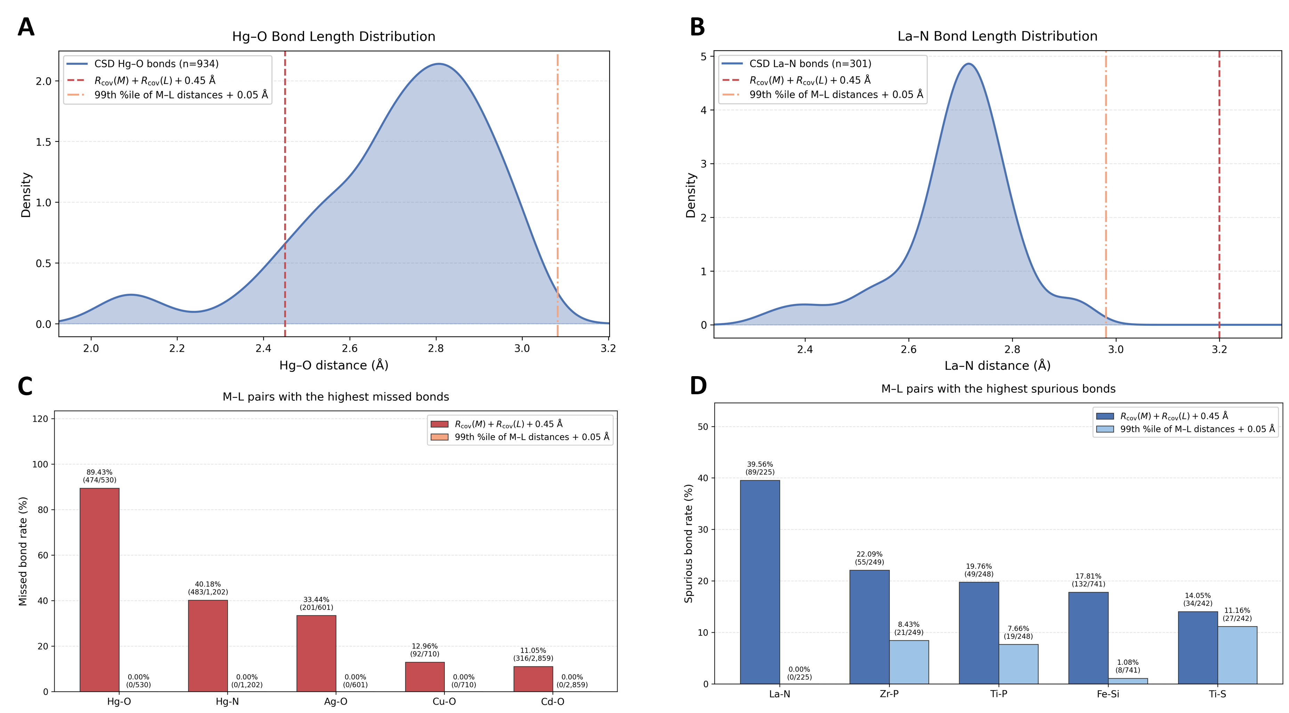
Potential $η$-coordinating fragments are identified from the raw connectivity graph by combining metal–ligand contact information with ligand-skeleton connectivity. For each metal center, all directly contacting nonmetal atoms are first collected from the raw graph. After removing metal–ligand edges, the remaining nonmetal graph is partitioned into connected ligand components. Within each ligand component, contacting atoms associated with the metal center are grouped if they remain connected through the ligand skeleton, and any group size of at least two is retained as a potential $η$-fragment.
Figure S1. Empirical calibration of transition-metal–ligand distance cutoffs from crystallographic bond-length distributions. (A) For Hg–O, the universal cutoff $R_{cov}(M)+R_{cov}(L)+0.45$Å truncates the observed bonded-distance distribution and leads to missed bonds. (B) For La–N, the same universal cutoff extends beyond the empirical upper tail and promotes spurious bonds. (C) Highest missed-bond rates and (D) highest spurious-bond rates under the universal and percentile-based schemes. The percentile-based criterion better matches pair-specific bond-length upper bounds and improves connectivity assignment in both directions.
All simple cycles up to a prescribed maximum size are enumerated from the molecular graph, and only minimal rings are subsequently retained for conjugated system analysis. Each minimal ring is then subjected to a planarity test using the minimum root-mean-square distance to a candidate plane,
 | $${RMSD}_{plane}=\min_{Π}{\left(\frac{1}{n}\sum_{k=1}^{n}{d}(r_{k},Π)^{2}\right)}^{1/2},$$ | (2)
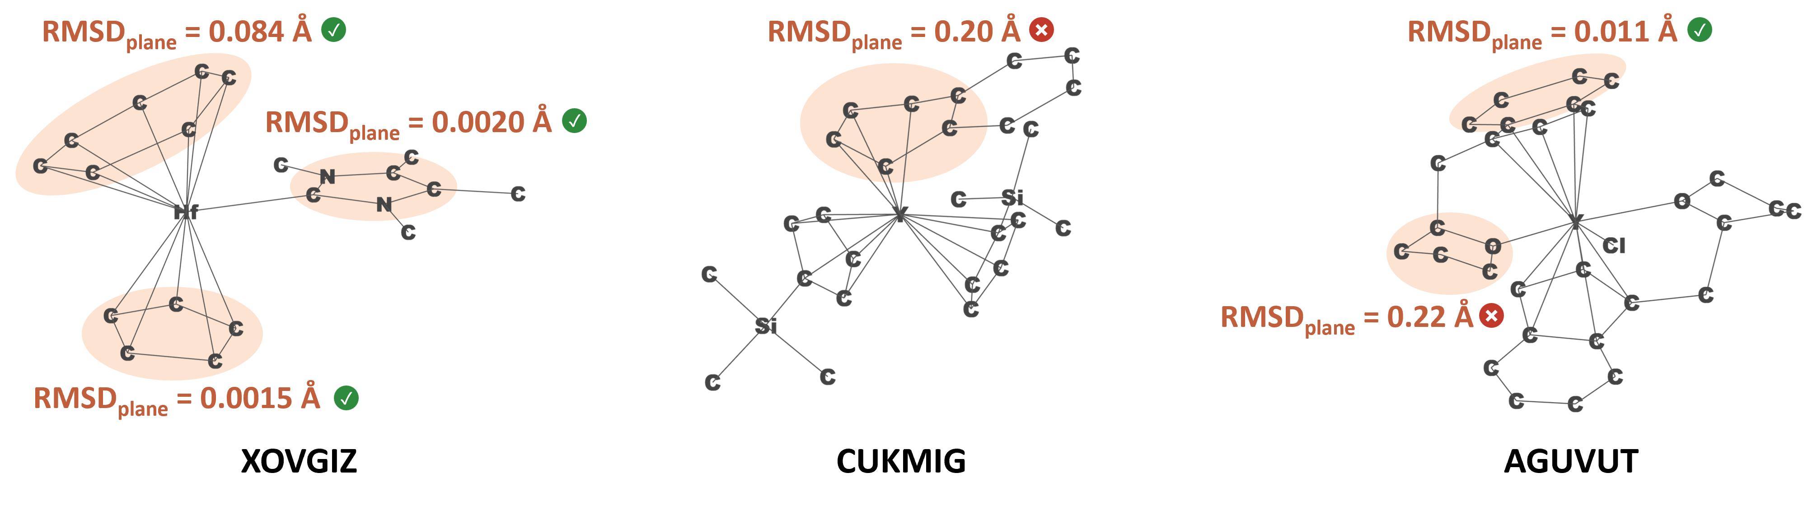
where $n$ is the number of atoms in the ring, $r_{k}$ is the Cartesian coordinate of atom $k$, and $d(r_{k},Π)$ is the perpendicular distance from atom $k$ to candidate plane $Π$. Candidate planes $Π$ are generated from all non-collinear triplets of ring atoms, and the minimum RMSD over all such planes is taken as the planarity measure. A ring is retained as planar if
Figure S2. Representative ring geometries illustrating the empirical ${RMSD}_{plane}$cutoff used in aromatic-candidate identification. Planar carbocyclic and heteroaromatic rings typically show values close to zero, while mildly distorted but still aromatic rings can approach $0.1$Å. By contrast, clearly nonplanar or nonconjugated rings generally exhibit larger values of about $0.2$Å. These examples support the use of 0.12 Å as a practical planarity threshold.
 | $${RMSD}_{plane}≤0.12 \text{Å}.$$ | (3)
Here, 0.12 Å was used as the planarity tolerance. This value was chosen empirically, as illustrated in Figure S2. For strictly planar carbocyclic aromatic rings, such as benzene and cyclopentadienyl-type rings, RMSD_{plane} is typically very small and close to zero. Similarly, planar heteroaromatic rings, such as the imidazole ring in XOVGIZ, also show near-zero RMSD_{plane} values. As ring size increases, however, aromatic rings may remain conjugated while exhibiting slight geometric distortion; for example, the seven-membered ring in XOVGIZ remains aromatic but shows a modest deviation from planarity, with RMSD_{plane} approaching 0.1 Å. In contrast, rings in which aromaticity is disrupted by pronounced puckering, such as the distorted six-membered ring in CUKMIG, or rings that are intrinsically non-aromatic because they contain saturated (sp³) atoms and/or nonconjugated heteroatoms, such as the O-containing ring in AGUVUT, typically exhibit substantially larger values, around 0.2 Å. Thus, 0.12 Å provides a practical empirical cutoff for retaining fully planar and mildly distorted rings that remain compatible with aromatic delocalization while excluding clearly nonplanar rings. Among the planar minimal rings, only those containing no hydrogen or transition-metal atoms and at least four atoms from $\{C,N, O, S, P\}$are retained as aromatic candidates. Fused aromatic systems are then assembled by merging rings that share an edge, and these systems are subsequently used in the aromaticity-related objective term.

ILP formulation: decision variables and hard constraints
During the bond-order optimization process, for each candidate bond in ligand $(i,j)∈E$, two binary upgrade variables are introduced,
 | $$u_{ij}^{(2)}, u_{ij}^{(3)}∈\{0,1\},$$ | (4)
subject to
 | $$u_{ij}^{(3)}≤u_{ij}^{(2)},$$ | (5)
such that the final bond order is
 | $$b_{ij}=1+u_{ij}^{(2)}+u_{ij}^{(3)}.$$ | (6)
Thus, each candidate edge is constrained to be at least single and may be promoted to double or triple bond order.
For each candidate transition-metal–ligand contact $(m,l)$, a binary variable
 | $$z_{ml}^{cov}∈\left\{0,1\right\}$$ | (7)
is introduced to distinguish covalent and dative assignments in the Lewis graph. Here, $z_{ml}^{cov}=1$denotes a covalent metal–ligand bond, whereas $z_{ml}^{cov}=0$denotes a dative/noncovalent interaction represented with Lewis bond order 0. Two additional binary promotion variables $u_{ml}^{\left(2\right)}$and $u_{ml}^{\left(3\right)}$are introduced with
 | $$u_{ml}^{\left(3\right)}≤u_{ml}^{\left(2\right)}≤z_{ml}^{cov},$$ | (8)
and an integer bond-order variable $b_{ml}∈${0, 1, 2, 3} is constrained so that
 | $$b_{ml}=0 \text{if } z_{ml}^{cov}=0,$$ | (9)
and
 | $$b_{ml}=1+u_{ml}^{\left(2\right)}+u_{ml}^{\left(3\right)} \text{if } z_{ml}^{cov}=1.$$ | (10)
Accordingly, a metal–ligand contact may be represented either as a zero-order dative interaction or as a covalent bond of order 1, 2, or 3. For monatomic ligands $\{H, F, Cl, Br, I\}$, dative assignment and bond-order promotion are disallowed, and the $b_{ml}$ is fixed at 1, corresponding to a covalent single bond.
For each non-transition-metal atom $i$treated under the standard valence model, integer variables are introduced for lone-pair count $lp_{i}$, formal charge $q_{i}$, and duet/octet slack variables $o_{i}^{+}$and $o_{i}^{-}$. If $N\left(i\right)$denotes the set of atoms connected to $i$in the ILP Lewis graph, the bond-order sum is
 | $$B_{i}=\sum_{j∈N(i)}{b_{ij}}.$$ | (11)
The assigned and local electron counts are then defined as
 | $$e_{i}^{ass}=2lp_{i}+B_{i},{ e}_{i}^{loc}=2lp_{i}+2B_{i},$$ | (12)
and the formal charge is given by
 | $$q_{i}=v_{i}-e_{i}^{ass},$$ | (13)
where $v_{i}$is the neutral-atom valence-electron count of atom $i$. Duet/octet balance is imposed through
 | $$e_{i}^{loc}-t_{i}=o_{i}^{+}-o_{i}^{-},$$ | (14)
where $t_{i}$is the allowed local electron target for atom $i$. For standard main-group atoms, $t_{i}$ = 2 for H and Li and $t_{i}$ = 8 otherwise. To accommodate common electron-deficient and hypervalent motifs, the allowed target set is expanded in an element- and environment-dependent manner: B and transition-metal-bound C/Si use a 6e/8e target set; S, P, and As atoms with suitable electronegative neighbors use an 8e/10e/12e target set; and heavy halogens Cl, Br, and I in selected hypervalent environments use an 8e/10e/12e/14e target set. In all cases, the selected target is enforced as a hard constraint
 | $$o_{i}^{+}=o_{i}^{-}=0.$$ | (15)
Ion-like $s$-block metals are treated through a simplified charge model without explicit lone-pair or octet variables, whereas transition metals are excluded from the standard octet-based electron-counting treatment.
To correctly represent carbene-type donor ligands, such as N-heterocyclic or thiazolium-derived carbenes, while avoiding chemically unreasonable lone-pair assignments within haptically coordinated carbon frameworks, carbon atoms belonging to geometrically identified $η$-fragments are constrained to have zero lone pairs:
 | $$lp_{i}=0,i∈C_{η}.$$ | (16)
Here, $C_{η}$denotes the set of carbon atoms belonging to geometrically identified $η$-coordinating fragments. Carbon lone-pair assignments outside $η$-fragments are not forbidden at this stage and are instead controlled by the objective function described below.
Global charge consistency is enforced through
 | $$\sum_{i∈V_{lig}}{q_{i}}+\sum_{m∈V_{TM}}{{ox}_{m}}-\sum_{(m,l)∈E_{M-L}}{b_{ml}}=Q_{mol},$$ | (17)
where $Q_{mol}$ is the total TMC charge and ${ox}_{m}$is the oxidation state assigned to transition-metal center $m$, selected from a predefined allowed set for that metal.

Objective-function construction and ILP optimization
The hard constraints defined above are assembled into a single ILP model, after which auxiliary variables and objective terms are introduced to encode charge separation, electronegativity bias, and aromaticity consistency.
To linearize absolute formal charges, an auxiliary nonnegative variable $a_{i}$ is introduced for each atom $i$, subject to
 | $$a_{i}≥q_{i}, a_{i}≥-q_{i}, a_{i}≥0.$$ | (18)
Another auxiliary nonnegative variable $q_{i}^{-}$ is introduced for each atom $i$ to represent the negative part of the formal charge, subject to
 | $$q_{i}^{-}≥-q_{i}, q_{i}^{-}≥0.$$ | (19)
Under minimization, these constraints yield
 | $a_{i}=∣q_{i}∣$and $q_{i}^{-}=max⁡(0,-q_{i})$. | (20)
To penalize localization of negative formal charge on atoms that are not strongly electronegative, an electronegativity-dependent coefficient $α_{i}$is assigned to each atom:
 | $$α_{i}=max⁡(0, 4.0-χ_{i}),$$ | (21)
where $χ_{i}$is the Pauling electronegativity of atom $i$. Thus, negative charge on less electronegative atoms incurs a larger penalty than negative charge on more electronegative atoms.
To suppress chemically unreasonable lone-pair assignments on ordinary carbon atoms, an additional elastic penalty is applied to carbon atoms not adjacent to any transition metal. For each such carbon atom $i∈C_{remote}$, a nonnegative integer violation variable $v_{i}^{C}$is introduced:
 | $$lp_{i}≤v_{i}^{C}.$$ | (22)
Because the objective function is minimized, the penalty term
 | $$w_{C,remote}\sum_{i∈C_{remote}}{v_{i}^{C}}$$ | (23)
strongly favors $lp_{i}$ = 0 for carbon atoms not adjacent to a transition metal, while still allowing exceptions when required by the remaining hard constraints.
For each aromatic candidate system $s$, a Hückel-type (4n+2) $π$-electron consistency term is introduced. Let $E_{s}$ denote the set of internal edges belonging to system $s$. The total $π$-electron count $π_{s}$is defined as
 | πs=2(i,j)∈Es​uij(2)-uij(3)+2i∈s​his, | (24)
where $h_{is}∈\{0,1\}$ indicates whether one lone pair on heteroatom $i∈\{N,O,S, P\}$ contributes to the aromatic $π$-system. Thus, only internal double bonds and explicitly assigned heteroatom lone-pair contributions are counted toward $π_{s}$. Lone-pair contribution is permitted only when the atom possesses at least one lone pair and is not simultaneously involved in an internal double bond.
The target $π$-electron count $T_{s}$is selected from a predefined table according to the number of atoms in the aromatic candidate system. In this implementation, the table covers candidate systems of 3–16 and 18 atoms, with one or two allowed target counts depending on the system size. For common system sizes, the table assigns chemically typical aromatic counts, including 6$π$electrons for five-, six-, and seven-membered systems and $10π$electrons for eight- to ten-membered systems. For sizes with two common aromatic possibilities, a binary variable is used to select between the predefined lower and higher target counts.
The deviation from the selected target is linearized as
 | $$π_{s}-T_{s}=d_{s}^{+}-d_{s}^{-},$$ | (25)
with $d_{s}^{+}$and $d_{s}^{-}$as nonnegative integer variables. The quantity $d_{s}^{+}+d_{s}^{-}$therefore measures the mismatch from the predefined aromatic target.
To encourage chemically consistent treatment of geometrically similar metal–ligand contacts on the same ligand, an additional soft consistency term is introduced for covalent versus dative assignment. For two contacts $a$ and $b$of the same metal–ligand element-pair type within one ligand fragment, with contact distances $d_{a}$and $d_{b}$, a pair weight is defined as
 | $$w_{ab}=max⁡(0,ε-∣d_{a}-d_{b}∣),$$ | (26)
where $ε$ = 0.15 Å. Let $z_{a}^{cov}$and $z_{b}^{cov}$denote the corresponding binary covalent-class variables. A binary disagreement variable $c_{ab}∈${0, 1} is introduced to represent whether these two contacts are assigned different classes, and is constrained by
 | $$c_{ab}≥z_{a}^{cov}-z_{b}^{cov},$$ | (27)

 | $$c_{ab}≥z_{b}^{cov}-z_{a}^{cov}.$$ | (28)
Under minimization of the weighted term
 | $$w_{ML}\sum_{(a,b)}{w_{ab}c_{ab},}$$ | (29)
this yields $c_{ab}=∣z_{a}^{cov}-z_{b}^{cov}∣$, so that geometrically similar contacts are biased toward the same covalent/dative classification.
An additional optional reward term is applied to ligand-internal edges belonging to geometric $η$-fragments. If $E_{η}$denotes the set of ligand edges lying within such fragments, then the term
 | $$- w_{η}\sum_{(i,j)∈E_{η}}{u_{ij}^{\left(2\right)}}$$ | (30)
is added to the objective. Because the global optimization problem is formulated as a minimization, this contribution rewards solutions containing a larger number of internal double bonds within haptically coordinated ligand fragments, thereby favoring bonding patterns compatible with delocalized $π$-systems.
The full objective function is therefore written as
 | $$\begin{aligned}\min{L}=&w_{fc}\sum_{i}{a_{i}}+w_{χ}\sum_{i}{α_{i}}q_{i}^{-} \\ &+ w_{C,remote}\sum_{i∈C_{remote}}{v_{i}^{C}}+w_{arom}\sum_{s}{\left(d_{s}^{+}+d_{s}^{-}\right)} \\ &+{ w}_{ML}\sum_{\left(a,b\right)}{w_{ab}}c_{ab}-w_{η}\sum_{\left(i,j\right)∈E_{η}}{u_{ij}^{\left(2\right)}}.\end{aligned}$$ | (31)
Here, $w_{fc}$, $w_{χ}$, $w_{C,remote}$, $w_{arom}$, $w_{ML}$, and $w_{η}$are user-defined weights controlling the relative importance of absolute formal charge, electronegativity-weighted negative charge, remote-carbon lone-pair violations, aromaticity deviation, metal–ligand class consistency, and maximization of ligand-internal double bonds in geometric $η$-fragments, respectively.
The resulting ILP is solved using the COIN-OR Branch-and-Cut solver¹¹ through the PuLP¹² interface. If the hard constraints are jointly feasible, the solver returns a globally optimal solution with respect to the weighted linear objective. That objective is a single weighted sum of chemically motivated penalties and need not admit a unique minimizer: distinct Lewis assignments (for example, Kekulé-equivalent placements of double bonds) can share the same objective value. The solver is invoked once and returns one minimizer; among equal-objective assignments, the first incumbent attaining the best objective is retained, with no secondary chemical ranking. Because a given XYZ file fixes the atom ordering, and thus the constraint matrix and variable order, this selection is deterministic for a given geometry and molecular charge. From the returned solution, the final bond orders, formal charges, oxidation states, and ligand bonding classifications are extracted.

Postprocessing: CBC bonding analysis and SMILES generation
After the globally optimal Lewis-like structure has been obtained, the solution is postprocessed to generate an interpretable metal-centered bonding analysis in the language of CBC as an automated implementation of Green’s $ML_{n}X_{m}$ method, together with an RDKit-compatible dative SMILES representation. This stage uses the optimized bond orders, lone-pair occupations, formal charges, and coordination geometry to classify local metal–ligand interactions as $L$-, $X$-, or $Z$-type contributions.
In general CBC terms, 1) coordinating atoms involved in dative metal–ligand interactions are interpreted as $L$-type donors with $b_{ml}=0$, 2) coordinating atoms participating in covalent metal–ligand bonds are interpreted as $X$-type donors with $z_{ml}^{cov}=1$ and $b_{ml}>0$. Electron-accepting interactions are assigned as $Z$-type contributions during the postprocessing stage.
For non-hydrogen ligand atoms in geometrically identified $η$-coordinating groups, the classification is derived from the ILP bond orders and local ligand bonding pattern. If a coordinating atom $i$ has positive metal–ligand bond order, the corresponding interaction is recorded as an $X$-type contribution. If the metal–ligand Lewis bond order is zero, the atom is treated as a dative-contact candidate. Adjacent dative-contact atoms within the same coordinating group are combined into one $L$-type record when their internal ligand–ligand bond order has at least double-bond character. Remaining unpaired dative-contact atoms are assigned as a single coordinating atom $L$-type donors only if they retain at least one lone pair in the optimized Lewis structure. The resulting $L/X$composition of a haptic fragment is therefore determined by the solved Lewis bond orders and lone-pair occupations rather than by a fixed mapping from hapticity alone.
Hydrogen-containing interactions are treated by a separate set of structural rules. A hydrogen atom with positive metal–hydrogen bond order is classified as an $X$-type hydride. When a hydrogen atom is not covalently bound to the metal but is attached to a neighboring atom $∈\{B,C,Si,Al,Ga\}$, the interaction is classified as an $L$-type agostic $σ$-coordination. Short $η^{2}$-$H_{2}$ contacts with a metal center are likewise treated as $L$-type donors. These dedicated hydrogen rules allow the method to distinguish hydride, agostic hydrogen, and dihydrogen motifs within the same postprocessing framework.
The CBC classification is stored as a set of interaction records of the form $(A, T)$, where $A$is either a single coordinating atom or a small atom tuple representing a paired donor fragment, and $T∈\left\{L,X,Z\right\}$is the assigned CBC type. For each metal center, the total numbers of $L$-, $X$-, and $Z$-type records are then summarized as an $L_{n}X_{m}Z_{p}$ designation. In cases of multiple covalent bond order between a metal and one donor atom, repeated $X$-type contributions are retained in the report so that terminal oxo-, imido-, or nitrido-like environments are represented by the corresponding multiplicity of covalent contributions.
In parallel with the CBC analysis, the optimized structure is converted into a graph-based molecular representation suitable for SMILES generation. Covalent bonds are written directly from the solved ILP bond orders. Dative metal–ligand interactions are then added from the CBC postprocessing stage, but only for contacts with a bond order of zero that are classified as $L$-type donors. For haptic donors, the dative representation is atom-resolved, so that each donating contact atom may contribute an individual donor-to-metal arrow in the exported graph. The resulting RDKit molecule is finally sanitized where possible and converted into a SMILES string containing both covalent and dative bonding information.
The final output therefore comprises the complete bond-order assignment, lone-pair counts, formal charges, transition-metal oxidation-state assignments, a center-specific CBC bonding report, and a corresponding SMILES string.

Algorithm efficiency
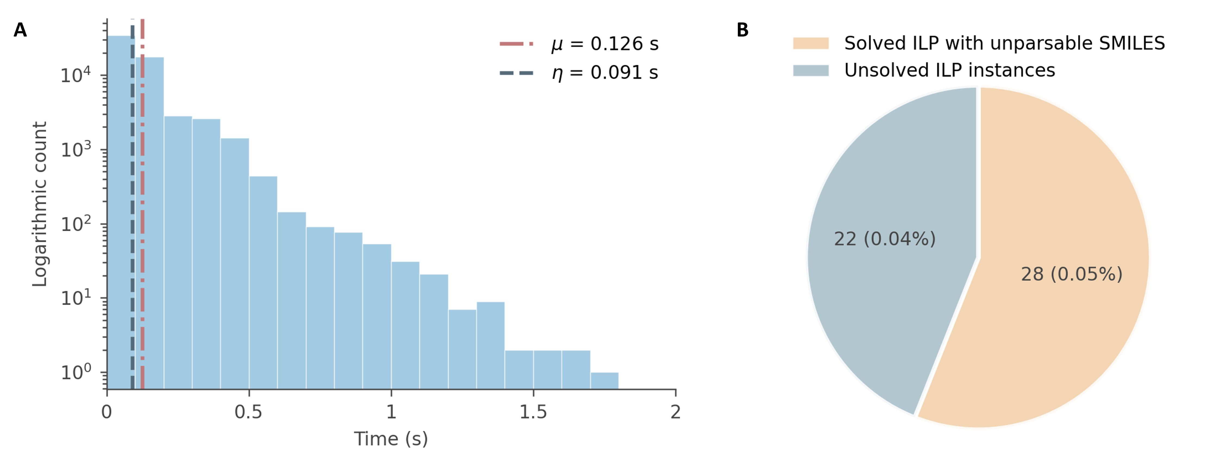
Figure S3 provides the distribution of ILP execution times for the tmQMg benchmark set used in this work, after removal of structures outside the intended scope of the current implementation. Both successful and failed workflow cases are included so that the timing analysis reflects the actual computational cost of applying the algorithm across the full benchmark set. The ILP optimization was completed within one second for most complexes, with mean and median execution times of 0.126 s and 0.091 s, respectively. This subsecond performance for the majority of cases demonstrates that the optimization-based formulation remains computationally efficient for large-scale annotation of mononuclear transition-metal complexes.
Figure S3. Histogram of ILP execution times for the tmQMg benchmark set. Most complexes were solved within one second, indicating that the ILP formulation is suitable for large-scale automated processing.

Comparison with xyz2mol_tm
Both TMC-LewisGen and xyz2mol_tm reconstruct molecular graphs and machine-readable SMILES representations of transition-metal complexes from Cartesian coordinates and the total molecular charge. However, the two methods use fundamentally different strategies. TMC-LewisGen formulates bond-order assignment as a global ILP problem, in which ligand bond orders, lone-pair populations, formal charges, metal oxidation states, and covalent versus dative metal–ligand interactions are determined simultaneously under specific constraints. In contrast, xyz2mol_tm uses a sequential heuristic workflow. It first generates a distance-based adjacency matrix, disconnects the metal from its ligands, estimates the charge of each ligand using extended Hückel calculations, reconstructs ligand bond orders (AC2mol), and finally reconnects the ligands to the metal and applies resonance, charge, and RDKit sanitization procedures. Consequently, errors introduced at an early stage of xyz2mol_tm, particularly during connectivity perception or ligand-charge estimation, can propagate through the remainder of the workflow, whereas the ILP formulation can resolve interdependent variables within a single globally constrained model.
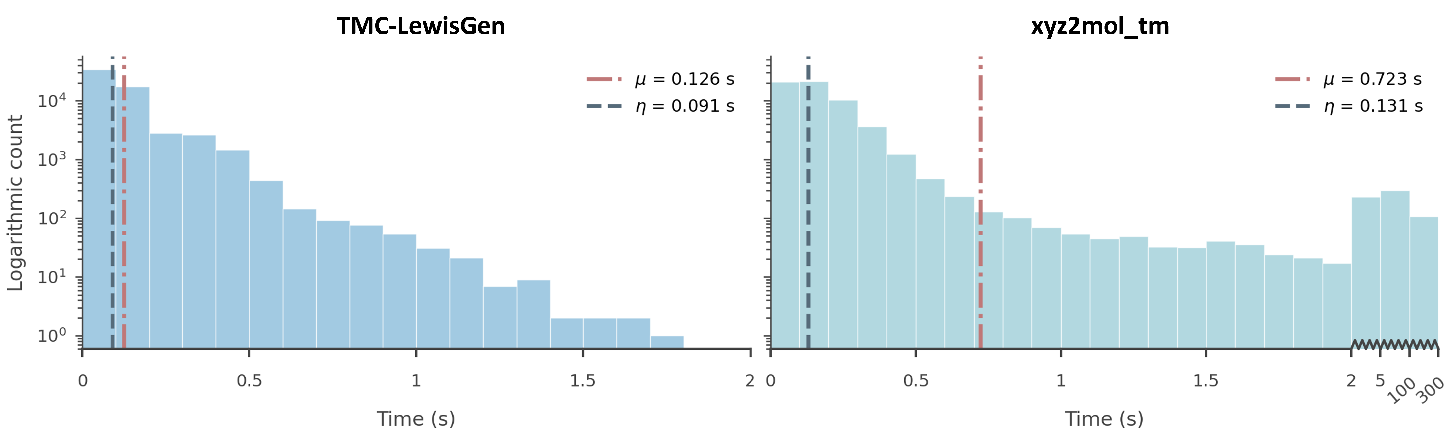
The computational efficiencies of the two approaches were compared using the same 59,596 complexes after applying the TMC-LewisGen exclusion criteria (Figure S4). After metal–ligand disconnection, xyz2mol_tm estimates each ligand charge by an extended Hückel calculation, enumerates bond-order matrices over the Cartesian product of atomic valence lists (AC2BO), and scores charge distributions by iterating RDKit ResonanceMolSupplier forms. The number of valence combinations grows approximately exponentially with the number of atoms that admit alternative valences. Large conjugated ligands remain a single fragment after the metal is removed, possess a vast Kekulé space. Representative cases on tmQMg CSD geometries include phthalocyanines (CINPOG, JUGRIO, OPEVIP), porphyrins (DEGPOW, MIKWIO, WETKOX), boron-capped clathrochelate oximes (KOGQED, MOGFAQ, KEKMAQ), and fullerene or carbon-cage complexes (FEHCAX, NUHPIR, TAZRAP). xyz2mol_tm is therefore fast for typical small ligands but develops a minutes-long tail on these systems: CINPOG, DEGPOW, KOGQED and NUHPIR each reached the 300 s wall-clock limit, whereas FEHCAX returned only after 262 s. The same four timeout structures were assigned by the ILP solver in 0.57, 0.31, 0.16 and 1.06 s, respectively.
Figure S4. Runtime histograms of TMC-LewisGen and xyz2mol_tm for 59,596 tmQMg complexes (logarithmic counts). The left axis is linear over 0–2 s; the right axis is broken after 2 s to show the xyz2mol_tm tail (2–5, 5–100, and 100–300 s). $μ$ and $η$ are the mean and median time. All TMC-LewisGen jobs finish within 1.71 s; xyz2mol_tm has 402 jobs slower than 5 s (57 at the 300 s timeout).
The ILP formulation treats bond orders, formal charges, and the metal oxidation state as decision variables of a single integer program on a distance-derived connectivity graph. It neither enumerates valence tuples nor expands resonance structures. The computational cost therefore tracks the number of atoms and bonding constraints rather than the size of the $π$-resonance space. On the same tmQMg CSD geometries, the ILP solver required a median of 0.09 s, a mean of 0.13 s, and a maximum of 1.7 s, with no instance exceeding 5 s. xyz2mol_tm showed a comparable median (0.13 s), but its mean rose to 0.7 s because of the long tail (Figure S4): more than 400 cases exceeded 5 s and several dozen reached the 300 s timeout. Among structures solved by both methods, the ILP assignment was faster in 72% of cases. The practical distinction is thus not a modest shift in the typical molecule, but the worst-case behaviour: combinatorial search in xyz2mol_tm loses a predictable time bound on large $π$ systems such as CINPOG and FEHCAX, whereas the ILP solution remains reproducible on the timescale of seconds for the same geometries.
On the aligned dataset, TMC-LewisGen generated a successful, RDKit-parseable SMILES for 59,546 of 59,596 complexes, corresponding to an end-to-end success rate of 99.92%. Under the same dataset definition, xyz2mol_tm successfully generated a SMILES for 58,993 complexes, corresponding to a success rate of 98.99%. There were 603 structures for which TMC-LewisGen produced a parseable result but xyz2mol_tm did not.
A substantial fraction of the failures occurred after the preliminary ligand-level reconstruction had already succeeded. In 366 diagnostic cases, the Hückel charge and preliminary AC2mol reconstruction were acceptable for all matched ligands, but the complete xyz2mol_tm workflow still failed during ligand processing, metal–ligand reassembly, resonance correction, or final molecular sanitization. Of these cases, predominantly because invalid or null intermediate molecular objects were passed to subsequent RDKit operations. Because xyz2mol_tm is a sequential workflow, contradictions detected during these late stages do not trigger a global reassignment of ligand charges, bond orders, and metal oxidation states. TMC-LewisGen largely avoids this failure mode by enforcing these quantities simultaneously and by explicitly representing common transition-metal bonding motifs, including haptic coordination, covalent and dative metal–ligand bonds, carbonyls, nitriles, isonitriles, nitrosyls, and carbene ligands.
Further diagnostic analysis showed that ligand-charge estimation was nevertheless an important source of failure. Among the reproducible non-timeout cases, 152 structures contained at least one ligand for which the extended Hückel charge differed from the charge obtained by the globally balanced ILP model. For 38 structures, replacing the Hückel-derived charge with the ILP-derived charge was sufficient to allow AC2mol to construct the ligand, providing direct evidence that ligand-charge estimation was the limiting step in these cases. Other failures arose because the fixed adjacency matrix and candidate valence combinations could not yield a valid bond-order assignment, even when the ligand charge was appropriate. This behavior is particularly relevant for several coordination environments, haptic ligands, metal–carbon and metal–silicon interactions, highly delocalized ligands, and structures containing unusual resonance or formal-charge distributions.
Overall, the principal advantage of TMC-LewisGen is the integration of chemical knowledge into a globally consistent and computationally efficient optimization framework. Its improved success rate does not arise merely from the use of an optimization solver, but from simultaneously enforcing molecular charge conservation, local electron-counting rules, chemically plausible metal oxidation states, aromaticity, and coordination-specific bonding constraints. This formulation reduces error propagation from local charge estimates, avoids much of the combinatorial runtime tail observed for xyz2mol_tm, and provides substantially more robust reconstruction of diverse transition-metal complexes.

Reproducibility and parameterization
The source code used in this work is available as an open repository https://github.com/Reecy-Z/TMC-Lewis-Structure. All calculations use Cartesian XYZ coordinates in Å, and the total molecular charge is supplied explicitly through the command-line interface or graphical interface. The input atom order is retained throughout connectivity construction, ILP formulation, and reporting of the final assignment.
For the default workflow, transition-metal–nonmetal contacts are identified from the element-pair-specific 99th-percentile distance limits in tm_nonmetal_bond_limits.json with an added margin of 0.05 Å. Other covalent contacts are identified using ccdc_covalent_radii.json and the criterion R_{cov,i} + R_{cov,j} + 0.45 Å; the margin is reduced to 0.40 Å when either atom is an s-block element (Li, Be, Na, Mg, K, Ca, Rb, Sr, Cs, or Ba). Atom pairs separated by less than 0.60 Å are rejected as overlapping. The metal–ligand distance-class consistency threshold is 0.15 Å: contacts to the same ligand with distance differences below this value are softly biased toward the same σ/coordination class. The minimum size of a haptic coordinating group is two contiguous metal-bound atoms, the MIP/Branch-and-Cut solver time limit is 10 s per structure, and a nitrosyl is treated as linear when the M–N–O angle is at least 160°.
Unless otherwise stated, the objective-function weights in Eq. 31 are w_{fc} = 100, w_{arom} = 100, w_{χ} = 10, w_{ML} = 50, w_{η} = 25, and w_{C,remote} = 200. Aromaticity is evaluated only for rings of at most 12 atoms that have a plane RMSD of at most 0.12 Å and contain at least four atoms from {C, N, O, S, P}. The allowed Hückel π-electron targets are 2 for three-membered rings; 2 or 6 for four-membered rings; 6 for rings of five to seven atoms; 10 for rings of eight to ten atoms; 10 or 14 for rings of 11 or 12 atoms. Carbon and silicon have a maximum connectivity of four. The octet, molecular-charge-balance, and η-coordinated-carbon lone-pair (lp = 0) constraints are enabled by default. The allowed oxidation-state sets are provided in the implementation and should be retained unchanged when reproducing the default workflow.
The command-line workflow requires Python 3, PuLP (≥2.7), and RDKit (≥2022.9.5); PuLP invokes its bundled COIN-OR CBC solver for the MIP calculation. Streamlit (≥1.32) is required only for the graphical interface. The repository provides the graphical workflow (streamlit run streamlit_ilp_app.py) and a command-line entry point (python Lewis-engine-ILP.py <molecule.xyz> [molecular_charge]), together with neutral and charged test inputs. Upon acceptance, we will archive a tagged release in Zenodo and cite its DOI in the final version of the SI. The archive will record the release tag, commit identifier, exact package and solver versions, parameter files, and expected outputs for these test cases.

SMILES string of the transition-metal complex
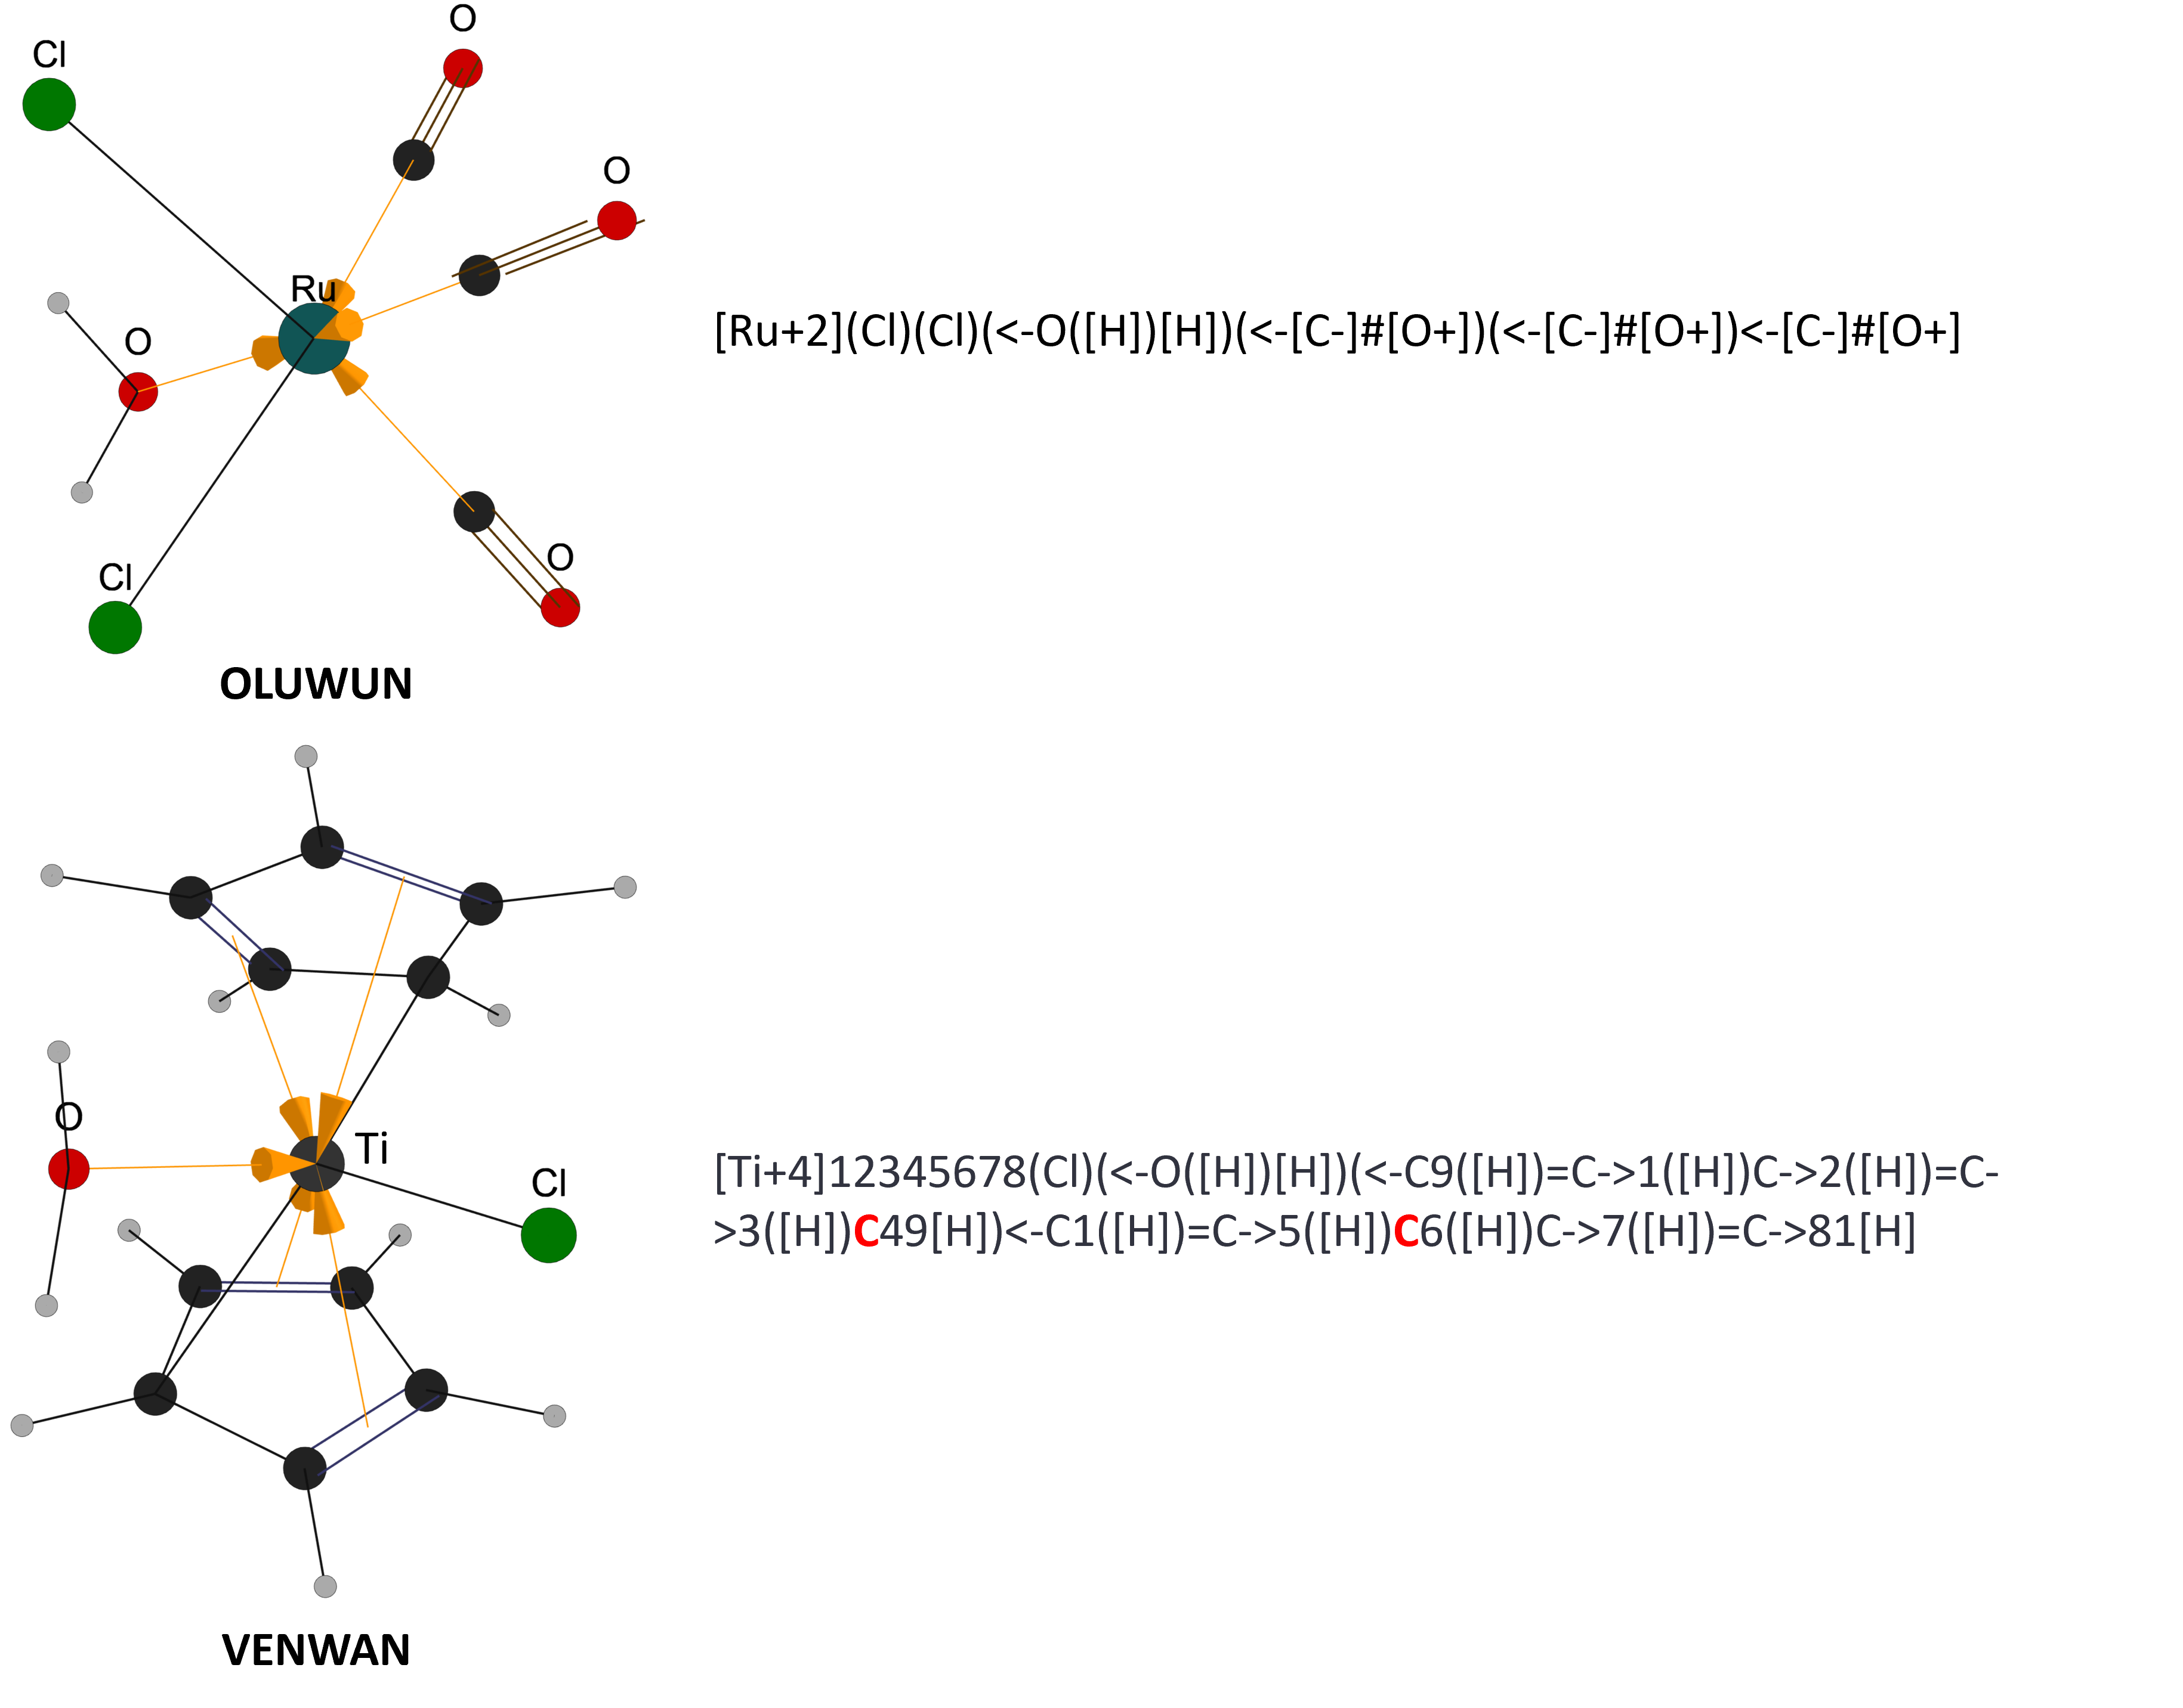
In the upper example (Figure S4), the two chloride ligands are represented as covalently bound to the metal, and this covalent connectivity is retained in the exported SMILES. The carbonyl ligands, by contrast, are classified as L-type donors, so their metal–carbon interactions are encoded as dative C→M bonds in both the graph representation and the SMILES. In the lower example (Figure S4), each Cp ring is visualized according to its CBC $L_{2}X$description: one Cp carbon atom acts as the X-type donor and forms a covalent bond to the metal, while the two C=C units act as L-type donors and are shown as dative interactions to the metal by yellow arrows. In the exported SMILES, however, dative bonds must be represented as atom-to-atom connections and cannot originate from an entire C=C bond. Therefore, for each Cp ring, the four carbon atoms involved in the two donor C=C units are individually connected to the metal by dative bonds. The Cp carbon atoms that are covalently bound to the metal in the two Cp rings retain their covalent metal–carbon connections in the SMILES and are highlighted in red. This provides an atom-resolved, SMILES-compatible representation of the CBC $L_{2}X$haptic interaction.
Figure S4. Examples of ILP-derived SMILES.
The SMILES generated in these examples are RDKit-parseable by design. This choice prioritizes compatibility with established cheminformatics infrastructure, including RDKit and Open Babel. Accordingly, the exported SMILES should be interpreted as atom-resolved connectivity representations rather than complete stereochemical descriptors of the transition-metal coordination environment. Although the covalent and dative atom-to-atom interactions assigned by TMC-LewisGen are retained, the resulting SMILES do not encode local stereochemical arrangements or coordination geometries around the metal center. Consequently, stereoisomers or complexes with the same connectivity but different coordination geometries will produce identical SMILES. This limitation is illustrated using the nonheme iron(IV)-oxo complex trans-[Fe^{IV}(O)(TetMC)(NCMe)]²⁺ reported by Rohde et al., where TetMC denotes 1,4,8,11-tetramethyl-1,4,8,11-tetraazacyclotetradecane.¹³ In the experimental structure, the terminal oxo ligand and the acetonitrile ligand occupy opposite axial positions of the iron center, while the four nitrogen donors of the macrocyclic TetMC ligand define the equatorial coordination plane. However, when represented using the RDKit-parseable SMILES exported by TMC-LewisGen, only the atom-to-atom connectivity is retained. The O_{anti} and O_{syn} arrangements shown in Figure S5 therefore share the same Fe=O, Fe–N_{TMC}, and Fe–N_{NCMe} bonding pattern and collapse to the same SMILES string. This example emphasizes that the exported SMILES should not be interpreted as complete descriptors of metal-centered stereochemistry, but rather as toolkit-compatible connectivity representations. Distinguishing such cases would require an additional geometry-aware representation layer, such as explicit coordination-site labels, axial/equatorial assignments, or specialized line notations.
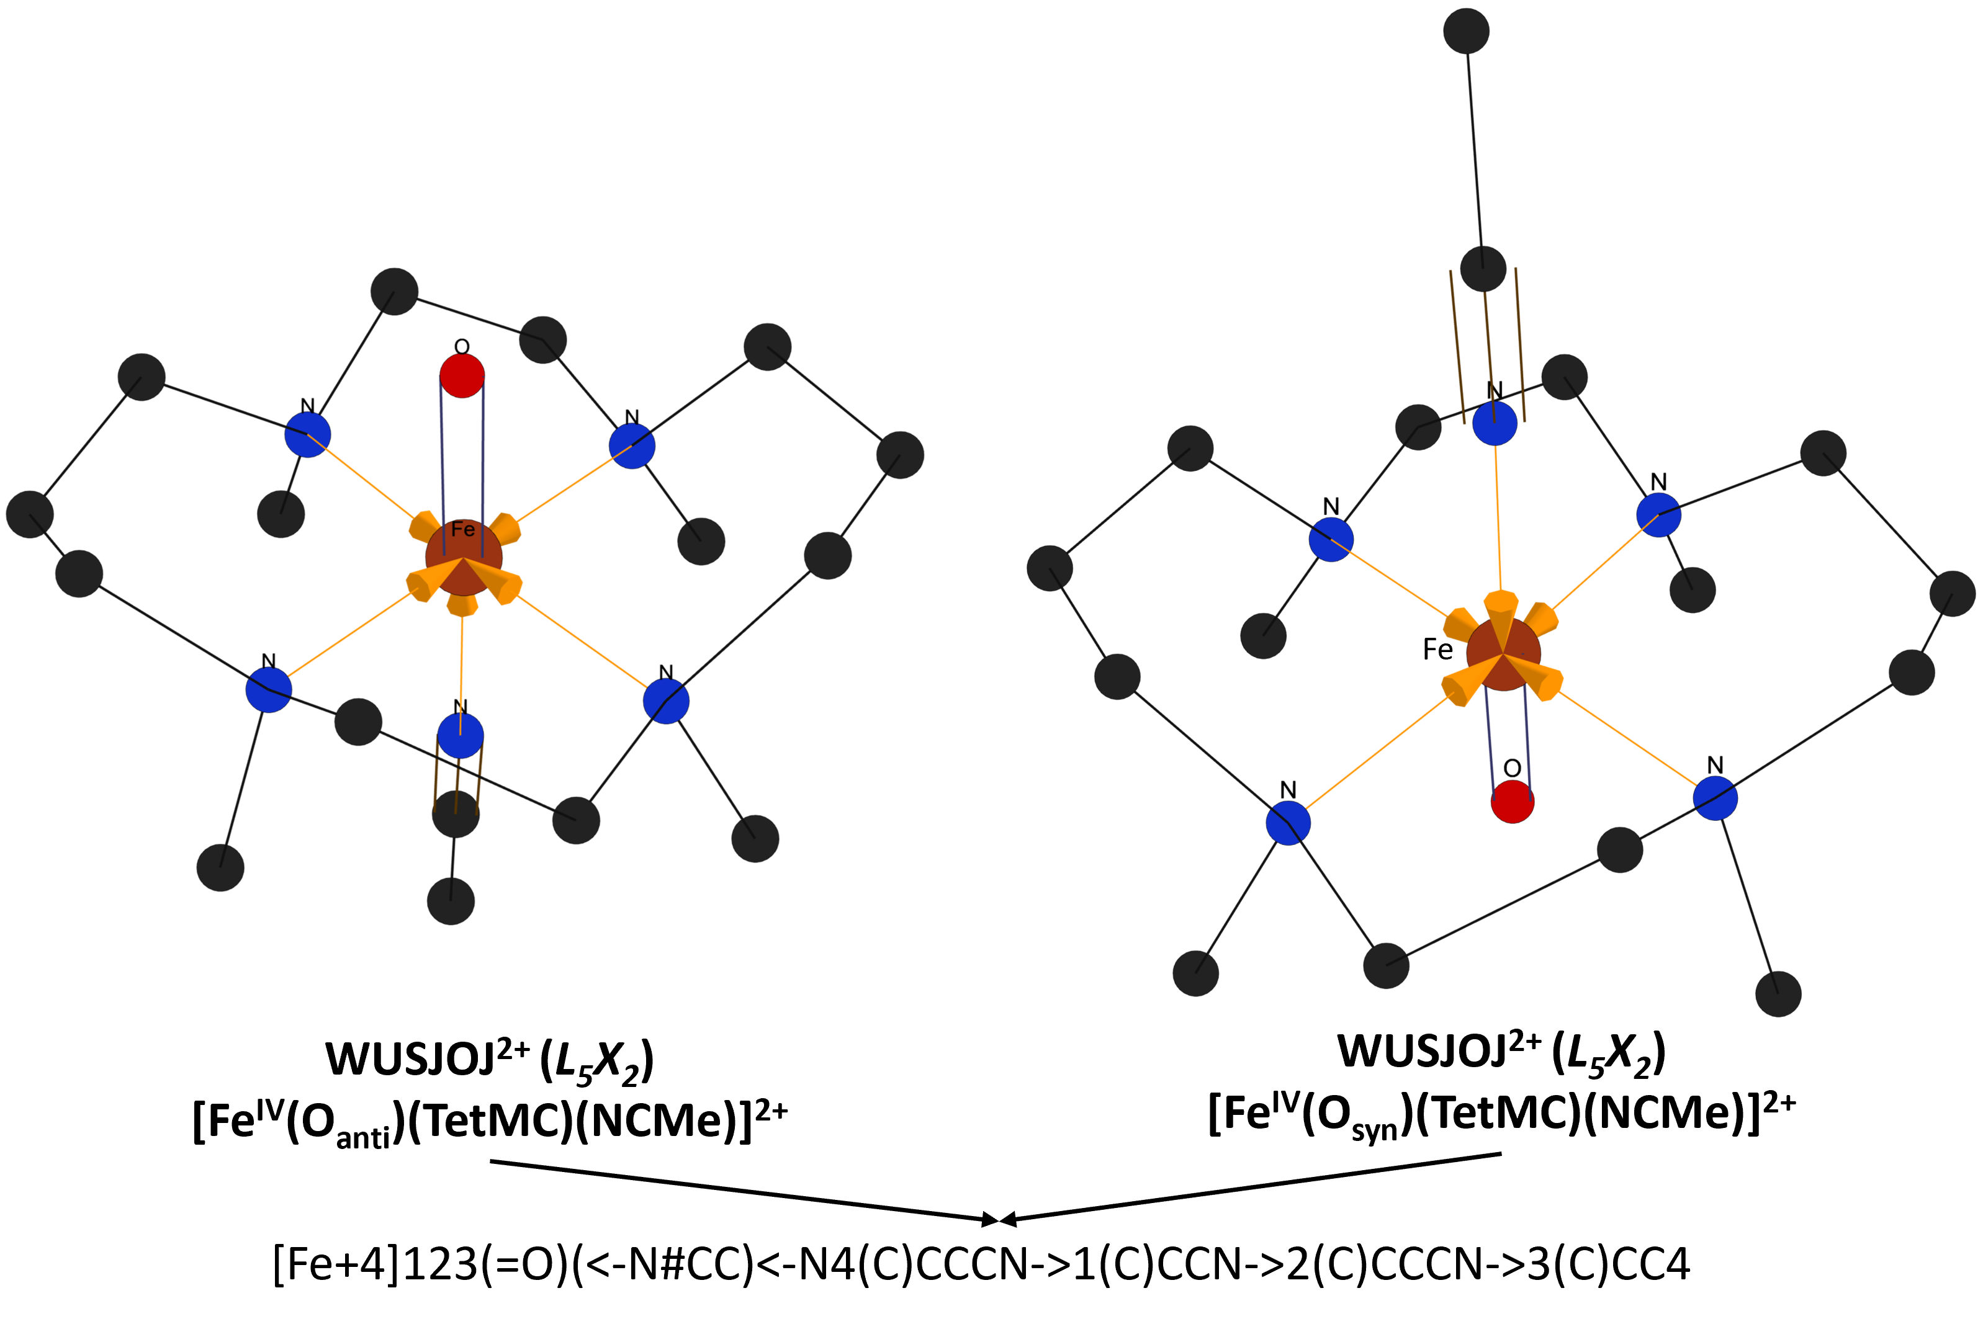
While geometry-aware representations for transition-metal complexes, such as m-SMILES¹⁴ and T-REX¹⁵, have been proposed to address this limitation, they remain specialized line notations that require dedicated parsers or conversion routines before they can be used in conventional cheminformatics workflows. For example, m-SMILES explicitly encodes coordination-site assignments and geometry tags to guide 3D conformer generation, but it is not directly compatible with RDKit standard SMILES parsing. T-REX introduces a canonical trans-pair map that can distinguish coordination isomers and improve geometry-aware machine-learning representations, but its current formal guarantees are mainly established for monometallic complexes with coordination numbers up to six, and higher-coordinate, or explicitly chiral metal-centered cases require further extension. Moreover, both representations require nonstandard syntax and dedicated processing before integration with standard SMILES-based routines such as canonicalization, substructure searching, fingerprint generation, and descriptor calculation. Therefore, TMC-LewisGen retains RDKit-parseable SMILES as the default exported string representation, enabling direct integration with existing molecular graph processing and cheminformatics workflows while providing a basis for future extensions toward geometry-aware representations.
Figure S5. Illustration of a limitation of the RDKit-parseable SMILES generated by TMC-LewisGen using the [Fe^{IV}(O)(TetMC)(NCMe)]²⁺ complex. The O_{anti} and O_{syn} depictions differ in the local three-dimensional arrangement of the terminal oxo ligand relative to the macrocyclic TetMC environment, but they have identical atom-to-atom connectivity around the Fe center. Consequently, both structures are represented by the same RDKit-parseable SMILES.

Formal Lewis-like structures of radical and redox non-innocent ligands
Radical ligands and redox non-innocent ligands are challenging cases for Lewis-structure generation workflows. In such systems, electronic-structure information cannot be uniquely encoded using only Cartesian coordinates and the total molecular charge. The current implementation of TMC-LewisGen treats ligands within a closed-shell formalism. Therefore, the generated Lewis structures should be regarded as formal Lewis-structure-based representations that provide an initial chemically interpretable description of the coordination environment, rather than as unique assignments of ligand redox states or metal oxidation states.
In the side-on dioxygen complex MOZDUC (Fig. S6A), the structure was assigned in the original report as an oxo-peroxo molybdenum complex of the type [CpMo(O₂)(O)R].¹⁶ However, in the current workflow, the O₂ fragment is represented as a neutral closed-shell dioxygen ligand, O=O, coordinated to the metal center through metal–oxygen coordination interactions. This representation results from the combination of formal-charge minimization and octet-rule constraints implemented in TMC-LewisGen. Thus, the workflow does not distinguish among neutral O₂, superoxo, and peroxo descriptions.
Nitrosyl ligands represent a special case and are treated using a geometry-based formal representation. For example, for a linear nitrosyl ligand, as shown for ACUYUT (Fig. S6B), TMC-LewisGen represents it as a coordination interaction between the metal center and a formally nitrosonium-like fragment, MN≡O⁺. For a bent nitrosyl ligand, as shown for FOHWII (Fig. S6C), the workflow generates a covalent M-N=O structure.
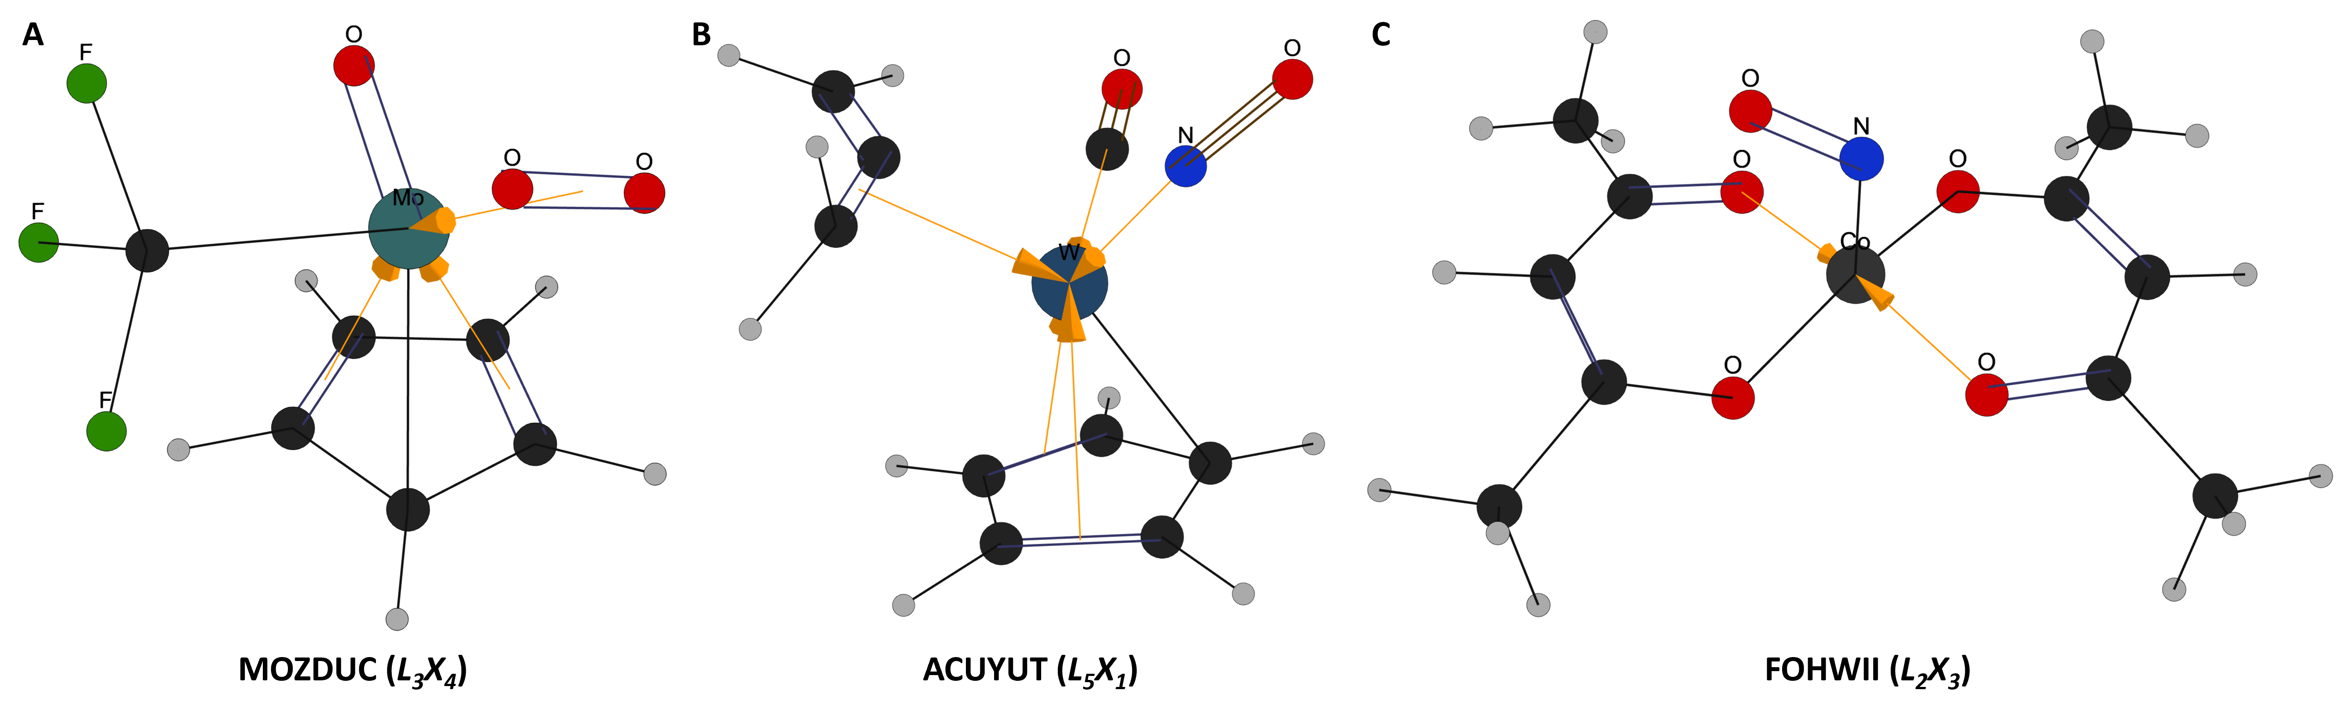
Overall, these examples highlight an important limitation of the current rule-based approach. TMC-LewisGen provides formal closed-shell Lewis structures that are useful as chemically interpretable starting points. However, when formal oxidation states, ligand redox states, or spin states are of interest, especially for radical and redox-noninnocent ligands, further expert inspection is required.
Figure S6. Representative Lewis-structure representations of radical and redox non-innocent ligands generated by TMC-LewisGen. (A) Side-on O₂ ligand in MOZDUC, represented as neutral O=O. (B) Linear nitrosyl ligand in ACUYUT, represented as MN≡O⁺. (C) Bent nitrosyl ligand in FOHWII, represented as M-N=O.

Failure cases
Table S1. Summary of failure cases in tmQMg data set
CSD ID | Type | Failure Note
BOJHOZ | Unsolved ILP | borazine
DUZPAP | Invalid SMILES | borole anion
CANROB | Invalid SMILES | borabenzene
CAXYEG | Invalid SMILES | azaborolyl
CIBHAX | Unsolved ILP | The distal S and O atoms are identified as coordinating atoms to Hg based on their distances.
FETBIS | Unsolved ILP | The two B atoms are determined to be bonded based on their distance.
FETBOY | Unsolved ILP | The two B atoms are determined to be bonded based on their distance.
FETBUE | Unsolved ILP | The two B atoms are determined to be bonded based on their distance.
GIDFUU | Unsolved ILP | The two B atoms are determined to be bonded based on their distance.
GIQGAO | Invalid SMILES | borole anion
JAFZAU | Unsolved ILP | The distal B atom is also identified as a coordinating atom to Ni based on the distance.
JOZJEN | Unsolved ILP | The distal H atom is also identified as a coordinating atom to Ta based on the distance.
KAGPAJ | Invalid SMILES | borole anion
KEZYIA | Unsolved ILP | C31 is not identified as a coordinating atom to Rh.
LOFMAV | Invalid SMILES | azaborolyl
MAWXIR | Invalid SMILES | borabenzene
MIZVUM | Invalid SMILES | borole anion
NAFSIW | Unsolved ILP | The distal H atom is also identified as a coordinating atom to Ta based on its distance.
NAWROS | Invalid SMILES | borabenzene
NAWRUY | Invalid SMILES | borabenzene
PADGOQ | Unsolved ILP | The distal S and O atoms are identified as coordinating atoms to Hg based on their distances.
PIQFIE | Unsolved ILP | Terminal Borylene
QAHFOV | Unsolved ILP | The distal C atom is identified as a coordinating atom to Ni based on its distance.
QEPDIZ | Unsolved ILP | Terminal Borylene
QIXSUL | Unsolved ILP | The distal S and O atoms are identified as coordinating atoms to Hg based on their distances.
RAKWUY | Unsolved ILP | The B and F atoms are identified as coordinating atoms to Pd based on their distances.
RURHUH | Invalid SMILES | borabenzene
RUSVEG | Invalid SMILES | borole anion
SEQXUH | Invalid SMILES | borole anion
SEQYES | Invalid SMILES | borole anion
SETRUE | Unsolved ILP | The distal B atom is identified as a coordinating atom to Ti based on its distance.
TIQVAQ | Unsolved ILP | The distal S atom is identified as a coordinating atom to Zn based on its distance.
TUZMAC | Invalid SMILES | borabenzene
UDOFIC | Invalid SMILES | borabenzene
VUNZUZ | Unsolved ILP | The distal S atom is identified as a coordinating atom to Zn based on its distance.
WEHTOT | Unsolved ILP | The distal S atom is identified as a coordinating atom to Zn based on its distance.
WEQCOK | Invalid SMILES | borabenzene
WEQCUQ | Invalid SMILES | borabenzene
XAGFAP | Invalid SMILES | azaborolyl
XAGFET | Invalid SMILES | azaborolyl
XAGFIX | Invalid SMILES | azaborolyl
XAGFOD | Invalid SMILES | azaborolyl
XAGGAQ | Invalid SMILES | azaborolyl
XITSEY | Unsolved ILP | The distal S atom is identified as a coordinating atom to Ti based on its distance.
XIXCUE | Invalid SMILES | borabenzene
XIXDIT | Invalid SMILES | borabenzene
XIXDOZ | Invalid SMILES | borabenzene
XOFPAM | Unsolved ILP | The distal B and F atoms are identified as coordinating atoms to Cu based on their distances.
YARMEL | Invalid SMILES | triiodide anion
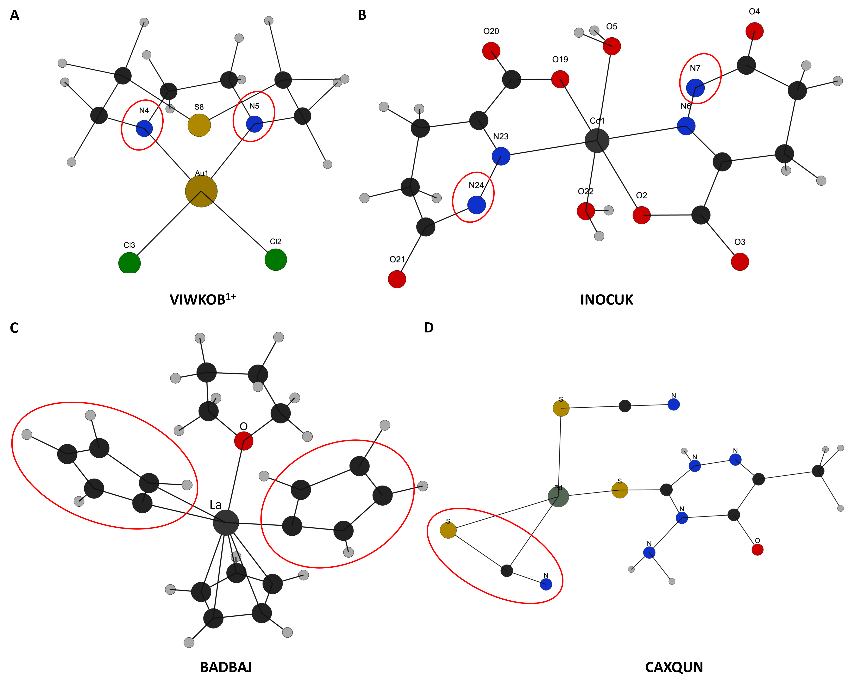
During manual inspection of the failed cases, we found that a small number of failures originated from problematic input geometries in the tmQMg data set. Because the tmQMg structures were generated by geometry optimization starting from CSD-derived experimental structures, structural issues in the initial structures or fragment displacement during optimization are retained in some entries. Representative examples are shown in Figure S7. In VIWKOB¹⁺ (Figure S7A), the two nitrogen atoms, N4 and N5, are missing hydrogen atoms. Similarly, in INOCUK (Figure S7B), the two nitrogen atoms, N7 and N24, are missing hydrogen atoms. These missing H atoms make the local bonding environment chemically incomplete, so the algorithm cannot assign bond orders, lone pairs, and formal charges in a way that satisfies all valence and electron-counting rules. In BADBAJ (Figure S7C), the two Cp rings contain missing hydrogen atoms and also adopt abnormal orientations relative to the La center. In CAXQUN (Figure S7D), the SCN fragment is displaced from the expected coordination geometry; in the intended coordination motif, only the S atom should be located within the Pd coordination sphere.
Figure S7. Representative examples of problematic geometries identified in the tmQMg data set. The problematic regions are highlighted with red circles. (A) In VIWKOB¹⁺, the two N atoms, N4 and N5, are missing H atoms. (B) In INOCUK, the two N atoms, N7 and N24, are missing H atoms. (C) In BADBAJ, the two Cp rings contain missing H atoms and adopt abnormal orientations relative to the La center. (D) In CAXQUN, the SCN fragment is displaced from the expected coordination geometry; in the intended coordination motif, only the S atom should be located within the Pd coordination sphere.

References
(1) Groom, C. R.; Bruno, I. J.; Lightfoot, M. P.; Ward, S. C. The Cambridge Structural Database. Acta Crystallogr. Sect. B Struct. Sci. Cryst. Eng. Mater. 2016, 72 (2), 171–179. https://doi.org/10.1107/S2052520616003954.
(2) Sykes, R. A.; Johnson, N. T.; Kingsbury, C. J.; Harter, J.; Maloney, A. G. P.; Sugden, I. J.; Ward, S. C.; Bruno, I. J.; Adcock, S. A.; Wood, P. A.; McCabe, P.; Moldovan, A. A.; Atkinson, F.; Giangreco, I.; Cole, J. C. What Has Scripting Ever Done for Us? The CSD Python Application Programming Interface (API). J. Appl. Crystallogr. 2024, 57 (4), 1235–1250. https://doi.org/10.1107/S1600576724005934.
(3) CSD Portfolio Release Notes.
(4) The RDKit Documentation — The RDKit 2026.03.2 documentation. https://www.rdkit.org/docs/index.html (accessed 2026-05-26).
(5) O’Boyle, N. M.; Banck, M.; James, C. A.; Morley, C.; Vandermeersch, T.; Hutchison, G. R. Open Babel: An Open Chemical Toolbox. J. Cheminformatics 2011, 3 (1), 33. https://doi.org/10.1186/1758-2946-3-33.
(6) Hanson, R. M. Jmol– a Paradigm Shift in Crystallographic Visualization. J. Appl. Crystallogr. 2010, 43 (5–2), 1250–1260. https://doi.org/10.1107/S0021889810030256.
(7) OpenEye Toolkits 2025.2.3 — Toolkits--python 2025.2.3 documentation. https://docs.eyesopen.com/toolkits/python/index.html (accessed 2026-05-26).
(8) Bruno, I. J.; Shields, G. P.; Taylor, R. Deducing Chemical Structure from Crystallographically Determined Atomic Coordinates. Acta Crystallogr. B 2011, 67 (4), 333–349. https://doi.org/10.1107/S0108768111024608.
(9) Groom, C. R.; Bruno, I. J.; Lightfoot, M. P.; Ward, S. C. The Cambridge Structural Database. Acta Crystallogr. Sect. B Struct. Sci. Cryst. Eng. Mater. 2016, 72 (2), 171–179. https://doi.org/10.1107/S2052520616003954.
(10) Balcells, D.; Skjelstad, B. B. tmQM Dataset—Quantum Geometries and Properties of 86k Transition Metal Complexes. J. Chem. Inf. Model. 2020, 60 (12), 6135–6146. https://doi.org/10.1021/acs.jcim.0c01041.
(11) Forrest, J.; Lougee-Heimer, R. CBC User Guide. In Emerging Theory, Methods, and Applications; INFORMS TutORials in Operations Research; INFORMS, 2005; pp 257–277. https://doi.org/10.1287/educ.1053.0020.
(12) Dunning, I.; Mitchell, S.; O’Sullivan, M. PuLP: A Linear Programming Toolkit for Python. Optimization Online September 22, 2011. https://optimization-online.org/?p=11731 (accessed 2026-05-26).
(13) Rohde, J.-U.; In, J.-H.; Lim, M. H.; Brennessel, W. W.; Bukowski, M. R.; Stubna, A.; Münck, E.; Nam, W.; Que, L. Crystallographic and Spectroscopic Characterization of a Nonheme Fe(IV)=O Complex. Science 2003, 299 (5609), 1037–1039. https://doi.org/10.1126/science.299.5609.1037.
(14) Lee, K.; Park, S.; Park, M.; Kim, W. Y. MetalloGen: Automated 3D Conformer Generation for Diverse Coordination Complexes. J. Chem. Inf. Model. 2025, 65 (21), 11878–11891. https://doi.org/10.1021/acs.jcim.5c02074.
(15) Kevlishvili, I. Taming T-REX: A Canonical Language for Geometry-Aware Generative Design of Transition-Metal Complexes. ChemRxiv 2025 (1222). https://doi.org/10.26434/chemrxiv-2025-7s3gx.
(16) Hauser, S. A.; Reich, R. M.; Mink, J.; Pöthig, A.; Cokoja, M.; Kühn, F. E. Influence of Structural and Electronic Properties of Organomolybdenum(Ii) Complexes of the Type [CpMo(CO)3R] and [CpMo(O2)(O)R] (R = Cl, CH3, CF3) on the Catalytic Olefin Epoxidation. Catal. Sci. Technol. 2015, 5 (4), 2282–2289. https://doi.org/10.1039/c4cy01604a.

