TMC-LewisGen: Automated Generation of Lewis-like Structures for Transition-Metal Complexes
Farshad Shiri, ^{‡a} Jingyuan Zhu, ^{‡a} Sin Hang Tong,ª Liren Xiao,ª and Zhenyang Lin^{*a}
ªDepartment of Chemistry, The Hong Kong University of Science and Technology, Clear Water Bay, Kowloon, Hong Kong SAR, Hong Kong 999077, China
‡These authors contributed equally.
Zhenyang Lin: chzlin@ust.hk

ABSTRACT
Lewis structures constitute a foundational language in chemical education, mechanistic reasoning, synthesis, and modern cheminformatics. With the accelerating shift toward data-driven and AI-assisted molecular science, the ability to rapidly generate Lewis-like representations, including RDKit-parsable SMILES, has become essential for large-scale analysis and predictive modeling. While mature tools exist for organic molecules, transition-metal complexes (TMCs) remain systematically underserved owing to their inherently diverse coordination patterns. To address this gap, we develop TMC-LewisGen, an automated tool for generating Lewis-like structures of TMCs directly from Cartesian coordinates. The task is formulated as a discrete variable optimization problem, where a comprehensive set of explicit chemical rules defines the feasible solution space and integer linear programming (ILP) identifies a globally optimal assignment of bond orders, lone pairs, and formal charges, followed by postprocessing corrections. The final outputs include Lewis-like structures, RDKit-parsable SMILES, and interpretive bonding reports framed within the covalent bond classification (CBC) formalism, in which ligands are categorized as L-, X-, or Z-type donors. Benchmarking on nearly 60,000 TMCs shows robust performance, generating valid SMILES for 99.92% of structures with subsecond ILP solution times in most cases. Representative examples, including Werner-type complexes, 𝜂-coordinated 𝜋-ligands, and metal–carbene motifs, demonstrate broad applicability. The framework supports large-scale structural annotation, automated chemical interpretation, and data-driven modeling of TMCs. A freely accessible web server for 3D TMC analysis and visualization is available at https://tmc-lewis-structure.streamlit.app/.

INTRODUCTION
The Lewis structure stands as one of the most enduring and productive abstractions in all of chemistry. Proposed by Gilbert N. Lewis in 1916,¹ the electron-pair bond model offered the first coherent explanation of molecular valence in terms of shared and unshared electron pairs, predating quantum mechanics and yet surviving its arrival intact, not as an approximation to be discarded, but as a language to be formalized. In the century that followed, the Lewis structure became the universal currency of chemical communication: the starting point for predicting molecular geometry through valence shell electron pair repulsion theory,² the framework for understanding reactivity through the arrow-pushing formalism,³ and the conceptual basis for the covalent bond classification (CBC) of organometallic ligands.⁴ The influence of the Lewis model extends beyond chemical reasoning to AI in chemistry, where molecular graphs⁵ and bond-order-based representations such as SMILES⁶ are likewise built upon the same description of atomic connectivity and bonding. In particular, these representations have been widely used for molecular property prediction,^{7–9} reactivity modeling,^{10–12} and inverse molecular design.^{13,14} More recently, large language models have demonstrated cutting-edge performance in chemistry-related tasks, yet the reliability of their generated solutions highly depends on correctly interpreting Lewis structures.^{15–17} Accordingly, efficient access to Lewis structures is important not only as a foundation for understanding molecular structure,¹⁸ bonding,¹⁹ and chemical behavior,²⁰ but also as an essential bridge to modern data-driven AI approaches.
Lewis structure assignment is governed by well-defined physical and chemical principles. The most rigorous approach calculates the actual electronic density distribution and applies the Natural Bond Orbital (NBO) method to derive bond orders and formal charges.^{21–23} However, these quantum-chemical calculations are computationally expensive, especially in the context of large molecular databases, high-throughput screening, and automated structure processing. This has created a persistent need for fast automated methods that can recover chemically reasonable Lewis-type representations from limited structural information.
To date, automated Lewis-structure reconstruction has primarily focused on organic molecules, drug-like compounds, and biological ligands. Early studies in this area, particularly in the 1990s and 2000s, were largely based on 3D structural information and heuristic chemical perception to infer bond characteristics.^{24–28} A major methodological shift occurred with the introduction of optimization-based formulations. Early integer linear programming (ILP)-based formulations were introduced for bond-order assignment,^{29,30} followed by additional exact solution strategies, including A* search and fixed-parameter tractable methods.^{31–34} Despite these methodological advances, their underlying valence models, scoring schemes, and search spaces are all designed around the assumptions of main-group chemistry, limiting their applicability to TMCs.^{31,32} Similarly, widely used open-source cheminformatics toolkits such as RDKit³⁵ and Open Babel³⁶ rely primarily on rule-based valence models, aromaticity perception schemes, and related heuristic chemical perception procedures for assigning or refining bond types. Although these toolkits are well developed for the manipulation and perception of organic molecules, their direct application to transition-metal complexes remains limited by the more diverse and less localized bonding patterns in metal-containing systems. Representative challenges include reliable perception of metal–ligand connectivity, assignment of metal oxidation states, explicit distinction between coordination bonds and covalent metal–ligand interactions, coherent treatment of multihapto $η$-coordinated $π$-ligands, and chemically meaningful representation of metal–carbene and other multiple-bonding motifs. For TMCs, comparable general-purpose and systematically validated methods are therefore still lacking.
Recent cheminformatics and machine-learning efforts have increasingly expanded the accessible chemical space of transition-metal, inorganic, and organometallic compounds. Large-scale TMC data sets derived from experimentally resolved crystal structures, such as tmQM,³⁷ tmQMg,³⁸ and BOS-TMC,³⁹ have provided curated three-dimensional geometries, quantum-chemical properties, and benchmarks for data-driven modeling. Beyond experimentally derived structures, automated generation platforms such as molSimplify^{40,41} and Architector⁴² have enabled broader exploration of inorganic and organometallic structure space from metal, ligand, oxidation-state, and coordination-geometry specifications, supporting larger-scale generated resources such as OMol25.⁴³ In parallel, representation-focused studies have developed machine-learning-ready descriptions of metal-containing molecules, including natural quantum graphs,³⁸ knowledge-graph representations,⁴⁴ canonical geometry-aware string formats,⁴⁵ and generative representations for inorganic and organometallic chemical space. Together, these advances highlight the need for robust tools that can translate 3D non-organic molecular structures into chemically meaningful, machine-readable forms. TMC-LewisGen addresses this need by generating Lewis-like structures, RDKit-parsable SMILES, and CBC-based bonding reports directly from Cartesian coordinates.
To narrow this gap, we develop TMC-LewisGen, an open-source tool for automatically generating Lewis-like structures of TMCs from Cartesian coordinates and total molecular charge. We use “Lewis-like” because transition-metal and inorganic structures are commonly drawn with simplified bond-line conventions, including lines for covalent bonds and arrows for dative bonds, while explicit lone pairs are often omitted. These Lewis-like structures preserve chemically meaningful valence and bonding patterns while remaining compatible with common lone-pair-implicit representations. Building on prior work that treated bond-order assignment as a discrete optimization problem,^{30,32} we employ an ILP formulation tailored to TMCs, incorporating a broad set of chemically informed constraints and objective terms to guide the selection of plausible bonding patterns from the vast candidate bonding space. Beyond generating Lewis-like structures, the method also produces a corresponding SMILES string and an interpretable metal-centered bonding patterns within the CBC formalism, in which ligands are categorized as L- (dative), X- (covalent), or Z- (Lewis-acid) type according to their electron-donation properties, yielding $L_{n}X_{m}Z_{p}$-type descriptions of ligand environments.
IMPLEMENTATION OVERVIEW
The workflow of TMC-LewisGen comprises four stages: (1) preprocessing of the input 3D geometry, including construction of the raw connectivity graph and identification of η-coordinating fragments and conjugated systems (ligands); (2) definition of the ILP decision variables and hard constraints; (3) assembly of the objective function and solution of the resulting ILP with the COIN-OR Branch-and-Cut solver; and (4) obtaining the optimal Lewis-like structure solution and generating a bonding report for the metal center and ligands. It should be noted that SMILES generated is for current Cheminformatics toolkits interoperability, such as RDKit or Openbabel, thus it doesn’t encode the stereochemical and coordination-geometrical information around the transition metal. Details of the algorithmic formulation, including ILP variable definitions, mathematical constraints, objective-function terms, postprocessing rules, and implementation parameters, are provided in the Methodology section of the SI.
RESULTS AND DISCUSSION
Algorithm efficiency and chemical consistency. We evaluated the computational efficiency and robustness of TMC-LewisGen using the tmQMg data set.³⁸ tmQMg is a large-scale transition-metal-complex database derived from the Cambridge Structural Database (CSD), containing 60k complexes spanning the 3d, 4d, and 5d transition-metal series. The data set was constructed from 3D-resolved, non-polymeric, non-disordered CSD structures with a single metal center, after removing co-crystallized molecules such as solvent. These structures were then processed by DFT geometry optimization, frequency and thermochemistry calculations, and single-point energy/NBO calculations, with failed calculations excluded. Prior to benchmarking, 51 complexes with evident structural issues, including missing hydrogen atoms and unreasonable geometric distortions, and 1,067 boron-cluster-containing complexes, which typically contain multicenter B–B bonds that cannot be adequately represented by conventional Lewis structures and are not considered in this work, were removed, resulting in a benchmark set of 59,596 transition-metal complexes. Figure S1 reports the distribution of ILP execution times over all benchmark cases, including both successful and failed instances. The ILP step was completed in less than one second for most complexes, with a mean execution time of 0.126 s and a median execution time of 0.091 s. Overall, 50 cases failed in the complete workflow, giving a failure rate of 0.08%. Manual examination showed that the 22 infeasible ILP cases mainly arose from distance-based graph-construction errors, including spurious metal coordination, incorrect B–B bonds, or missed η-coordinated carbon atoms. The 28 invalid-SMILES cases occurred after feasible ILP solutions and were concentrated in boron-containing heterocycles, where assigned B formal charges were incompatible with the standard valence model. The corresponding failure-mode analysis is shown in Table S1.
Beyond computational efficiency and failure statistics, we further evaluated the chemical consistency of the CBC assignments derived from the generated Lewis structures by examining whether the resulting ${ML}_{n}X_{m}$distributions reproduce established organometallic trends. For a complex assigned as ${ML}_{n}X_{m}$, the ligand bond number, $L.B.N.$, is defined as the total number of ligand fragments bound to the metal,
 | $$L.B.N.=n+m.$$ | (1)
The valency number, $V.N.$, corresponds to the number of X-type ligands,
 | $$V.N.=m.$$ | (2)
The electron number, $E.N.$, is calculated as the sum of the metal group number and the electrons donated by the ligands,
 | $$E.N.=g_{M}+2n+m-q,$$ | (3)
where $g_{M}$is the group number of the metal center $M$, and $q$is the total charge of the complex. For Group-6 metals such as Cr, Mo, and W, $g_{M}$ = 6.
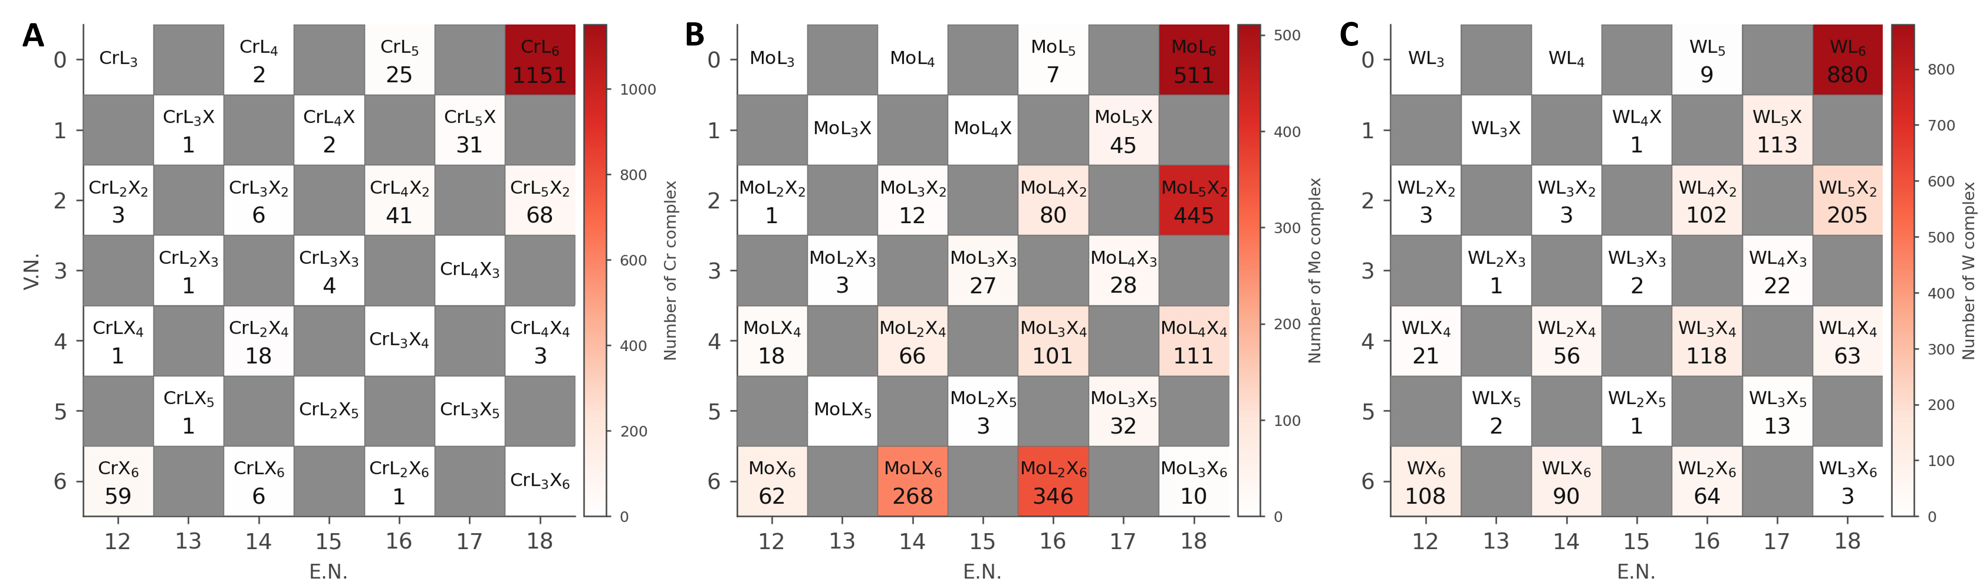
Inspired by Green’s classical ${ML}_{n}X_{m}$analysis,⁴ we constructed ${ML}_{n}X_{m}$distribution maps for the Group-6 elements Cr, Mo, and W in the tmQMg data set (Figure 1). Several qualitative trends can be extracted from these maps: (i) complexes of all three metals show a pronounced preference for 18-electron configurations, especially in the ${ML}_{6 }$class, for which $E.N.$ = 18; (ii) complexes with $L.B.N.$ < 6, corresponding to the upper-triangular region of the maps, are only sparsely populated; (iii) complexes with $L.B.N.$= 6 are well represented, and a similar pattern along this diagonal relationship is observed for all three elements, although it is less extensive for Cr; (iv) the high-valency X-rich region is much more populated for Mo and W than for Cr, as illustrated by the substantial populations of classes such as ${MoLX}_{6}$, ${MoL}_{2}X_{6}$, ${WLX}_{6}$, and ${WL}_{2}X_{6}$, reflecting the greater accessibility of high-valent 4d and 5d Group-6 chemistry relative to 3d chromium; and (v) the low-valency $V.N.$= 0-2 regions are populated for all three metals, consistent with the prevalence of L-rich donor–acceptor ligand environments in Group-6 chemistry. These general trends are qualitatively consistent with Green’s Group-6 ${ML}_{n}X_{m}$analysis, supporting the chemical plausibility of the automated Lewis structure generation algorithm and the subsequent CBC assignments.
Figure 1. ${ML}_{n}X_{m}$ distribution maps for group-6 Cr (A), Mo (B), and W (C) complexes in tmQMg data set.
The main discrepancy is the weak enrichment of ${CrL}_{3}X_{3}$, a class emphasized by Green for inert octahedral $d^{3}$ Cr compounds. Instead, tmQMg is dominated by 18-electron ${CrL}_{6}$ species, mainly chromium carbonyl and related L-type complexes, reflecting data-set sampling bias.
Representative Complexes and Bonding Motif Case Studies. To complement the large-scale statistical analysis, we examined a series of representative complexes covering several common and challenging bonding motifs in transition-metal chemistry. These examples probe different components of the workflow, including L/X ligand classification, $η$-coordinated $π$-ligand perception, metal–carbene representation, metal–ligand multiple bonding, and ligands containing hypervalent main-group elements. In each case, the generated Lewis-like structure and CBC assignment are presented together with the corresponding 3D graphical visualization, allowing the automated bonding interpretation to be directly compared with the molecular geometry.
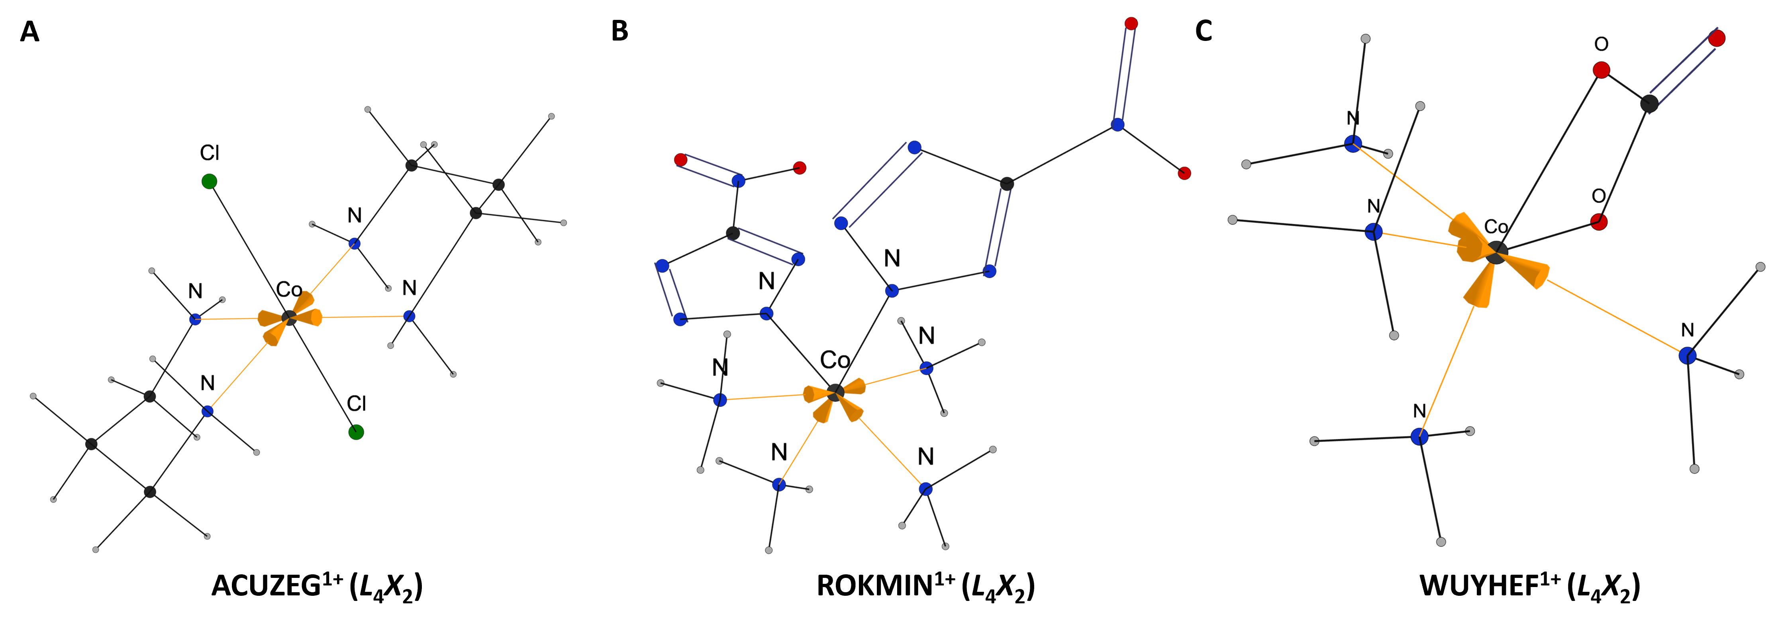
Werner-type coordination complexes. Werner-type coordination compounds, with well-defined neutral and anionic ligand environments, provide a benchmark for evaluating L/X classification and metal–ligand depiction. In the implemented representation scheme, neutral L-type donors are rendered as dative arrows directed from the donor atom to the metal center, whereas anionic X-type ligands are rendered as conventional covalent bonds. As shown in Figure 2, ACUZEG has a cobalt center coordinated by four neutral N-donor ligands and two anionic chloride ligands. Accordingly, the Co–N interactions are classified as L-type donor interactions and visualized as dative arrows, while the Co–Cl bonds are classified as X-type ligation and visualized as covalent bonds. ROKMIN presents a more challenging bonding situation: the four ammine ligands are recognized as neutral L-type donors, whereas the two metal-bound nitrogen atoms embedded in aromatic N-heterocyclic ligands are represented as covalent Co–N bonds. Correct treatment of this structure requires reliable aromatic bond-order perception for the heteroaromatic ligand. WUYHEF extends the analysis to a mixed N/O donor pattern, in which neutral N donors are assigned as L-type coordination interactions, while two carbonate-derived O donors are assigned as anionic X-type ligands and displayed as conventional Co–O bonds. These cases demonstrate that the method provides chemically coherent L/X-type assignments and bond depictions across representative Werner-type complexes, including halide, ammine, aromatic N-heterocyclic, and oxygen-donor coordination environments.
Figure 2. Werner-type coordination complexes. Generated Lewis structures distinguish L-type donor interactions, shown as dative bonds, from X-type ligands, shown as conventional covalent bonds.
Complexes with π-Ligands. π-Ligand complexes constitute a particularly challenging class for automated metal–ligand bond perception because their coordination is governed by delocalized ligand-based orbitals rather than by localized donor atoms. In the CBC framework, such bonding is described in terms of ligand functions: an L-function denotes a filled ligand orbital that donates two electrons to the metal, whereas an X-function denotes a singly occupied ligand orbital participating in covalent bond formation. This orbital-based view is essential for η-bound π ligands, for which the formal ligand class cannot be assigned simply by counting the number of atoms in contact with the metal. Instead, the method must perceive the π manifold, assign hapticity, distinguish neutral and anionic donor types, and preserve chemically meaningful bond orders within conjugated ligand frameworks.
The series in Figure 3 is arranged to progress from simple localized π donation to increasingly complex delocalized and reduced π systems. It begins with Zeise’s salt (Figure 3A), an anionic Pt(II) complex where ethylene is a neutral η²-alkene ligand and is classified as an L-type donor in CBC terms. Because donation originates from the filled C=C π orbital, the dative interaction is represented from the double bond to the metal center, rather than from an individual atom as in a conventional lone-pair donor. The next level of complexity is introduced by the η⁶-benzene complex (Figure 3B), for which Green assigns the arene as an L₃ ligand. This assignment reflects the three filled π molecular orbitals of benzene that can act as two-electron donor functions, and it also illustrates why η⁶ coordination should not be reduced to six independent metal–carbon donor interactions. The algorithm correctly treats the arene as a coherent π-ligand rather than as a collection of localized contacts.
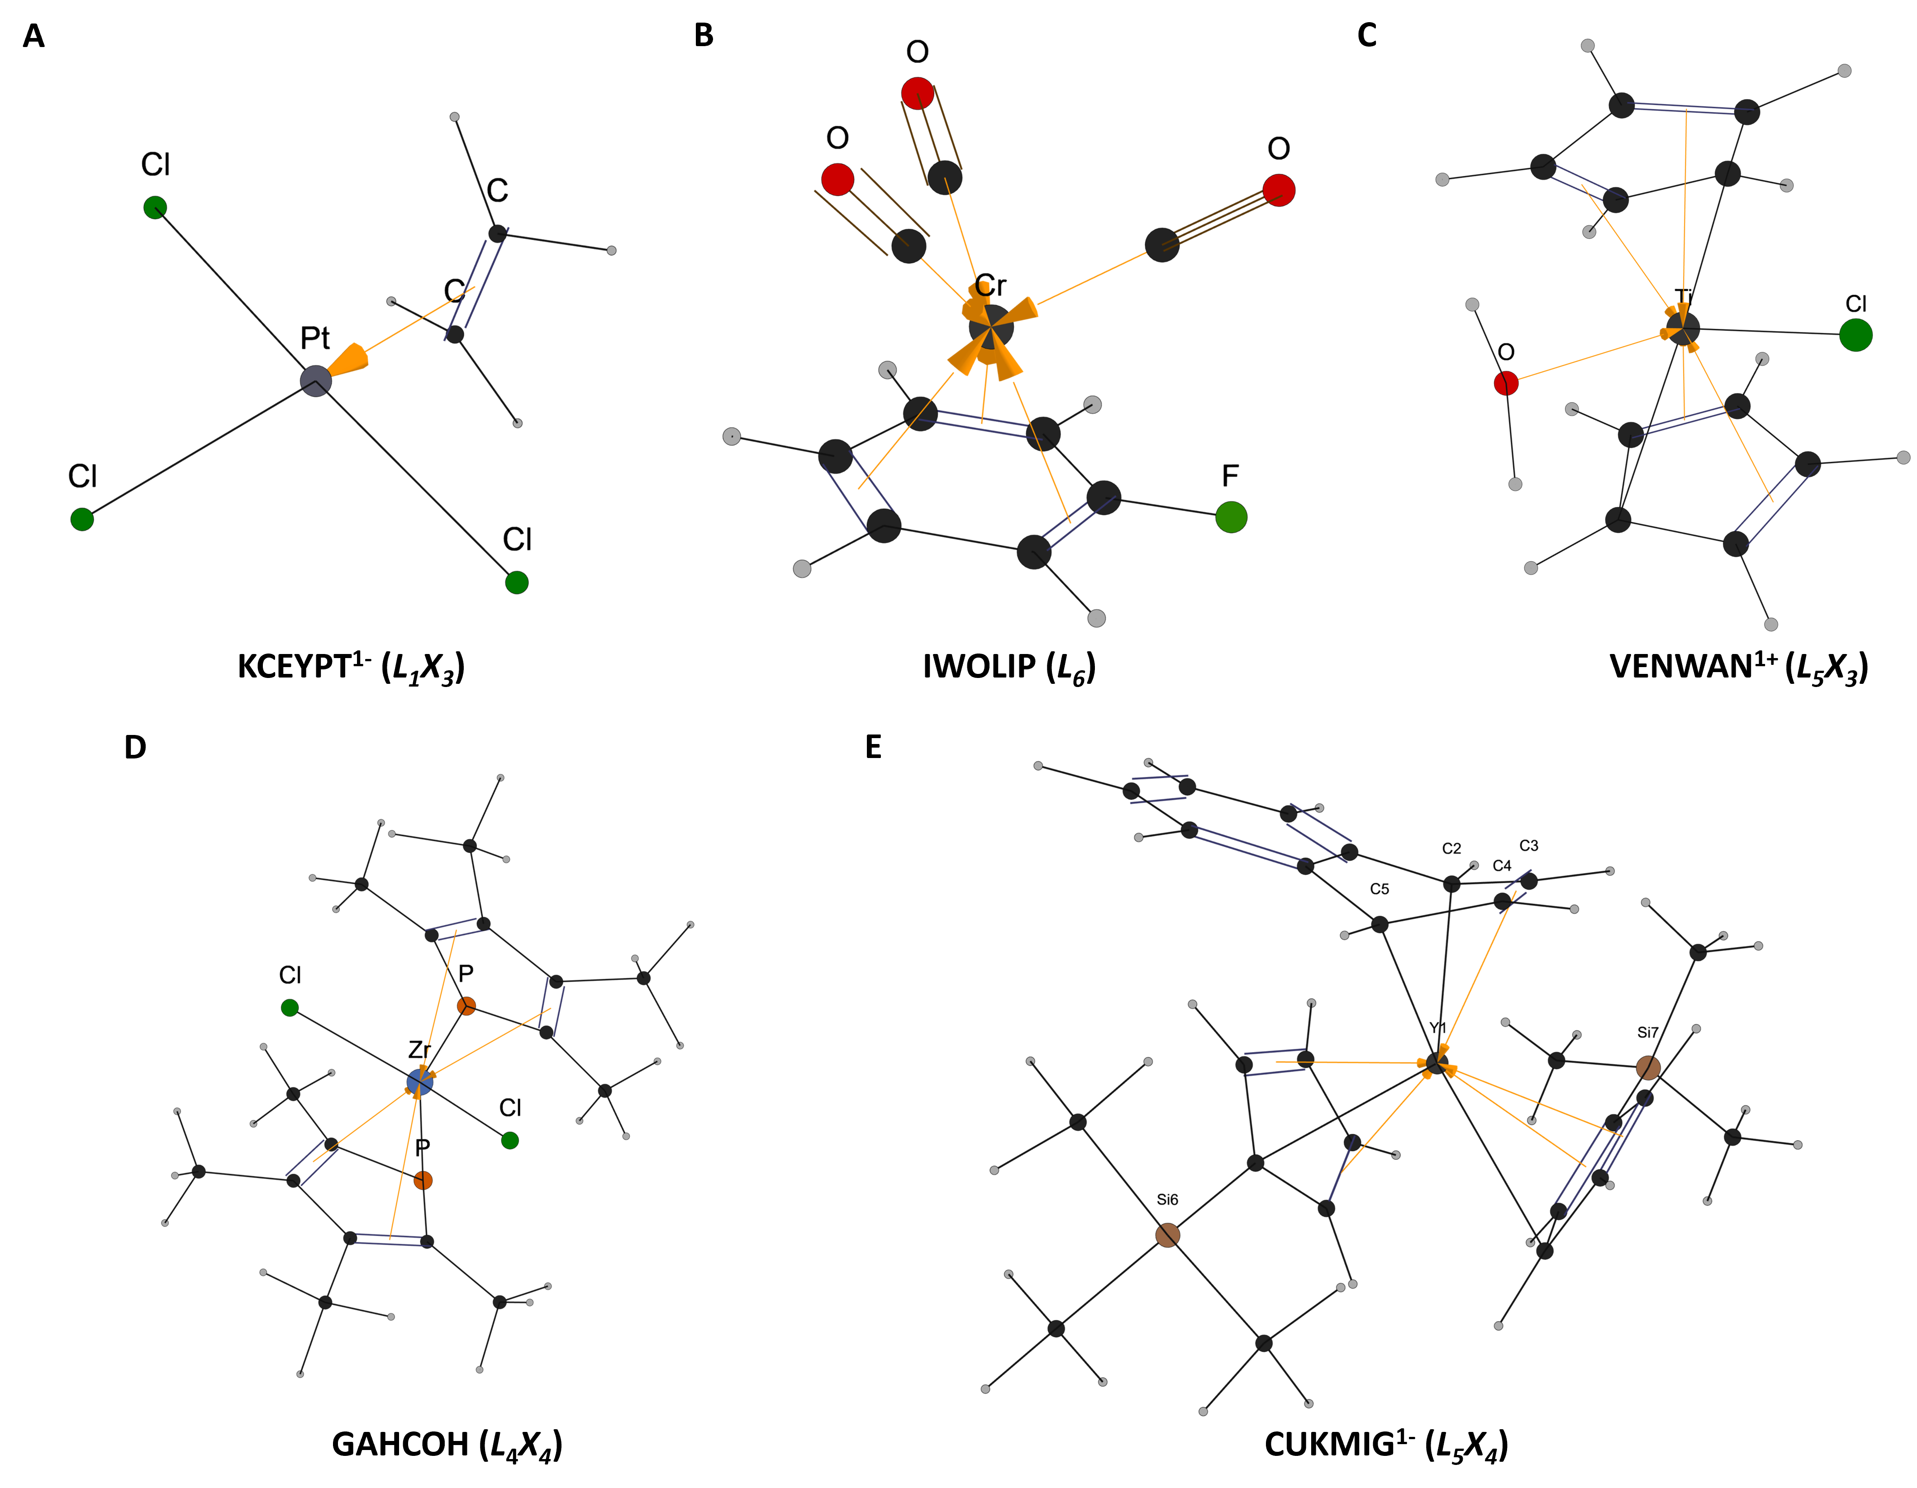
A further distinction is required for η⁵-cyclopentadienyl (Cp) coordination, as illustrated by the Cp-containing complex in Figure 3C. Although Cp⁻ and benzene are both commonly described as six-electron π donors, their CBC descriptions differ: η⁶-benzene is an $L_{3 }$ligand, whereas η⁵-Cp is classified as $L_{2}X$, with the two $L$functionalities corresponding to the two olefinic fragments while the $X$ functionality corresponds to the CH radical portion of the resonance structure. This distinction becomes more demanding in the heteroaromatic Cp-like complex GAHCOH (Figure 3D), where the π-framework contains heteroatoms and therefore tests whether the perception model can generalize CBC-consistent assignments beyond simple all-carbon rings. At the higher level of complexity, the bent naphthalene dianion complex (Figure 3E) tests whether the method can combine π-ligand recognition with robust bond-order perception in a reduced polycyclic framework. The algorithm correctly localizes the C3–C4 double bond in the coordinated naphthalene fragment, rather than assigning double bonds at C2–C3 and C4–C5, indicating that it preserves chemically coherent Kekulé patterns even in distorted and non-innocent π-ligand environments⁴⁶.
Figure 3. η-Coordinated $π$-donor ligand complexes. Examples include alkene, arene, cyclopentadienyl, heteroaromatic, and reduced polycyclic systems, illustrating the treatment of localized and delocalized $π$-ligand bonding.
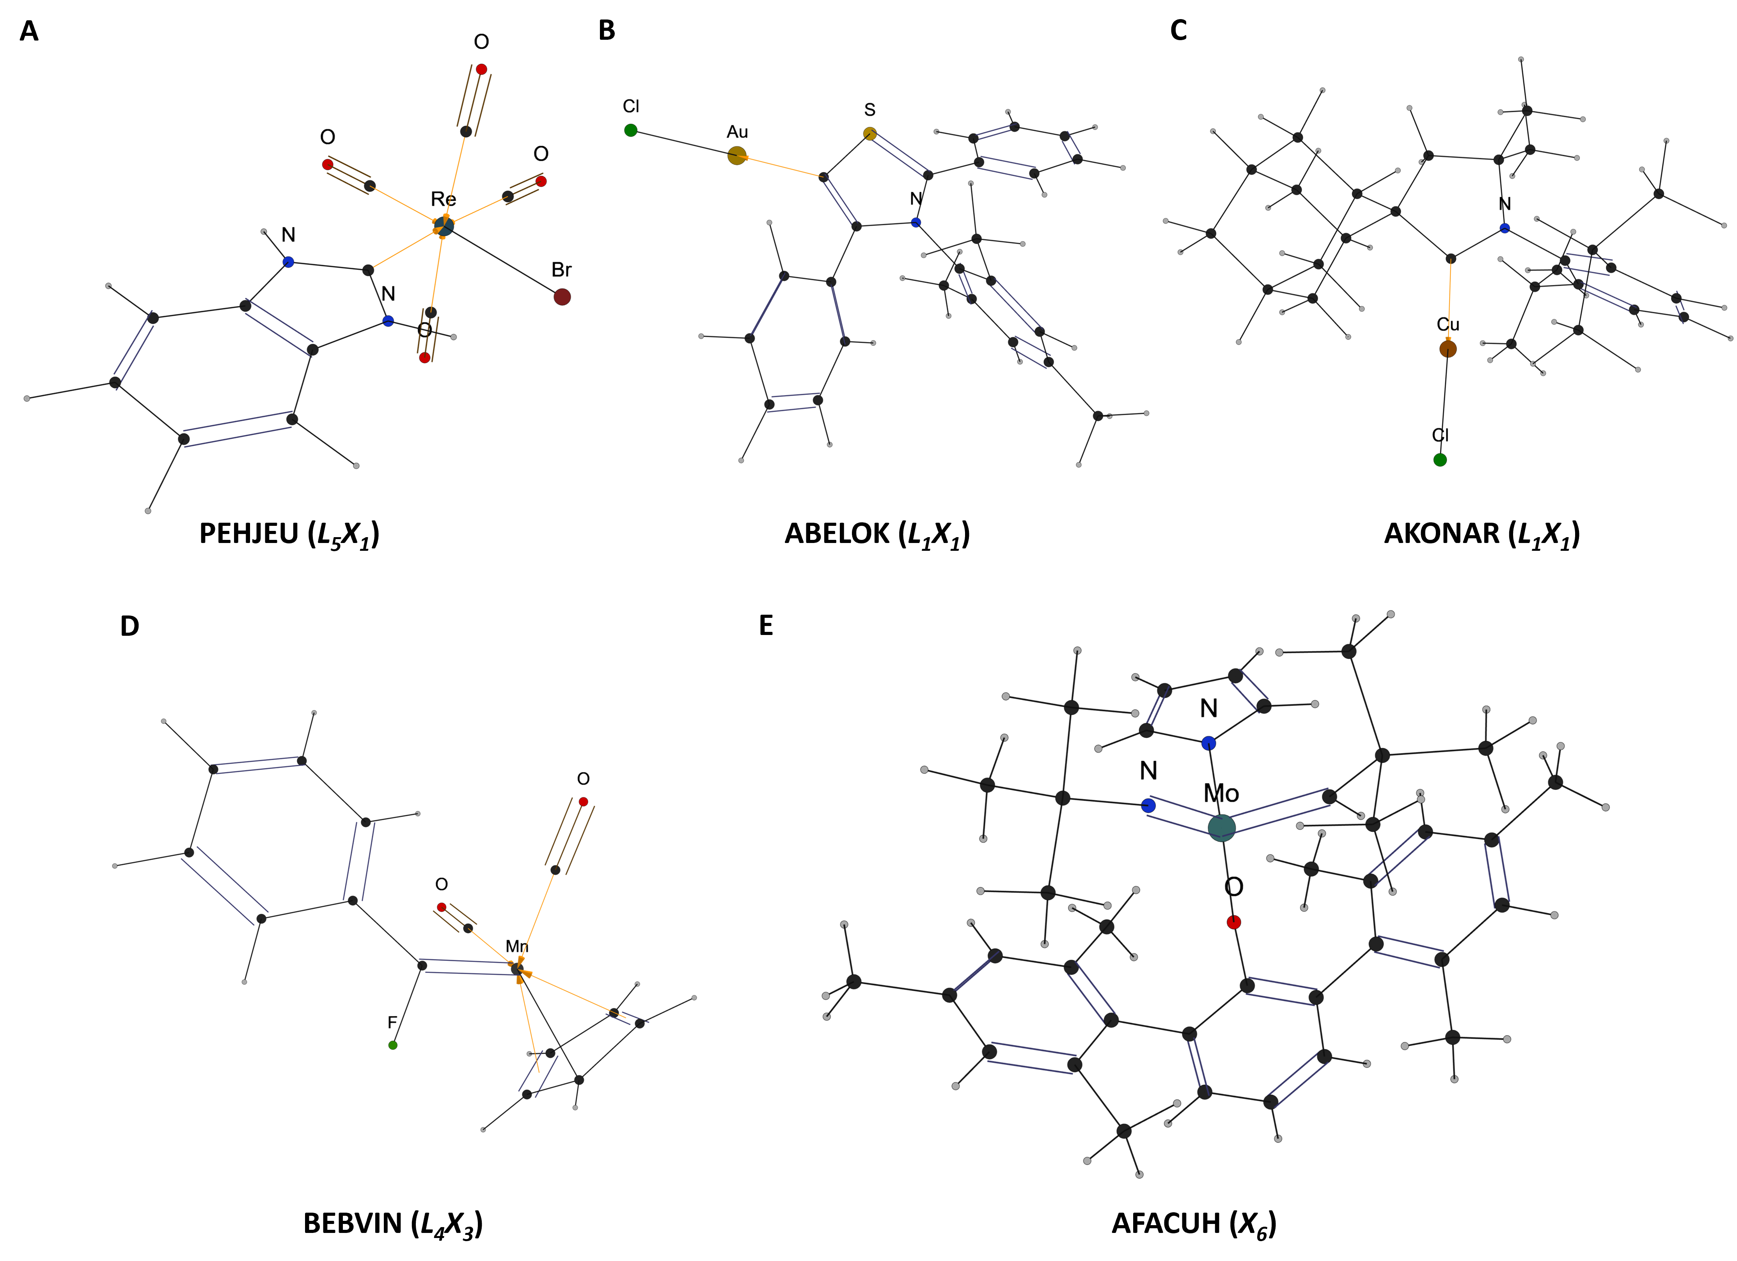
Metal–carbene complexes. Metal–carbene complexes pose a distinct challenge for Lewis-like structure generation because metal-bound carbene carbons span diverse bonding regimes, from persistent neutral carbenes such as N-heterocyclic carbenes (NHCs), mesoionic carbenes (MICs), and cyclic alkyl amino carbenes (CAACs), which are commonly represented as neutral σ-donor ligands, to Fischer- and Schrock-type carbenes, where metal–carbon multiple-bond formulations are often important. In many cases, the carbene-to-metal dative and formal M=C multiple bonding descriptions are limiting resonance formulations. Thus, we apply ligand-framework-based CBC heuristics. NHC, MIC, and CAAC motifs are recognized from the ILP-derived local bonding and electronic patterns around the candidate carbene carbon, including connectivity, heteroatom formal charges, and aromaticity. These motifs are treated as neutral L-type σ donors with dative metal–C_{carbene} interactions, whereas other carbene motifs retain their ILP-derived covalent metal–carbon bond multiplicities.
Figure 4. Metal–carbene complexes. Persistent neutral carbenes, including NHC, MIC, and CAAC ligands, are represented as L-type dative donors, whereas Fischer- and Schrock-type carbenes retain ILP-derived metal–carbon multiple-bond character.
Figures 4A-4C illustrate how persistent neutral carbenes are handled by the ligand-framework heuristic. In Figure 4A, the Re(I) center bears a benzannulated NHC ligand, where the carbene carbon is flanked by two nitrogens within a benzimidazol-2-ylidene ring. Therefore, the Re–C_{carbene} interaction is assigned as a dative C→Re bond. The ligand in Figure 4B is a thiazol-5-ylidene, representing a MIC framework in which the metal-bound carbon is embedded in a sulfur- and nitrogen-containing heterocycle. MICs are commonly described by charge-separated resonance structures, where negative charge at the carbene carbon is compensated by positive charge on the heteroatoms. In our Lewis-like representation, the metal–C_{carbene} bond is consistently encoded as a carbene-to-metal dative interaction. In Figure 4C, a CAAC ligand is coordinated to a Cu(I) halide fragment. The carbene carbon is stabilized by one amino substituent and one alkyl carbon in a cyclic framework. It is therefore assigned a dative C→Cu bond.
Figures 4D and 4E illustrate the complementary treatment of Fischer- and Schrock-type carbenes. In Figure 4D, the carbene carbon belongs to a fluorophenyl-substituted Fischer carbene coordinated to a Mn carbonyl/Cp fragment. Because this local environment does not match the recognized NHC, MIC, or CAAC motifs, the structure is not converted into a neutral L-type carbene representation. The Mn=C bond multiplicity obtained from the ILP solution is therefore retained. Similarly, Figure 4E shows a Schrock-type alkylidene in a molybdenum monoaryloxide pyrrolide imido alkylidene complex. Here, the carbene carbon is attached to an alkyl substituent and to a high-valent Mo imido center supported by anionic ancillary ligands. This motif is treated within the covalent X-type framework, and the ILP-derived Mo=C bond order is preserved rather than replaced by a dative C→Mo interaction. The Lewis-like representations presented here are consistent with common practice in organometallic chemistry.
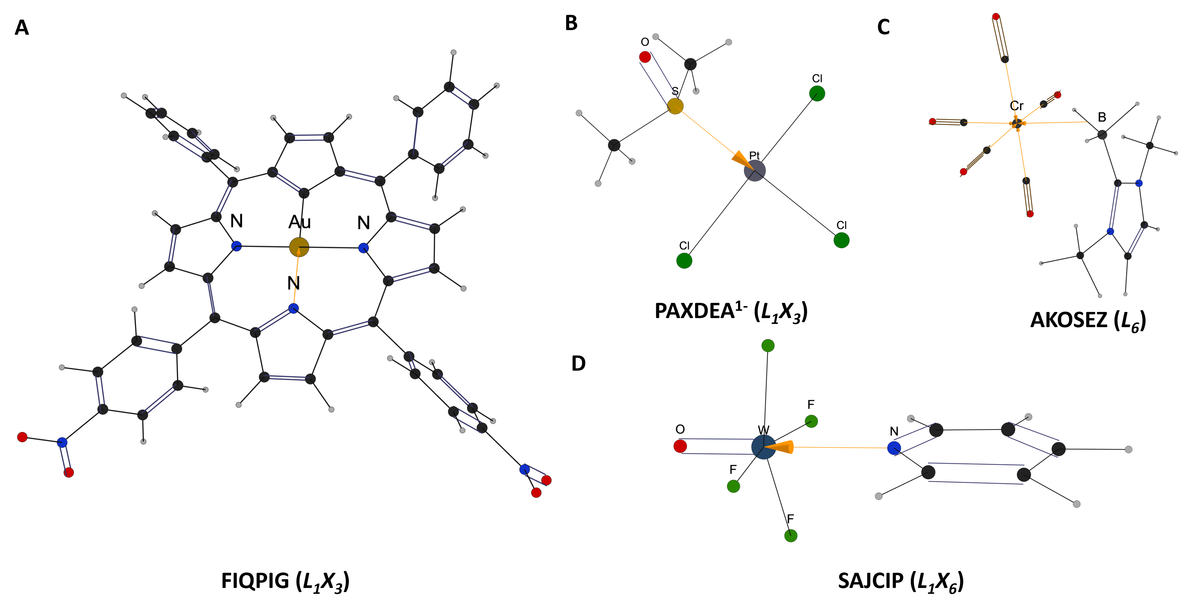
Additional common bonding motifs. Beyond the Werner-type, π-ligand, and carbene complexes, we examined additional motifs that extend beyond simple local valence rules, including a macrocyclic metal-binding framework, a polarized sulfoxide donor, a borane-derived B–H–M three-center two-electron interaction, and a terminal metal–oxo unit. In Figure 5A, the gold complex features a contracted carbaporphyrinoid macrocycle formed through Au(III)-mediated contraction of a $p$-phenylene unit to a cyclopentadiene fragment. The reported structure contains a square-planar Au(III) center bound within the macrocyclic cavity by three nitrogen donors and one trigonal carbon donor. Correct representation of this complex requires both recognition of the Au(III) coordination environment and assignment of the alternating double-bond pattern across the extended conjugated macrocycle. The generated Lewis structure preserves these features, retaining the macrocyclic conjugation and the Au–C/N coordination pattern in agreement with the original structural description.⁴⁷ Figure 5B shows a Pt(II) anionic complex bearing an S–bound DMSO ligand. This example probes the treatment of polarized main-group donor ligands that may otherwise appear formally hypervalent in a simple valence-counting scheme. The algorithm assigns the Pt–S linkage as a dative coordination interaction while maintaining the sulfoxide S=O bond, thereby producing a representation consistent with the conventional description of sulfur-bound DMSO coordination. An NHC–borane metal complex shown in Figure 5C features a B–H–M three-center two-electron interaction. Consistent with the original assignment of end-on $η^{1}$-borane coordination, the generated representation avoids introducing a B–M bond and instead preserves the B–H–M three-center interaction.^{48,49} Terminal oxo and nitrido ligands are common multiply bonded motifs in high-valent transition-metal complexes and must be distinguished from neutral donor ligands in Lewis-like representations. Figure 5D highlights this requirement with a tungsten oxo fluoride pyridine adduct. The generated structure preserves the terminal W=O linkage as a metal–ligand multiple bond, demonstrating that the algorithm can retain oxo-type multiple bonding rather than assigning it as a simple dative interaction.
Figure 5. Additional structural and bonding motifs. Examples include extended macrocyclic coordination, polarized sulfoxide donation, borane-derived three-center interactions, and terminal metal–oxo multiple bonding.
CONCLUSIONS
In this study, we developed TMC-LewisGen, an automated tool for generating Lewis-like structures of TMCs. Based on statistically derived distance connectivity and chemically reasonable rules, coupled assignments of bond orders, lone pairs, formal charges, and TM oxidation states are obtained through ILP optimization. Subsequent CBC analysis, guided by heuristic rules, further refines and clarifies the coordination patterns. The final outputs include a complete Lewis-like structure, a RDKit-parsable-SMILES, and a bonding report, which can also be visualized through a specifically designed graphical interface. Overall, this framework provides a practical and readily extensible route for large-scale structural annotation, chemical interpretation, and data-driven modeling of TMCs. In the current implementation, ligands are uniformly treated within a closed-shell formalism; therefore, the reported representations should be regarded as formal Lewis-structure-based depictions rather than unique electronic-structure descriptions. Future work will focus on improving the treatment of metal–metal bonds, electron-deficient motifs such as boron clusters, and transition-state structures, as well as curating more challenging edge cases.
ASSOCIATED CONTENT
Data and Software Availability Statement
The accession codes are available free of charge at https://github.com/Reecy-Z/TMC-Lewis-Structure. The tmQMg data set is openly available at https://github.com/hkneiding/tmqmg.
Supporting Information
The Supporting Information is available free of charge at https://pubs.acs.org/doi/10.1021/acs.jcim.xxxxxx. It contains details on the scope and applicability of the current implementation, algorithm efficiency, methodology and parameterization, SMILES representation for TMC, radical and redox non-innocent ligand cases, and failure-case analysis.
AUTHOR INFORMATION
Corresponding Author
Zhenyang Lin - Department of Chemistry, The Hong Kong University of Science and Technology, Clear Water Bay, Kowloon, Hong Kong SAR, Hong Kong 999077, China; orcid.org/0000-0003-4104-8767; Email: chzlin@ust.hk
Author
Farshad Shiri - Department of Chemistry, The Hong Kong University of Science and Technology, Clear Water Bay, Kowloon, Hong Kong SAR, Hong Kong 999077, China
Jingyuan Zhu - Department of Chemistry, The Hong Kong University of Science and Technology, Clear Water Bay, Kowloon, Hong Kong SAR, Hong Kong 999077, China
Sin Hang Tong - Department of Chemistry, The Hong Kong University of Science and Technology, Clear Water Bay, Kowloon, Hong Kong SAR, Hong Kong 999077, China
Liren Xiao - Department of Chemistry, The Hong Kong University of Science and Technology, Clear Water Bay, Kowloon, Hong Kong SAR, Hong Kong 999077, China
Author Contributions
The manuscript was written through contributions of all authors. All authors have given approval to the final version of the manuscript. ‡These authors contributed equally.
ACKNOWLEDGMENT
This work was supported by the Research Grants Council of Hong Kong (HKUST 16302425).
REFERENCES
(1) Lewis, G. N. THE ATOM AND THE MOLECULE. J. Am. Chem. Soc. 1916, 38 (4), 762–785. https://doi.org/10.1021/ja02261a002.
(2) Gillespie, R. J.; Nyholm, R. S. Inorganic Stereochemistry. Q. Rev. Chem. Soc. 1957, 11 (4), 339–380. https://doi.org/10.1039/QR9571100339.
(3) Knizia, G.; Klein, J. E. M. N. Electron Flow in Reaction Mechanisms—Revealed from First Principles. Angew. Chem. Int. Ed. 2015, 54 (18), 5518–5522. https://doi.org/10.1002/anie.201410637.
(4) Green, M. L. H. A New Approach to the Formal Classification of Covalent Compounds of the Elements. J. Organomet. Chem. 1995, 500 (1), 127–148. https://doi.org/10.1016/0022-328X(95)00508-N.
(5) Balaban, A. T. Applications of Graph Theory in Chemistry. J. Chem. Inf. Comput. Sci. 1985, 25 (3), 334–343. https://doi.org/10.1021/ci00047a033.
(6) Weininger, D. SMILES, a Chemical Language and Information System. 1. Introduction to Methodology and Encoding Rules. J. Chem. Inf. Model. 1988, 28 (1), 31–36. https://doi.org/10.1021/ci00057a005.
(7) Duvenaud, D.; Maclaurin, D.; Aguilera-Iparraguirre, J.; Gómez-Bombarelli, R.; Hirzel, T.; Aspuru-Guzik, A.; Adams, R. P. Convolutional Networks on Graphs for Learning Molecular Fingerprints. In Proceedings of the 29th International Conference on Neural Information Processing Systems - Volume 2; NIPS’15; MIT Press: Cambridge, MA, USA, 2015; Vol. 2, pp 2224–2232.
(8) Gilmer, J.; Schoenholz, S. S.; Riley, P. F.; Vinyals, O.; Dahl, G. E. Neural Message Passing for Quantum Chemistry. In Proceedings of the 34th International Conference on Machine Learning - Volume 70; ICML’17; JMLR.org: Sydney, NSW, Australia, 2017; pp 1263–1272.
(9) Ross, J.; Belgodere, B.; Chenthamarakshan, V.; Padhi, I.; Mroueh, Y.; Das, P. Large-Scale Chemical Language Representations Capture Molecular Structure and Properties. Nat. Mach. Intell. 2022, 4 (12), 1256–1264. https://doi.org/10.1038/s42256-022-00580-7.
(10) Coley, C. W.; Barzilay, R.; Jaakkola, T. S.; Green, W. H.; Jensen, K. F. Prediction of Organic Reaction Outcomes Using Machine Learning. ACS Cent. Sci. 2017, 3 (5), 434–443. https://doi.org/10.1021/acscentsci.7b00064.
(11) Schwaller, P.; Laino, T.; Gaudin, T.; Bolgar, P.; Hunter, C. A.; Bekas, C.; Lee, A. A. Molecular Transformer: A Model for Uncertainty-Calibrated Chemical Reaction Prediction. ACS Cent. Sci. 2019, 5 (9), 1572–1583. https://doi.org/10.1021/acscentsci.9b00576.
(12) Schwaller, P.; Probst, D.; Vaucher, A. C.; Nair, V. H.; Kreutter, D.; Laino, T.; Reymond, J.-L. Mapping the Space of Chemical Reactions Using Attention-Based Neural Networks. Nat. Mach. Intell. 2021, 3 (2), 144–152. https://doi.org/10.1038/s42256-020-00284-w.
(13) Gómez-Bombarelli, R.; Wei, J. N.; Duvenaud, D.; Hernández-Lobato, J. M.; Sánchez-Lengeling, B.; Sheberla, D.; Aguilera-Iparraguirre, J.; Hirzel, T. D.; Adams, R. P.; Aspuru-Guzik, A. Automatic Chemical Design Using a Data-Driven Continuous Representation of Molecules. ACS Cent. Sci. 2018, 4 (2), 268–276. https://doi.org/10.1021/acscentsci.7b00572.
(14) Weiss, T.; Mayo Yanes, E.; Chakraborty, S.; Cosmo, L.; Bronstein, A. M.; Gershoni-Poranne, R. Guided Diffusion for Inverse Molecular Design. Nat. Comput. Sci. 2023, 3 (10), 873–882. https://doi.org/10.1038/s43588-023-00532-0.
(15) Guo, T.; Guo, K.; Nan, B.; Liang, Z.; Guo, Z.; Chawla, N.; Wiest, O.; Zhang, X. What Can Large Language Models Do in Chemistry? A Comprehensive Benchmark on Eight Tasks. Adv. Neural Inf. Process. Syst. 2023, 36, 59662–59688. https://doi.org/10.52202/075280-2607.
(16) Jablonka, K. M.; Schwaller, P.; Ortega-Guerrero, A.; Smit, B. Leveraging Large Language Models for Predictive Chemistry. Nat. Mach. Intell. 2024, 6 (2), 161–169. https://doi.org/10.1038/s42256-023-00788-1.
(17) Zhu, J.; Shiri, F.; Xiao, L.; Wang, Y.; Su, H.; Lin, Z. 3DTMC-LLM: A 3D Geometry-Aware Large Language Model for Transition Metal Complexes. J. Chem. Inf. Model. 2026. https://doi.org/10.1021/acs.jcim.6c01415.
(18) The Nature of the Chemical Bond and the Structure of Molecules and Crystals. Nature 1941, 148 (3762), 677–677. https://doi.org/10.1038/148677c0.
(19) Pauling, L. THE NATURE OF THE CHEMICAL BOND. IV. THE ENERGY OF SINGLE BONDS AND THE RELATIVE ELECTRONEGATIVITY OF ATOMS. J. Am. Chem. Soc. 1932, 54 (9), 3570–3582. https://doi.org/10.1021/ja01348a011.
(20) Fukui, K. Role of Frontier Orbitals in Chemical Reactions. Science 1982, 218 (4574), 747–754. https://doi.org/10.1126/science.218.4574.747.
(21) Reed, A. E.; Curtiss, L. A.; Weinhold, F. Intermolecular Interactions from a Natural Bond Orbital, Donor-Acceptor Viewpoint. Chem. Rev. 1988, 88 (6), 899–926. https://doi.org/10.1021/cr00088a005.
(22) Glendening, E. D.; Landis, C. R.; Weinhold, F. Natural Bond Orbital Methods. WIREs Comput. Mol. Sci. 2012, 2 (1), 1–42. https://doi.org/10.1002/wcms.51.
(23) Weinhold, F.; Landis, C. R.; Glendening, E. D. What Is NBO Analysis and How Is It Useful? Int. Rev. Phys. Chem. 2016, 35 (3), 399–440. https://doi.org/10.1080/0144235X.2016.1192262.
(24) Leach, A. R.; Dolata, D. P.; Prout, K. Automated Conformational Analysis and Structure Generation: Algorithms for Molecular Perception. J. Chem. Inf. Comput. Sci. 1990, 30 (3), 316–324. https://doi.org/10.1021/ci00067a017.
(25) Meng, E. C.; Lewis, R. A. Determination of molecular topology and atomic hybridization states from heavy atom coordinates. J. Comput. Chem. 1991, 12 (7), 891–898. https://doi.org/10.1002/jcc.540120716.
(26) Baber, J. C.; Hodgkin, E. E. Automatic Assignment of Chemical Connectivity to Organic Molecules in the Cambridge Structural Database. J. Chem. Inf. Comput. Sci. 1992, 32 (5), 401–406. https://doi.org/10.1021/ci00009a001.
(27) Lang, E.; von der Lieth, C.-W.; Förster, T. Automatic Assignment of Bond Orders Based on the Analysis of the Internal Coordinates of Molecular Structures. Anal. Chim. Acta 1992, 265 (2), 283–289. https://doi.org/10.1016/0003-2670(92)85034-4.
(28) Hendlich, M.; Rippmann, F.; Barnickel, G. BALI: Automatic Assignment of Bond and Atom Types for Protein Ligands in the Brookhaven Protein Databank. J. Chem. Inf. Comput. Sci. 1997, 37 (4), 774–778. https://doi.org/10.1021/ci9603487.
(29) Gomory, R. E. Outline of an Algorithm for Integer Solutions to Linear Programs. Bull. Am. Math. Soc. 1958, 64 (5), 275–278.
(30) Froeyen, M.; Herdewijn, P. Correct Bond Order Assignment in a Molecular Framework Using Integer Linear Programming with Application to Molecules Where Only Non-Hydrogen Atom Coordinates Are Available. J. Chem. Inf. Model. 2005, 45 (5), 1267–1274. https://doi.org/10.1021/ci049645z.
(31) Welsh, I. D.; Allison, J. R. Automated Simultaneous Assignment of Bond Orders and Formal Charges. J. Cheminformatics 2019, 11 (1), 18. https://doi.org/10.1186/s13321-019-0340-0.
(32) Dehof, A. K.; Rurainski, A.; Bui, Q. B. A.; Böcker, S.; Lenhof, H.-P.; Hildebrandt, A. Automated Bond Order Assignment as an Optimization Problem. Bioinformatics 2011, 27 (5), 619–625. https://doi.org/10.1093/bioinformatics/btq718.
(33) Hart, P. E.; Nilsson, N. J.; Raphael, B. A Formal Basis for the Heuristic Determination of Minimum Cost Paths. IEEE Trans. Syst. Sci. Cybern. 1968, 4 (2), 100–107. https://doi.org/10.1109/TSSC.1968.300136.
(34) Downey, R. G.; Fellows, M. R. Parameterized Complexity; Gries, D., Schneider, F. B., Series Eds.; Monographs in Computer Science; Springer: New York, NY, 1999. https://doi.org/10.1007/978-1-4612-0515-9.
(35) The RDKit Documentation — The RDKit 2026.03.2 documentation. https://www.rdkit.org/docs/index.html (accessed 2026-05-26).
(36) O’Boyle, N. M.; Banck, M.; James, C. A.; Morley, C.; Vandermeersch, T.; Hutchison, G. R. Open Babel: An Open Chemical Toolbox. J. Cheminformatics 2011, 3 (1), 33. https://doi.org/10.1186/1758-2946-3-33.
(37) Balcells, D.; Skjelstad, B. B. tmQM Dataset—Quantum Geometries and Properties of 86k Transition Metal Complexes. J. Chem. Inf. Model. 2020, 60 (12), 6135–6146. https://doi.org/10.1021/acs.jcim.0c01041.
(38) Kneiding, H.; Lukin, R.; Lang, L.; Reine, S.; Pedersen, T. B.; Bin, R. D.; Balcells, D. Deep Learning Metal Complex Properties with Natural Quantum Graphs. Digit. Discov. 2023, 2 (3), 618–633. https://doi.org/10.1039/D2DD00129B.
(39) Garrison, A. G.; Toney, J. W.; Nikolaeva, T.; St Michel, R. G.; Stein, C. J.; Kulik, H. J. BOS-TMC Data Set: DFT Properties of 159k Experimentally Characterized Transition Metal Complexes Spanning Multiple Charge and Spin States. J. Chem. Inf. Model. 2026. https://doi.org/10.1021/acs.jcim.6c01792.
(40) Ioannidis, E. I.; Gani, T. Z. H.; Kulik, H. J. molSimplify: A Toolkit for Automating Discovery in Inorganic Chemistry. J. Comput. Chem. 2016, 37 (22), 2106–2117. https://doi.org/10.1002/jcc.24437.
(41) Terrones, G. G.; St. Michel, R. G.; Toney, J. W.; Ball, A. K.; Wang, Y.; Garrison, A. G.; Nandy, A.; Meyer, R.; Edholm, F.; Oh, C.; Pujet, S. G.; Chu, D. B. K.; Muhammetgulyyev, D.; Kulik, H. J. molSimplify 2.0: Improved Structure Generation for Automating Discovery in Inorganic Molecular and Reticular Chemistry. J. Chem. Inf. Model. 2026, 66 (5), 2753–2767. https://doi.org/10.1021/acs.jcim.5c02733.
(42) Taylor, M. G.; Burrill, D. J.; Janssen, J.; Batista, E. R.; Perez, D.; Yang, P. Architector for High-Throughput Cross-Periodic Table 3D Complex Building. Nat. Commun. 2023, 14 (1), 2786. https://doi.org/10.1038/s41467-023-38169-2.
(43) Levine, D. S.; Shuaibi, M.; Spotte-Smith, E. W. C.; Taylor, M. G.; Hasyim, M. R.; Michel, K.; Batatia, I.; Csányi, G.; Dzamba, M.; Eastman, P.; Frey, N. C.; Fu, X.; Gharakhanyan, V.; Krishnapriyan, A. S.; Rackers, J. A.; Raja, S.; Rizvi, A.; Rosen, A. S.; Ulissi, Z.; Vargas, S.; Zitnick, C. L.; Blau, S. M.; Wood, B. M. The Open Molecules 2025 (OMol25) Dataset, Evaluations, and Models. arXiv May 13, 2025. https://doi.org/10.48550/arXiv.2505.08762.
(44) Cibinel, L.; Linjordet, T.; Pensar, J.; Balcells, D.; De Bin, R.; Ell, B. tmQM-RDF Data Set: A Knowledge Graph Representing Transition Metal Complexes. J. Chem. Inf. Model. 2026, 66 (13), 7524–7538. https://doi.org/10.1021/acs.jcim.6c01281.
(45) Kevlishvili, I. Taming T-REX: A Canonical Language for Geometry-Aware Generative Design of Transition-Metal Complexes. ChemRxiv 2025 (1222). https://doi.org/10.26434/chemrxiv-2025-7s3gx.
(46) Kotyk, C. M.; MacDonald, M. R.; Ziller, J. W.; Evans, W. J. Reactivity of the Ln2+ Complexes [K(2.2.2-Cryptand)][(C5H4SiMe3)3Ln]: Reduction of Naphthalene and Biphenyl. Organometallics 2015, 34 (11), 2287–2295. https://doi.org/10.1021/om501063h.
(47) Szyszko, B.; Kupietz, K.; Szterenberg, L.; Latos-Grażyński, L. Gold(III)-Mediated Contraction of Benzene to Cyclopentadiene: From p-Benziporphyrin to Gold(III) True Tetraarylcarbaporphyrin. Chem. – Eur. J. 2014, 20 (5), 1376–1382. https://doi.org/10.1002/chem.201304162.
(48) Xu, Z.; Lin, Z. Transition Metal Tetrahydroborato Complexes: An Orbital Interaction Analysis of Their Structure and Bonding. Coord. Chem. Rev. 1996, 156, 139–162. https://doi.org/10.1016/S0010-8545(96)01254-4.
(49) Lin, Z. Transition Metal σ-Borane Complexes. In Contemporary Metal Boron Chemistry I: Borylenes, Boryls, Borane σ-Complexes, and Borohydrides; Marder, T. B., Lin, Z., Eds.; Springer: Berlin, Heidelberg, 2008; pp 123–148. https://doi.org/10.1007/430_2007_074.

For Table of Contents Only:
