***MODULE - 04***

**1. Explain Memory Hierarchy Design and its Characteristics in details**

**ANS:-**

* In Computer System Design, Memory Hierarchy is an enhancement to organize the memory such that it can minimize the access time.
* The Memory Hierarchy was developed based on a program behavior known as locality of references.
* Memory Hierarchy is one of the most required things in Computer Memory as it helps in optimizing the memory available in the computer.

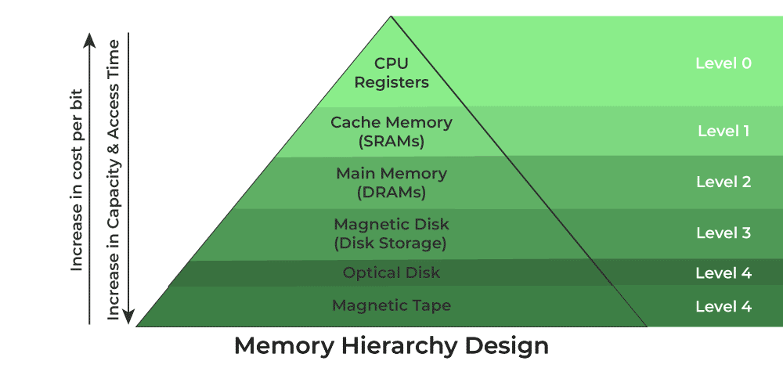

Characteristics:

* **Capacity:** It is the global volume of information the memory can store. As we move from top to bottom in the Hierarchy, the capacity increases.
* **Access Time:** It is the time interval between the read/write request and the availability of the data. As we move from top to bottom in the Hierarchy, the access time increases.
* **Performance:** Earlier the speed gap increased between the CPU registers and Main Memory due to a large difference in access time. This results in lower performance. After enhancement was made in the form of Memory Hierarchy Design the performance of the system increased. One of the most significant ways to increase system performance is minimizing how far down the memory hierarchy one has to go to manipulate data.
* **Cost Per Bit:** As we move from bottom to top in the Hierarchy, the cost per bit increases i.e. Internal Memory is costlier than External Memory.

**2. Explain the random access memory and Read only memory.**

**3. Compare RAM and ROM.**

**ANS:-**

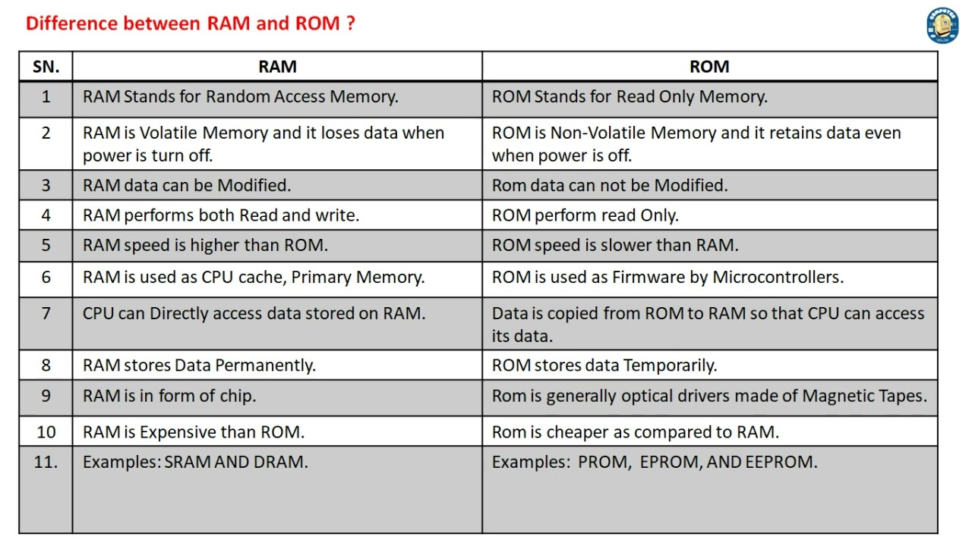

**4. Compare Static RAM and Dynamic RAM.**

**ANS:-**

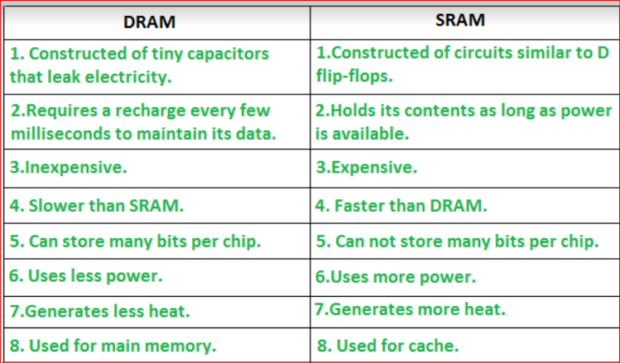

**5. Compare Primary memory and Secondary memory.**

**ANS:-**

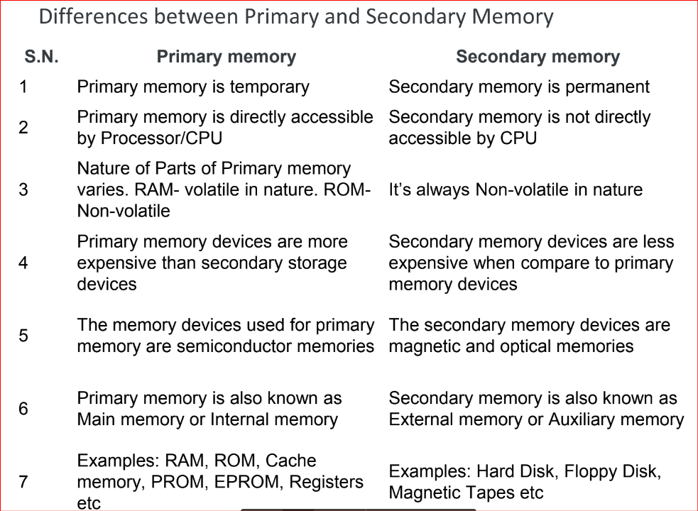

**6. Explain the 3 level cache memory organizations with a diagram.**

**ANS:-**

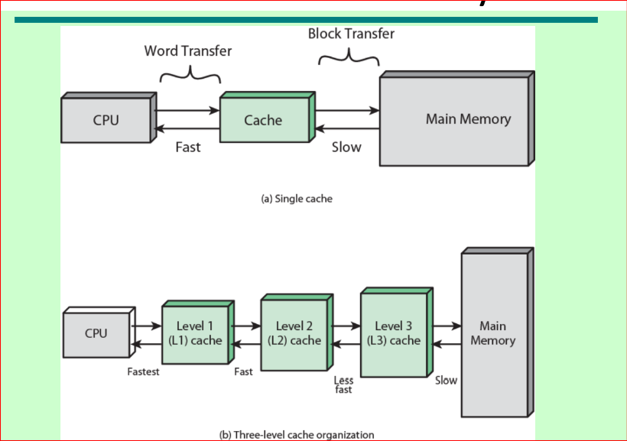

* L1 or Level 1 Cache: sometimes called Primary Cache, is the smallest and fastest memory level. It is the first level of cache memory that is present inside the processor. It is present in a small amount inside every core of the processor separately. The size of this memory ranges from 2KB to 64 KB.
* L2 or Level 2 Cache: It is the second level of cache memory that may present inside or outside the CPU. If not present inside the core, it can be shared between two cores depending upon the architecture and is connected to a processor with the high-speed bus. The size of memory ranges from 256 KB to 512 KB.
* L3 or Level 3 Cache: Not individually embedded but acts as a shared storage pool that the entire processor can access. It is the third level of cache memory that is present outside the CPU and is shared by all the cores of the CPU. Some high processors may have this cache. This cache is used to increase the performance of the L2 and L1 cache. The size of this memory ranges from 1 MB to 8MB.

**7. Explain Direct Mapping in cache memory mapping technique.**

**ANS:-**

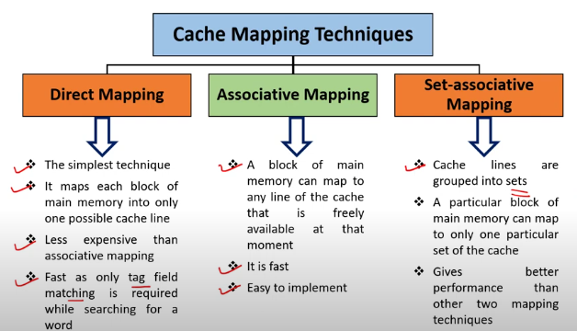

In direct mapping,

A particular block of main memory can map only to a particular line of the cache.

The line number of cache to which a particular block can map is given by-

Cache line number = ( Main Memory Block Address )

Modulo

(Number of lines in Cache)

**8. Explain Characteristics of Cache memory.**

**ANS:-**

* Cache memory is an extremely fast memory type that acts as a buffer between RAM and the CPU.
* It holds frequently requested data and instructions so that they are immediately available to the CPU when needed.
* Cache memory is costlier than main memory or disk memory but more economical than CPU registers.
* Cache Memory is used to speed up and synchronize with a high-speed CPU.

***MODULE - 06***

**1. State the Features of 8051 Microcontroller.**

**ANS:-**

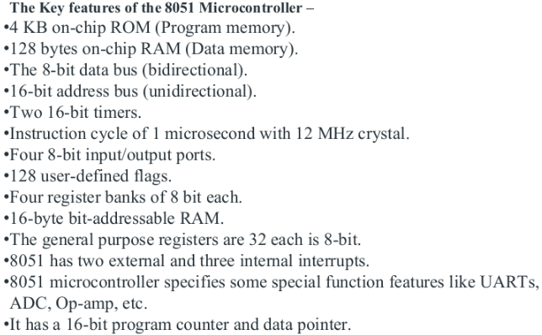

**2. Difference between Microcontroller and Microprocessor.**

**ANS:-**

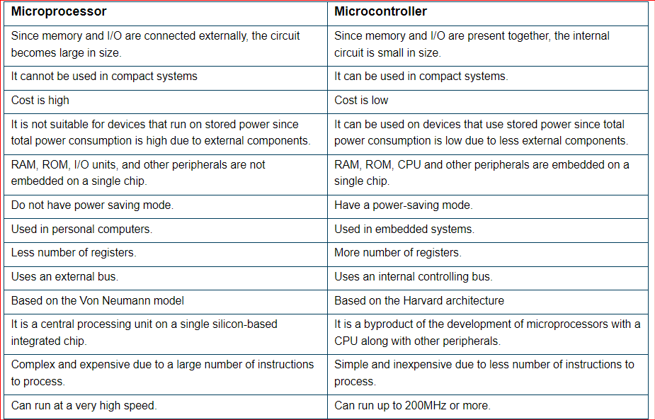

**3. Draw and explain Architecture of 8051 Microcontroller.**

**ANS:- SKIPPING THIS**

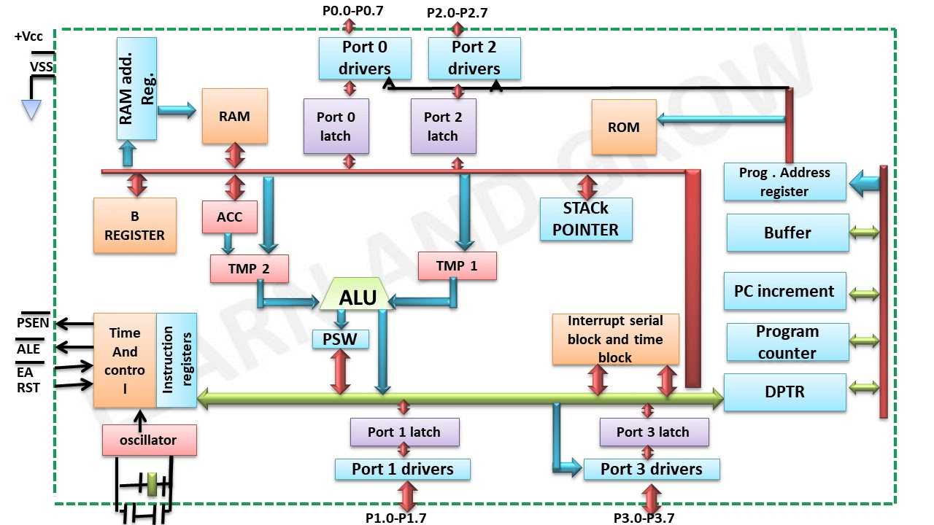

**1. Oscillator and Timing**

**Oscillator:** This circuit provides the microcontroller with a clock signal. All of the microcontroller’s actions are synchronized by means of the clock signal.

**Timing: I**n order to control the timing of activities within the microcontroller and guarantee that each instruction is performed at the appropriate moment, the timing circuit collaborates with the oscillator.

2. **4096 Byte Program Memory**

**Program Memory (ROM):** The program code is kept in this type of non-volatile memory. Typically, the on-chip ROM of an 8051 microcontroller is 4KB (4096 bytes).

3. **128 Byte RAM**

While the microcontroller is in operation, temporary data is stored in Random Access Memory (RAM), a form of volatile memory. The 8051 has 128 bytes of inbuilt RAM.

**4. Timers:** Timer 0 and Timer 1 are the two 16-bit timers on the 8051. These clocks may be used for counting events, monitoring time intervals, and creating time delays, among other things.

**5.** **64 Byte Bus Expansion Control**

The microcontroller may interact with external memory or peripherals thanks to bus expansion control. It facilitates the extension of control signals for external devices and the accessible memory area.

**6. Programmable I/O**

Programmable Input/Output Ports: The four I/O ports (Ports 0 through 3) of the 8051 microcontroller may be configured to carry out a range of input and output operations.

**7. Programmable Serial Port**

Serial Port (UART): Serial communication is made possible via the Universal Asynchronous Receiver/Transmitter (UART). It can send and receive data concurrently while operating in full duplex mode.

**8. Synchronous Shifter**

Data is shifted in and out of the microcontroller in synchrony using a synchronous shifter. It is frequently employed in communication protocols when exact time is necessary.

**9. 8051 CPU**

Central Processing Unit (CPU): The microcontroller’s central processing unit (CPU) is responsible for carrying out instructions read from program memory. It controls the other parts, handles data flow inside the microcontroller, and executes arithmetic and logic operations.

Together, these parts provide the 8051 microcontroller its versatility and strength as an embedded system application tool.

**4. Explain the pin diagram of 8051 microcontroller.**

**ANS:-**

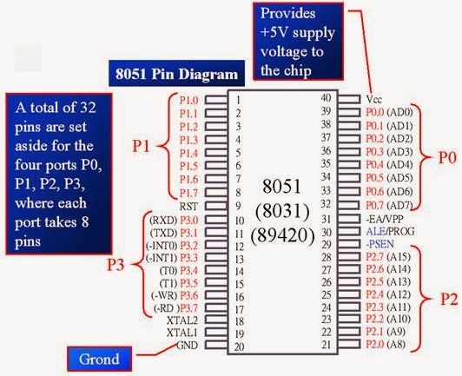

The 8051 microcontroller is a popular 8-bit microcontroller used in embedded systems. It has a 40-pin DIP (Dual Inline Package) configuration. Here's a brief description of the important pins:

Pin Descriptions of 8051 Microcontroller

1. VCC (Pin 40):
   * Power supply pin; typically +5V to the chip.
2. GND (Pin 20):
   * Ground pin; connected to 0V.
3. Port 0 (Pins 32-39):
   * P0.0 to P0.7 (Pins 32 to 39): 8-bit bidirectional I/O port.
   * Also acts as a multiplexed address/data bus (AD0-AD7) in external memory interfacing.
4. Port 1 (Pins 1-8):
   * P1.0 to P1.7 (Pins 1 to 8): 8-bit bidirectional I/O port.
   * General-purpose I/O; no dual functionality.
5. Port 2 (Pins 21-28):
   * P2.0 to P2.7 (Pins 21 to 28): 8-bit bidirectional I/O port.
   * Also serves as a high-order address bus (A8-A15) during external memory access.

6. Port 3 (Pins 10-17):

* + P3.0 to P3.7 (Pins 10 to 17): 8-bit bidirectional I/O port.
  + Has alternate functions:
    - P3.0 (RXD): Serial data input (receive).
    - P3.1 (TXD): Serial data output (transmit).
    - P3.2 (INT0): External interrupt 0.
    - P3.3 (INT1): External interrupt 1.
    - P3.4 (T0): Timer 0 external input.
    - P3.5 (T1): Timer 1 external input.
    - P3.6 (WR): External memory write.
    - P3.7 (RD): External memory read.

**5. Write embedded C program for addition and subtraction of two 16 bit numbers for 8051 microcontroller.**

**ANS:-**

#include <reg51.h> // 8051 microcontroller header

void main(void)

{

unsigned int num1 = 0x1234; // First 16-bit number

unsigned int num2 = 0x4321; // Second 16-bit number

unsigned int result_add;

unsigned int result_subtract;

result_add = num1 + num2;

result_subtract = num1 - num2;

while (1) {

// Infinite loop to simulate or debug the results

// You can observe the result by setting breakpoints or in the debugger

}

}

**6. Describe the Addressing mode of 8051 Microcontroller.**

**ANS:- NOT IN SYLLABUS**

**7. Write an embedded C program to transfer a block of data from one memory location to another memory location(8051 Microcontroller).**

**ANS:-**

#include <reg51.h> // 8051 microcontroller header

void main()

{

unsigned char i;

unsigned char source[5] = { 0x11, 0x22, 0x33, 0x44, 0x55};

unsigned char destination[5];

for (i=0; i<5; i++)

{

destination [i] = source [i];

}

while (1);

}

**8. Explain PSW register.**

**ANS:-**

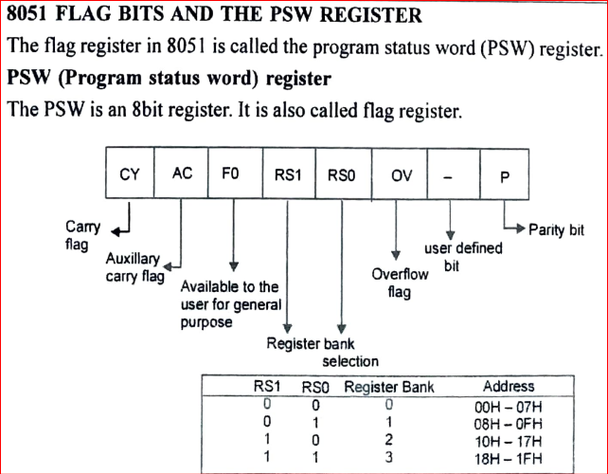

***MODULE - 05***

**1. Difference between Programmed and DMA I/O data transfer.**

**ANS:-**

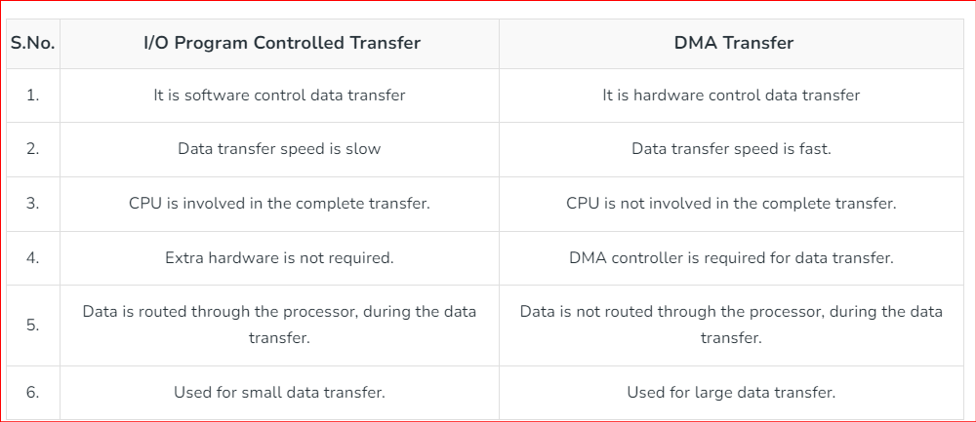

**2. Explain I/O Module Structure with the help of a neat diagram.**

**ANS:-**

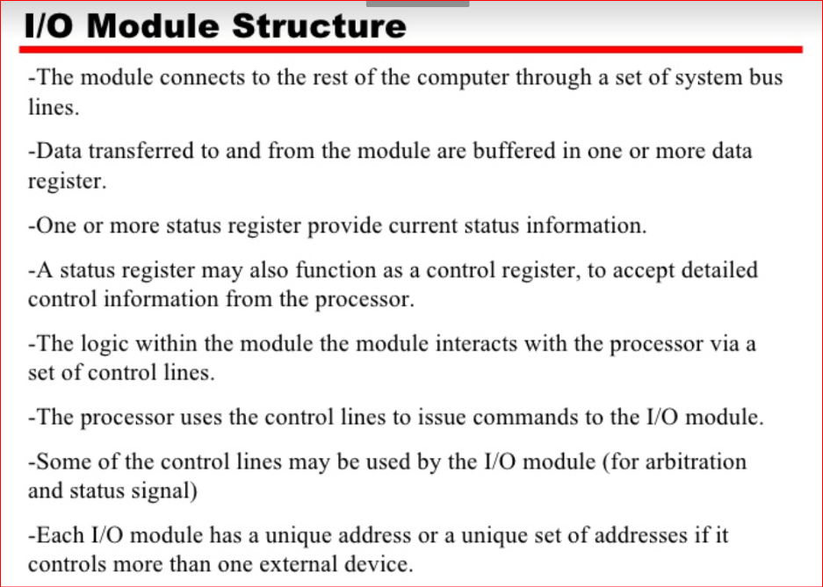

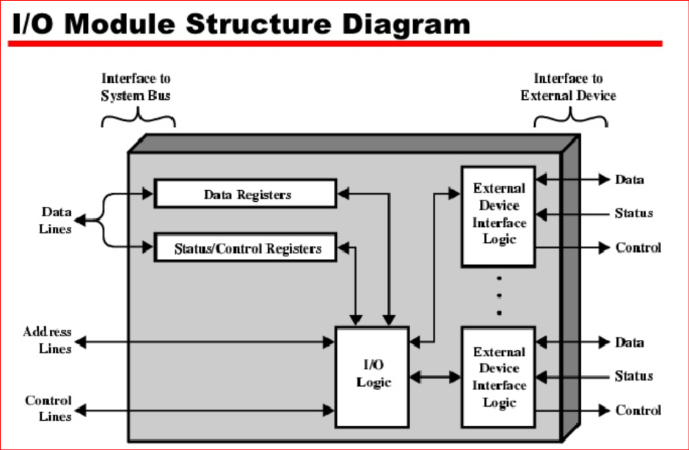

**3. Explain Programmed I/O of Data Transfer Techniques.**

**ANS:-**

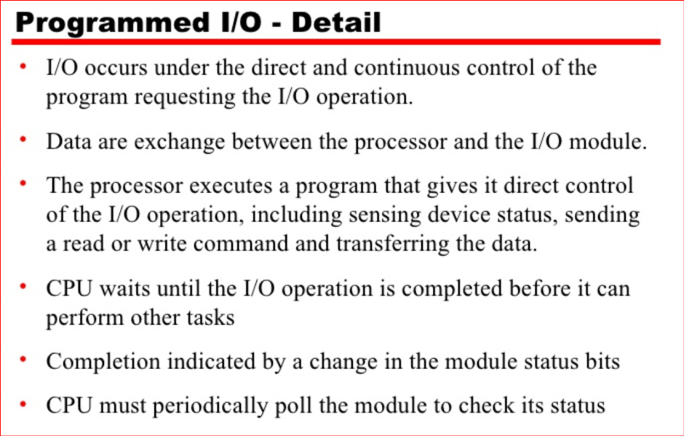

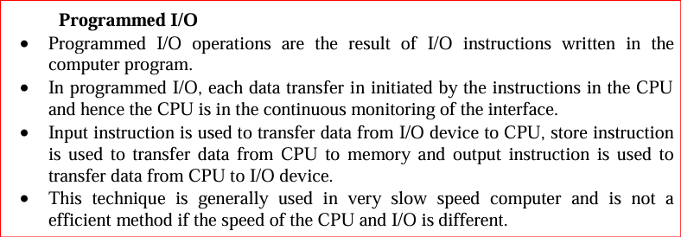

**4. Explain Interrupt Driven of Data Transfer Techniques.**

**ANS:-**

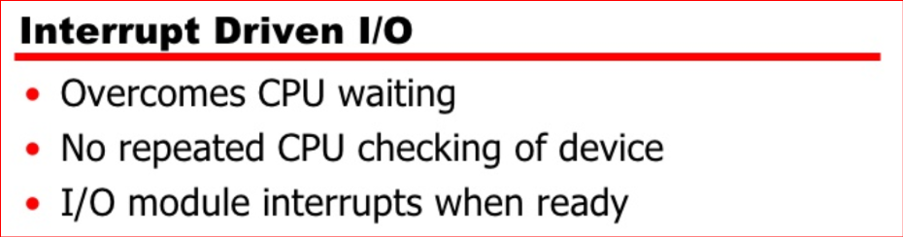

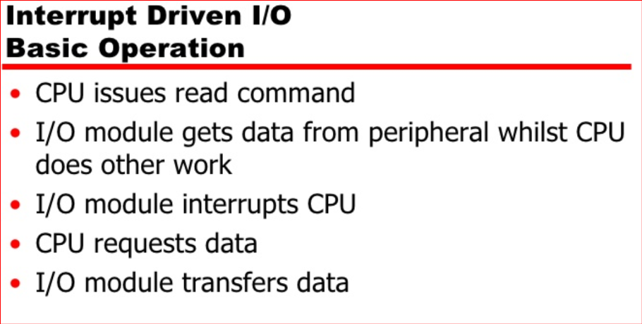

**5. Explain DMA based data transfer technique for I/O devices.**

**ANS:- misha ne ye likha hai**



