Problem 7

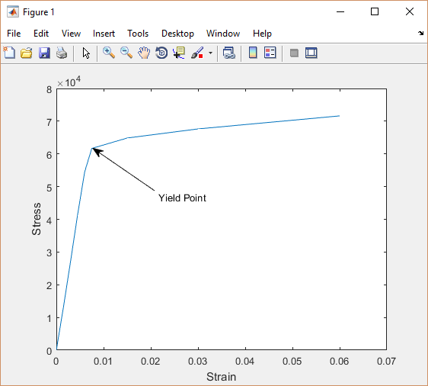

Problem 9a

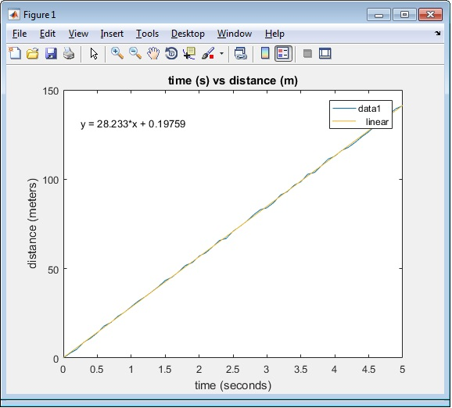

Problem 9b

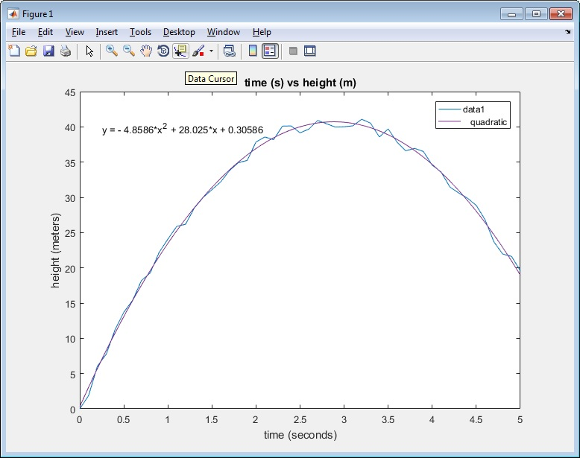

Problem 10

|  |  |
| --- | --- |
| **Absolute Temperature (K)** | **Estimated Reaction Rate, k(s^-1)** |
| **280** | 2.9076 |
| **285** | 4.4288 |
| **290** | 6.693 |
| **295** | 9.825 |
| **300** | 14.494 |

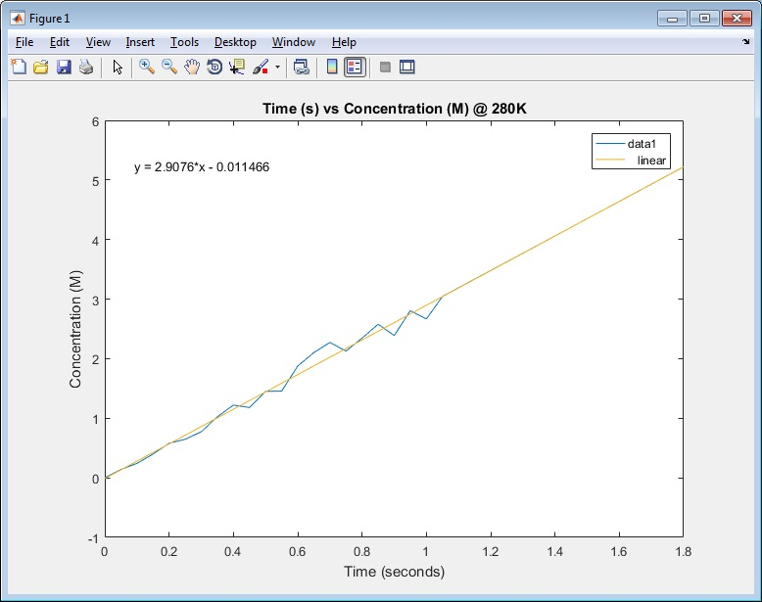

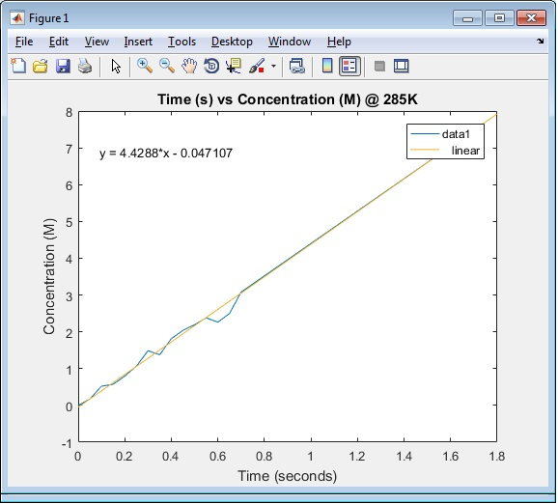

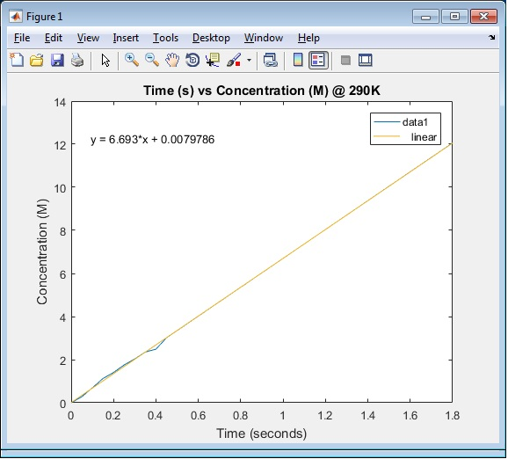

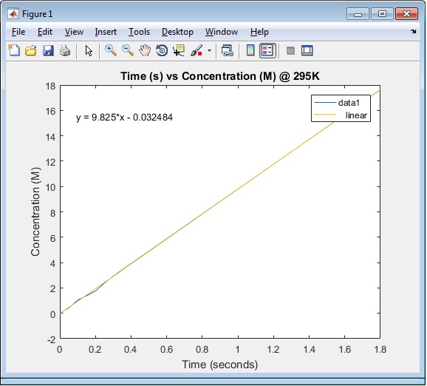

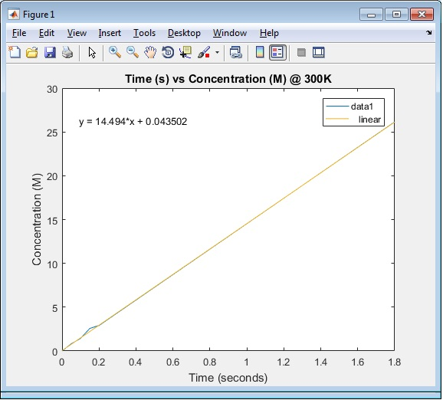

Problem 14a

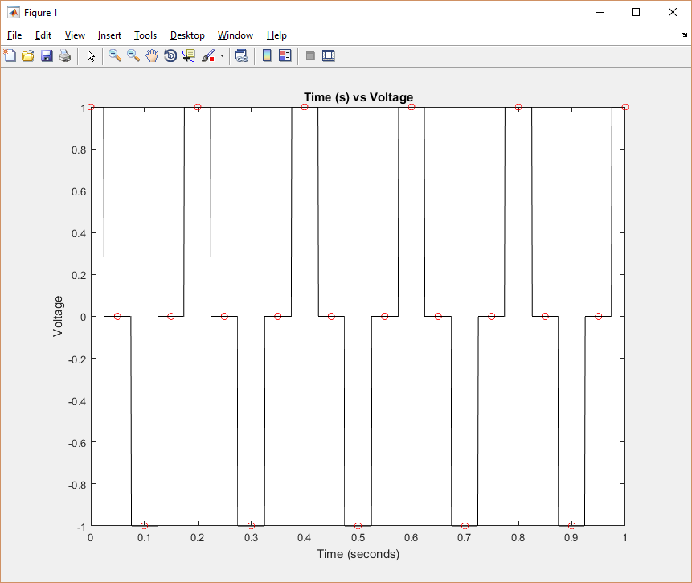

Problem 14b

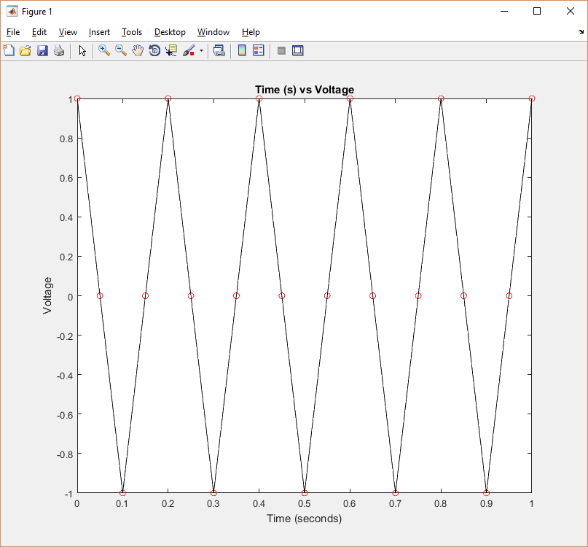

Problem 14c

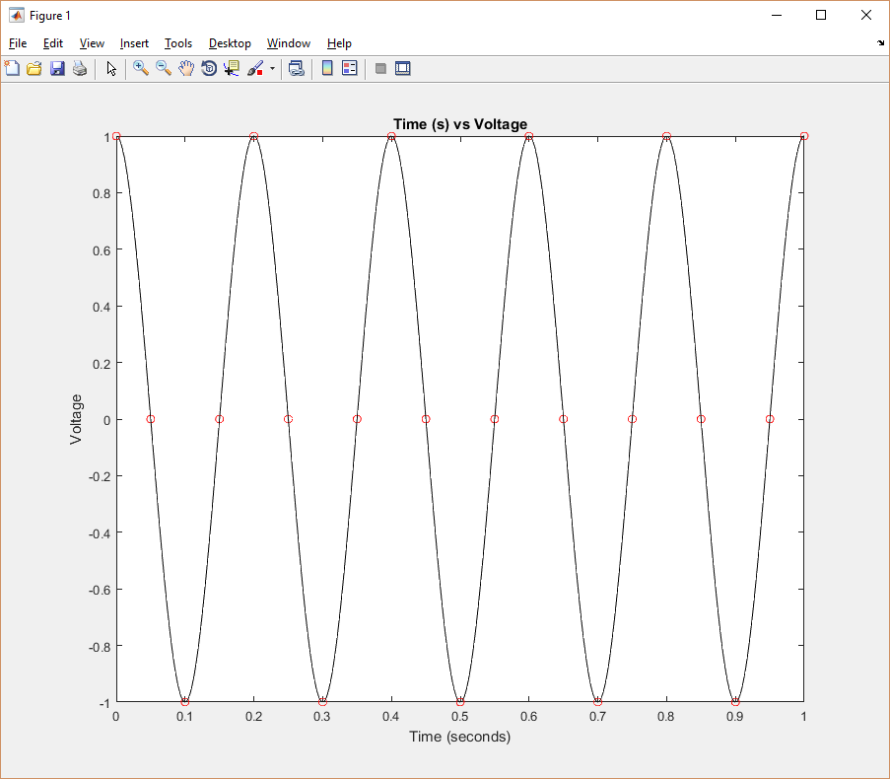

Problem 14d: What kind of waveform does your plot in part (c) look like? Could you possibly have picked this up from looking at the original data points?

Plot looks like a Sin waveform. This isn’t surprising because at repeating intervals of 0.1(s) the voltage is at it’s maximum but it’s sign is reversed.