AWS

Labs 1-3

Reed Holman | CCNP | 3/1/2023

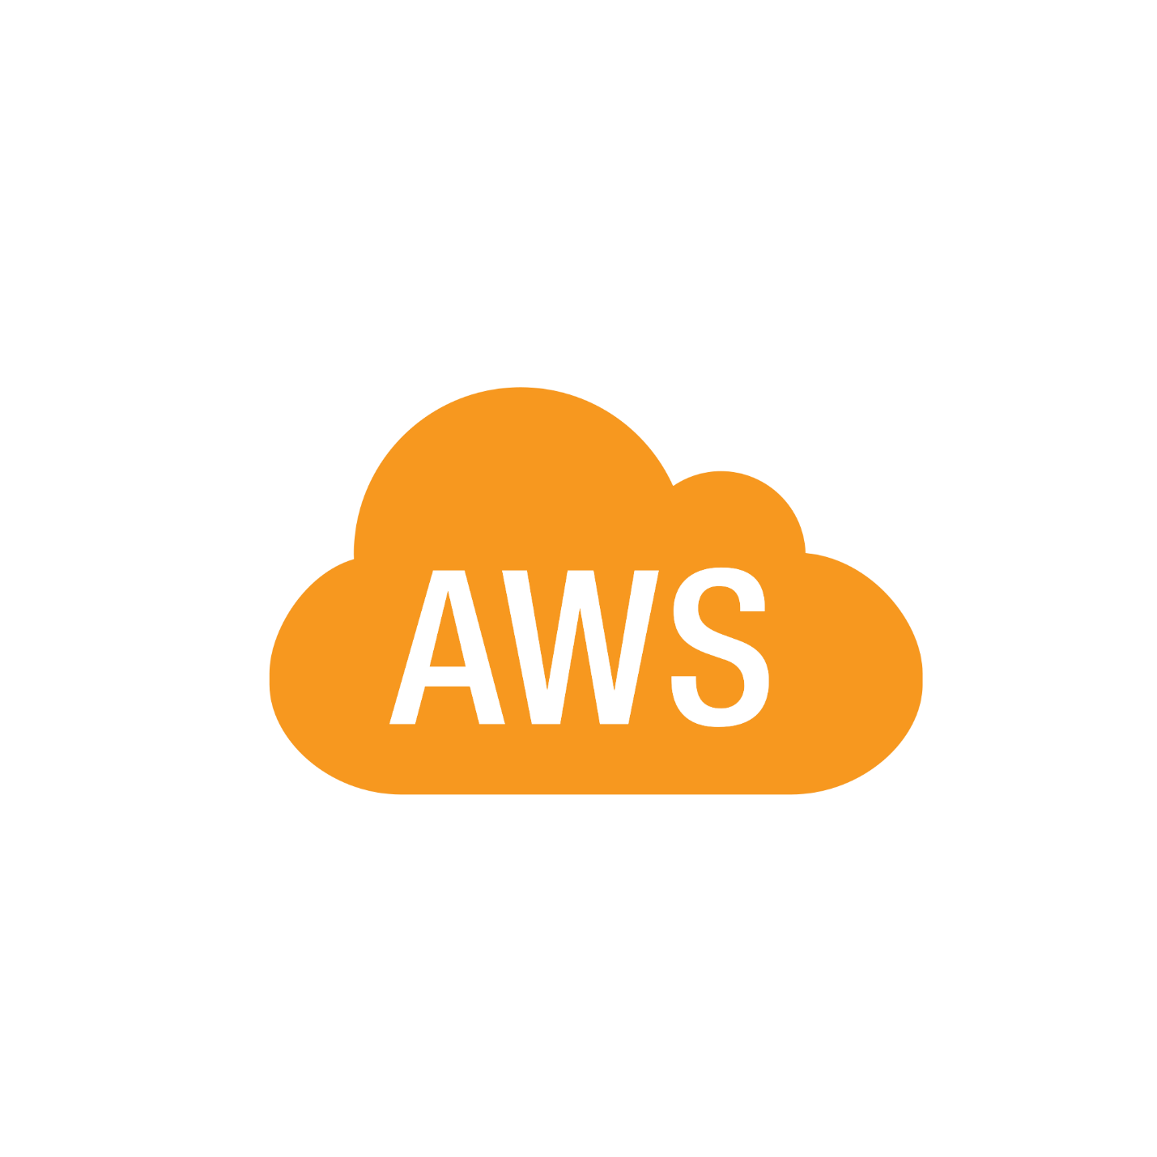

Purpose: To learn the basics of AWS

Background Information:

AWS or Amazon web services is one of the biggest cloud computing services there is. Usually, you must purchase physical IT management devices like routers and switches. These cost money and lots of space which also costs money. Cloud computing is the ability to do everything you need without owning a physical device. At the time of AWS’s creation Amazon claimed that 70% of their network engineers’ time was spent fixing IT infrastructure problems. Having a way to use cloud computing would allow the engineers to have more time to fix more critical issues.

AWS uses a pay-as-you-go system when charging its customers. Combined with autoscaling AWS can save a user money. Autoscaling is the process in which a client will use more resources when traffic is high and will use less during times of low traffic, meaning they are only using/paying for what necessary at that time.

An important aspect of AWS is the Elastic Compute Cloud or the EC2. It allows clients to rent their own virtual computer which can run their own applications.

LAB 1: Introduction to AWS IAM: **AWS Identity and Access Management (IAM)**

**Purpose: This first lab focused on IAM, looking at and exploring IAM policies and groups.**

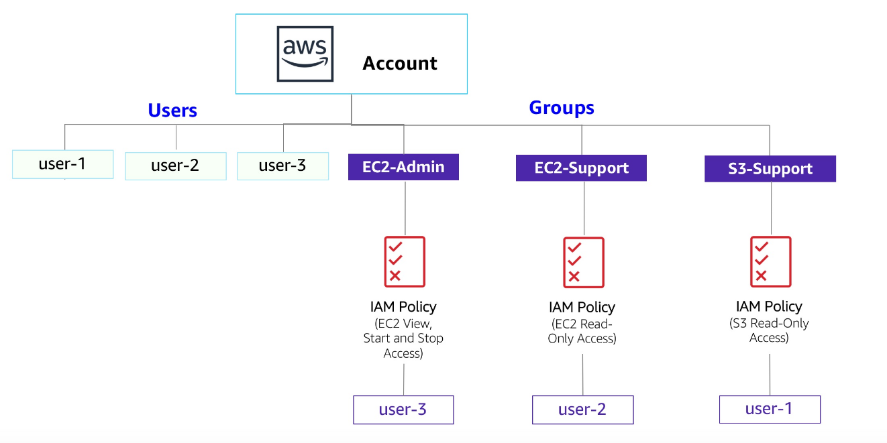

Tasks: This first lab was all about exploring AWS. You needed to look at the different permissions for different user profiles. We saw what groups there were and what users were apart of which groups. We also examined the different permissions that each group had.

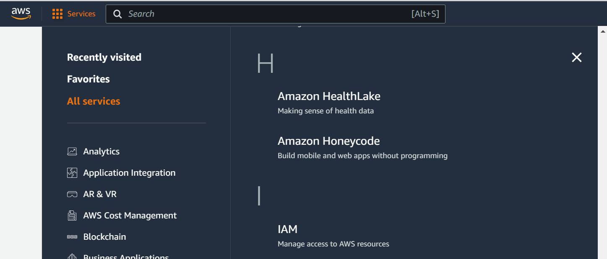

Go to Services and fine IAM

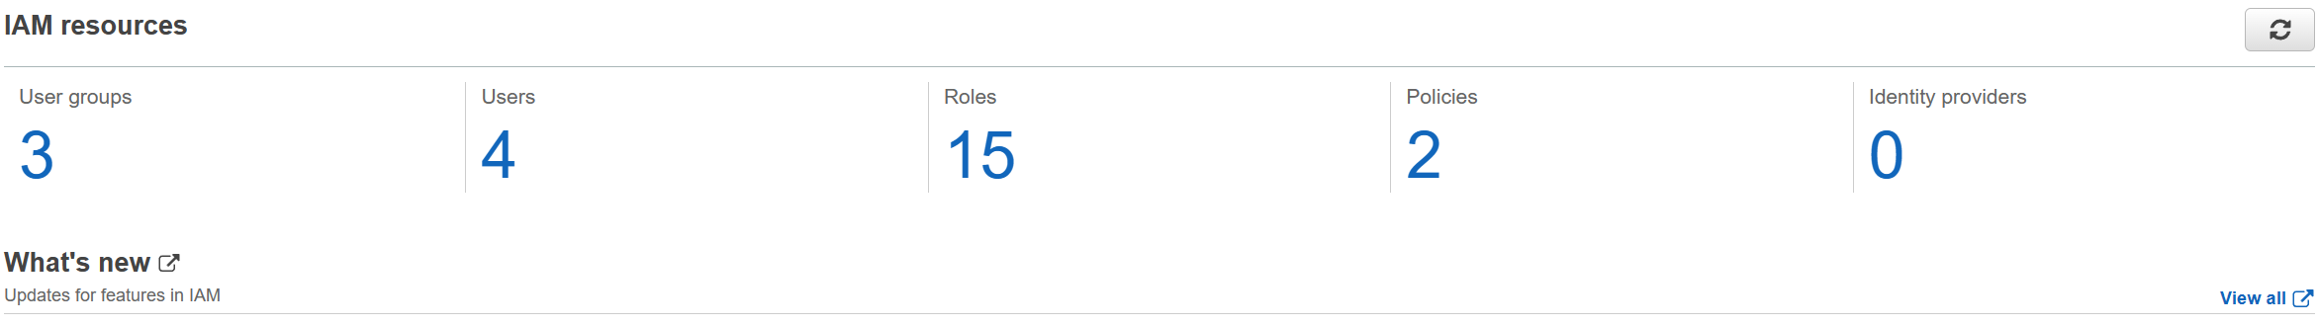

Here you see the users and the User Groups

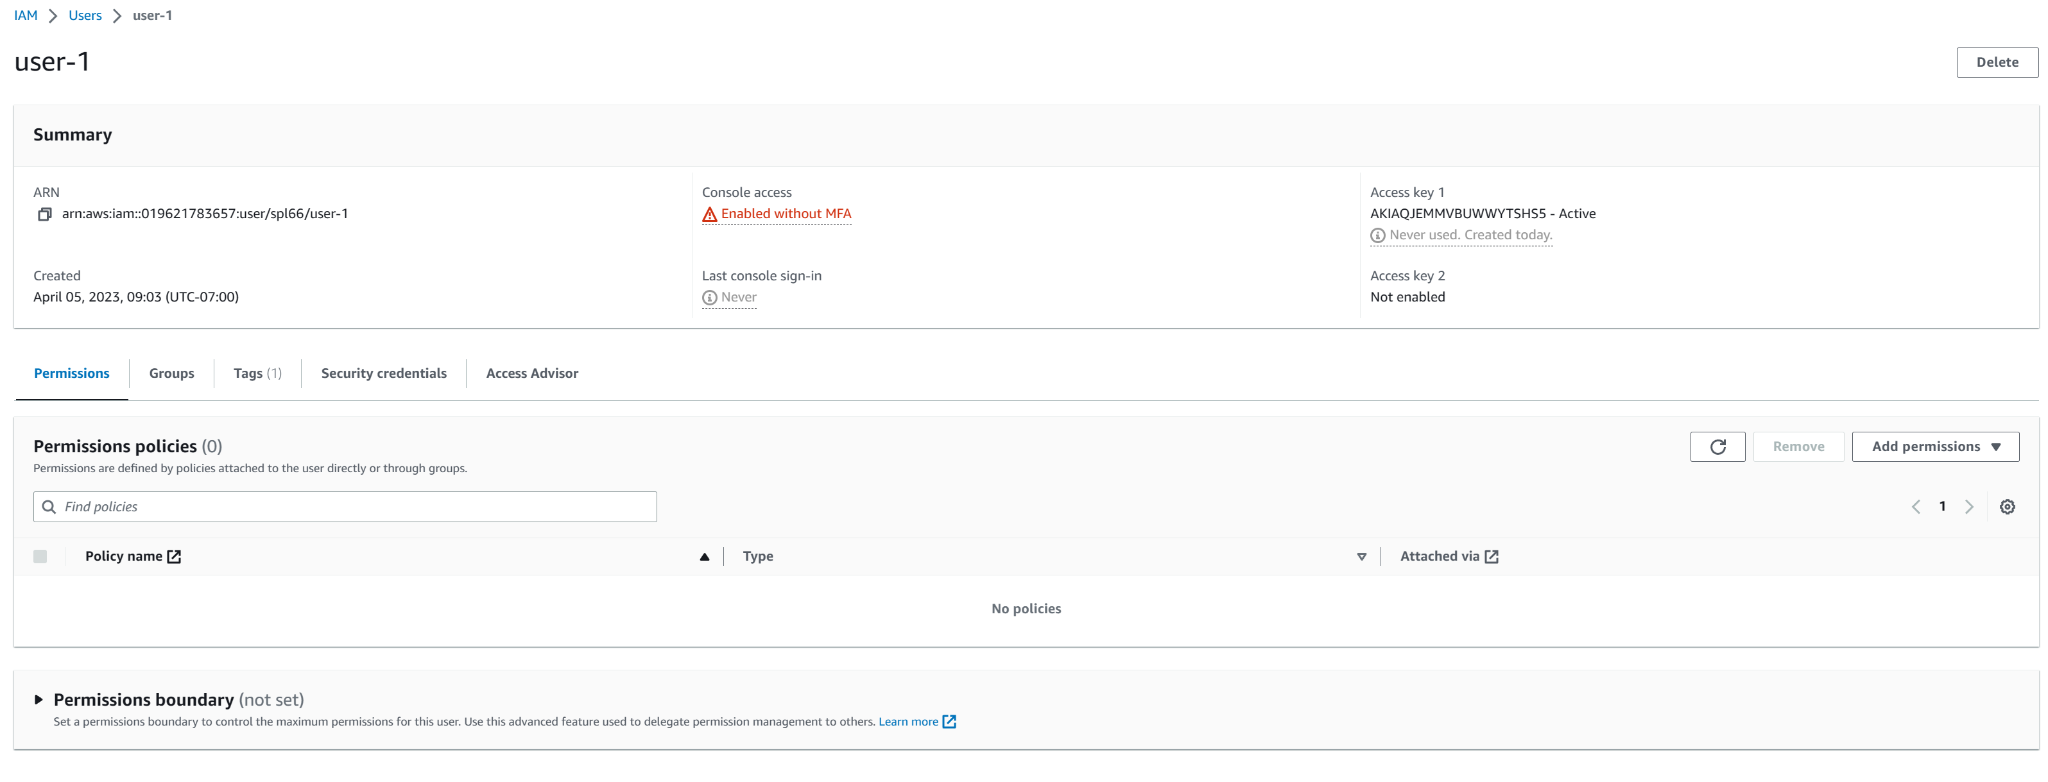

The details of each user are displayed after clicking on it

We Also had to add users to Groups.

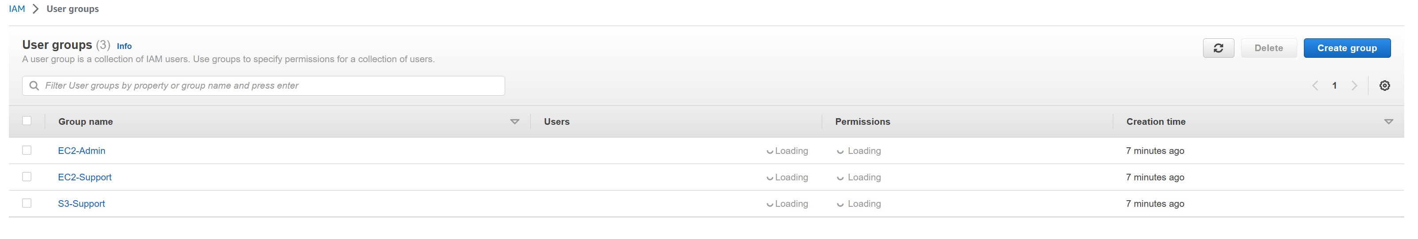

See All User Groups here

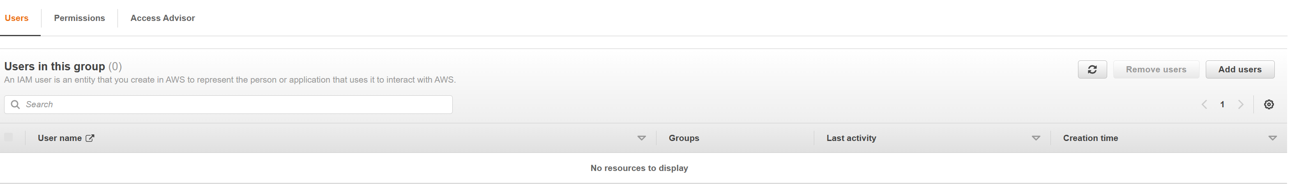

Once clicking on a group, you the ability to add users to that group

Finally, we need to sign-in and test the abilities of each user.

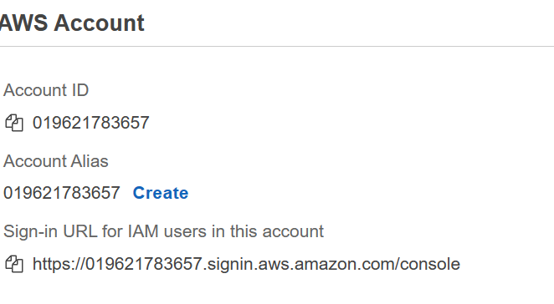

Back on the dashboard there is a link on the right to sign in to the IAM users

Lab 2: Build your VPC and Launch a Web Server (Virtual Private Cloud)

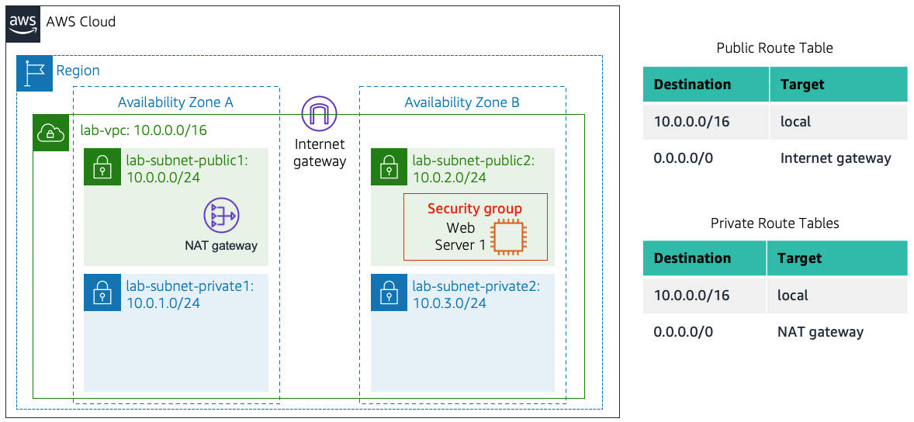

Go to services and select VPC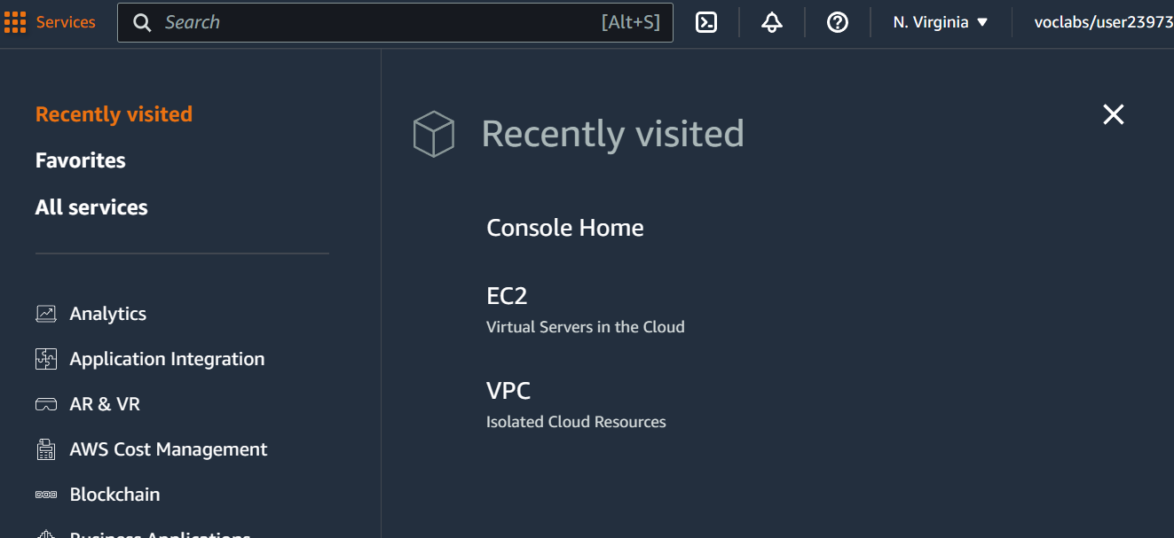

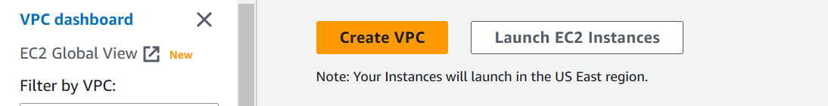

Click the ‘Create VPC’ button

Then you see all the different properties you can change when creating your VPC

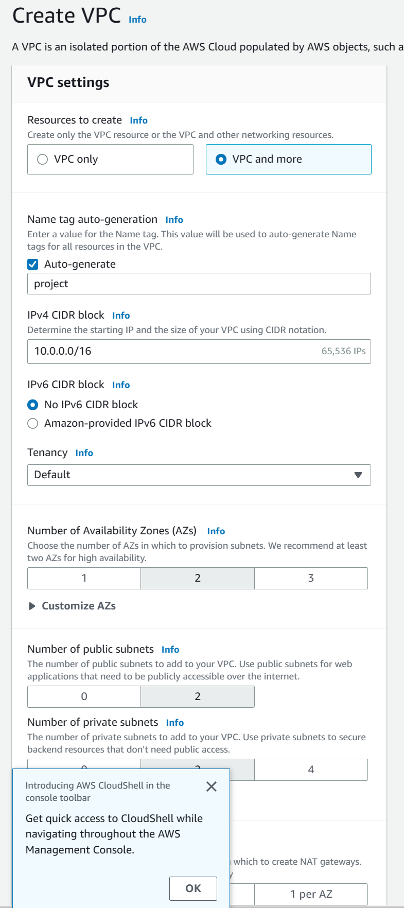

On the left-hand side clicking the Subnets button will bring you to this page where you can create new subnets

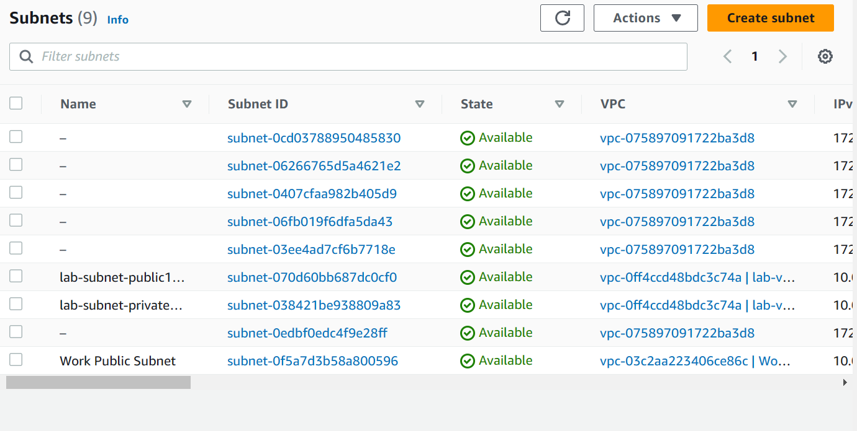

We used these setting to create a public subnet

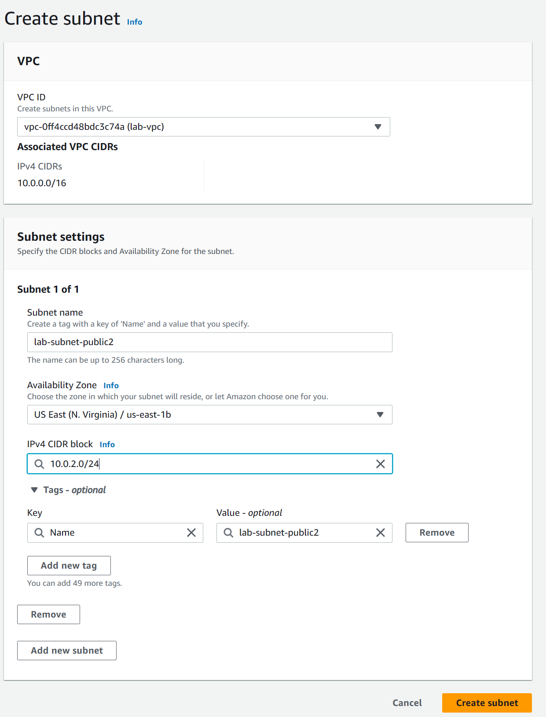

And these settings to create a private one

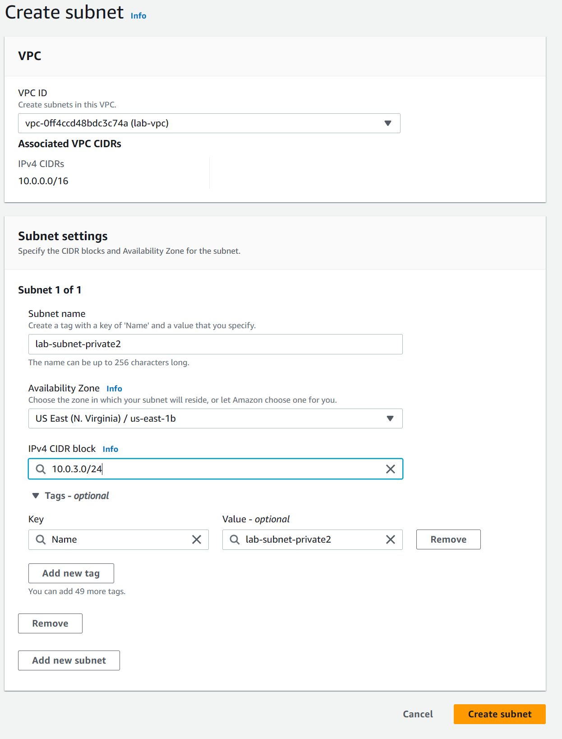

By clicking on the Route tables page, you can manage the different route tables like adding new subnets

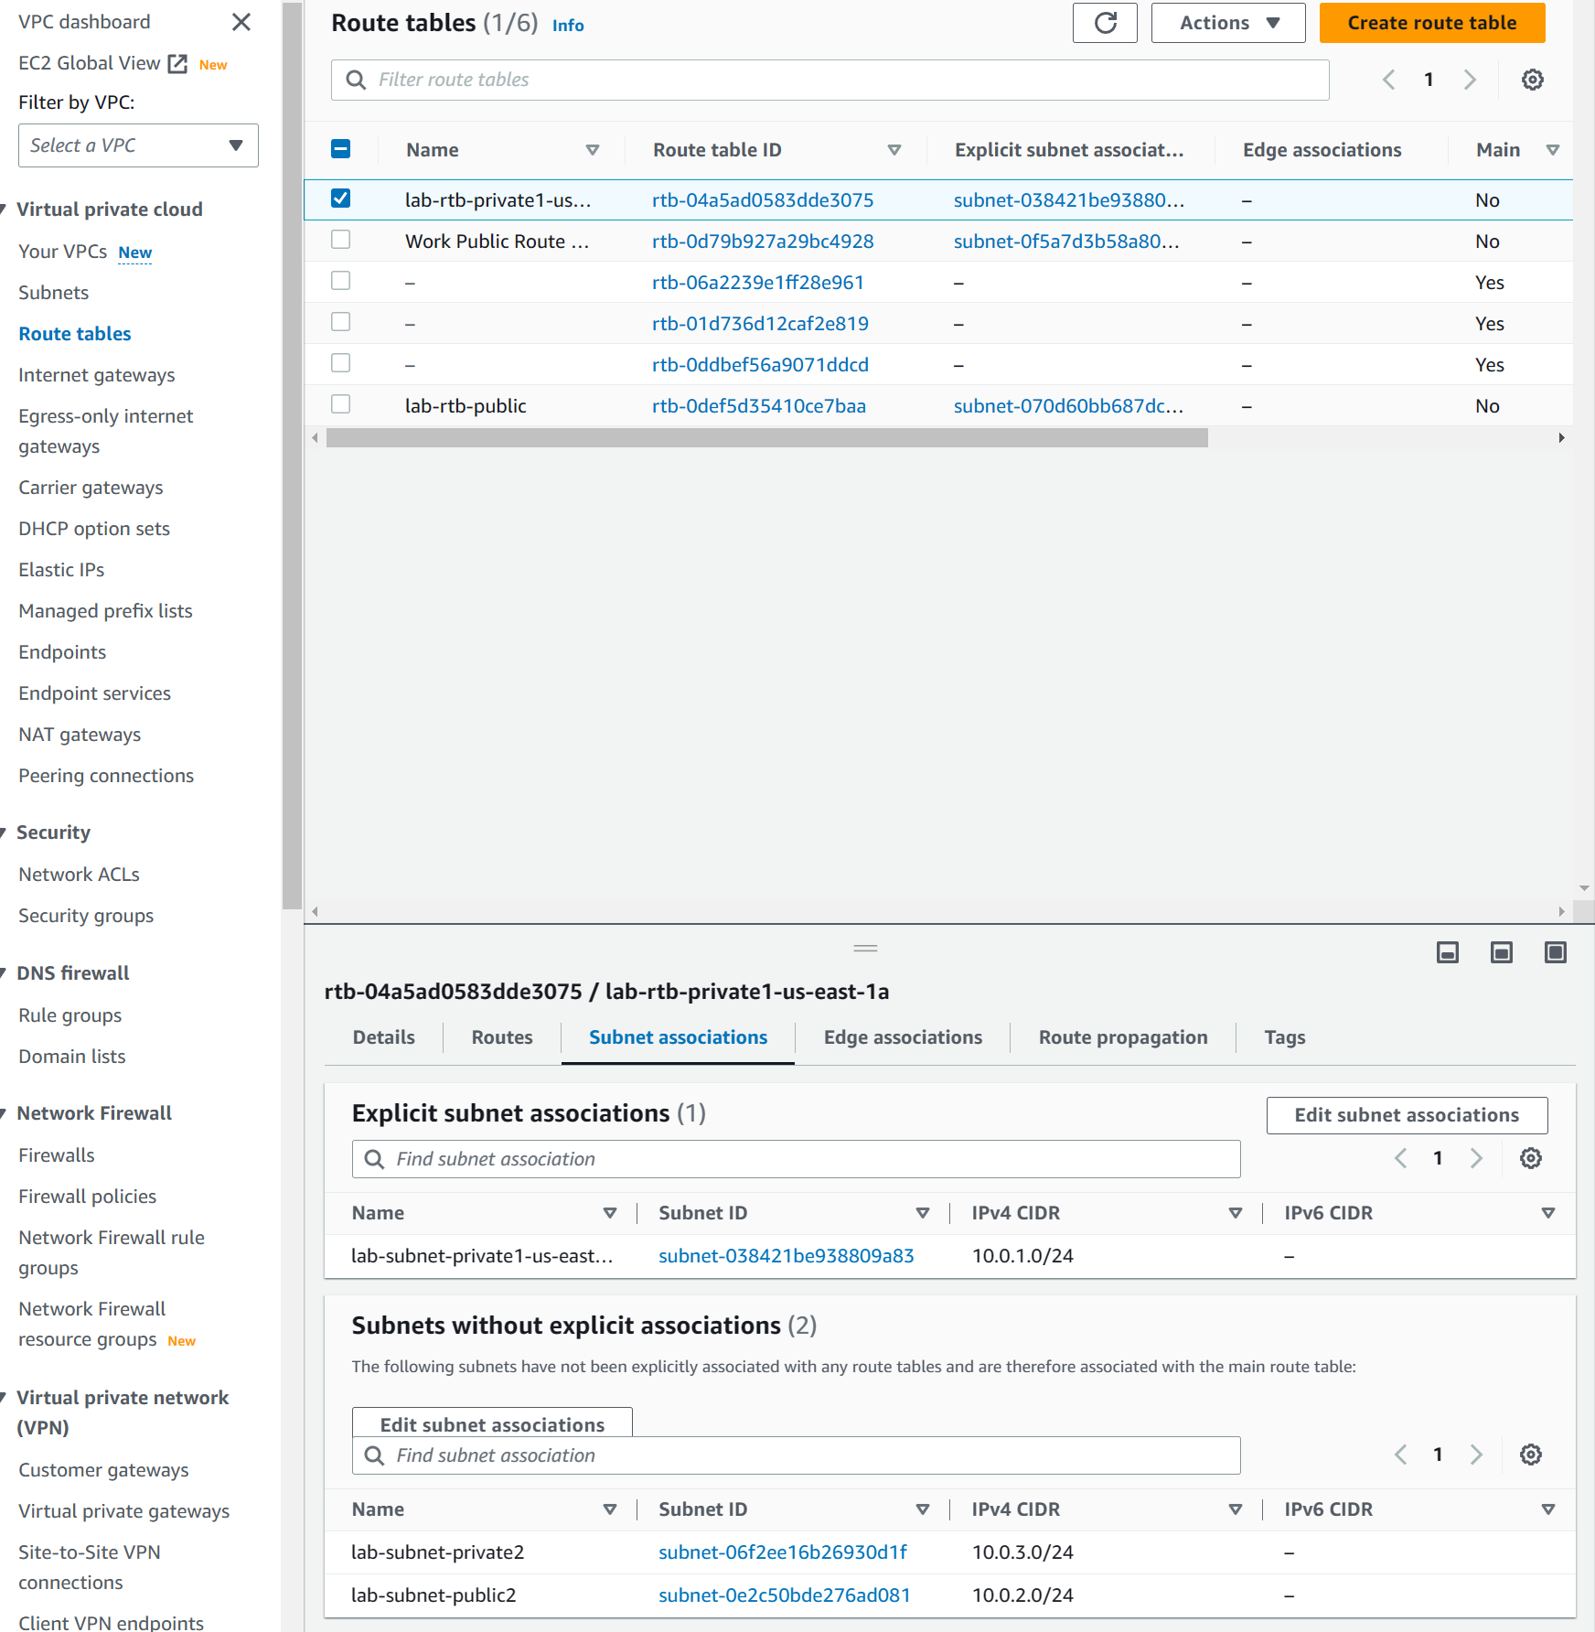

Click on Security groups then ‘Create security group’

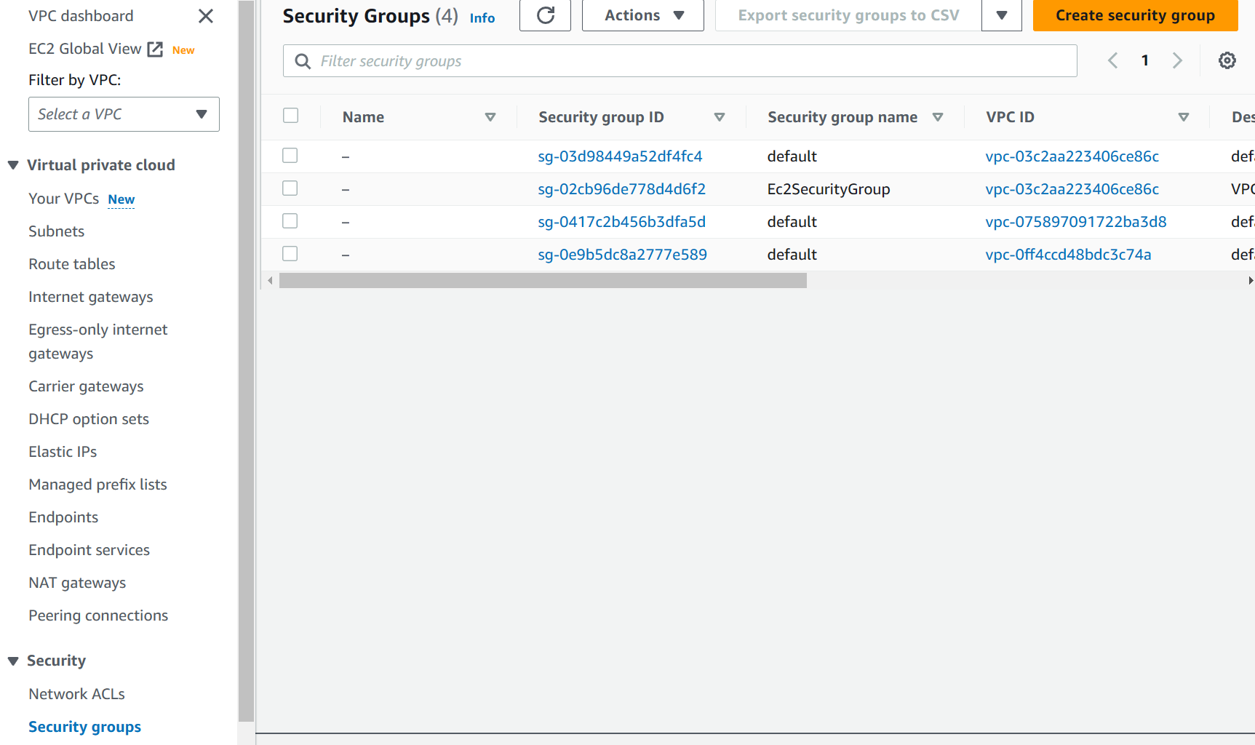

We used these configurations to create a security group

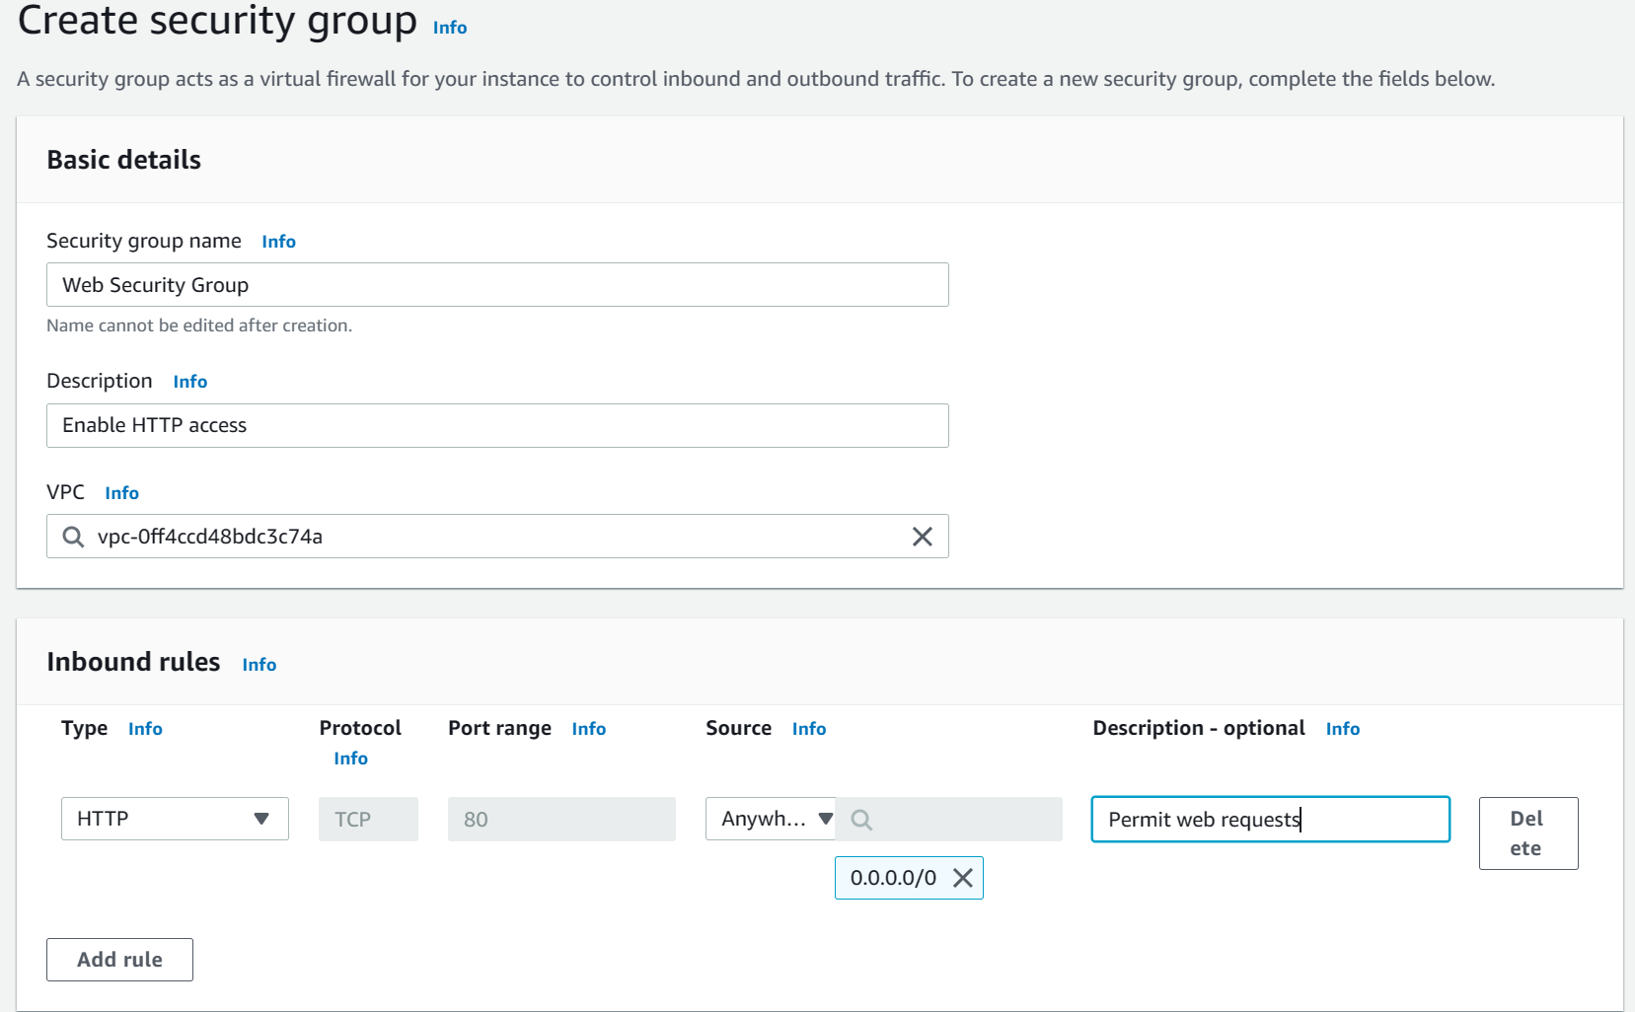

Launch an Amazon EC2 instance into the new VPC. You will configure the instance to act as a web server.

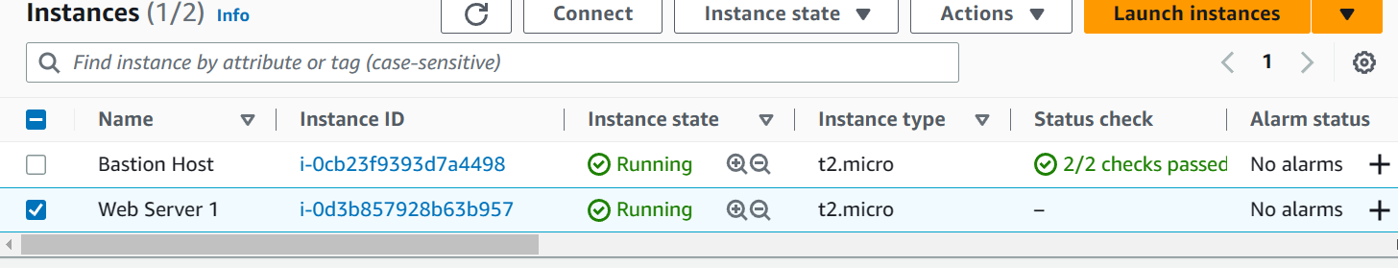

Lab 3: Introduction to Amazon EC2

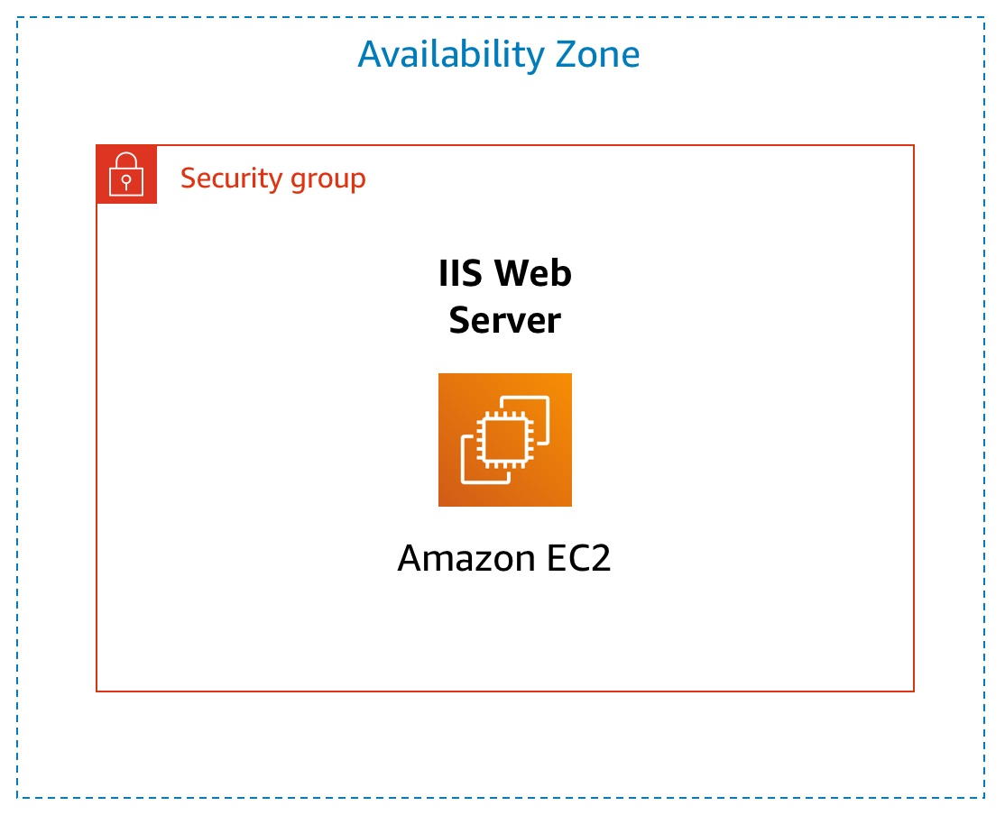

Create a new Ec2 instance

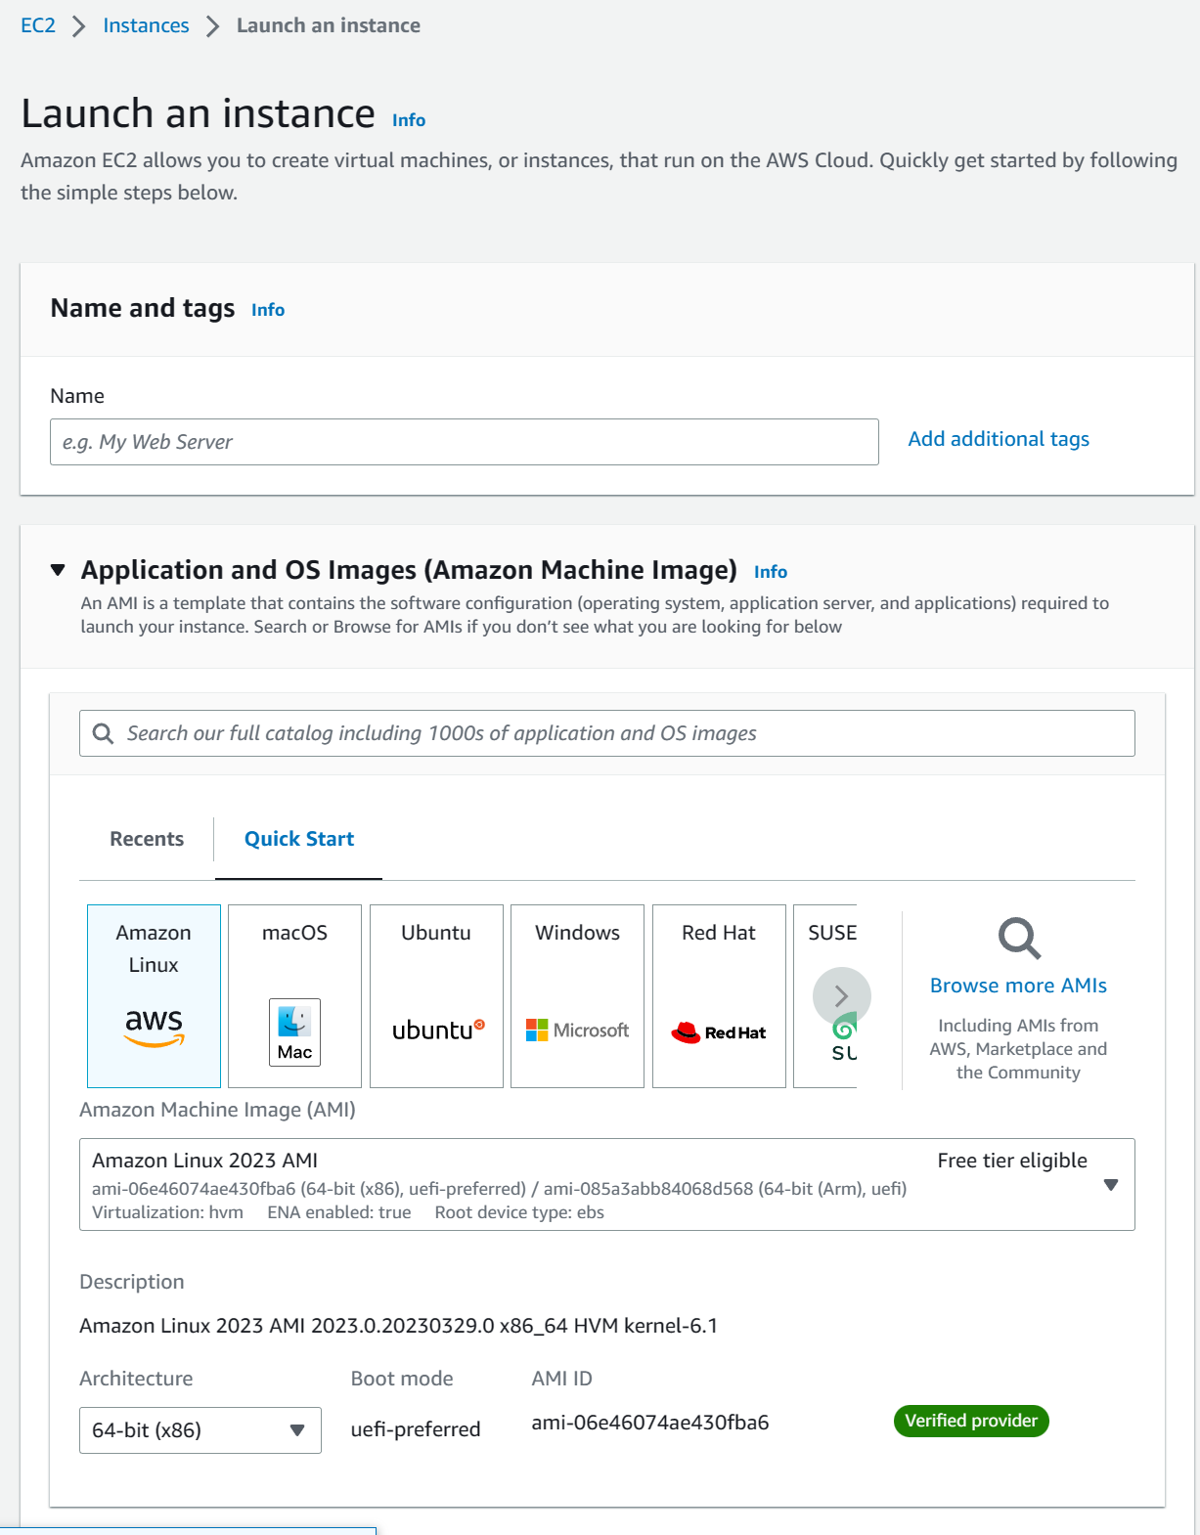

We used these network settings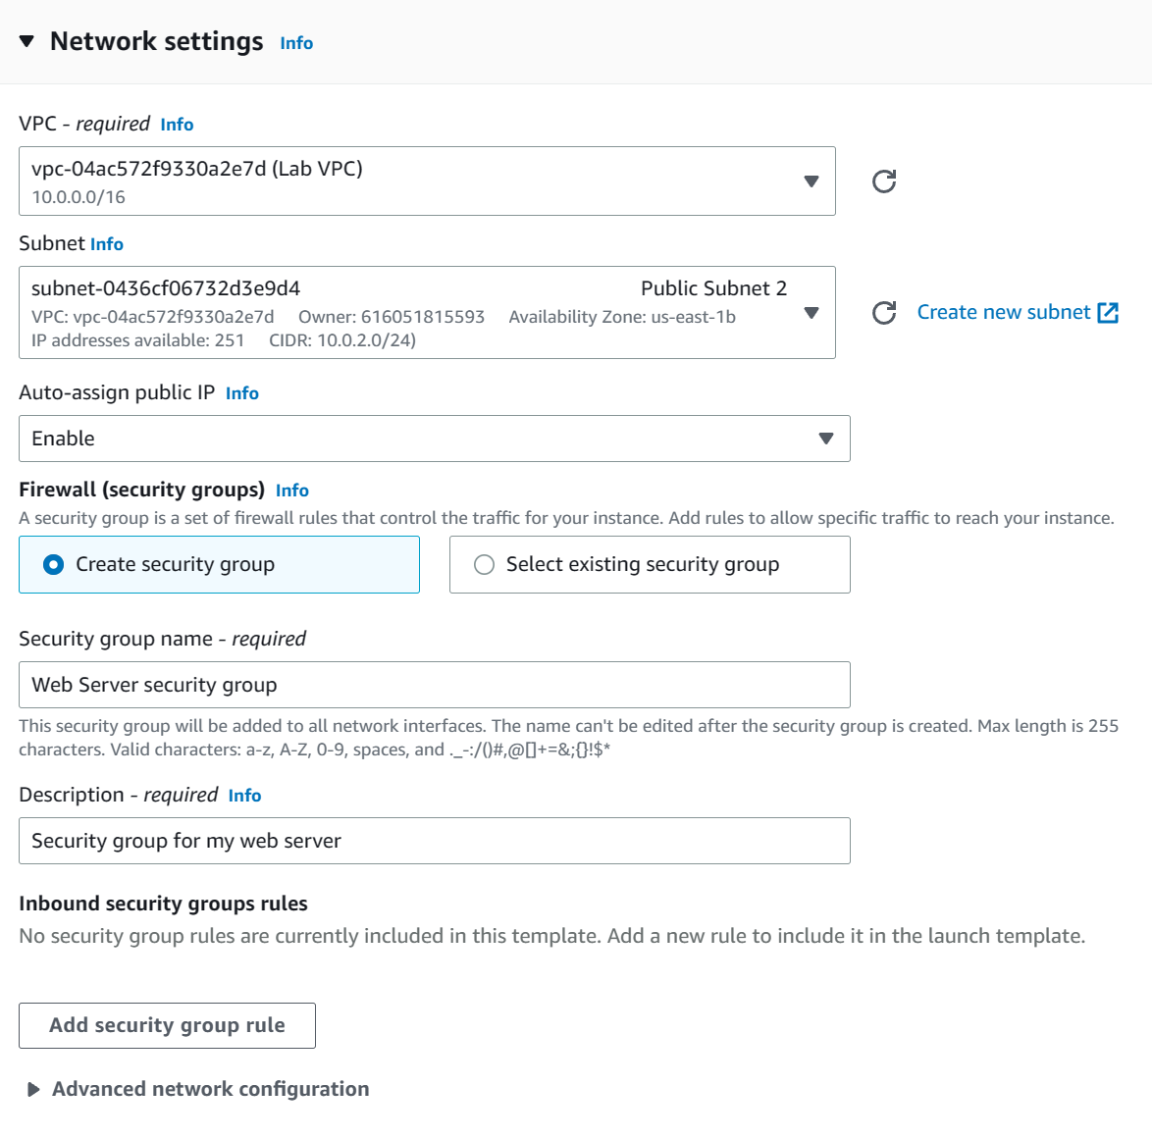

And changed the advance settings to this

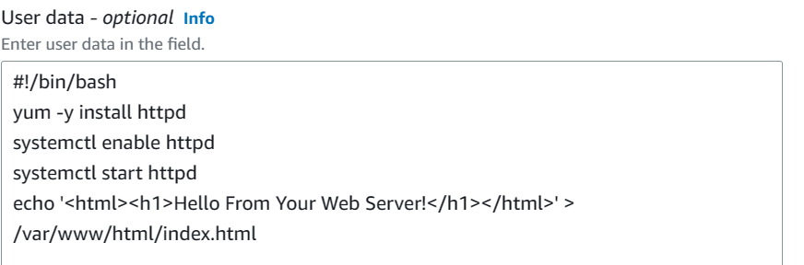

That code will automatically configure and run our web server

You can monitor your instance by clicking on any on these menus



Change your security rules to allow HTTP traffic to the web server

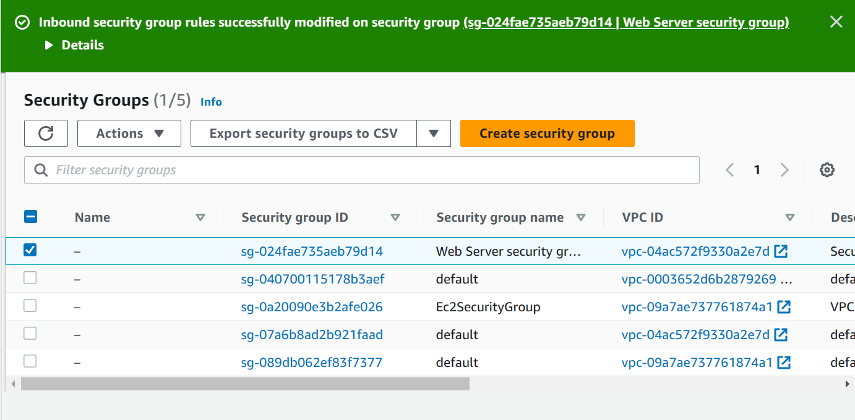

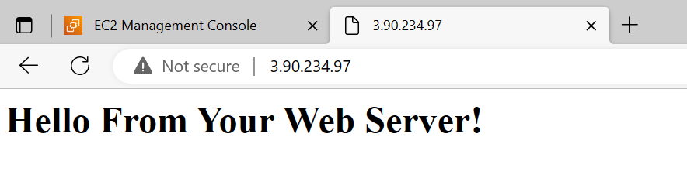

Change instance type to t2.small

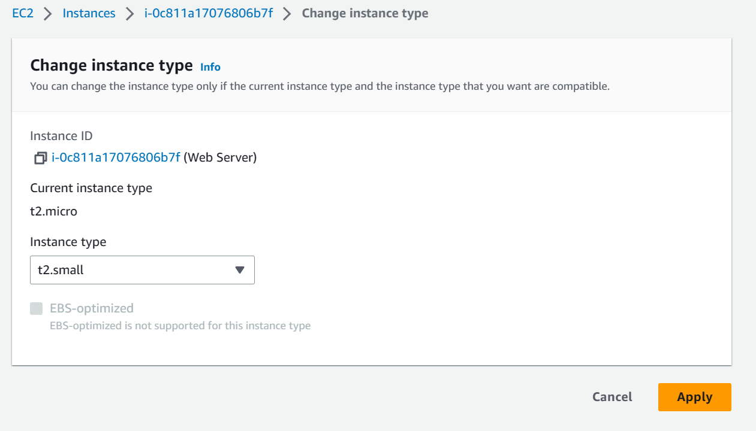

Also changed the size from 8gb to 10gb

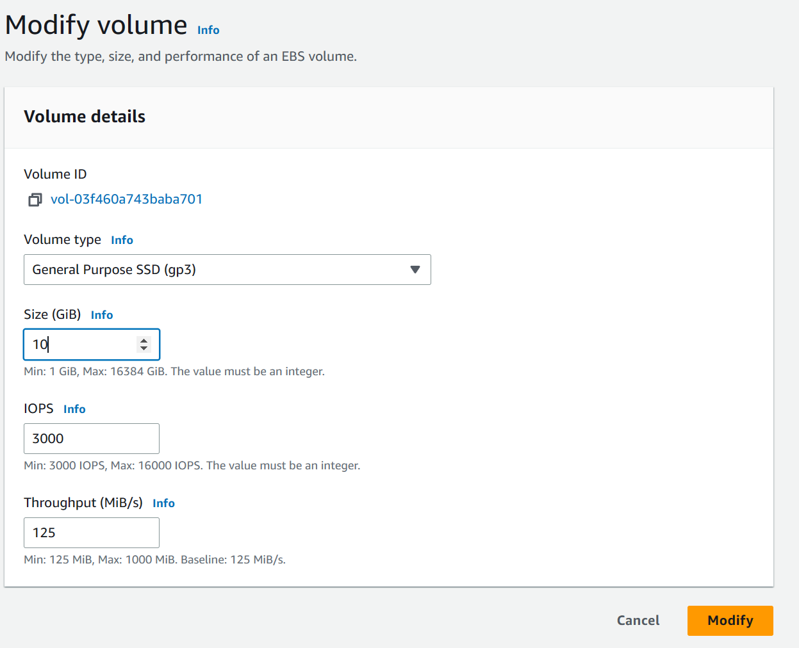

Conclusion: We learned the basics of AWS and how to navigate and what the major aspects are. Later, we configurated things like EC2 instances and web servers.