AWS

Labs 4-7

Reed Holman | CCNP | 3/30/2023



Purpose: To learn the basics of AWS

Background Information:

AWS or Amazon web services is one of the biggest cloud computing services there is. Usually, you must purchase physical IT management devices like routers and switches. These cost money and lots of space which also costs money. Cloud computing is the ability to do everything you need to do without actually having to own a physical device. At the time of AWS’s creation Amazon claimed that 70% of their network engineers’ time was spent fixing IT infrastructure problems. Having a way to use cloud computing would allow the engineers to have more time to fix more important issues.

AWS uses a pay-as-you-go system when charging its customers. Combined with autoscaling AWS can greatly save a user money. Autoscaling is the process in which a client will use more resources when traffic is high and will use less during times of low traffic, meaning they are only using/paying for what necessary at that time.

An important part of AWS is the Amazon Elastic Block Store (EBS) volume, they are attached to your EC2 instance and are able encrypt and store data. You have multiple EBS attached to a single EC2 instance, and they are very customizable allowing you to store several types of data.

Amazon also had the Amazon Relational Database Service (Amazon RDS) which is the way you are able to set up a database in the cloud. Specifically, we used a Multi-AZ Amazon RDS that means one primary DB instance is created and replicated to a standby instance located in a different Availability Zone. Things like Elastic Load Balancing (ELB) and Auto Scaling help improve the stability of your architecture.

LAB 4: Working with EBS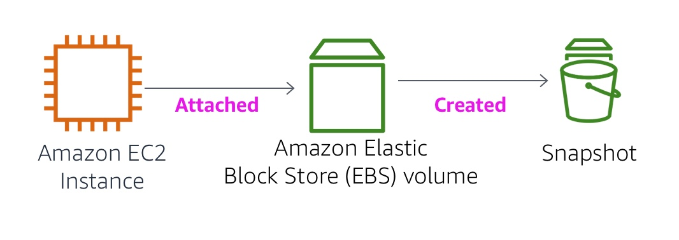

Create a new Volume with these setting and adding a tag

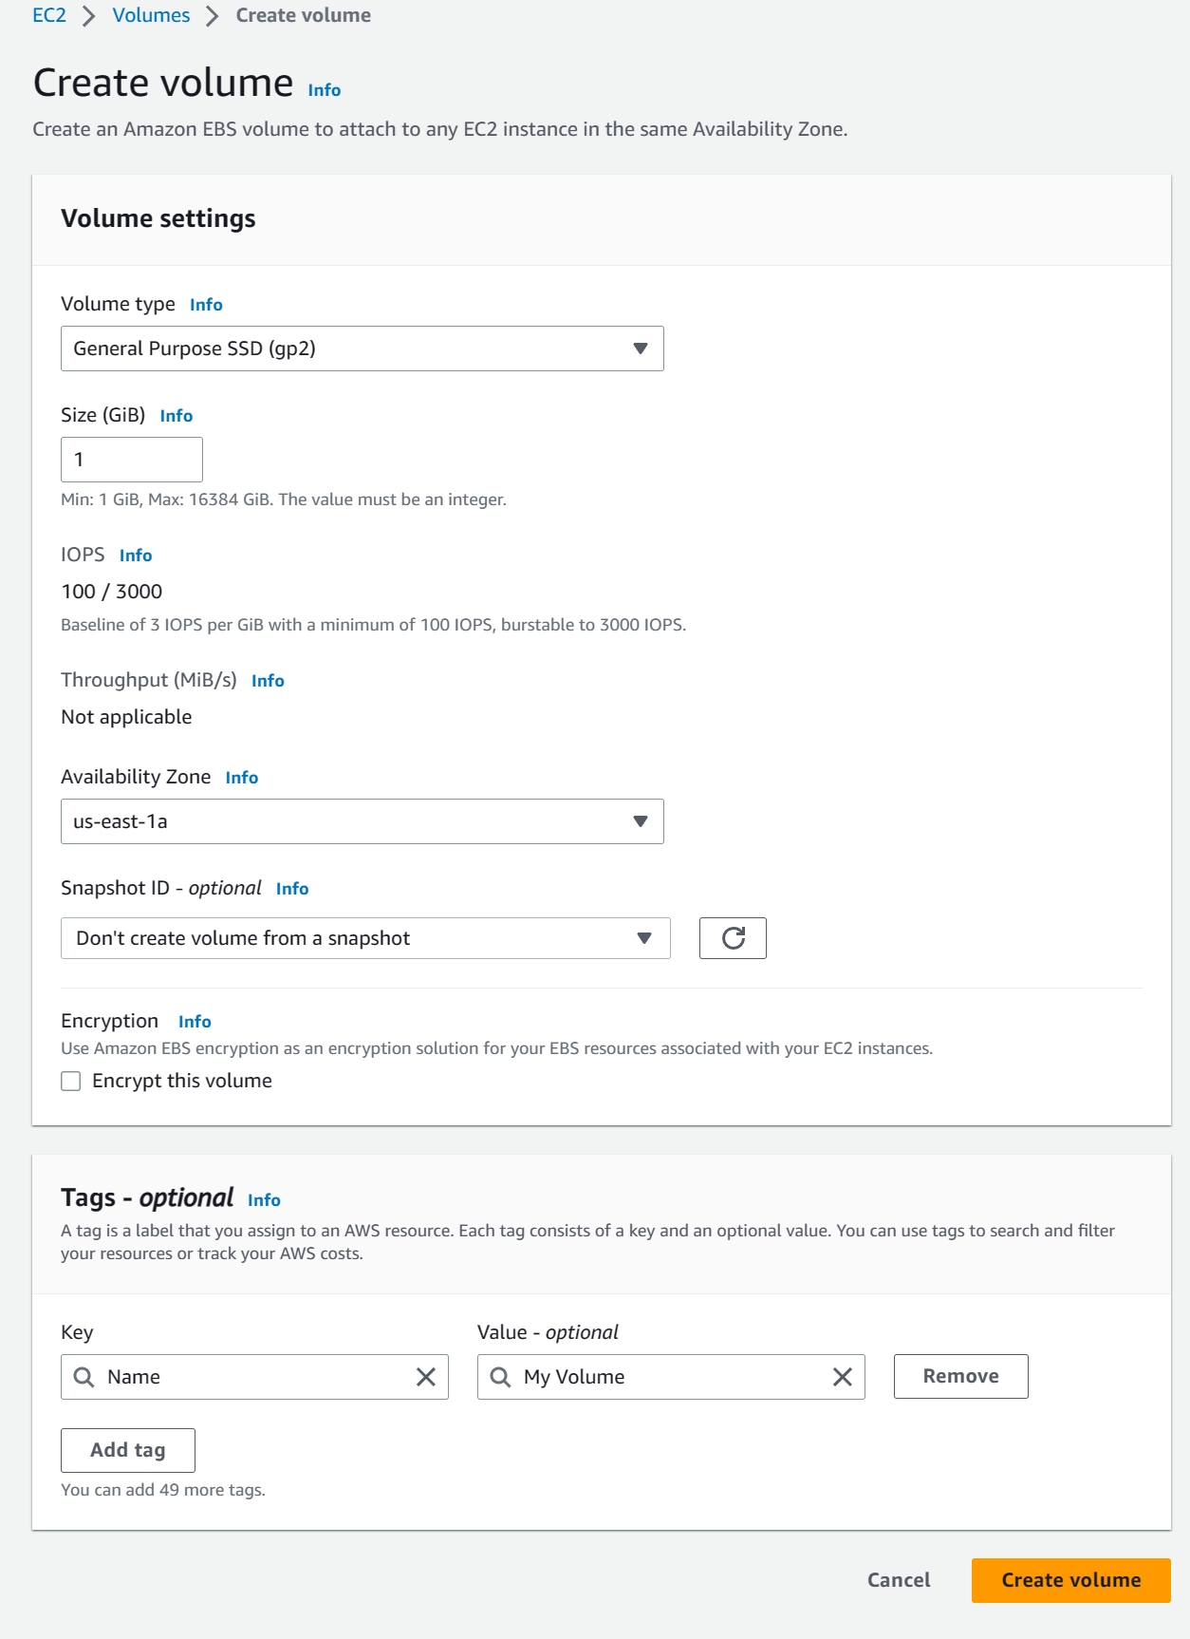

Add the volume to the Ec2 instance

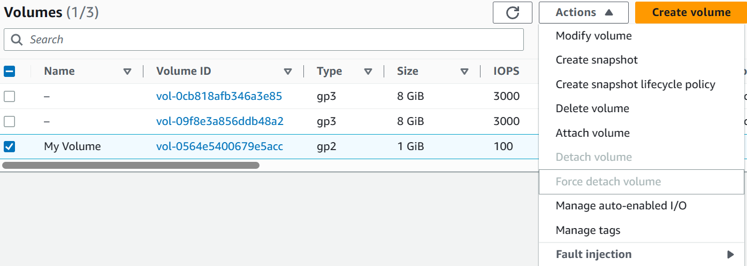

Login using putty

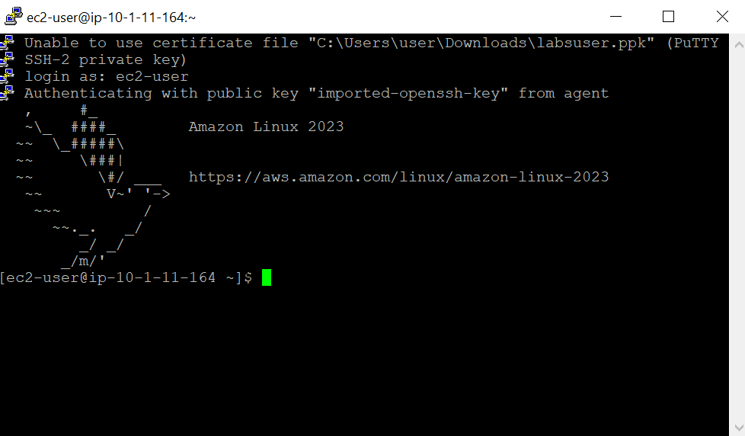

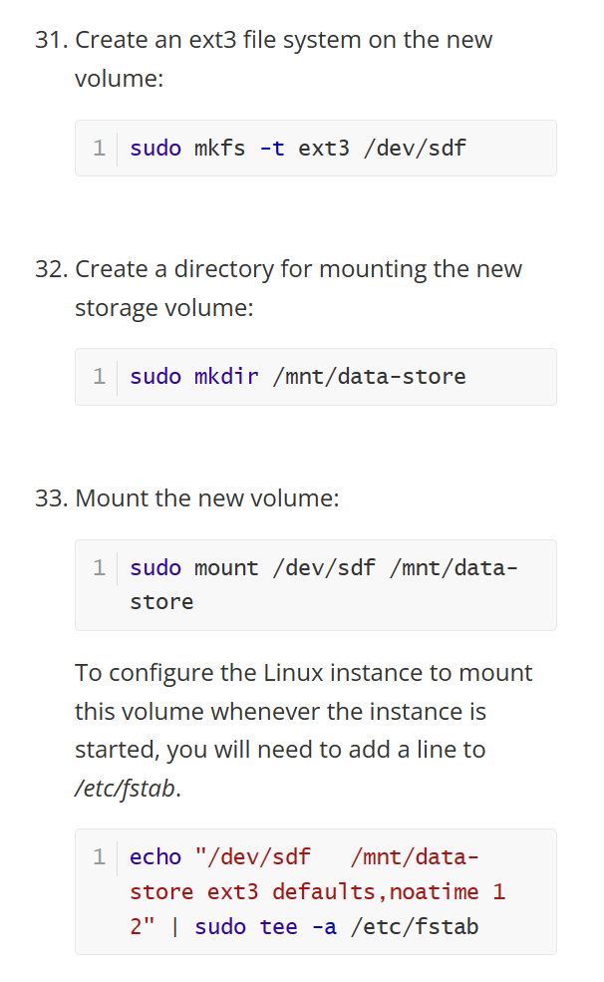

Create a snapshot on the Volume

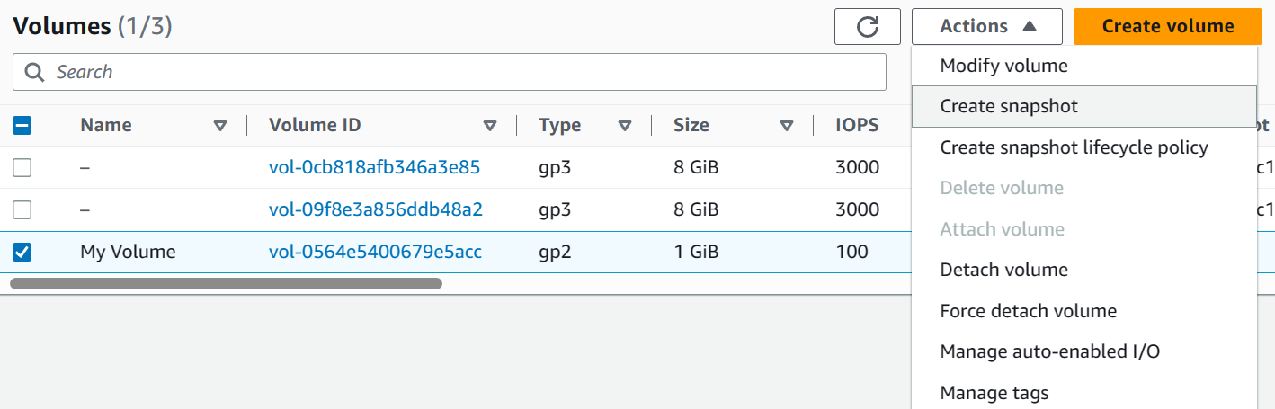

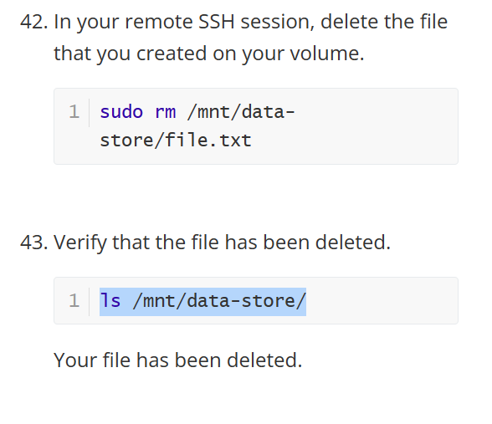

Create volume from snapshot

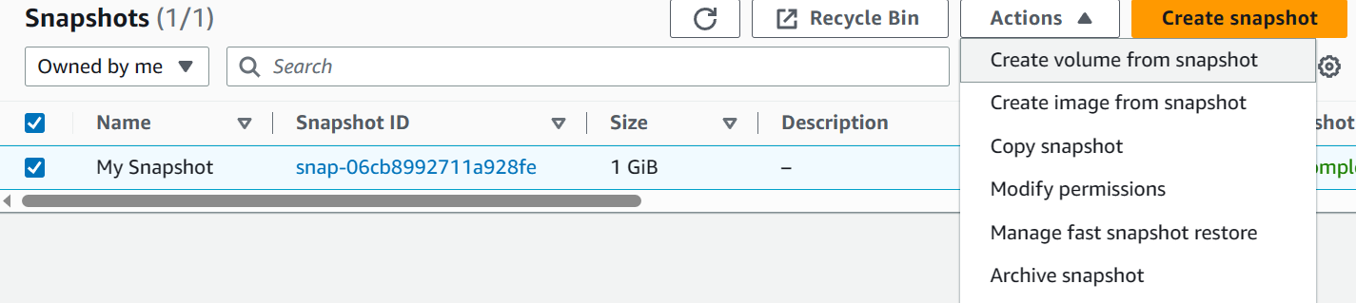

Then attached the restored volume to the instance

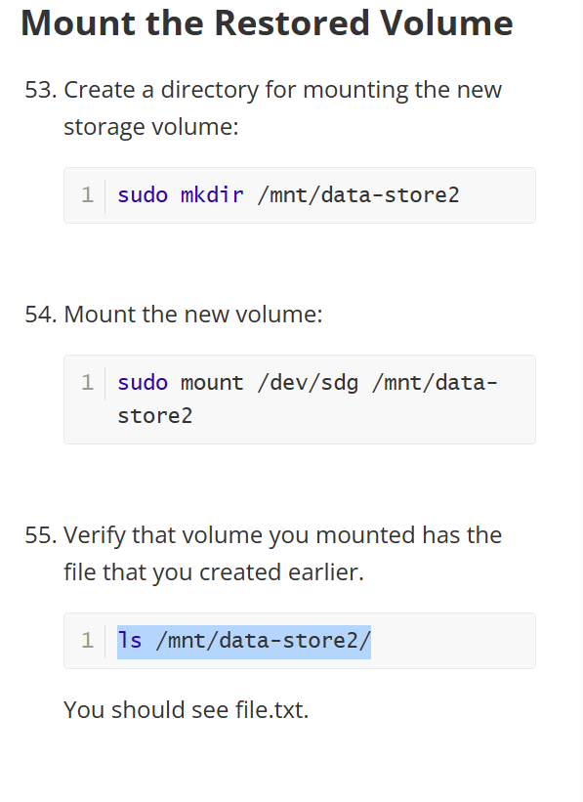

Lab 5: Build Your DB Server and Interact With Your DB Using an App

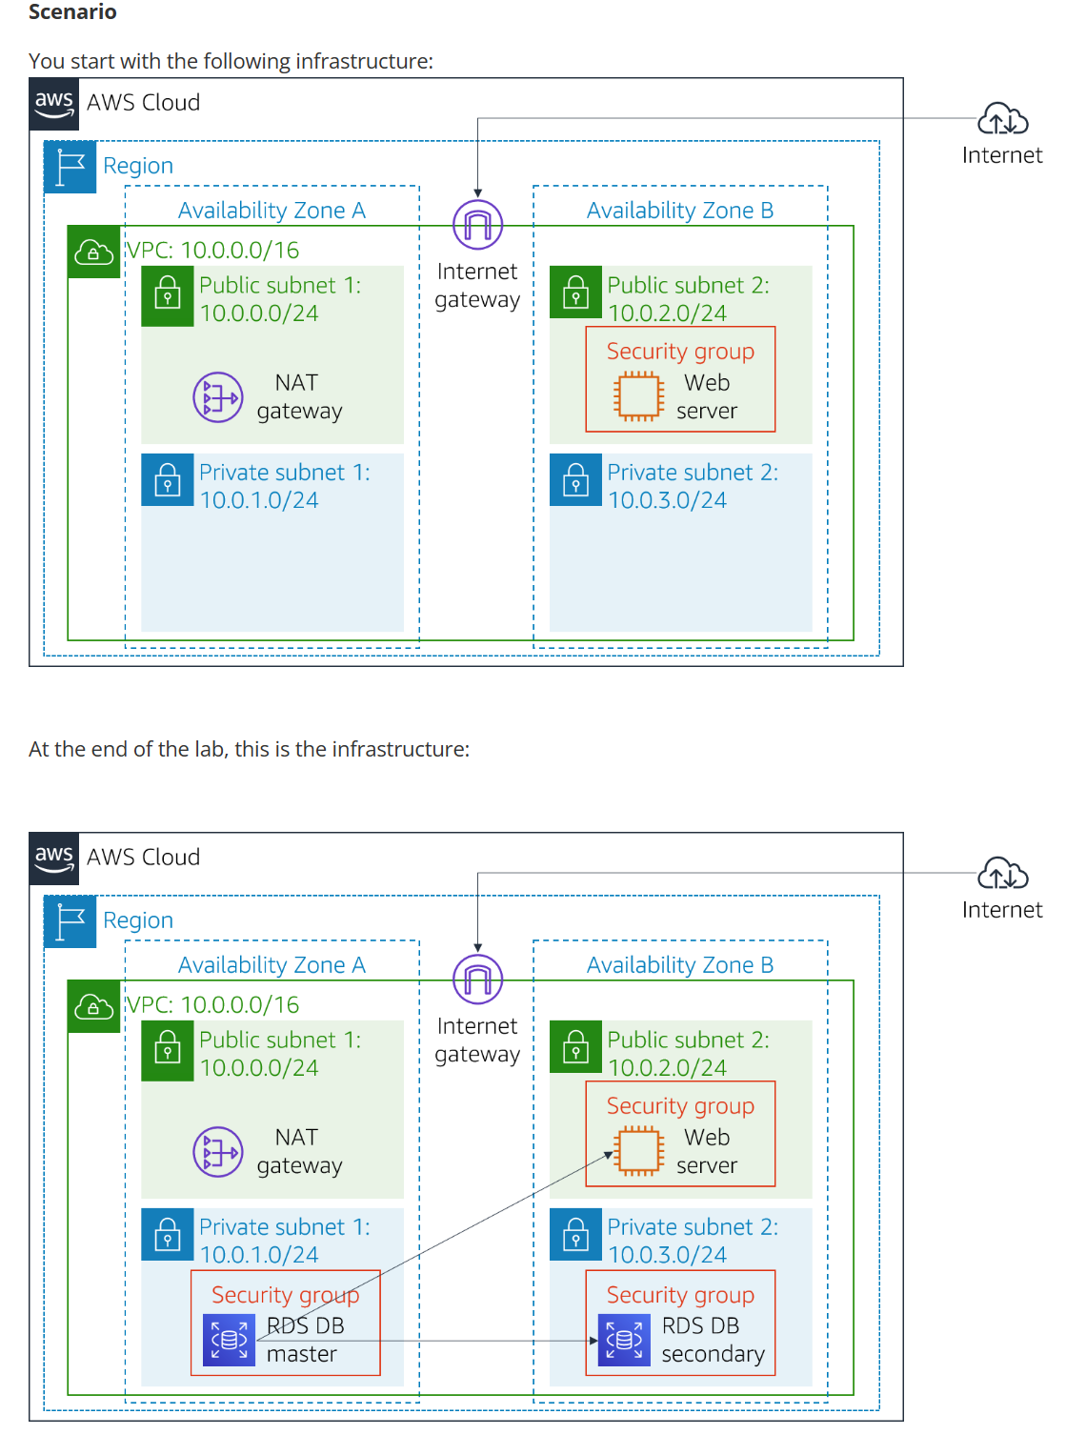

Create a new security group and add an inbound rule

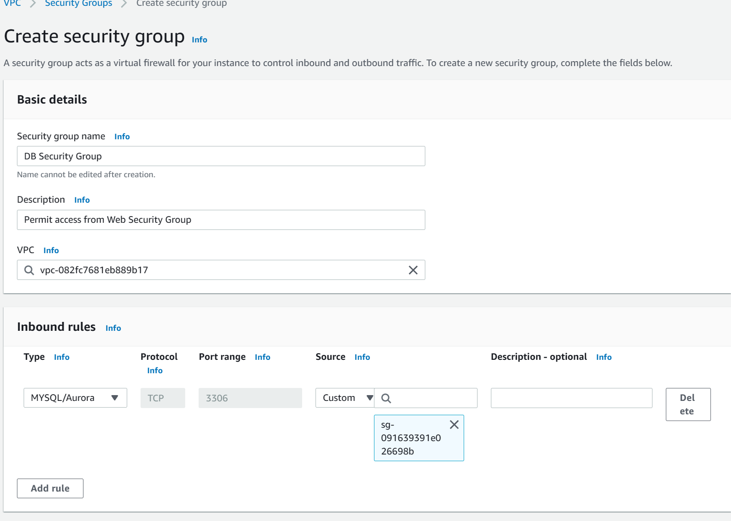

Create a new DB subnet group and add the correct subnets

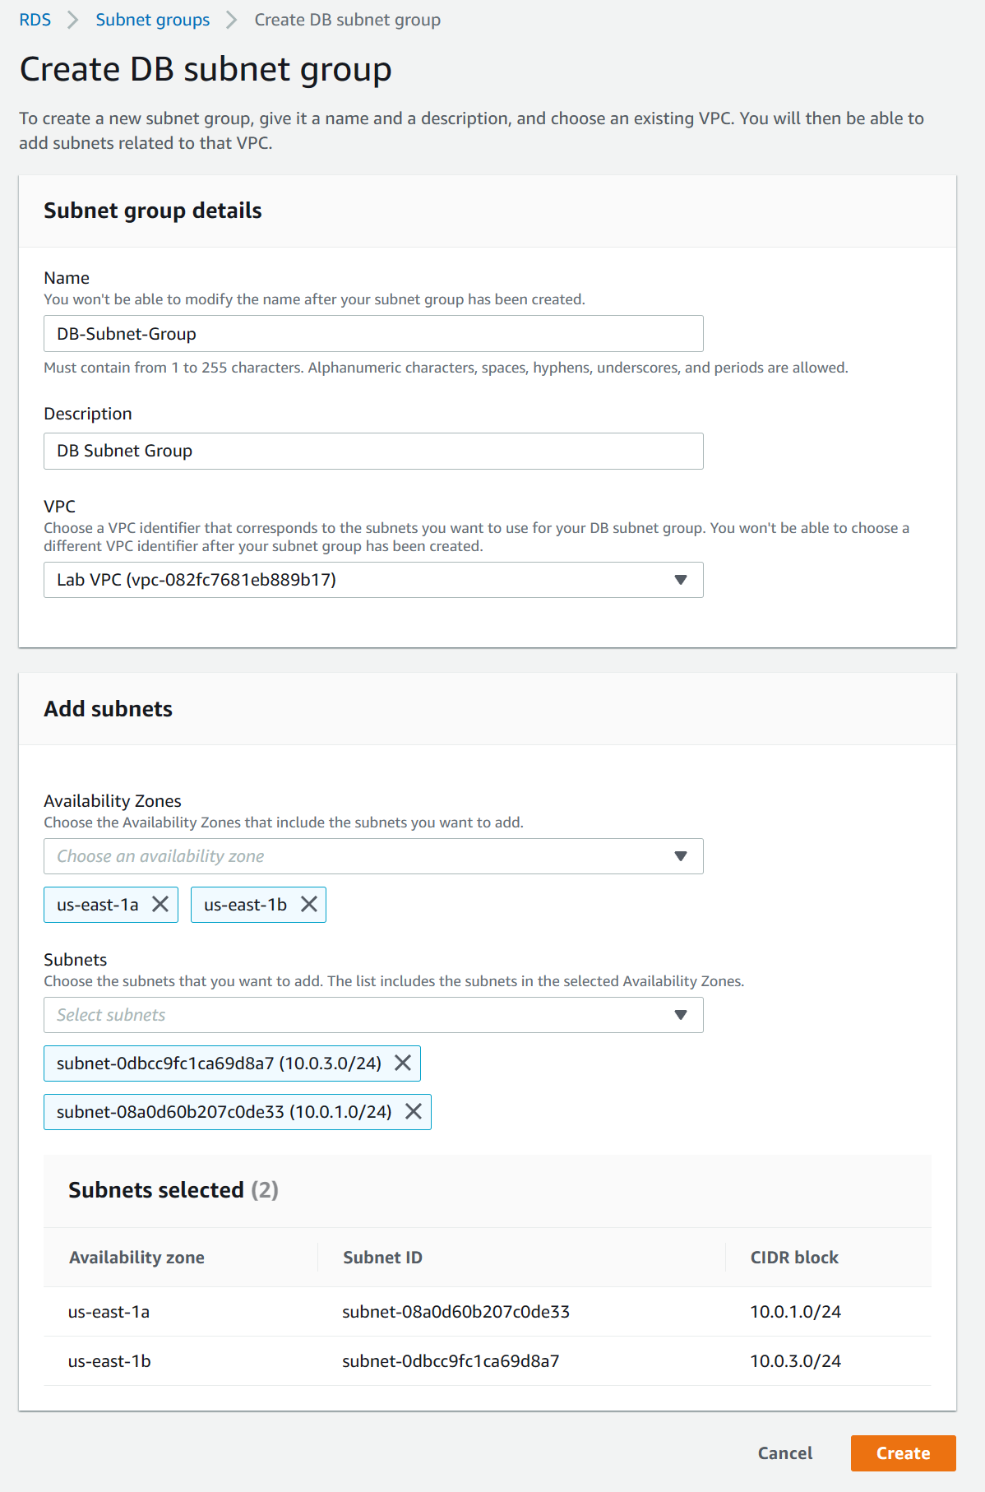

We create a new database using these settings

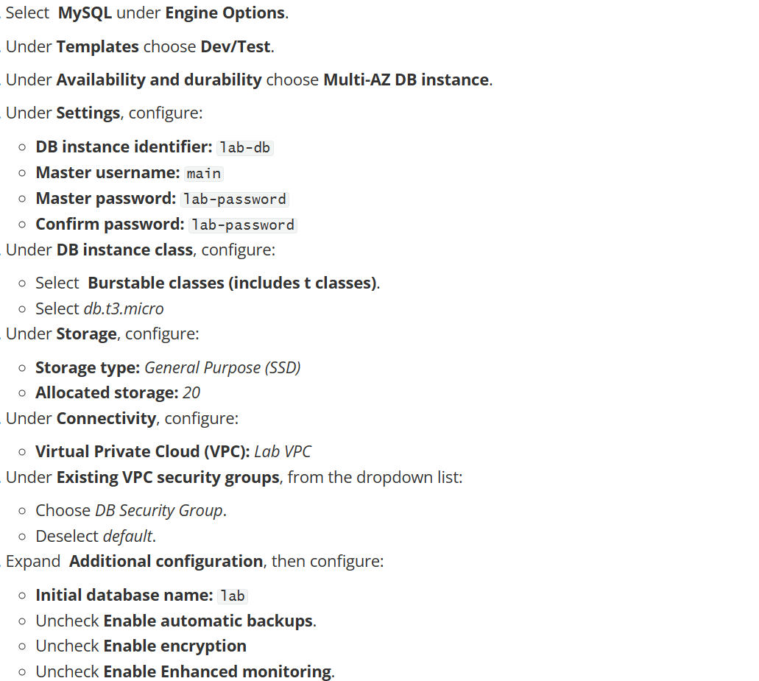

Then you should be able to go the webserver and interact with your database

Lab 6: Lab 6: Scale and Load Balance Your Architecture

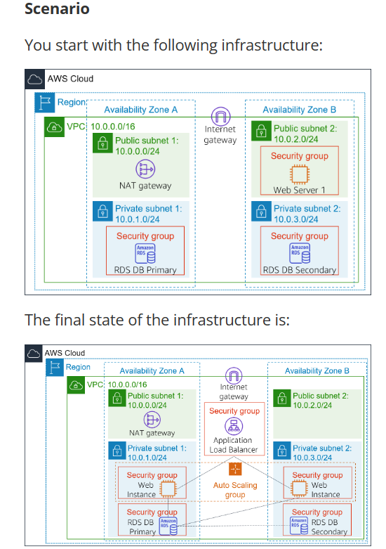

Create new AMI for your webserver so you can use auto scaling

Create a target group, they respond to requests from the load balancer

Then create the load balancer, using both public subnets

Create a launch configuration

Put it in the web server security group

Create an auto scaling group

Put it in the LAB VPC network

Control the number of instances to be between 2 and 6

