Multiprotocol Label Switching (MPLS)

Reed Holman | CCNP | 5/8/2023

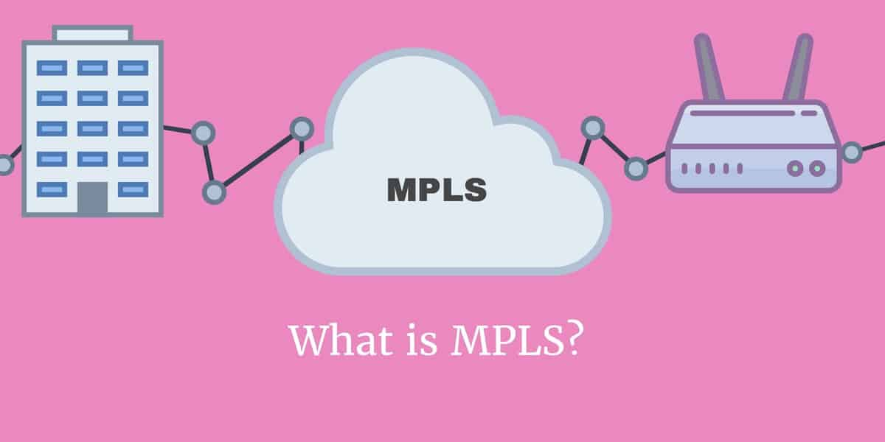



Purpose:

To set up a MPLS network using layer 3 switches.

Background Information:

A way of privately connecting different networks with multiple different connection types. Instead of using network addresses which use endpoints to tell where a packet needs to go, MPLS uses labels that point to a specified path between endpoints. MPLS is capable of encapsulating packets that are of different network protocols, and it also supports a wide array of access technologies like T1, Frame Relay, etc.

MPLS works by making decisions based on the label without needing to look at the packet itself. This gets rid of the need to rely of a specific Layer 2 technology. It works at a layer is sort between Layer 2 and 3 because of its ability to carry different type of traffic. The labels are decided on the requirements of the network and specific forwarding needs. This means that there is no need to look at a routing table which can greatly increase the speed of a network. Packets can edit their labels as they move through the network and when the packet reaches the end router the MPLS label is drooped from the packet, and it just uses the IP header.

There are two different labeling protocols that MPLS packets use, they are TDP (Tag Distribution Protocol) and LDP (Label Distribution Protocol). LDP is the most used protocol, and it uses target session approach. While TDP is a legacy protocol and is thus not used very often. You can also manually assign labels but that is not very efficient.

Configurations: 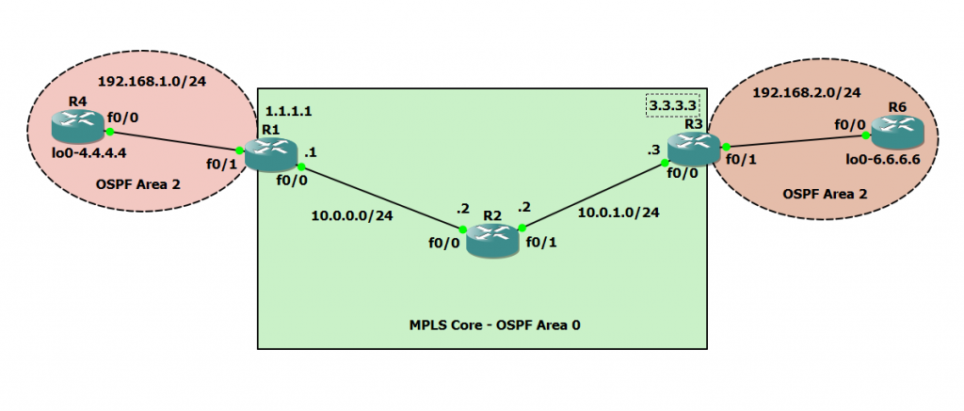

R1:

hostname Switch

boot-start-marker

boot-end-marker

no aaa new-model

system mtu routing 1500

ip routing

ip vrf RED

rd 4:4

route-target export 4:4

route-target import 4:4

vtp domain CCNP

vtp mode transparent

crypto pki trustpoint TP-self-signed-1670285312

enrollment selfsigned

subject-name cn=IOS-Self-Signed-Certificate-1670285312

revocation-check none

rsakeypair TP-self-signed-1670285312

crypto pki certificate chain TP-self-signed-1670285312

certificate self-signed 01

3082023E 308201A7 A0030201 02020101 300D0609 2A864886 F70D0101 04050030

31312F30 2D060355 04031326 494F532D 53656C66 2D536967 6E65642D 43657274

69666963 6174652D 31363730 32383533 3132301E 170D3933 30333031 30323336

32375A17 0D323030 31303130 30303030 305A3031 312F302D 06035504 03132649

4F532D53 656C662D 5369676E 65642D43 65727469 66696361 74652D31 36373032

38353331 3230819F 300D0609 2A864886 F70D0101 01050003 818D0030 81890281

8100B055 59A8F7C9 35957E0F 1AF94EFA DF71453E 1AE867A9 ED566AE8 F05297CE

4790E1B9 8C9EBBCC C4ECE3A4 6A31B313 FA60AD9B C3245475 F88CC864 318C5A19

BF0158FE DC10D401 9F8F663B 06689850 F2A9F410 F016B0D9 5F4823BC C98BEDB6

34F1DC29 66514197 F1B5F862 5D04FFD2 9530F1B2 DBF4DD9B 4257EA8A 93345164

CD8D0203 010001A3 66306430 0F060355 1D130101 FF040530 030101FF 30110603

551D1104 0A300882 06537769 74636830 1F060355 1D230418 30168014 BDFEDCE3

C9C78D0F E45FF0DA 3BB4EB4A 4151B2A2 301D0603 551D0E04 160414BD FEDCE3C9

C78D0FE4 5FF0DA3B B4EB4A41 51B2A230 0D06092A 864886F7 0D010104 05000381

81003C4B C99FFE18 448344C6 ABA9E038 76C3ECC0 097CB0B1 8997C568 30FEEDAB

9241C5EF 30EEBFA5 07EBD08B A70BF21C DC23881F 61276776 A940C3D4 B8BE038F

84E3A43D 8E97EAFB 42837C65 153F5BE2 BA044AB1 A7AE6B43 E1E7B764 69BF085E

67C1E0DD E273A7BE 8A232EA8 33670A82 1CE11A37 B4BEF826 3F793E07 17F382C9 39C6

quit

spanning-tree mode pvst

spanning-tree extend system-id

vlan internal allocation policy ascending

vlan 2

name data

vlan 3

name voice

vlan 4

name management

vlan 5

name Phoneline

vlan 6

name native

vlan 10

name Trivago

vlan 20

name Data

vlan 30

name Expedia

vlan 40

name google

vlan 50

name Microsoft

vlan 100

name Voice

vlan 400,707

vlan 996

name CUSTOMER_NATIVE

vlan 999

interface Loopback0

ip address 1.1.1.1 255.255.255.255

ip ospf 1 area 0

interface FastEthernet1/0/1

no switchport

ip vrf forwarding RED

ip address 192.168.1.1 255.255.255.0

ip ospf 2 area 2

interface FastEthernet1/0/2

interface FastEthernet1/0/3

interface FastEthernet1/0/4

interface FastEthernet1/0/5

interface FastEthernet1/0/6

interface FastEthernet1/0/7

interface FastEthernet1/0/8

interface FastEthernet1/0/9

interface FastEthernet1/0/10

interface FastEthernet1/0/11

interface FastEthernet1/0/12

interface FastEthernet1/0/13

interface FastEthernet1/0/14

interface FastEthernet1/0/15

interface FastEthernet1/0/16

interface FastEthernet1/0/17

interface FastEthernet1/0/18

interface FastEthernet1/0/19

interface FastEthernet1/0/20

interface FastEthernet1/0/21

interface FastEthernet1/0/22

interface FastEthernet1/0/23

interface FastEthernet1/0/24

interface GigabitEthernet1/0/1

interface GigabitEthernet1/0/2

interface GigabitEthernet1/1/1

interface GigabitEthernet1/1/2

no switchport

ip address 10.0.0.1 255.255.255.0

ip ospf 1 area 0

speed auto 1000

mpls ip

interface Vlan1

no ip address

shutdown

router ospf 2 vrf RED

redistribute bgp 1 subnets

router ospf 1

router bgp 1

bgp log-neighbor-changes

neighbor 3.3.3.3 remote-as 1

neighbor 3.3.3.3 update-source Loopback0

no auto-summary

address-family vpnv4

neighbor 3.3.3.3 activate

neighbor 3.3.3.3 send-community extended

exit-address-family

address-family ipv4 vrf RED

redistribute ospf 2 vrf RED

exit-address-family

ip http server

ip http secure-server

logging esm config

line con 0

line vty 0 4

login

line vty 5 15

login

end

S2:

hostname Switch

boot-start-marker

boot-end-marker

no aaa new-model

system mtu routing 1500

ip routing

crypto pki trustpoint TP-self-signed-2727259264

enrollment selfsigned

subject-name cn=IOS-Self-Signed-Certificate-2727259264

revocation-check none

rsakeypair TP-self-signed-2727259264

crypto pki certificate chain TP-self-signed-2727259264

certificate self-signed 01

3082023E 308201A7 A0030201 02020101 300D0609 2A864886 F70D0101 04050030

31312F30 2D060355 04031326 494F532D 53656C66 2D536967 6E65642D 43657274

69666963 6174652D 32373237 32353932 3634301E 170D3933 30333031 30323338

31355A17 0D323030 31303130 30303030 305A3031 312F302D 06035504 03132649

4F532D53 656C662D 5369676E 65642D43 65727469 66696361 74652D32 37323732

35393236 3430819F 300D0609 2A864886 F70D0101 01050003 818D0030 81890281

8100C751 3C16B82A 9EC1AF2A 27585018 73F90B4A 01E28286 5544D576 4865AC9F

41894752 6DB55F71 89C1044D 0C472C64 F3F4CB0A 21A7F267 53E35BE8 EB8C3D08

1EEAD022 65BF1F42 CC0731E0 4A82ABD8 5D207AB5 B0FBE035 7940520C 6EA5BC92

F3B9F79C 35B02C44 AADAA153 5599083B 4E8D11A2 B0769206 BD9736BD B82323CE

F80F0203 010001A3 66306430 0F060355 1D130101 FF040530 030101FF 30110603

551D1104 0A300882 06537769 74636830 1F060355 1D230418 30168014 86C6A4FA

1E5E9045 99B0F3F3 FB15BD20 CB7BFC2B 301D0603 551D0E04 16041486 C6A4FA1E

5E904599 B0F3F3FB 15BD20CB 7BFC2B30 0D06092A 864886F7 0D010104 05000381

8100810A FD1DD6FE 6F9579E1 28560A18 9E67CCDF F0546F19 F383D35C 4A5B5BA0

32C8B8B7 291805D5 3EB23DEF 97E869EE 8F5DDD14 97396A85 E5B64D5C 712B3DE2

19E95626 BEF91592 19E1988B 571DC84B 39A82394 B902770C C429A542 7AB9B415

8092811A 7B5DB5A3 82F75D9E 625B928D 1E784522 4E11631B D0828FAA 4B7F8323 EB4E

quit

spanning-tree mode pvst

spanning-tree extend system-id

vlan internal allocation policy ascending

interface Loopback0

ip address 2.2.2.2 255.255.255.255

ip ospf 1 area 0

interface FastEthernet1/0/1

interface FastEthernet1/0/2

interface FastEthernet1/0/3

interface FastEthernet1/0/4

interface FastEthernet1/0/5

interface FastEthernet1/0/6

interface FastEthernet1/0/7

interface FastEthernet1/0/8

interface FastEthernet1/0/9

interface FastEthernet1/0/10

interface FastEthernet1/0/11

interface FastEthernet1/0/12

interface FastEthernet1/0/13

interface FastEthernet1/0/14

interface FastEthernet1/0/15

interface FastEthernet1/0/16

interface FastEthernet1/0/17

interface FastEthernet1/0/18

interface FastEthernet1/0/19

interface FastEthernet1/0/20

interface FastEthernet1/0/21

interface FastEthernet1/0/22

interface FastEthernet1/0/23

interface FastEthernet1/0/24

interface GigabitEthernet1/0/1

interface GigabitEthernet1/0/2

interface GigabitEthernet1/1/1

no switchport

ip address 10.0.1.2 255.255.255.0

ip ospf 1 area 0

speed auto 1000

mpls ip

interface GigabitEthernet1/1/2

no switchport

ip address 10.0.0.2 255.255.255.0

ip ospf 1 area 0

speed auto 1000

mpls ip

interface Vlan1

no ip address

shutdown

router ospf 1

ip http server

ip http secure-server

logging esm config

line con 0

line vty 0 4

login

line vty 5 15

login

end

S3:

hostname Switch

boot-start-marker

boot-end-marker

no aaa new-model

system mtu routing 1500

ip routing

ip vrf RED

rd 4:4

route-target export 4:4

route-target import 4:4

vtp domain cisco

vtp mode transparent

crypto pki trustpoint TP-self-signed-1380261888

enrollment selfsigned

subject-name cn=IOS-Self-Signed-Certificate-1380261888

revocation-check none

rsakeypair TP-self-signed-1380261888

crypto pki certificate chain TP-self-signed-1380261888

certificate self-signed 01

3082023E 308201A7 A0030201 02020101 300D0609 2A864886 F70D0101 04050030

31312F30 2D060355 04031326 494F532D 53656C66 2D536967 6E65642D 43657274

69666963 6174652D 31333830 32363138 3838301E 170D3933 30333031 30333031

32375A17 0D323030 31303130 30303030 305A3031 312F302D 06035504 03132649

4F532D53 656C662D 5369676E 65642D43 65727469 66696361 74652D31 33383032

36313838 3830819F 300D0609 2A864886 F70D0101 01050003 818D0030 81890281

8100BA91 EC278264 DB0EAAB0 31A09257 F346C532 D4DA7D9C BAF6BB16 379DD651

4E5B1645 B8965F28 BA62669E 70A91218 763341BF 61EBCA6D E336DDEA 5ED20540

A1737E7B 36805AD2 3B471822 56CEE7B3 45E3CD3B CEF76C1C 37FDF2E2 96EA4279

2A203757 C0F5495B 849869C8 F63A3794 403CE1AE 3C2F72DB 7F1859AD 0C04A64C

556B0203 010001A3 66306430 0F060355 1D130101 FF040530 030101FF 30110603

551D1104 0A300882 06537769 74636830 1F060355 1D230418 30168014 12AA9F1E

A46258DA DC53CEF5 A565F2AC 8195EDD2 301D0603 551D0E04 16041412 AA9F1EA4

6258DADC 53CEF5A5 65F2AC81 95EDD230 0D06092A 864886F7 0D010104 05000381

81002726 16360629 BD2E0961 B6E01286 6012B3E3 FE36F949 3DD6B2FA 83EFF34A

A2720A56 63D0AE15 06131887 0DEBFC60 34BA26FB 3DD6F8EE C1827374 F3DFB946

DA39BE23 71FD6CA6 61F0694E 258EC9B6 DC204E09 DEDF62A0 A43B6762 879F3EC0

6828AC8D A5AF8C53 3A0483EB FF90C9E3 94AA1A66 0A39A7B9 B16F58BB CF8846A6 8B33

quit

spanning-tree mode pvst

spanning-tree extend system-id

vlan internal allocation policy ascending

vlan 2-3,10,20

vlan 996

name CUSTOMER_NATIVE

interface Loopback0

ip address 3.3.3.3 255.255.255.255

ip ospf 1 area 0

interface FastEthernet1/0/1

no switchport

ip vrf forwarding RED

ip address 192.168.2.1 255.255.255.0

ip ospf 2 area 2

interface FastEthernet1/0/2

interface FastEthernet1/0/3

interface FastEthernet1/0/4

interface FastEthernet1/0/5

interface FastEthernet1/0/6

interface FastEthernet1/0/7

interface FastEthernet1/0/8

interface FastEthernet1/0/9

interface FastEthernet1/0/10

interface FastEthernet1/0/11

interface FastEthernet1/0/12

interface FastEthernet1/0/13

interface FastEthernet1/0/14

interface FastEthernet1/0/15

interface FastEthernet1/0/16

interface FastEthernet1/0/17

interface FastEthernet1/0/18

interface FastEthernet1/0/19

interface FastEthernet1/0/20

interface FastEthernet1/0/21

interface FastEthernet1/0/22

interface FastEthernet1/0/23

interface FastEthernet1/0/24

interface GigabitEthernet1/0/1

interface GigabitEthernet1/0/2

interface GigabitEthernet1/1/1

interface GigabitEthernet1/1/2

no switchport

ip address 10.0.1.3 255.255.255.0

ip ospf 1 area 0

speed auto 1000

mpls ip

interface Vlan1

no ip address

shutdown

router ospf 2 vrf RED

redistribute bgp 1 subnets

router ospf 1

router bgp 1

bgp log-neighbor-changes

neighbor 1.1.1.1 remote-as 1

neighbor 1.1.1.1 update-source Loopback0

no auto-summary

address-family vpnv4

neighbor 1.1.1.1 activate

neighbor 1.1.1.1 send-community extended

exit-address-family

address-family ipv4 vrf RED

redistribute ospf 2 vrf RED

exit-address-family

ip http server

ip http secure-server

logging esm config

line con 0

line vty 0 4

login

line vty 5 15

login

end

R4:

hostname Switch

boot-start-marker

boot-end-marker

no aaa new-model

system mtu routing 1500

ip routing

ip vrf RED

rd 4:4

route-target export 4:4

route-target import 4:4

vtp domain cisco

vtp mode transparent

crypto pki trustpoint TP-self-signed-1380261888

enrollment selfsigned

subject-name cn=IOS-Self-Signed-Certificate-1380261888

revocation-check none

rsakeypair TP-self-signed-1380261888

crypto pki certificate chain TP-self-signed-1380261888

certificate self-signed 01

3082023E 308201A7 A0030201 02020101 300D0609 2A864886 F70D0101 04050030

31312F30 2D060355 04031326 494F532D 53656C66 2D536967 6E65642D 43657274

69666963 6174652D 31333830 32363138 3838301E 170D3933 30333031 30333031

32375A17 0D323030 31303130 30303030 305A3031 312F302D 06035504 03132649

4F532D53 656C662D 5369676E 65642D43 65727469 66696361 74652D31 33383032

36313838 3830819F 300D0609 2A864886 F70D0101 01050003 818D0030 81890281

8100BA91 EC278264 DB0EAAB0 31A09257 F346C532 D4DA7D9C BAF6BB16 379DD651

4E5B1645 B8965F28 BA62669E 70A91218 763341BF 61EBCA6D E336DDEA 5ED20540

A1737E7B 36805AD2 3B471822 56CEE7B3 45E3CD3B CEF76C1C 37FDF2E2 96EA4279

2A203757 C0F5495B 849869C8 F63A3794 403CE1AE 3C2F72DB 7F1859AD 0C04A64C

556B0203 010001A3 66306430 0F060355 1D130101 FF040530 030101FF 30110603

551D1104 0A300882 06537769 74636830 1F060355 1D230418 30168014 12AA9F1E

A46258DA DC53CEF5 A565F2AC 8195EDD2 301D0603 551D0E04 16041412 AA9F1EA4

6258DADC 53CEF5A5 65F2AC81 95EDD230 0D06092A 864886F7 0D010104 05000381

81002726 16360629 BD2E0961 B6E01286 6012B3E3 FE36F949 3DD6B2FA 83EFF34A

A2720A56 63D0AE15 06131887 0DEBFC60 34BA26FB 3DD6F8EE C1827374 F3DFB946

DA39BE23 71FD6CA6 61F0694E 258EC9B6 DC204E09 DEDF62A0 A43B6762 879F3EC0

6828AC8D A5AF8C53 3A0483EB FF90C9E3 94AA1A66 0A39A7B9 B16F58BB CF8846A6 8B33

quit

spanning-tree mode pvst

spanning-tree extend system-id

vlan internal allocation policy ascending

vlan 2-3,10,20

vlan 996

name CUSTOMER_NATIVE

interface Loopback0

ip address 3.3.3.3 255.255.255.255

ip ospf 1 area 0

interface FastEthernet1/0/1

no switchport

ip vrf forwarding RED

ip address 192.168.2.1 255.255.255.0

ip ospf 2 area 2

interface FastEthernet1/0/2

interface FastEthernet1/0/3

interface FastEthernet1/0/4

interface FastEthernet1/0/5

interface FastEthernet1/0/6

interface FastEthernet1/0/7

interface FastEthernet1/0/8

interface FastEthernet1/0/9

interface FastEthernet1/0/10

interface FastEthernet1/0/11

interface FastEthernet1/0/12

interface FastEthernet1/0/13

interface FastEthernet1/0/14

interface FastEthernet1/0/15

interface FastEthernet1/0/16

interface FastEthernet1/0/17

interface FastEthernet1/0/18

interface FastEthernet1/0/19

interface FastEthernet1/0/20

interface FastEthernet1/0/21

interface FastEthernet1/0/22

interface FastEthernet1/0/23

interface FastEthernet1/0/24

interface GigabitEthernet1/0/1

interface GigabitEthernet1/0/2

interface GigabitEthernet1/1/1

interface GigabitEthernet1/1/2

no switchport

ip address 10.0.1.3 255.255.255.0

ip ospf 1 area 0

speed auto 1000

mpls ip

interface Vlan1

no ip address

shutdown

router ospf 2 vrf RED

redistribute bgp 1 subnets

router ospf 1

router bgp 1

bgp log-neighbor-changes

neighbor 1.1.1.1 remote-as 1

neighbor 1.1.1.1 update-source Loopback0

no auto-summary

address-family vpnv4

neighbor 1.1.1.1 activate

neighbor 1.1.1.1 send-community extended

exit-address-family

address-family ipv4 vrf RED

redistribute ospf 2 vrf RED

exit-address-family

ip http server

ip http secure-server

logging esm config

line con 0

line vty 0 4

login

line vty 5 15

login

end

R6:

hostname Router

boot-start-marker

boot-end-marker

vrf definition Mgmt-intf

address-family ipv4

exit-address-family

address-family ipv6

exit-address-family

no aaa new-model

login on-success log

subscriber templating

vtp domain cisco

vtp mode transparent

multilink bundle-name authenticated

crypto pki trustpoint TP-self-signed-2105456491

enrollment selfsigned

subject-name cn=IOS-Self-Signed-Certificate-2105456491

revocation-check none

rsakeypair TP-self-signed-2105456491

crypto pki certificate chain TP-self-signed-2105456491

certificate self-signed 01

30820330 30820218 A0030201 02020101 300D0609 2A864886 F70D0101 05050030

31312F30 2D060355 04031326 494F532D 53656C66 2D536967 6E65642D 43657274

69666963 6174652D 32313035 34353634 3931301E 170D3233 30353235 31373538

34315A17 0D333030 31303130 30303030 305A3031 312F302D 06035504 03132649

4F532D53 656C662D 5369676E 65642D43 65727469 66696361 74652D32 31303534

35363439 31308201 22300D06 092A8648 86F70D01 01010500 0382010F 00308201

0A028201 01009846 14ECFE82 B0F248C5 C553C1BC 281630BF 8616A065 6DA4831D

D3AA4E8F E1E6398C 847F02B9 91D3AED9 74637F99 566E58FD B653A3C1 D584CC1E

6F8BC38F D5DF255E F2AAF14C DF93E5F5 54FE2A74 3F469D73 B9ED28CF 442D8AEB

F1AD950C 973E0A49 6F749677 14540EEE 9B248618 100427FA FE6EBEE3 EE78E7CC

C8376085 72AA40D7 0B5EEB07 3146CFC4 49A92DAD 8AEF14BA D4272A9D 2A17BDA1

19997FCB 04B297B5 EA9744EF 8B28E395 FB8048A4 02BE84E9 0230D660 FA136B30

C1A8B92D 40B88561 64A59A5F 78040D18 2B9C1048 4C596C06 3F440BC2 36BA9949

46D449F1 8EE0F63D 70FDF8D1 3F9DB8B7 44B67A1F 389CC373 54DA2B1A 9E88A36A

50784E1C CAA30203 010001A3 53305130 0F060355 1D130101 FF040530 030101FF

301F0603 551D2304 18301680 14843C87 65353814 08C4EAC6 E8A1185C 590937CD

AF301D06 03551D0E 04160414 843C8765 35381408 C4EAC6E8 A1185C59 0937CDAF

300D0609 2A864886 F70D0101 05050003 82010100 5E11C308 BA9A58C7 E0CEB14A

A8883D33 D5473E1E 8844EC2F 8B7D9580 E92437EF DFB3F9B2 A57ADC71 BD83C7E8

E36D75CE 2D34A508 6A8DF723 BEE7008C 06B86EDF 9E0D2E07 4439E7D1 8FFE2E97

FAA00F7B 8C0EDC55 2FCF4576 DCB8E0E2 8F57B81D 46A818E3 BA589AAC F9162D24

6A5E70CF 1CD4F69F EFE19168 F3476C8C 2A9CFB21 6901E350 F701B902 70036FCE

40E0D327 51CE85B3 062276DC FAFBE587 7D3FD6DB 55FF87B3 87E824EB 01C551CE

393C31A3 D7F7597C 7AAD0E48 4CD5CE3C BD00A12C 42C5CB12 6F3D0D65 9AC370AB

CB53D93A DEF958A0 A0BF0A2E 6BBBA9A9 641B06E8 8BD4C05C DF490673 0162A7C4

647565AF DC9E9297 429E6844 D8F0C43D 16AABB16

quit

license udi pid ISR4321/K9 sn FDO21482DWJ

no license smart enable

diagnostic bootup level minimal

spanning-tree extend system-id

redundancy

mode none

interface Loopback0

ip address 6.6.6.6 255.255.255.255

ip ospf 2 area 2

interface GigabitEthernet0/0/0

no ip address

shutdown

negotiation auto

interface GigabitEthernet0/0/1

ip address 192.168.2.6 255.255.255.0

ip ospf 2 area 2

negotiation auto

interface Serial0/1/0

no ip address

shutdown

interface Serial0/1/1

no ip address

shutdown

interface GigabitEthernet0

vrf forwarding Mgmt-intf

no ip address

shutdown

negotiation auto

router ospf 2

ip forward-protocol nd

ip http server

ip http authentication local

ip http secure-server

ip tftp source-interface GigabitEthernet0

control-plane

line con 0

transport input none

stopbits 1

line aux 0

stopbits 1

line vty 0 4

login

end

Problems:

One of the first issues was that I didn’t have IP routing enabled on the switches so OSPF wouldn’t work. I also needed to do the no switchport command on my ES ports so that I could assign IP address to them. Besides that, the actual configuring of MPLS was fairly simple and we add no issues with it.