VoIP with CME

Reed Holman | CCNP | 1/7/2023

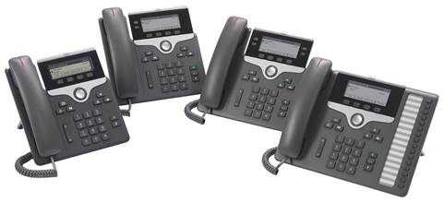

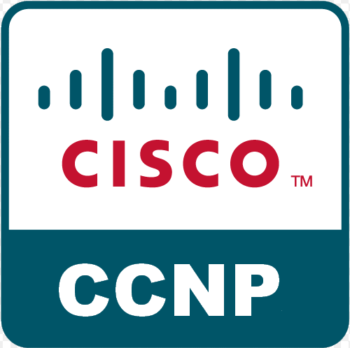

Purpose: This lab's purpose was to set up two cisco Ip phones that can call each other and dial an outside number.

Background Information:

VoIP stands for Voice over Internet Protocol; this is how phones can make calls over the internet. VoIP has been adapted and improved into things like Skype and Microsoft teams, which was the service that we had to use to do school during the pandemic. Many businesses also use that or a similar service to communicate with their employees no matter where they are, showing just how important VoIP has become. Especially during a time were working remotely as become so popular.

Cisco CME also known as Call Manager Express which is the application that allows cisco devices to handle VoIP data. CME has lots of features and is great for small networks. You need to install CME files onto your Cisco router’s flash. A DHCP server is also required to get CME working so that the phones can have IP address. Another important aspect of configuring the Phones is setting up ephones and ephone-dn. An ephone-dn is a virtual voice port that you need to configure. And the ephone is the physical telephone that you need to plug into the router.

Using Cisco Unified Communications Manager, you can use CME for larger networks. It manages all of your IP phones, mobile devices, computers into one place. It integrates all of voice, video and data into a single infrastructure. CUCM has many useful features such as Call processing, Signaling, and controlling devices, Administration of dial plan and phone characteristics. We used a Cisco 2811 because it has FXO or Foreign Exchange Office ports that how us to connect to an actual phone line.

Lab Commands:

dial-peer voice 1 pots

destination-pattern 91[2-9].........

port 0/3/3

(creates the voice port w/ an extension to dial out)

ephone-dn 1

number 1010

(Sets local number for phone)

ephone 1

mac-address 0015.2B47.6685

type 7960

(Sets defining characteristics of phone like mac-address and type)

Network Diagram: 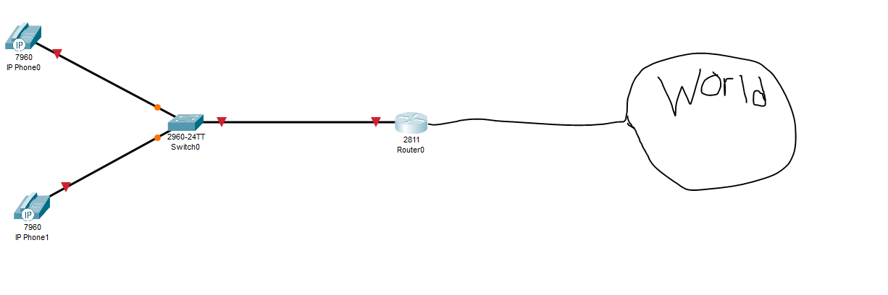

Configurations:

R1:

hostname Router

boot-start-marker

boot-end-marker

no aaa new-model

resource policy

memory-size iomem 10

no network-clock-participate slot 1

ip subnet-zero

ip cef

no ip dhcp use vrf connected

ip dhcp excluded-address 192.168.20.1 192.168.20.5

ip dhcp pool VOICE20

network 192.168.20.0 255.255.255.0

default-router 192.168.20.1

option 150 ip 192.168.20.1

voice-card 0

no dspfarm

voice-card 1

no dspfarm

archive

log config

hidekeys

interface FastEthernet0/0

ip address dhcp

duplex auto

speed auto

interface FastEthernet0/0.10

encapsulation dot1Q 10

ip address 192.168.10.1 255.255.255.0

no snmp trap link-status

interface FastEthernet0/0.20

encapsulation dot1Q 20

ip address 192.168.20.1 255.255.255.0

no snmp trap link-status

interface FastEthernet0/0.50

encapsulation dot1Q 50 native

no snmp trap link-status

interface FastEthernet0/1

no ip address

duplex auto

speed auto

interface FastEthernet0/1/0

interface FastEthernet0/1/1

interface FastEthernet0/1/2

interface FastEthernet0/1/3

interface FastEthernet0/1/4

interface FastEthernet0/1/5

interface FastEthernet0/1/6

interface FastEthernet0/1/7

interface FastEthernet0/1/8

interface Serial0/2/0

no ip address

shutdown

interface Vlan1

no ip address

ip classless

no ip http server

no ip http secure-server

control-plane

voice-port 0/3/0

voice-port 0/3/1

voice-port 0/3/2

voice-port 0/3/3

voice-port 1/0/0

voice-port 1/0/1

dial-peer voice 1 pots

destination-pattern 91[2-9].........

port 0/3/3

forward-digits all

telephony-service

max-ephones 2

max-dn 2

ip source-address 192.168.20.1 port 2000

create cnf-files version-stamp Jan 01 2002 00:00:00

max-conferences 8 gain -6

transfer-system full-consult

ephone-dn 1

number 1010

ephone-dn 2

number 1020

ephone 1

mac-address 0015.2B47.6685

type 7960

button 1:1

ephone 2

mac-address 0015.62B5.E72C

type 7960

button 1:2

line con 0

line aux 0

line vty 0 4

login

scheduler allocate 20000 1000

S1:

hostname Switch

boot-start-marker

boot-end-marker

no aaa new-model

system mtu routing 1500

vtp domain CCNP

vtp mode transparent

authentication mac-move permit

ip subnet-zero

spanning-tree mode pvst

spanning-tree etherchannel guard misconfig

spanning-tree extend system-id

vlan internal allocation policy ascending

vlan 10

name DATA

vlan 20

name VOICE

vlan 30

name MGT

vlan 40

name MISC

vlan 50

name NATIVE

vlan 99

name MANAGEMENT

interface FastEthernet0/1

switchport trunk encapsulation dot1q

switchport trunk native vlan 50

switchport mode trunk

interface FastEthernet0/2

switchport mode access

switchport voice vlan 20

spanning-tree portfast

interface FastEthernet0/3

switchport mode access

switchport voice vlan 20

spanning-tree portfast

interface FastEthernet0/4

interface FastEthernet0/5

interface FastEthernet0/6

interface FastEthernet0/7

interface FastEthernet0/8

interface FastEthernet0/9

interface FastEthernet0/10

interface FastEthernet0/11

interface FastEthernet0/12

interface FastEthernet0/13

interface FastEthernet0/14

interface FastEthernet0/15

interface FastEthernet0/16

interface FastEthernet0/17

interface FastEthernet0/18

interface FastEthernet0/19

interface FastEthernet0/20

interface FastEthernet0/21

interface FastEthernet0/22

interface FastEthernet0/23

interface FastEthernet0/24

interface GigabitEthernet0/1

interface GigabitEthernet0/2

interface Vlan1

no ip address

shutdown

ip classless

ip http server

ip sla enable reaction-alerts

line con 0

line vty 0 4

login

line vty 5 15

login

end

Problems:

One of our very first problems was that we were working under the assumption every router already had CME when in fact only one router in our lab had it. We needed to edit the flash files of the routers so they would have CME. It took us a little bit to get CME all the routers but once we did, we were able to get back to work. Another issue we ran into was some of the physical phones simply just didn’t work so some people stayed late and tested every phone and labeled the ones that worked so that every group could have good equipment. We were also using a switch that did not have power over ethernet so even if we had good phones, it still did not work. When then switched over to the switch in our rack that did have power over Ethernet. After that, it was simple to get the phones to call each other, but we still struggled with how to call an outside line. We eventually figured out that we were missing a very crucial command. It was the destination pattern that created the extension to dial an outside number. Once we did that, we were able to successfully call each other and a local pizza place.

Conclusion: This lab was very different from our pervious labs. We used a new router and IP phones for the first time. We learned about how CME works and how you can make calls using IP. It took a little bit but completing this lab was very rewarding.